**QUESTION 1**

#include<bits/stdc++.h>

using namespace std;

int main()

{

    float a,b,c;

    cin>>a>>b>>c;

    float sum,average;

    sum=a+b+c;

    average=sum/3;

    cout<<"Sum is = "<<sum<<endl<<"Average is ="<<average<<endl;

}

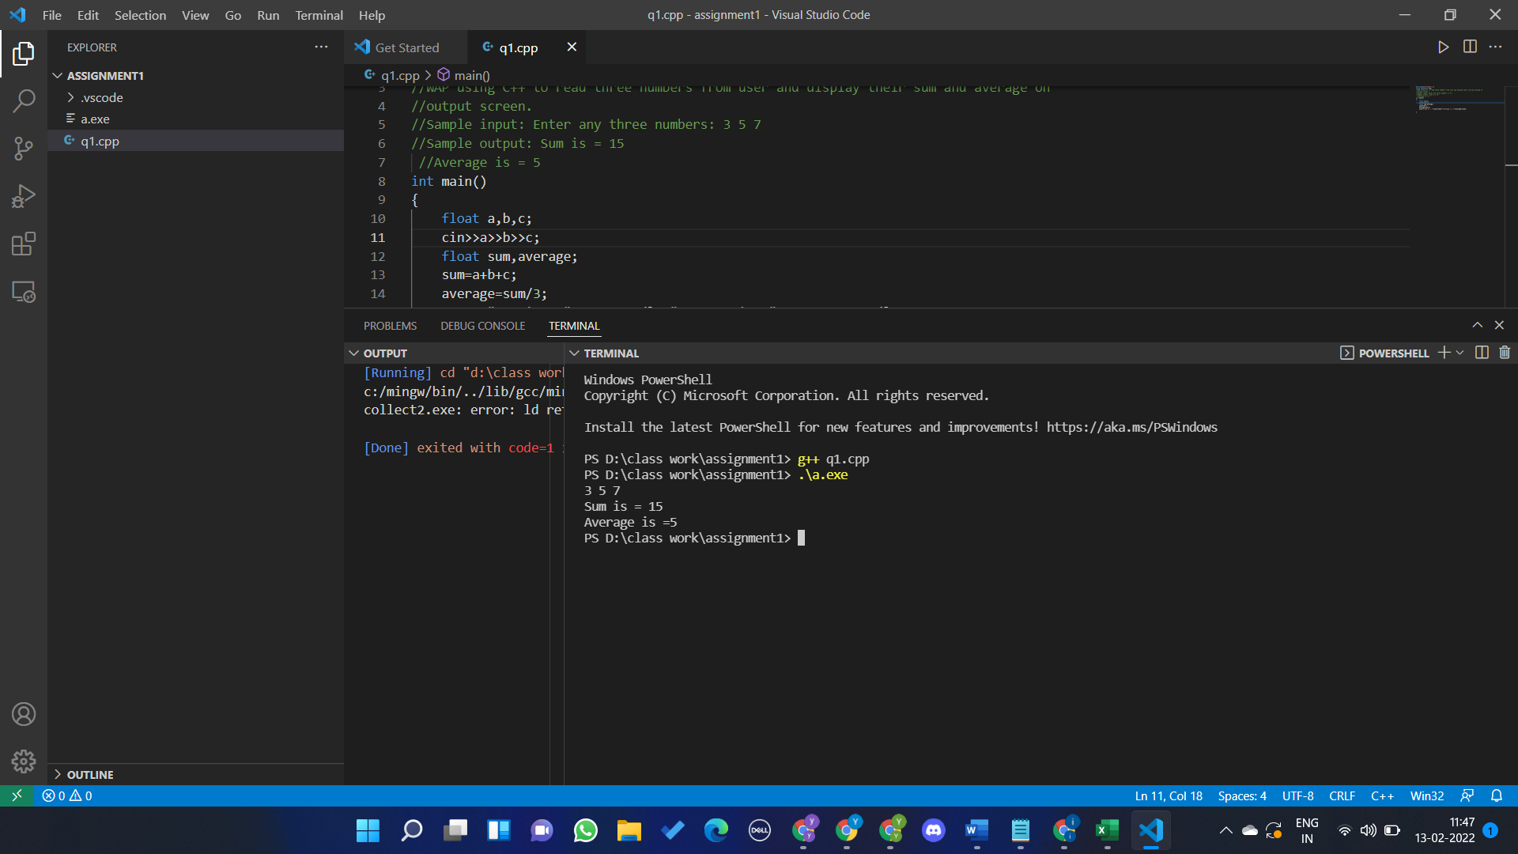

**QUESTION 2**

#include<bits/stdc++.h>

using namespace std;

int main()

{

    float a,b,max;

    cout<<"enter 2 numbers"<<endl;

    cin>>a>>b;

    if(a!=b)

    max=a>b?a:b;

    else

    {

        cout<<"both are equal";

        return EXIT_SUCCESS;

    }

    cout<<"max of two is "<<max;

}

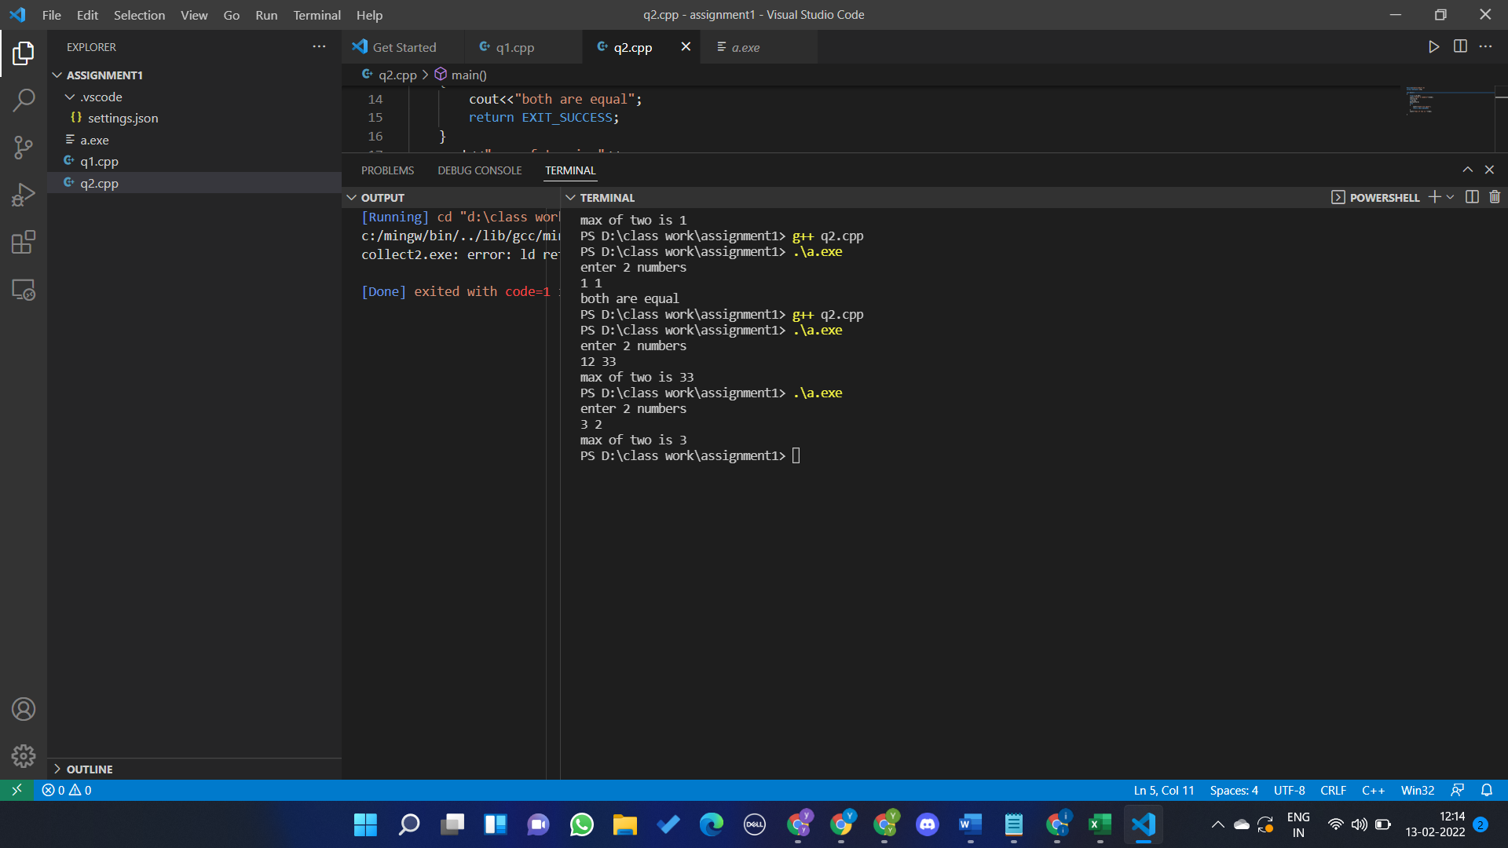

QUSTION 3

#include<iostream>

using namespace std;

/*Write a C++ program to read the values of variables: a, b c and d from user and display

the value of x on output screen, where

x = a / (b -c) + d

Sample input1: Enter the value of a,b,c& d :

250 85 25 2

Sample output1: x=a/(b-c) +d = 6.16667

Sample input2: Enter the value of a,b,c& d :

300 60 60 5*/

int main()

{

    float a,b,c,d,x;

    cin>>a>>b>>c>>d;

    if((b-c)==0)

    {

        cout<<"infinity";

        return 0;

    }

    x = (a/(b-c))+d;

    cout<<"x = (a/(b-c))+d = " <<x<<endl;

}

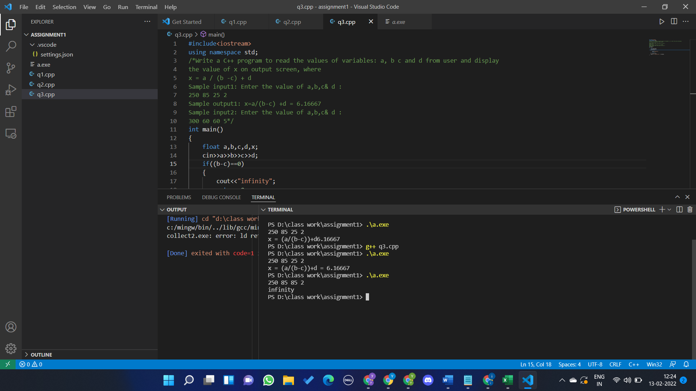

Question 4

#include <iostream>

using namespace std;

int main()

{

    int n;

    cin>>n;

    int a[n];

    for(int i=0;i<n;i++)

    {

        cin>>a[i];

    }

    int s[100]={0};

    for(int i=0;i<n;i++)

    {

        if(a[i]>0)

        {

            s[a[i]]=1;

        }

    }

    for(int i=1;i<n+1;i++)

    {

        if(s[i]==0){

            cout<<i;

            return 0;

        }

    }

}

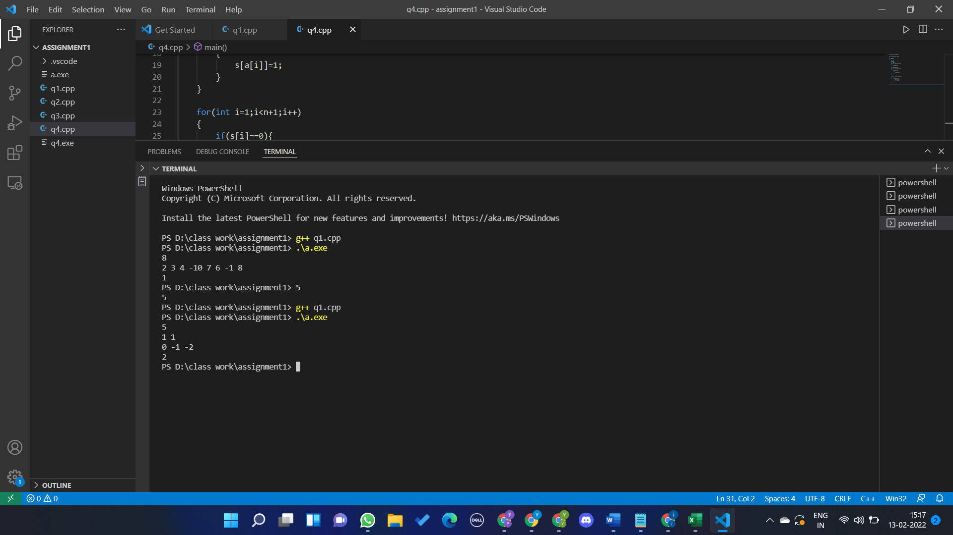

Question 5

#include <iostream>

#include<climits>

using namespace std;

int main()

{

    int n;

    cin>>n;

    int a[n];

    for(int i=0;i<n;i++){

        cin>>a[i];

    }

    int prime[100]={0};

    for(int i=2;i<n;i++){

        if(prime[i]==0){

            for(int j=i*i;j<=n;j++){

                prime[j]=1;

            }

        }

    }

    int mx=INT_MIN;

    for(int i=0;i<n;i++)

    {

        prime[a[i]]+=1;

        mx=max(mx,a[i]);

    }

    for(int i=2;i<mx;i++)

    {

        if(prime[i]==2)

        {

            cout<<i+1;

            return 0;

        }

    }

    cout<<"no prime is missing";

}

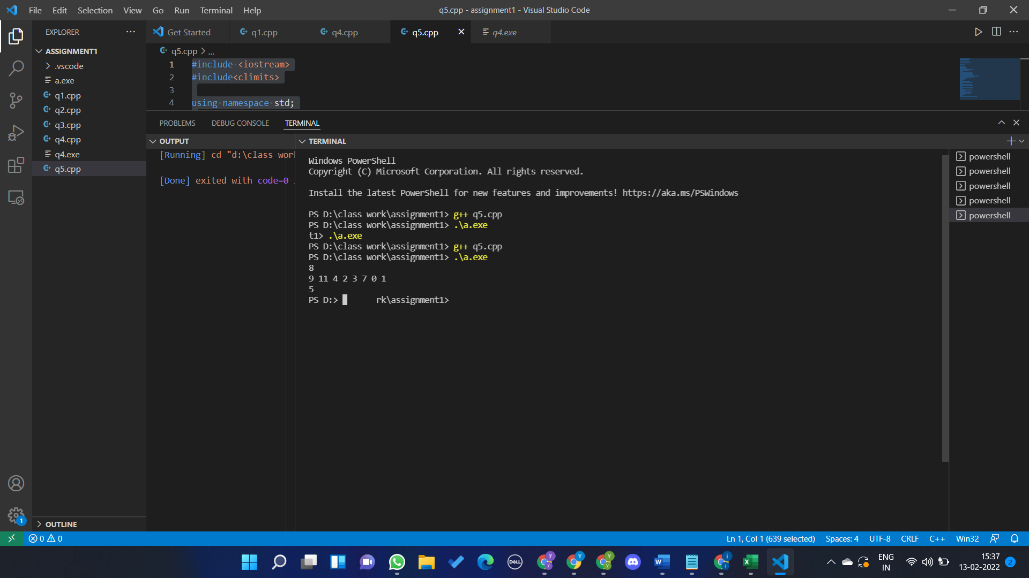

Question 6

#include<iostream>

using namespace std;

int main(){

    int row,col;

    cin>>row>>col;

    bool a[row][col];

    bool r[row]={0},c[col]={0};

    for(int i=0;i<row;i++)

    {

        for(int j=0;j<col;j++)

        {

            cin>>a[i][j];

        }

    }

    for(int i=0;i<row;i++)

    {

        for(int j=0;j<col;j++)

        {

            if(a[i][j]==1)

            {

                r[i]=1;

                c[j]=1;

            }

        }

    }

     for(int i=0;i<row;i++)

    {

        for(int j=0;j<col;j++)

        {

            if(r[i]==1 || c[j]==1)

            {

                a[i][j]=1;

            }

        }

    }

    cout<<endl;

    for(int i=0;i<row;i++)

    {

        for(int j=0;j<col;j++)

        {

            cout<<a[i][j]<<" ";

        }

        cout<<endl;

    }

}

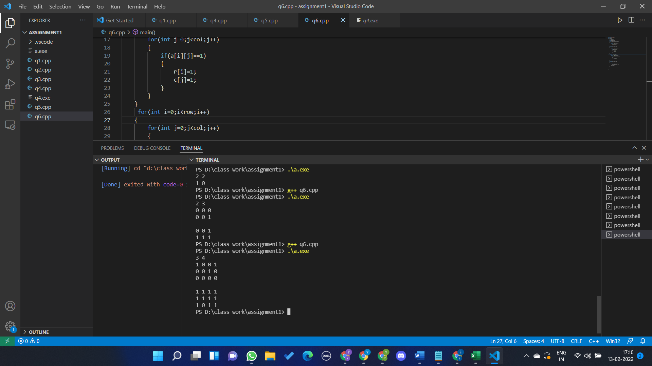

Question 7

#include<iostream>

using namespace std;

struct employee

{

    char name[30];

    int age;

    float salary;

}e1;

int main()

{

    cout<<"Enter Full name: ";

    cin.getline(e1.name,30);

    cout<<"enter age : ";

    cin>>e1.age;

    cout<<"enter salary :";

    cin>>e1.salary;

    cout<<"Displaying Information. "<<endl;

    cout<<"Name : "<<e1.name<<endl;

    cout<<"Age : "<<e1.age<<endl;

    cout<<"Salary : "<<e1.salary<<endl;

}

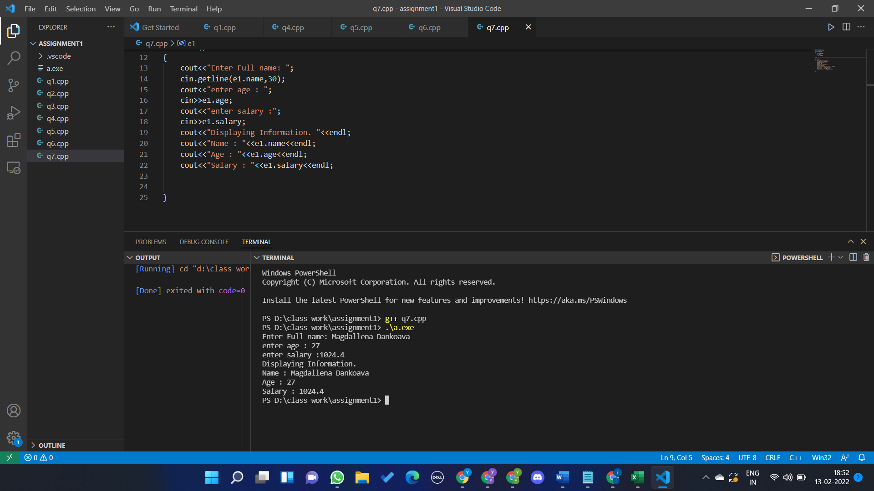

Question 7.1

#include<iostream>

using namespace std;

struct employee

{

    char name[30];

    int age;

    float basic;

    float HRA,BOOK_allowance,furniture_allowance,special_allowance;

    float total;

}e1;

int main()

{

    cout<<"Enter Full name: ";

    cin.getline(e1.name,30);

    cout<<"enter age : ";

    cin>>e1.age;

    cout<<"enter salary components:"<<endl;

    cout<<"Basic :";

    cin>>e1.basic;

    cout<<"HRA : ";

    cin>>e1.HRA;

    cout<<"Book Allowance :";

    cin>>e1.BOOK_allowance;

    cout<<"furniture allowance :";

    cin>>e1.furniture_allowance;

    cout<<"special allowance :";

    cin>>e1.special_allowance;

    e1.total=e1.basic+e1.HRA+e1.BOOK_allowance+e1.furniture_allowance+e1.special_allowance;

    cout<<endl;

    cout<<"Displaying Information. "<<endl;

    cout<<"Name : "<<e1.name<<endl;

    cout<<"Age : "<<e1.age<<endl;

    cout<<"Total salary : "<<e1.total<<endl;

}

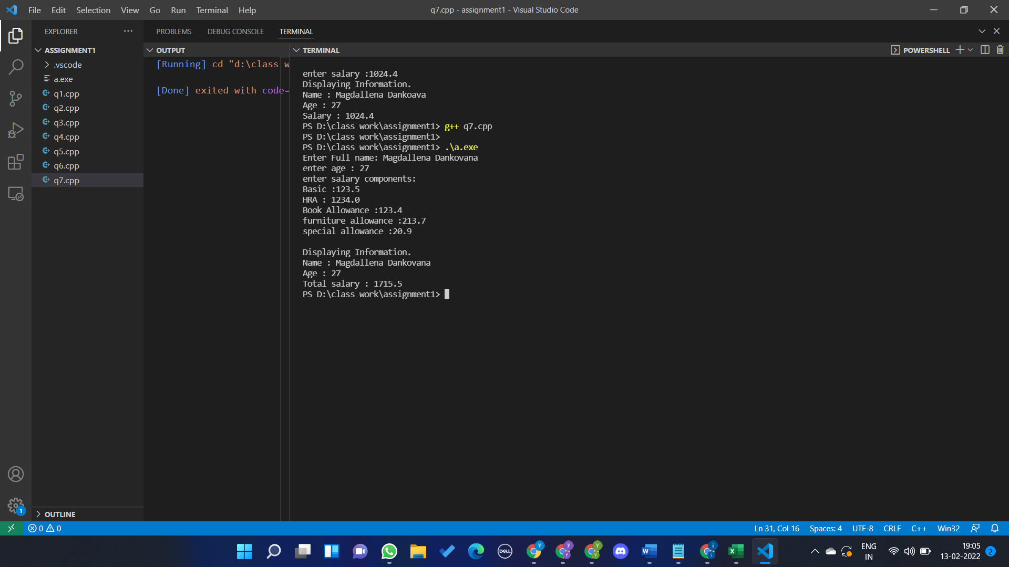

Question 8

#include<bits/stdc++.h>

using namespace std;

struct phone{

    float price;

    int battery_power;

    float rating;

}p[2];

int main()

{

    for(int i=0;i<2;i++)

    {

        cout<<"Enter phone"<<i+1<<" Details";

        cout<<"Enter Price : ";

        cin>>p[i].price;

        cout<<"Enter Battery Power (in mAH) : ";

        cin>>p[i].battery_power;

        cout<<"Enter Rating (betwen 0-5)";

        cin>>p[i].rating;

    }

    cout<<endl;

    if(p[0].price<p[1].price) cout<<"Phone better w.r.t Price is Phone1"<<endl;

    else if(p[0].price>p[1].price) cout<<"Phone better w.r.t Price is Phone2"<<endl;

    else cout<<"same in pricing point"<<endl;

    if(p[0].battery_power>p[1].battery_power) cout<<"Phone better w.r.t battery power is Phone1"<<endl;

    else if(p[0].battery_power<p[1].battery_power) cout<<"Phone better w.r.t battery power is Phone2"<<endl;

    else cout<<"same in battery point of view"<<endl;

    if(p[0].rating>p[1].rating) cout<<"Phone better w.r.t rating is Phone1"<<endl;

    else if(p[0].rating<p[1].rating) cout<<"Phone better w.r.t rating is Phone2"<<endl;

    else cout<<"same in rating point"<<endl;

}

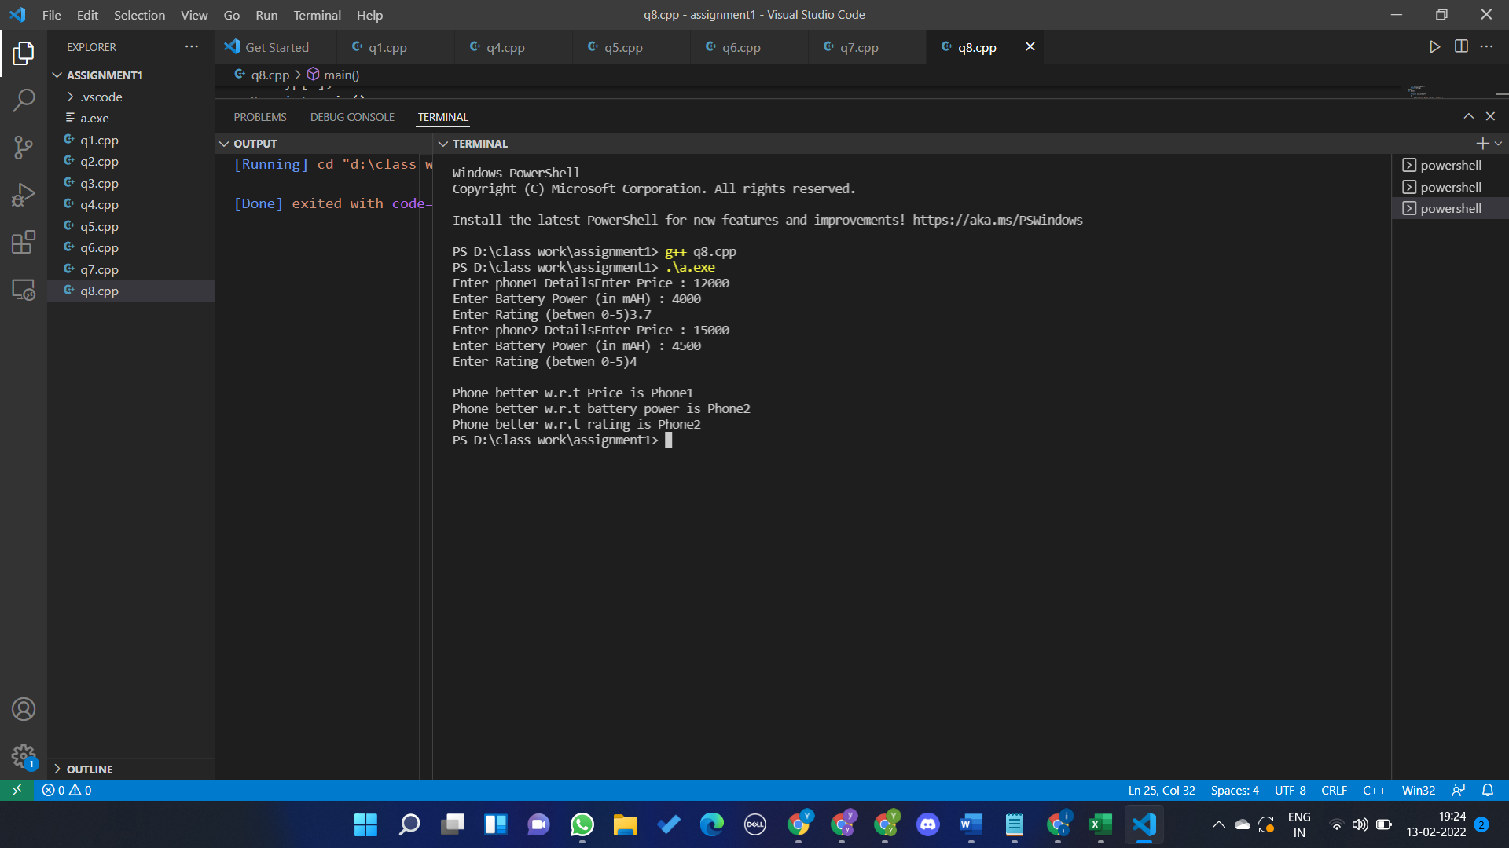

Question 9

#include<iostream>

using namespace std;

int main()

{

    int row,col;

    cin>>row>>col;

    int a[row][col];

    for(int i=0;i<row;i++)

    {

        for(int j=0;j<col;j++)

        {

            cin>>a[i][j];

        }

    }

    int start_row=0,start_col=0,end_col=col-1,end_row=row-1;

    while(start_row<=end_row && start_col<=end_col)

    {

        for(int i=start_col;i<=end_col;i++)

        {

            cout<<a[start_row][i]<<" ";

        }

        start_row++;

        for(int i=start_row;i<=end_row;i++)

        {

            cout<<a[i][end_col]<<" ";

        }

        end_col--;

        if(start_row<end_row){

            for(int i=end_col;i>=start_col;i--)

            {

                cout<<a[end_row][i]<<" ";

            }

            end_row--;

        }

        if(start_col<end_col)

        {

            for(int i=end_row;i>=start_row;i--)

            {

                cout<<a[i][start_col]<<" ";

            }

            start_col++;

        }

    }

}

