Question 1

#include<iostream>

#include <cmath>

using namespace std;

class triangle{

    float a,b,c;

    public:

    void perimeter(){

        cout<<endl<<"the perimeter of the triangle is : "<<a+b+c;

    }

    void area()

    {

        float s;

        s=((a+b+c)/2);

        cout<<endl<<"the area of the triangle is : "<< pow(s*(s-a)*(s-b)*(s-c),0.5);

    }

    void set_side (float r,float s,float t)

    {

        a=r;

        b=s;

        c=t;

    }

};

int main()

{

    cout<<"enter the sides of triangle"<<endl;

    float a,b,c;

    cin>>a>>b>>c;

    triangle t1;

    t1.set_side(a,b,c);

    t1.perimeter();

    t1.area();

    return 0;

}

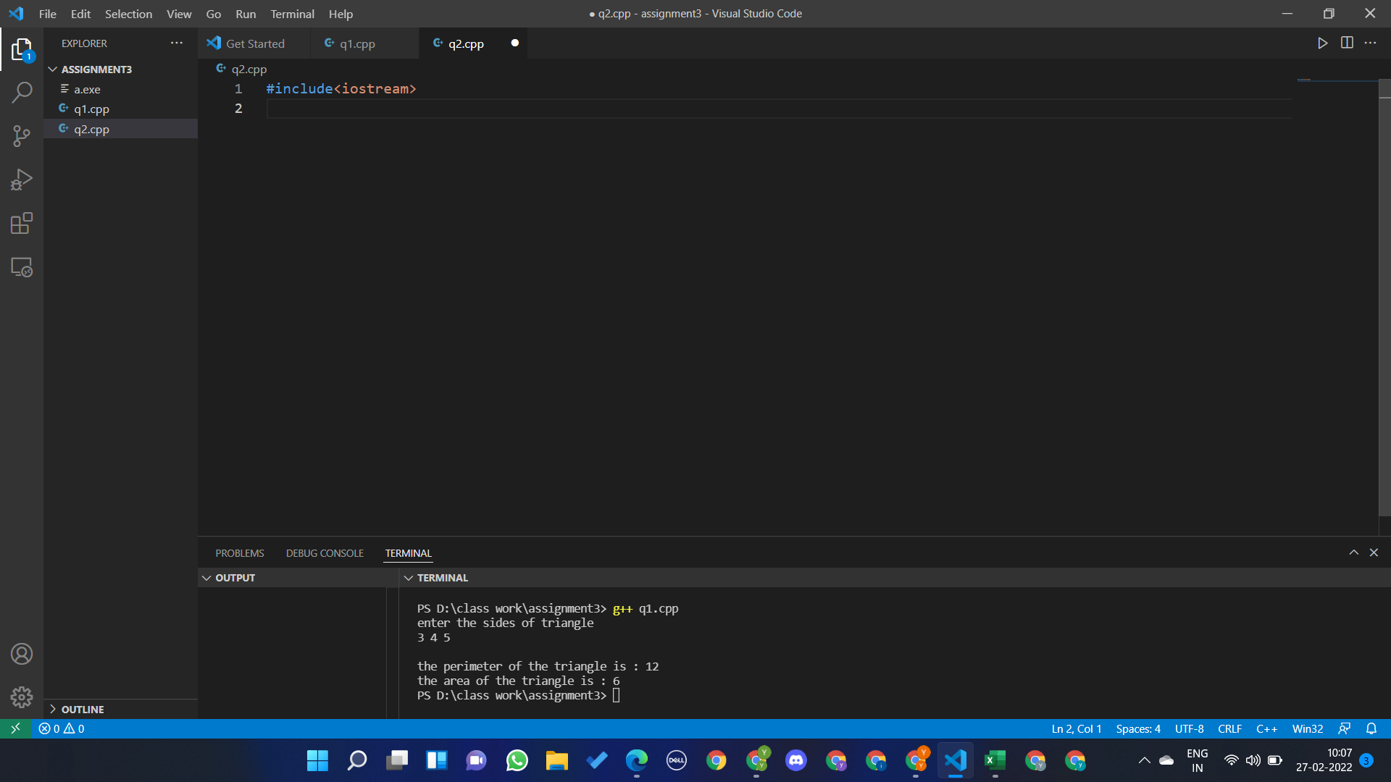

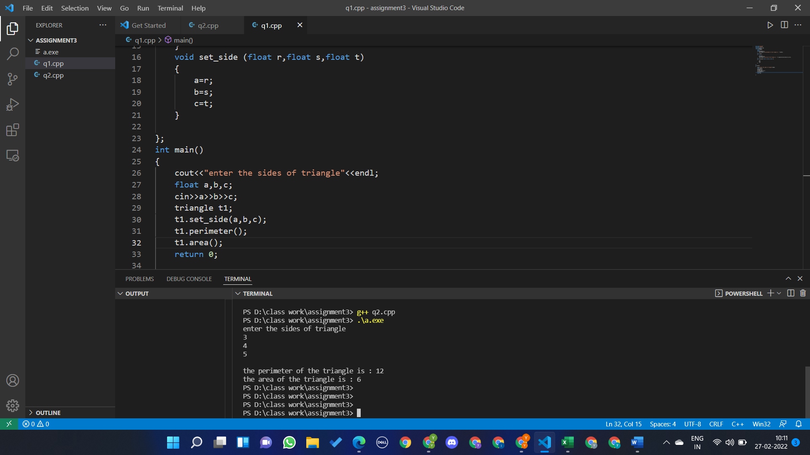Question 2

#include<iostream>

#include <cmath>

using namespace std;

class triangle{

    float a,b,c;

    public:

    void perimeter(){

        cout<<endl<<"the perimeter of the triangle is : "<<a+b+c;

    }

    void area()

    {

        float s;

        s=((a+b+c)/2);

        cout<<endl<<"the area of the triangle is : "<< pow(s*(s-a)*(s-b)*(s-c),0.5);

    }

    void set_side (float r,float s,float t)

    {

        a=r;

        b=s;

        c=t;

    }

};

int main()

{

    cout<<"enter the sides of triangle"<<endl;

    float a,b,c;

    cin>>a>>b>>c;

    triangle t1;

    t1.set_side(a,b,c);

    t1.perimeter();

    t1.area();

    return 0;

}

Question 3

#include<iostream>

#include <cmath>

using namespace std;

class complex{

    int re;

    int cx;

    public:

    complex(int r,int c){re=r;cx=c;} //parameterised constructor

    void get_re(int r){

        re=r;

    }

    void get_cx(int c){

        cx=c;

    }

    void sum(complex &a)

    {

        cout<<"The sum of the complex numbers are : "<<re+a.re<<"+("<<cx+a.cx<<")i"<<endl;

    }

    void diffrence(complex &a)

    {

        cout<<"The diffrence of the complex numbers are : "<<re-a.re<<"+("<<cx-a.cx<<")i"<<endl;

    }

    void multiple(complex &a)

    {

        int r=(re*(a.re))-(cx*(a.cx));

        int c=(re*(a.cx))+(cx*(a.re));

        cout<<"The multiplication of the complex numbers are : "<<r<<"+("<<c<<")i"<<endl;

    }

};

int main()

{

    cout<<"Enter the real and imaginary part of complex no 1 : "<<endl;

    int r1,c1;

    cin>>r1>>c1;

    cout<<"Enter the real and imaginary part of complex no 2 : "<<endl;

    int r2,c2;

    cin>>r2>>c2;

    complex C1(r1,c1),C2(r2,c2);

    C1.sum(C2);

    C1.diffrence(C2);

    C1.multiple(C2);

    return 0;

}

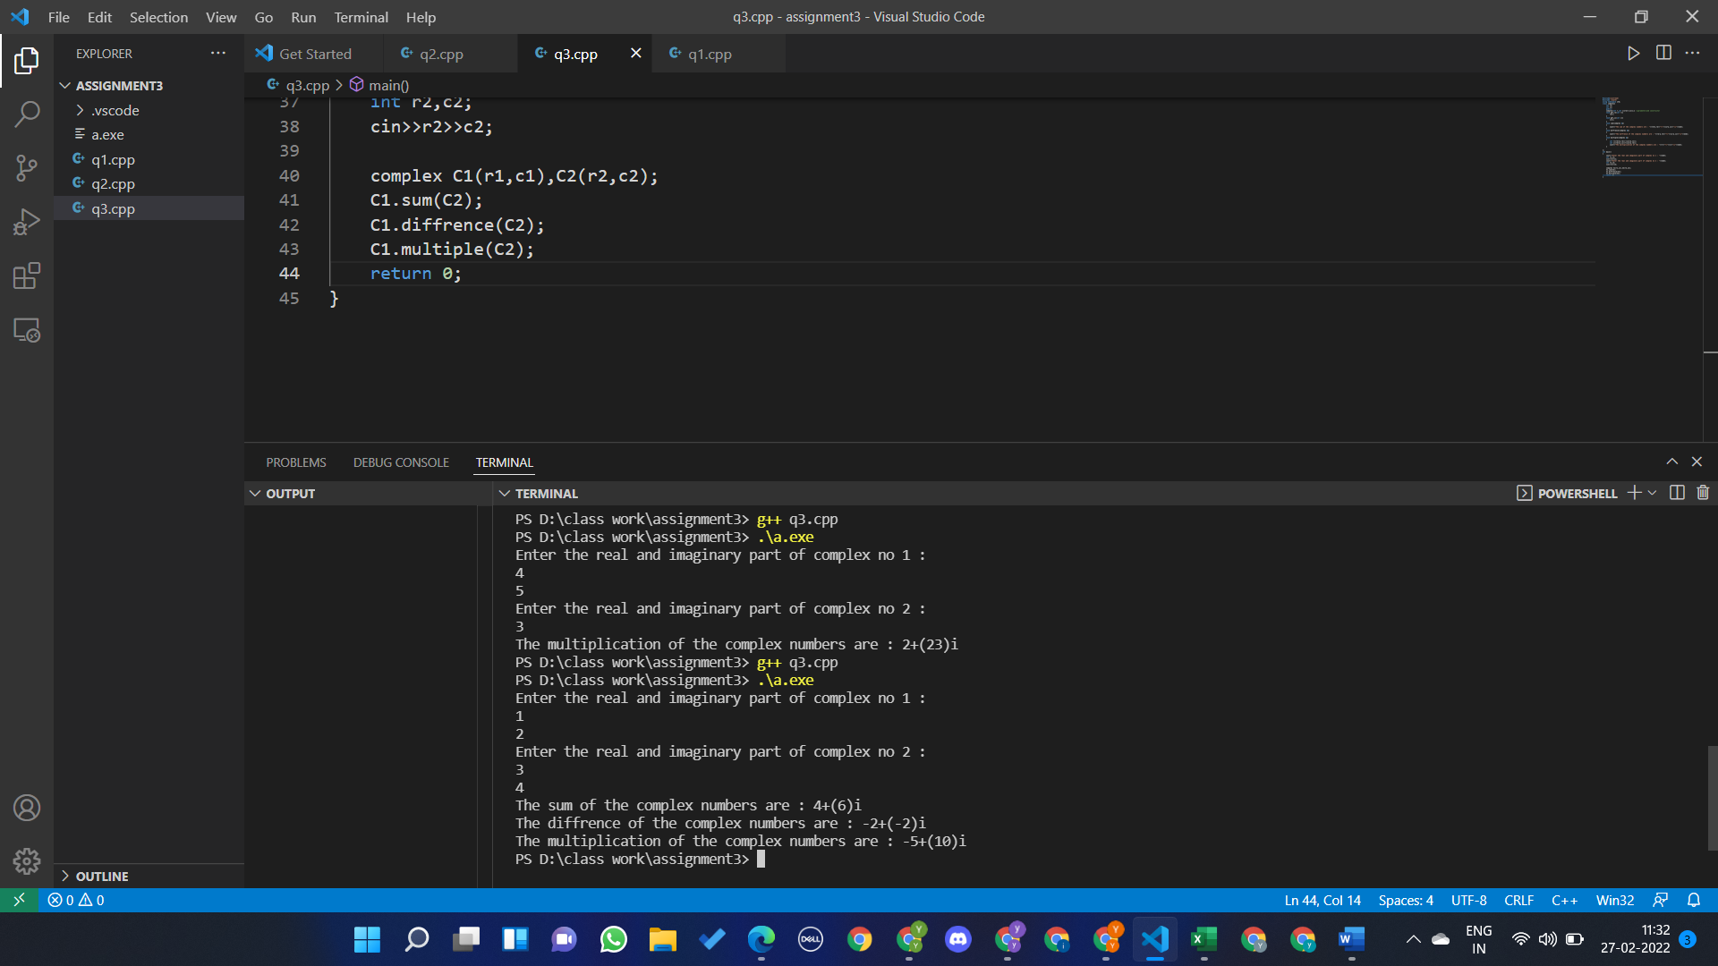

Question 4

#include<iostream>

#include <cmath>

#include <cstring>

using namespace std;

class frist{

    string s1;

    public:

    void get_name()

    {

        cout<<"enter the name : "<<endl;

        getline(cin,s1);

    }

    void put_name()

    {

        cout<<"the name is : "<<s1<<endl;

    }

};

int main()

{

    frist student;

    student.get_name();

    student.put_name();

    return 0;

}

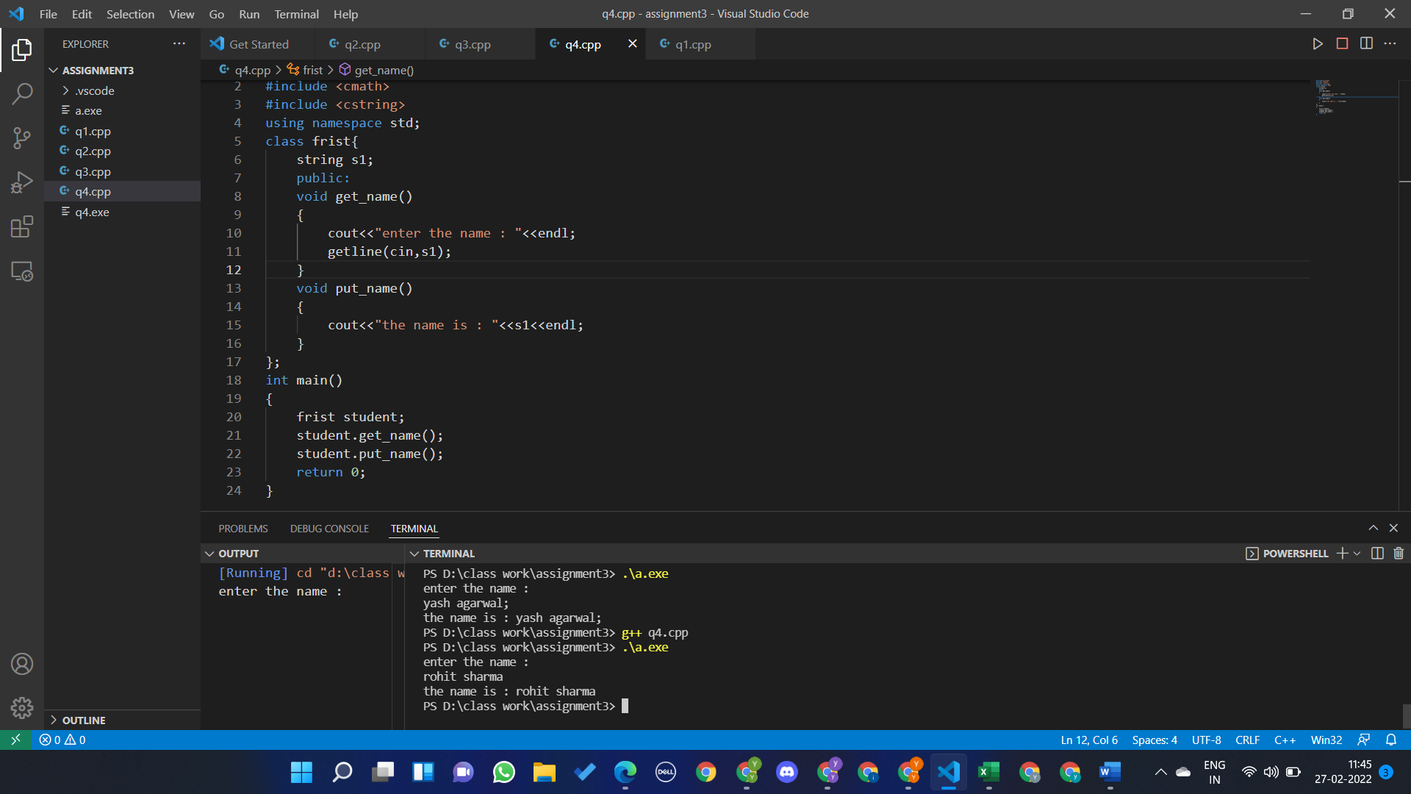

Question 5

#include<iostream>

using namespace std;

class second{

    int person_id;

    public:

    second(){}; //default constructor

    second(int id){person_id=id;}

    ~second(){}

    void get_id(){

        cout<<"enter the id : ";

        cin>>person_id;

    }

    void put_id()

    {

        cout<<"the id is : "<<person_id<<endl;

    }

};

int main()

{

    second ob1;

    ob1.get_id();

    ob1.put_id();

    int a;

    cout<<"enter the personal id : ";

    cin>>a;

    second ob2(a);

    ob2.put_id();

    return 0;

}

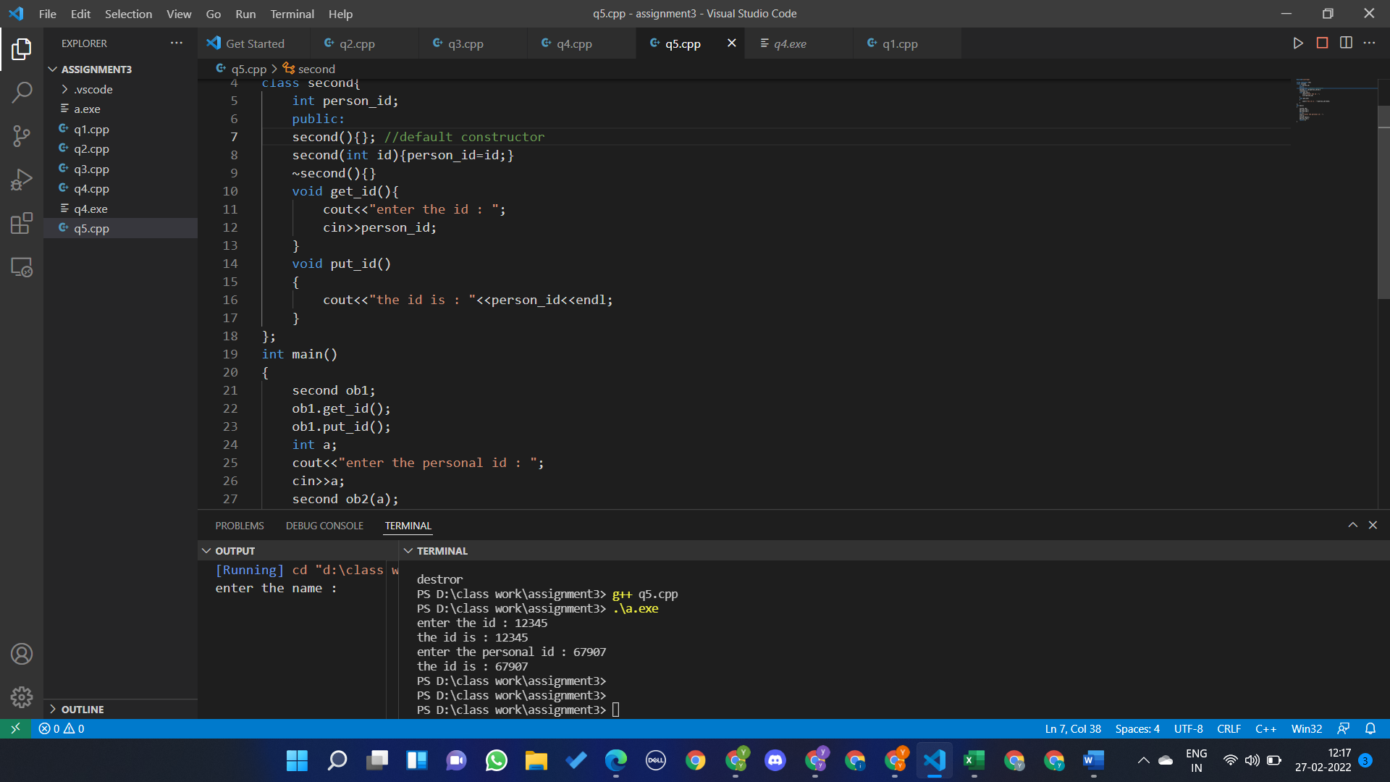

Question 6

#include<iostream>

using namespace std;

class Area{

    float length , breadth;

    public:

    void setDim(){

        cout<<"enter the length and breadth of rectangle : "<<endl;

        cin>>length>>breadth;

    }

    float getArea(){return length*breadth;}

};

int main()

{

    Area ob1;

    ob1.setDim();

    float area;

    area=ob1.getArea();

    cout<<"THE AREA OF THE RECTANGLE IS : \n"<<area;

    return 0;

}

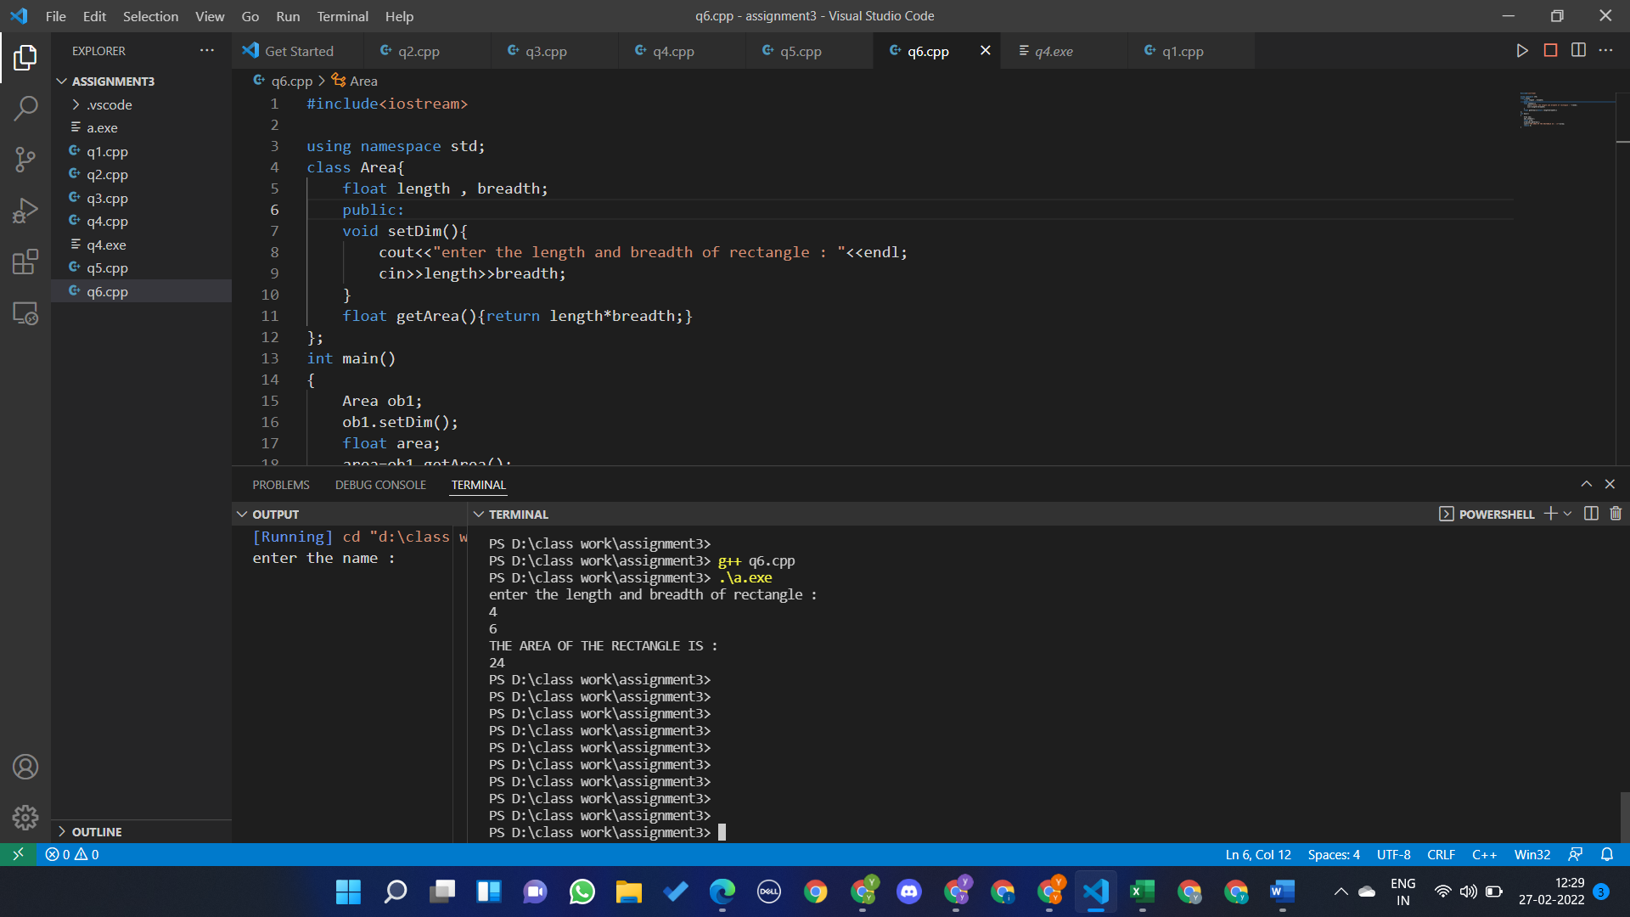

Question 7

#include<iostream>

using namespace std;

class student{

    float s1,s2,s3,s4;//s1 represent subject1

    public:

    student(float a,float b,float c,float d){

        s1=a;

        s2=b;

        s3=c;

        s4=d;

    }

    void average_marks()

    {

        float a=((s1+s2+s3+s4)/4);

        cout<<"the average marks of student is : "<<a<<endl;

    }

};

int main()

{

    student p[]={student(40,50,60,77.5),student(50,70.9,60.4,66)};

    for(int i=0;i<2;i++)

    {

        p[i].average_marks();

    }

    return 0;

}

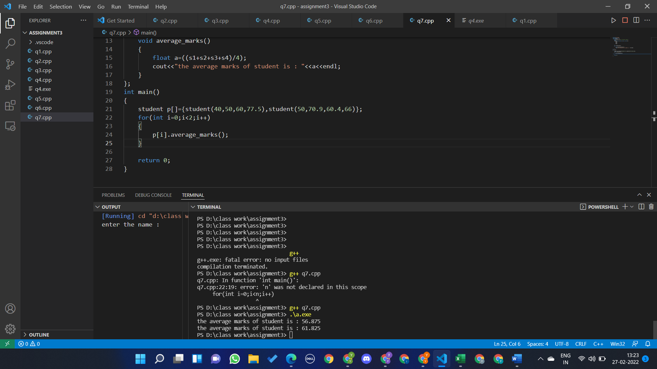

Question 8

#include<iostream>

#include<string>

#include<cstring>

using namespace std;

class student{

    int en_roll;

    string name,batch;

    float cgpa;

    public:

    student(int en,string n,string b,float cg){

        en_roll =en;

        name=n;

        batch=b;

        cgpa=cg;

    }

    student(int en,string n,float cg){

        en_roll =en;

        name=n;

        string c="CSE";

        batch=c;

        cgpa=cg;

    }

    student(){

        en_roll =1;

        string a="UNKNOWN";

        name=a;

        string c="CSE";

        batch=c;

        cgpa=6.0;

    }

    void set_enroll(){

        cout<<"enter enrollment no : "<<endl;

        cin>>en_roll;

    }

    void set_name(){

        cout<<"enter name : "<<endl;

        cin.ignore();

        getline(cin,name);

    }

    void set_batch(){

        cout<<"enter batch : "<<endl;

        getline(cin,batch);

    }

    void set_cgpa(){

        cout<<"enter cgpa : "<<endl;

        cin>>cgpa;

    }

    void get_enroll(){

        cout<<"enrollment no : "<<en_roll<<endl;

    }

    void get_name(){

        cout<<"name : "<<name<<endl;

    }

    void get_batch(){

        cout<<"batch : "<<batch<<endl;

    }

    void get_cgpa(){

        cout<<"cgpa : "<<cgpa<<endl;

    }

    void display()

    {

        cout<<"name : "<<name<<endl;

        cout<<"enrollment no : "<<en_roll<<endl;

        cout<<"batch : "<<batch<<endl;

        cout<<"cgpa : "<<cgpa<<endl;

    }

};

int main()

{

    string a="rahul garg";

    string b="it";

    cout<<"constructor with all parameters "<<endl;

    student s1(1234,a,b,8);

    s1.display();

    cout<<endl<<"constructor with default batch cse "<<endl;

    string c="rohit sharma";

    student s2(1235,c,8.9);

    s2.display();

    cout<<endl<<"default constructor \n ";

    student s3;

    s3.display();

    cout<<endl<<"using getter and setter"<<endl;

    s3.set_cgpa();

    s3.set_enroll();

    s3.set_name();

    s3.set_batch();

    s3.display();

    return 0;

}

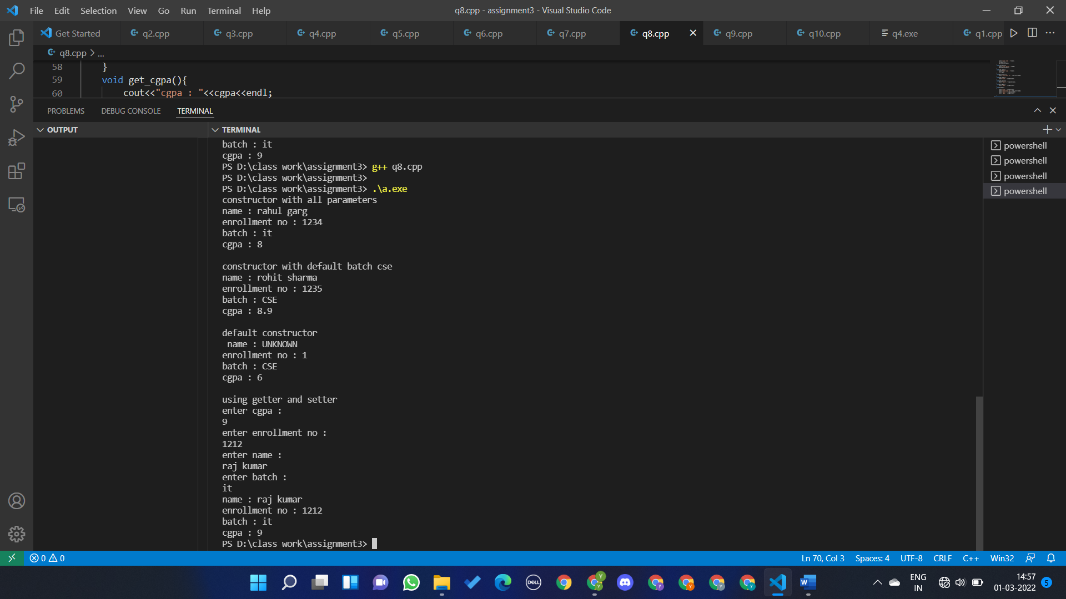

Question 9

#include<iostream>

#include <string>

using namespace std;

class electric_bill{

    int id;

    string name;

    string address;

    float bill;

    public:

    void get(){

        cout<<"enter the the id : "<<endl;

        cin>>id;

        cout<<"enter the name : "<<endl;

        cin.ignore();

        getline(cin,name);

        cout<<"enter the address : "<<endl;

        cin.ignore();

        getline(cin,address);

    }

    void calc_bill(){

        float a,c;

        cout<<"enter the cost of 1 unit :  "<<endl;

        cin>>c;

        cout<<"enter unit consumed : "<<endl;

        cin>>a;

        bill=a*c;

    }

    void put(){

        cout<<endl<<"the id : "<<id<<endl;

        cout<<"the name : "<<name<<endl;

        cout<<"the address : "<<address<<endl;

        cout<<"your bill : "<<bill;

    }

};

int main()

{

    electric_bill e1;

    e1.get();

    e1.calc_bill();

    e1.put();

}

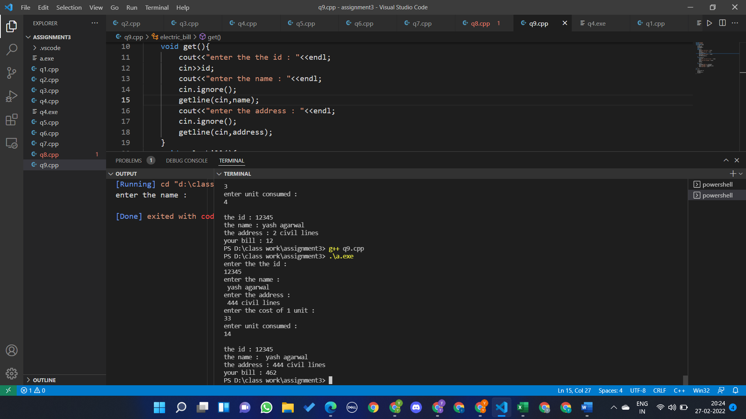

Question 10

l1.a = 10, l1.b = 15

p2.a = 10, l2.b = 15