Question 1

#include<iostream>

using namespace std;

class complex

{

    int r,i;

    public:

    int get_r(){return r;}

    int get_i(){return i;}

    void set_i(int im){i=im;}

    void set_r(int re){r=re;}

    complex(int re,int im){r=re; i=im;}

    complex(){r=0; i=0;}

    complex operator+ (complex b)

    {

        complex temp;

        temp.set_r(r+b.get_r());

        temp.set_i(i+b.get_i());

        return temp;

    }

    void operator=(complex b)

    {

        r=b.get_r();

        i=b.get_i();

    }

    void display(){

        cout<<r<<"+"<<i<<"i"<<endl;

    }

};

int main(){

    complex a1(3,4) , a2(4,5);

    a1=a1+a2;

    a1.display();

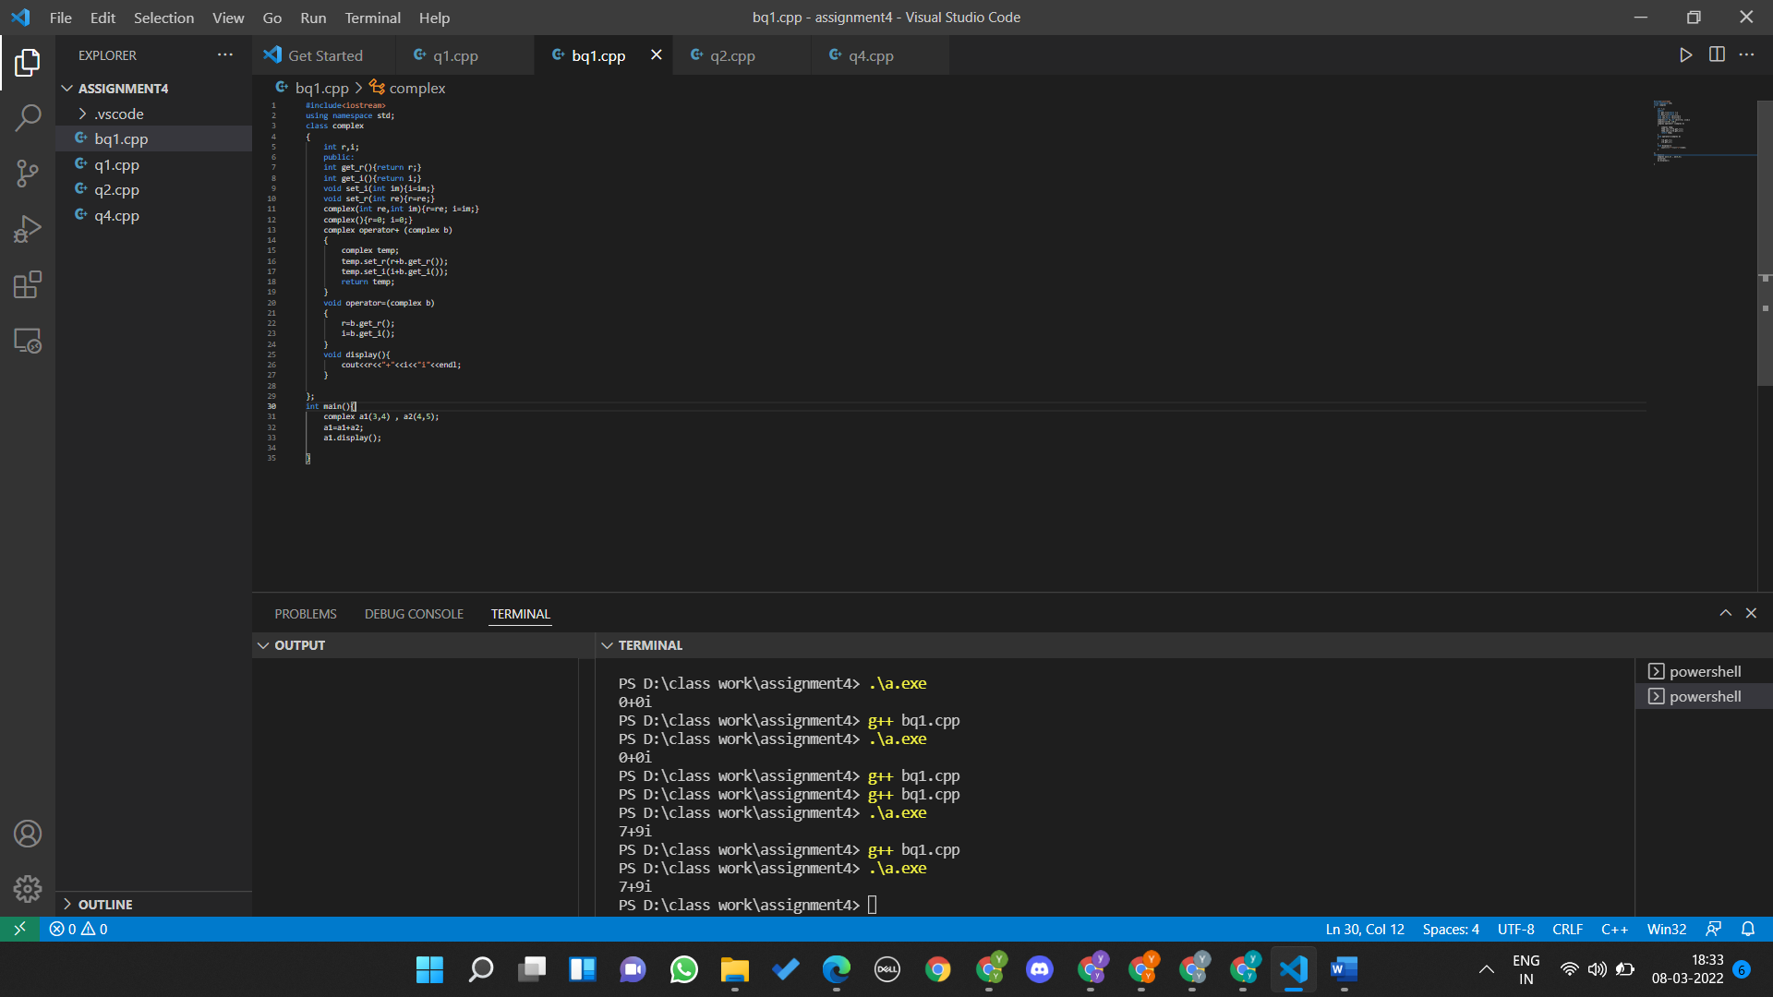}

Question 2

#include<iostream>

#include<string>

using namespace std;

class Box

{

int capacity;

public:

int get_capacity(){

    return capacity;

}

Box(){}

Box(double capacity){

this->capacity = capacity;

}

bool operator<(Box a)

{

    if(capacity <a.get_capacity()){

        return 1;

    }

    else return 0;

}

};

int main(int argc, char const *argv[])

{

Box b1(10);

Box b2 = Box(14);

if(b1 < b2){

cout<<"Box 2 has large capacity.";

}

else{

cout<<"Box 1 has large capacity.";

}

return 0;

}

Question 3

#include<iostream>

using namespace std;

class test{

    int a;

    public:

    void set(int aa){a=aa;}

    int get(){return a;}

    void operator++(){

        a++;

    }

    test operator++(int t)

    {

        a++;

        return *this;

    }

    void display(){

        cout<<"the value of a is "<<a<<endl;

    }

};

int main(){

    test t1;

    t1.set(5);

    t1.display();

    t1++;

    t1.display();

    ++t1;

    t1.display();

}

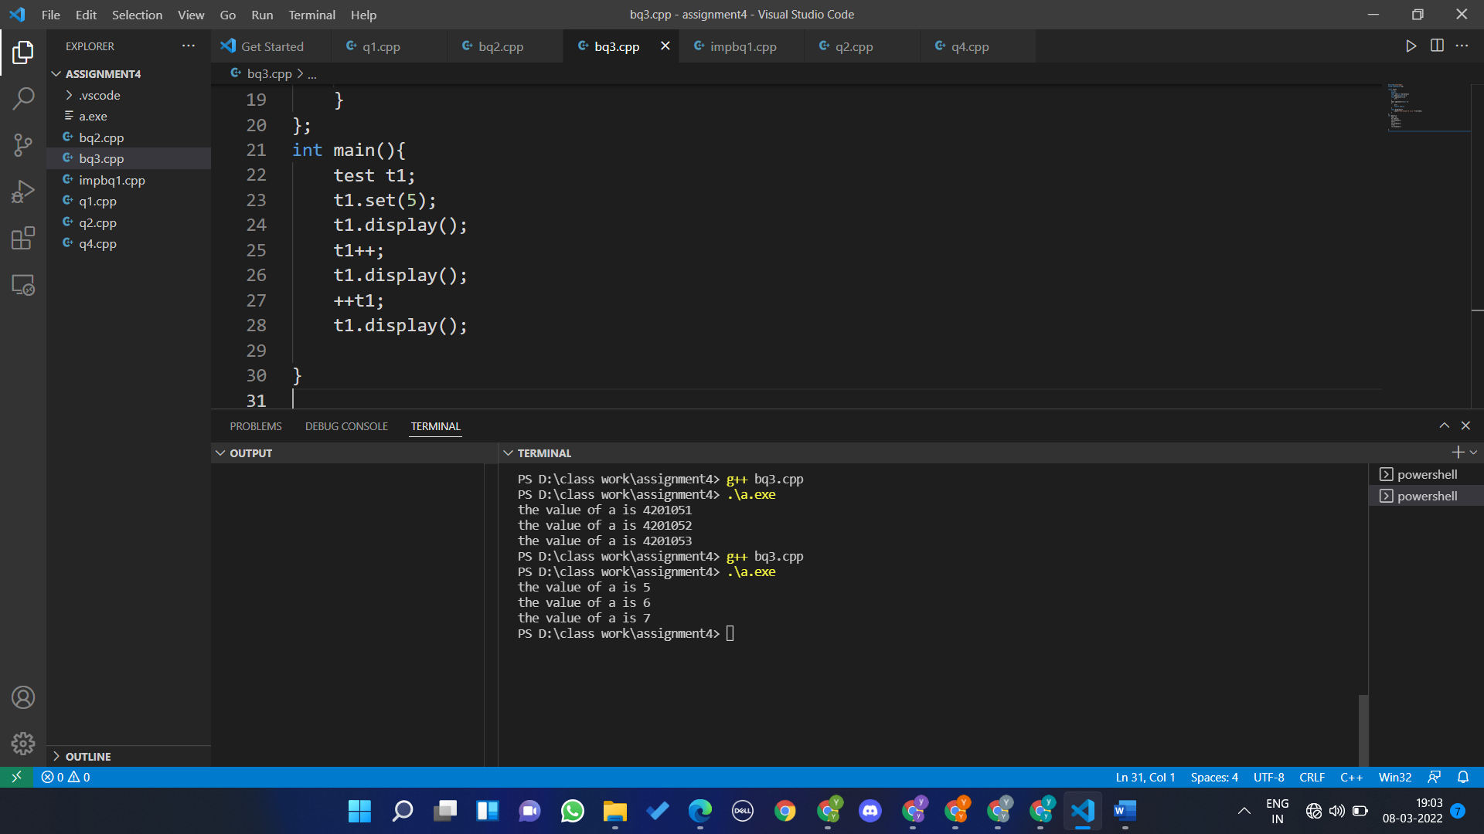

Question 4

Hey Guys, I am a teacher

I am a Math Teacher

Name: Negan

College Name: Beginnersbook

Main Subject: Math

Question 5

#include <iostream>

#include <string>

using namespace std;

class publication

{

string title;

float price;

public:

void getdata_base()

{

cout << "Enter title: ";

getline(cin, title);

cout << "Enter price: ";

cin >> price;

}

void printdata()

{

cout << "Title is " << title << endl;

cout << "Price is " << price << endl;

}

};

class book : public publication

{

int pageCount;

public:

void getdata_book()

{

getdata_base();

cout << "Enter Page count: ";

cin >> pageCount;

}

void printdata_book()

{

printdata();

cout << "Page Count is " << pageCount << endl;

}

};

class tape : public publication

{

float playingTimeinMinutes;

public:

void getdata_tape()

{

getdata_base();

cout << "Enter Playing time in Minutes: ";

cin >> playingTimeinMinutes;

}

void printdata_tape()

{

printdata();

cout << "Playing time in minutes is " << playingTimeinMinutes << endl;

}

};

int main()

{

book b1;

tape t1;

b1.getdata_book();

fflush(stdin);

t1.getdata_tape();

cout << endl;

b1.printdata_book();

cout << endl;

t1.printdata_tape();

return 0;

}

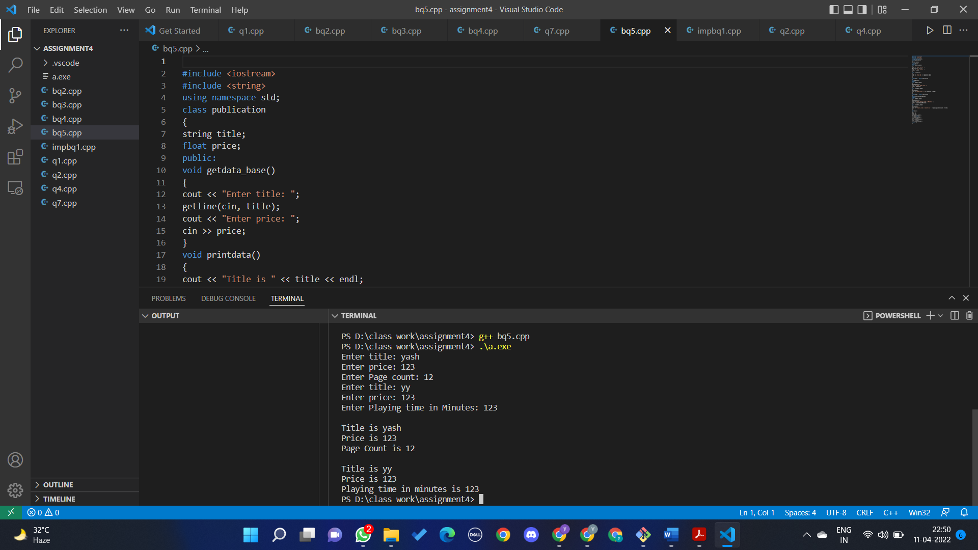

Question 6

#include <iostream>

#include <string>

using namespace std;

class publication

{

string title;

float price;

public:

void getdata_pub()

{

cout << "Enter title: ";

getline(cin, title);

cout << "Enter price: ";

cin >> price;

}

void printdata_pub()

{

cout << endl;

cout << "Title is " << title << endl;

cout << "Price is " << price << endl;

}

};

class sales

{

float arr[3]; // storing dollar sales for last 3 months

public:

void getdata_sale()

{

for (int i = 0; i < 3; i++)

{

cout << "Enter Sale " << i + 1 << " : ";

cin >> arr[i];

}

}

void printdata_sale()

{

for (int i = 0; i < 3; i++)

{

cout << "Sale " << i + 1 << " = " << arr[i] << endl;

}

}

};

class book : public publication, public sales

{

int pageCount;

public:

void getdata_1()

{

getdata_pub();

cout << "Enter Page count: ";

cin >> pageCount;

getdata_sale();

}

void printdata_1()

{

printdata_pub();

cout << "Page Count is " << pageCount << endl;

printdata_sale();

}

};

class tape : public publication, public sales

{

float playingTimeinMinutes;

public:

void getdata_2()

{

getdata_pub();

cout << "Enter Playing time in Minutes: ";

cin >> playingTimeinMinutes;

getdata_sale();

}

void printdata_2()

{

printdata_pub();

cout << "Playing time in minutes is " << playingTimeinMinutes << endl;

printdata_sale();

}

};

int main()

{

book b1;

tape t1;

b1.getdata_1();

fflush(stdin);

cout << endl;

t1.getdata_2();

b1.printdata_1();

t1.printdata_2();

return 0;

}

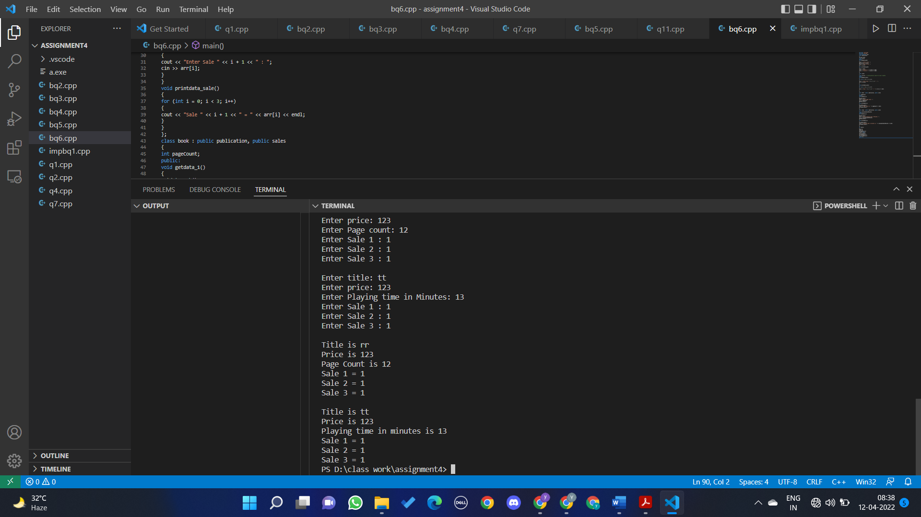

Question 7

#include <iostream>

#include <string>

using namespace std;

class account

{

protected:

string name;

long long int acc_no;

int type;

public:

void setData()

{

cout << "Enter Name: ";

getline(cin, name);

cout << "Enter Account Number: ";

cin >> acc_no;

cout << "Enter Number for Type of Account:\n1.Savings\n2.Current " << endl;

cin >> type;

}

int getType()

{

return type;

}

};

class cur_acct : public account

{

float curr_balance;

float interest;

float withd, pen = 0, pp;

public:

void depositMoney()

{

cout << "\nNOTE : Minimum Balance of Rs 3000 should be maintained in bank account. If

not maintained Penality of Rs 500/month will automatically be deducted." << endl;

cout << "Enter Money: ";

cin >> curr_balance;

}

void displayBalance()

{

cout << "\t\t\tBalance = " << curr_balance << endl;

cout << "\t\t\tPenality = " << pen << endl;

}

void withdraw()

{

cout << "Enter amount to withdraw: ";

cin >> withd;

if (withd > curr_balance)

{

cout << "Not enough Balance" << endl;

}

else

{

curr_balance -= withd;

}

if (curr_balance < 3000)

{

pen = pen + 500;

}

}

void payPenality()

{

cout << "Recent value of Penality = " << pen << endl;

cout << "Enter amount to pay Penality: ";

cin >> pp;

pen = pen - pp;

}

};

class sav_acct : public account

{

float sav_balance = 0;

float withd, intrst;

int time;

public:

void depositMoney()

{

cout << "Enter Amount: ";

cin >> sav_balance;

}

void displayBalance()

{

cout << "\n\t\t\tBalance = " << sav_balance << endl;

}

void withdraw()

{

cout << "Enter amount to withdraw: ";

cin >> withd;

if (withd > sav_balance)

{

cout << "Not enough Balance" << endl;

}

else

{

sav_balance -= withd;

}

}

void displayInterst()

{

cout << "\nEnter time in years: ";

cin >> time;

int rst = sav_balance * 0.07 * time;

sav_balance += intrst;

cout << "\t\t\tInterst = " << intrst << endl;

cout << "\t\t\tBalance of Saving account = " << sav_balance << endl;

}

};

int main()

{

account a1;

int ch;

a1.setData();

if (a1.getType() == 1)

{

sav_acct s1;

while (1)

{

cout << "\nEnter Choice:\n1.Deposit Money\n2.Display Balance \n3.Withdraw Money

\n4.Display Interest\n5.Exit" << endl;

cin >> ch;

switch (ch)

{

case 1:

s1.depositMoney();

break;

case 2:

s1.displayBalance();

break;

case 3:

s1.withdraw();

break;

case 4:

s1.displayInterst();

break;

case 5:

goto end;

default:

break;

}

}

}

else

{

cur_acct c1;

while (1)

{

cout << "\nEnter Choice:\n1.Deposit Money\n2.Display Balance \n3.Withdraw Money

\n4.Pay Penality\n5.Exit\n" << endl;

cin >> ch;

switch (ch)

{

case 1:

c1.depositMoney();

break;

case 2:

c1.displayBalance();

break;

case 3:

c1.withdraw();

break;

case 4:

c1.payPenality();

break;

case 5:

goto end;

break;

default:

break;

}

}

}

end :

return 0;

}

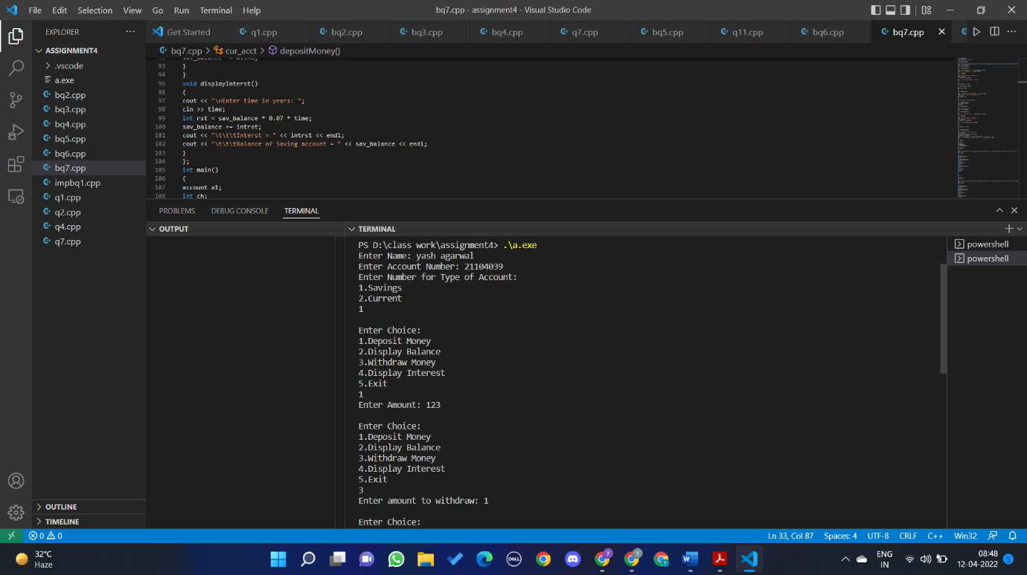  
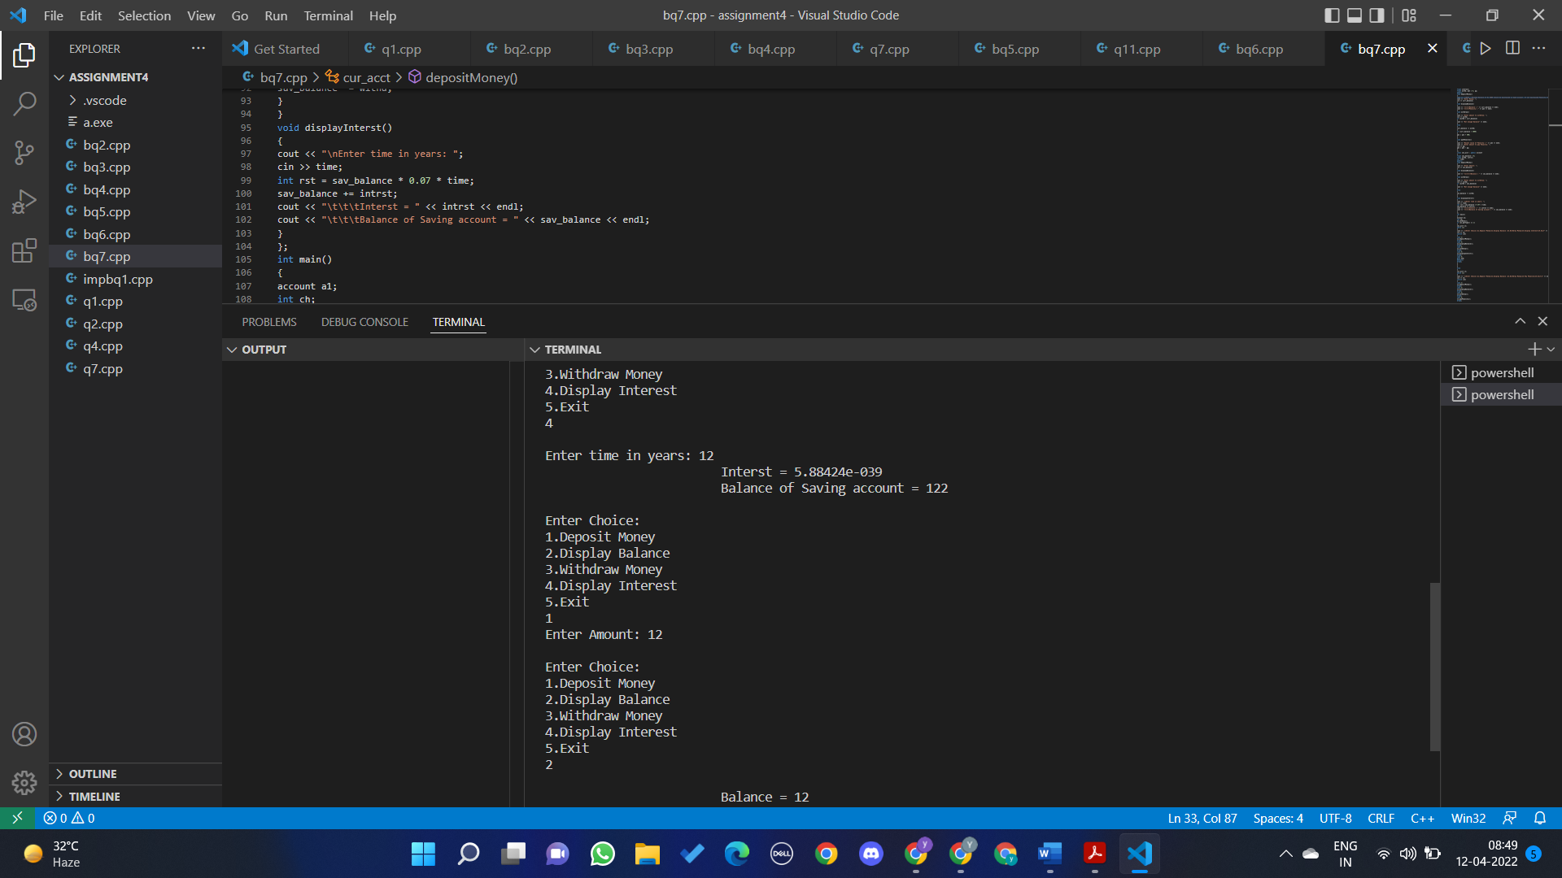

**Question 8**

Output 96

2*size of array of 10 elements=2*4*10=80 [multiplied by 2 because base class is not virtual]

2*size of f(int )=2*4=8 [multiplied by 2 because base class is not virtual]

1 *size of c (int)=4

1*size of d(int )=4

Total size=96