Question 1

X=1 count=0

X=1 count=1

X=1.1 count=0

Question 2

2

1

Question 3

#include<iostream>

using namespace std;

template <class x>

class cal

{

    x a;

    x b;

    public:

    cal(x s,x d)

    {

        a=s;

        b=d;

    }

    x add()

    {

        return a+b;

    }

    x sub()

    {

        return a-b;

    }

    x div()

    {

        try{

            if(b==0)

            {

                throw b;

            }

            return a/b;

        }

        catch(x b)

        {

            cout<<"dividing by zero "<<endl;

        }

    }

    x mul()

    {

        return a*b;

    }

};

int main()

{

    cal <int> s1(10,20);

    cal <float> s2(10.9,0);

    cout<<" adding 10 and 20 :"<<s1.add();

    cout<<endl;

    cout<<" subtrating 10 and 20 :"<<s1.sub();

    cout<<endl;

    cout<<" multiplying 10 and 20 :"<<s1.mul();

    cout<<endl;

    cout<<" dividing 10 and 20 :"<<s1.div();

    cout<<endl;

    cout<<" adding 10.9 and 0 :"<<s2.add();

    cout<<endl;

    cout<<" subtrating 10.9 and 0 :"<<s2.sub();

    cout<<endl;

    cout<<" dividing 10.9 and 0 "<<s2.div();

    cout<<endl;

    cout<<" multiplying 10.9 and 0 :"<<s2.mul();

}

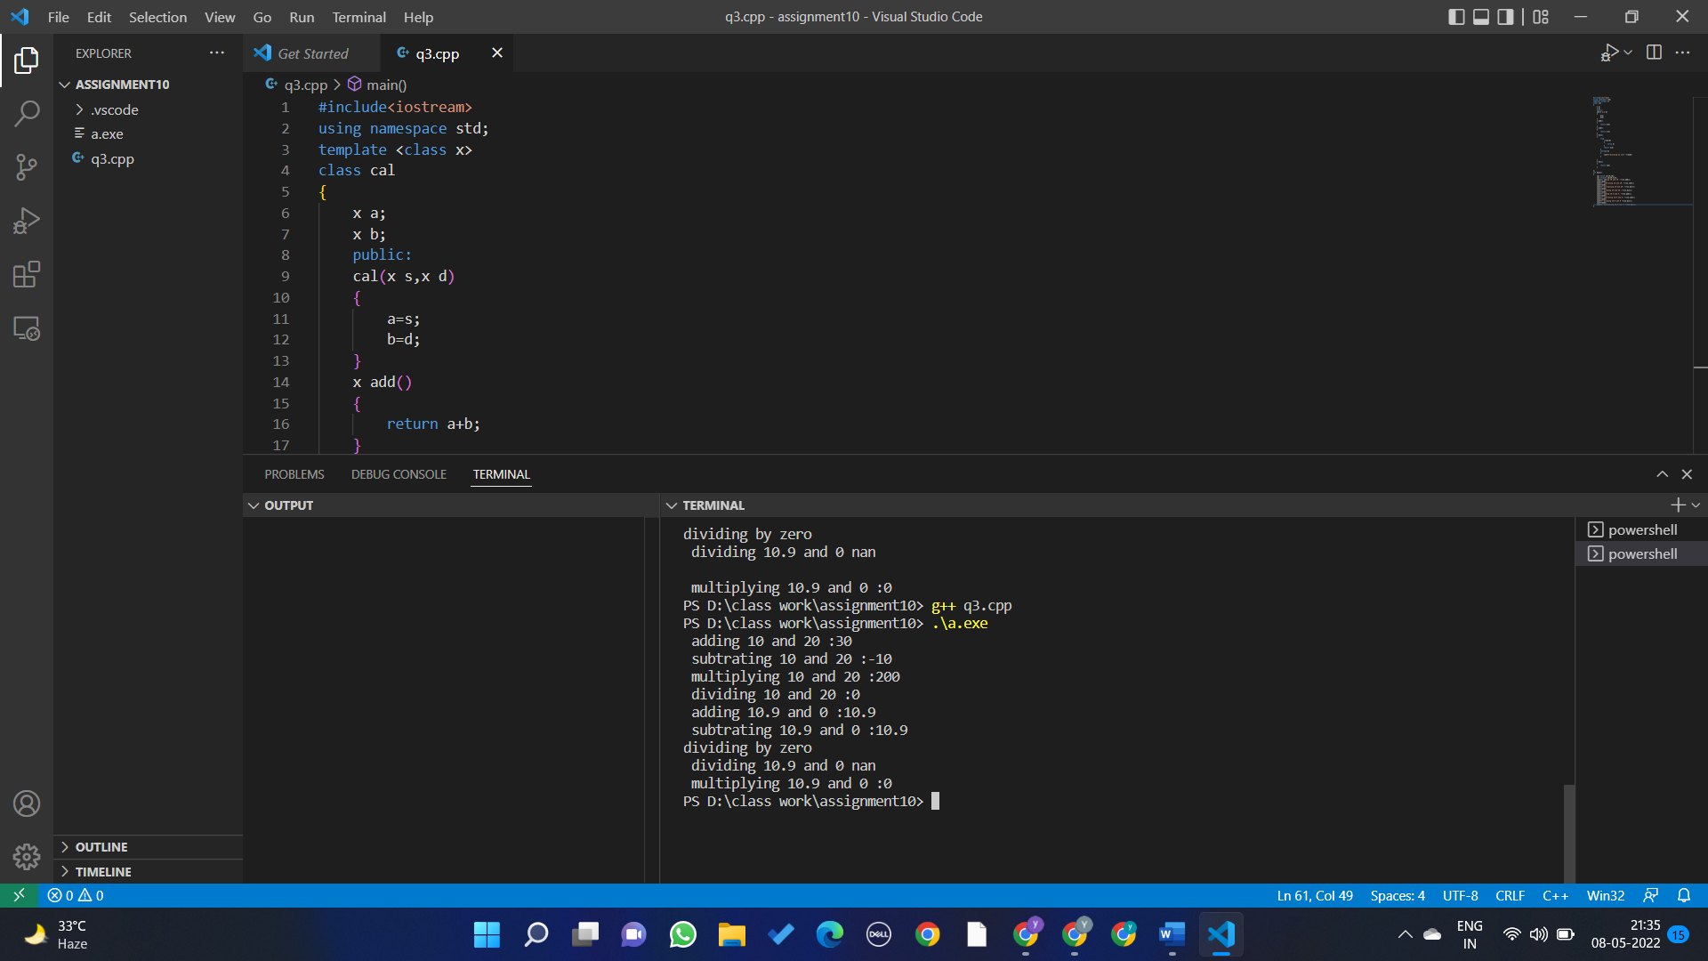

Question 4

#include<iostream>

using namespace std;

template<class x>

x Min(x a,x b)

{

    if(a>b) return b;

    else return a;

}

template<class x>

x Max(x a,x b)

{

    if(a>b)return a;

    else return b;

}

int main()

{

    int a=3,b=4;

    float c=3.3,d=3.4;

    cout<<"max of "<<a<<" and "<<b<<" : "<<Max(a,b)<<endl;

    cout<<"min of "<<a<<" and "<<b<<" : "<<Min(a,b)<<endl;

    cout<<"max of "<<c<<" and "<<d<<" : "<<Max(c,d)<<endl;

    cout<<"min of "<<c<<" and "<<d<<" : "<<Min(c,d)<<endl;

}

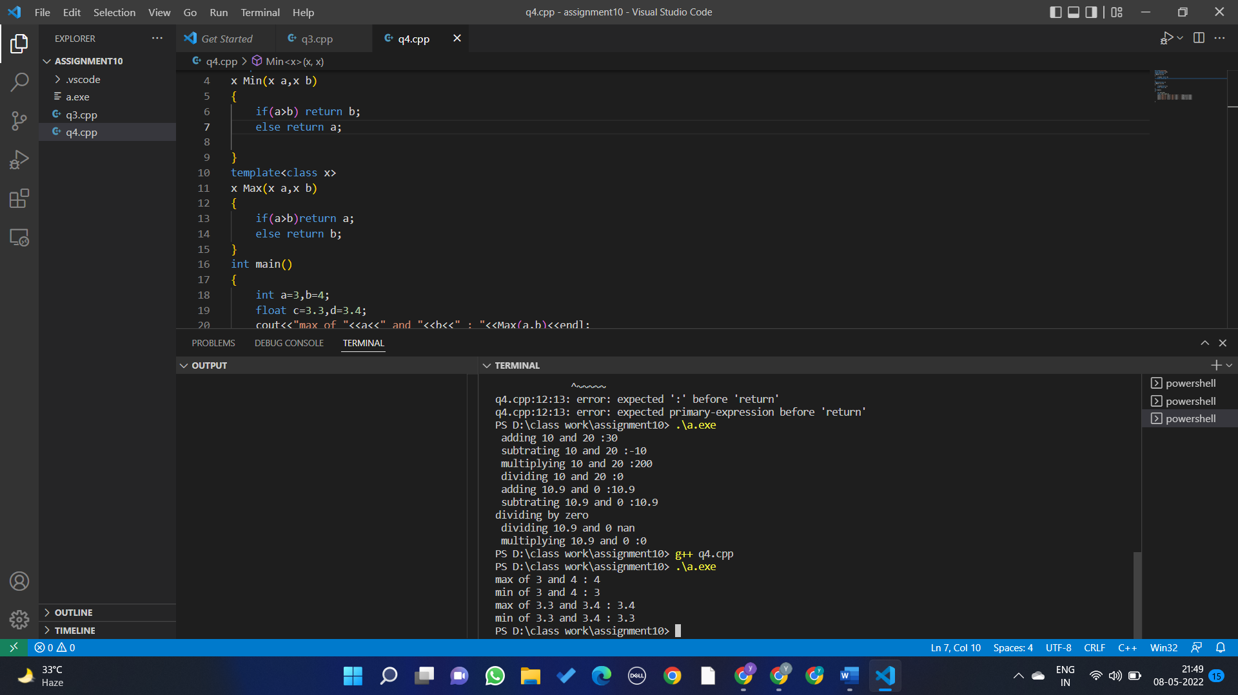

Question 5

#include<iostream>

using namespace std;

template<class x>

class myvector{

    x *a;

    int count=1,sz=1;

    public:

    myvector()

    {

        a=new x[1];

        a[0]=0;

    }

    x size()

    {

        return count-1 ;

    }

    void push_back(x c)

    {

        if(count > sz )

        {

            realloc(a,sz*2);

            sz=sz*2;

        }

        if(count==1)

        {

            a[0]=c;

            count++;

        }

        else{

        a[count-1]=c;

        count++;

        }

    }

    x capacity()

    {

        return sz;

    }

    void display()

    {

        for(int i=0;i<count-1;i++)

        {

            cout<<a[i]<<" ";

        }

        cout<<endl;

    }

    void pop_back()

    {

        realloc(a,--count);

    }

};

int main()

{

    myvector <int> m;

    cout<<"the size is "<<m.size()<<endl;

    cout<<"the capacity is "<<m.capacity()<<endl;

    m.display();

    m.push_back(2);

    m.display();

    cout<<"the size is "<<m.size()<<endl;

    cout<<"the capacity is "<<m.capacity()<<endl;

    m.push_back(9);

    cout<<"the size is "<<m.size()<<endl;

    cout<<"the capacity is "<<m.capacity()<<endl;

    m.display();

    m.push_back(4);

    cout<<"the size is "<<m.size()<<endl;

    cout<<"the capacity is "<<m.capacity()<<endl;

    m.display();

    m.pop_back();

    m.display();

    cout<<"the size is "<<m.size()<<endl;

    cout<<"the capacity is "<<m.capacity()<<endl;

}

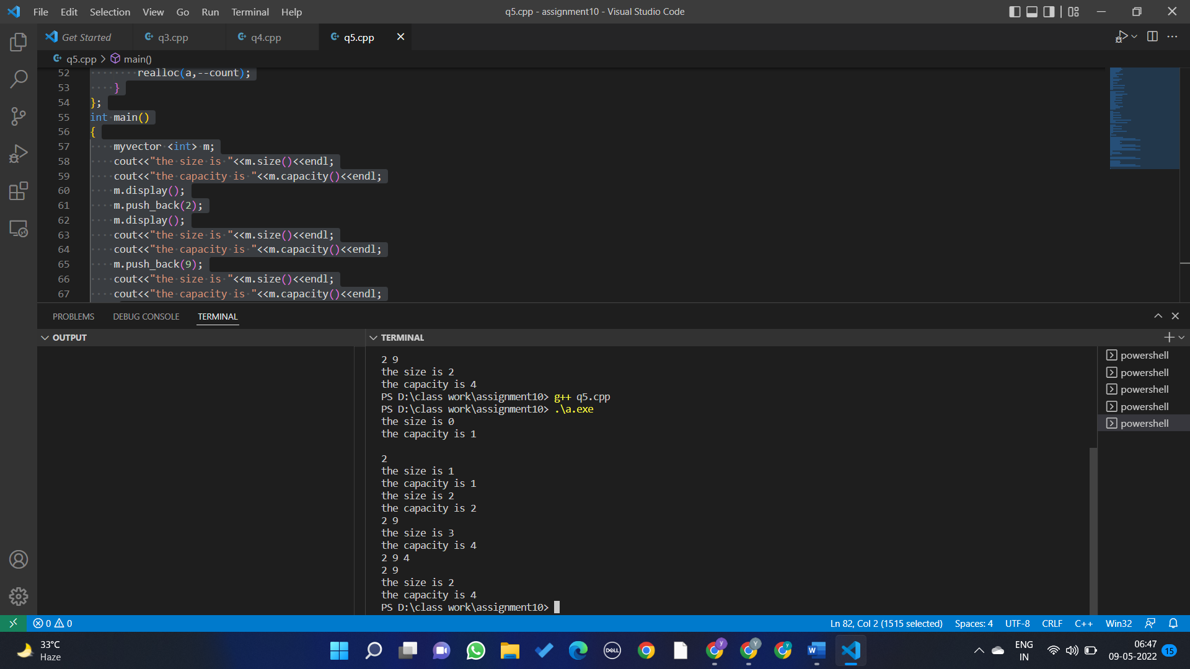

Question 6

#include<iostream>

#include<vector>

#include<algorithm>

using namespace std;

int main()

{

    vector<int> a,b;

    int l;

    while(l)

    {

        cout<<"enter the element in first array (stop when you enter -ve value) : ";

        cin>>l;

        a.push_back(l);

        if(l<0)l=0;

    }

    l=1;

    while(l)

    {

        cout<<"enter the element in second array (stop when you enter -ve value) : ";

        cin>>l;

        b.push_back(l);

        if(l<0)l=0;

    }

    a.insert(a.end(),b.begin(),b.end());

    sort(a.begin(),a.end());

    for(int i=1;i<a.size();i++)

    {

        if(a[i]==a[i-1])

        {

            a.erase(a.begin()+i-1);

        }

    }

    for(int x:a)

    {

        cout<<x<<" ";

    }

}

