**NAME : YASH AGARWAL**

**EN.ROLL : B64015**

**WEEK 2 LAB A**

ANSWER :5,2,3

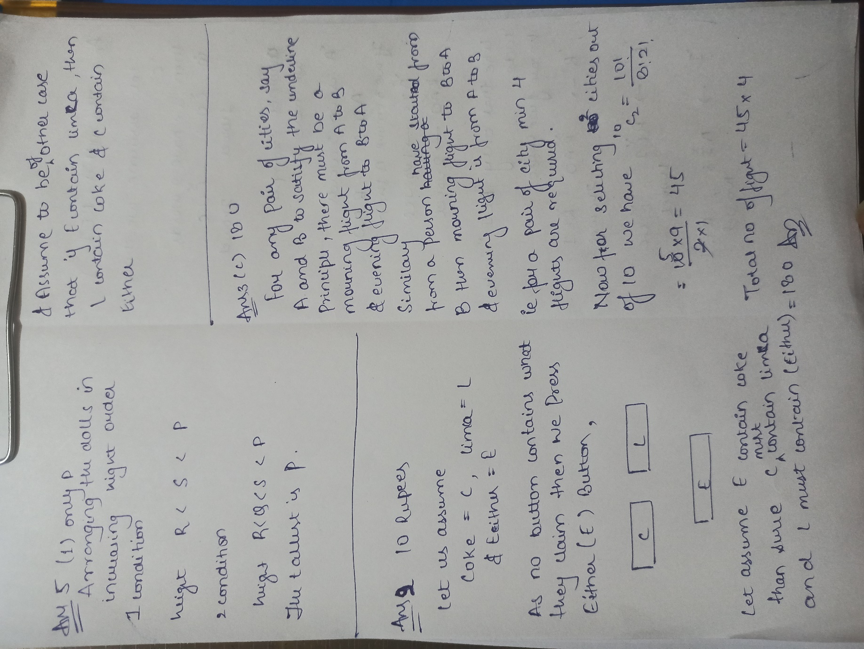

ANSWER 4

