**Question 1**

#include <stdio.h>

#include <stdlib.h>

void main()

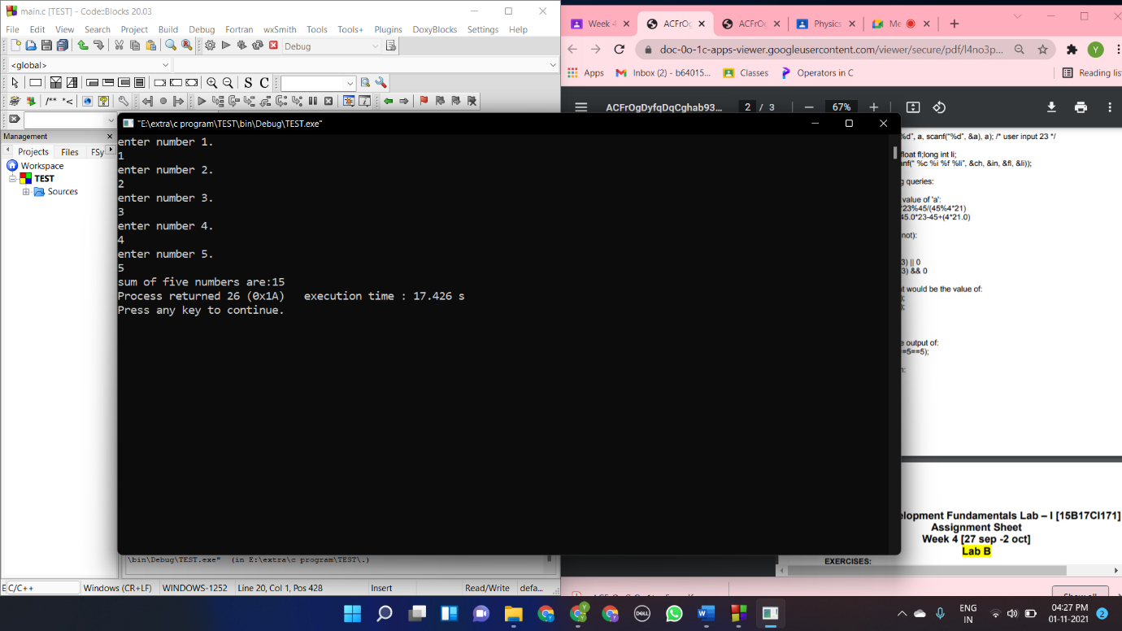{

int a,b,c,d,e,sum;

printf("enter number 1.\n");

scanf("%d",&a);

printf("enter number 2.\n");

scanf("%d",&b);

printf("enter number 3.\n");

scanf("%d",&c);

printf("enter number 4.\n");

scanf("%d",&d);

printf("enter number 5.\n");

scanf("%d",&e);

sum=a+b+c+d+e;

printf("sum of five numbers are:%d",sum);

}

**Question 2**

#include <stdio.h>

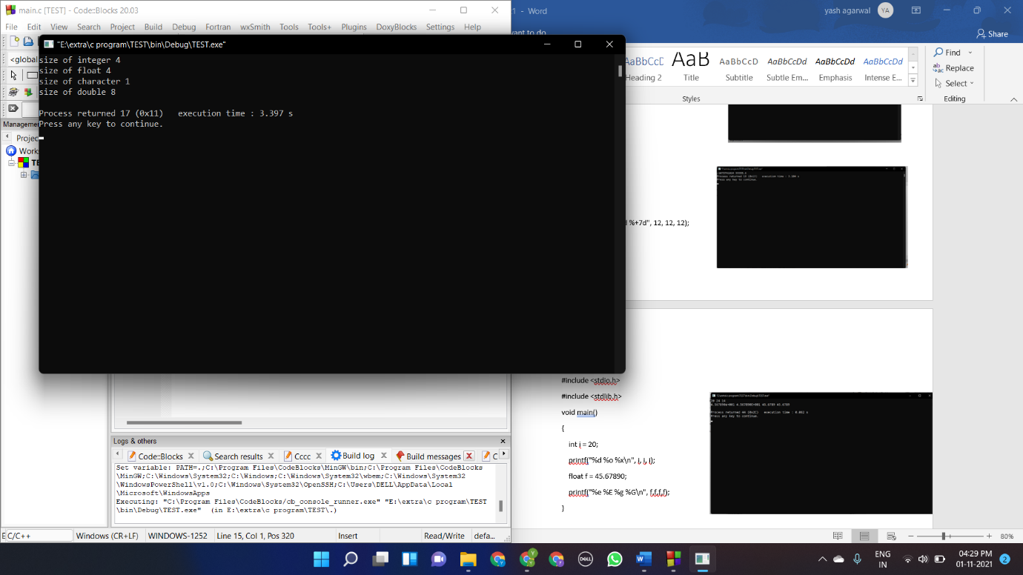#include <stdlib.h>

void main()

{

int a=1;

float b=14.3;

char c='a';

double d=12.43;

printf("size of integer %d\n",sizeof(a));

printf("size of float %d\n",sizeof(b));

printf("size of character %d\n",sizeof(c));

printf("size of double %d\n",sizeof(d));

}

**Question 3**

#include <stdio.h>

int main()

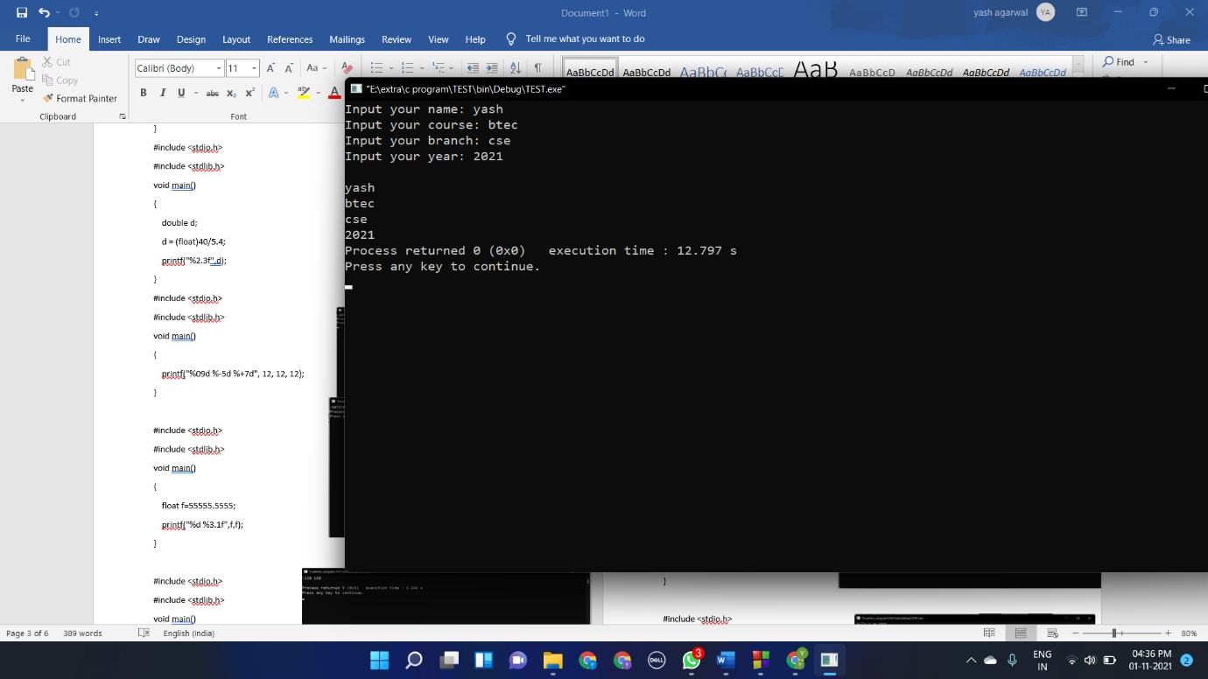{

char name[20], course[20],branch[20], year[20];

int bir_year;

printf("Input your name: ");

scanf("%s", &name);

printf("Input your course: ");

scanf("%s", &course);

printf("Input your branch: ");

scanf("%s", &branch);

printf("Input your year: ");

scanf("%s", &year);

printf("\n%s\n%s\n%s\n%s", name, course, branch,year);

return 0;

}

**Question 4**

#include <stdio.h>

#include <stdlib.h>

void main()

{

int a;

float b;

a = 12/5;

b = 12/5;

printf("%d %f %d %f", a, a,b,b);

printf("%d", 60*60*60/60/60);

}

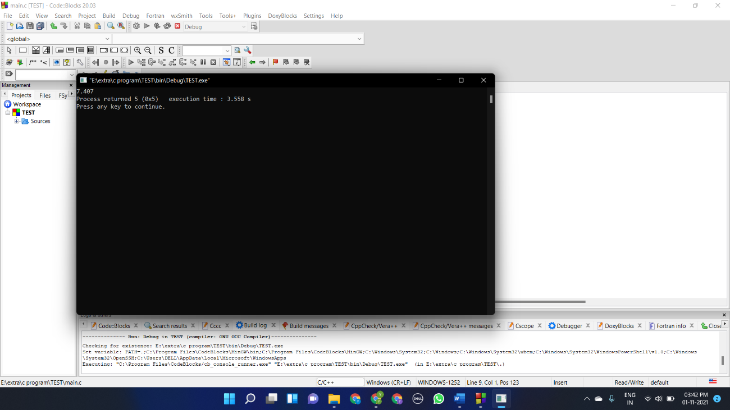#include <stdio.h>

#include <stdlib.h>

void main()

{

double d;

d = (float)40/5.4;

printf("%2.3f",d);

}

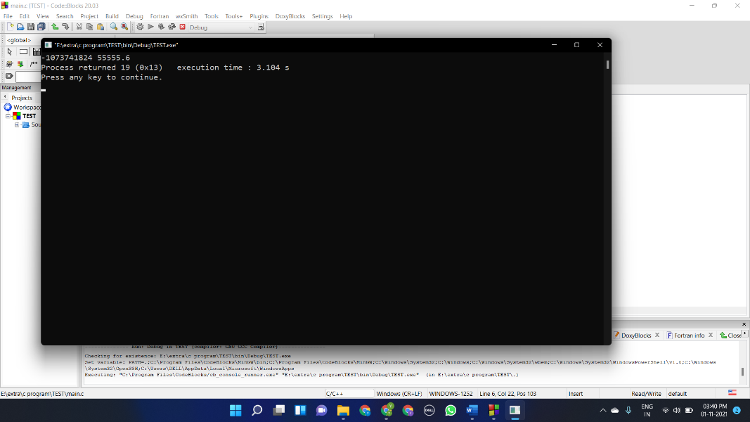#include <stdio.h>

#include <stdlib.h>

void main()

{

printf("%09d %-5d %+7d", 12, 12, 12);

}

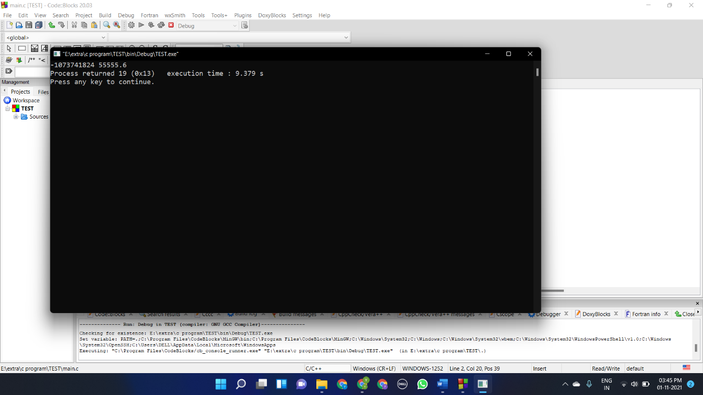#include <stdio.h>

#include <stdlib.h>

void main()

{

float f=55555.5555;

printf("%d %3.1f",f,f);

}

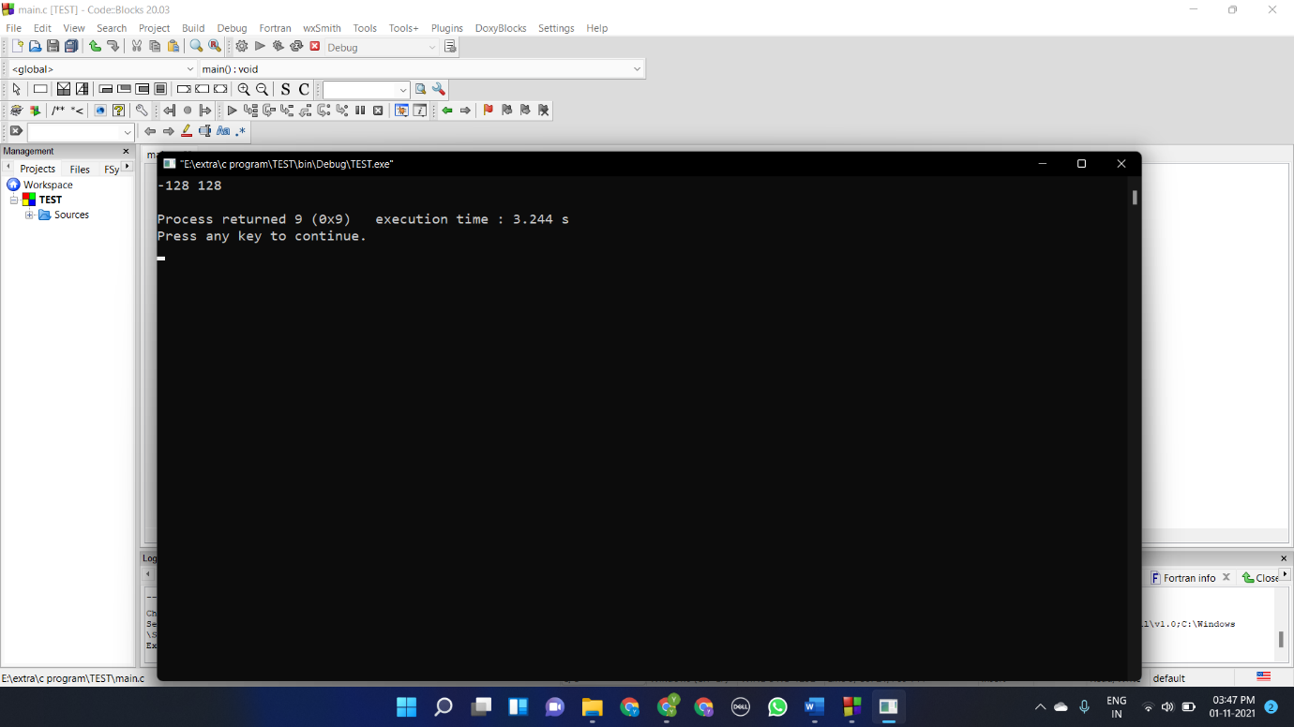

#include <stdio.h>

#include <stdlib.h>

void main()

{

char c1;

unsigned char c2;

c1 = 128;

c2 = 128;

printf("%d %u\n", c1, c2);

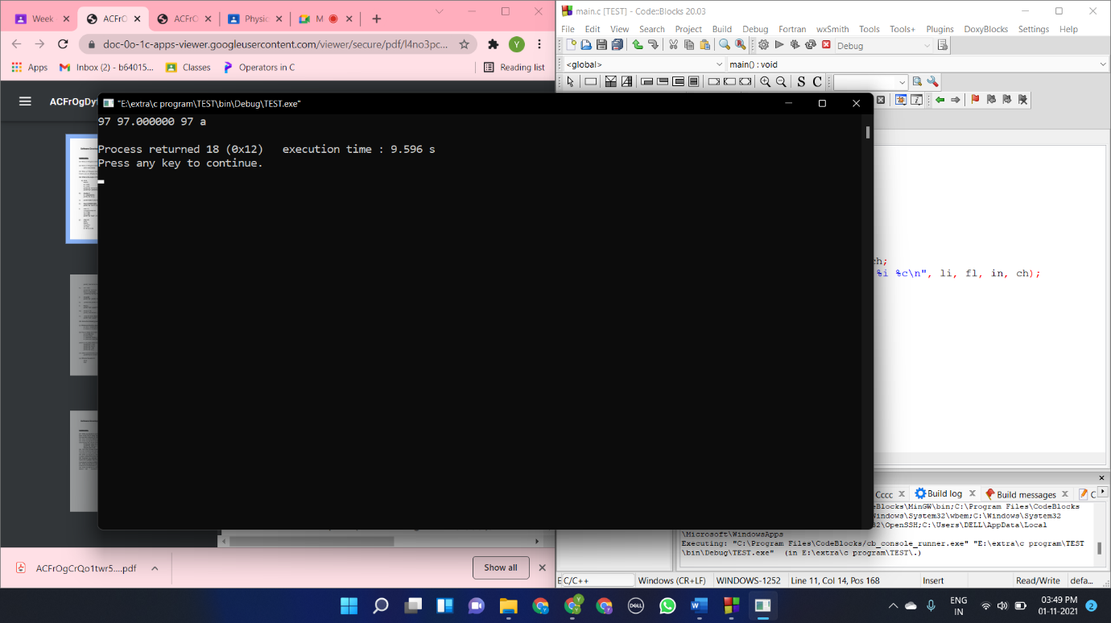}

#include <stdio.h>

#include <stdlib.h>

void main()

{

char ch;

int in;

float fl;

long int li;

ch = 97;

li = fl = in = ch;

printf( "%ld %f %i %c\n", li, fl, in, ch);

}

#include <stdio.h>

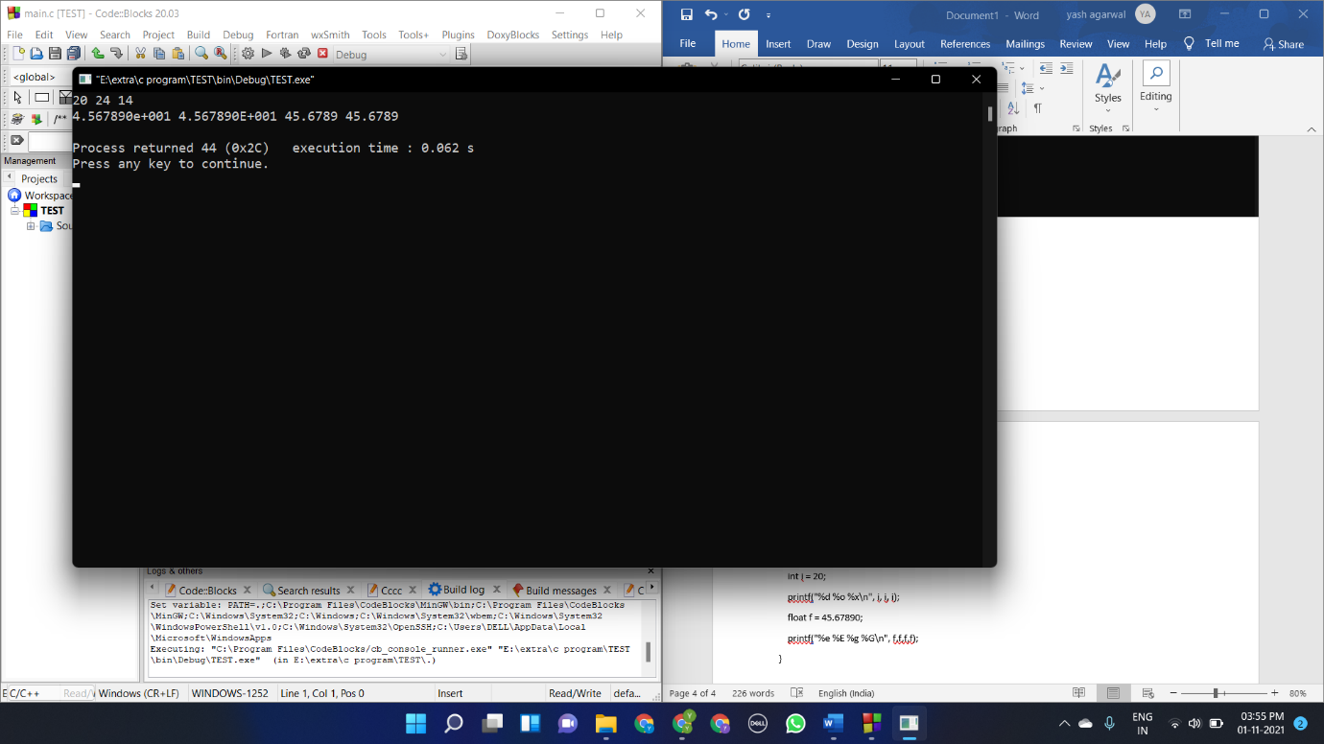#include <stdlib.h>

void main()

{

int i = 20;

printf("%d %o %x\n", i, i, i);

float f = 45.67890;

printf("%e %E %g %G\n", f,f,f,f);

}

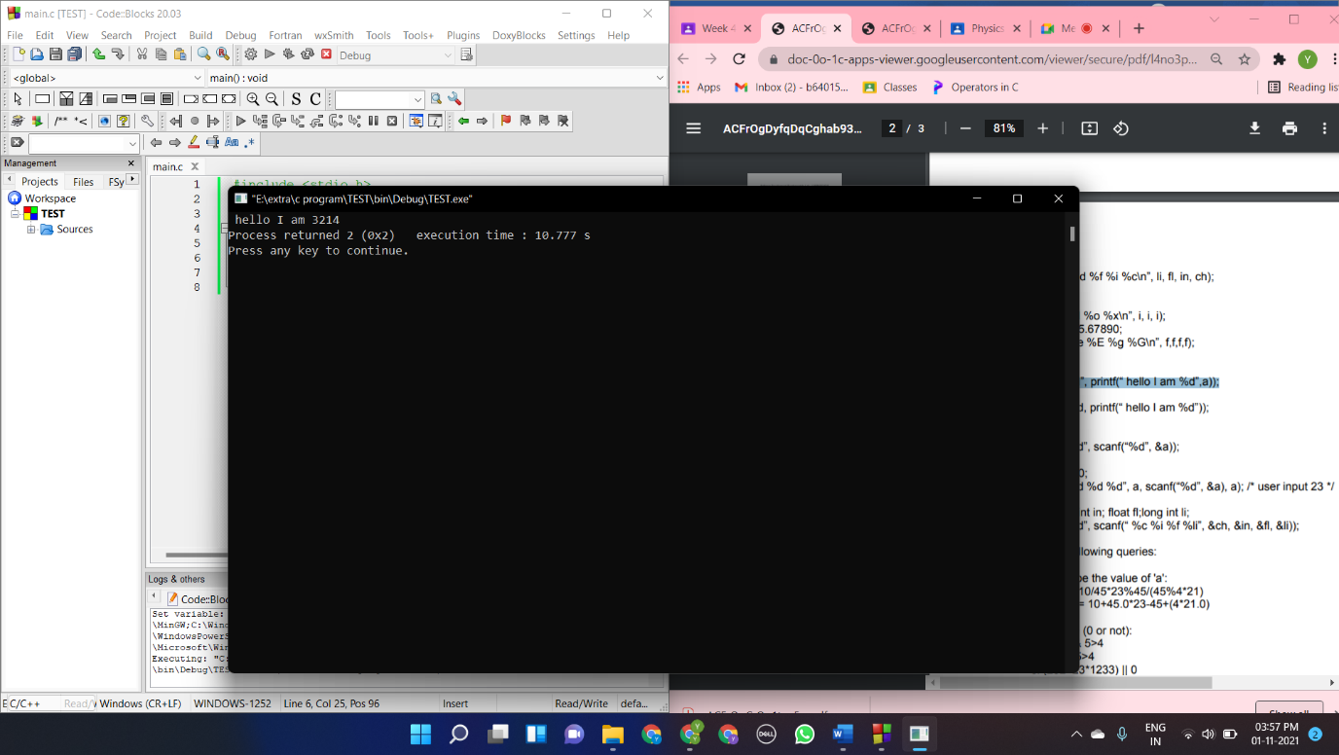#include <stdio.h>

#include <stdlib.h>

void main()

{

int a=32;

printf("%d", printf(" hello I am %d",a));

}

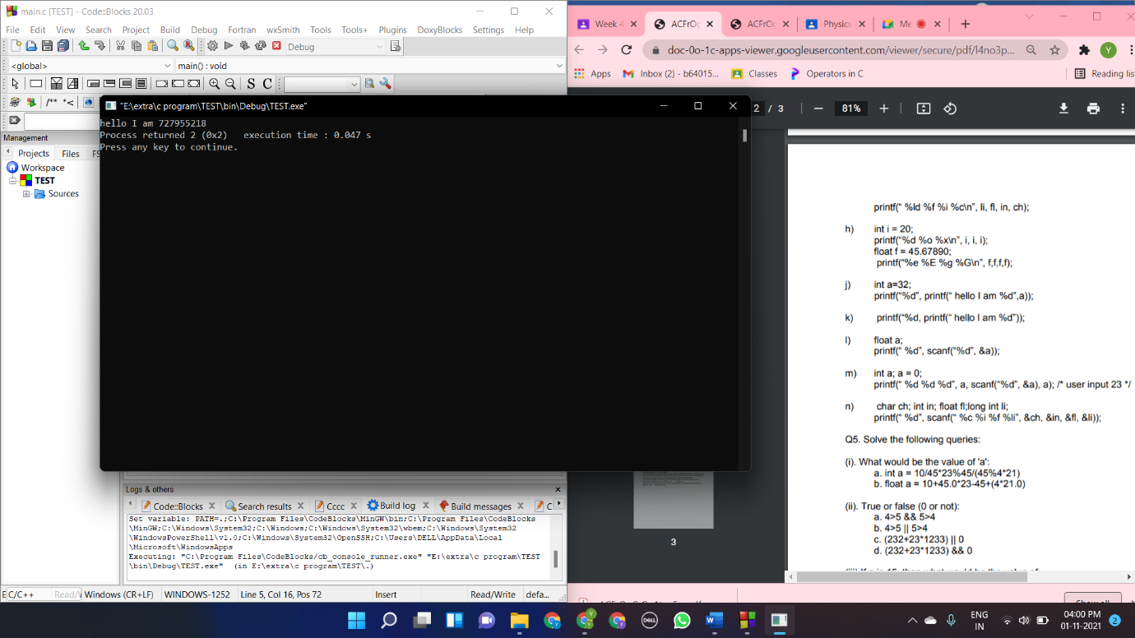

#include <stdio.h>

#include <stdlib.h>

void main()

{

printf("%d", printf("hello I am %d"));

}

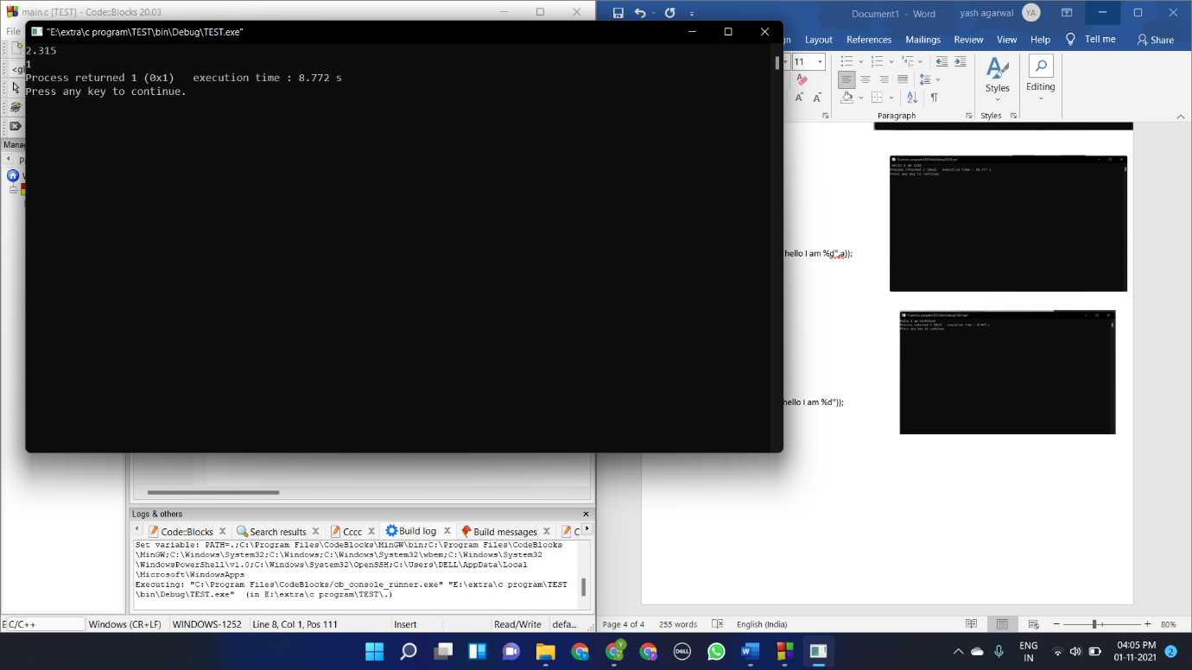#include <stdio.h>

#include <stdlib.h>

void main()

{

float a;

printf( "%d", scanf("%d", &a));

}

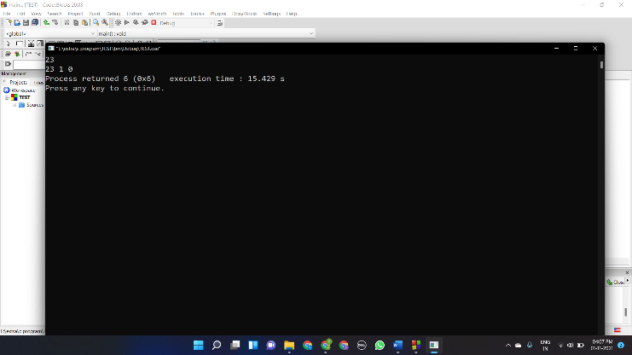#include <stdio.h>

#include <stdlib.h>

void main()

{

int a; a = 0;

printf("%d %d %d", a, scanf("%d", &a), a); /* user input 23 */

}

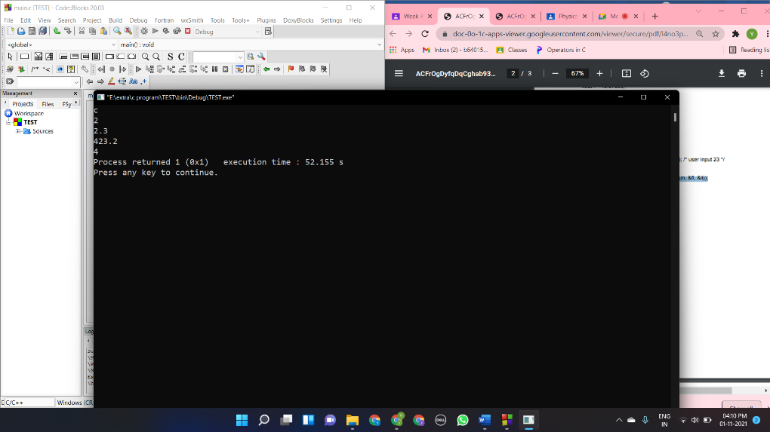#include <stdio.h>

#include <stdlib.h>

void main()

{

char ch; int in; float fl;long int li;

printf( "%d", scanf("%c %i %f %li", &ch, &in, &fl, &li));

}

Question 5

1. (a) a =0 , (b) a=1084.000000
2. (a)0,(b)1,(c)1,(d)0
3. a = 15
4. 0
5. Lvalue required as left operand of assignment