**Question 1**

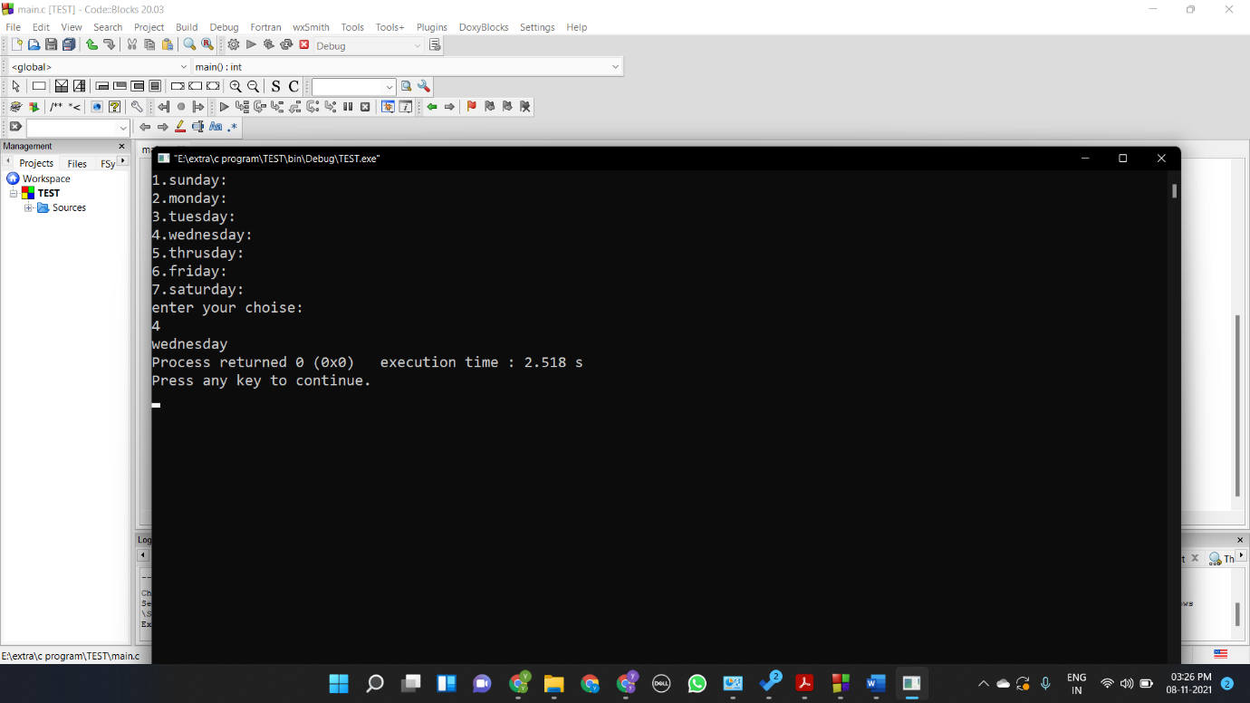#include <stdio.h>

int main()

{

int a,b;

printf("1.sunday:\n");

printf("2.monday:\n");

printf("3.tuesday:\n");

printf("4.wednesday:\n");

printf("5.thrusday:\n");

printf("6.friday:\n");

printf("7.saturday:\n");

printf("enter your choise:\n");

scanf("%d",&a);

switch(a)

{

case 1:

printf("sunday");

break;

case 2:

printf("monday");

break;

case 3:

printf("tuesday");

break;

case 4:

printf("wednesday");

break;

case 5:

printf("thrusday");

break;

case 6:

printf("friday");

break;

case 7:

printf("saturday");

break;

default:

printf("its not a valid no.");

}

}

**Question 2**

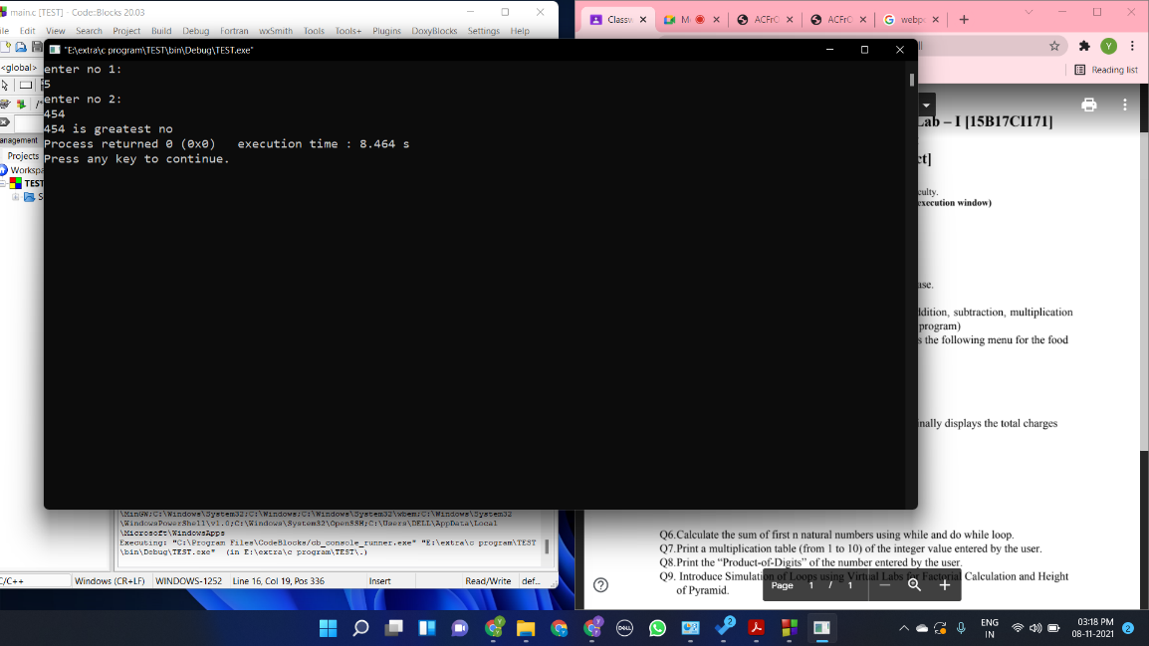#include <stdio.h>

int main()

{

int a,b;

printf("enter no 1:\n");

scanf("%d",&a);

printf("enter no 2:\n");

scanf("%d",&b);

switch(a>b)

{

case 0:

printf("%d is greatest no",b);

break;

case 1:

printf("%d is greatest no.",a);

break;

}

}

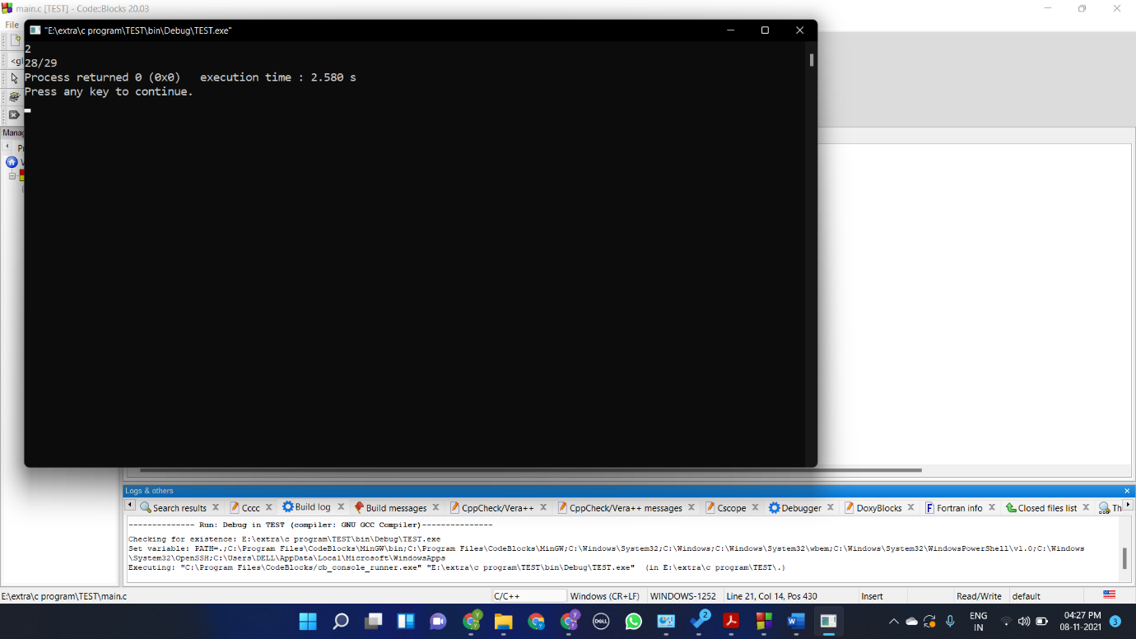**question 3**

#include <stdio.h>

#include <stdlib.h>

int main()

{

int a,c;

scanf("%d",&a);

if(a==1 ||a==3 ||a==5 ||a==7 ||a==8 ||a==10 ||a==12)c=0;

else if(a==2)c=1;

else c=2;

switch(c){

case 0:

printf("31");

break;

case 1:

printf("28/29");

break;

case 2:

printf("30");

break;

}

return 0;

}

**Question 4**

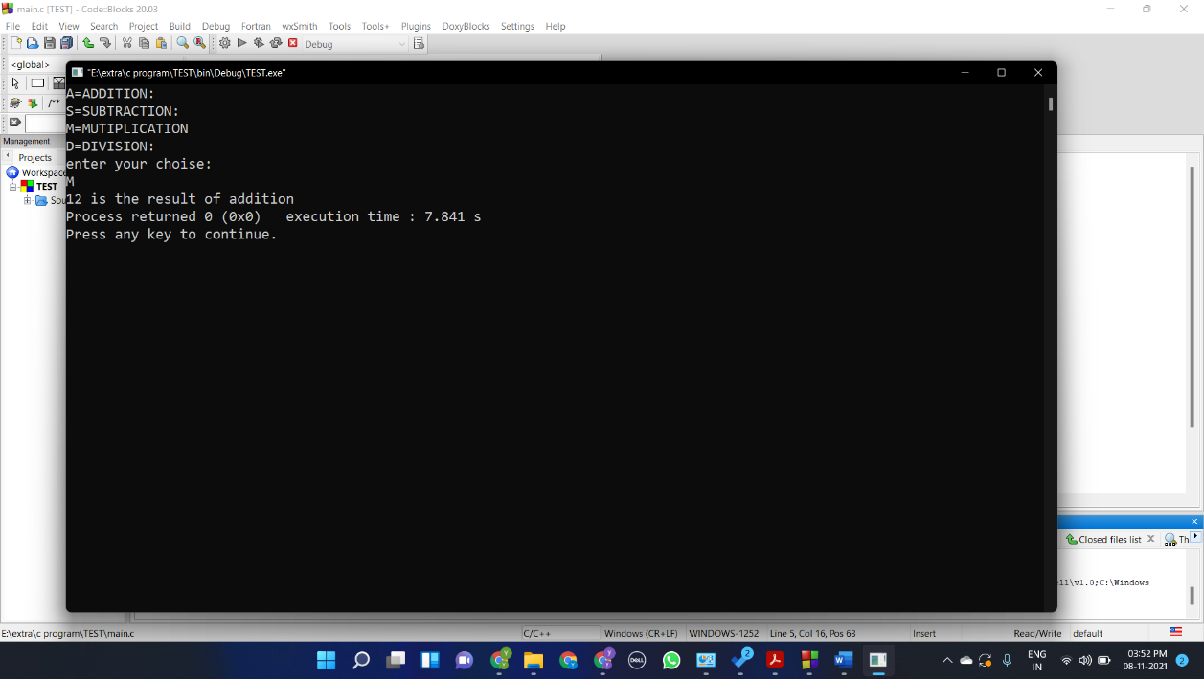#include <stdio.h>

int main()

{

char q;

int a=3,b=4,result;

printf("A=ADDITION:\n");

printf("S=SUBTRACTION:\n");

printf("M=MUTIPLICATION\n");

printf("D=DIVISION:\n");

printf("enter your choise:\n");

scanf("%c",&q);

switch(q)

{

case 'A':

result=a+b;

printf("%d is the result of addition",result);

break;

case 'S':

result=a-b;

printf("%d is the result of addition",result);

break;

case 'M':

result=a*b;

printf("%d is the result of addition",result);

break;

case 'D':

result=a/b;

printf("%d is the result of addition",result);

break;

default:

printf("invalid choise");

}

}

**Question 5**

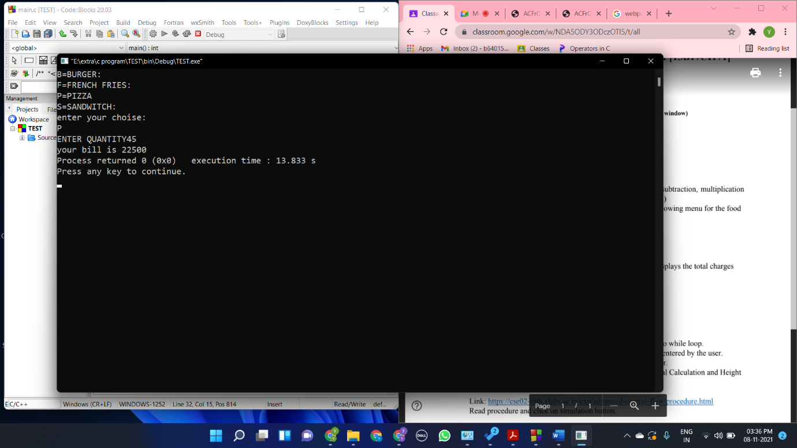#include <stdio.h>

int main()

{

char a;

int bill,s;

printf("B=BURGER:\n");

printf("F=FRENCH FRIES:\n");

printf("P=PIZZA\n");

printf("S=SANDWITCH:\n");

printf("enter your choise:\n");

scanf("%c",&a);

switch(a)

{

case 'B':

printf("ENTER QUANTITY");

scanf("%d",&s);

bill = s*200;

printf("your bill is %d",bill);

break;

case 'F':

printf("ENTER QUANTITY");

scanf("%d",&s);

bill = s*50;

printf("your bill is %d",bill);

break;

case 'P':

printf("ENTER QUANTITY");

scanf("%d",&s);

bill = s*500;

printf("your bill is %d",bill);

break;

case 'S':

printf("ENTER QUANTITY");

scanf("%d",&s);

bill = s*150;

printf("your bill is %d",bill);

break;

default:

printf("YOUR CHOISE IS INVALID OR IT IS CASE SENSITIVE");

}

**Question6**

**While loop**

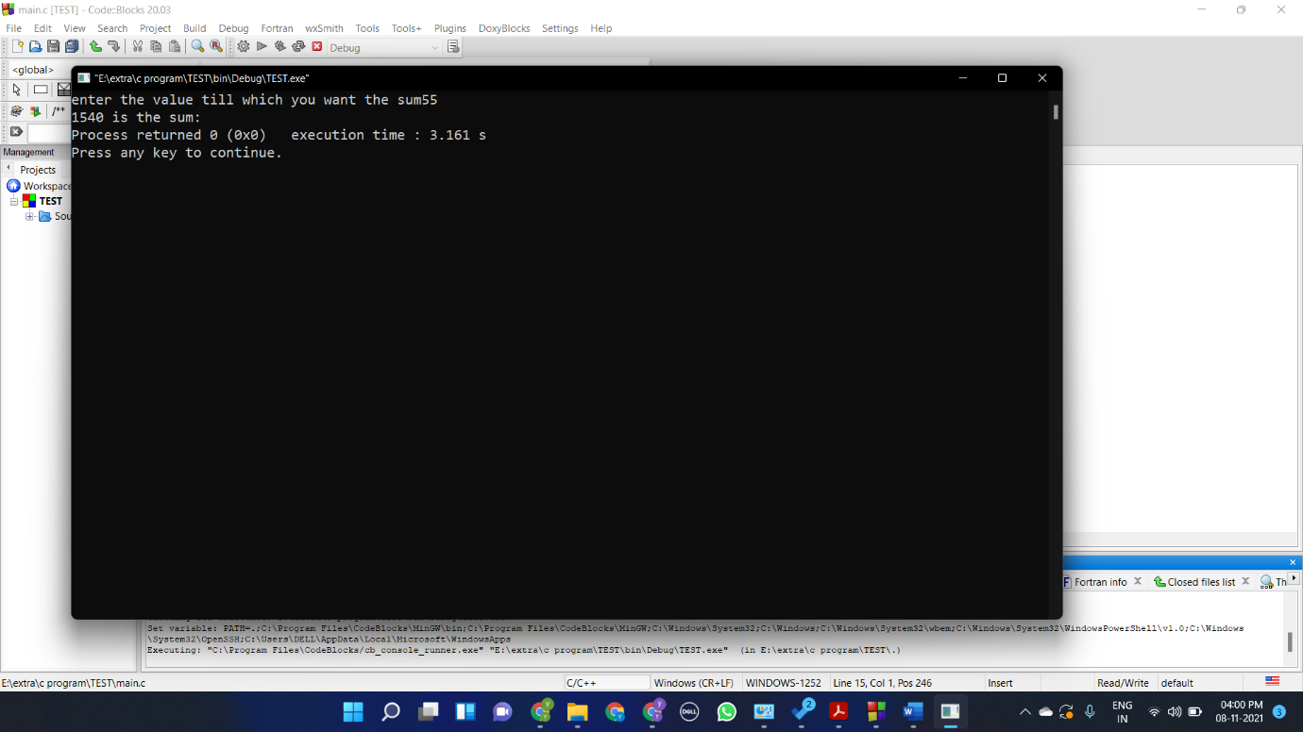#include <stdio.h>

int main()

{

int a,b=0;

printf("enter the value till which you want the sum");

scanf("%d",&a);

while (a>0)

{

b+=a;

a--;

}

printf("%d is the sum:",b);

}

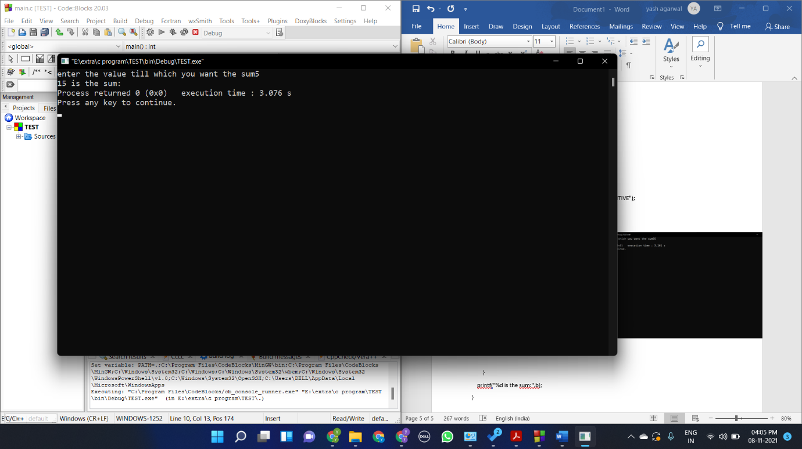**Do while loop**

#include <stdio.h>

int main()

{

int a,b=0;

printf("enter the value till which you want the sum");

scanf("%d",&a);

do

{

b+=a;

a--;

}while (a>-1);

printf("%d is the sum:",b);

}

**Question 7**

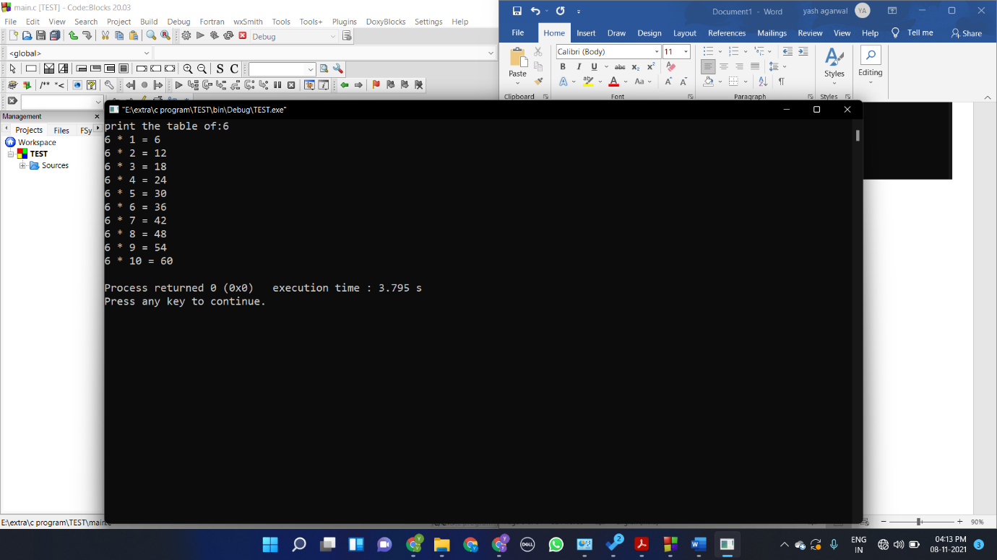#include <stdio.h>

int main()

{

int a,i;

printf("print the table of:");

scanf("%d",&a);

for (i=1;i<11;i++)

{

printf("%d * %d = %d\n",a,i,a*i);

}

}

**Question8**

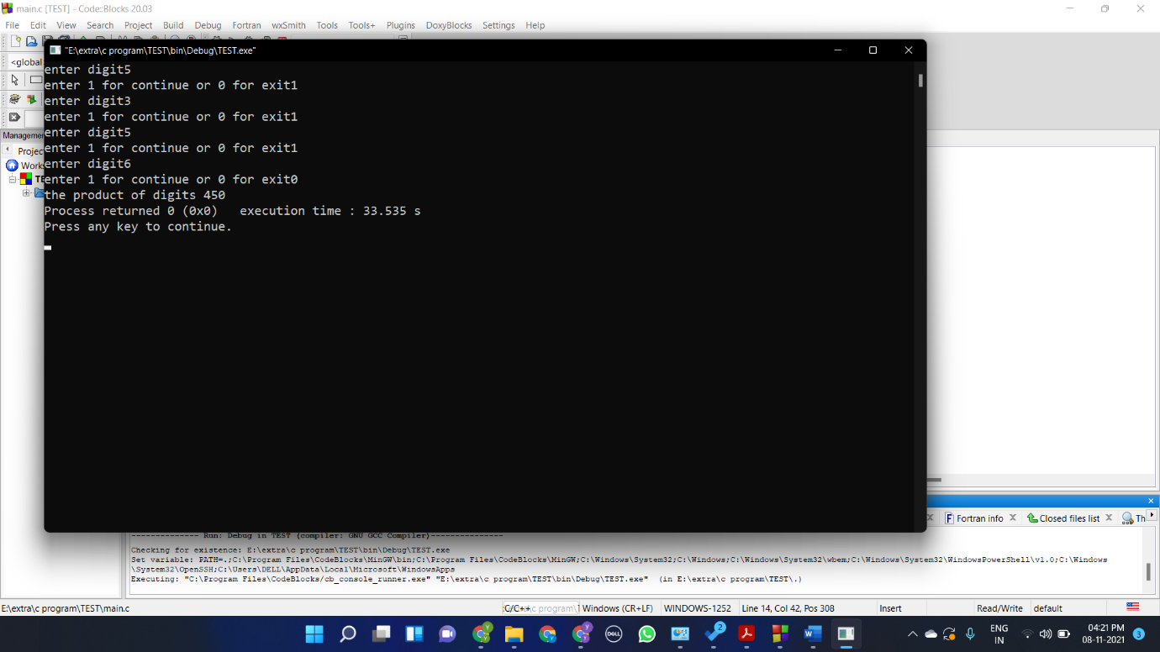#include <stdio.h>

int main()

{

int a=1,b=1;

while (a==1)

{

printf("enter digit");

scanf("%d",&a);

b*=a;

printf("enter 1 for continue or 0 for exit");

scanf("%d",&a);

}

printf("the product of digits %d",b);

}

Question 9,10

