Question 1

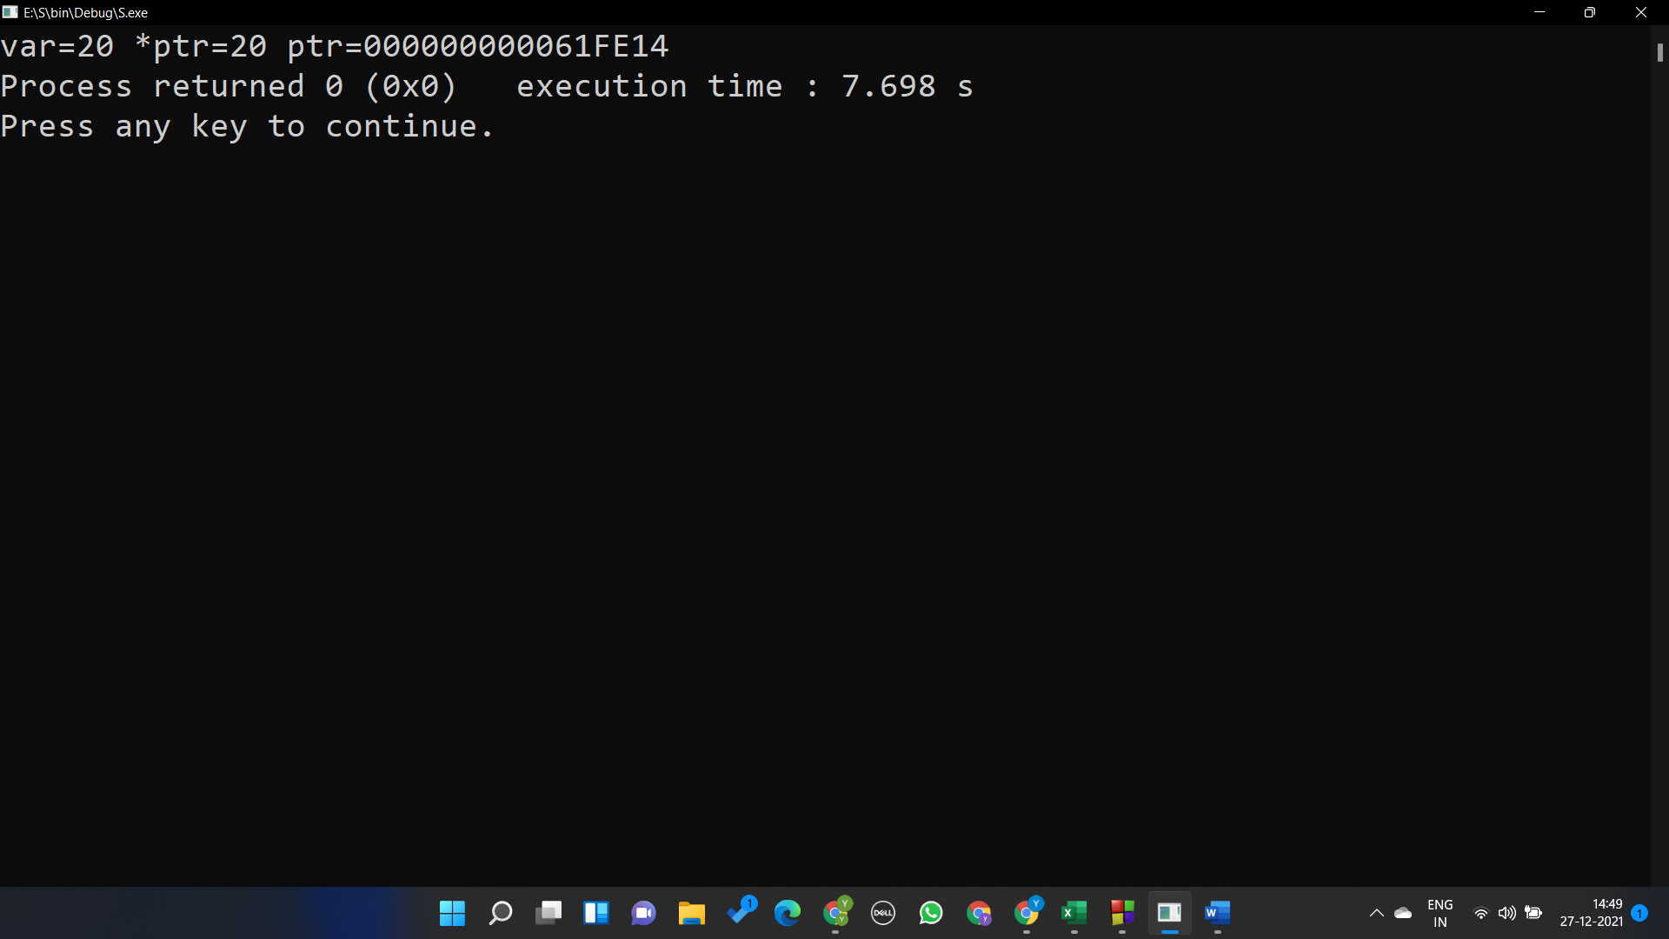

#include <stdio.h>

#include <string.h>

#include<stdlib.h>

int main()

{

int \*ptr;

int var=20;

ptr = &var;

printf("var=%d \*ptr=%d ptr=%p",var,\*ptr,ptr);

}

Question 2

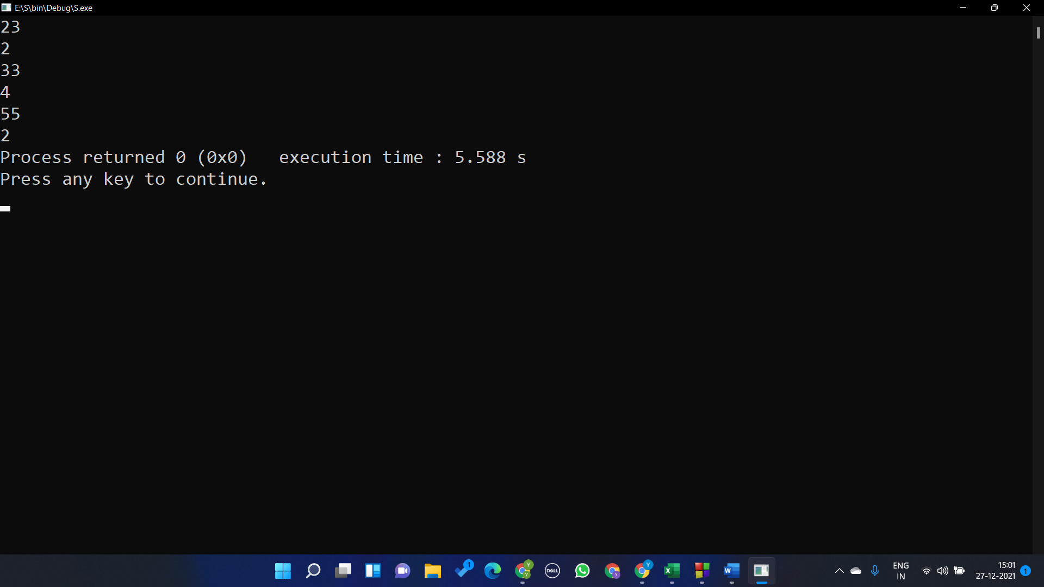

#include <string.h>

#include<stdlib.h>

int main()

{

int \*ptr,i,min;

int var[5];

for (i=0;i<5;i++)

{

scanf("%d",&var[i]);

}

ptr=var;

min=\*ptr;

for(i=0;i<5;i++)

{

if(min>\*ptr) min=\*(ptr);

ptr++;

}

printf("%d",min);

}

Question 3

#include <stdio.h>

#include <string.h>

#include<stdlib.h>

#include<stdlib.h>

int main()

{

int m,n,i,j,max;

printf("enter m\*n");

scanf("%d %d",&m,&n);

printf("enter the matrix\n");

int \*ptr,min;

ptr=malloc(n\*m\*sizeof(int));

for (i=0;i<m\*n;i++)

{

scanf("%d",ptr+i);

}

min=\*(ptr+i-1);

max=\*(ptr+i-1);

for (i=m\*n-1;i>=0;i--)

{

if(min>\*(ptr+i)) min=\*(ptr+i);

if(max<\*(ptr+i)) max=\*(ptr+i);

}

printf("min %d\n",min);

printf("max %d\n",max);

}

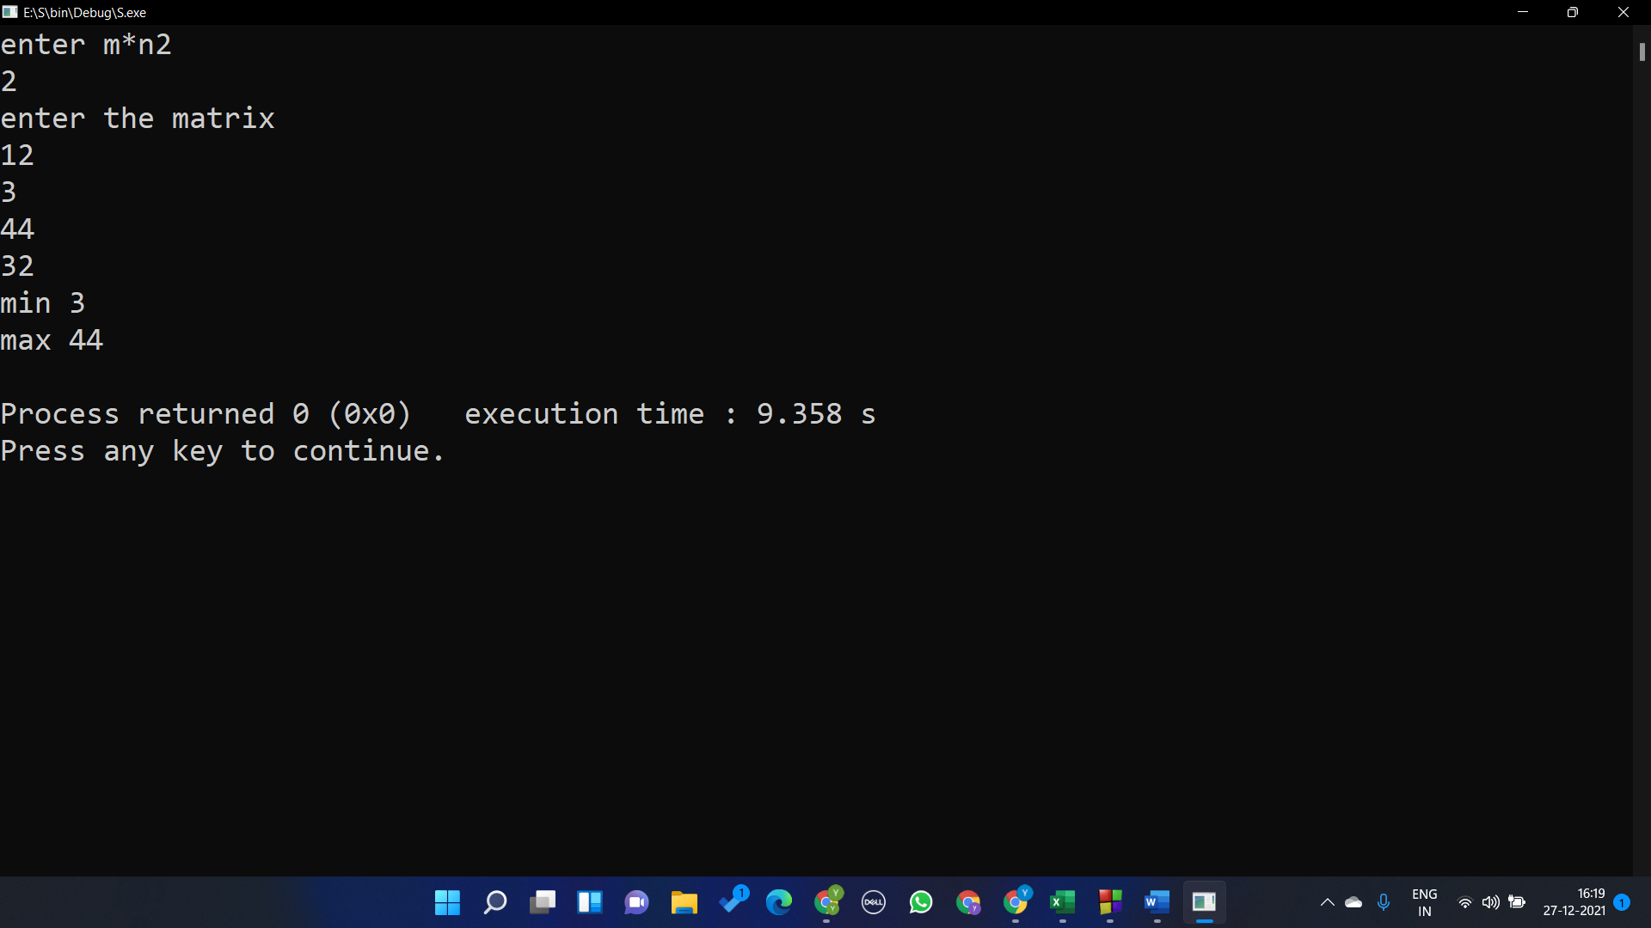

Question 4

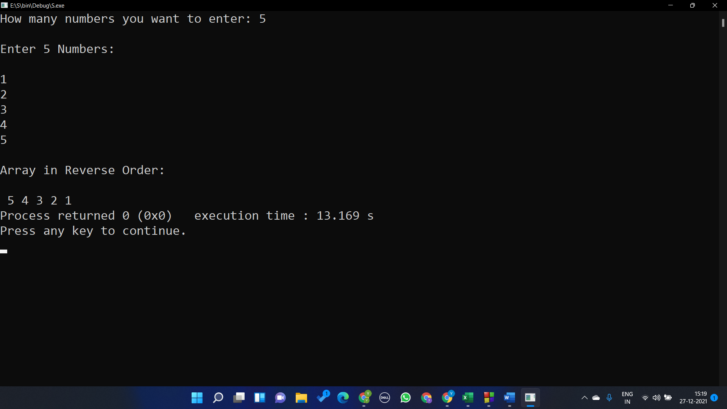

#include <stdlib.h>

#include <stdio.h>

int main()

{

int \*p,n,i;

printf("How many numbers you want to enter: ");

scanf("%d",&n);

p=malloc(n \* sizeof(int));

printf("\nEnter %d Numbers:\n\n",n);

for(i=0;i<n;i++)

{

scanf("%d",p+i);

}

printf("\nArray in Reverse Order: \n\n");

for(i=n-1;i>=0;i--)

{

printf(" %d",\*(p+i));

}

return 0;

}

Question 5;

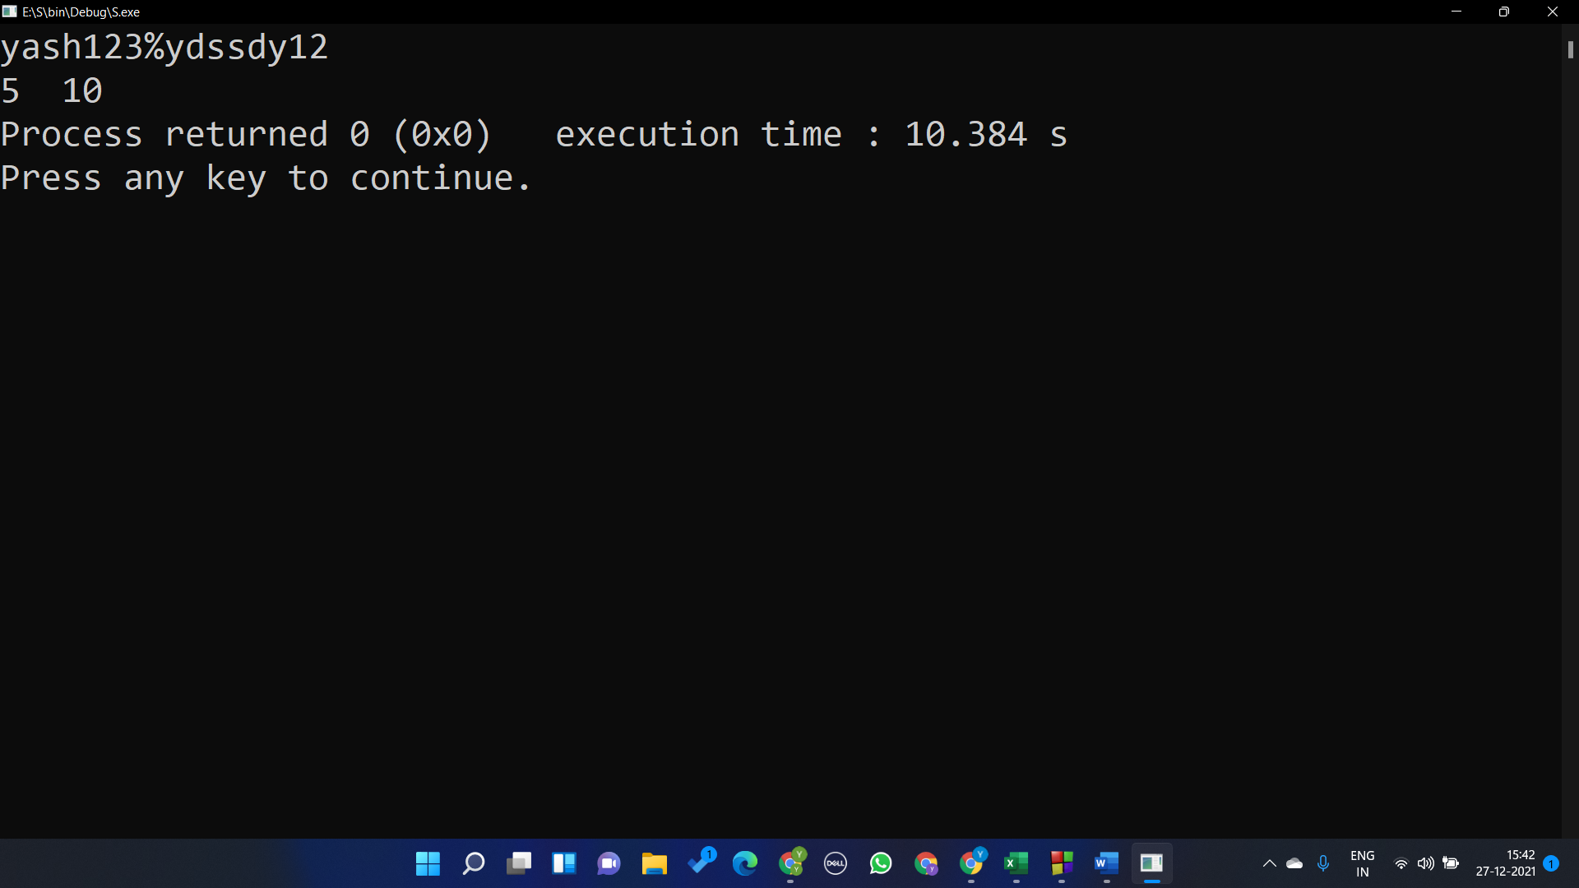

#include <stdio.h>

#include <string.h>

#include<stdlib.h>

int main()

{

char s[30];

int i,num=0,alp=0;

char \*p;

gets(s);

p=s;

for(i=0;i<strlen(s);i++)

{

if( \*p >='0'&& \*p<='9' ) num++;

else if( \*p>='a' && \*p<='z' ) alp++;

p++;

}

printf("%d %d",num,alp);

}

Question 6

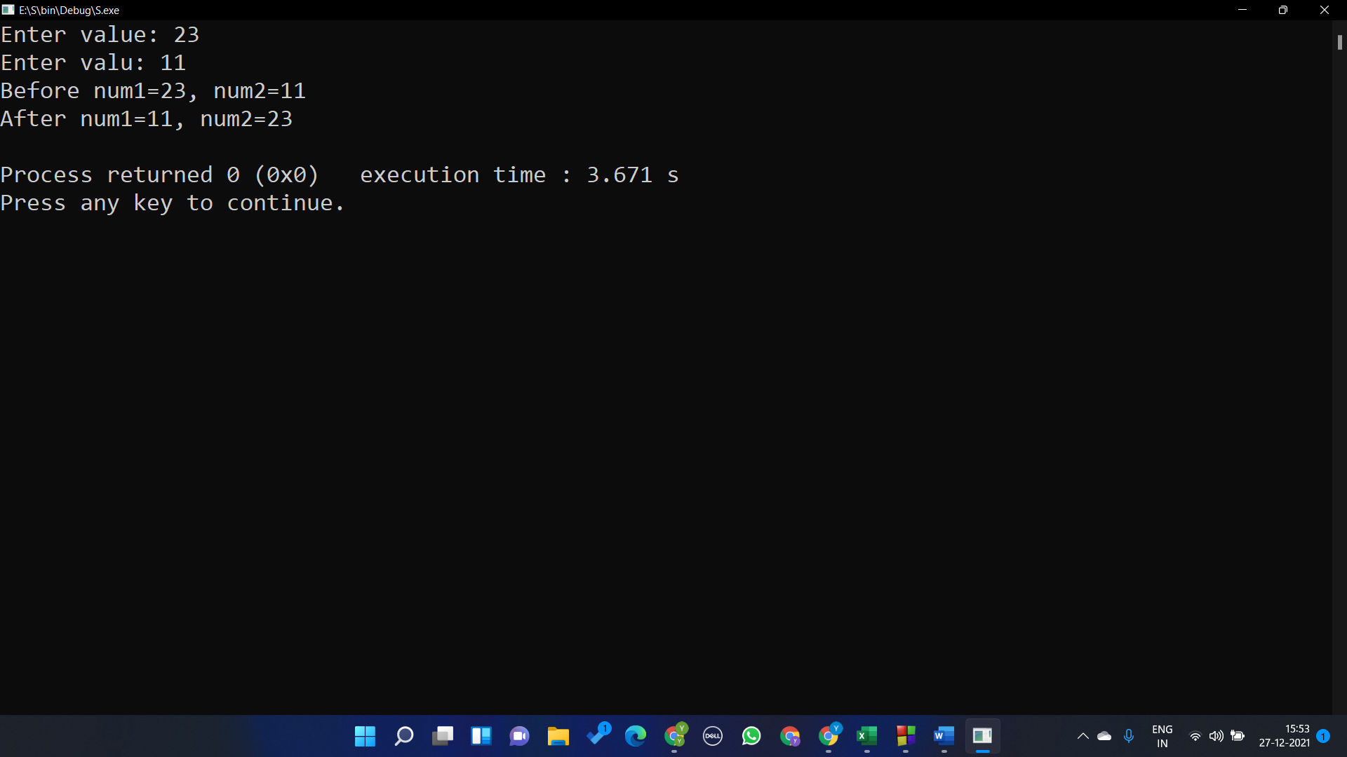

#include <stdio.h>

#include <string.h>

#include<stdlib.h>

int main()

{

int num1,num2;

int \*a,\*b;

printf("Enter value: ");

scanf("%d",&num1);

printf("Enter valu: ");

scanf("%d",&num2);

printf("Before num1=%d, num2=%d\n",num1,num2);

a=&num1;

b=&num2;

int t;

t = \*a;

\*a = \*b;

\*b = t;

printf("After num1=%d, num2=%d\n",num1,num2);

return 0;

}

Question 7

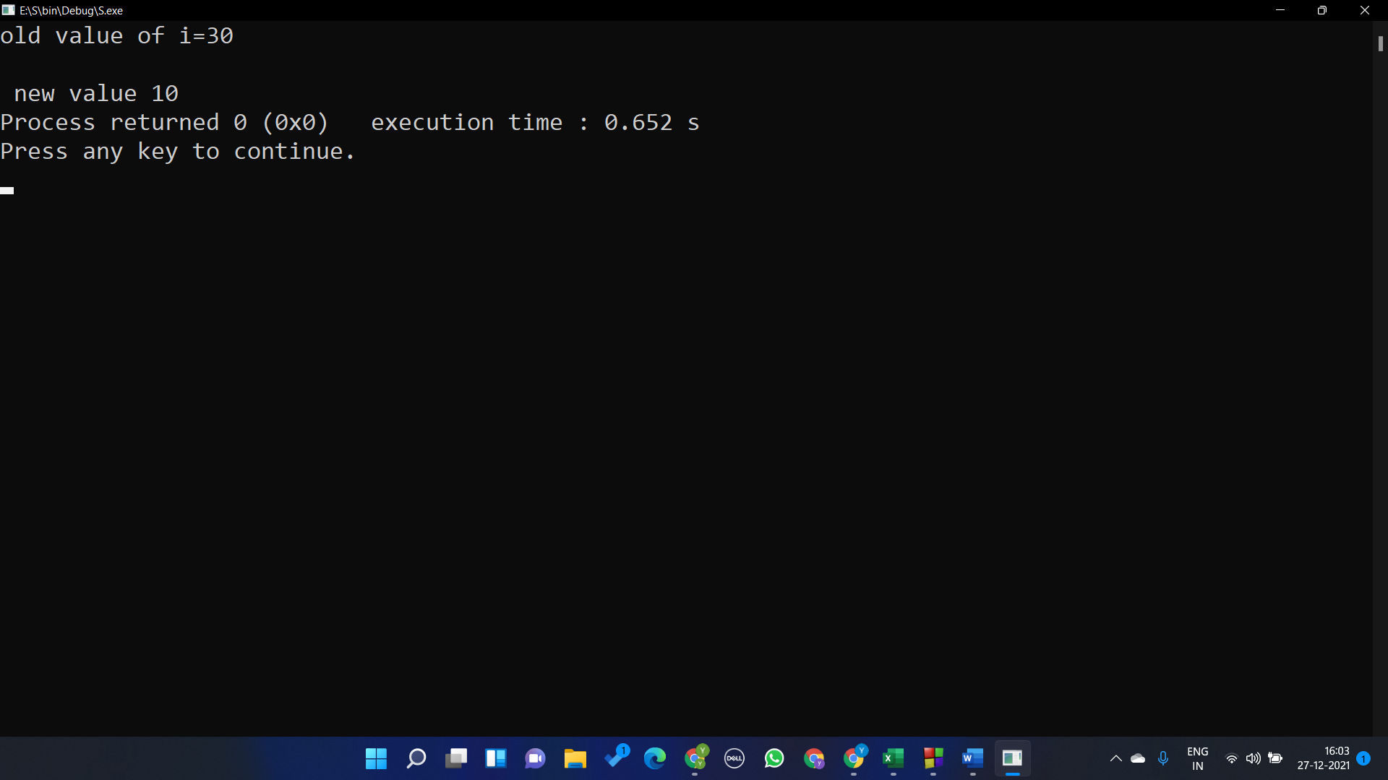

#include <stdio.h>

#include <string.h>

#include<stdlib.h>

int main()

{

const int i=30;

int \*p;

p=&i;

\*p=10;

printf("%d",i);

}

Question 8

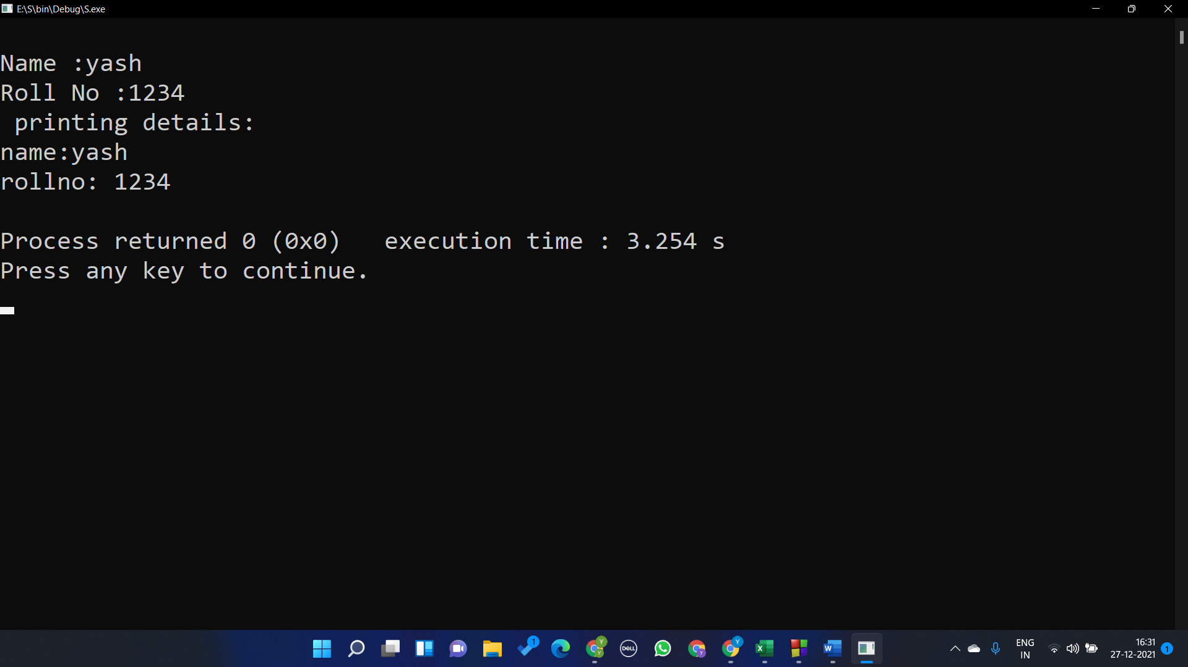

#include <stdio.h>

#include <string.h>

#include<stdlib.h>

#include<stdlib.h>

#include <stdio.h>

struct student{

char name[20];

int roll;

};

int main()

{

struct student std;

struct student \*ptr;

ptr= &std;

printf("\nName :");

gets(ptr->name);

printf("Roll No :");

scanf("%d",&ptr->roll);

printf( " printing details: ");

printf("\nname:%s \nrollno: %d \n",ptr->name,ptr->roll);

}