Question 1

#include <stdio.h>

int main()

{

FILE \*f1;

char c;

/\* open file for writing \*/

f1= fopen("E:\INPUT1.txt", "w");

if(f1== NULL)

{

printf("the file is not created");

exit(1);

}

printf("the file is created succucefully");

fclose(f1);

return 0;

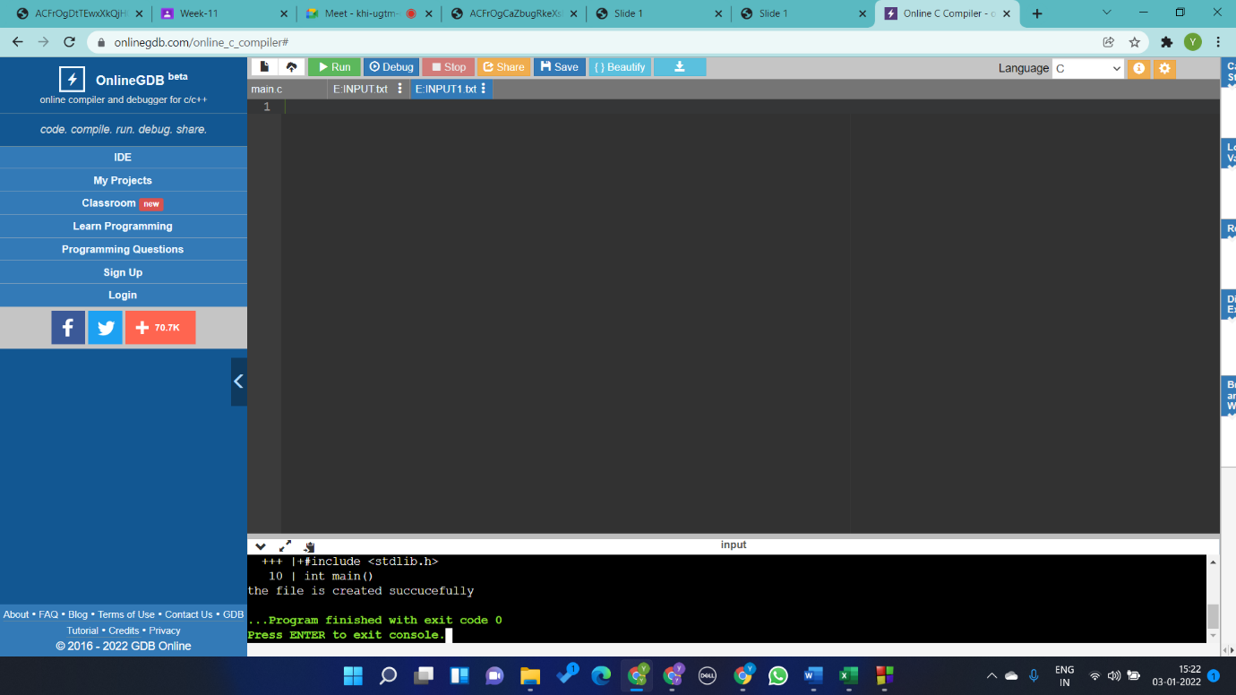}

Question 2

#include <stdio.h>

int main()

{

FILE \*f1;

int c=55;

char line[1000];

/\* open file for writing \*/

f1= fopen("E:\INPUT2.txt", "w");

if(f1== NULL)

{

printf("the file is not created");

exit(1);

}

printf("the file is created succucefully");

gets(line);

fprintf(f1,line);

fclose(f1);

f1= fopen("E:\INPUT1.txt", "r");

while (fgets(line,1000,f1) != NULL)

{

printf ("\nRead line %s\n",line);

}

fclose(f1);

return 0;

}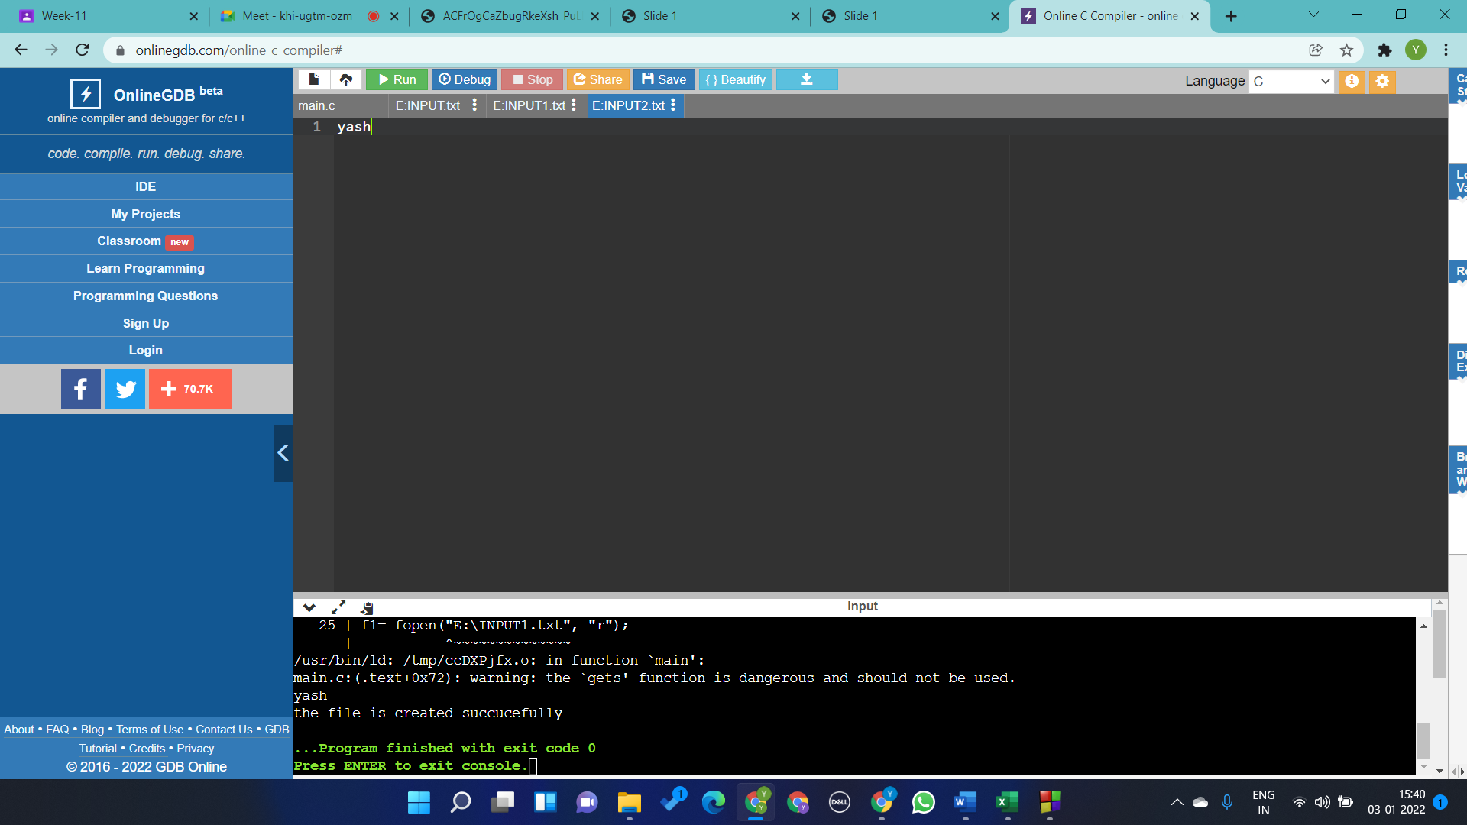

Question 3

#include <stdio.h>

#include<string.h>

int main ()

{

FILE \* fptr;

int i,n;

char str[100];

char fname[20]="test.txt";

char str1;

scanf("%d", &n);

fptr = fopen (fname,"w");

for(i = 0; i<n+1 ;i++)

{

fgets(str, sizeof(str), stdin);

fputs(str, fptr);

}

fclose (fptr);

fptr = fopen (fname, "r");

printf("\n The content of the file %s is :\n",fname);

str1 = fgetc(fptr);

while (str1 != EOF)

{

printf ("%c", str1);

str1 = fgetc(fptr);

}

printf("\n\n");

fclose (fptr);

return 0;

}

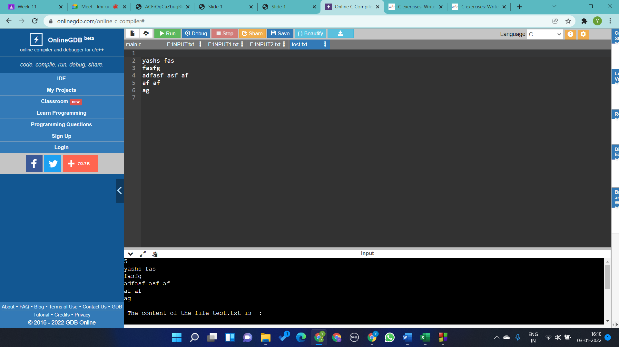

Queston 4

#include <stdio.h>

#include<string.h>

int main ()

{

FILE \* fptr;

int i,n;

char str[100];

char fname[20]="test.txt";

char str1;

fptr = fopen (fname, "r");

printf("\n The content of the file %s is :\n",fname);

str1 = fgetc(fptr);

while (str1 != EOF)

{

printf ("%c", str1);

str1 = fgetc(fptr);

if(str1=='\n') i++;

}

printf(" the no of lines are %d",i);

printf("\n\n");

fclose (fptr);

return 0;

}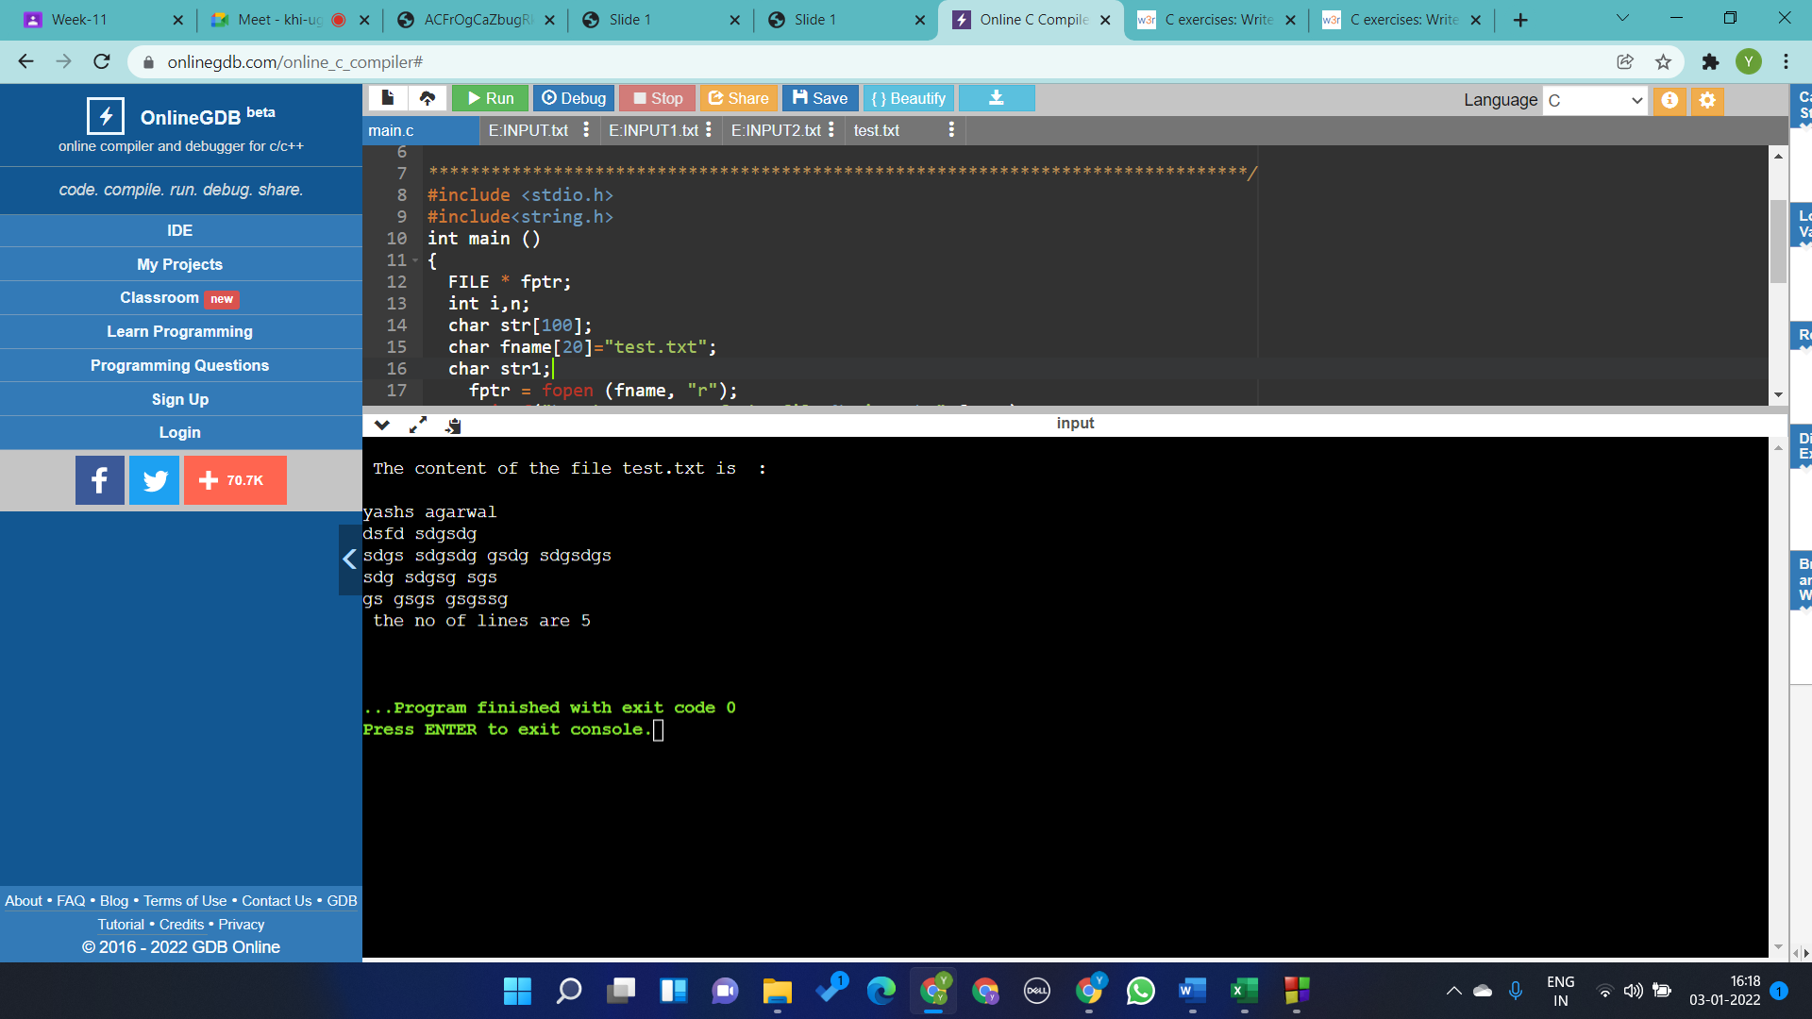

Question 5

int main()

{

// Open two files to be merged

FILE \*fp1 = fopen("INPUT1.txt", "r");

FILE \*fp2 = fopen("INPUT2.txt", "r");

// Open file to store the result

FILE \*fp3 = fopen("file3.txt", "w");

char c;

if (fp1 == NULL || fp2 == NULL || fp3 == NULL)

{

puts("Could not open files");

exit(0);

}

// Copy contents of first file to file3.txt

while ((c = fgetc(fp1)) != EOF)

fputc(c, fp3);

// Copy contents of second file to file3.txt

while ((c = fgetc(fp2)) != EOF)

fputc(c, fp3);

printf("Merged ");

fclose(fp1);

fclose(fp2);

fclose(fp3);

return 0;

}