**Question 1**

**(a)**

#include <stdio.h>

#include <stdlib.h>

#include<string.h>

struct employee

{

char name[30];

int salary ;

int employee_id;

};

int main()

{

int i=10;

struct employee e[i];

for(i=1;i<11;i++)

{

printf("enter name of %d employee\n",i);

scanf("%[^\n]",&e[i].name);

printf("\nenter salary\n");

scanf("%d",&e[i].salary);

printf("\nenter employee id\n");

scanf("%d",&e[i].employee_id);

char c=getchar();

}

printf("_______________________printing_____________________________");

for(i=1;i<11;i++)

{

printf("name of %d employee\n",i);

printf("%s",e[i].name);

printf("\n salary\n");

printf("%d",e[i].salary);

printf("\n employee id\n");

printf("%d",e[i].employee_id);

}

}

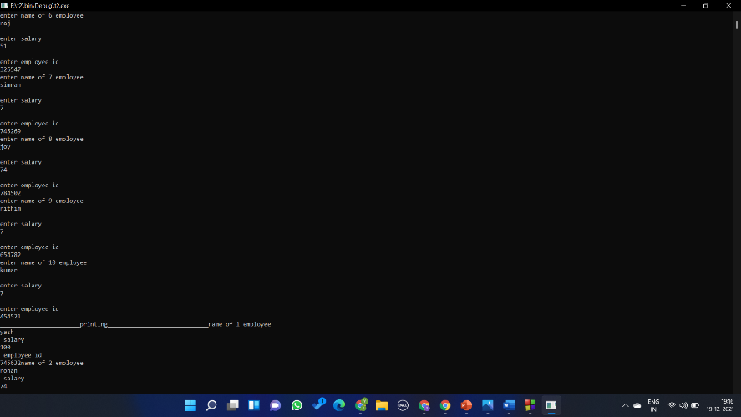

(b)

#include <stdio.h>

#include <stdlib.h>

#include<string.h>

struct employee

{

char name[30];

int salary ;

int employee_id;

int hour;

};

int main()

{

int i=11;

struct employee e[i];

for(i=1;i<11;i++)

{

printf("enter name of %d employee\n",i);

scanf("%[^\n]",&e[i].name);

printf("\nenter salary\n");

scanf("%d",&e[i].salary);

printf("\nenter employee id\n");

scanf("%d",&e[i].employee_id);

printf("\n enter working hours\n");

scanf("%d",&e[i].hour);

}

for(i=1;i<11;i++)

{

if(e[i].hour>=8 && e[i].hour<10) e[i].salary+=50;

else if(e[i].hour>=10 && e[i].hour<12) e[i].salary+=100;

else if(e[i].hour>=12) e[i].salary+=150;

}

printf("_______________________printing_____________________________");

for(i=1;i<11;i++)

{

printf("name of %d employee\n",i);

printf("%s",e[i].name);

printf("\n final salary\n");

printf("%d",e[i].salary);

}

}

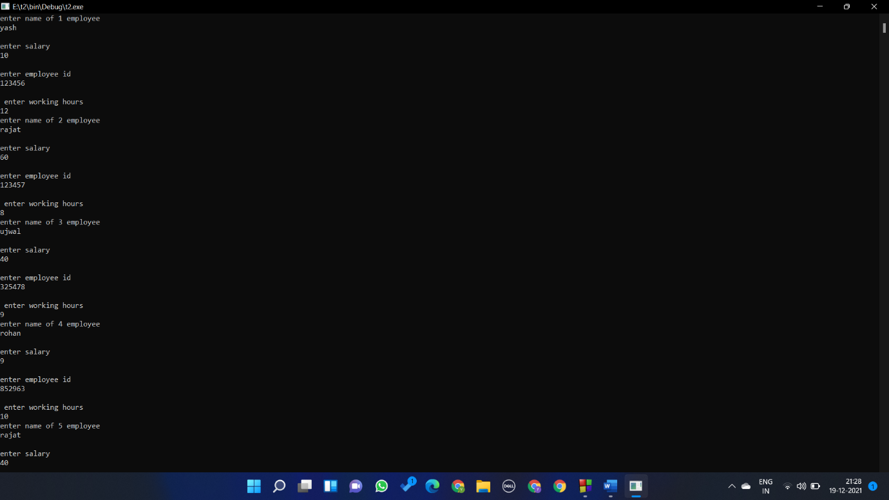

Question 2

#include <stdio.h>

#include <stdlib.h>

#include<string.h>

struct inches_feet

{

int inches ;

int feet;

}d1,d2,sum;

int main()

{

printf("enter distances 1\n");

printf("inches and feets \n");

scanf("%d %d",&d1.inches,&d1.feet);

printf("\nenter distances 2\n");

printf("inches and feets \n");

scanf("%d %d",&d2.inches,&d2.feet);

sum.inches=d2.inches+d1.inches;

sum.feet=d2.feet+d1.feet;

printf("\n total inches %d\n",sum.inches);

printf("\n total feets %d\n",sum.feet);

printf("\n total distance %d\n",(sum.inches/12)+sum.feet);

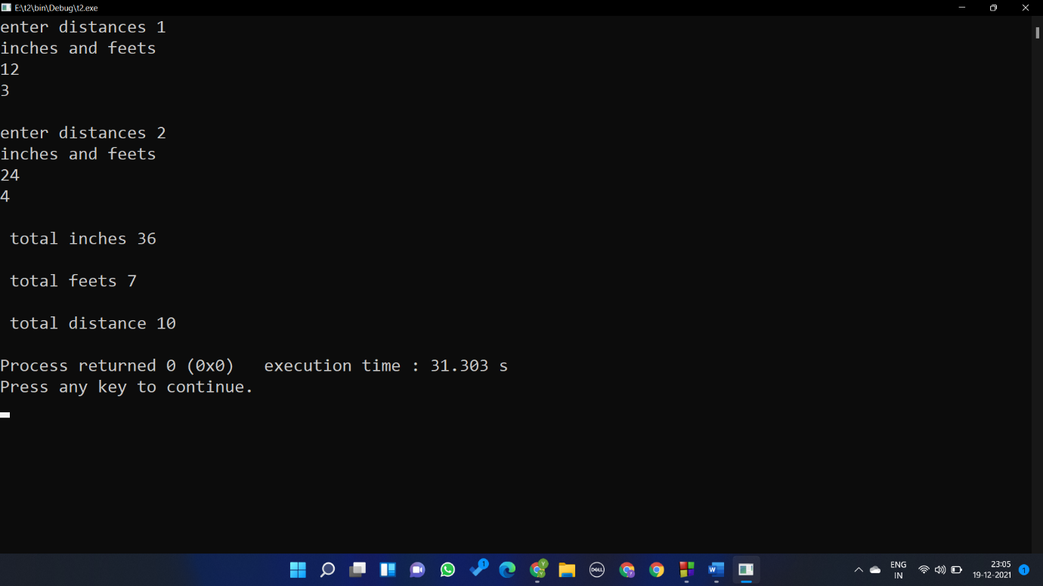}

Question 3

#include <stdio.h>

#include <stdlib.h>

#include<string.h>

struct boat

{

char name[30] ;

int seat_no;

int fare;

};

int main()

{

int i=2,n;

printf("enter no of passenger\n");

scanf("%d",&n);

struct boat b[i];

for(i=0;i<n;i++)

{

printf("enter name of passenger\n");

scanf("%s",b[i].name);

b[i].seat_no=i+1;

printf("enter fare\n");

scanf("%d",&b[i].fare);

}

printf("\nticket genetated\n");

printf("----------------------------\n");

for(i=0;i<n;i++)

{

printf("NAME : %s \n",b[i].name);

printf("SEAT NUNBER : %d\n",b[i].seat_no);

printf("FARE : %d\n",b[i].fare);

printf("----------------------------\n");

}

}

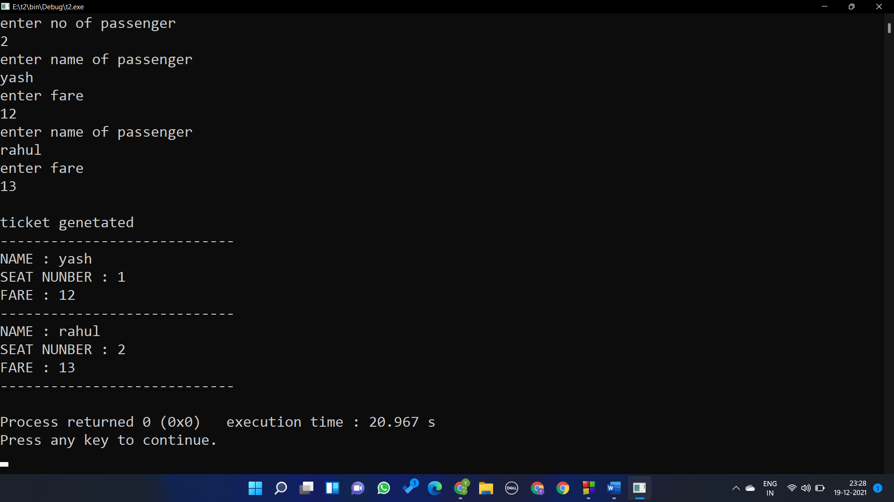

Question 4

# include <stdio.h>

struct a{

char name[30];

int age;

float salary;

};

void show(struct a d1)

{

printf("---------------------------------\n");

printf("enter the name %s\n",d1.name);

printf("enter the age %d\n",d1.age);

printf("enter the salary %f\n",d1.salary);

printf("---------------------------------\n");

}

struct a read(struct a d1)

{

printf("enter your name\n");

scanf("%s",d1.name);

printf("enter age\n");

scanf("%d",&d1.age);

printf("enter salary\n");

scanf("%f",&d1.salary);

return d1;

}

int main()

{

int i=10;

struct a b[i];

for(i=0;i<4;i++)

{

b[i]=read(b[i]);

}

for(i=0;i<4;i++)

{

show(b[i]);

}

