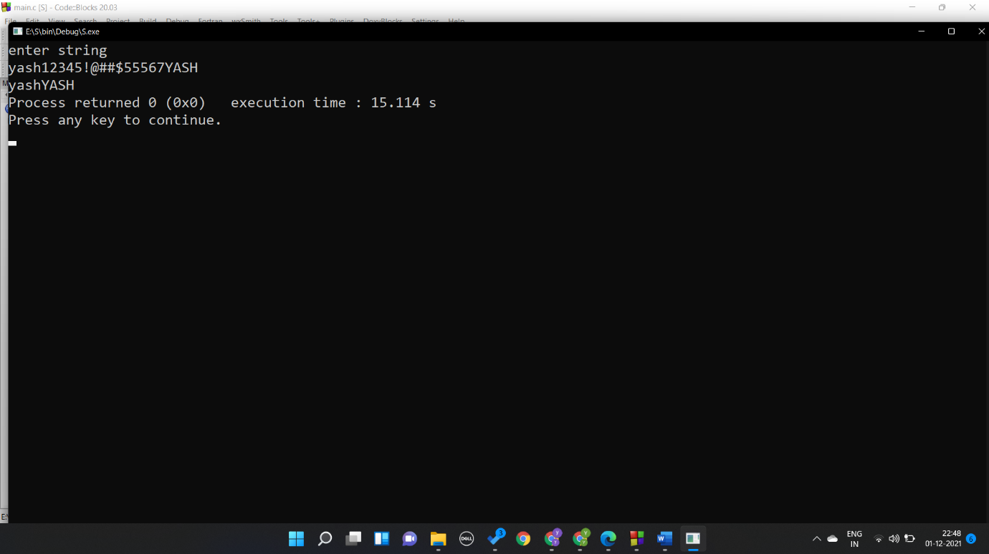**Question 1**

#include <stdio.h>

#include <stdlib.h>

#include <string.h>

int main()

{

char a[100];

int len,i,j,count=0;

printf("enter string \n");

gets(a);

len=strlen(a);

for (i=0;i<len;i++)

{

if((a[i]<65 || a[i]>90) && (a[i]<97 || a[i]>122))

{

for(j=i;j<len-1;j++)

{

a[j]=a[j+1];

}

i--;// mistake//

++count;

}

}

len=len-count;

for(i=0;i<len;i++)

{

printf("%c",a[i]);

}

}

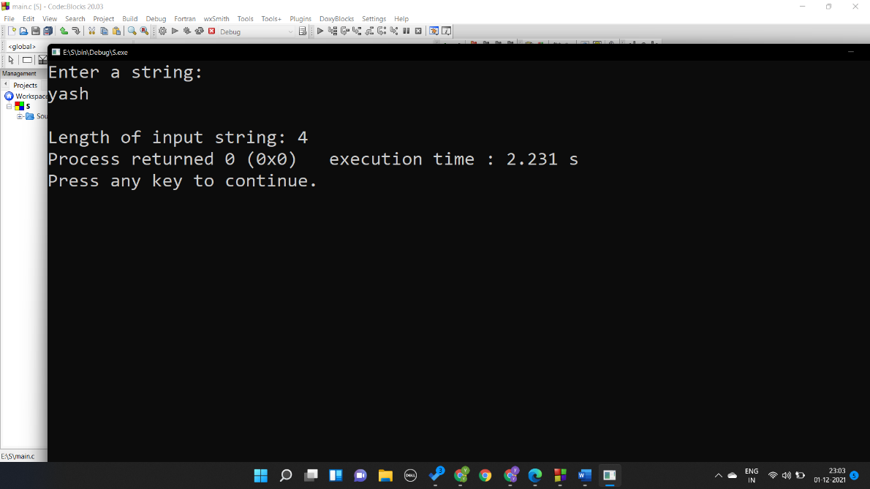**QUESTION 2**

#include <stdio.h>

#include <stdlib.h>

int main()

{

char str[100],i;

printf("Enter a string: \n");

scanf("%s",str);

for(i=0; str[i]!='\0'; ++i);

printf("\nLength of input string: %d",i);

return 0;

}

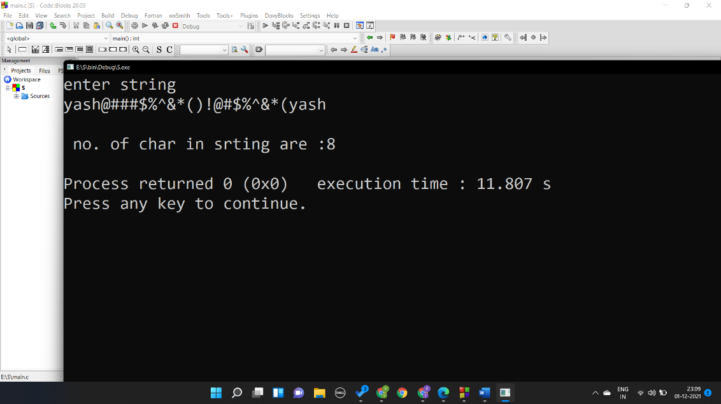**Question 3**

#include <stdio.h>

#include <stdlib.h>

int main()

{

char a[100];

int len,i,count=0;

printf("enter string \n");

gets(a);

len=strlen(a);

for (i=0;i<len;i++)

{

if((a[i]>64 && a[i]<92) || (a[i]>96 && a[i]<123))

{

count++;

}

}

printf("\n no. of char in srting are :%d\n",count);

}

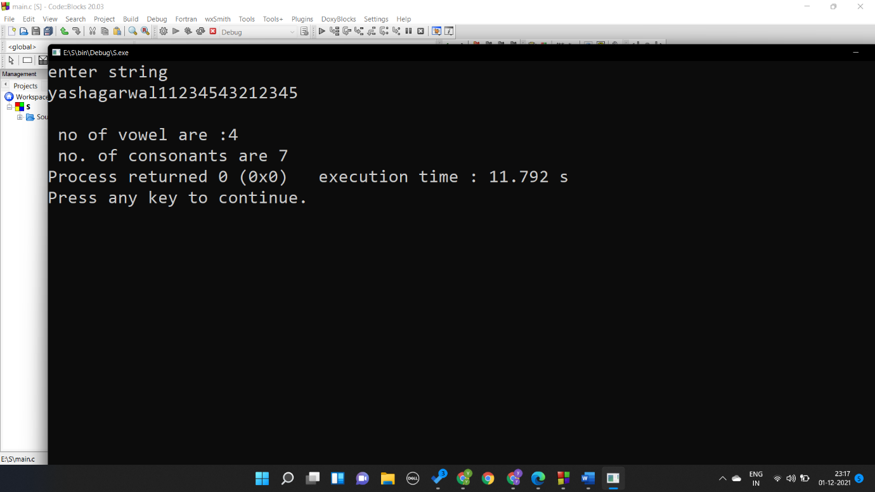**Question 4**

int main()

{

char a[100];

int len,i,count=0,vow=0;

printf("enter string \n");

gets(a);

len=strlen(a);

for (i=0;i<len;i++)

{

if((a[i]>64 && a[i]<92) || (a[i]>96 && a[i]<123))

{

if(a[i]==65 || a[i]==69 || a[i]==73 ||a[i]==79 || a[i]==85 || a[i]==97 ||a[i]==101 || a[i]==105 || a[i]==111 || a[i]==117 ) vow++;

count++;

}

}

printf("\n no of vowel are :%d\n no. of consonants are %d",vow,count-vow);

}

**Question 5**

1. Compare two strings

#include <stdio.h>

int comp(char a[],char b[])

{

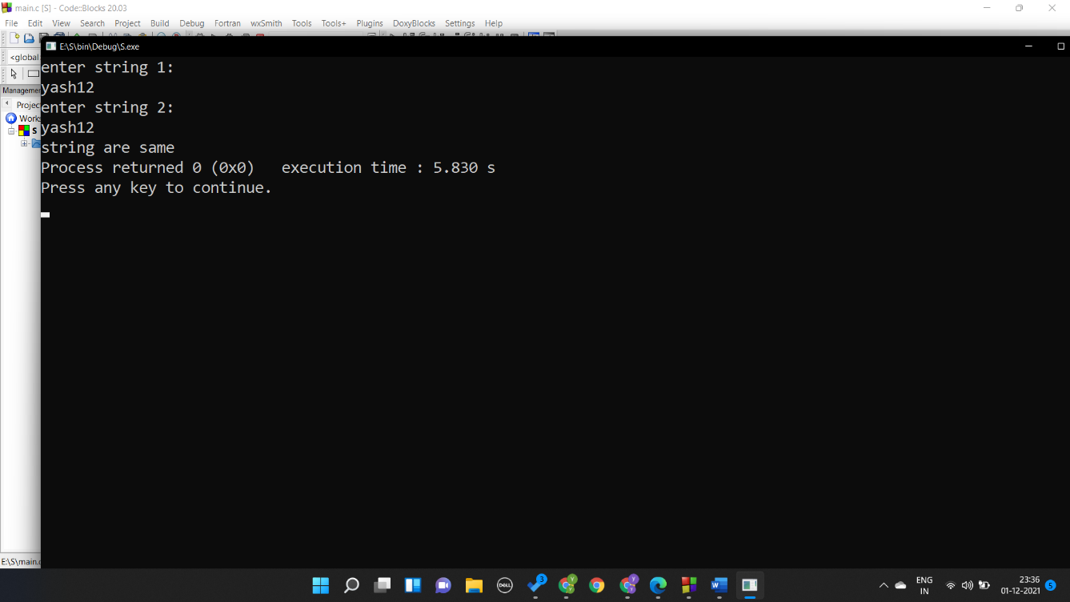 int i,len_a,len_b;

len_a=len(a);

len_b=len(b);

if (len_a!=len_b) return 1;

for(i=0;i<len_a;i++)

{

if(a[i]!= b[i]) return 1;

}

return 0;

}

int len(char a[])

{

int i;

for(i=0;a[i]!='\0';i++);

return i;

}

int main()

{

char a[100],b[100];

int c;

printf("enter string 1:\n");

gets(a);

printf("enter string 2:\n");

gets(b);

c=comp(a,b);

if (c==0) printf("string are same");

else printf("strings are different");

}

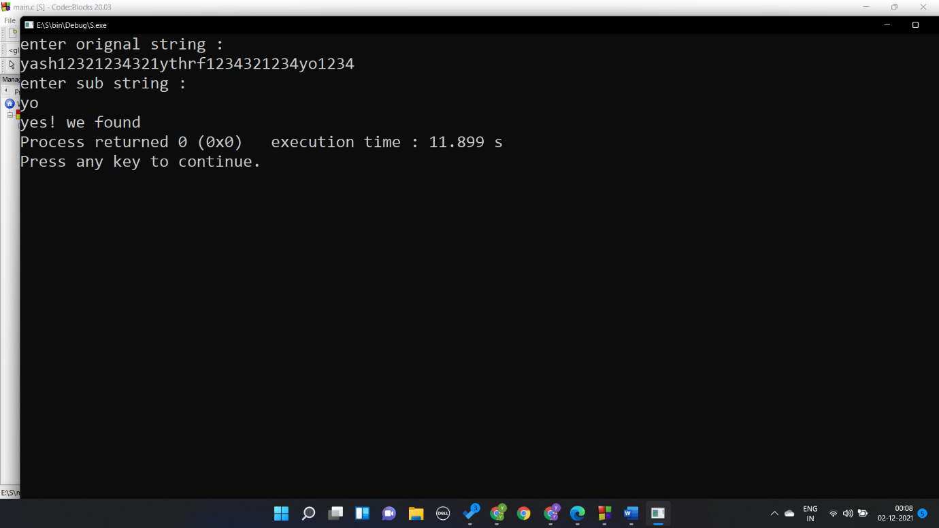(b)Finding sub string

#include <stdio.h>

int find(char a[],char b[])

{

int i,len_a,len_b,j,count=0;

len_a=len(a);

len_b=len(b);

for(i=0;i<len_a;i++)

{

if(a[i]== b[0])

{

for(j=0;j<len_b-1;j++)

{

if(a[i+1+j]==b[j+1])count++;

}

if(count==len_b-1) return 1;

}

}

return 0;

}

int len(char a[])

{

int i;

for(i=0;a[i]!='\0';i++);

return i;

}

int main()

{

char a[100],b[100];

int c;

printf("enter orignal string :\n");

gets(a);

printf("enter sub string :\n");

gets(b);

c=find(a,b);

if (c==0) printf("sorry!not found");

else printf("yes! we found");

}

(c)sorting name of student

#include<stdio.h>

#include<string.h>

int main(){

int i,j,count;

char str[25][25],temp[25];

puts("How many strings u are going to enter?: ");

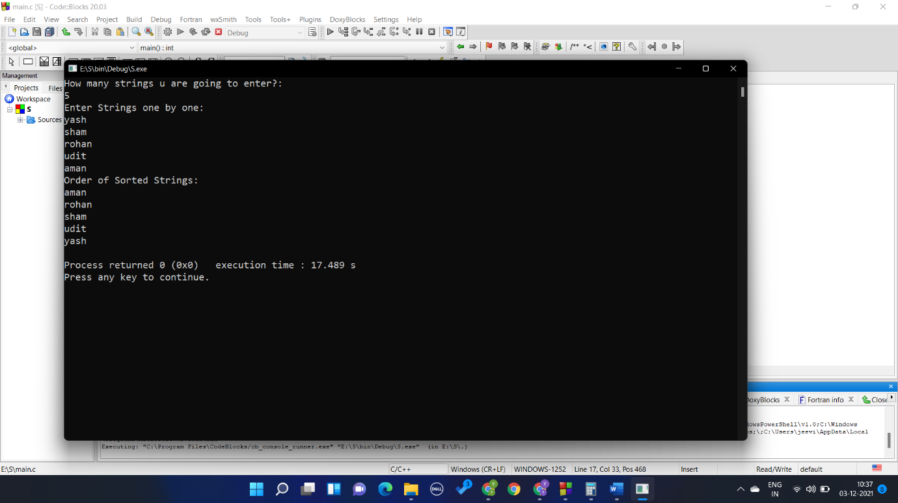 scanf("%d",&count);

puts("Enter Strings one by one: ");

for(i=0;i<=count;i++)

gets(str[i]);

for(i=0;i<=count;i++)

for(j=i+1;j<=count;j++){

if(strcmp(str[i],str[j])>0){

strcpy(temp,str[i]);

strcpy(str[i],str[j]);

strcpy(str[j],temp);

}

}

printf("Order of Sorted Strings:");

for(i=0;i<=count;i++)

puts(str[i]);

return 0;

}