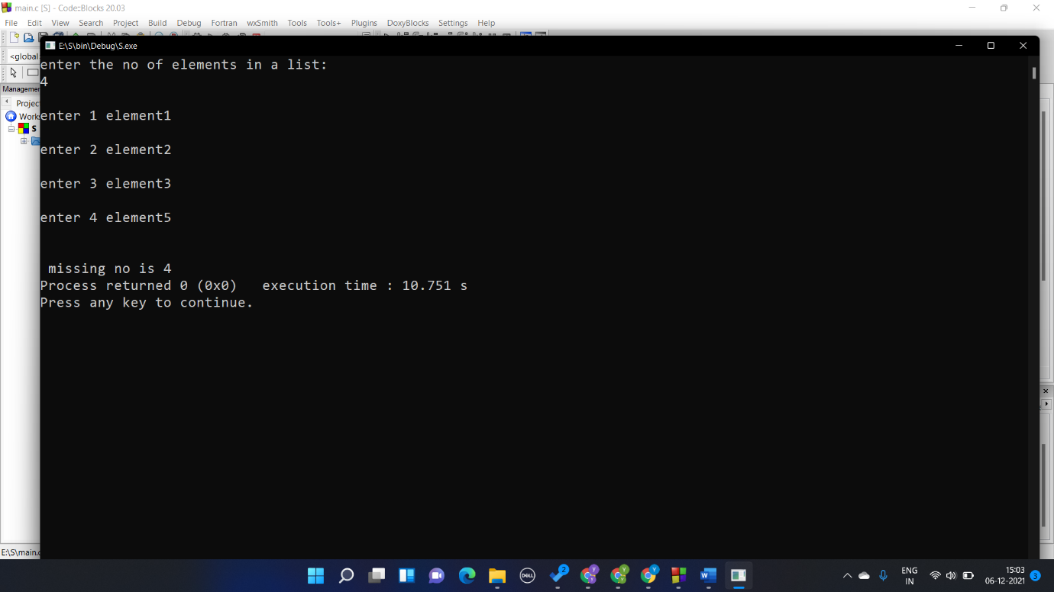Question 1

#include<stdio.h>

#include<string.h>

int miss(int a[],int n)

{

int i;

for(i=0;i<n;i++)

{

if(i+1!=a[i] && i!=0)

{

return i+1;

}

}

return 0;

}

int main()

{

int n,i,c;

int a[10];

printf("enter the no of elements in a list:\n");

scanf("%d",&n);

for(i=0;i<n;i++)

{

printf("\nenter %d element",i+1);

scanf("%d",&a[i]);

}

printf("\n");

c=miss(a,n);

if(c!=0) printf("\n missing no is %d",c);

else printf("no number is missing");

}

Question 2

#include<stdio.h>

#include<string.h>

void arr_sort(int a[], int n)

{

int i, j,tem;

for (i = 0; i < n; ++i){

for (j = i + 1; j < n; ++j){

if (a[i] > a[j]){

tem = a[i];

a[i] = a[j];

a[j] = tem;

}

}

}

for(i=0;i<n;i++)

{

printf("\nenter %d element",i+1);

printf("%d",a[i]);

}

}

int main()

{

int n,i,c;

int a[10];

printf("enter the no of elements in a list:\n");

scanf("%d",&n);

for(i=0;i<n;i++)

{

printf("\nenter %d element",i+1);

scanf("%d",&a[i]);

}

printf("\n");

arr_sort(a,n);

}

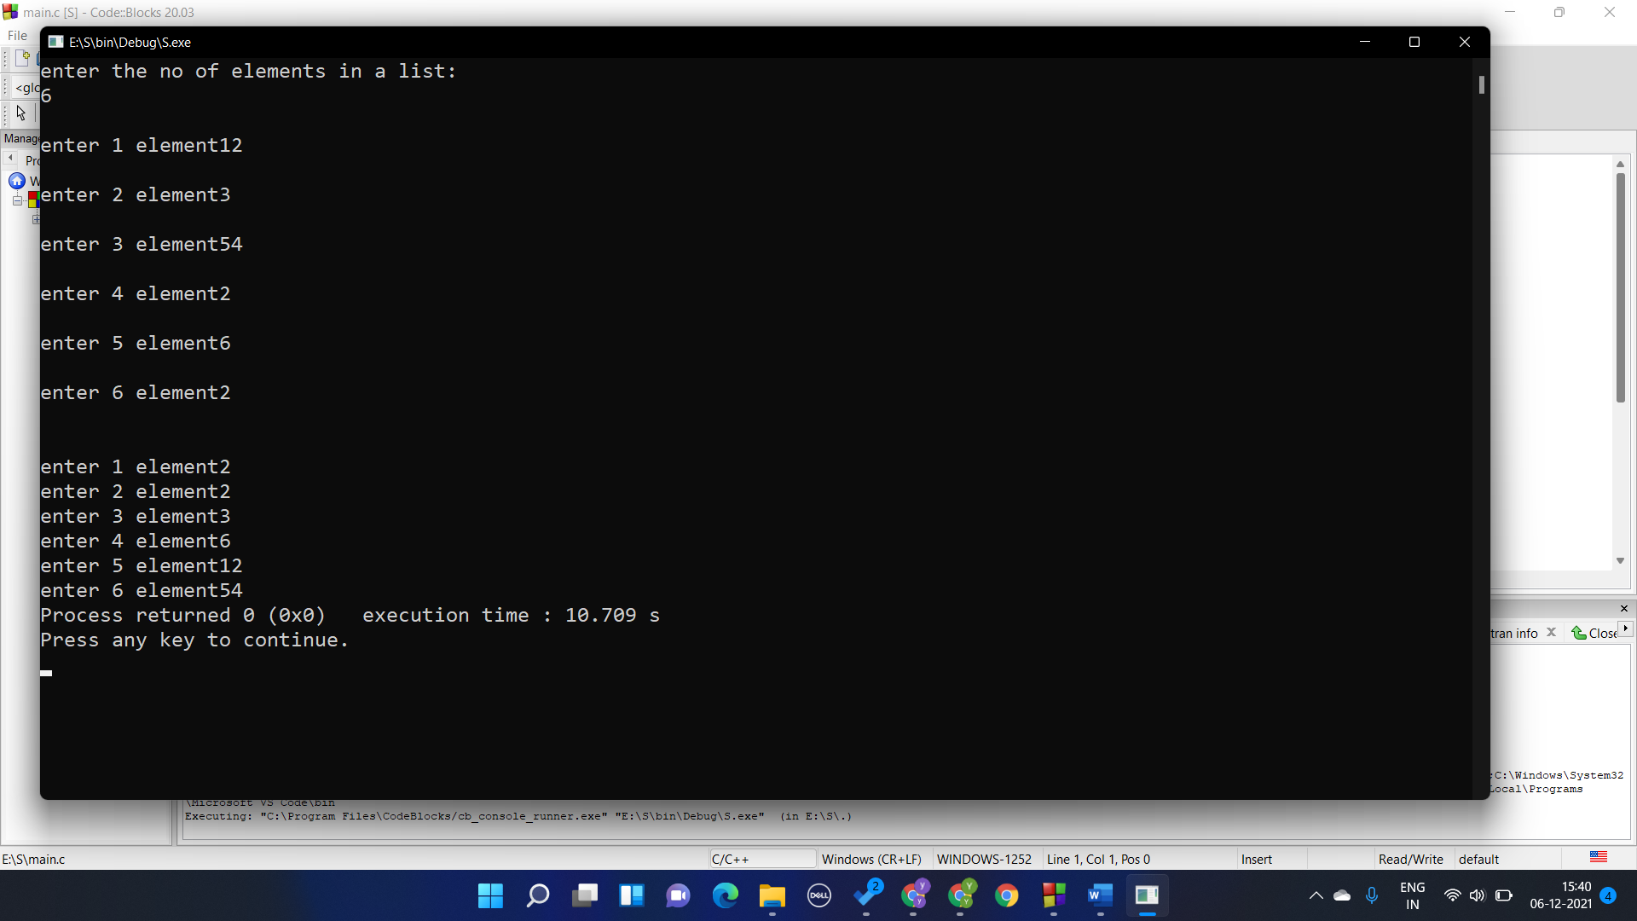

Question 3

#include<stdio.h>

#include<string.h>

int sum_digit(int n)

{

if (n < 10) return n;

else return sum_digit(n/10)+(n%10);

}

int main()

{

int n,a;

printf("enter the no of elements in a list:\n");

scanf("%d",&n);

a=sum_digit(n);

printf("%d",a);

}

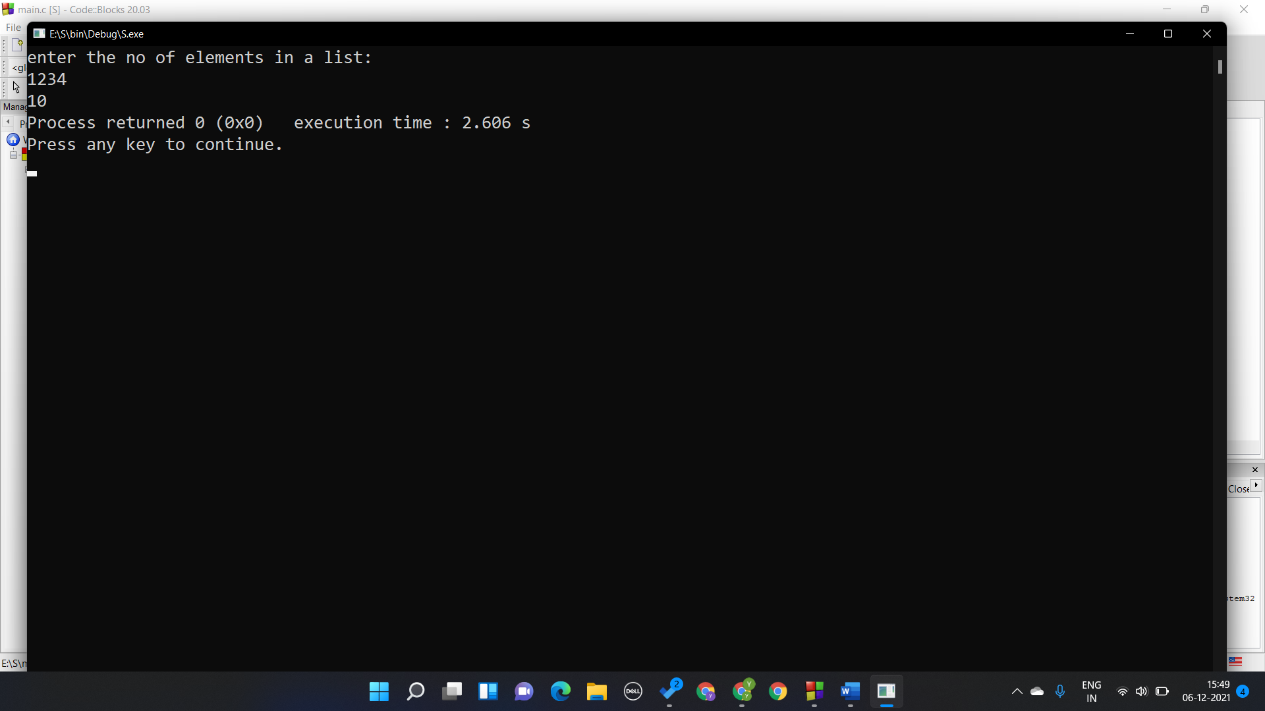

Question 4

#include<stdio.h>

#include<string.h>

int rev_digit(int n,int b)

{

if (n == 0) return 0;

else return (n%10 * pow(10,b-1)) + rev_digit(n/10,b-1);

}

int count_digit(int n)

{

if(n==0) return 0;

else return 1+count_digit(n/10);

}

int main()

{

int n,a,b;

printf("enter the no:\n");

scanf("%d",&n);

b=count_digit(n);

a=rev_digit(n,b);

printf("%d",a);

}

