Question 1

#include <stdio.h>

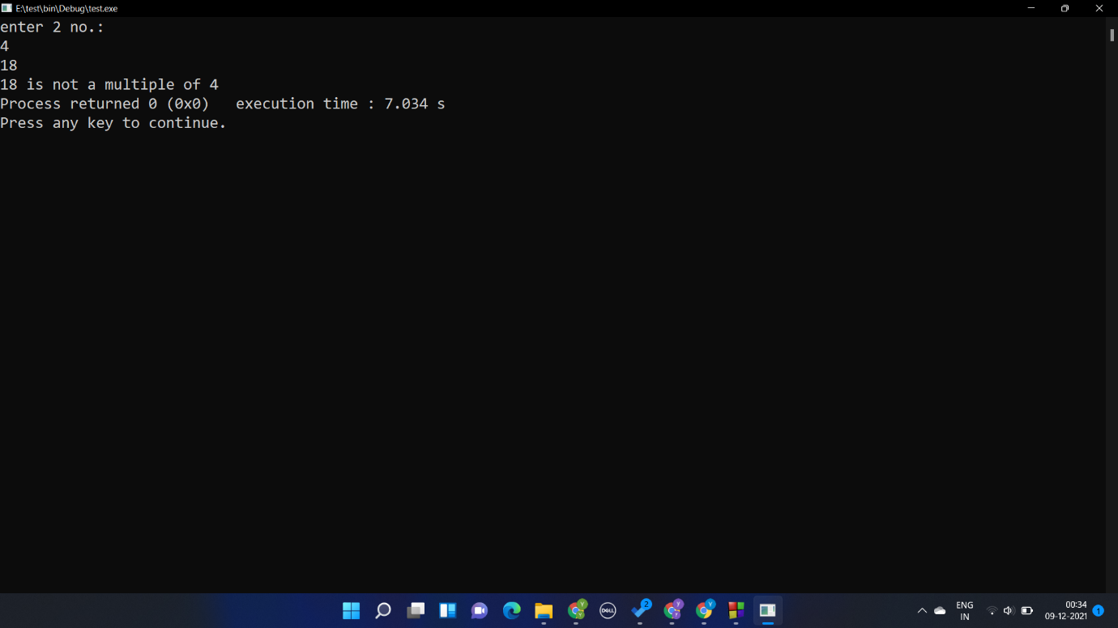void mult(int a,int b)

{

if(a%b==0)printf("%d is a multiple of %d",a,b);

else printf("%d is not a multiple of %d",a,b);

}

int main()

{

int a,b;

printf("enter 2 no.:\n");

scanf("%d %d",&a,&b);

if(b>a)

{

a=a+b;

b=a-b;

a=a-b;

}

mult(a,b);

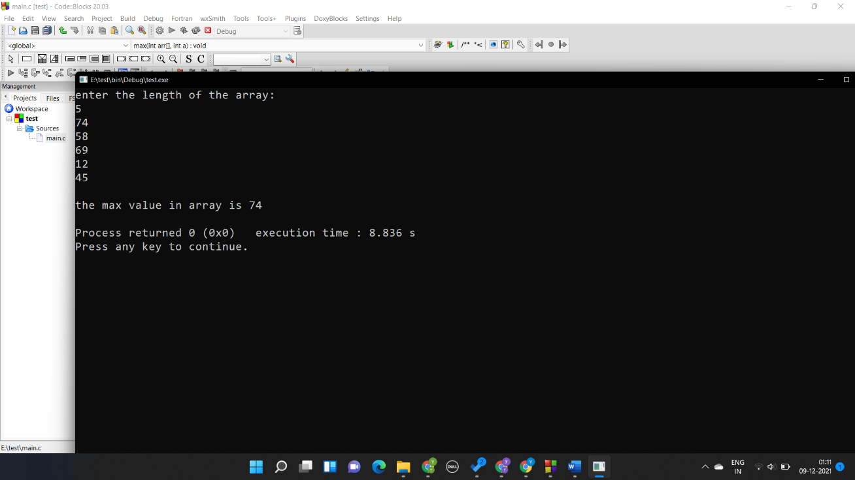}

Question 2

#include<stdio.h>

void max(int arr[],int a)

{

int maximum,i;

maximum= arr[0];

for(i=0;i<a;i++)

{

if(arr[i] > maximum) maximum=arr[i];

}

printf("\nthe max value in array is %d\n",maximum);

}

int main()

{

int a,i;//a=length of array

int arr[50];

printf("enter the length of the array:\n");

scanf("%d",&a);

for(i=0;i<a;i++)

{

scanf("%d",&arr[i]);

}

max(arr,a);

}

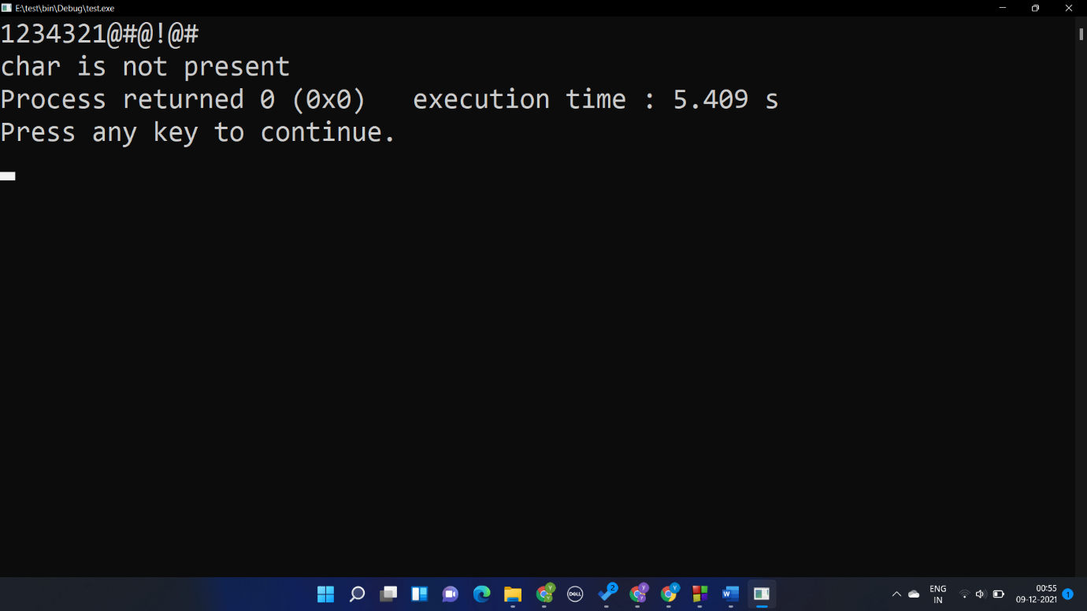Question 3

int ch(char a[])

{

int i;

for(i=0;a[i] !='\0';i++)

{

if(a[i]>='A' && a[i]<='Z' ||a[i]>='a' && a[i]<='z' ) return 0;

}

return 1;

}

int main()

{

char a[50];

int s;

gets(a);

s=ch(a);

if(s==0)printf("char is present");

else printf("char is not present");

}

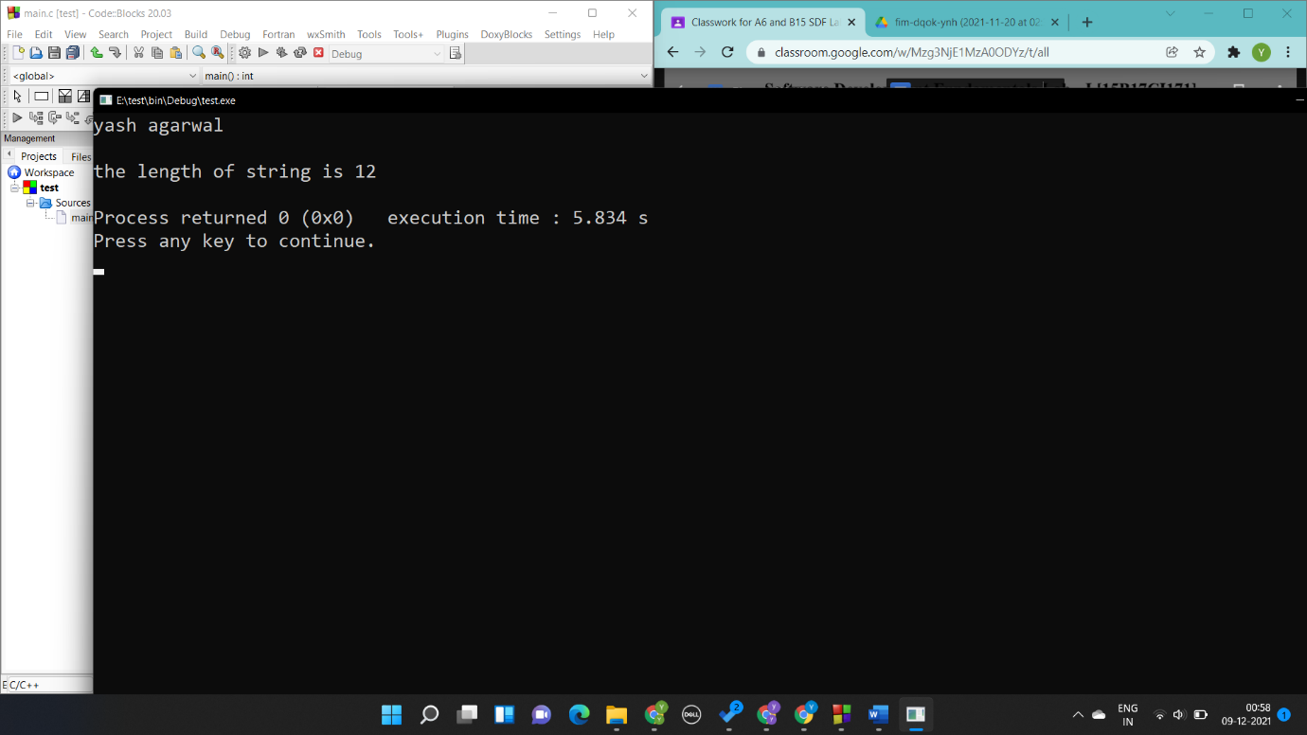Question 4

int len(char a[])

{

int i;

for(i=1;a[i] !='\0';i++);

return i;

}

int main()

{

char a[50];

int s;

gets(a);

s=len(a);

printf("\nthe length of string is %d\n",s);

}

Question 5

int fact(int s)

{

if(s<=1) return 1;

else return s\*fact(s-1);

}

int main()

{

int s,fac;

printf("enter the no.");

scanf("%d",&s);

fac=fact(s);

printf("\n Factorial of th no. is %d ",fac);

}

