Question 1

#include<stdio.h>

#include<stdlib.h>

#include<string.h>

union student {

char name[33];

long int roll_no;

int age;

};

int main()

{

printf("size of union %d",sizeof(union student ));

}

The size should be 33 but because of the concept of padding since 33 is not a multiple of 8 ,I gives the bigger bites

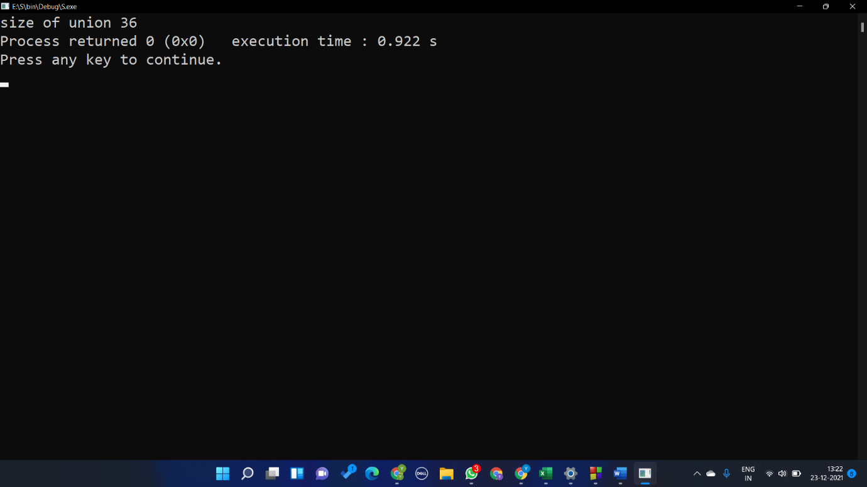

Question 2 and 3

#include<stdio.h>

#include<stdlib.h>

#include<string.h>

union student {

char name[33];

long int roll_no;

int age;

char courses[5][20];

};

int main()

{

int n,i,b,j;

printf("enter the no of students\n");

scanf("%d",&n);

union student s[n];

for(i=0;i<n;i++)

{

printf("enter student name \n");

scanf("%s",s[i].name);

printf("name %s\n",s[i].name);

printf("enter the roll no\n");

scanf("%d",&s[i].roll_no);

printf("roll no %d\n",s[i].roll_no);

printf("enter age\n ");

scanf("%d",&s[i].age);

printf("age %d\n",s[i].age);

printf("enter the no of subject you want to enroll\n ");

scanf("%d",&b);

for(j=0;j<b;j++)

{

printf("enter subject name \n");

scanf("%s",s[i].courses[j]);

}

for(j=0;j<b;j++)

{

printf("subject name %s \n",s[i].courses[j]);

}

printf("size of union %d", sizeof(s[i]));

}

}

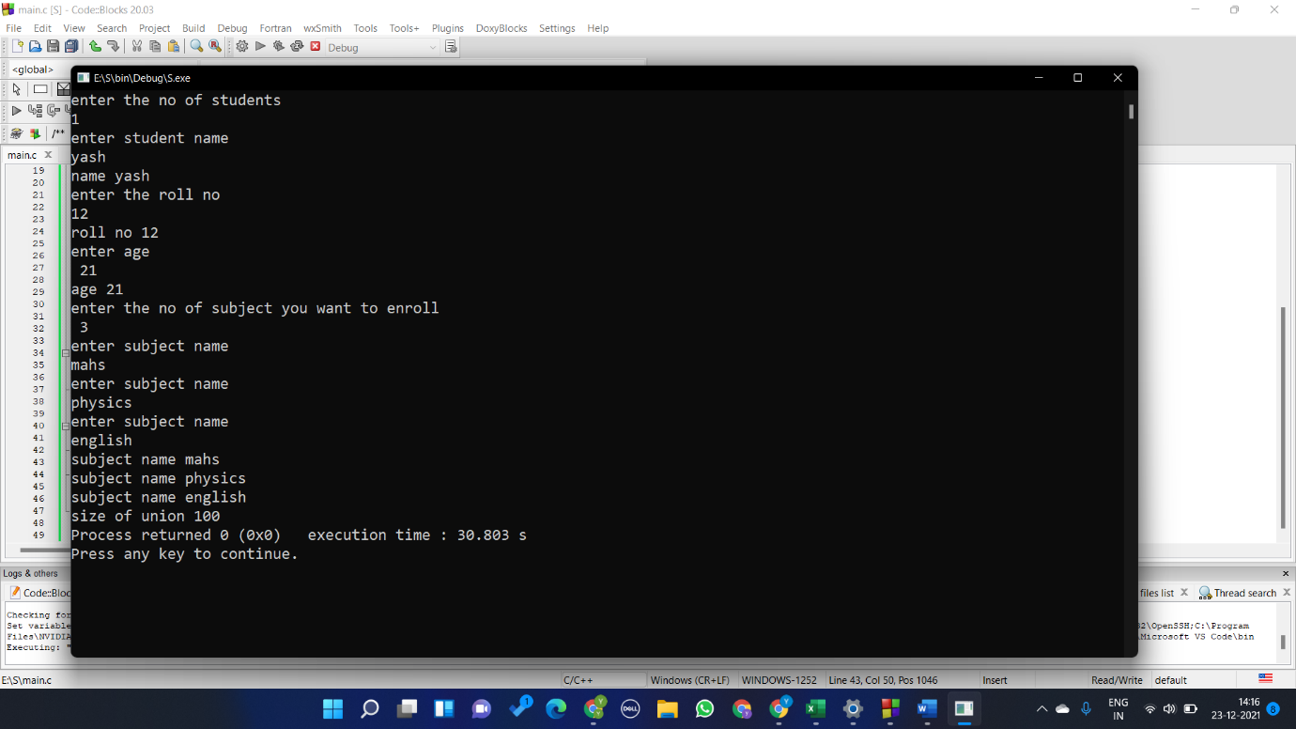

Question 4

#include<stdio.h>

#include<stdlib.h>

#include<string.h>

union student {

char name[80];

int age;

float percentage;

};

union student* emp = NULL;

int main()

{

emp = (union student*)

malloc(sizeof(union student));

emp->age = 18;

printf("%d",emp->age);

}

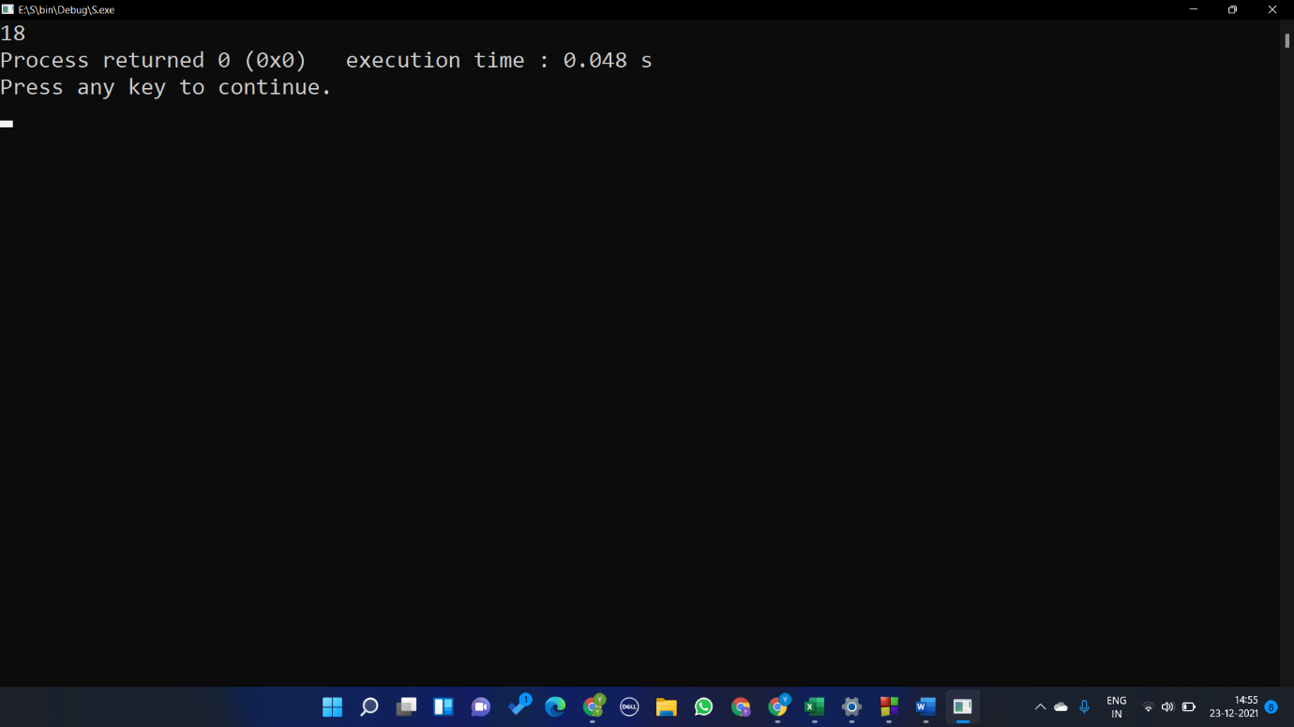

Question 5

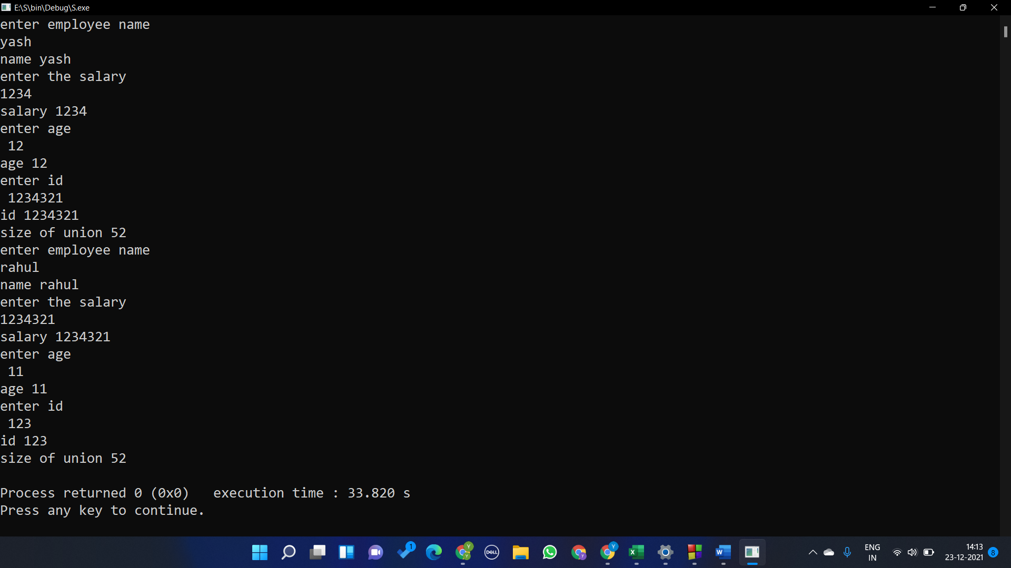

#include<stdio.h>

#include<stdlib.h>

#include<string.h>

union employee {

char name[50];

int salary;

int id;

int age;

};

int main()

{

int n,i,b,j;

printf("enter the no of students\n");

scanf("%d",&n);

union employee e[n];

for(i=0;i<n;i++)

{

printf("enter employee name \n");

scanf("%s",e[i].name);

printf("name %s\n",e[i].name);

printf("enter the salary\n");

scanf("%d",&e[i].salary);

printf("salary %d\n",e[i].salary);

printf("enter age\n ");

scanf("%d",&e[i].age);

printf("age %d\n",e[i].age);

printf("enter id\n ");

scanf("%d",&e[i].id);

printf("id %d\n",e[i].id);

printf("size of union %d\n", sizeof(e[i]));

}

}

Question6

#include<stdio.h>

#include<stdlib.h>

#include<string.h>

union test {

char name[10];

int age;

float salary;

}t1,t2;

int main()

{

printf("enter student name \n");

scanf("%s",t1.name);

printf("name %s\n",t1.name);

printf("enter age\n ");

scanf("%d",&t1.age);

printf("age %d\n",t1.age);

printf("enter the salary\n");

scanf("%f",&t1.salary);

printf("salary %f\n",t1.salary);

printf("enter student name \n");

scanf("%s",t2.name);

printf("enter age\n ");

scanf("%d",&t2.age);

printf("enter the salary \n");

scanf("%f",&t2.salary);

printf("name %s\n",t2.name);

printf("age %d\n",t2.age);

printf("salary %f\n",t2.salary);

}

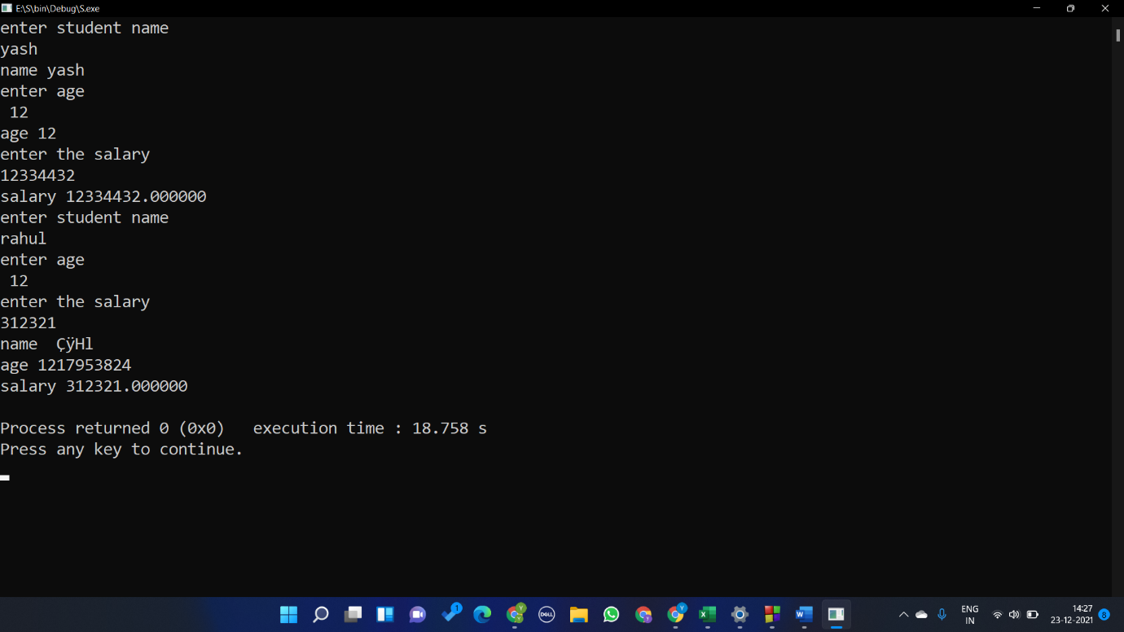

Question 7

#include<stdio.h>

#include<stdlib.h>

#include<string.h>

union test {

char name[10];

int age;

float salary;

}t1;

struct test1{

char name[10];

int age;

float salary;

}t2;

int main()

{

printf("enter student name \n");

scanf("%s",t1.name);

printf("enter age\n ");

scanf("%d",&t1.age);

printf("enter the salary\n");

scanf("%f",&t1.salary);

printf("age %d\n",t1.age);

printf("name %s\n",t1.name);

printf("salary %f\n",t1.salary);

printf("%d size of union \n\n",sizeof(union test));

printf("enter student name \n");

scanf("%s",t2.name);

printf("enter age\n ");

scanf("%d",&t2.age);

printf("enter the salary \n");

scanf("%f",&t2.salary);

printf("name %s\n",t2.name);

printf("age %d\n",t2.age);

printf("salary %f\n",t2.salary);

printf("%d size of structure",sizeof(struct test1));

}

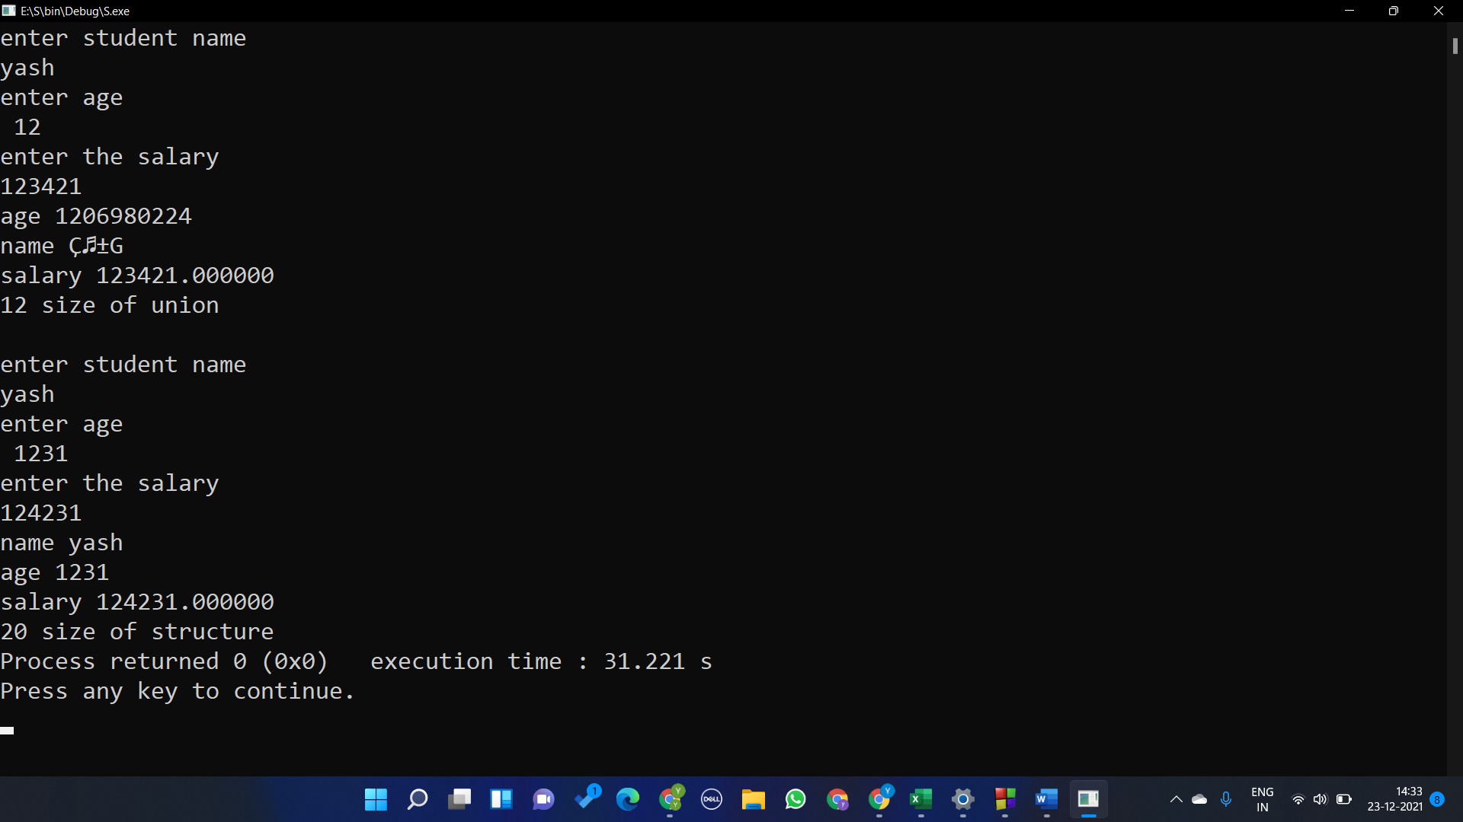

Question 8

Symtab[i].u.sval