Question 1

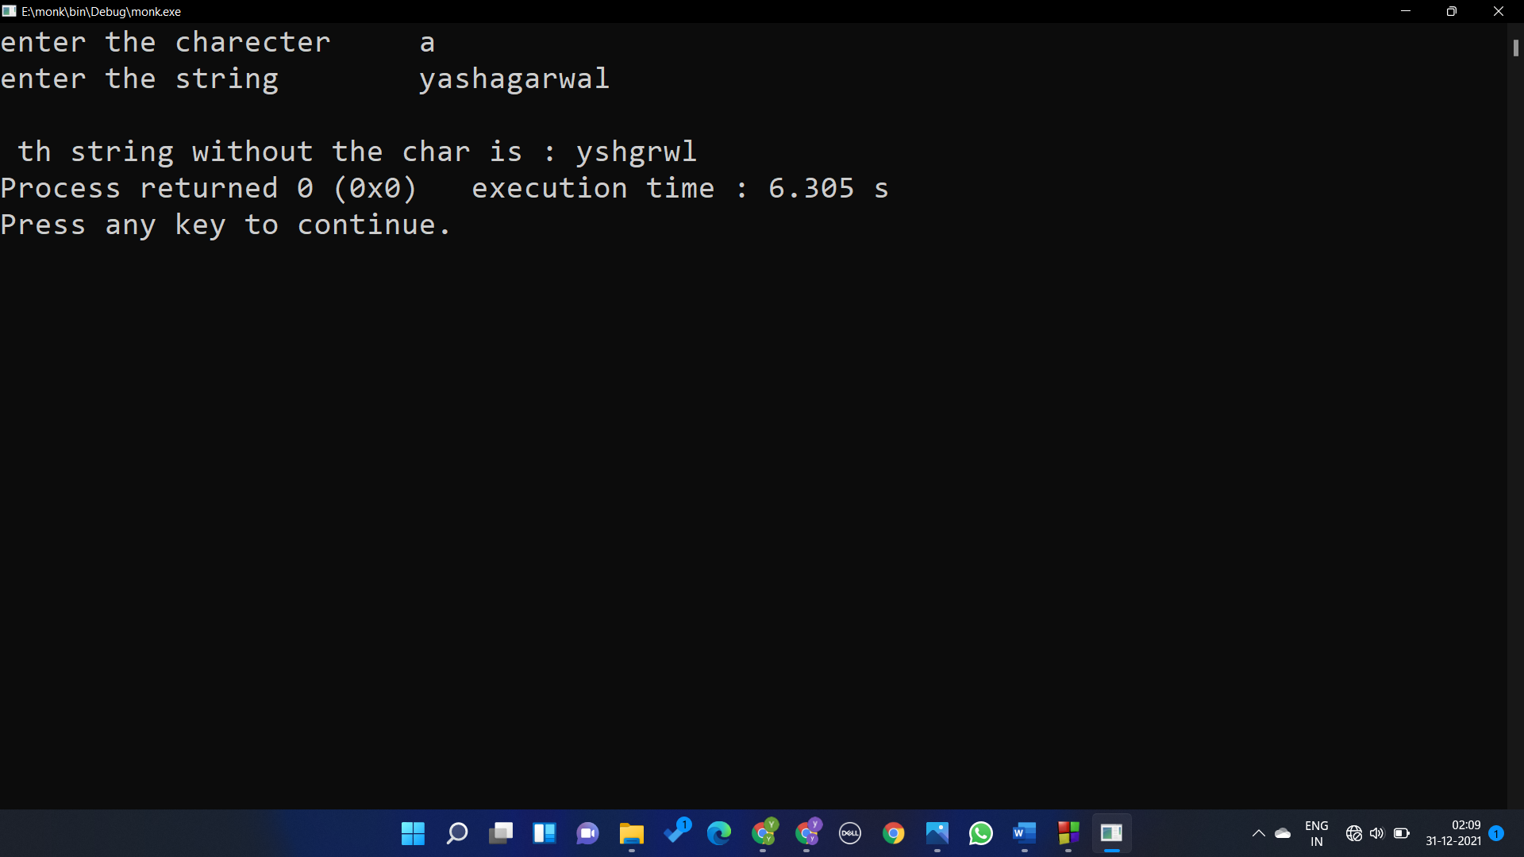

#include <stdio.h>

#include <stdlib.h>

#include <string.h>

int main()

{

char a[50],h,\*ptr;

int i,j,count=0;

printf("enter the charecter\t");

scanf("%c",&h);

printf("enter the string\t");

scanf("%s",a);

ptr=&a;

for(i=0;i<strlen(a);i++)

{

if(\*(ptr+i)==h)

{

for(j=i;j<strlen(a)-count;j++)

{

\*(ptr+j)=\*(ptr+j+1);

}

count++;

}

}

\*(ptr+strlen(a)-count+1)='\0';

printf("\n th string without the char is : ");

for(i=0;a[i]!='\0';i++)

{

printf("%c",\*(ptr+i));

}

}

Question2

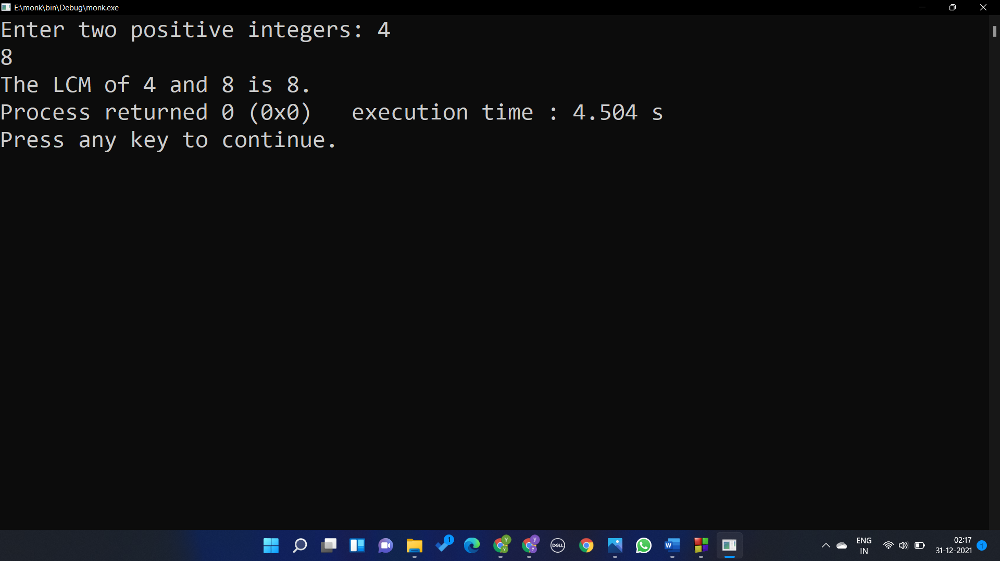

#include <stdio.h>

#include <stdlib.h>

#include <string.h>

#include <stdio.h>

int main() {

int n1, n2, max;

printf("Enter two positive integers: ");

scanf("%d %d", &n1, &n2);

max = (n1 > n2) ? n1 : n2;

while (1) {

if (max % n1 == 0 && max % n2 == 0) {

printf("The LCM of %d and %d is %d.", n1, n2, max);

break;

}

++max;

}

return 0;

}

Question 3

1. 30
2. 31,504,504
3. Mello
4. 8,8,8
5. K
6. 8,1
7. JACK
8. 8,10
9. 1006,2,2
10. 2,0
11. 300
12. Ce
13. hello
14. Hello
15. Bndia BIdia BIXia
16. Alice lice ice ce e