***PROJECT REPORT***

***ON***

***Library Management System***

*Submitted as the partial fulfillment of Bachelor of Science in Information Technology (B.Sc IT) course under Gauhati University.*



**Gauhati University, Gauhati**

#### Submitted By:

Jushmita Sarma Priya Sarma

Roll No: UA-191-194-0918 Roll No: UA-191-194-0923

Registration No: 19110394 Registration No: 19110396

B.sc IT 5th Semester B.sc IT 5th Semester

Nalbari College,Nalbari Nalbari College,Nalbari

Session: 2019-2022 Session: 2019-2022

NALBARI COLLEGE, NALBARI

**TO WHOM IT MAY CONCERN**

This is to certify that ***Jushmita Sarma*** and ***Priya Sarma*** of B.Sc-IT 5th Semester of Nalbari College, Nalbari have successfully completed the project “**LIBRARY MANAGEMENT SYSTEM**” as per partial fulfillment of requirements for the award of the degree of **B.Sc in Information Technology** for the session 2019-22. During this program they were given all necessary feedback regarding the existing system.

They were found sincere throughout this academic session. Success is wished for their future life.

Dated: 02 /04/2022 Mr. Dhruba Jyoti Mishra

Place: Nalbari HoD, Asst. Professor

Dept. Of Computer Science

Nalbari College, Nalbari

**CERTIFICATE**

This is to certify that the project entitled “**Library Management System**” is a bona-fide work done by ***Jushmita Sarma and Priya Sarma*** of B.Sc-IT 5th Semester, 2019-22, Roll No. UA-191-194-0918, and Roll No.UA-191-194-0923, G.U. Registration No.19110394 of Jushmita Sarma, Registration No. 19110396 of Priya Sarma, respectively in partial fulfillment of B.Sc-IT 5th Semester examination and has been carried out under my direct supervision and guidance.

It is certified that the work reported in this project has been presented as a part of academic work. This report or a similar report on the topic has not been submitted for any other examination and does not form part of any other course undergone by the candidate.

The project has been developed in HTML and PHP. During the course of the project I found them very sincere and hardworking. I wish them success in life.

Date: 02/04/2022 Signature of guide

Place: Nalbari Mr. Pranjal Dutta

Asst. Professor

Department of Computer Science

Nalbari College, Nalbari

**ACKNOWLEDGEMENT**

With immense pleasure I acknowledge my indebtedness to all persons whose support and guidance have helped me in caring out this project.

At the very outset, I acknowledge most sincerely and respectfully my hearty thanks and gratitude to Mr. Pranjal Dutta, Computer Science Dept., Nalbari College, Nalbari for allowing me to work under his edifying guidance and support. I consider myself to be fortunate and lucky enough to be able work under Mr. Pranjal Dutta who has guided me throughout the period of this project work.

I would like to take the opportunity to express my deep sense gratitude to all of the Lecturers in the Department of Computer Science, Nalbari College, Nalbari for their valuable suggestions, references and encouragement and allowing us to use the department computers whenever necessary.

To those mentioned above and to those who inspired and encouraged me, I am expressing my gratitude once again.

**With due regards**

**Name: Jushmita Sarma**

**B.Sc-IT 5th Semester**

**Roll No:**  **UA-191-194-0918**

**Reg. No: 19110394**

**Nalbari College, Nalbari**

**Name: Priya Sarma**

**B.Sc-IT 5th Semester**

**Roll No: UA-191-194-0923**

**Reg. No: 19110396**

**Nalbari College, Nalbari**

**Contents**

**CHAPTER 1. INTRODUCTION**

* 1. INTRODUCTION
  2. OBJECTIVE OF THE PROJECT
  3. ABOUT HTML AND PHP
  4. ABOUT HTML5
  5. ABOUT MYSQL
  6. STRUCTURED QUERY LANGUAGE (SQL)
  7. ABOUT CSS3, JAVASCRIPT
  8. ABOUT OPERATING SYSTEM

**CHAPTER 2. PROJECT OUTLINE**

2.1 TITLE OF THE PROJECT

2.2 INTRODUCTION AND OBJECTIVE OF THE PROJECT

2.3 HARDWARE AND SOFTWARE USED

**CHAPTER 3. OVERVIEW OF THE SYSTEM**

3.1 INTRODUCTION

3.2 THE EXISTING SYUSTEM

3.3 DISADVANTAGE OF EXISTING SYSTEM

3.4 CHARACTERISTICS OF THE PROPOSED SYSTEM

3.5 LIMITATION OF THE PROPOSED SYSTEM

3.6 SCOPE OF THE PROPOSED SYSTEM

**CHAPTER 4. FEASIBILITY STUDY**

4.1 INTRODUCTION

4.2 FEASIBILITY ANALYSIS:

4.2.1 ECONOMIC FEASIBILITY

4.2.2 SCHEDULE FEASIBILITY

4.2.3 BEHAVIOURAL FEASIBILITY

4.2.4 TECHNICAL FEASIBILITY

4.2.5 MANAGEMENT FEASIBILITY

4.2.6 TIME FEASIBILITY

4.3 CONCLUSION

**CHAPTER 5. STRUCTURED ANALYSIS**

5.1 INTRODUCTION.

5.2 CONTEXT DIAGRAM

5.3 DATA FLOW DIAGRAM

5.4 ENTITY RELATIONSHIP MODEL.

5.5 DATA DICTIONARY

**CHAPTER 6. SYSTEM PLANNING**

6.1 TEAM STRUCTURE

6.2 COST ESTIMATION

6.3 SOFTWARE SIZE ESTIMATION

6.4 PRINCIPLES OF PROJECT SCHEDULING

6.5 SOFTWARE CONFIGURATION MANAGEMENT

6.6 PLANNING TOOLS

**CHAPTER 7. SYSTEM DESIGN**

7.1 INTRODUCTION

7.1.1 LOGICAL DESIGN

7.1.2 PHYSICAL DESIGN

7.2 INPUT DESIGN

7.3 OUTPUT DESIGN

7.4 DATABASE DESIGN

**CHAPTER 8. SCREENSHOTS**

**CHAPTER 9. SYSTEM TESTING**

9.1 INTRODUCTION

9.2 TESTING

9.2.1 MODULE TESTING

9.2.2 SYSTEM TESTING

9.2.2.1 PROGRAM TESTING

9.2.2.2 STRING TESTING

9.2.2.3 SYSTEM TESTING

9.2.2.4 USER ACCEPTANCE TESTING

9.2.3 FUNCTIONAL TESTING

9.2.4 STRUCTURAL TESTING

9.2.5 COMBINED STRUCTURAL TESTING AND FUNCTIONAL

9.3 DEBUGGING

**CHAPTER 10. SYSTEM IMPLEMENTATION**

10.1 INTRODUCTION

10.2 USER TRAINING

10.3 POST IMPLEMENTATION

**CHAPTER 11. CONCLUSION**

11.1 CONCLUDING REMARKS

11.2 SALIENT FEATURES OF THE PROPOSED SYSTEM

11.3 LIMITATIONS OF THE PROJECT

11.4 SCOPE FOR FUTURE WORKS

**CHAPTER 12. BIBLIOGRAPHY**

***CHAPTER 1***

***INTRODUCTION***

**1.1 Introduction:**

Library management system is a project which aims in developing a computerized system to maintain all the daily work of library .This project has many features which are generally not available in normal library management systems like facility of user login and a facility of teachers login .It also has a facility of admin login through which the admin can monitor the whole system .It also has facility of an online notice board where teachers can student can put up information about workshops or seminars being held in our colleges or nearby colleges and librarian after proper verification from the concerned institution organizing the seminar can add it to the notice board . It has also a facility where student after logging in their accounts can see list of books issued and its issue date and return date and also the students can request the librarian to add new books by filling the book request form. The librarian after logging into his account i.e. admin account can generate various reports such as student report , issue report, teacher report and book report Overall this project of ours is being developed to help the students as well as staff of library to maintain the library in the best way possible and also reduce the human efforts.

**1.2 Objectives Of The Proposed System**

The project aims and objectives that will be achieved after completion of this project are discussed in this subchapter. The aims and objectives are as follows:

* Online book issue
* Request column for librarian for providing new books
* A separate column for digital library
* Student login page where student can find books issued by him/her and date of return.
* A search column to search availability of books
* A teacher login page where teacher can add any events being organized in the college and important suggestions regarding books.
* Online notice board about the workshop.

**1.3 Technologies Used**

**Tools:**

Front End: HTML5, CSS3, Java script

Back End: PHP, MySQL

**Platform:**

Operating System: Windows 10

**Software:**

Adobe Dreamweaver CS6

WAMP Server

Server Configuration:

Apache Version: 2.2.21

PHP version: 5.3.8

MySQL Version: 5.5.16

**Hardware:**

Processor: Intel(R) Core(TM) i5-2450M CPU @2.50GHz 2.50GHz

RAM: 4 GB

Hard Disk Drive: 500GB

***CHAPTER 2***

***Overall Description***

**2.1 Goals of proposed System**

1. Planned approach towards working:- The working in the organization will be well planned and organized. The data will be stored properly in data stores, which will help in retrieval of information as well as its storage.

2. Accuracy:- The level of accuracy in the proposed system will be higher. All operation would be done correctly and it ensures that whatever information is coming from the center is accurate.

3. Reliability: - The reliability of the proposed system will be high due to the above stated reasons. The reason for the increased reliability of the system is that now there would be proper storage of information.

4. No Redundancy:- In the proposed system utmost care would be that no information is repeated anywhere, in storage or otherwise. This would assure economic use of storage space and consistency in the data stored.

**2.2 Background**

To debug the existing system, remove procedures those cause data redundancy, make navigational sequence proper. To provide information about audits on different level and also to reflect the current work status depending on organization/auditor or date. To build strong password mechanism.

**2.3 Project requirement:**

**Hardware:**

Processor: Pentium or higher

RAM: 64 MB or higher

Disk Space: 130 MB or higher

**Software:**

Operating System: Win 98, Windows XP or higher

Browser: Google Chrome version 33 or higher, Firefox 28 or higher or latest version of any browser

**2.4 User Characteristics:**

Every user should be

* Comfortable of working on online system.
* He must also have basic knowledge of English language.

***CHAPTER 3***

***About Languages***

**3.1 HTML:**

HTML (Hyper Text Markup Language) documents are written in plain text (ASCII) with special markup codes embedded right in the text. This means HTML files contain nothing but printable characters and HTML markup codes. Markup codes are typed into a document and control the formatting and layout of your finished document. The markup codes that are typed into a document are enclosed within these angle brackets: "<>". The angle brackets and the markup codes together constitute a tag. When you are talking about an HTML document you refer to it as a "source" document.

**3.2 HTML5:**

HTML5 is a core technology markup language of the Internet used for structuring and presenting content for the World Wide Web. It is the fifth revision of the HTML standard and, as of December 2012, is a Candidate recommendation of the World Wide Web Consortium (W3C). Its core aims have been to improve the language with support for the latest multimedia while keeping it easily readable by humans and consistently understood by computers and devices (Web browsers, parsers etc.).

**3.3 PHP:**

PHP stands for Hypertext Preprocessor and is a server-side language. This means that the script is run on your web server, not on the user's browser, so you do not need to worry about compatibility issues. PHP is relatively new (compared to languages such as Perl (CGI) and Java) but is quickly becoming one of the most popular scripting languages on the internet.

**3.4 MySQL:**

MYSQL is an object relational database management system MYSQL is an open-source descendant of this original Berkeley code. It supports a large part of the SQL standard and offers many modern features:

* complex queries
* foreign keys
* triggers
* views
* transactional integrity
* multi-version concurrency control

**3.5 Structured Query Language (SQL):**

Structured Query Language (SQL) is a non-procedural language used for database management. Unlike procedural language, in which we must describe how to access and manipulate data, in SQL we specify what to do. It is the official and de-factors standard language for interfacing with a relational database. SQL exist as an American National Standard Institute (ANSI) and International Standard Organization (ISO) standards as well as an industry standard.

**3.6 CSS3:**

Cascading Style Sheets (CSS) is a [style sheet language](http://en.wikipedia.org/wiki/Style_sheet_language) used for describing the [look and formatting](http://en.wikipedia.org/wiki/Presentation_semantics) of a document written in a markup. While most often used to style [web pages](http://en.wikipedia.org/wiki/Web_page) and user interfaces written in [HTML](http://en.wikipedia.org/wiki/HTML) and [XHTML](http://en.wikipedia.org/wiki/XHTML), the language can be applied to any kind of [XML](http://en.wikipedia.org/wiki/XML) document, including [plain XML](http://en.wikipedia.org/wiki/Plain_Old_XML), [SVG](http://en.wikipedia.org/wiki/Scalable_Vector_Graphics) and [XUL](http://en.wikipedia.org/wiki/XUL). CSS is a cornerstone specification of [the web](http://en.wikipedia.org/wiki/The_web) and almost all web pages use CSS style sheets to describe their presentation.

**3.7 Java Script:**

JavaScript (JS) is a [dynamic](http://en.wikipedia.org/wiki/Dynamic_programming_language) computer [programming language](http://en.wikipedia.org/wiki/Programming_language). It is most commonly used as part of [web browsers](http://en.wikipedia.org/wiki/Web_browser), whose implementations allow [client-side scripts](http://en.wikipedia.org/wiki/Client-side_scripting) to [interact with the user](http://en.wikipedia.org/wiki/User_interface), control the browser, communicate [asynchronously](http://en.wikipedia.org/wiki/Ajax_(programming)), and alter the document that is displayed. It is also being used in server-side network programming (with [Node.js](http://en.wikipedia.org/wiki/Node.js)), game development and the creation of desktop and mobile application.

***CHAPTER 4***

***Feasibility Study***

**4.1 INTRODUCTION**

**4.2 FEASIBILITY ANALYSI**

**4.2.1 ECONOMIC FEASIBILITY**

**4.2.2 SCHEDULE FEASIBILITY**

**4.2.3 BEHAVIOURAL FEASIBILITY**

**4.2.4 TECHNICAL FEASIBILITY**

**4.2.5 MANAGEMENT FEASIBILITY**

**4.2.6 TIME FEASIBILITY**

**4.3 CONCLUSION**

**4.1 INTRODUCTION:**

This section depicts on of the most important stages of the initial investigation carried out as a part of life cycle of the project development-feasibility of the project faces certain shortcomings.

**4.2 FEASIBILITY OF THE PROPOSED SYTEM:**

Feasibility of the proposed system is evaluated to determine whether the new system can be implemented or not.

**4.2.1 Economic feasibility**

**4.2.2 Schedule feasibility**

**4.2.3 Behavioral feasibility**

**4.2.4 Technical feasibility**

**4.2.5 Management feasibility**

**4.2.6 Time feasibility**

**4.2.1 ECONOMIC FEASIBILITY:**

The economic feasibility aims at determining the benefits of the candidate system, which is accepted if the benefits outweigh the cost involved in the development of the new system.

**4.2.2 SCHEDULE FEASIBILITY:**

This involves whether the project is feasible enough to be completed within the stipulated time. Schedule feasibility depends on

* + 1. **BEHAVIORAL FEASIBILITY:**

The behavioral feasibility should also be judged in order to estimate the mentality of the people to whom the system is being developed and with whom the system is being carried out as well as ultimate beneficiaries.

* + 1. **TECHNICAL FEASIBILITY:**

Technical feasibility is an evaluation to determine whether a system can be technically built. It represents whether the project can be done or not with the currently available equipments, existing software technology etc.

* + 1. **MANAGEMENT FEASIBILITY:**

Once the existence of a problem is acknowledged and the need for a solution is agreed upon, it is necessary to establish that a solution to the problem is feasible. For this, a study is conducted.

**4.2.6 TIME FEASIBILITY:**

It is determination of whether of whether a proposed project can be implemented fully within a stipulated frame of time.

**4.3 CONCLUSION:**

From the observation made in the feasibility study described above it was recommended that the proposed Student Information Management System is feasible for its development and implementation.

***CHAPTER 5***

***STRUCTURED ANALYSIS***

**5.1 INTRODUCTION**

**5.2 CONTEXT DIAGRAM**

**5.3 DATA FLOW DIAGRAM**

**5.4 ENTITY RELATIONSHIP MODEL**

**5.1 INTRODUCTION**

The goal of system development is to deliver systems in line with user requirements. Analysis is the heart of the process. The first phase focuses on problem definition where analysis helps us to understand the present system. In phase two the study goes in a detailed manner, studying the present system and determining potential solutions.

The various tools used in structured analysis are-

* Context diagram.
* Data flow diagram.
* E-R Diagram (Entity Relationship model).
* Data dictionary.

**5.2 CONTEXT DIAGRAM**

In the initial stage of System Analysis, Context Diagram is constructed to show the higher-level model of a system. It is used to represent pictorially the boundaries of a system. Expanding the Context Diagram we get the detailed DFD of the system. Context Diagram is generally used to show the sources of data and the destination where the processed data goes. From source data is sent for processing and then the processed data is sent to the destination.

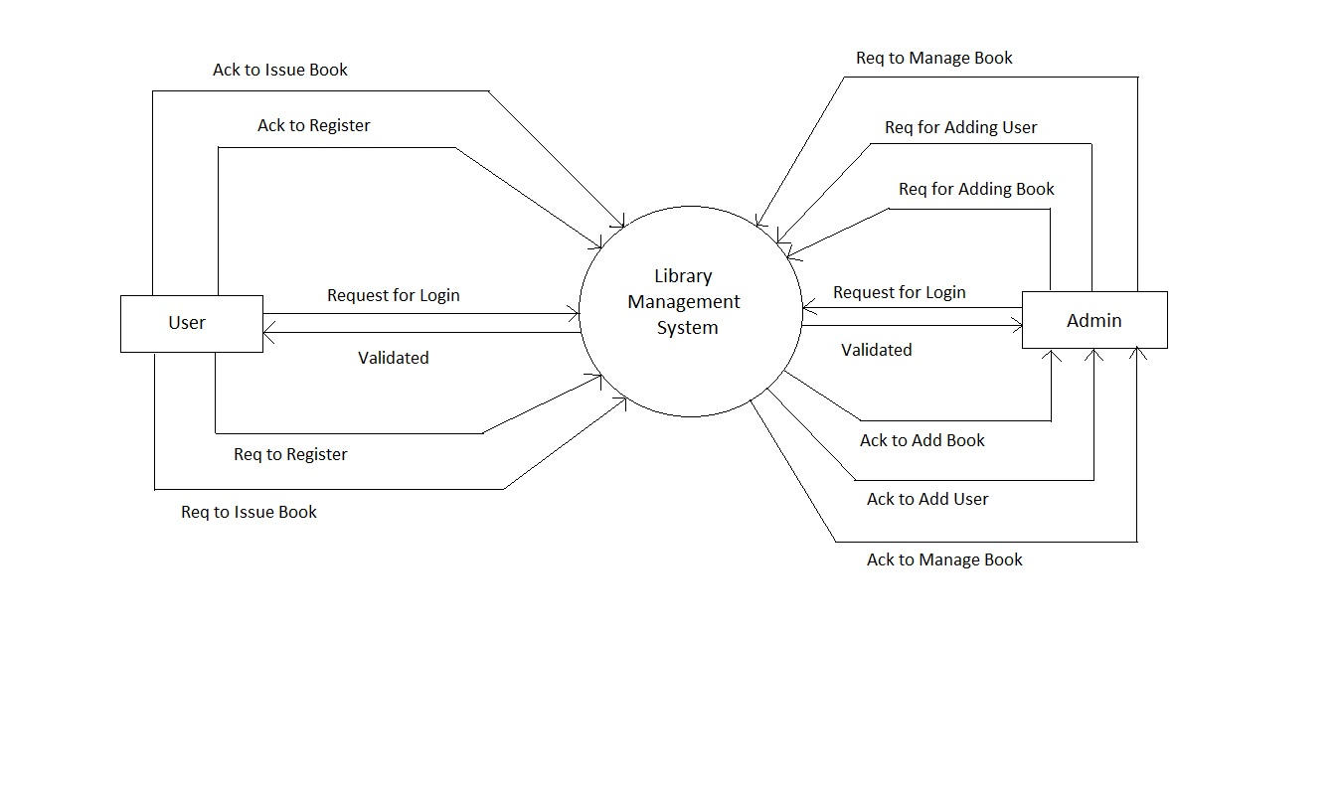

Fig: Contex Diagram

**5.3 DATA FLOW DIAGRAM**

DFD is a pictorial representation which depicts the different processes at work within a system. It is used to show the information flow from process to process, process to store, or store to process. The DFD of the individual processes may be broken down into forms which may be shown level wise.

The context diagram is the starting point of the DFD. A DFD is a series of bubbles joined by lines-which represents the data transformations and the lines represent the data flows in the system. So it is also known as “BUBBLE CHART”. There are various symbols used to draw a DFD, like-

**SQUARE**:- A square defines a source (originator) or destination of system data.

**ARROW: -** An arrow indicates data flow- data in motion. It is a pipeline for flow of information.

**CIRCLE: -** A circle or bubble represents a process that transforms incoming data in to outgoing data.

**OPEN RECTANGLE**: - An open rectangle is a data store- data at rest, or temporary repository of data.

**1st level DFD: Admin**

Login

0.1

Login request

Status

Status

admin

Login

Add book

0.2

details

Status

Status

book

book

Add user

0.3

details

Status

Status

user

user

Manage book

0.4

details

Status

Status

book

Manage

Manage user

0.5

User details

Status

Status

user

Manage

**1st level DFD: User**

login

0.1

details

Status

Status

user

loginage

Req issue book

0.1

Book details

Status

Status

issue

issue

**5.4 E-R DIAGRAM (ENTITY RELATIONSHIP DIAGRAM)**

Entity Relationship Diagram represents the relationship between various entities and their attributes. Relationship between entities makes up a data structure. There are three type of relationship we can find in an ERD-

* **One to one.**
* **One to many**
* **Many to many.**

Symbols used in ER diagram are as follows:

1. **Entity:** An entity is collected of sets of attributes in a data model. We can represent it by a rectangle box.
2. **Attributes**: Attributes are the fields of database we can represent it by an oval.
3. **Relationship**: Relationship represents various relations between the entities.

Relationships Identifying relationship

1. **Lines:** Line is nothing but it connects the relationships, attributes and entities.

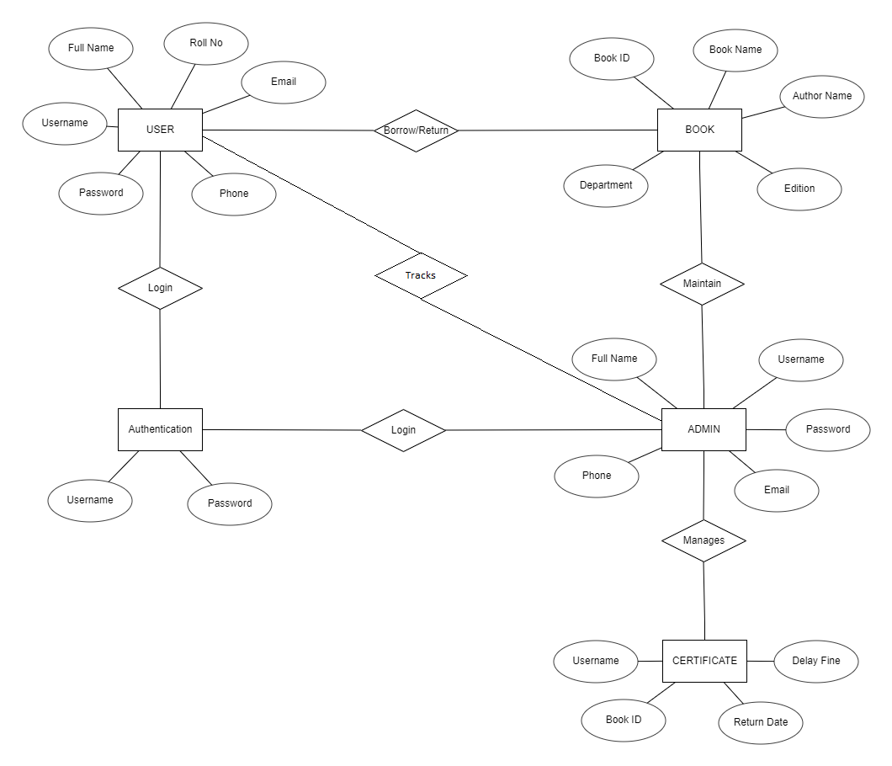

Fig: ER Diagram

**5.5 DATA DICTIONARY:**

Data Dictionary is a structured repository of data, which provides detailed information about the data flowing among functions and to or from data stores.

***Admin:***

|  |  |  |  |
| --- | --- | --- | --- |
| **Fields** | **Data Type** | **Size** | **Constraints** |
| id | Int | 100 | Primary Key |
| f_name | Varchar | 100 |  |
| u_name | Varchar | 30 |  |
| email | Varchar | 30 |  |
| phone | Varchar | 10 |  |
| pass | Varchar | 10 |  |

***Books:***

|  |  |  |  |
| --- | --- | --- | --- |
| **Fields** | **Data Type** | **Size** | **Constraints** |
| book_id | Varchar | 100 | Primary Key |
| book | Varchar | 100 |  |
| authors | Varchar | 100 |  |
| edition | Varchar | 100 |  |
| status | Varchar | 100 |  |
| quantity | Varchar | 100 |  |
| dept | Varchar | 100 |  |

**Issued Book details:**

|  |  |  |  |
| --- | --- | --- | --- |
| **Fields** | **Data Type** | **Size** | **Constraints** |
| Id | Int | 100 | Primary Key |
| u_name | Varchar | 30 | Foreign Key |
| book_id | Varchar | 100 | Foreign Key |
| book | Varchar | 100 |  |
| approve | Varchar | 100 |  |
| issue | Varchar | 30 |  |
| return | Varchar | 30 |  |

**Registration:**

|  |  |  |  |
| --- | --- | --- | --- |
| **Fields** | **Data Type** | **Size** | **Constraints** |
| f_name | Varchar | 100 |  |
| u_name | Varchar | 30 |  |
| roll | Varchar | 5 | Primary Key |
| dept | Varchar | 100 |  |
| email | Varchar | 30 |  |
| phone | Varchar | 10 |  |
| pass | Varchar | 10 |  |

**Fine:**

|  |  |  |  |
| --- | --- | --- | --- |
| **Fields** | **Data Type** | **Size** | **Constraints** |
| id | Int | 100 | Primary Key |
| u_name | Varchar | 30 |  |
| book_id | Varchar | 100 |  |
| returned | Varchar | 100 |  |
| day | Int | 50 |  |
| fine | Double | 10 |  |
| status | Varchar | 10 |  |

***CHAPTER 6***

***System planning***

**6.1 TEAM STRUCTURE**

**6.2 COST ESTIMATION**

**6.3 SOFTWARE SIZE ESTIMATION**

**6.4 PRINCIPLES OF PROJECT SCHEDULING**

**6.5 SOFTWARE CONFIGURATION MANAGEMENT**

**6.6 PLANNING TOOLS**

**6.1** **TEAM STRUCTURE**

Effective software project management focuses on: people, problem and process. The manager who forgets that software restaurant work is an intensely human endeavor will never have success in project management.

**6.2** **COST ESTIMATION**

Software cost and effort estimation will never be exact science. Too many variables – human, technical, environmental .

**6.3** **PRINCIPLES OF PROJECT SCHEDULING**

Compartmentalization: - The project must be compartmentalized into a number of manageable activities and tasks.

**6.4 SOFTWARE CONFIGURATION MANAGEMENT**

Software Configuration Management (SCM) is an umbrella activity that is applied throughout the software process.

**6.5 PLANNING TOOL**

Without planning it is difficult to measure progress. Project planning involves plotting project activities against a time frame.

***CHAPTER 7***

***System design***

**7.1 INTRODUCTION**

**7.1.1 LOGICAL DESIGN**

**7.1.2 PHYSICAL DESIGN**

**7.2 INPUT DESIGN**

**7.3 OUTPUT DESIGN**

**7.4 DATABASE DESIGN**

##### 7.1 SYSTEM DESIGN:

System design is a solution a “how to approach the creation of a new system”. This important phase is composed of several steps.

**7.1.1 LOGICAL DESIGN:**

We know that the data flow diagram shows the logical flow of the system and defines the boundaries of the system

**7.1.2 PHYSICAL DESIGN:**

It provides the working system by defying the design specification that tells the programmers exactly what the candidate system must do. In short it can state that physical design is the implementation of the logical design.

**7.2 MENU DESIGN:**

In any computer system, a user first interact with its menus, therefore it should be good enough such that the user can feel comfortable while using it.

**7.3 OUTPUT DESIGN:**

Computer output is the most important and direct source information to the users.

**7.4 DATABASE DESIGN**

Usually, a collection of interrelated data is as database. The database contains information about one particular enterprise. Database system is to stair and manages large volume of information.

***CHAPTER 8***

***Screenshots***

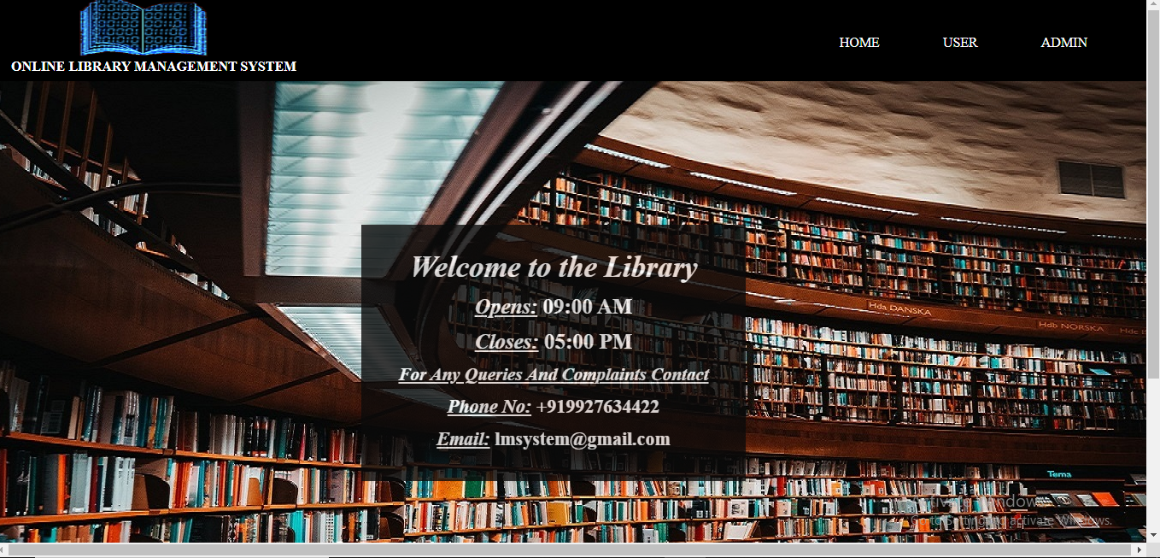

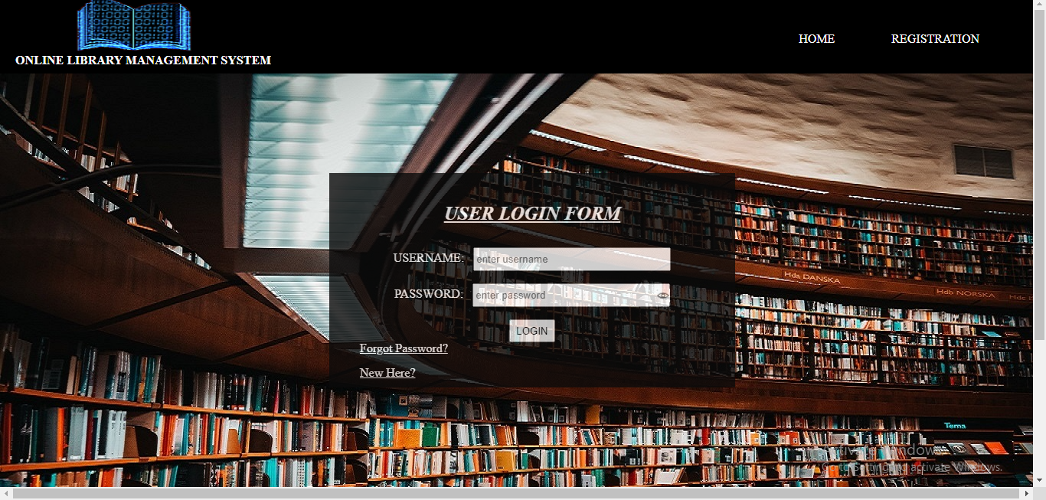

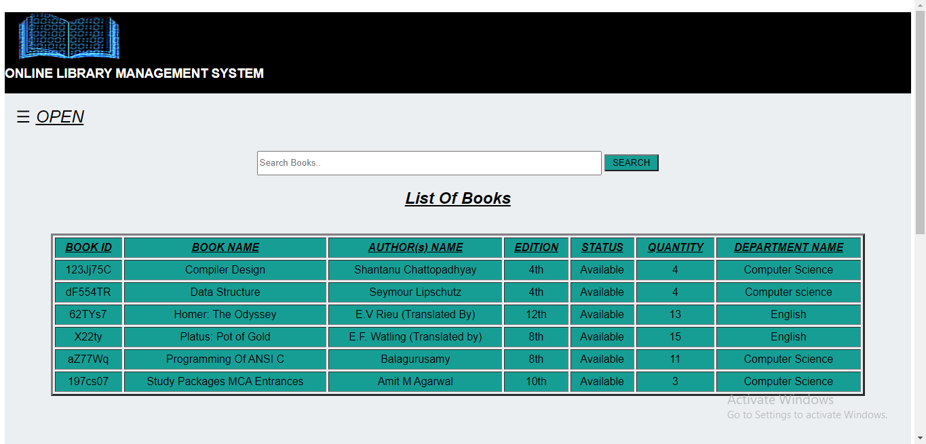

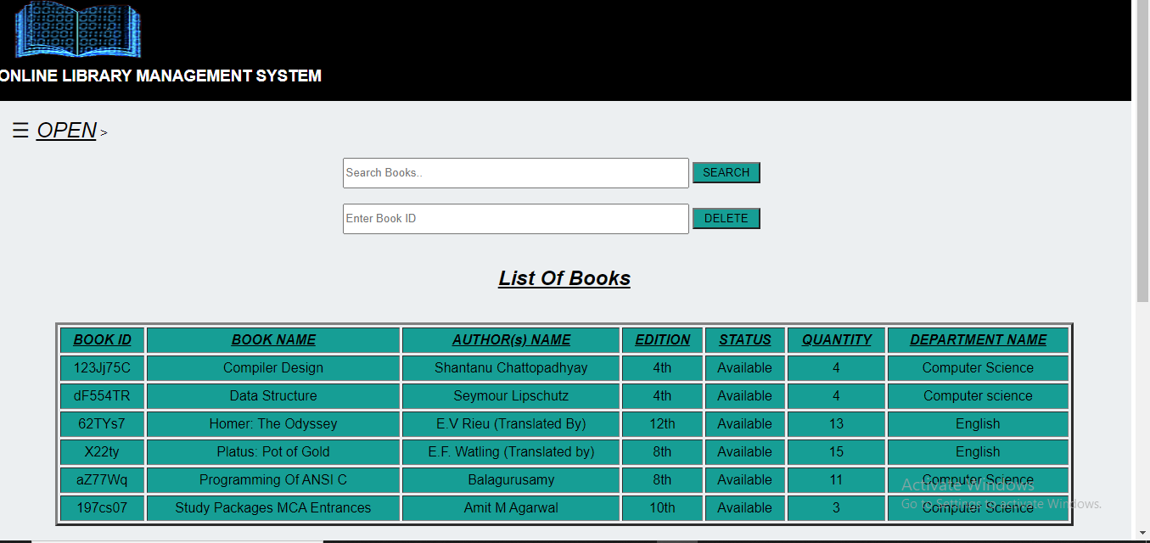

***CHAPTER 9***

***System testing***

**9.1 INTRODUCTION**

**9.2 TESTING**

**9.2.1 MODULE TESTING**

**9.2.2 SYSTEM TESTING**

**9.2.2.1 PROGRAM TESTING**

**9.2.2.2 STRING TESTING**

**9.2.2.3 SYSTEM TESTING**

**9.2.2.4 USER ACCEPTANCE TESTING**

**9.2.3 FUNCTIONAL TESTING**

**9.2.4 STRUCTURAL TESTING**

**9.2.5 COMBINED STRUCTURAL TESTING AND FUNCTIONAL**

**9.3 DEBUGGING**

**9.1 INTRODUCTION**

A system should always be tested thoroughly before implementing it, as regards its individual programs, the system as a whole user acceptance etc

**Testing is done based on the following principles:**

Programming and testing is followed by the stage of installing the new computer based system.

**9.2 TESTING**

**9.2.1 MODULE TESTING**

The testing of individual modules was completed during the development itself. Some real data entered manually and necessary testing was completed for each module.

**9.2.2 SYSTEM TESTING**

**9.2.2.1 PROGRAM TESTING**

A program represents the logical elements of a system. For a program to run satisfactorily, it must compile and test data correctly and tie in properly with other programs.

**9.2.2.2 STRING TESTING**

Programs are invariably related to one another and interact in a total system.

**9.2.2.3 SYSTEM TESTING**

System testing is designed to uncover weaknesses that were not found in earlier tests. This includes forced system failure and validation of the total system.

**9.2.2.4 USER ACCEPTANCE TESTING**

An acceptance test has the objective of selling the user on the validity and reliability of the system.

**9.2.3 FUNCTIONAL TESTING**

The functional testing specifies the operating conditions, input values and expected results.

**9.2.4 STRUCTURAL TESTING**

The structural testing is concerned with examining the internal processing logic of a software system.

**9.2.5 COMBINED STRUCTURAL TESTING AND FUNCTIONALTESTING**

The combining structural and functional testing of all the operating conditions, input values, expected results along with the internal processing logic of the software system, which means these combined effort is through the study of the whole system.

**9.3 DEBUGGING**

Debugging occurs as a consequence of successful testing. That is, when a test case uncovers an error, debugging can and should be an orderly process that results in removal of the error.

**The debugging process will always have one of two outcomes:**

**1.** The cause will be found, corrected and removed.

**2.** The cause will not be found.

The software was tested vigorously before implementation and when errors were found they were corrected and removed.

***CHAPTER 10***

***System Implementation***

**10.1 INTRODUCTION**

**10.2 USER TRAINING**

**10.1 INTRODUCTION**

System implementation means converting a new system design into operation. The successful implementation of the new software package is the most important part of the System Development life cycle**.**

**System implementation comprises the followings:**

* 1. Creating computer-compatible files.
  2. Training the people who are going to actually operate the system i.e. the operating off.
  3. Installing the necessary hardware, terminals and telecommunication network (if required).
  4. Installing the application packages.

**10.2 USER TRAINING**

User training is an important aspect to be taken into account before implementing a system

**10.3 POST IMPLEMENTATION**

After the installation phase is completed and the user staff is adjusting to the changes created by the candidate system, evaluation and maintenance begins.

***CHAPTER 11***

***Conclusion***

**11.1 CONCLUDING REMARKS**

**11.2 SALIENT FEATURES OF THE PROPOSED SYSTEM**

**11.3 LIMITATIONS OF THE PROJECT**

**11.4 SCOPE FOR FUTURE WORKS**

**11.1 CONCLUDING REMARKS**

The process of developing the project was a unique experience for us. The process of development shows us trying to maneuver the ups and downs, which appeared at each process of the development of the software. Especially, as the system is handling sensitive data, each steps of the development was conducted cautiously and after proper scrutiny. The interaction in due course gave me the privilege of making the sample users appreciate the benefits of a computerized system and so also their active involvement throughout the development of the project indeed left us all much richer in an experience hitherto never enjoyed.

**11.2 SALIENT FEATURES OF THE PROPOSED SYSTEM**

**There are some silent features of the proposed system:-**

1. Reduce paper work.
2. Easy to operate.
3. Reduce man power.
4. Maintain quality.
5. Easy linking of the various files.

**11.3 LIMITATIONS OF THE PROJECT**

I have collected the information necessary for the system as much as possible and I have tried my level best to develop user-friendly software but due to my inexperience and lack of time there are also some limitations in the system. These are: -

**1.** Not any special error handling procedure has been used.

**2.** Although the system is password protected, there is no operating system level security.

**11.4 SCOPE FOR FUTURE WORK**

Software development is never ending process and continues throughout the life of the software. The software has been developed keeping in mind easy modification and enhancement that may be required from time to time.

There are always chances to improve in everything. My project can also be improved with little modification. From the tools points view, I have used HTML 5, PHP and CSS3 for designing for its user friendly interface.

***CHAPTER 12***

***Bibliography***

1. Fundamentals Of Software Engineering by Rajib Mall

2. Database Design by Shio Kumar Singh

3. PHP and MySQL for Dynamic Web Pages by Larry Ullman

4.Web Technology-A Developer’s Perspective by N.P. Gopland and J. Akilandeswari

5. Internet site: w3schools.org