**E-Commerce Application on IBM Cloud Foundry**

**Phase 4 : Development Part 2**

**Problem Statement**:

In this part you will continue building your project.

Continue building the e-commerce platform by implementing user authentication, shopping cart, and checkout functionality.

Implement user registration and authentication features using a backend server (e.g. Node.js, Python).

Implement shopping cart functionality, calculate the total, and enable a smooth checkout process

**Problem Description:**

The tasked with developing a feature-rich e-commerce platform to enable users to shop for products and make purchases online. The platform must provide user authentication, shopping cart functionality, and a smooth checkout process. The primary goal is to create a seamless shopping experience for customers and ensure the security and reliability of the platform.

**Key Requirements:**

**User Authentication**:

Implement a user registration system where individuals can create accounts with their personal information.

Develop a secure authentication system for user login, including password hashing for user data protection.

Create a user profile management feature that allows users to update their information and reset passwords.

**Shopping Cart**:

Design a shopping cart system that allows users to add products, specify quantities, and remove items from their cart.

Calculate the total price of items in the cart and display it to the user.Ensure that the cart data is maintained between sessions, so users can continue shopping across multiple visits.

**Checkout Process:**

Implement a smooth and intuitive checkout process that guides users through the final steps of their purchase.

Integrate with a secure payment gateway to handle transactions, such as Stripe or PayPal.

Store order details, including the items purchased and customer information, for order fulfillment and tracking.

**Security and Reliability**:

Ensure that all user data, including personal information and payment details, is stored and transmitted securely.

Implement appropriate security measures to protect against common web application vulnerabilities, such as SQL injection and cross-site scripting (XSS).

Implement HTTPS to encrypt data during transmission, enhancing data security.

**Code For Home page:**

<!DOCTYPE html>

<html lang="en">

<head>

<meta charset="UTF-8">

<meta name="viewport" content="width=device-width, initial-scale=1.0">

<title>Document</title>

<link href="https://cdn.jsdelivr.net/npm/bootstrap@5.3.2/dist/css/bootstrap.min.css" rel="stylesheet"

integrity="sha384-T3c6CoIi6uLrA9TneNEoa7RxnatzjcDSCmG1MXxSR1GAsXEV/Dwwykc2MPK8M2HN" crossorigin="anonymous">

<link rel="stylesheet" href="./nm1.css">

</head>

<body>

<section id="navbar">

<nav class="hello">

<div class="container-fluid bg-danger-subtle">

<div class="d-flex flex-wrap align-items-center justify-content-center justify-content-lg-start">

<a href="/" class="d-flex align-items-center mb-2 mb-lg-0 text-white text-decoration-none">

<img src="./hand-made.png" alt=" artsinal logo" height="40px">

</a>

<p>

<ul class="nav col-12 col-lg-auto me-lg-auto mb-2 justify-content-center mb-md-0">

<li><a href="#" class="nav-link px-2 text-secondary">Home</a></li>

<li><a href="./nm.html" class="nav-link px-2 text-white">Features</a></li>

<li><a href="./pricing.html" class="nav-link px-2 text-white">shopping cart</a></li>

<li><a href="#" class="nav-link px-2 text-white">FAQs</a></li>

<li><a href="./checkout.html" class="nav-link px-2 text-white">checkout</a></li>

</ul>

<div class="text-end">

<button type="button" class="btn btn-outline-light me-2">Login</button>

<button type="button" class="btn btn-warning">Sign-up</button>

</div>

</div>

</div>

</nav>

</section>

<section id=" belownav">

<div class="bg">

<div class="container col-xxl-8 px-4 py-5">

<div class="row flex-lg-row-reverse align-items-center g-5 py-5">

<div class="col-10 col-sm-8 col-lg-6">

<img src="./pexels-jansel-ferma-1619602.jpg" class="d-block mx-lg-auto img-fluid" alt="Bootstrap Themes" width="700" height="400" loading="lazy">

</div>

<div class="col-lg-6">

<h1 class="display-5 fw-bold text-body-emphasis lh-1 mb-3">Elegance in Every Stitch: Your Artisanal Destination</h1>

<p class="lead">Artisanal Destination is where the timeless art of craftsmanship thrives. We take pride in curating and crafting exquisite handmade items that speak to your sense of style and quality.</p>

<div class="d-grid gap-2 d-md-flex justify-content-md-start">

<button type="button" class="btn btn-outline-danger" fdprocessedid="1htb6">

<svg xmlns="http://www.w3.org/2000/svg" width="16" height="16" fill="currentColor" class="bi bi-bag-heart-fill" viewBox="0 0 16 16">

<path d="M11.5 4v-.5a3.5 3.5 0 1 0-7 0V4H1v10a2 2 0 0 0 2 2h10a2 2 0 0 0 2-2V4h-3.5ZM8 1a2.5 2.5 0 0 1 2.5 2.5V4h-5v-.5A2.5 2.5 0 0 1 8 1Zm0 6.993c1.664-1.711 5.825 1.283 0 5.132-5.825-3.85-1.664-6.843 0-5.132Z"></path>

</svg>

Like

</button>

</div>

</div>

</div>

</div>

</div>

</section>

<section id="foot">

<footer class="pt-5 my-5 text-body-secondary border-top">

Created by the naan mudhalvan team· © 2023

</footer>

</section>

<script src="https://cdn.jsdelivr.net/npm/bootstrap@5.3.2/dist/js/bootstrap.bundle.min.js"

integrity="sha384-C6RzsynM9kWDrMNeT87bh95OGNyZPhcTNXj1NW7RuBCsyN/o0jlpcV8Qyq46cDfL" crossorigin="anonymous"></script>

</body>

</html>

**Sample page:**

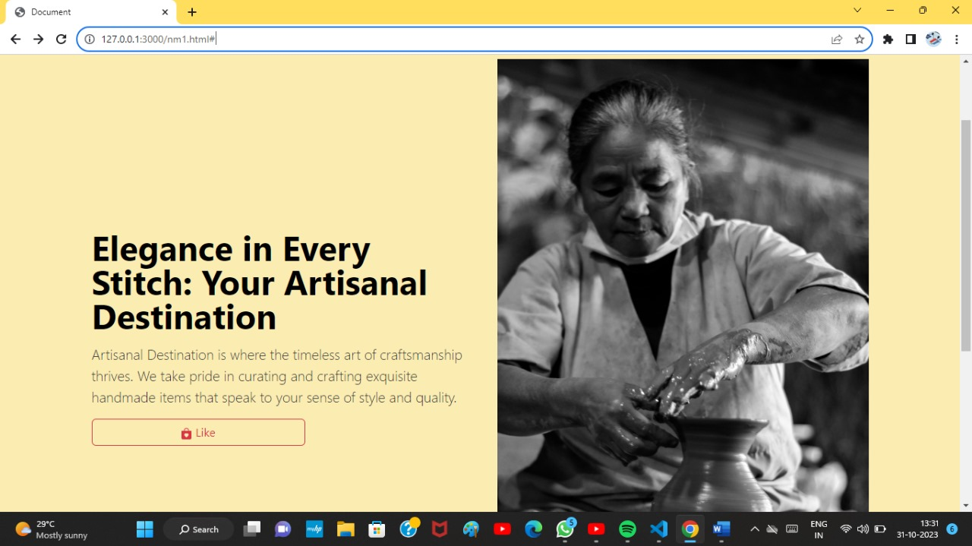

**Code for Shopping Feature:**

<!DOCTYPE html>

<html>

<head>

<title>Handmade Products E-commerce Website</title>

<meta charset="UTF-8">

<meta name="viewport" content="width=device-width, initial-scale=1.0">

<link href="https://cdn.jsdelivr.net/npm/bootstrap@5.3.2/dist/css/bootstrap.min.css" rel="stylesheet"

integrity="sha384-T3c6CoIi6uLrA9TneNEoa7RxnatzjcDSCmG1MXxSR1GAsXEV/Dwwykc2MPK8M2HN" crossorigin="anonymous">

<link rel="stylesheet" type="text/css" href="nmm.css">

</head>

<body>

<header>

<h1>Handmade Products</h1>

</header>

<main>

<section>

<h2>Featured Products</h2>

<div class="product">

<img src="product1.jpg" >

<h3>Product 1</h3>

<p>Description of Product 1</p>

<button>Add to Cart</button>

</div>

<div class="product">

<img src="./img7.jpg" height="200" alt="Product 2">

<h3>Product 2</h3>

<p>Description of Product 2</p>

<button>Add to Cart</button>

</div>

<div class="product">

<img src="demo products.jpg" height="200" alt="Product 3">

<h3>Product 3</h3>

<p>Description of Product 3</p>

<button>Add to Cart</button>

</div>

</section>

<section>

<h2>Latest Products</h2>

<div class="product">

<img src="./img5.jpg" height= 200 alt="Product 4">

<h3>Product 4</h3>

<p>Description of Product 4</p>

<button>Add to Cart</button>

</div>

<div class="product">

<img src="p.jpeg" width=500 alt="Product 5">

<h3>Product 5</h3>

<p>Description of Product 5</p>

<button>Add to Cart</button>

</div>

<div class="product">

<img src="product6.jpg" height="200" alt="Product 6">

<h3>Product 6</h3>

<p>Description of Product 6</p>

<button>Add to Cart</button>

</div>

</section>

</main>

<footer>

<p>&copy; 2023 Handmade Products. All rights reserved.</p>

</footer>

<script src="https://cdn.jsdelivr.net/npm/bootstrap@5.3.2/dist/js/bootstrap.bundle.min.js"

integrity="sha384-C6RzsynM9kWDrMNeT87bh95OGNyZPhcTNXj1NW7RuBCsyN/o0jlpcV8Qyq46cDfL" crossorigin="anonymous"></script>

</body>

</html>

**Sample Feature Output:**

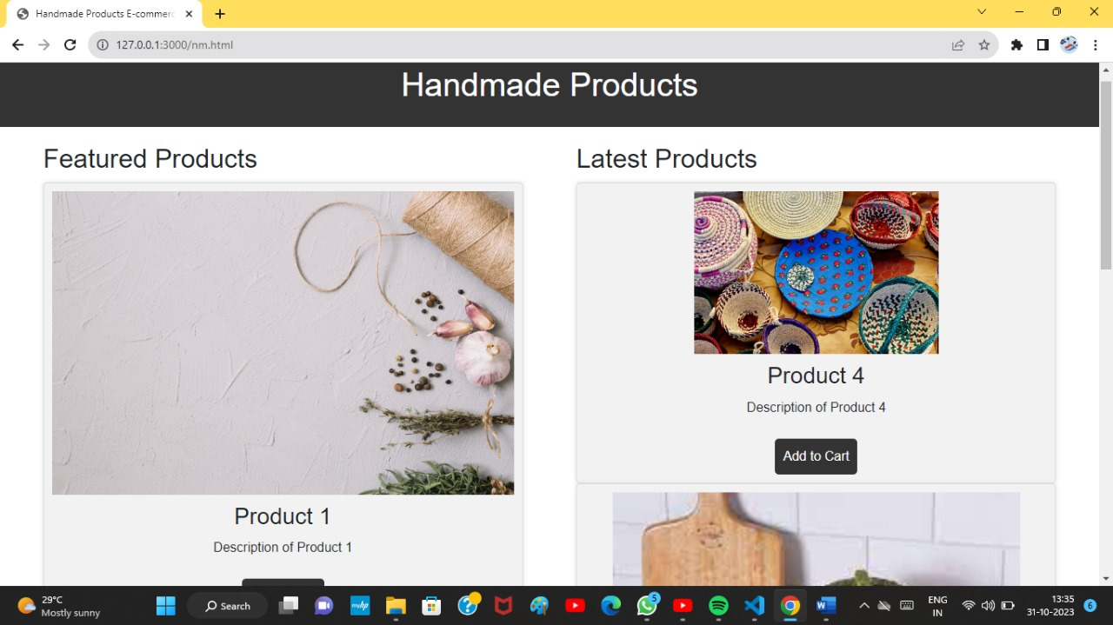

**Code for Shopping Cart Page:**

<!DOCTYPE html>

<html lang="en">

<head>

<meta charset="UTF-8">

<meta name="viewport" content="width=device-width, initial-scale=1.0">

<title>Document</title>

<link href="https://cdn.jsdelivr.net/npm/bootstrap@5.3.2/dist/css/bootstrap.min.css" rel="stylesheet"

integrity="sha384-T3c6CoIi6uLrA9TneNEoa7RxnatzjcDSCmG1MXxSR1GAsXEV/Dwwykc2MPK8M2HN" crossorigin="anonymous">

</head>

<body>

<section class="py-5 text-center container-fulid bg-success-subtle">

<div class="row py-lg-5">

<div class="col-lg-6 col-md-8 mx-auto">

<h1 class="fw-light">Album collection and price </h1>

<p class="lead text-body-secondary">The Artinal Collection is a captivating fusion of contemporary and traditional artistic expressions. Its diverse range of pieces, from abstract paintings to intricate sculptures, invites viewers to explore the interplay of colors, textures, and emotions. With a keen eye for innovation and a deep appreciation for heritage, this collection offers a unique visual journey that resonates with art enthusiasts and connoisseurs alike.</p>

</div>

</div>

</section>

<div class="album py-5 bg-info-subtle">

<div class="container">

<div class="row row-cols-1 row-cols-sm-2 row-cols-md-3 g-3">

<div class="col">

<div class="card shadow-sm">

<img src="./demo products.jpg" alt="">

<div class="card-body">

<p class="card-text">Our heart-shaped handcrafted product is a symbol of love and craftsmanship. Priced at $15, it makes for a heartfelt and affordable gift that radiates charm and thoughtfulness. Share your love with this beautiful piece of art today!

</p>

<div class="d-flex justify-content-between align-items-center">

<div class="btn-group">

<button type="button" class="btn btn-sm btn-outline-secondary">View</button>

<button type="button" class="btn btn-sm btn-outline-secondary">order</button>

</div>

<small class="text-body-secondary">9mins</small>

</div>

</div>

</div>

</div>

<div class="col">

<div class="card shadow-sm">

<img src="./img2.jpg" alt="art">

<div class="card-body">

<p class="card-text">A handmade artisanal bucket, crafted with care and attention to detail.Made from high-quality, it features intricate hand-carved patterns. This artisanal bucket is a testament to craftsmanship and can serve as a beautiful addition to your home or garden. Price: $75.</p>

<div class="d-flex justify-content-between align-items-center">

<div class="btn-group">

<button type="button" class="btn btn-sm btn-outline-secondary">View</button>

<button type="button" class="btn btn-sm btn-outline-secondary">order</button>

</div>

<small class="text-body-secondary">9 mins</small>

</div>

</div>

</div>

</div>

<div class="col">

<div class="card shadow-sm">

<img src="./img3.jpg" alt=" art">

<div class="card-body">

<p class="card-text">A sacred bucket for temple offerings, meticulously handcrafted with reverence. This unique vessel bears intricate religious motifs, ideal for transporting offerings in a traditional and meaningful manner. Price: $45.

A divine bucket for temple offerings, carefully adorned with sacred symbols, embodies spiritual reverence</p>

<div class="d-flex justify-content-between align-items-center">

<div class="btn-group">

<button type="button" class="btn btn-sm btn-outline-secondary">View</button>

<button type="button" class="btn btn-sm btn-outline-secondary">order</button>

</div>

<small class="text-body-secondary">9 mins</small>

</div>

</div>

</div>

</div>

<div class="col">

<div class="card shadow-sm">

<img src="./img4.jpg" alt="art">

<div class="card-body">

<p class="card-text">An exquisite cloth-made cup, designed for plant decoration, adds a touch of elegance to your greenery. Crafted with eco-friendly materials, it's a unique blend of style and sustainability. Price: $12.</p>

<div class="d-flex justify-content-between align-items-center">

<div class="btn-group">

<button type="button" class="btn btn-sm btn-outline-secondary">View</button>

<button type="button" class="btn btn-sm btn-outline-secondary">order</button>

</div>

<small class="text-body-secondary">9 mins</small>

</div>

</div>

</div>

</div>

<div class="col">

<div class="card shadow-sm">

<img src="./img5.jpg" alt="art">

<div class="card-body">

<p class="card-text">A handcrafted, intricately designed Kachifu that exudes timeless elegance. This unique piece, woven with skill and passion, serves as a versatile accessory to elevate your style. Price: $30.

A finely handcrafted Kachifu, a symbol of artistry and culture, showcasing exquisite patterns and textures

Elevate your fashion with a $30 handcrafted Kachifu, a symbol of artistry and culture with intricate patterns and textures.</p>

<div class="d-flex justify-content-between align-items-center">

<div class="btn-group">

<button type="button" class="btn btn-sm btn-outline-secondary">View</button>

<button type="button" class="btn btn-sm btn-outline-secondary">order</button>

</div>

<small class="text-body-secondary">9 mins</small>

</div>

</div>

</div>

</div>

<div class="col">

<div class="card shadow-sm">

<img src="./img6.jpg" alt=" art" height="390px">

<div class="card-body">

<p class="card-text">Exquisite hand-painted egg craft, showcasing intricate designs and vibrant colors. Each egg is a unique piece of art, perfect for decor or gifting. Price: $15 per egg.</p>

<div class="d-flex justify-content-between align-items-center">

<div class="btn-group">

<button type="button" class="btn btn-sm btn-outline-secondary">View</button>

<button type="button" class="btn btn-sm btn-outline-secondary">order</button>

</div>

<small class="text-body-secondary">9 mins</small>

</div>

</div>

</div>

</div>

</div>

</div>

</div>

</div>

</div>

<script src="https://cdn.jsdelivr.net/npm/bootstrap@5.3.2/dist/js/bootstrap.bundle.min.js"

integrity="sha384-C6RzsynM9kWDrMNeT87bh95OGNyZPhcTNXj1NW7RuBCsyN/o0jlpcV8Qyq46cDfL" crossorigin="anonymous"></script>

</body>

</html>

**Shopping Cart Page:**

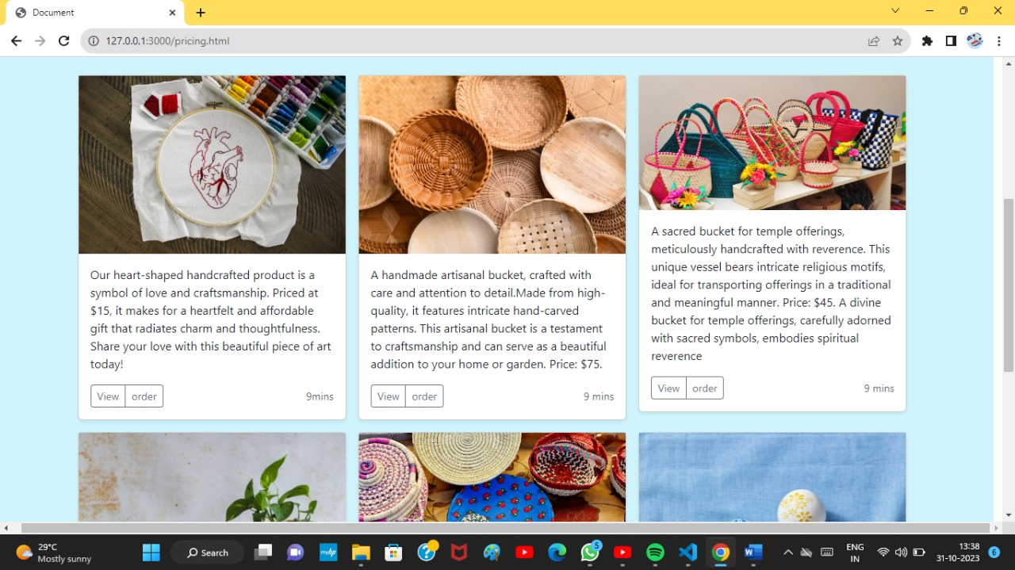

**Code for Checkout Page**:

<!DOCTYPE html>

<html lang="en">

<head>

<meta charset="UTF-8">

<meta name="viewport" content="width=device-width, initial-scale=1.0">

<title>Document</title>

<link href="https://cdn.jsdelivr.net/npm/bootstrap@5.3.2/dist/css/bootstrap.min.css" rel="stylesheet"

integrity="sha384-T3c6CoIi6uLrA9TneNEoa7RxnatzjcDSCmG1MXxSR1GAsXEV/Dwwykc2MPK8M2HN" crossorigin="anonymous">

</head>

<body>

<h2>Checkout form</h2>

<div class="col-md-7 col-lg-8">

<h4 class="mb-3">Billing address</h4>

<form class="needs-validation" novalidate="">

<div class="row g-3">

<div class="col-sm-6">

<label for="firstName" class="form-label">First name</label>

<input type="text" class="form-control" id="firstName" placeholder="" value="" required="" fdprocessedid="hlp2g">

<div class="invalid-feedback">

Valid first name is required.

</div>

</div>

<div class="col-sm-6">

<label for="lastName" class="form-label">Last name</label>

<input type="text" class="form-control" id="lastName" placeholder="" value="" required="" fdprocessedid="7dfam7">

<div class="invalid-feedback">

Valid last name is required.

</div>

</div>

<div class="col-12">

<label for="username" class="form-label">Username</label>

<div class="input-group has-validation">

<span class="input-group-text">@</span>

<input type="text" class="form-control" id="username" placeholder="Username" required="" fdprocessedid="vqx5eh">

<div class="invalid-feedback">

Your username is required.

</div>

</div>

</div>

<div class="col-12">

<label for="email" class="form-label">Email <span class="text-body-secondary">(Optional)</span></label>

<input type="email" class="form-control" id="email" placeholder="you@example.com" fdprocessedid="z7n2on">

<div class="invalid-feedback">

Please enter a valid email address for shipping updates.

</div>

</div>

<div class="col-12">

<label for="address" class="form-label">Address</label>

<input type="text" class="form-control" id="address" placeholder="1234 Main St" required="" fdprocessedid="fddda2c">

<div class="invalid-feedback">

Please enter your shipping address.

</div>

</div>

<div class="col-12">

<label for="address2" class="form-label">Address 2 <span class="text-body-secondary">(Optional)</span></label>

<input type="text" class="form-control" id="address2" placeholder="Apartment or suite" fdprocessedid="ssbyoi">

</div>

<div class="col-md-5">

<label for="country" class="form-label">Country</label>

<select class="form-select" id="country" required="" fdprocessedid="tvgzb">

<option value="">Choose...</option>

<option>United States</option>

</select>

<div class="invalid-feedback">

Please select a valid country.

</div>

</div>

<div class="col-md-4">

<label for="state" class="form-label">State</label>

<select class="form-select" id="state" required="" fdprocessedid="7g8j1">

<option value="">Choose...</option>

<option>California</option>

</select>

<div class="invalid-feedback">

Please provide a valid state.

</div>

</div>

<div class="col-md-3">

<label for="zip" class="form-label">Zip</label>

<input type="text" class="form-control" id="zip" placeholder="" required="" fdprocessedid="mo8ks">

<div class="invalid-feedback">

Zip code required.

</div>

</div>

</div>

<hr class="my-4">

<div class="form-check">

<input type="checkbox" class="form-check-input" id="same-address">

<label class="form-check-label" for="same-address">Shipping address is the same as my billing address</label>

</div>

<div class="form-check">

<input type="checkbox" class="form-check-input" id="save-info">

<label class="form-check-label" for="save-info">Save this information for next time</label>

</div>

<hr class="my-4">

<h4 class="mb-3">Payment</h4>

<div class="my-3">

<div class="form-check">

<input id="credit" name="paymentMethod" type="radio" class="form-check-input" checked="" required="">

<label class="form-check-label" for="credit">Credit card</label>

</div>

<div class="form-check">

<input id="debit" name="paymentMethod" type="radio" class="form-check-input" required="">

<label class="form-check-label" for="debit">Debit card</label>

</div>

<div class="form-check">

<input id="paypal" name="paymentMethod" type="radio" class="form-check-input" required="">

<label class="form-check-label" for="paypal">PayPal</label>

</div>

</div>

<div class="row gy-3">

<div class="col-md-6">

<label for="cc-name" class="form-label">Name on card</label>

<input type="text" class="form-control" id="cc-name" placeholder="" required="" fdprocessedid="d5j3or">

<small class="text-body-secondary">Full name as displayed on card</small>

<div class="invalid-feedback">

Name on card is required

</div>

</div>

<div class="col-md-6">

<label for="cc-number" class="form-label">Credit card number</label>

<input type="text" class="form-control" id="cc-number" placeholder="" required="" fdprocessedid="r77o4x">

<div class="invalid-feedback">

Credit card number is required

</div>

</div>

<div class="col-md-3">

<label for="cc-expiration" class="form-label">Expiration</label>

<input type="text" class="form-control" id="cc-expiration" placeholder="" required="" fdprocessedid="z6tgg9">

<div class="invalid-feedback">

Expiration date required

</div>

</div>

<div class="col-md-3">

<label for="cc-cvv" class="form-label">CVV</label>

<input type="text" class="form-control" id="cc-cvv" placeholder="" required="" fdprocessedid="yx5jpo">

<div class="invalid-feedback">

Security code required

</div>

</div>

</div>

<hr class="my-4">

<button class="w-100 btn btn-primary btn-lg" type="submit" fdprocessedid="7ozbgq">Continue to checkout</button>

</form>

</div>

</div>

<script src="https://cdn.jsdelivr.net/npm/bootstrap@5.3.2/dist/js/bootstrap.bundle.min.js"

integrity="sha384-C6RzsynM9kWDrMNeT87bh95OGNyZPhcTNXj1NW7RuBCsyN/o0jlpcV8Qyq46cDfL" crossorigin="anonymous"></script>

</body>

</html>

**Checkout Page:**

