INTERNATIONAL JOURNAL OF INNOVATIVE TECHNOLOGIES AND MODERN TRENDS IN ENGINEERING & SCIENCE
( P E E R - R E V I E W E D , O P E N A C C E S S , F U L L Y R E F E R E E D I N T E R N A T I O N A L J O U R N A L )

R E F : I J I T M E S / C E R T I F I C A T E / V O L U M E 0 1 / I S S U E 0 1 / 0 0 0 5
DATE:28/5/2025



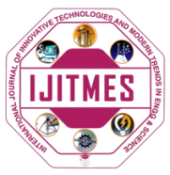

Certificate of Publication

This is to certify that author “Ritik” with paper ID “IJITMES810” hs published paper entitled “Test” in International Journal of Innovative Technologies and Modern Trends in Engineering and science(IJITMES),Volume 01,Issue 01,MAY 2025,Page Number -1 to 3
 |  | 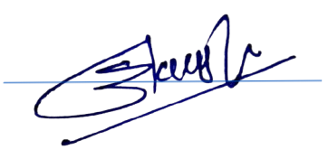  Editor in Chief
WE WISH FOR YOUR BETTER FUTURE
WWW.IJITMES.COM

