INTERNATIONAL JOURNAL OF INNOVATIVE TECHNOLOGIES AND MODERN TRENDS IN ENGINEERING & SCIENCE
( P E E R - R E V I E W E D , O P E N A C C E S S , F U L L Y R E F E R E E D I N T E R N A T I O N A L J O U R N A L )

R E F : I J I T M E S / C E R T I F I C A T E / V O L U M E 0 3 / I S S U E 0 5 / 0 0 0 7
DATE:28/9/2027



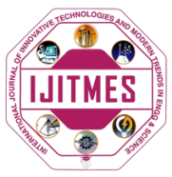

Certificate of Publication

This is to certify that author “Ritik” with paper ID “IJITMES810” hs published paper entitled “Test” in International Journal of Innovative Technologies and Modern Trends in Engineering and science(IJITMES),Volume 03,Issue 05,SEPTEMBER 2027,Page Number -1 to 3
 |  | 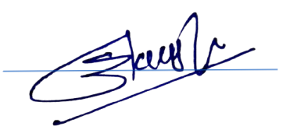  Editor in Chief
WE WISH FOR YOUR BETTER FUTURE
WWW.IJITMES.COM

