INTERNATIONAL JOURNAL OF INNOVATIVE TECHNOLOGIES AND MODERN TRENDS IN ENGINEERING & SCIENCE
( P E E R - R E V I E W E D , O P E N A C C E S S , F U L L Y R E F E R E E D I N T E R N A T I O N A L J O U R N A L )

R E F : I J I T M E S / C E R T I F I C A T E / V O L U M E 0 1 / I S S U E 1 2 / 0 0 0 2
DATE:15/5/2025



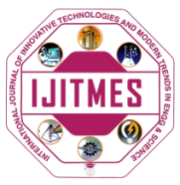

Certificate of Publication

This is to certify that author “Harshad” with paper ID “IJITMES001” hs published paper entitled “c;dvjmcvkjewo” in International Journal of Innovative Technologies and Modern Trends in Engineering and science(IJITMES),Volume 01,Issue 12,MAY 2025,Page Number -120 to 230

