Task 2: JavaScript Mini Project – To-Do List Application
- This project is a mini interactive To-Do List application developed using HTML, CSS, and JavaScript.
It focuses on implementing core JavaScript concepts such as DOM manipulation to dynamically manage tasks.
Users can add, complete, filter, and delete tasks through an intuitive and user-friendly interface.
SCREENSHOTS
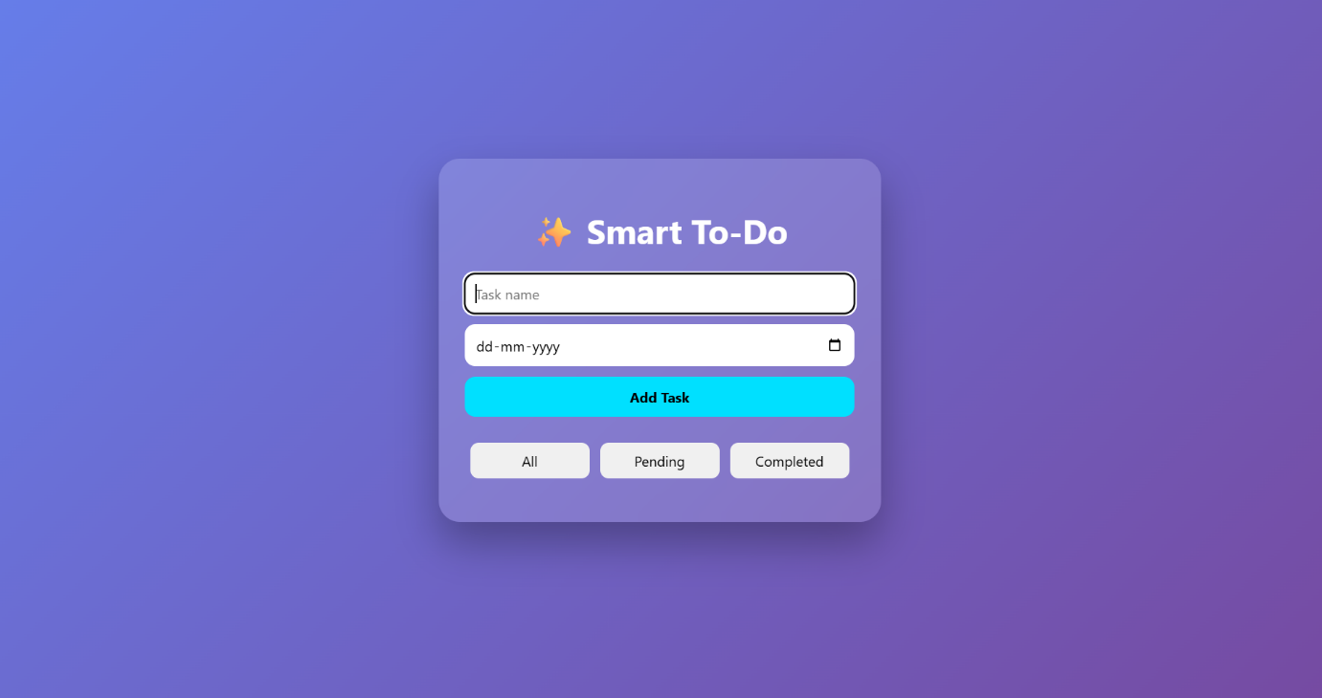
HOME PAGE
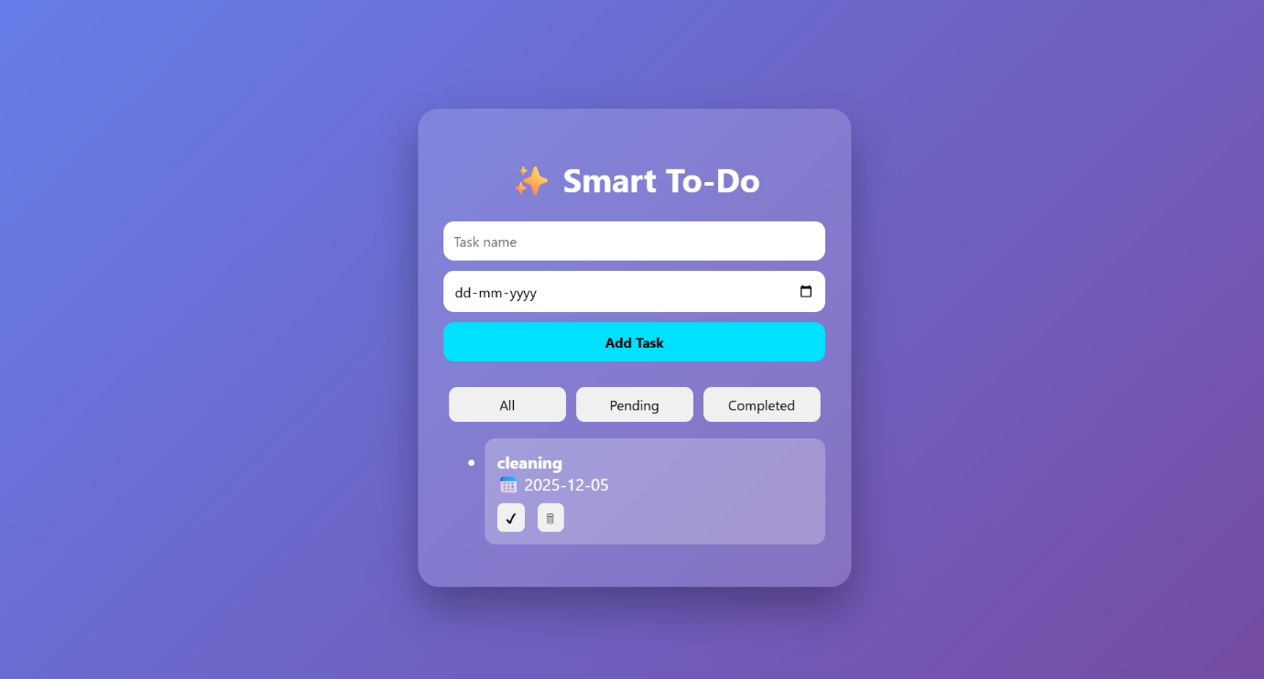
AFTER ADDING TASK
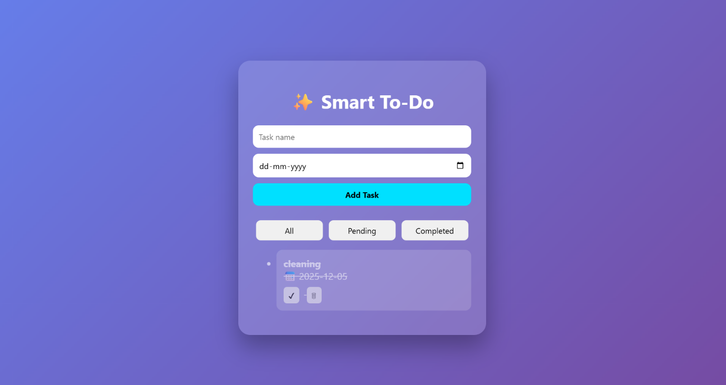
TASK IS MARKED AS COMPLETED
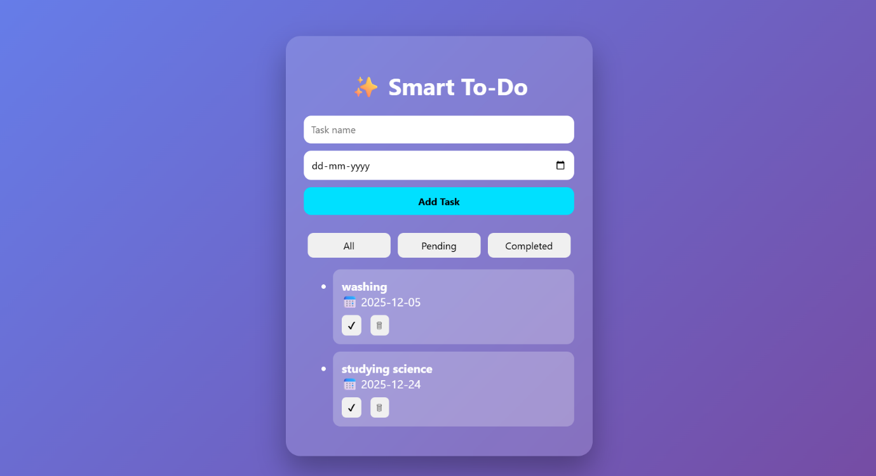
ADDING MULTIPLE TASK
CODE SNIPPETS
function addTask() {
const taskInput = document.getElementById("taskInput");
const dateInput = document.getElementById("dateInput");

const name = taskInput.value.trim();

if (name === "") {
alert("Please enter a task name");
return;
}

tasks.push({
name: name,
date: dateInput.value,
completed: false
});

saveTasks();
renderTasks();

taskInput.value = "";
dateInput.value = "";
}
function toggleTask(index) {
tasks[index].completed = !tasks[index].completed;
saveTasks();
renderTasks();
}

// Delete task
function deleteTask(index) {
tasks.splice(index, 1);
saveTasks();
renderTasks();
}

Hosted Link:
https://itz-swetha.github.io/todo-list-js/
GitHub Repository:
https://github.com/itz-swetha/todo-list-js

