Task 2: JavaScript Mini Project – To-Do List Application
This project is a mini interactive To-Do List application built using
HTML, CSS, and JavaScript. It demonstrates DOM manipulation by allowing
users to dynamically add, complete, filter, and delete tasks.
SCREENSHOTS
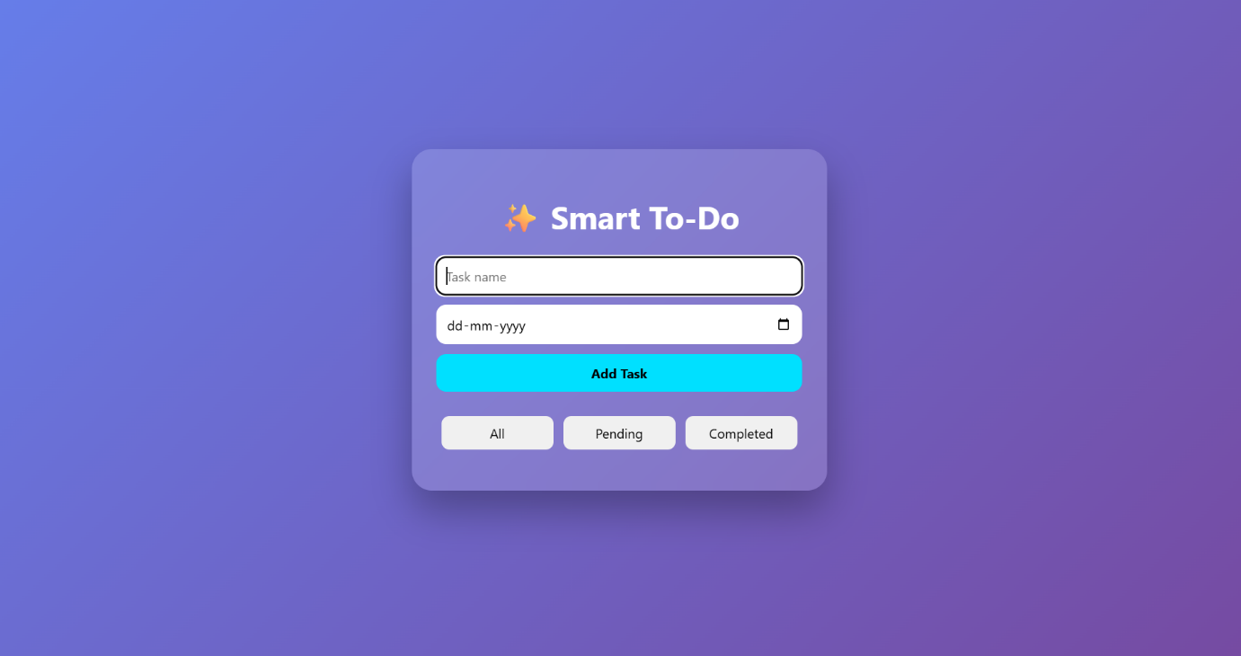
HOME PAGE
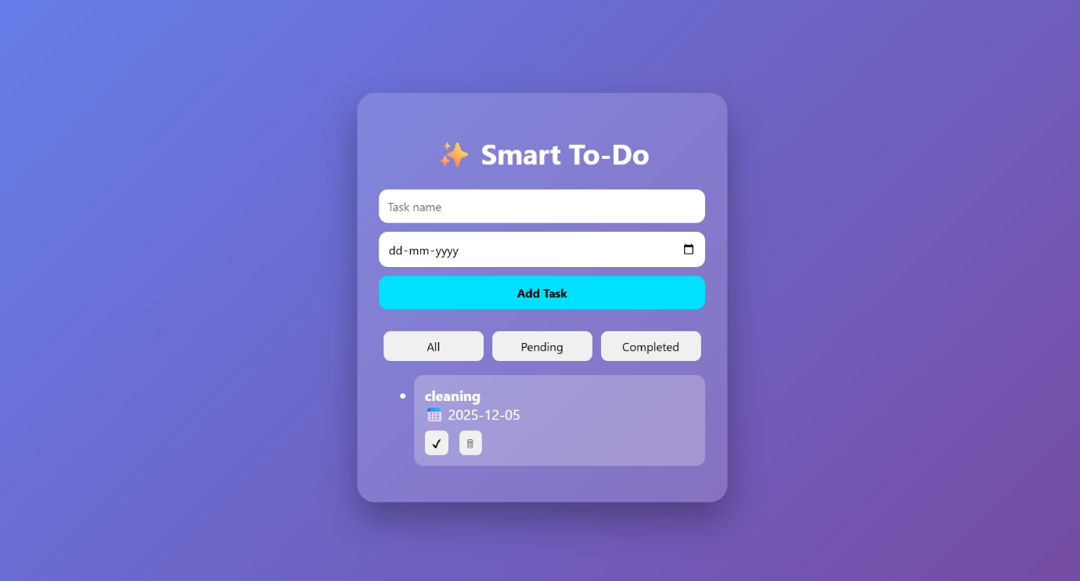
AFTER ADDING TASK
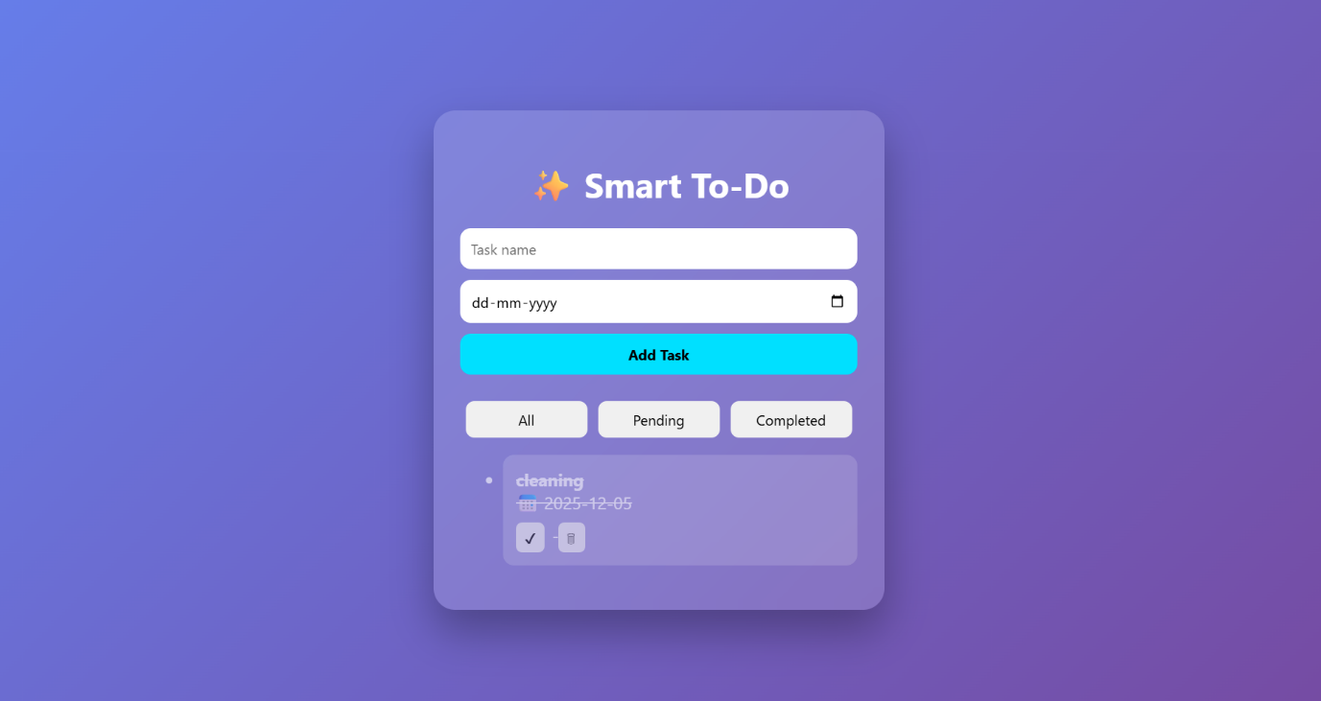
TASK IS MARKED AS COMPLETED
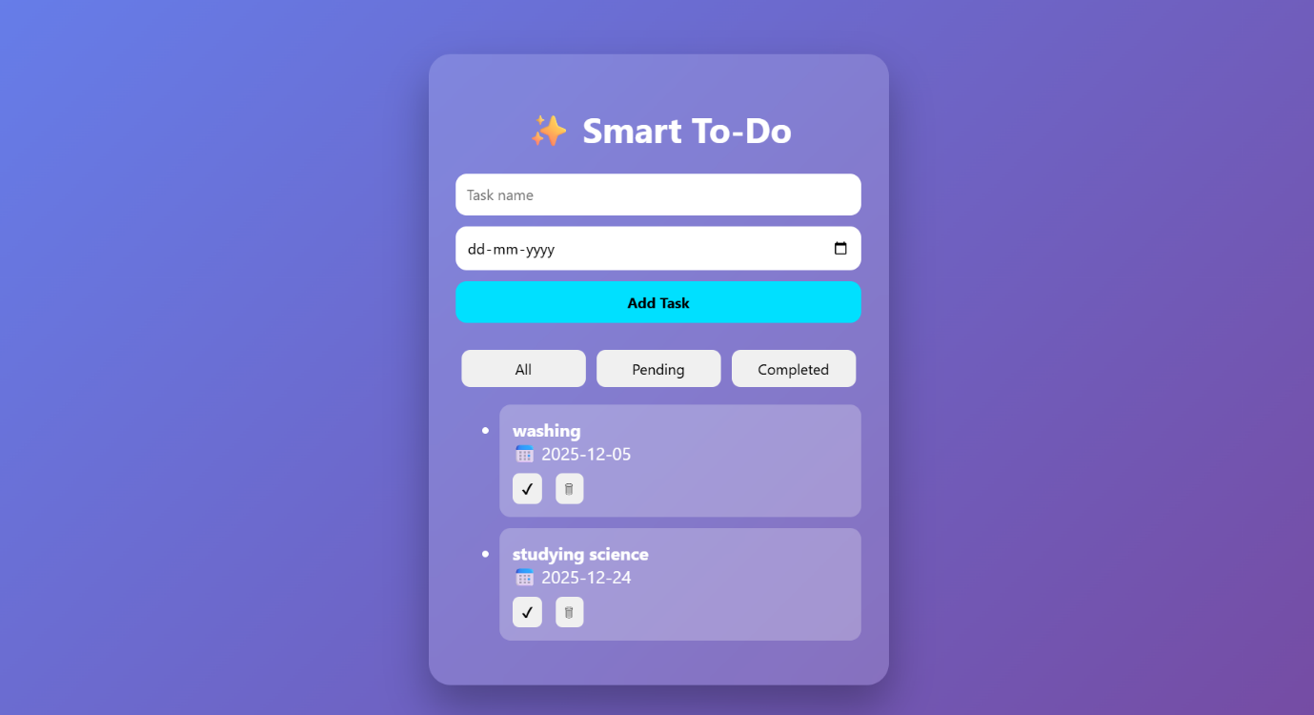
ADDING MULTIPLE TASK
CODE SNIPPETS
function addTask() {
const taskInput = document.getElementById("taskInput");
const dateInput = document.getElementById("dateInput");

const name = taskInput.value.trim();

if (name === "") {
alert("Please enter a task name");
return;
}

tasks.push({
name: name,
date: dateInput.value,
completed: false
});

saveTasks();
renderTasks();

taskInput.value = "";
dateInput.value = "";
}
function toggleTask(index) {
tasks[index].completed = !tasks[index].completed;
saveTasks();
renderTasks();
}

// Delete task
function deleteTask(index) {
tasks.splice(index, 1);
saveTasks();
renderTasks();
}

Hosted Link:
https://itz-swetha.github.io/todo-list-js/
GitHub Repository:
https://github.com/itz-swetha/todo-list-js

