Topic Modeling Analysis of Formula 1 Twitter Discourse: Uncovering Fan Engagement Patterns and Racing Narratives

Introduction
Social media text analysis is becoming more and more crucial for comprehending public sentiment as social media platforms have developed into effective means of sharing information and voicing opinions. Because of its large user base and real-time nature, Twitter is a great tool for examining public opinion on a variety of subjects. In this study, public topics are extracted from Formula 1-related tweets using machine learning and natural language processing techniques. The BERTopic algorithm is used to find hidden thematic patterns in the corpus.

Formula 1 is an ideal domain for topic modelling analysis due to its global reach and passionate fan engagement, which generates significant social media activity. The goals of this analysis are to identify underlying discussion themes, understand fan sentiment patterns, and evaluate the effectiveness of contemporary topic modelling techniques in analysing short-text social media data.

Data Collection and Pre-processing
Data Source Selection
The dataset used in this study was sourced from Kaggle. From the original collection of over 600,000 tweets, a sample of 45,000 tweets was randomly selected using stratified sampling (random_state=42) to ensure computational efficiency while maintaining statistical validity for the topic modeling analysis.
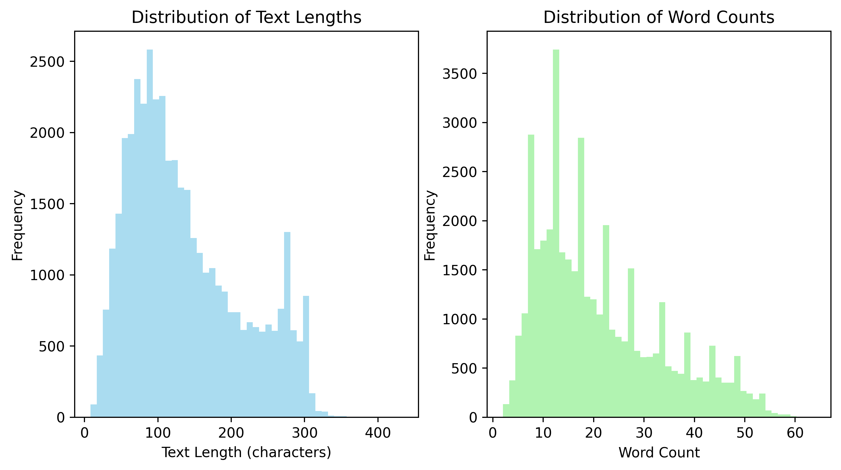
The dataset was specifically chosen because it includes discussions from several racing seasons, giving us enough data for valuable topic extraction while maintaining relevance to current F1 conversations.
Figure 1.

Pre-processing Pipeline
As shown in the figure above, the initial dataset exhibited significant variability in text characteristics. The distribution of text lengths revealed that most tweets ranged between 50-150 characters, with a right-skewed distribution peaking around 100 characters. Word count analysis showed a similar pattern, with most tweets containing 10-20 words, demonstrating the typical brevity of social media content.

A comprehensive preprocessing pipeline was implemented to optimize the data for topic modeling analysis. The process began with language detection using the langdetect library, filtering for English-language tweets to ensure linguistic consistency.

Text cleaning procedures included converting all text to lowercase, removing URLs and email addresses, and handling F1-specific hashtag patterns.
A custom approach was developed to extract meaningful content from F1-related hashtags while removing generic social media noise. Retweet indicators, mentions, and non-alphanumeric characters were systematically removed.

Advanced preprocessing steps incorporated lemmatization using WordNet Lemmatizer with part-of-speech tagging to ensure accurate word reduction. Stop words were removed using an enhanced list combining standard English stop words with F1-specific terms identified during exploratory analysis. The preprocessing pipeline also implemented length-based filtering, retaining tweets between 30-200 characters and 5-25 words to focus on substantive content.
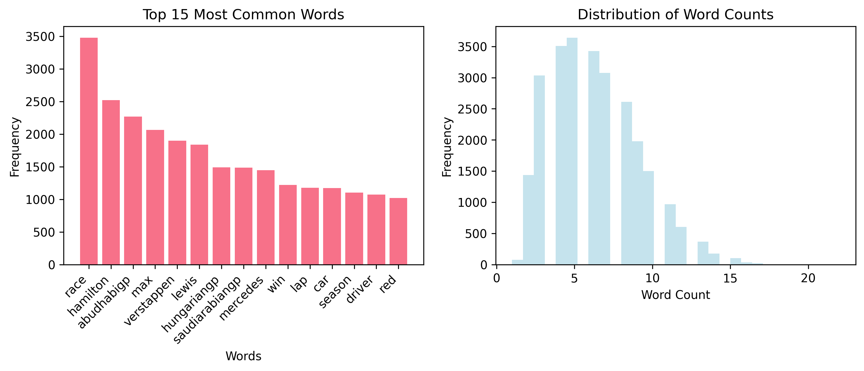
Figure 2.

Figure 2. demonstrates the effectiveness of the preprocessing pipeline. The cleaned data shows a more focused distribution of word counts, with the top 15 most common words revealing clear F1-related themes including driver names (Lewis, Max), race-related terms (race, season), and F1-specific vocabulary.

Topic Modelling Building and Explanation
BERTopic Implementation
BERTopic was selected as the primary topic modeling technique due to its superior performance with short-text data and ability to leverage pre-trained transformer embeddings.
The implementation utilized the BERTweet model, specifically designed for Twitter data, as the embedding backbone. This choice was made by BERTweet's training on Twitter-specific language patterns, making it suitable for social media text analysis.

Model Configuration
UMAP (Uniform Manifold Approximation and Projection) was employed for dimensionality reduction with optimized parameters: n_neighbors=8, n_components=15, min_dist=0.1, and cosine metric. These parameters were selected to balance local and global structure preservation while maintaining computational efficiency.

HDBSCAN (Hierarchical Density-Based Spatial Clustering of Applications with Noise) served as the clustering algorithm with min_cluster_size=25 and min_samples=2. This configuration ensures topic coherence while allowing for outlier detection, crucial for identifying noise in social media data.

The CountVectorizer component was configured with n-gram ranges (1,3), maximum features of 5,000, and custom stop word lists incorporating both general English and F1-specific terms. This setup optimizes topic representation by focusing on meaningful term combinations.

Outlier Handling Strategy
A sophisticated outlier handling mechanism was implemented to maximize tweet utilization. Outlier tweets (those not assigned to primary clusters) underwent secondary processing using K-means clustering on their embeddings. This approach recovered additional topics from initially unclustered content, improving overall clustering success rates.

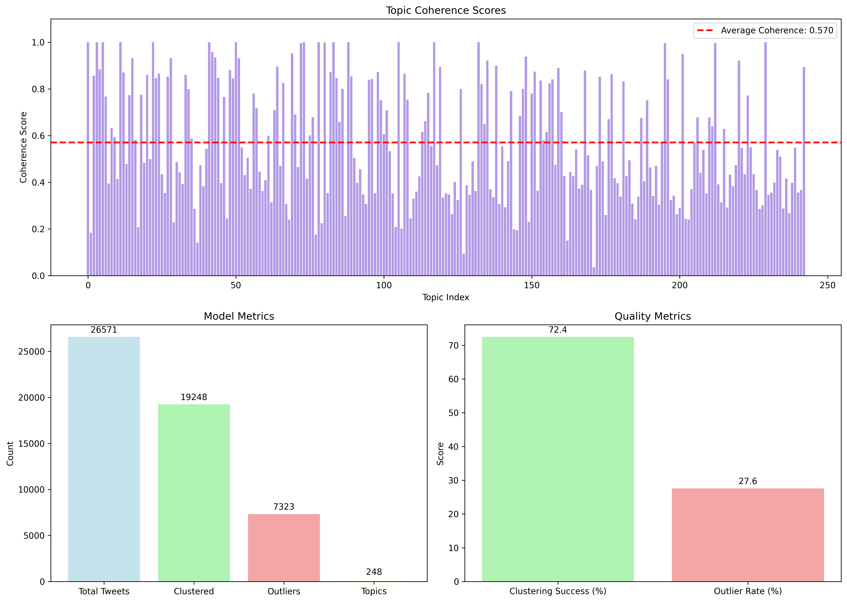
Unsupervised Topic Modelling Evaluation
Figure 3.

The detailed evaluation metrics demonstrate the model's effectiveness across both quantitative and qualitative measures. The coherence score of 0.5702 using the c_v measure indicates good topic interpretability, suggesting that extracted topics contain semantically related terms that frequently co-occur in Formula 1 contexts. This score falls within the acceptable range for social media text analysis, where shorter texts typically yield lower coherence scores compared to longer tweets.

The clustering performance visualization reveals that 19,248 tweets (72.4%) were successfully assigned to 248 distinct topics, while 7,323 tweets (27.6%) remained as outliers. This outlier rate is reasonable for social media data, representing either noise, highly specific discussions, or tweets that didn't align with the dominant thematic patterns.

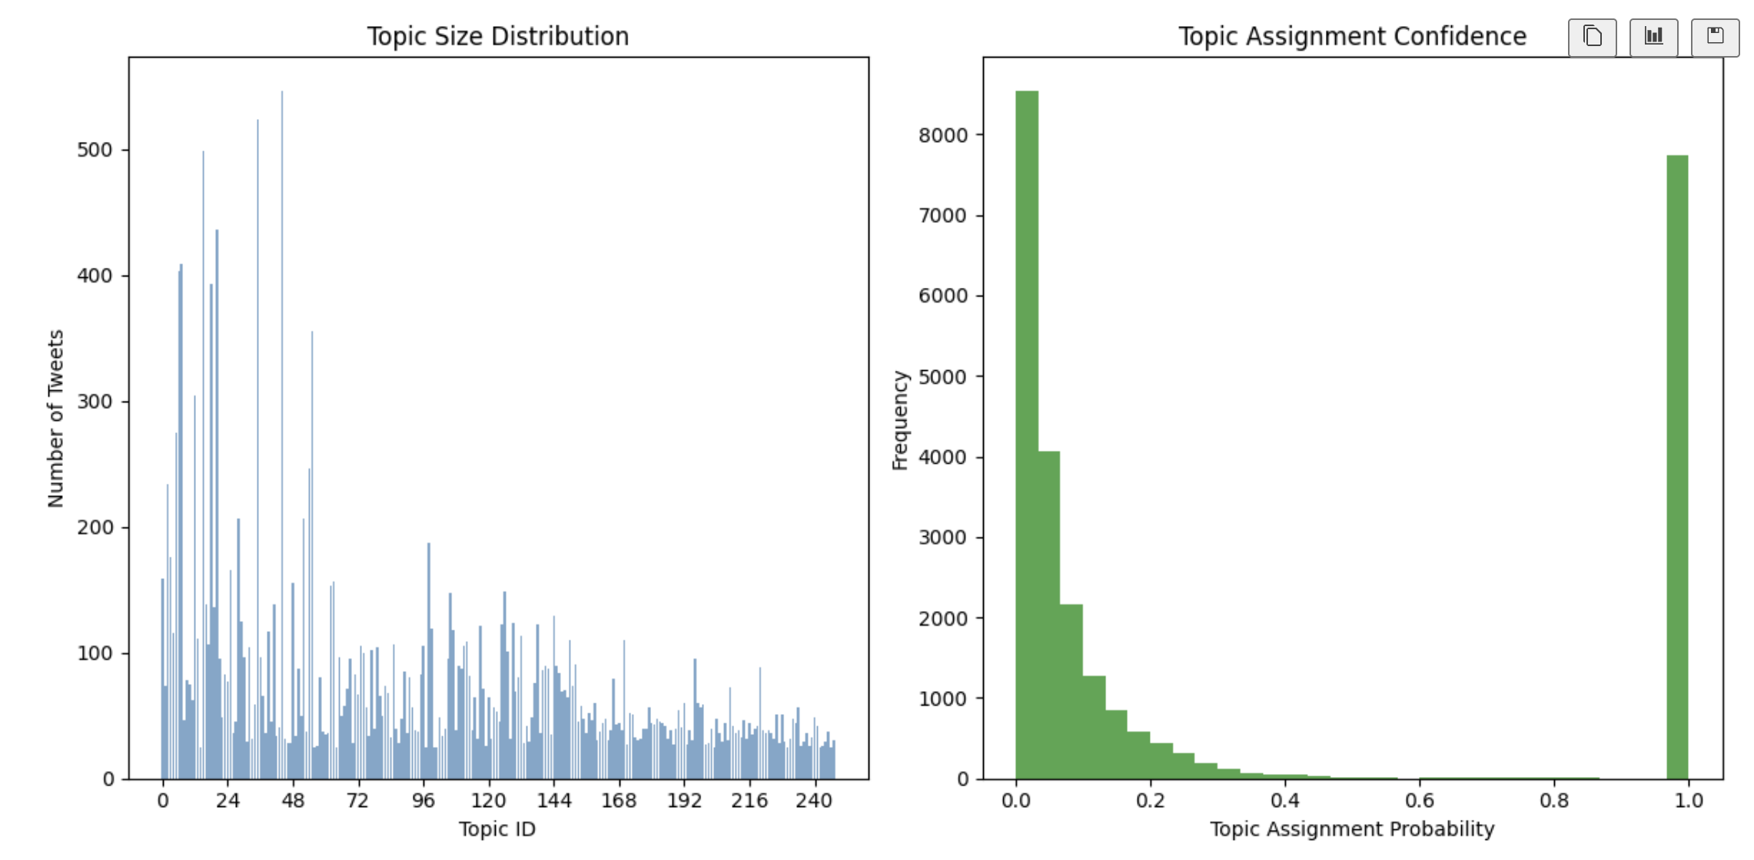
Topic Distribution and Model Performance Analysis
Figure 4.

As illustrated in the topic modeling results visualization, the model demonstrated strong performance across multiple dimensions. The topic size distribution reveals a typical long-trail pattern, with a few dominant topics capturing significant portions of the discourse while numerous smaller topics represent more specialized discussions.
The topic assignment confidence histogram shows that most tweets were assigned with high probability scores, indicating robust clustering decisions by the model.

Figure 5.
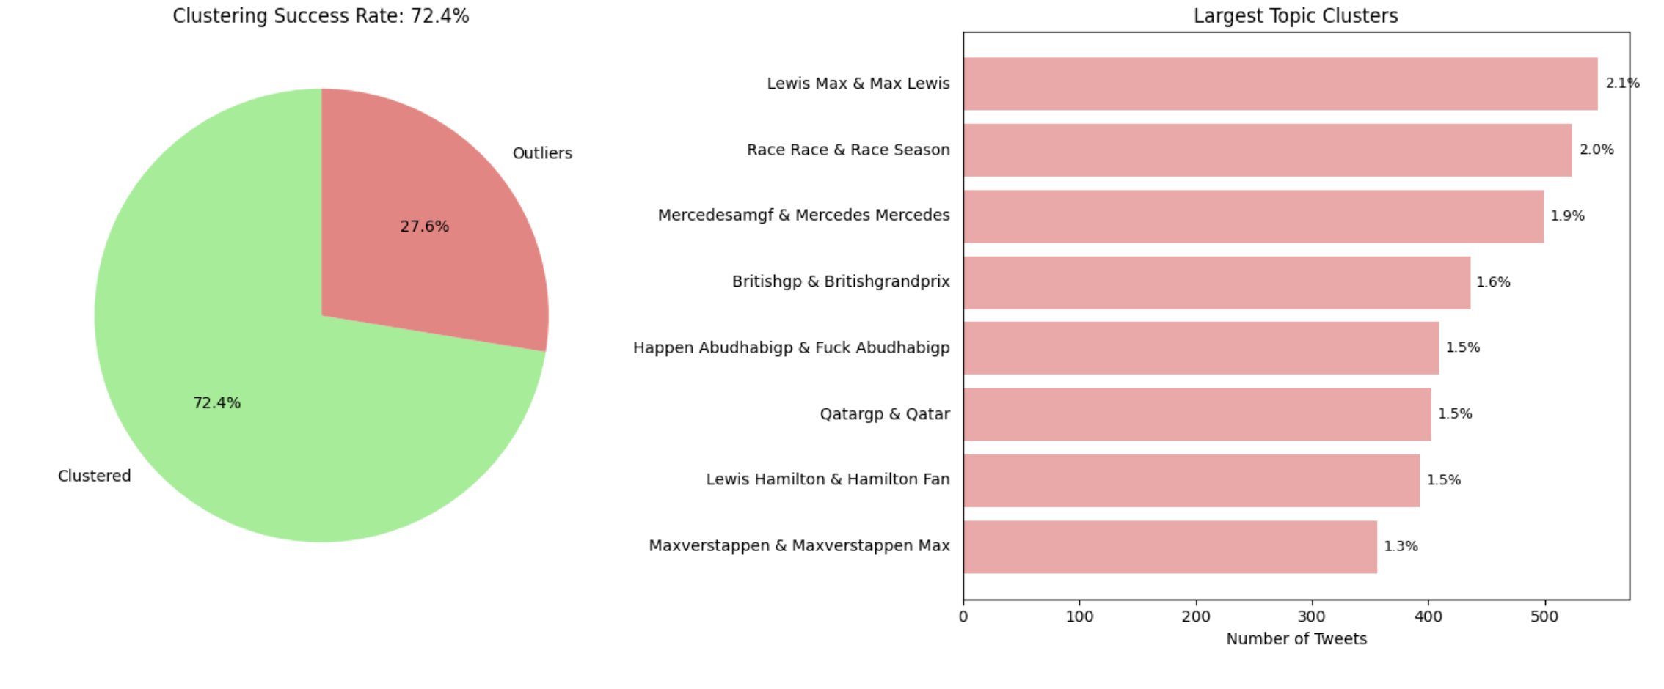
The largest topic clusters centered on key championship narratives, with “Max & Lewis” discussions dominating at 546 tweets (2.1%), followed by "Race Season" topics at 524 tweets (2.0%). This distribution reflects the intense rivalry that characterized the 2021 Formula 1 season, particularly during the controversial Abu Dhabi Grand Prix finale.

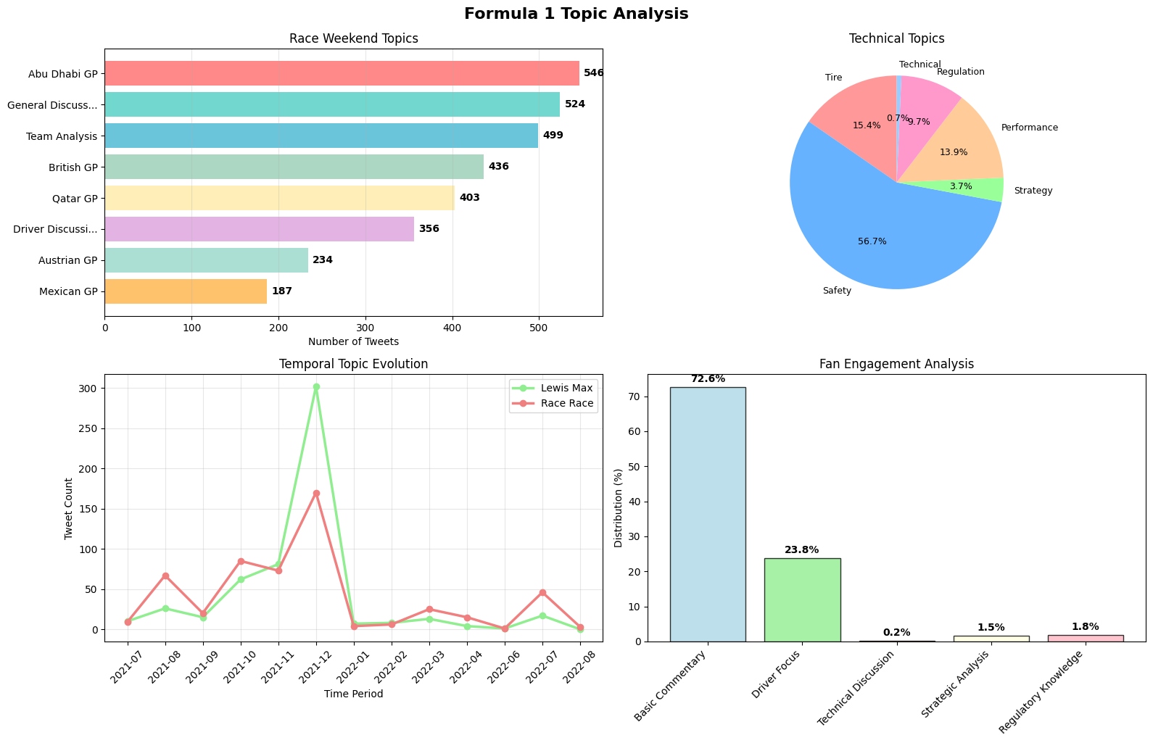
Temporal and Thematic Patterns
Figure 6.

Geographical clustering emerged around key race weekends, with discussions on the Abu Dhabi GP, British GP, and Qatar GP forming the most prominent topics.

Temporal evolution revealed that key topics followed a spiky trajectory, with a dramatic peak in discussion corresponding with the 2021 championship finale. This shows that controversy and title-deciding moments are the primary drivers of conversation.

Technical topics demonstrated a clear hierarchy in fan engagement, with "Safety" discussions overwhelmingly dominating the conversation, followed by tire talk, performance analysis, and race regulations.

Discussions also encompassed grid penalties, and strategic decision-making, indicating that fans actively engage with both the sporting and technical dimensions of Formula 1.

Conclusion
This study successfully demonstrated the effectiveness of BERTopic for extracting meaningful topics from Formula 1 Twitter data.
The comprehensive preprocessing pipeline proved crucial for optimizing topic model performance, particularly the domain-specific filtering and F1-entity recognition approaches. These preprocessing steps significantly improved topic coherence and relevance compared to generic text processing approaches.

BERTopic's superior performance over traditional methods like LDA was evident in its ability to handle the sparse, noisy nature of Twitter data while maintaining interpretable topic representations. The model successfully captured both broad thematic patterns and specific event-driven discussions, providing comprehensive coverage of F1 discourse.

Limitations and Future Work
The study faced limitations including dataset temporal constraints and language restrictions. Future research could expand to multilingual analysis, incorporate longer temporal ranges, and explore real-time topic evolution during live racing events. Additionally, sentiment analysis integration could provide deeper insights into fan emotional responses to specific F1 events.

The methodology established in this research provides a solid foundation for social media analysis of motorsports and demonstrates the practical value of advanced topic modeling techniques in understanding fan discourse patterns and engagement dynamics.

References

Egger, R., & Yu, J. (2022). A topic modeling comparison between LDA, NMF, Top2Vec, and BERTopic to demystify Twitter posts.
https://www.frontiersin.org/journals/sociology/articles/10.3389/fsoc.2022.886498/full

Mileski, M., Campos, D. P., Carvalho, L. F., & Mantovani, R. G. (2024). Sentiment analysis in social networks during the 2021 and 2022 Formula 1 seasons: A study using natural language processing on Twitter.
https://periodicos.univali.br/index.php/acotb/article/view/20360

Nguyen, D. Q., Vu, T., & Nguyen, A. T. (2020). BERTweet: A pre-trained language model for English Tweets. In Proceedings of the 2020 Conference on Empirical Methods in Natural Language Processing: System Demonstrations (pp. 9-14).

Python Software Foundation, Python 3 documentation, 2024. [Online]. Available: https://docs.python.org/3/
kaushiksuresh147. (n.d.). Formula 1 (F1) trending tweets [Data set]. Kaggle. https://www.kaggle.com/datasets/kaushiksuresh147/formula-1-trending-tweets

de Groot, M., Aliannejadi, M., & Haas, M. R. (2022). Experiments on generalizability of BERTopic on multi-domain short text.
https://doi.org/10.48550/arXiv.2212.08459

Tezel, S., Can, V. B., & Korkut, S. O. (2024). Recent trends in web intelligence and agent technology: Hybrid topic modeling approaches.
https://ieeexplore.ieee.org/document/10973572

Google. (2025). Google Gemini [Large language model]. https://gemini.google.com/

