Linux Troubleshooting Lab

1. Project Overview
Objective: Practice basic system diagnostics and document troubleshooting procedures on Linux Mint 22.3 Cinnamon.
Environment: Lenovo ThinkCentre M710s — Linux Mint 22.3 Cinnamon

2. Test Record

Test 01 — System Identification
Operating system: Linux Mint 22.3 Cinnamon
Command used: hostnamectl
Expected observation: The command displays the computer’s hostname, operating system, kernel version, hardware architecture, and hardware manufacturer/model where available.Actual observation: The terminal identified the hostname as ThinkCentre-M-710s, operating system as Linux Mint 22.3, kernel as 7.0.0-38-generic, architecture as x86-64, and hardware model as ThinkCentre M710s.Result: Pass

Test 02 — Network Loopback
Operating system: Linux Mint 22.3 Cinnamon
Command used: ping –c 4 127.0.0.1
Expected observation: The local loopback address responds to all four ICMP requests without packet loss
Actual observation: Four packets were transmitted, four were received, and packet loss was 0%. The reported average round-trip time was 0.062 ms.
Result: Pass

Test 03 — Disk Space
Operating system: Linux Mint 22.3 Cinnamon
Command used: df -h
Expected observation: The command displays filesystem capacity, used space, available space, usage percentage, and mount points, in human-readable points.
Actual observation: The root filesystem /dev/mapper/vgmint-root reported 108 GB total, 57 GB used, 46 GB available, and 56% usage. The /boot/efi filesystem showed 511 MB total, 6.2 MB used, and 2% usage.
Result: Pass

Test 04 — Memory Usage
Operating system: Linux Mint 22.3 Cinnamon
Command used: free -h
Expected observation: The command displays memory and swap statistics in human-readable units.
Actual observation: The output reported approximately 19 GiB total RAM, 4.0 GiB used, 12 GiB free, 3.2 GiB in the buff/cache column, and 15 GiB available. Swap totalled 1.9 GiB, w/ 0 B used.
Result: Pass

Test 05 — Network Configuration
Operating system: Linux Mint 22.3 Cinnamon
Command used: ip addr
Expected observation: The command displays network interfaces, interface states, and configured IP addresses.
Actual observation: The output showed the lo loopback interface, the enp1s0 Ethernet interface marked UP, and a docker0 interface marked DOWN. IP address information was displayed for the listed interfaces w/ sensitive values redacted in the screenshot.
Result: Pass

3. Findings
The initial Linux Mint 22.3 diagnostic tests successfully retrieved system identification, network interface information, memory statistics, and filesystem usage. The loopback test transmitted and received four packets with 0% packet loss. The root filesystem reported 56% usage, with approximately 46 GB available. Memory information showed approximately 15 GiB available and no swap currently in use. These results establish a baseline for further troubleshooting; they do not independently confirm external internet connectivity or the absence of hardware problems.

4. Lessons Learned
I practiced using Linux terminal commands to identify system hardware and software, test local network communication, inspect network interfaces, review RAM and swap usage, and assess filesystem capacity. I learned that a successful loopback test does not establish external network connectivity, that Linux memory caching affects memory statistics, and that disk usage must be interpreted alongside the available space and filesystem mount point.

5. Evidence

System Information
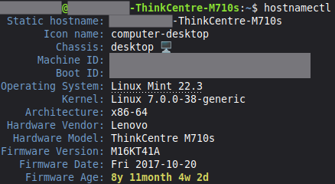

Network Loopback
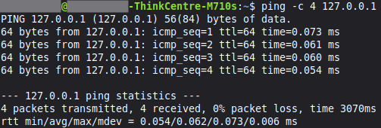

Disk Space
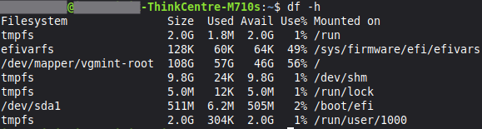

Memory Usage
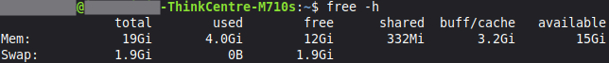

Network Configuration
