Windows Troubleshooting Lab

1. Project Overview
Objective: Practice basic system diagnostics and document troubleshooting procedures on Windows 11 Pro 23H2.
Environment: Dell Latitude 5420 — Windows 11 Pro 23H2

2. Test Record

Test 01 — System Identification
Operating system: Windows 11 Pro 23H2
Command used: systeminfo
Expected observation: “systeminfo” displays the operating system, system manufacturer, system model, processor, and memory information.
Actual observation: The command completed successfully and displayed the Windows edition, system model, processor, and memory details.
Result: Pass

Test 02 — Network Loopback
Operating system: Windows 11 Pro 23H2
Command used: ping 127.0.0.1
Expected observation: The local TCP/IP loopback address responds successfully.
Actual observation: Four packets were sent, four replies were received, and packet loss was 0%.
Result: Pass

Test 03 — Disk Space
Operating system: Windows 11 Pro 23H2
Command used: Get-Volume
Expected observation: Volume information displays without errors.
Actual observation: “Get-Volume” displayed the C: volume as NTFS, w/ a total size of 235.8 GB and 160.87 GB remaining. The volume reported Healthy status and operational status OK.
Result: Pass

Test 04 — Memory Usage
Operating system: Windows 11 Pro 23H2
Command used:Get-CimInstance Win32_OperatingSystem |
Select-Object `
@{Name="Total RAM (GB)";Expression={[math]::Round($_.TotalVisibleMemorySize/1MB,2)}},
@{Name="Free RAM (GB)";Expression={[math]::Round($_.FreePhysicalMemory/1MB,2)}}
@{Name="Used RAM (GB)";Expression={[math]::Round(($_.TotalVisibleMemorySize-$_.FreePhysicalMemory/1MB,2)}}
Expected observation: Total, free, and calculated used RAM appear in GB.
Actual observation: The command reported 15.39 GB total visible RAM, and 7.64 GB calculated used RAM at the time of testing.
Result: Pass

Test 05 — Network Configuration
Operating system: Windows 11 Pro 23H2
Command used: ipconfig /all
Expected observation: The command displays network adapter configuration, including IP addressing, subnet mask, gateway, and DNS information where applicable.
Actual observation: “ipconfig /all” displayed the Wi-Fi adapter configuration, including DHCP status, IP addressing, subnet mask, default gateway, and DNS server information. Sensitive values were redacted in the evidence screenshot.
Result: Pass

3. Findings
The initial diagnostic tests returned system information, disk volume details, memory information, and network configuration. The loopback test recorded four successful replies with 0% packet loss. No conclusions about external internet connectivity were drawn from the loopback test alone. Further testing is required to verify external network connectivity. The disk-space and memory measurements provide a baseline for future troubleshooting, but additional context is needed to determine whether available resources are sufficient for the computer's workload.

4. Lessons Learned
I practiced using Command Prompt and PowerShell to collect system information, test the local TCP/IP stack, inspect disk volumes, review physical memory, and examine network adapter configuration. I learned to distinguish between a successful local loopback test and a test of external network connectivity. I also learned to compare expected behavior against actual output before assigning a test result.

5. Evidence

System Information
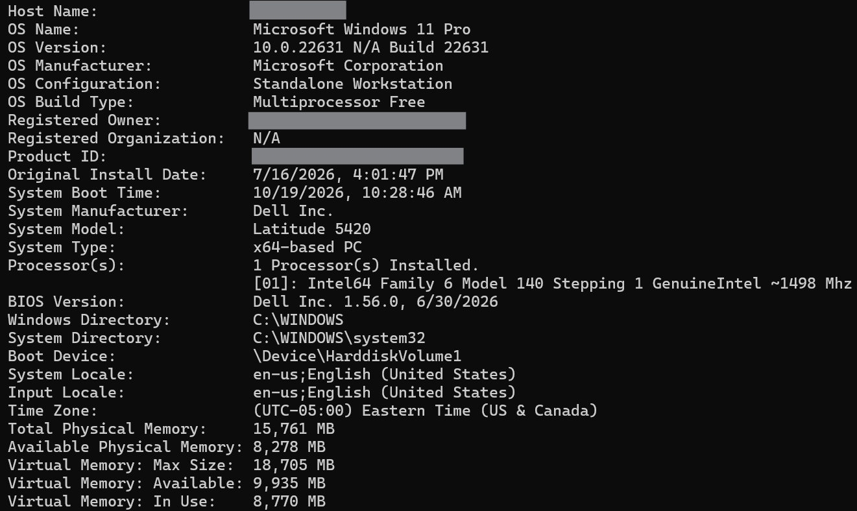

Network Loopback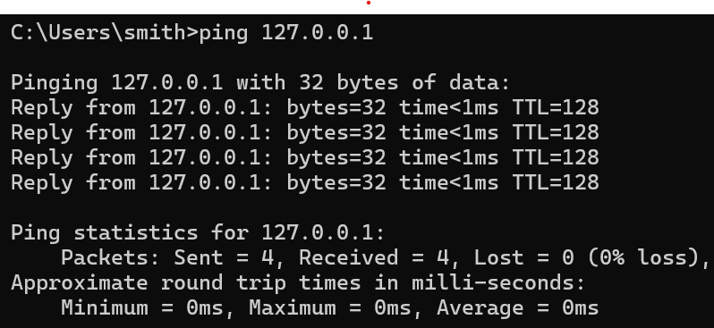

Disk Space

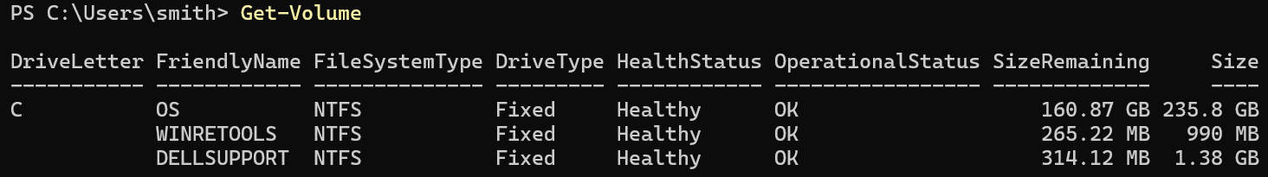

Memory Usage

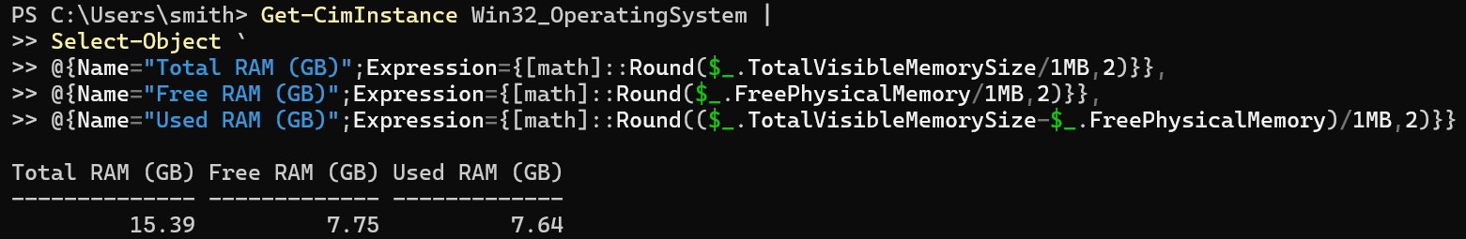

Network Configuration

