BoothIQ: Technical Pitch & Operational Strategy
Strategic Presentation for Judges & Governance Experts

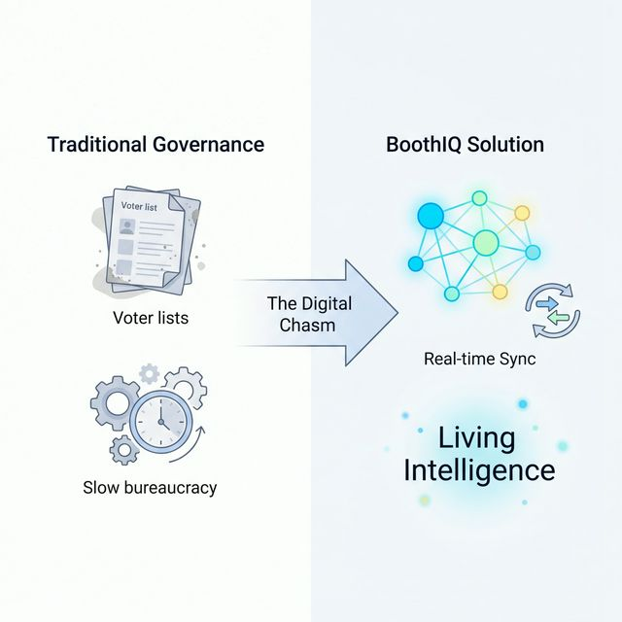
Figure 1: The Digital Chasm - From Static Lists to Living Intelligence

🎙️ 1. The Official Pitch Script

1. The Hook
Ladies and Gentlemen, we aren't just missing data; we’re missing Intelligence at the Edge.

1.1 The Problem Statement (The 'PS')
How do we transform static, siloed voter lists into a living knowledge system? BoothIQ bridges the 'Digital Chasm' by moving from rows in a spreadsheet to real-time execution oversight.

2. The Solution
Introducing BoothIQ—a Hybrid Intelligence platform designed to operationalize governance at the last mile.

3. The Demo: Citizen Reporter
Utilizing Sarvam AI and GPT-4o-mini for hyper-localized Speech-to-Text and classification.

4. The Demo: The Command Matrix
Real-time sentiment volatility, Knowledge Graphs, and Social Fabric mapping.

5. The Technical Moat
Hybrid Data Resilience (Supabase + MongoDB), AI-First Middleware, and the Social Fabric Algorithm.

6. Impact & Scaling
Moving from Passive Representation to Predictive Governance.

🛠️ 2. Technical Stack
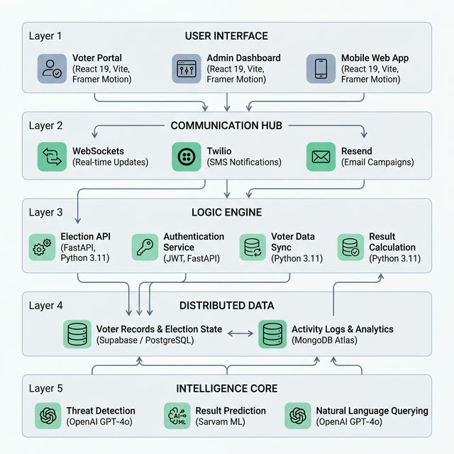
Figure 2: Comprehensive Technology Stack Architecture
Component | Technology Used
Frontend | React 19, Vite, Framer Motion, Tailwind CSS
Backend | FastAPI (Python 3.11), Pydantic V2, WebSockets
Data Layer | Supabase (Relational), MongoDB Atlas (Document/Graph)
Intelligence | OpenAI (GPT-4o-mini), Sarvam AI (STT/TTS)
Communication | Twilio (SMS/WhatsApp), Resend (Email)

🧠 3. AI & Machine Learning Pipeline
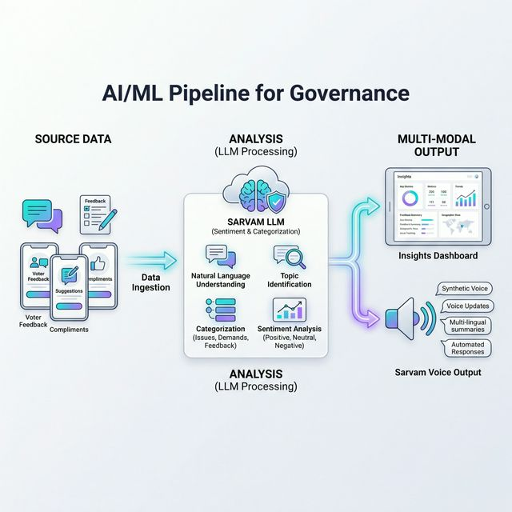
Figure 3: Multi-Modal AI Pipeline Flow
- Grievance Classification: GPT-4o-mini for real-time prioritization.
- Voice Interface: Sarvam-m for localized Indian language processing.
- Social Fabric mapping: Knowledge Graph linkage based on household clustering.

🧩 4. Knowledge Graph & Social Fabric: Deep Dive
Q: What is the BoothIQ Knowledge Graph?
Ans: It is a non-linear data structure representing voters as nodes and their relationships (family clusters, geographic proximity, and engagement history) as edges. While traditional databases store 'isolated data', the Knowledge Graph stores 'interconnected reality'.

Q: Why use a Knowledge Graph instead of a standard SQL database?
Ans: Standard databases (SQL) are designed for tables and rows. Querying relationships (e.g., 'Who are all the influencers in this building?') requires complex, slow joins. The Knowledge Graph (powered by MongoDB Document/Graph models) allows us to traverse relationships at millisecond speed, crucial for real-time command centers.

Q: How does the 'Social Fabric' mapping actually work?
Ans: We use a proprietary algorithm that links voters based on: 1. Household ID (Family unit), 2. Geographic Clustering (Building/Street proximity), and 3. Historical Interaction (Call logs and grievance patterns). This creates a 'Map of Influence'.

Q: What is the primary reason for using it in governance?
Ans: It transitions us from 'Passive Reporting' to 'Predictive Action'. If we see a grievance from a community 'influencer' at Booth 17, we prioritize it because satisfying that one node positively impacts 50 other connected nodes in the graph. It's about 'Strategic Resource Optimization'.

Q: How does the AI interact with the Graph?
Ans: Our LLM (ESarthi) queries the graph to provide tactical advice. Instead of just saying 'Grievance received', it says: 'This issue is from a high-influence household; resolution here will likely trigger a +5% sentiment shift in the ward.'

💡 5. Judges' FAQ: Technical Defenses
Q: How do you handle fake reports?
Ans: AI Vision analyzes photo attachments; Reporter Trust Scores based on resolution history.
Q: Why MongoDB AND Supabase?
Ans: Supabase for relational data; MongoDB for high-velocity graphs.
Q: Is it privacy-compliant?
Ans: JWT-based RBAC ensures PII is only visible to authorized personnel.
Q: How do you handle low connectivity?
Ans: Queued Dispatcher pattern; asynchronous voice transcription.

🛡️ 6. Security & Mitigation
Loophole | Tackle/Fix
Zero-Password Auth | Implement OAuth 2.0 or OTP-based verification.
Universal IDOR | Add owner-validation decorators to endpoints.
Hardcoded Secrets | Rotate secrets and enforce environment-only config.
Demo Bypass | Strictly reject unauthenticated requests in production.
Regex AI Manipulation | Use LLM-based verification instead of simple RegEx.

