
MaintainIQ: An Explainable MongoDB-Native Decision Support Platform for Industrial Asset Health Monitoring
Divya (23MIA1099) , LokiReddy Madhavi (23MIA1135) | Prassana J | TARP | Vellore Institute of Technology, Chennai
  Motivation / Introduction
  Industrial systems rely on continuous sensor measurements to avoid unexpected machine failure. While anomaly detection identifies abnormal behaviour, engineers also need to know how serious the condition is, what contributed to the alert, and which asset should be inspected first.
  MaintainIQ connects sensor analytics to maintenance decisions through interpretable health scoring, prioritization and rule-based explanations.
  Scope and Objectives
  • Ingest MetroPT-3 APU sensor data into MongoDB time-series collections.
  • Learn normal temporal patterns with an LSTM Autoencoder and flag deviations.
  • Compute a Dynamic Asset Health Index (DAHI) from sensor-level scores.
  • Rank maintenance attention with MAPE using health, risk and criticality.
  • Provide EME inspection recommendations and AMA natural-language queries.
  Methodology — End-to-End Processing Flow
  Eight connected stages transform raw observations into an engineer-facing decision.
  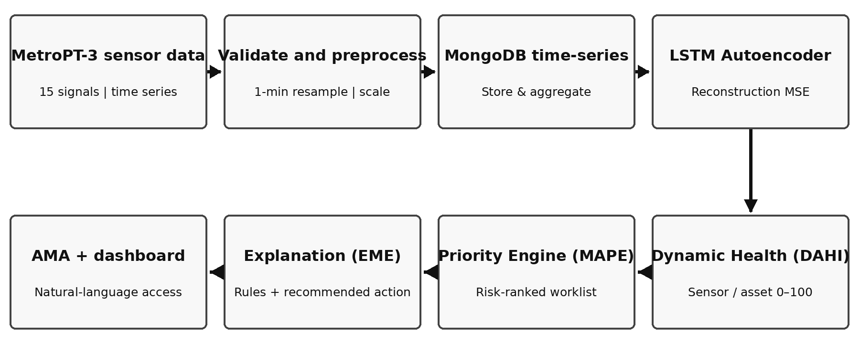
  Fig. 1. Connected MaintainIQ methodology: sensing → analysis → maintenance decisions
  MongoDB stores and aggregates time-series readings; Python/TensorFlow performs LSTM inference. The DAHI score is derived from sensor deviation, while MAPE and EME turn analytical outputs into maintenance priority and explanations.
  Implementation Details
  Stage | Method / Configuration
  Input | MetroPT-3: 1,516,948 records; 15 channels; four documented failures
  Preprocessing | 10-second → 1-minute; mean/mode; 5-point smoothing; Z-score
  LSTM model | 60-step × 10-feature inputs; encoder 64/32; latent 16; decoder 32/64
  Anomaly rule | Reconstruction MSE above 95th-percentile training threshold
  Health scoring | MongoDB aggregation combines weighted sensor scores
  Decision layer | MAPE priority, EME rules, AMA approved query intents
  Methodology Visuals and Results
  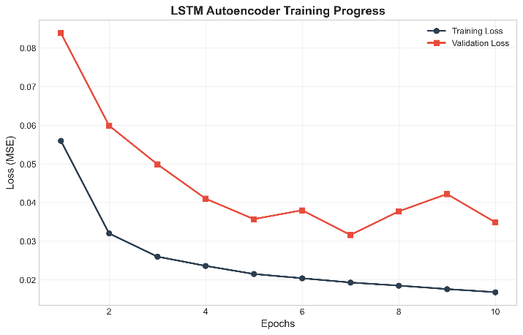  Fig. 2. Model training loss | 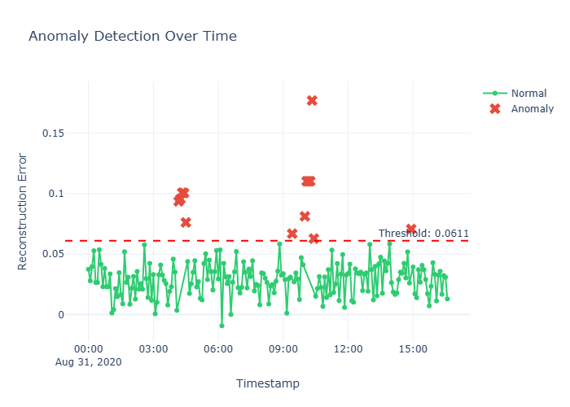  Fig. 3. Anomaly scores over time
  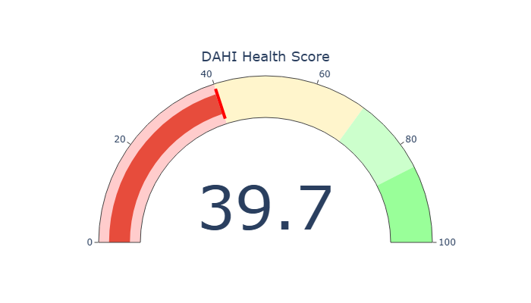  Fig. 4. COMP_01 DAHI gauge | 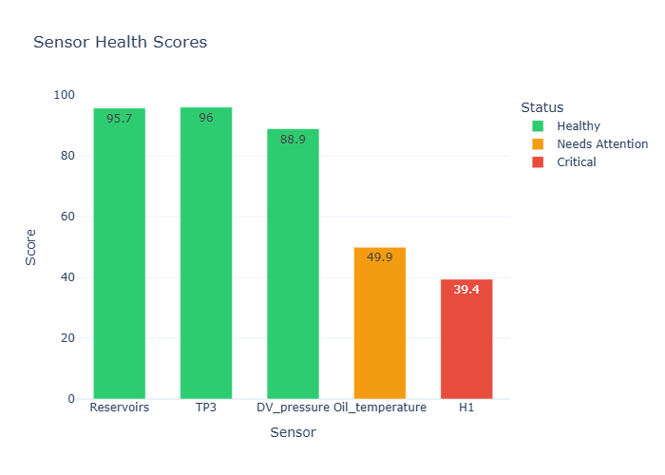  Fig. 5. Sensor health scores
  Figs. 2–3: Training MSE declines, and reconstruction-error peaks cross the chosen threshold. Figs. 4–5: COMP_01 has low asset health, with H1 and oil temperature contributing the weakest scores.
  Implementation Inference
  The project does more than label a record as normal or anomalous. The connected modules translate sensor evidence into an interpretable health assessment, a maintenance queue and suggested follow-up checks. The explanation identifies plausible causes for review, not a confirmed physical diagnosis.
  Related-Work Comparison
  Approach | Contribution | Remaining gap
  Alhammadi et al. | Autoencoder APU anomaly detection | No ranked maintenance decisions
  XAI methods | Explanations of model predictions | Limited direct maintenance guidance
  Industrial NoSQL | Flexible sensor-data management | Often used mainly for storage
  MaintainIQ | Detection + health + ranking + explanation | Field-scale validation remains future work
  Operational Interpretation
  When a compressed-air system shows abnormal pressure and load patterns, an anomaly score triggers closer analysis rather than an automatic repair order. DAHI exposes weakened sensor contributions; MAPE ranks the asset for attention; EME supplies a possible inspection path for review by a qualified engineer.
  Results — Anomaly Detection
  The LSTM Autoencoder was evaluated using reconstruction-error detection. The reported best model results are shown below; the base paper’s earlier MLP autoencoder is distinct from the LSTM used in MaintainIQ.
  Measure | Value | Interpretation
  Best F1-score | 0.9869 | Strong precision–recall balance in the best evaluated setting
  Maximum ROC-AUC | 0.999 | High discrimination across score thresholds
  Train MSE | 0.0168 | Final training reconstruction loss
  Validation MSE | 0.0349 | Held-out reconstruction loss
  Threshold | 95th pct. | Training-error percentile used to flag anomalies
  Inference: the model distinguishes many anomalous sequences from learned normal behaviour, but performance varies by failure split and operating period.
  Results — Model and Database Visuals
  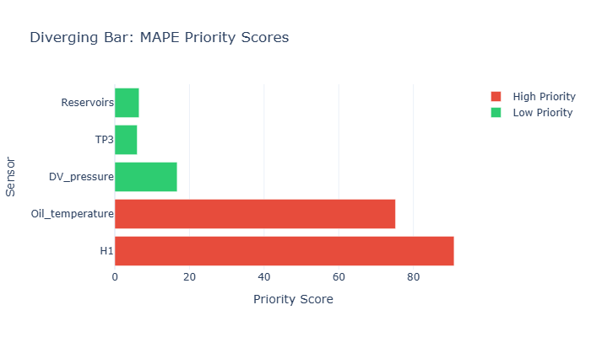  Fig. 6. Signal attention visualization | 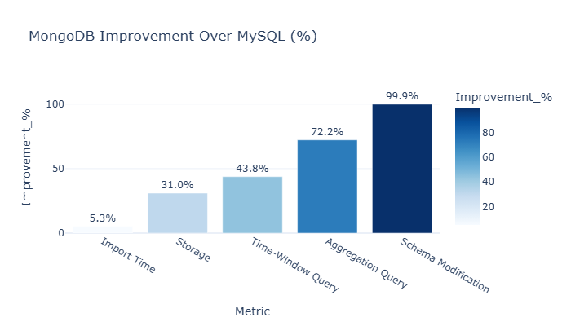  Fig. 7. Database comparison (%)
  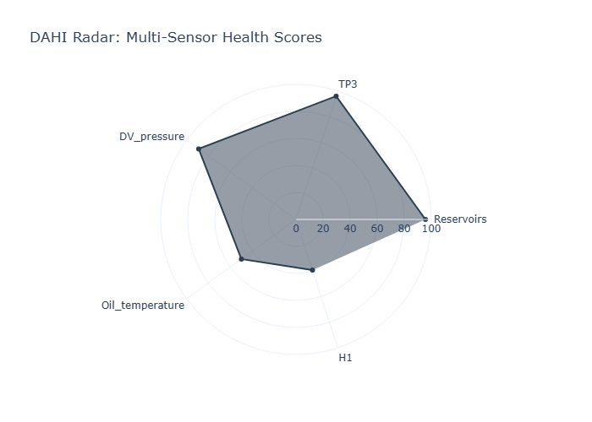  Fig. 8. Sensor health radar | 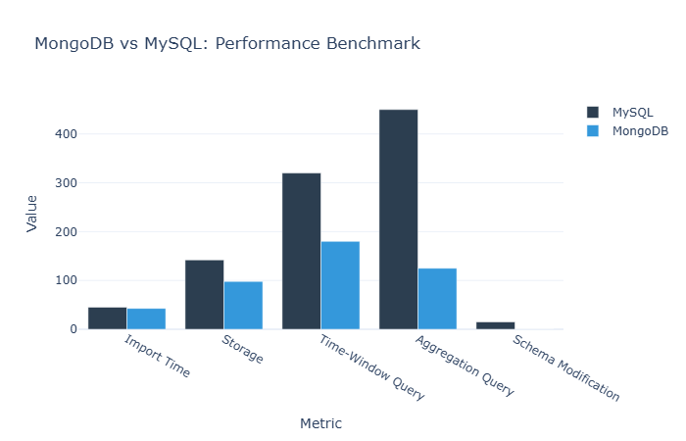  Fig. 9. Comparative workload chart
  Inference: the health plots expose uneven sensor conditions; the benchmark comparison suggests benefits for MongoDB under the tested time-series aggregation workload, not for every possible database workload.
  Evaluation Metrics — Asset Decision Output
  Output | Observed | Meaning
  DAHI: COMP_01 | 39.66 / 100 | Critical / near-critical asset condition; requires attention
  H1 health | 39.4 / 100 | Weak sensor-health contributor
  Oil-temperature health | 49.9 / 100 | Additional weakened contributor
  MAPE priority | 84.1 | High-ranked maintenance attention
  EME | Rule based | Readable inspection recommendations
  AMA | 5 intents | Retrieve health, risk, history and sensor readings
  End-to-end case: abnormal temporal behaviour → COMP_01 health 39.66 → MAPE 84.1 → review H1 and oil-temperature evidence → inspect according to approved maintenance procedures.
  MongoDB vs MySQL — Benchmark Findings
  Workload indicator | MongoDB relative finding | Meaning
  Storage footprint | 31.0% smaller | Compact tested data storage
  Time-window query | 43.8% lower cost | Faster selected window analysis
  Aggregation query | 72.2% lower latency | Faster tested aggregation
  Schema modification | 99.9% less time | Flexible new-field adaptation
  These differences concern one benchmark setup. Hardware, indexes, query definitions and repeated timing logs are needed before generalizing beyond the measured workload.
  Conclusion / Summary
  MaintainIQ integrates a temporal anomaly detector with MongoDB-native health analytics and maintenance decision support. It turns raw anomaly flags into graded asset health, ranked urgency, rule-based explanations and natural-language access. The main contribution is the unified workflow, rather than a new standalone algorithm.
  The current evaluation uses MetroPT-3 from one APU with four documented failure periods. Live operational benefit, reduced downtime and large-scale generalization still require field validation.
  Acknowledgement / References
  Acknowledgement: Vellore Institute of Technology, Chennai, and the researchers who made the MetroPT dataset and related work available for academic study.
  [1] M. Alhammadi, I. Zaiter and R. Jaradat, “An Autoencoder-Based Framework for Time-Series Anomaly Detection in Metro Train Air Production Units,” IEEE GCAIoT, 2025.
  [2] B. Veloso et al., “The MetroPT dataset for predictive maintenance,” Scientific Data, 2022.
  [3] N. Davari et al., “A survey on data-driven predictive maintenance for the railway industry,” Sensors, 2021.
  [4] L. Cummins et al., “Explainable predictive maintenance: A survey,” IEEE Access, 2024.
  Explainable Maintenance Rules — Examples
  Observed condition | Interpretation / inspection cue
  Pressure drop + rising current | Possible leakage or load issue; examine pneumatic path
  High oil temperature | Inspect lubrication level and cooling
  Low reservoir pressure + LPS flag | Review insufficient air-production condition
  These are transparent engineering heuristics, not validated causal diagnoses. The maintenance team makes the final operational decision.
  Next Steps / Future Scope
  Evaluate on additional APUs and operating environments; audit alert burden and false alarms; test the explainability rules with maintenance engineers; validate database benchmarks under controlled hardware settings; and assess real deployment benefits such as faster fault triage.

