# Project Title

The Development of Software to help teach Mathematics to Primary School Children.

By

Nicholas Grahame M. Flint

# Statement of Originality

## CS3D660 Individual Project

This is to certify that, except where specific reference is made, the work described within this project is the result of the investigation carried out by myself, and that neither this project, nor any part of it, has been submitted in candidature for any other award other than this being presently studied.

Any material taken from published texts or computerized sources have been fully referenced, and I fully realize the consequences of plagiarizing any of these sources.

Student Name (Printed) : Nicholas Grahame M. Flint

Student Signature: N. Flint

Registered Course of Study:

Date of Signing:

Abstract

Table of Contents

Project Title 1

Statement of Originality 2

Abstract 3

Introduction 5

Project Statement 5

Project Objectives 5

Details of initial prototyping 6

Project Timeline 7

Literature review 9

Minutes of Meetings 12

National Curriculum in England: Mathematics Programmes of Study 15

Methodology 19

Modifications to the Original Asset 20

Problems and Resolutions 21

Final Product 22

Critical Evaluation 23

Conclusions and Future Work 24

Legal, Social, Ethical and Professional Issues 25

Source Code – C++ Prototype Version 26

Source Code – Unity Final Version 27

Software Used for Development of Prototype 28

Appendix 29

Ethics Checklist 30

References 31

# Introduction

# Project Statement

How best can software be used as a learning aid to help in the education of Key Stage 1 children?

# Project Objectives

* Design and develop a piece of software that is both entertaining for children that is also educational.
* Have multiple sections to cover the majority of the KS1 curriculum
* Create a point system to award children who get the answers correct, and in the time it took them to do so.
* Have the software be visually appealing to school children.

# Details of initial prototyping

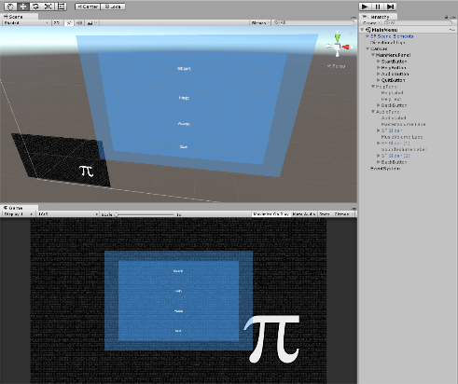One of the problems that has been faced so far is the lack of knowledge using C# and Unity Engine. The first solution to tackling this was to spend a few weeks getting used to the UI of Unity, its tools and following some tutorials to help get a grasp on what the engine has to offer.

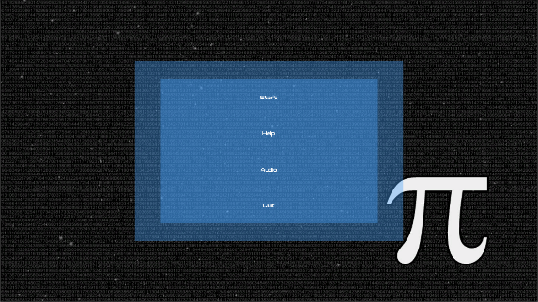Another problem that was faced is that there are only a limited amount of video games that are being used within the classroom, most of which are being made by big studios with experience of making games tailored for children. From the more indie games that were looked into there were common themes of bright colours and a cartoonist approach to the visuals of the game, this will need to be taken into account during the development of the game’s visuals.

So far the experimentation that has been completed within the Unity Engine is the creation of a basic Main Menu UI.

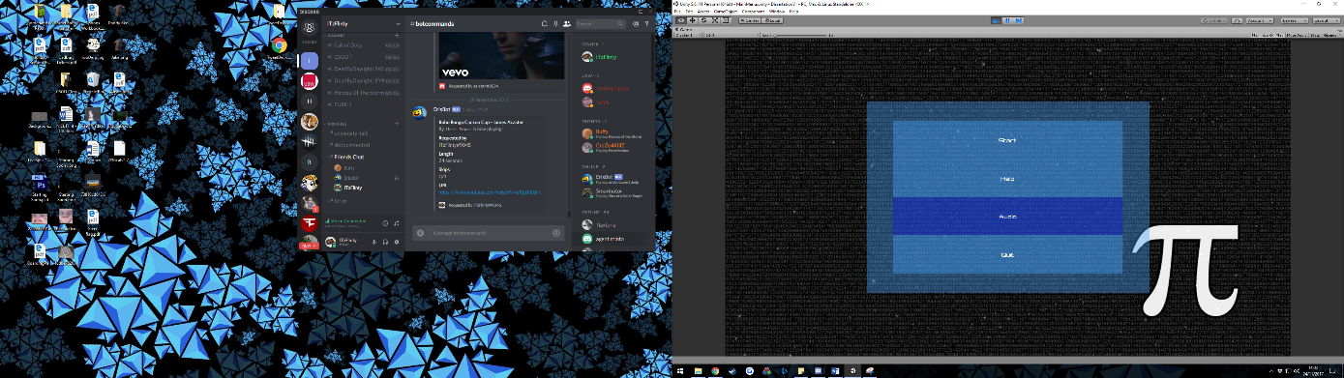The simple main menu that has been created has buttons that will be able to take the user to each of the created menus, whether this be to find the controls or to adjust the audio and video settings or even quit the software from the main menu.

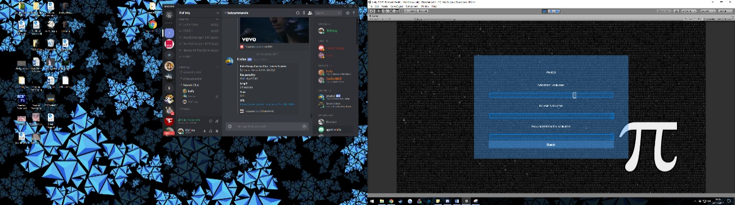When the user hovers the mouse cursor over one of the buttons, it changed to a different colour, and then the colour of the button dims when it is pressed. From the main menu, the user can currently go to the ‘Start’, ‘Help’, ‘Audio’ menus, and quit the program. On the Help Screen the user currently sees a paragraph of placeholder text that will be changed later in development. On the audio menu the user can change sliders that will later be able to adjust volume levels within the program.

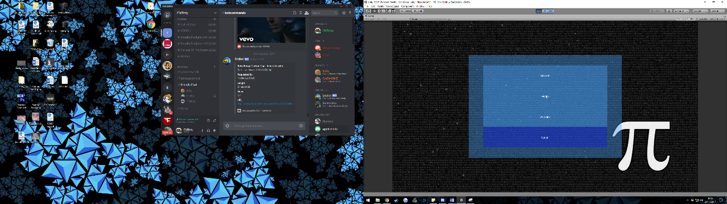From each of these 2 menus the user is able to press a back button to be returned to the main menu. Later in development the user will be able to change the resolution of the software to best suit the device it is being use on. And naturally the main menu will look more visually appealing, however for now the main menu will remain basic as functionality is more important at this stage than how it looks.

The next stage of the development is to improve the menu to have each section for the key Stage 1 curriculum to have its own menu, so that the user can quickly choose which aspect they wish to study. As well as this a list of all the possible questions will need to be written out so that the planning of coding them into the game can begin.

# Project Timeline

## Milestone 1 – 24/11/2017

* Get Unity Installed and become familiar with the UI and development tools
* Look into previously made games for classroom use.
* Look for and follow tutorials to get an idea on developing a game in unity
* Narrow down the sections of the Key Stage that will need to be developed
* Conduct background reading around the use and appliances of video games within the classroom.
* Have a basic main menu UI created as a base to start the Unity Development
* Have a list of all the questions and subject areas that will need to be included.

## Milestone 2 – 02/02/2018

Prototype

* Have The menu UI completed to go to and from every section and exit
* Start, section by section implementing each of the question choices into the software
* Have a very basic graphical design for the software
* Implement a score system based on:
  + Time taken to complete the set of questions
  + Number of mistakes made
  + Difficulty of Questions answered
* Have a screen at the end of a question set showing in green the answers that are correct and those that are incorrect, and then display the correct answer.
* Have a local score board on the device to see the score achieved
* Have details the whole way through on the development process.
  + Problems faced
  + Tasks completed
  + Resources used for guidance
* Have a different build number for each major update in development e.g. 1.0.1, 1.0.2, 1.1.0,
* Be working on graphical designs for the product.

## Milestone 3 – 20/04/2018

* Consistently be adding to the report under the headings
  + Title Page
  + Statement of Originality
  + Abstract
  + Table of Contents
  + Introduction, Problem Statement, Objectives
  + Background Research
  + Methodology
  + Results
  + Critical Evaluation
  + Conclusions and Future Works
  + References
  + Appendices
  + Ethical, Legal, Social and Professional Issues
* Whether the objectives were met or how they changed throughout the project
* Source Code

## Milestone 4 – 04/05/2018

* Presentation
* Poster

# Literature review

For a long time, many schools have adapted to using social games in order to help with the education of children and many people have completed research to explore just what impact these games have on the development of the child’s learning. However, a lot of the time it is argued whether or not video games and other forms of media would help or hinder the children’s learning and motivation.

Technology does in fact have many benefits to assist with education, and in turn, help with keeping children motivated (Anderson, 2000). The use of technology within the classroom can change the way the student perceived the task they are undergoing, making them more motivated to complete the task, increasing both efficiency and self-worth upon completion. Technology can be used to help diversify tasks (Heafner, 2016) allowing children to build on their prior knowledge and develop their own understanding of the content.

In many ways, the computer is one of the most important tools that is of daily access in modern society, so why would we limit kid’s opportunity to play with them. This is the view of (Gray, 2012) who states that children are better at adapting to new situation than adults are, which is why when there is a new technology innovation children learn how to use it quicker than their parents do.

Some of the issues faced that make it difficult for games to be integrated into the curriculum are. Being able to quickly determine whether the game is relevant and how accurate its content is to the curriculum (Kirriemuir & McFarlane Angela, 2006). The lack of time teachers have to familiarise themselves with the game to figure out the best way to use the game for effective learning. And the amount of content within the game that is irrelevant to the subject, that can’t be ignored or removed, and then resulting in a waste of valuable lesson time.

This does not stop many teachers and parent in realising the potential valuable skills that can be developed from games (Kirriemuir & McFarlane Angela, 2006), such as: Strategic thinking, planning, and communication, as well as the application of numbers, negotiating, group decision-making and data handling. For some children, the instant and specific feedback given by games help them to figure out a right way to succeed, and the element of competition or teamwork with their peers has shown to also be motivational for children (Teed, 2016). Which is leading to many schools within the U.S. are having video games taking an ever increasing role of being integrated in their curriculum as teachers can use them to help deliver core lessons, included but not limited to, math, reading and developing new skills such as computer programming (Malykhina, 2014). This gamification of education can lead to children developing technology skills that will help them to succeed within their academic and professional careers in an active form of learning.

One argument tackled by Miller (2011) is that Game Based learning (GBL) is simply just using a game, whether it be physical or on the web, within the classroom and that it required high end technology. He States that Game Based Learning is taking a ‘rigorous unit of study’ and making it into a game that goes in depth to explore the learning concepts, and not just for one day.

Pupil motivation is significantly greater when computer games are integrated into the educational process (Wastiau, et al., 2009). They enjoy that they give more concrete purpose to the work they are doing as the approach of using computer games takes account of their everyday reality. The increase of motivation can be seen to link with the increase in self-confidence some pupils develop, which gives them the opportunity to help and guide less experienced pupils.

The four major concerns surrounding video games and thus halting their potential to be used within the classroom are that they can lead to violent and aggressive behaviour, they can ‘employ destructive gender stereotyping’ (Squire, n.d.), promote unhealthy attitudes and halter creative play. These views are reasonable as the vast majority of mainstream games have a plotline that is more or less ‘kill or be killed’ which also house themes that are inappropriate for the classroom. So far, research has found little to no relationship between the increase of aggressive behaviour and video games.

At Patrick Henry Elementary School, U.S., games are used both formally and informally to help children to connect to the curriculum through play (EducationWorld, n.d.). Prompting the Principal, Marcia Baldanza to say “Children learn best when the content is relevant to them and when they can connect new learning with old.” EducationWorld.com has a list of a few websites that have access to games designed to enrich the learning of school children. These websites are exempt from ad pop-ups, as many young children “have trouble distinguishing between the ads and the games.” One of the key reasons that some schools have chosen to promote the use of educational games is that they help to encourage children to learn outside of the classroom (Teed, 2016), video games are also useful for helping to bridge the Digital Generation Divide as children growing up now have grown accustom to very different technologies that their teachers had used whilst at school.

In an article by the Stanford news (Mackay, 2013) a panel discussion was held at the Graduate School of Education, U.S, discussed “gaming to learn” a concept that was argued to have been around for close to a decade, however it has only been recently that gamification’s properties have been appreciated in education. It was argued that the use of games within education is not simply a matter of dumbing down the learning. Games are actually hard, and are a medium that aid to set our minds free to help humans think better as part of their own network. Steinkuehler, an associate professor of digital media at the University of Wisconsin-Madison, discussed that most massively Multiplayer Online (MMO) games, which include a “system of points, badges, rewards and leader boards” can in fact be replicated within education to help with different peoples motivational needs for ‘interaction and self-expression. It is argued by Steinkuehler that not having access to games that teach the same amount of content than compared to books is not the problem for using games for education, the problem is the approach to using them. With books you learn to read like a writer, with games that will not work and that you need to allow them to play like a designer.

Children in ‘grade 3’ learn that an island is ‘a piece of land surrounded by water on all sides’ however this formal definition is absent from creativity (Mubaslat, 2012), leaving little to nothing to the imagination. A story told by a teacher with descriptions slowly building up an image of what an island is, will help children to have a clearer image, as well as leaving room for them to populate their image with whatever their imagination sees fit. Creative learning through video games is a vast difference to having children sit for hours, listening to what the teacher says.

Active learning allows the children to experience the curriculum in more creative ways. A similar example to this is when Secondary School Children perform experiments in Science classes. It is very easy for a teacher to stand at the front of the class and describe how a chemical reaction works, but allowing the children to witness it for themselves by actively undergoing the experiment, and changing measurements to see how that changed the outcome will help to get the information they are learning to sink in more. Both ways are learning within the classroom, however the experiments are also allowing them to be more creative within their learnings as compared to reading and copying from a textbook.

GlassLab (the Games and learning Assessment Lab) is responsible for some of the most significant research on Game Based Learning. They design and implement ‘game based formative assessments’ in response to the current issue of student disengagement that exists within the classroom (Sharpiro, 2014). Games based learning can be used as an effective tool to provide a more contextualised active learning experience. D’Angelo, et al., (2014) conducted a study which, the results, show that games don’t need to include ‘gold coins or badges’ to motivate players. The reason for this is because there is a distinct difference between gamification and game based learning. The game does not need to be necessarily competitive, as the achievement lies with the ‘learning and understanding’ (Sharpiro, 2014). The results from SRI are ‘hardly surprising’ as a survey from The Joan Ganz Cooney Center (2016) found that ‘55 percent of children play games at least weekly and 78 percent reported using games in the classroom at all.’ (Korbey, 2014). Of the Teachers that were surveyed, 47 percent said low performing children were found to benefit from using games, whereas only 15 percent said that high performing children were also benefiting from playing games.

The bad reputation that is surrounding the ‘generation of gamers’ is mostly ‘based on fear’ (Sharpiro, 2014). This is based on news stories that surround games that make children “hyper, violent, stupid and anti-social.” Whereas games can help to ‘break down the boundaries between academic subjects (Shapiro, 2014).

## Examples

An example of video games that have been used within the classroom is BBC Bitesize, the BBC created a website designed to help with the education of children, from Key Stage 1 all the way through to GCSE. For Key Stage 1, particularly maths, the games and clips they have cover the U.K curriculum, spanning Numbers, Shapes and Movement, Measurements and Data Handling (BBC Bitesize, 2017). BBC Bitesize has been designed to help student with both schoolwork and for older children, exams (Wikipedia, 2017).

MinecraftEdu, a modified version of Minecraft created for classroom use (MinecraftEdu, n.d.), is an example of a mainstream video game that has been extensively developed to help with classroom learning. Granted the game has not been developed for education by Mojang, the creators of Minecraft, directly, TeacherGaming; the company behind MinecraftEdu, licenses the game from Mojang for the explicit purpose of making the game more affordable and accessible to educational institutions worldwide, and is currently in use by teachers in over 40 countries (TeacherGaming, 2017). This modified version of Minecraft was so innovative that Microsoft, who purchased Minecraft in 2014 for $2.5bn (Miller, 2014) have also acquired MinecraftEdu to produce Minecraft: Education Edition (Microsoft, 2017) and develop it further than they necessarily would have been able to before.

The aim for this is to bridge the gap between the researches into how video games can be useful within the educational system, along with working on the examples that have been highlighted above. To work on both the good aspects of each approach, as well as taking into account the problems that have been faced by each example to create a game that is both engaging for the student and is able to keep them motivated to not only keep on playing, but also helping to develop their learning and understanding while doing so.

# Minutes of Meetings

## Meeting 0 – 21/09/2017

* We confirmed the titles for our projects and then began to discuss how we think we should go about undergoing them and what we would like to get out as an end product.
* For the next project meeting we were asked to look up both Agile Development and Waterfall method as the university used to operate under the waterfall method, but this year we are given the option as to which version we want to operate around, based on which we find best suits us.
* We also looked at out timetables to discuss when would be best to have weekly meetings, we decided on Mondays from 13:00 – 14:00 until the end of term 1 when our timetables change.

## Meeting 1 – 25/09/2017

* During this meeting we discussed in more detail the outlines of our project tasks. Nicky and I (as we have the same project title) asked whether our project is to be focused on the entirety of primary years, or whether we are just asked to focus on a particular Key stage of Learning.
* Andrew confirmed that we should more focus on one Key Stage. Thinking about this we realised that if we were going to tackle key stage 2 the product will need to be suitable for key stage 1 as well, so we agreed that it is better off us focusing on Key Stage 1.
* Next Andrew suggested that we think about gamification and how we could make that fit in with our projects. And to come back to next week’s meeting with a page or 2 detailing what we want to produce with screenshots either comparing it to existing pieces of work or showing how we want ours to look.
* During the next week I made sure that I had Unity installed as this is the game engine I have decided to create my project in.

## Meeting 2 – 02/10/2017

* Discussed how we want our projects to work when they are finished
* Started to discuss as a group anything that could be done to help with that development.
* We discussed the background reading that we had done over the past week and Andrew advised that we should spend a few weeks getting used to the software that we have decided to use, which is Unity in all our cases, and follow some tutorials to get us started.
* It is better to spend a few weeks making little progress and learning the software, rather than to dive straight in and not have a clue how to use the software and get stuck.
* Throughout the next week I have had a look at existing games that have been used to aid in the learning of Key Stage 1 pupils. Particularly on Cool Math-Games and BBC Bitesize.

## Meeting 3 – 10/10/2017

* This meeting was rescheduled for the Tuesday rather than the agreed Monday.
* This was a smaller meeting as it had to take part during another of Andrew lessons as it was the only time that was suitable for everyone,
* Nicky was absent due to traffic as an accident had occurred on the roads.
* We discussed our progress over the previous week since our last meeting. I stated how I have been looking at existing maths games to gauge a trend, and I have been looking at C# tutorials that could potentially aid in the development of my project.
* Over the next week I am going to narrow down the section of Key Stage 1 learning that will need to be tackled within my project and see if there are any Unity C# tutorials that can give some assistance with getting a starting point in my project.

## Meeting 4 – 16/10/2017

## Meeting 5 – 23/10/2017

* During this meeting I explained to Andrew that I was not planning on making much progress over the next week as my girlfriend was coming to visit and it was the only time I would be able to see her till Christmas.

## Meeting 6 – 30/10/17

* As stated from last week’s meeting I had done some work on the research and background reading for milestone 1, but besides that not much progress in the form of development for my project was done.
* Nicky and Josh both showed a demo of the progress they had made so far.
* I stated to Andrew that I would be able to have a demo of the menu done for the next meeting.

## Meeting 7 – 06/11/17

* I showed Andrew and the others my menu that I had created following a tutorial to use as a base. After this I showed Andrew the method that I was thinking about using to create the times table aspect of my project. And I wanted to double check that he thought it was a good method or if he could advise doing it another way.
* Andrew wanted us to discuss to make sure that we knew exactly what needed to be put into it and the final project.
* He was a bit shocked when we told him that our final project was not to exceed 10,000 words, as he told us that they are usually 60 to 80 pages of content, whereas 10,000 words would only be around 20.
* He told us he would get back to us on the word count, but to not worry about the limit for now.

Some points that we were advised to keep in mind for our milestone 1 included:

* The information on why we’re going down the game route
* What work has been done on it previously
* And did it have any educational benefits
* Any reviews that have been conducted from the research
* We were told to find studies that have been made in the past for both sides
* For and against the use of using software to teach children, and to reference them accordingly
* Talk about where the projects or studies have succeeded or failed in the past, so that we can work on that to make sure our project works well as intended.

## Meeting 8 – 13/11/2017

Updates on our progress, slowed down due to Milestone 1 hand in drawing closer

## Meeting 9 – 20/11/2017

Updates on progress of milestone 1 as hand in is the end of the week

## Meeting 10 – 27/11/2017

Talked about our milestone 1s and how we felt they went

## Meeting 11 – 4/12/2017

Discussed how our projects are going and explained that we had a deadline at the end of the week and another the following week so work is being prioritised on them.

## Meeting 12 – 11/12/2017

No meeting scheduled as time was being prioritised for deadlines at the end of the week.

## Meeting 13 – 15/01/2018

1st meeting after the Christmas Break, general updates

## Meeting 14 – 22/01/2018

Absent from Meeting

## Meeting 15 – 29/01/2018

Showed off updated menu-ing system and timetable code that I had written in C++ which I now need to convert to C# and implement in unity

# National Curriculum in England: Mathematics Programmes of Study

The following Headings and Bullet points have been taken directly from the Department for Education (2014) and underlie the National Curriculum in England for Years 1 and 2, I have broke them down into subheadings which will be made into the sections of the software that will be developed for this project.

## Addition and Subtraction

Year 1

### Addition

### Subtraction

* read, write and interpret mathematical statements involving addition (+), subtraction (−) and equals (=) signs
* represent and use number bonds and related subtraction facts within 20
* add and subtract one-digit and two-digit numbers to 20, including 0
* Solve one-step problems that involve addition and subtraction, using concrete objects and pictorial representations, and missing number problems such as 7 = ? – 9

Year 2

### Addition

### Subtraction

* solve problems with addition and subtraction:
* using concrete objects and pictorial representations, including those involving numbers, quantities and measures
* applying their increasing knowledge of mental and written methods
* recall and use addition and subtraction facts to 20 fluently, and derive and use related facts up to 100
* add and subtract numbers using concrete objects, pictorial representations, and mentally, including:
* a two-digit number and 1s
* a two-digit number and 10s
* 2 two-digit numbers
* adding 3 one-digit numbers
* show that addition of 2 numbers can be done in any order (commutative) and subtraction of 1 number from another cannot
* recognise and use the inverse relationship between addition and subtraction and use this to check calculations and solve missing number problems

## Multiplication and Division

Year 1

### Multiplication

### Division

* solve one-step problems involving multiplication and division, by calculating the answer using concrete objects, pictorial representations and arrays with the support of the teacher

Year 2

### Multiplication

### Division

### Times Table

* calculate mathematical statements for multiplication and division within the multiplication tables and write them using the multiplication (×), division (÷) and equals (=) signs
* show that multiplication of 2 numbers can be done in any order (commutative) and division of 1 number by another cannot
* solve problems involving multiplication and division, using materials, arrays, repeated addition, mental methods, and multiplication and division facts, including problems in contexts
* recall and use multiplication and division facts for the 2, 5 and 10 multiplication tables, including recognising odd and even numbers

## Days of the Week

## Time

Numbers and Place Values

Year 1

### Place Values

### One More, One Less

### Number Words

* count to and across 100, forwards and backwards, beginning with 0 or 1, or from any given number
* count, read and write numbers to 100 in numerals; count in multiples of 2s, 5s and 10s
* given a number, identify 1 more and 1 less
* identify and represent numbers using objects and pictorial representations including the number line, and use the language of: equal to, more than, less than (fewer), most, least
* read and write numbers from 1 to 20 in numerals and words

Year 2

### Place Values

### More Than, Less Than

### Number Words

* count in steps of 2, 3, and 5 from 0, and in 10s from any number, forward and backward
* recognise the place value of each digit in a two-digit number (10s, 1s)
* identify, represent and estimate numbers using different representations, including the number line
* compare and order numbers from 0 up to 100; use <, > and = signs
* read and write numbers to at least 100 in numerals and in words
* use place value and number facts to solve problems

## Fractions

Year 1

* recognise, find and name a half as 1 of 2 equal parts of an object, shape or quantity
* recognise, find and name a quarter as 1 of 4 equal parts of an object, shape or quantity

Year 2

* recognise, find, name and write fractions 1/3 , 1/4 , 2/4 and 3/4 of a length, shape, set of objects or quantity
* write simple fractions, for example 1/2 of 6 = 3 and recognise the equivalence of 2/4 and 1/2

## Geometry - Shapes 2D/3D

### Shapes: 2D, 3D, Mix

Year 1

Recognise and name common 2-D and 3-D shapes, including:

* 2-D shapes [for example, rectangles (including squares), circles and triangles]
* 3-D shapes [for example, cuboids (including cubes), pyramids and spheres]
* describe position, direction and movement, including whole, half, quarter and three-quarter turns

Year 2

### Shapes: 2D, 3D, Mix

* identify and describe the properties of 2-D shapes, including the number of sides, and line symmetry in a vertical line
* identify and describe the properties of 3-D shapes, including the number of edges, vertices and faces
* identify 2-D shapes on the surface of 3-D shapes, [for example, a circle on a cylinder and a triangle on a pyramid]
* compare and sort common 2-D and 3-D shapes and everyday objects
* order and arrange combinations of mathematical objects in patterns and sequences
* use mathematical vocabulary to describe position, direction and movement, including movement in a straight line and distinguishing between rotation as a turn and in terms of right angles for quarter, half and three-quarter turns (clockwise and anti-clockwise)

## Measurement

Year 1

### Measurements

### Mass / Weight

### Money

### Time

### Days of the Week

* compare, describe and solve practical problems for:
* lengths and heights [for example, long/short, longer/shorter, tall/short, double/half]
* mass/weight [for example, heavy/light, heavier than, lighter than]
* capacity and volume [for example, full/empty, more than, less than, half, half full, quarter]
* time [for example, quicker, slower, earlier, later]
* measure and begin to record the following:
* lengths and heights
* mass/weight
* capacity and volume
* time (hours, minutes, seconds)
* recognise and know the value of different denominations of coins and notes
* sequence events in chronological order using language [for example, before and after, next, first, today, yesterday, tomorrow, morning, afternoon and evening]
* recognise and use language relating to dates, including days of the week, weeks, months and years
* tell the time to the hour and half past the hour and draw the hands on a clock face to show these times

Year 2

### Measurements

### Mass / Weight

### Money

### Time

### Days of the Week

* choose and use appropriate standard units to estimate and measure length/height in any direction (m/cm); mass (kg/g); temperature (°C); capacity (litres/ml) to the nearest appropriate unit, using rulers, scales, thermometers and measuring vessels
* compare and order lengths, mass, volume/capacity and record the results using >, < and =
* recognise and use symbols for pounds (£) and pence (p); combine amounts to make a particular value
* find different combinations of coins that equal the same amounts of money
* solve simple problems in a practical context involving addition and subtraction of money of the same unit, including giving change
* compare and sequence intervals of time
* tell and write the time to five minutes, including quarter past/to the hour and draw the hands on a clock face to show these times
* know the number of minutes in an hour and the number of hours in a day

# Methodology

The way that I have decided to complete the development of the prototype is to develop it to the extent of more than what is required for the curriculum of the students, to make sure there are no apparent errors. And then be able to scale it down so that the sections comply with the knowledge that the student should already know. The expectation of the prototype is not to be used as a learning aid to help teach students, but to be used as a tool to help practise knowledge that they have already learned.

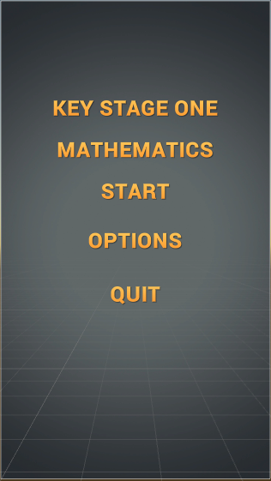One of the major drawbacks that was faced was being able to convert code that is in a familiar language (C++) into C# in visual studio so that it can then be edited to work for Unity Engine.

Being able to write the C# code in Visual Studio is a fair amount different to Unity, even though they are the same language. This is because in Unity you need to add buttons and text boxes which you need to complete a set function, this caused a fair amount of time loss as a lot of time was spent following tutorials to make sure that I can get the functionality correct before getting the project to a standard that can work like a product.

In keeping with the theme of being used in schools, the default resolution of the software will be 16:9, this is because some schools have access to laptops that students can use, and others have tablets such as iPads that can be used in landscape, which would make it easier for children to hold and use.

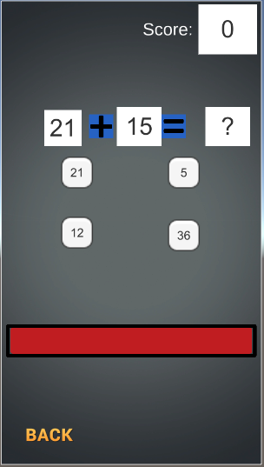As a starting point for the numeracy aspect of the project I have found an Asset on the Unity Store which has a lot of functionality that is similar the end goal that was pictured for the prototype. Now when you select which form of equation you are going to be doing (addition, subtraction, multiplication, division), it loads the Game scene and then the controller of the Maths checks which version you are on and then assigns questions accordingly, for a correct answer you get one point and for an incorrect answer you do not. Also, when a correct answer is given the timer refills but when it runs out the game is over. Currently as the asset is the score does not reset back to 0 when the player hits the retry button or goes back to the menu and tries a different method. This will need to be changed.

I have reached out to the developer of the ‘Maths Challenge’ asset who has given me permission to use their asset as a starting point to be adapted from. Proof of Permission is in Appendix 1.

Addition, Subtraction, Division, Multiplication

Using the asset, making modifications

Times Tables

During the next stage of development, I have implemented the times table section of the prototype only using a small amount of functionality that was within the original asset.

Number Words

Using button presses rather than inputs as this is for younger children who most likely are not able to type as easily as they can press a button.

Days of the week / Months of the year

Using a similar method to the Number Words method

Both sections will ask the child either which [day/month] is the e.g. 3rd in the [week/year], which [day/month] is before or after the one they are given.

# Modifications to the Original Asset

Within the original ‘Maths Challenge’ asset that I have used for a starting point there was a few things that I needed to change to make it more fitting for my target audience. One of these being that, in the original when you pressed the back button to return to the menu after answering questions it would keep the score that you have saved, meaning when you return to the game you will already have points saved, even if you change to a different section. I have changed this so that the score gets reset back to 0, whenever the game is exited or retried. My next step is to have different score variables for different sections so that each can have their own high score saved so that the child that is using it knows how well they have previously done in that specific section.

# Problems and Resolutions

## Getting Started In Unity

One of the problems that I was facing frequently with this project was the programming language that I was developing in. As well as how to manipulate the language to work with Unity’s predefined systems.

The method that I chose to resolve this was to break down the work that I was going to be doing into sections, as would have been done in Unity. I decided that it would be more beneficial to, in practise do more work so that I was able to work faster. I was already familiar with C++ so I decided to make a version of my project within visual studio and have it text based, so that I can see just how I wanted the code to work. Doing this gave me a more firm base to start with when it comes to putting it into Unity and changing it into C# code.

I decided to take a step away from using the ‘Math Challenge’ Asset and wrote the sections in C++ with little to no guidance, so that I knew completely what every single line was doing and why. The main improvement that would need to be completed to the C++ versions it to have it so that the code works through a state machine rather than calling it to re-run the main function each time.

The sections that I could complete in Visual Studio are:

* Addition
* Subtraction
* Division
* Multiplication / Times Tables
* One More One Less
* More Than Less Than
* Days of The Week
* Number Words
* Time

## Duplicate Correct Answers

When implementing the Times Table section I ran into a problem where, because the values never exceeded 60 for times tables below 5, there was a chance where one of the possible answers could be given the same value as the button with the correct answer, meaning it was a 50/50 chance to get it correct, despite selecting the correct value. This will need to be changed so that a button with an answer on cannot equal another, and if it did it will have to pick another random number until they don’t match.

* This problem also occurred during the development of numerous sections, mainly due to the constraints of the random function being smaller.

## Input Fields

* Errors with input fields on being able to check the answer
* Resorted to using buttons and having them just chose the correct numbers text rather than writing the text themselves.

Number Words

Problem where one of the sections always displays 0 when the section starts

Variables not updating

I have a problem where sometimes the variable that is being displayed on the button is not always updating. So for instance I have a number from the last section being displayed when I am meant to have the text being displayed.

## Same Button As Answer

A common problem that I have experiencd with multiple sections within development is that the first button will always be set to the answer and will never change.

# Final Product

# Critical Evaluation

# Conclusions and Future Work

# Legal, Social, Ethical and Professional Issues

## Legal

The Legal issues that surround this project are the same that surround any computer based company who are developing a digital product. They must make sure that they have the correct licences for the software that they are using. For example the License for Unity Engine to publish and make revenue from projects made within, is different to the student Licence that is being used for this project as this is not intended for commercial publication.

Another issue that computing projects could face is the Intellectual Property rights that surround assets that they could use. They would need to have the relevant permissions detailing how they are allowed to use the IP.

## Social

To make sure that the product is not seen to be tailored towards a specific gender the use of gender neutral colour schemes as a default. If a feature was going to be added to change up the colour scheme that would be later on in production and would have a variety of schemes that are not necessarily aimed towards a single gender.

To combat any socio economic issues this product will be designed to be used within the classroom as a large amount of schools have access to tablets or laptops for students to use and learn form.

## Ethical

One of the Ethical issues that could be faced is the Data Protection Act of 1998 and the Human Rights Act of 1998, as a vast number of Computer based software has some sort of storage on them, to battle this the information that would be stored from the final product of this project will not be used to store any data when the product is not in use, it will not store names or details of any fashion. The only data it will store is a High Score which will be erased after the product has closed.

If any Student Data is to be gathered for the purpose of constructive feedback to improve the product it will be completely anonymous and only for the intent of improving the product to make it suitable for the students, such as colour schemes, font size, sounds and appropriate imagery to make it more engaging for students.

Another issue is that if Children are to test this product in any form then correct measures will need to be taken to make sure the duty of care for the children is not affected in any form. As this is a product that is intended for child use it would need to be worded correctly so that they can coherently understand, it would be unsuitable to use wording and terminology that a child in the target audience would not be familiar with.

## Professional Issues

As this is a research project and not set for where members of the public could gain access, I am unable to foresee any professional issues that could arise with my project or my end deliverable.

# Source Code – C++ Prototype Version

# Source Code – Unity Final Version

# Software Used for Development of Prototype

* Visual Studio 2015
* Adobe Photoshop
* Unity Engine

# Appendix

## Appendix 1

Proof of permission to use the ‘Maths Challenge’ from the Unity Asset Store from the developer as a starting point to build upon.

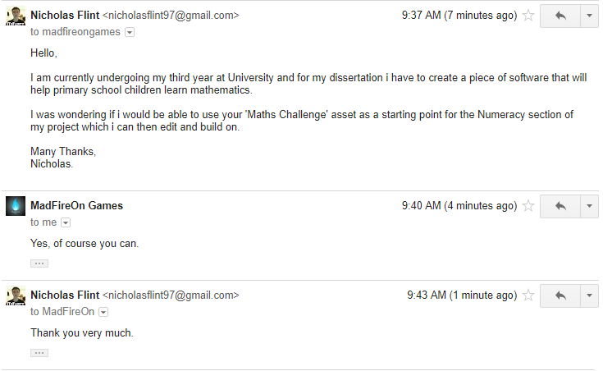

# Ethics Checklist

This form is only applicable for assessed exercises that use other people (‘participants’) for the collection of information, typically in getting comments about a system or a system design, or getting information about how a system could be used, or evaluating a working system.

If your proposed activity does not comply with any one or more of the points below then please contact your project supervisor and/or project coordinator for advice. If your evaluation does comply with all the points below, please sign this form and submit it with your assessed work.

1. Participants were not exposed to any risks greater than those encountered in their normal working life. *Investigators have a responsibility to protect participants from physical and mental harm during the investigation. The risk of harm must be no greater than in ordinary life. Areas of potential risk that require ethical approval include, but are not limited to, investigations that occur outside usual laboratory areas, or that require participant mobility (e.g. walking, running, use of public transport), unusual or repetitive activity or movement, that use sensory deprivation (e.g. ear plugs or blindfolds), bright or flashing lights, loud or disorienting noises, smell, taste, vibration, or force feedback.*
2. The experimental materials were paper-based, or comprised software running on standard hardware. *Participants should not be exposed to any risks associated with the use of non-standard equipment: anything other than pen-and-paper, standard PCs, mobile phones and PDAs.*
3. All participants explicitly stated that they agreed to take part, and that their data could be used in the project. If the results of the evaluation are likely to be used beyond the term of the project (for example, the software is to be deployed, or the data is to be published), then signed consent is necessary. A separate consent form should be signed by each participant. Otherwise, verbal consent is sufficient, and should be explicitly requested in the introductory script.
4. No incentives were offered to the participants. The payment of participants must not be used to induce them to risk harm beyond that which they risk without payment in their normal lifestyle.
5. No information about the evaluation or materials was intentionally withheld from the participants. Withholding information or misleading participants is unacceptable if participants are likely to object or show unease when debriefed.
6. No participant was under the age of 16. Parental consent is required for participants under the age of 16.
7. No participant has an impairment that may limit their understanding or communication. Additional consent is required for participants with impairments.
8. Neither I nor my supervisor is in a position of authority or influence over any of the participants. A position of authority or influence over any participant must not be allowed to pressurise participants to take part in, or remain in, any experiment.
9. All participants were informed that they could withdraw at any time. All participants have the right to withdraw at any time during the investigation. They should be told this in the introductory script.
10. All participants have been informed of my contact details. All participants must be able to contact the investigator after the investigation. They should be given the details of both student and module co-ordinator or supervisor as part of the debriefing.
11. The evaluation was discussed with all the participants at the end of the session, and all participants had the opportunity to ask questions. The student must provide the participants with sufficient information in the debriefing to enable them to understand the nature of the investigation.
12. All the data collected from the participants is stored in an anonymous form. All participant data (hard-copy and soft-copy) should be stored securely, and in anonymous form.

Student Name: Nicholas Flint

Student ID: 15008134

Student’s Signature: N.Flint

Date: 10/11/17

# References

Anderson, M. A. (2000). It’s in the research. Library Talk, 13(1), 31-33.

BBC Bitesize, 2017. *BBC Bitesize.* [Online]   
Available at: https://www.bbc.co.uk/education  
[Accessed 23 November 2017].

D’Angelo, C. et al., 2014. *Simulations for STEM Learning: Systematic Review and Meta-Analysis.* Menlo Park: SRI Education.

Department for Education, 2014. *National curriculum in England: mathematics programmes of study.* [Online]   
Available at: https://www.gov.uk/government/publications/national-curriculum-in-england-mathematics-programmes-of-study/national-curriculum-in-england-mathematics-programmes-of-study  
[Accessed 22 November 2017].

Doran, J., 2016. *Unity 5.x Game Development Blueprints.* Birmingham: Packt Publishing Ltd.

EducationWorld, n.d. *Teaching With Games.* [Online]   
[Accessed 23 November 2017].

Gray, P., 2012. *The Many Benefits, for Kids, of Playing Video Games.* [Online]   
[Accessed 23 November 2017].

Heafner, T., 2016. *Using Technology to Motivate Students to learn Social Studies.* [Online]   
Available at: http://www.citejournal.org/volume-4/issue-1-04/social-studies/using-technology-to-motivate-students-to-learn-social-studies/  
[Accessed 23 November 2017].

Herger, M., 2011. *Gamification Facts & Figures.* [Online]   
Available at: http://enterprise-gamification.com/index.php?option=com_content&view=article&id=41&Itemid=26&lang=en  
[Accessed 23 November 2017].

Hocking, J., 2015. *Unity In Action.* s.l.:Manning Publications Co..

ICANSEEYOU7687, 2009. *Making a Wait In Milliseconds Function.* [Online]   
Available at: http://www.cplusplus.com/forum/beginner/15716/  
[Accessed 29 January 2018].

Kirriemuir, J. & McFarlane Angela, U. o. B., 2006. *Literature Review in.* Bristol: FutureLab.

Korbey, H., 2014. *Surprising Insights: How Teachers Use Games in the Classroom.* [Online]   
Available at: https://ww2.kqed.org/mindshift/2014/06/09/surprising-insights-how-teachers-use-games-in-the-classroom/  
[Accessed 23 November 2017].

Lavieri, E., 2015. *Getting Started with Unity 5.* Birmingham: Packt Publishing Ltd.

Lukosek, G., 2016. *Learning C# by Developing Games with Unity 5.x.* 2nd ed. Birmingham: Packt Publishing Ltd.

Mackay, R. F., 2013. *Playing to learn: Panelists at Stanford discussion say using games as an educational tool provides opportunities for deeper learning.* [Online]   
Available at: https://news.stanford.edu/2013/03/01/games-education-tool-030113/  
[Accessed 23 November 2017].

Malykhina, E., 2014. *Fact or Fiction?: Video Games Are the Future of Education.* [Online]   
Available at: https://www.scientificamerican.com/article/fact-or-fiction-video-games-are-the-future-of-education/  
[Accessed 23 November 2017].

MarketsAndMarkets, 2016. *Gamification Market by Solution (Consumer driven and Enterprise driven), Applications (Sales and Marketing), Deployment Type (On-Premises and Cloud), User Type (Large Enterprise, SMBs), Industry and Region - Global Forecast to 2020,* s.l.: Markets And Markets.

Microsoft, 2017. *Minecraft: Education Edition.* [Online]   
Available at: https://education.minecraft.net/  
[Accessed 23 November 2017].

Miller, A., 2011. *Game-Based Learning Units for the Everyday Teacher.* [Online]   
Available at: https://www.edutopia.org/blog/video-game-model-unit-andrew-miller  
[Accessed 23 November 2017].

Miller, J., 2014. *Microsoft pays $2.5bn for Minecraft maker Mojang.* [Online]   
Available at: http://www.bbc.co.uk/news/technology-29204518  
[Accessed 23 November 2017].

MinecraftEdu, n.d. *What is MinecradtEdu.* [Online]   
Available at: https://wiki.education.minecraft.net/wiki/What_is_MinecraftEdu  
[Accessed 23 November 2017].

Moursund, D., 2007. *Introduction to Using Games in Education: A Guide for Teachers and Parents,* s.l.: University of Oregon.

Mubaslat, M., 2012. *The Effect of Using Educational Games on the Students’ Achievement in English Language for the Primary Stage,* Jordan: s.n.

Sakamoto, T., n.d. *Present State of Videogames and Learning Games – Use and Effects,* Tokyo: s.n.

Shapiro, J., 2014. *Math, Science, History: Games Break Boundaries Between Subjects.* [Online]   
Available at: https://ww2.kqed.org/mindshift/2014/05/08/math-science-history-games-break-boundaries-between-subjects-interdisciplinary-learning/  
[Accessed 23 November 2017].

Sharpiro, J., 2014. *Games In The Classroom: What the Research Says.* [Online]   
Available at: https://ww2.kqed.org/mindshift/2014/06/27/games-in-the-classroom-what-the-research-says/  
[Accessed 23 November 2017].

Smith, M. & Queiroz, C., 2015. *Unity 5.x Cookbook.* Birmingham: Packt Publishing Ltd.

Smith-Robbins, S., 2011. "This Game Sucks": How to Improve the Gamification of Education. 7 February.

Squire, K., n.d. *Video Games In Education,* Cambridge: Massachusetts Institute of Technology.

Takeuchi, L. & Vaala, S., 2014. *Level up learning: A National Survey On Teaching with Digital games,* New York: The Joan Ganz Cooney Center.

TeacherGaming, 2017. *What is MinecraftEdu.* [Online]   
Available at: https://wiki.education.minecraft.net/wiki/What_is_MinecraftEdu  
[Accessed 23 November 2017].

Teed, R., 2016. *Game-Based Learning.* [Online]   
Available at: https://serc.carleton.edu/introgeo/games/index.html  
[Accessed 23 November 2017].

The Joan Ganz Cooney Center, 2016. *The Joan Ganz Cooney Center.* [Online]   
Available at: http://joanganzcooneycenter.org  
[Accessed 23 November 2017].

Thorn, A., 2016. *Unity 5.x By Example.* Birmingham: Packt Publishing Ltd.

Wastiau, P., Kearney, C. & Van den Berghe, W., 2009. *How are Digital Games used in schools,* Belgium: European Schoolnet.

Wikipedia, 2017. *Bitesize.* [Online]   
Available at: https://en.wikipedia.org/wiki/Bitesize  
[Accessed 23 November 2017].