De randomizing for better run-ability

* Loop limit – to make sure every loop will finish we inject code to make it break after a configurable number of runs.  
  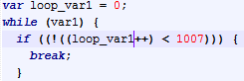  
  loop_var1- 1 is generated via a running counter  
  1007 – is chosen from normal probability *LOOP_MAX_ITERATIONS_NORMAL_EXP*
* First statement is a var declaration
* Object Expression cannot be generated as a statement
  + Js does not allow it if some key is a string (which is allowed if the ObjExpr is not a statement).