De randomizing for better run-ability

* **Loop limit** – to make sure every loop will finish we inject code to make it break after a configurable number of runs.  
  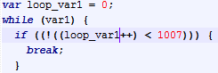  
  loop_var1- 1 is generated via a running counter  
  1007 – is chosen from normal probability *LOOP_MAX_ITERATIONS_NORMAL_EXP*
* **First statement is** **always a** **var declaration**  
  some statements relay on the existence of at least one global variable
* **Object Expression cannot be generated as a statement**  
  JS does not allow it, if some key is a string (which is allowed if the Obj Expr is not a statement).