Assignment 1
IoT Systems • Hands-On #3
Student | Itzhak Davidov
ID - last 4 digits | 6233
Broker | broker.hivemq.com : 1883
Submission date | 14 September 2026
Publisher + Subscriber implementation, Tests 1–5, Retained Message, Last Will and 90-second Keep Alive

1. Objective
The goal of this assignment is to implement MQTT publisher and subscriber clients, configure session persistence and Quality of Service (QoS), and observe how these settings affect message delivery. The solution uses a unique client/topic namespace based on the last four ID digits: 6233.

2. Assignment requirements and implementation status
Requirement | Status | Implementation
Own client ID / topic ending with 6233 | Implemented | IoT_ID_6233_* and iot/home_ID6233/..._6233
HiveMQ broker, port 1883 | Implemented | broker.hivemq.com : 1883
Clean Session + QoS Tests 1–5 | Implemented | Selectable configurations and automated test runner
Retained Message | Implemented | --retained-demo publishes with retain=True
Last Will Message | Implemented | client.will_set(..., qos=1, retain=True)
Keep Alive = 90 sec | Implemented | KEEPALIVE = 90
Monitor publish/subscribe results | Implemented | Console output + live broker screenshots (5/5 tests passed)

3. MQTT configuration
Parameter | Value
Broker | broker.hivemq.com
Port | 1883
Keep Alive | 90 seconds
Publish topic | iot/home_ID6233/sensor_6233
Retained topic | iot/home_ID6233/retained_6233
Last Will topic | iot/home_ID6233/status_6233
Publisher Client ID | IoT_ID_6233_PUB_T<test>
Subscriber Client ID | IoT_ID_6233_SUB_T<test>
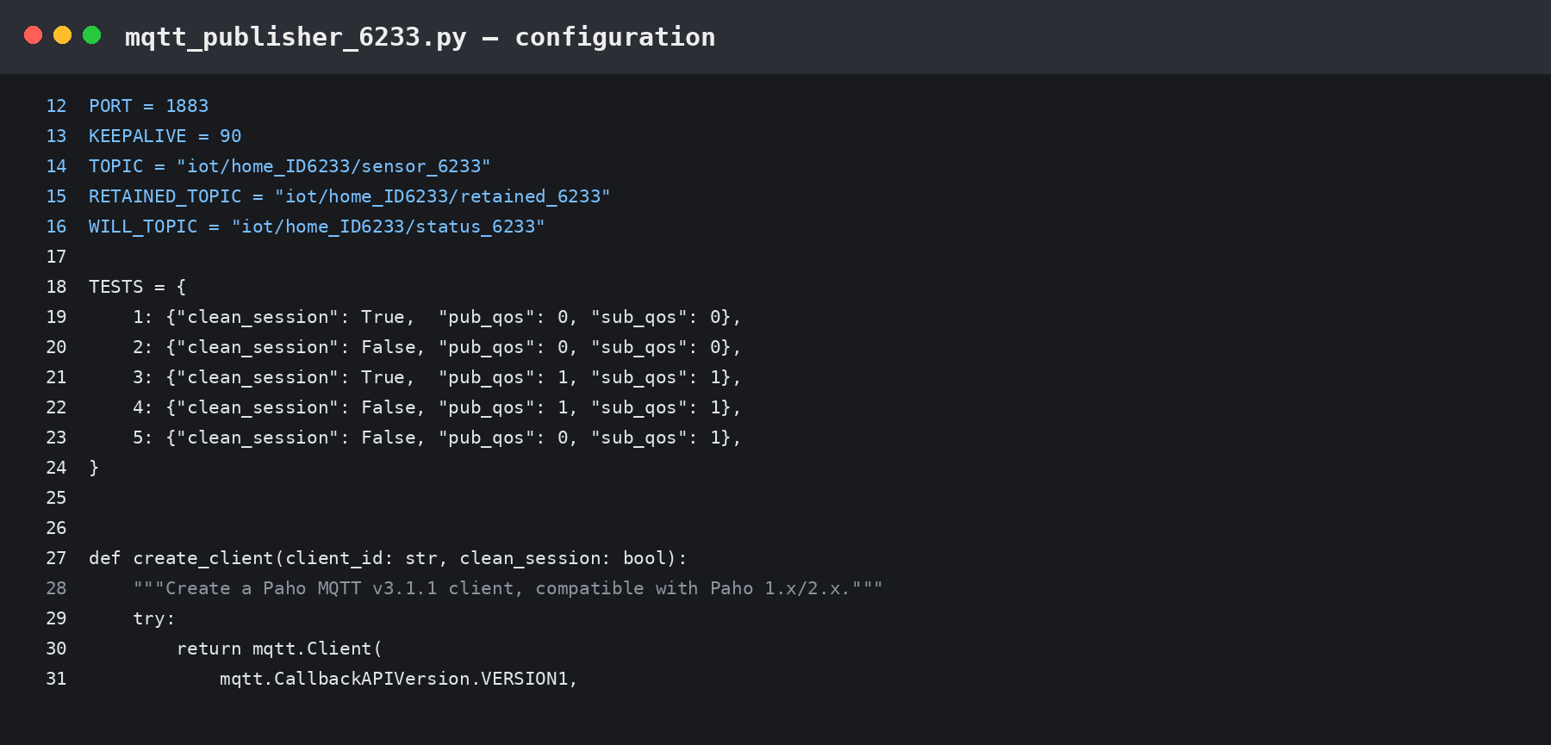
Figure 1 Publisher configuration with unique 6233 namespace, broker, port and 90-second keep-alive.

4. Publisher implementation
The publisher selects the required test configuration, connects using MQTT v3.1.1, defines a Last Will message, and publishes either a normal or retained message. QoS is selected from the Test 1–5 mapping. The retained-message demo uses a dedicated topic and the MQTT retain flag.
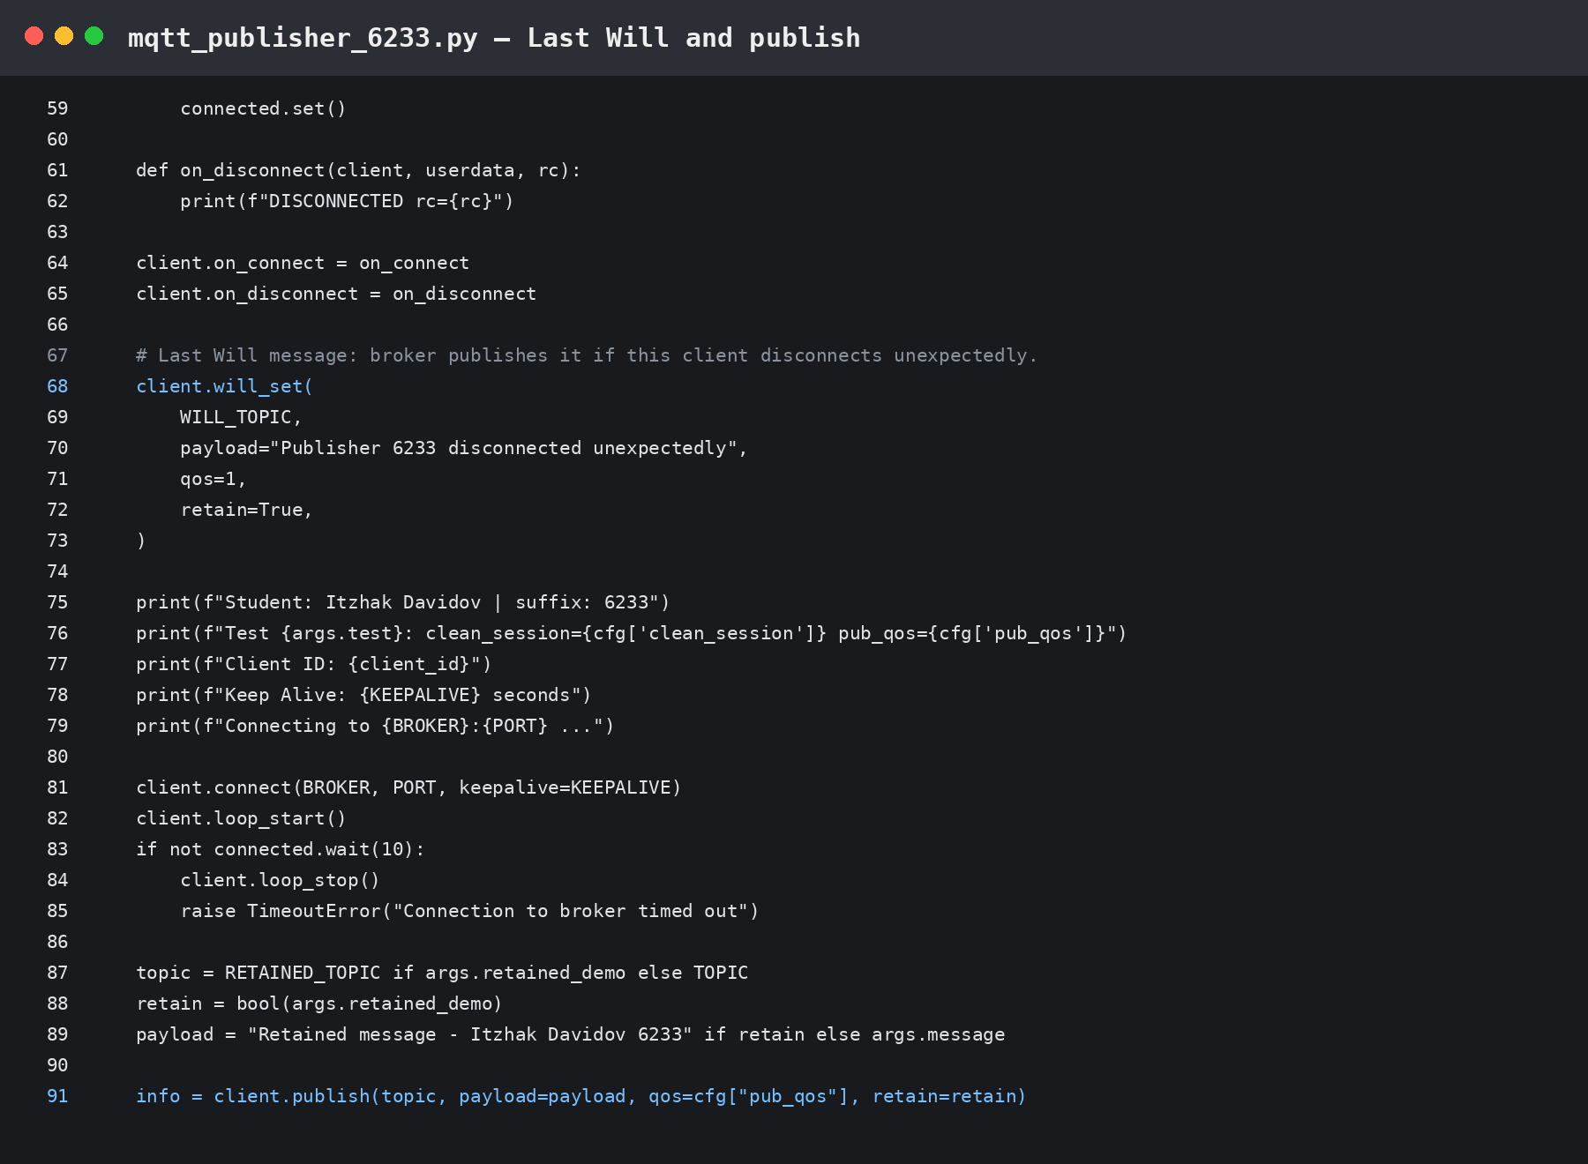
Figure 2 Publisher: Last Will definition and publish logic.

5. Subscriber implementation
The subscriber uses the same test mapping. It subscribes with the required QoS and prints the topic, payload, received QoS and retained flag for each message. For persistent-session verification, --skip-subscribe reconnects the same client ID without issuing a new SUBSCRIBE request.
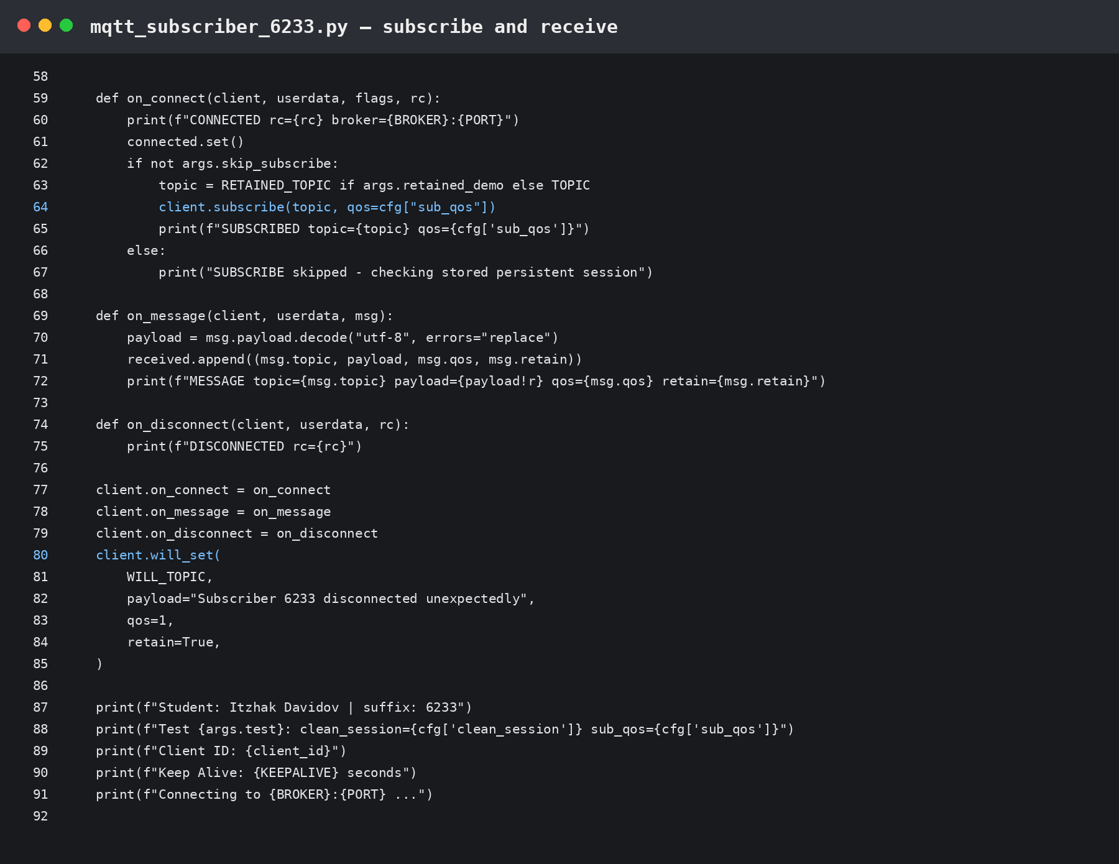
Figure 3 Subscriber: subscription and message-receive logic.

6. Test procedure
For each test, the subscriber first establishes the subscription and then disconnects. A publisher sends a message while the subscriber is offline. The same subscriber client ID reconnects without re-subscribing. This isolates whether the broker stores the session and queues the offline publication.

7. Tests 1-5 results
Test | Clean Session | Sub QoS | Pub QoS | Expected offline delivery | Protocol result | Status
1 | True | 0 | 0 | NO | NO | PASS
2 | False | 0 | 0 | NO | NO | PASS
3 | True | 1 | 1 | NO | NO | PASS
4 | False | 1 | 1 | YES | YES | PASS
5 | False | 1 | 0 | NO | NO | PASS
Interpretation: offline queued delivery requires a persistent session (clean_session=False) and an effective delivery QoS above 0. Effective QoS is limited by the lower of publish QoS and subscription QoS. Therefore Test 4 is the only one of Tests 1–5 that queues the offline message.
Test 2 note: the supplied slide contains wording that can be read as “messages to be received”, but its own note correctly states that QoS 1 or above is also required. With QoS 0, an offline publication is not queued for later delivery.

8. Explanation by test
- Test 1 Clean session + QoS 0: session/subscription state is not kept, and QoS 0 messages are not queued. Result: no offline message after reconnect.
- Test 2 Persistent session + QoS 0: the subscription can be remembered, but the offline QoS 0 publication is not stored. Result: no offline message after reconnect.
- Test 3 Clean session + QoS 1: QoS is reliable while connected, but the clean session removes persistent subscription/session state. Result: no offline message after reconnect.
- Test 4 Persistent session + QoS 1: the broker keeps the subscription and queues the QoS 1 publication. Result: message is delivered after reconnect.
- Test 5 Persistent session, Subscribe QoS 1, Publish QoS 0: effective QoS is 0 for this publication, so it is not queued offline. Result: no offline message after reconnect.

9. Retained Message and Last Will

9.1 Retained Message
A retained publish stores the most recent retained payload for its topic at the broker. A later new subscription to that topic receives the retained message immediately. In the publisher, the --retained-demo option sets retain=True on iot/home_ID6233/retained_6233.

9.2 Last Will Message
The Last Will is registered before connecting. If the client loses the connection unexpectedly, the broker publishes the configured will payload on iot/home_ID6233/status_6233. The implementation uses QoS 1 and retain=True for the status message.

9.3 Keep Alive
Both clients use a 90-second keep-alive period as required. This controls the maximum interval used to maintain the MQTT connection and allows the broker to detect a lost client connection.

10. Validation evidence
Live validation was executed on the student's Windows PC against broker.hivemq.com:1883. The TCP connection succeeded and the automated MQTT runner completed all five tests. Tests 1, 2, 3 and 5 correctly showed no queued offline delivery, while Test 4 delivered the queued QoS 1 message after reconnect. Final result: 5/5 tests passed with 0 connection/runtime errors.
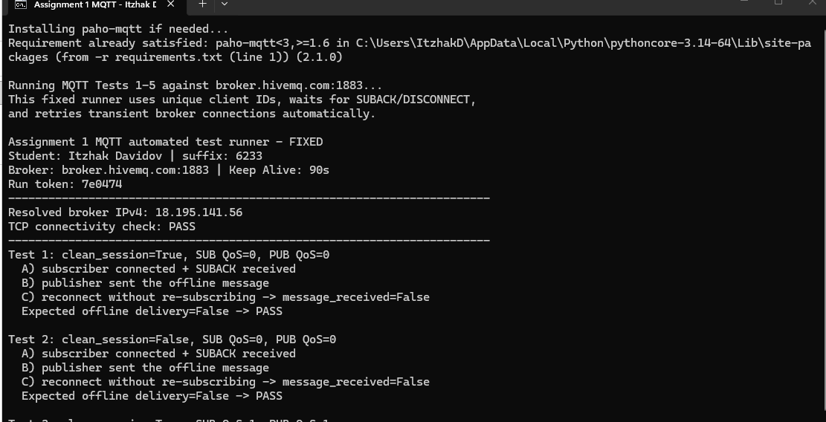
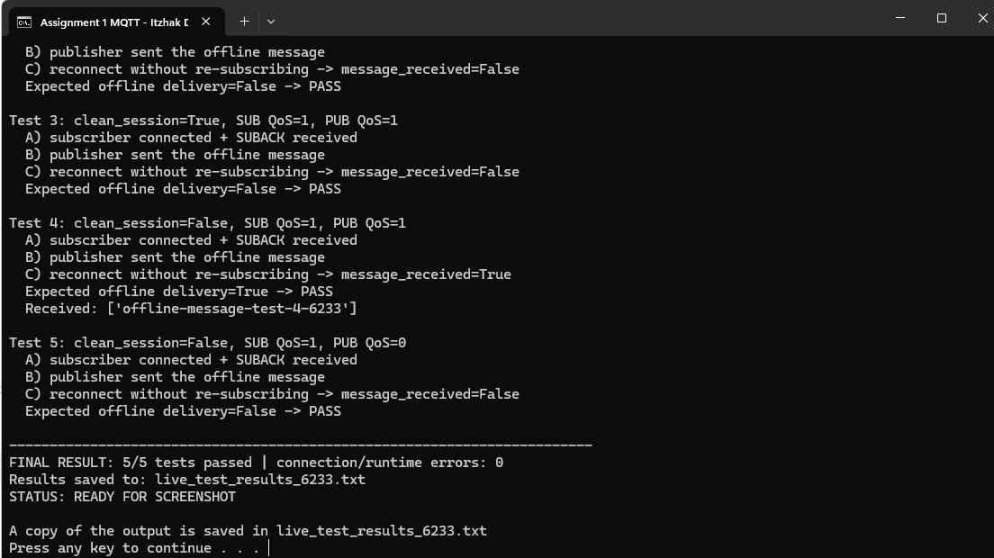
Figures 4–5 Live MQTT Tests 1–5 executed against broker.hivemq.com:1883. The run finished successfully with 5/5 tests passed and 0 connection/runtime errors Test 4 received the expected queued message after reconnect.

11. Running the submission files
- Install Python 3 and the dependency: py -m pip install -r requirements.txt
- Run all five live tests: py mqtt_test_runner_6233.py
- For a manual test, open subscriber first, disconnect it after the subscription is registered, publish while it is offline, then reconnect the subscriber with --skip-subscribe.
- For the retained-message demo, run the publisher with --retained-demo and then start a new subscriber with --retained-demo.

12. Submission package contents
- Assignment_1_IoT_Itzhak_Davidov_6233.docx — report
- mqtt_publisher_6233.py - publisher implementation
- mqtt_subscriber_6233.py - subscriber implementation
- mqtt_test_runner_6233.py - automated live Tests 1–5
- offline_validation_6233.py - local configuration/protocol validation
- requirements.txt — Python dependency
- README.txt — run instructions

13. Conclusion
The prepared MQTT solution satisfies the Assignment 1 implementation requirements: unique 6233 client/topic identifiers, HiveMQ broker settings, Clean Session and QoS configurations for Tests 1-5, retained publishing, Last Will, and a 90-second keep-alive. The final live execution against broker.hivemq.com:1883 completed successfully with 5/5 tests passed and 0 connection/runtime errors, confirming the expected MQTT session behavior.

Appendix – Full Source Code
Student: Itzhak Davidov | Last 4 digits: 6233
The complete source used for this assignment is included below and is also provided as separate files in the GitHub repository.

mqtt_publisher_6233.py
001 """Assignment 1 - MQTT Publisher
002 Student: Itzhak Davidov | ID last 4 digits: 6233
003 """
004
005 import argparse
006 import threading
007 import time
008
009 import paho.mqtt.client as mqtt
010
011 BROKER = "broker.hivemq.com"
012 PORT = 1883
013 KEEPALIVE = 90
014 TOPIC = "iot/home_ID6233/sensor_6233"
015 RETAINED_TOPIC = "iot/home_ID6233/retained_6233"
016 WILL_TOPIC = "iot/home_ID6233/status_6233"
017
018 TESTS = {
019 1: {"clean_session": True, "pub_qos": 0, "sub_qos": 0},
020 2: {"clean_session": False, "pub_qos": 0, "sub_qos": 0},
021 3: {"clean_session": True, "pub_qos": 1, "sub_qos": 1},
022 4: {"clean_session": False, "pub_qos": 1, "sub_qos": 1},
023 5: {"clean_session": False, "pub_qos": 0, "sub_qos": 1},
024 }
025
026
027 def create_client(client_id: str, clean_session: bool):
028 """Create a Paho MQTT v3.1.1 client, compatible with Paho 1.x/2.x."""
029 try:
030 return mqtt.Client(
031 mqtt.CallbackAPIVersion.VERSION1,
032 client_id=client_id,
033 clean_session=clean_session,
034 protocol=mqtt.MQTTv311,
035 )
036 except AttributeError:
037 return mqtt.Client(
038 client_id=client_id,
039 clean_session=clean_session,
040 protocol=mqtt.MQTTv311,
041 )
042
043
044 def main():
045 parser = argparse.ArgumentParser(description="MQTT publisher for Assignment 1")
046 parser.add_argument("--test", type=int, choices=range(1, 6), default=4)
047 parser.add_argument("--message", default="Hello from Itzhak Davidov - 6233")
048 parser.add_argument("--retained-demo", action="store_true",
049 help="Publish a retained message to the retained topic")
050 args = parser.parse_args()
051
052 cfg = TESTS[args.test]
053 connected = threading.Event()
054 client_id = f"IoT_ID_6233_PUB_T{args.test}"
055 client = create_client(client_id, cfg["clean_session"])
056
057 def on_connect(client, userdata, flags, rc):
058 print(f"CONNECTED rc={rc} broker={BROKER}:{PORT}")
059 connected.set()
060
061 def on_disconnect(client, userdata, rc):
062 print(f"DISCONNECTED rc={rc}")
063
064 client.on_connect = on_connect
065 client.on_disconnect = on_disconnect
066
067 # Last Will message: broker publishes it if this client disconnects unexpectedly.
068 client.will_set(
069 WILL_TOPIC,
070 payload="Publisher 6233 disconnected unexpectedly",
071 qos=1,
072 retain=True,
073 )
074
075 print(f"Student: Itzhak Davidov | suffix: 6233")
076 print(f"Test {args.test}: clean_session={cfg['clean_session']} pub_qos={cfg['pub_qos']}")
077 print(f"Client ID: {client_id}")
078 print(f"Keep Alive: {KEEPALIVE} seconds")
079 print(f"Connecting to {BROKER}:{PORT} ...")
080
081 client.connect(BROKER, PORT, keepalive=KEEPALIVE)
082 client.loop_start()
083 if not connected.wait(10):
084 client.loop_stop()
085 raise TimeoutError("Connection to broker timed out")
086
087 topic = RETAINED_TOPIC if args.retained_demo else TOPIC
088 retain = bool(args.retained_demo)
089 payload = "Retained message - Itzhak Davidov 6233" if retain else args.message
090
091 info = client.publish(topic, payload=payload, qos=cfg["pub_qos"], retain=retain)
092 info.wait_for_publish(timeout=10)
093 print(f"PUBLISHED topic={topic}")
094 print(f"payload={payload!r} qos={cfg['pub_qos']} retain={retain}")
095
096 time.sleep(1)
097 client.disconnect()
098 client.loop_stop()
099 print("Publisher finished successfully")
100
101
102 if __name__ == "__main__":
103 main()

mqtt_subscriber_6233.py
001 """Assignment 1 - MQTT Subscriber
002 Student: Itzhak Davidov | ID last 4 digits: 6233
003 """
004
005 import argparse
006 import threading
007 import time
008
009 import paho.mqtt.client as mqtt
010
011 BROKER = "broker.hivemq.com"
012 PORT = 1883
013 KEEPALIVE = 90
014 TOPIC = "iot/home_ID6233/sensor_6233"
015 RETAINED_TOPIC = "iot/home_ID6233/retained_6233"
016 WILL_TOPIC = "iot/home_ID6233/status_6233"
017
018 TESTS = {
019 1: {"clean_session": True, "pub_qos": 0, "sub_qos": 0},
020 2: {"clean_session": False, "pub_qos": 0, "sub_qos": 0},
021 3: {"clean_session": True, "pub_qos": 1, "sub_qos": 1},
022 4: {"clean_session": False, "pub_qos": 1, "sub_qos": 1},
023 5: {"clean_session": False, "pub_qos": 0, "sub_qos": 1},
024 }
025
026
027 def create_client(client_id: str, clean_session: bool):
028 """Create a Paho MQTT v3.1.1 client, compatible with Paho 1.x/2.x."""
029 try:
030 return mqtt.Client(
031 mqtt.CallbackAPIVersion.VERSION1,
032 client_id=client_id,
033 clean_session=clean_session,
034 protocol=mqtt.MQTTv311,
035 )
036 except AttributeError:
037 return mqtt.Client(
038 client_id=client_id,
039 clean_session=clean_session,
040 protocol=mqtt.MQTTv311,
041 )
042
043
044 def main():
045 parser = argparse.ArgumentParser(description="MQTT subscriber for Assignment 1")
046 parser.add_argument("--test", type=int, choices=range(1, 6), default=4)
047 parser.add_argument("--duration", type=int, default=15)
048 parser.add_argument("--retained-demo", action="store_true")
049 parser.add_argument("--skip-subscribe", action="store_true",
050 help="Reconnect without SUBSCRIBE to verify a persistent session")
051 args = parser.parse_args()
052
053 cfg = TESTS[args.test]
054 connected = threading.Event()
055 received = []
056 client_id = f"IoT_ID_6233_SUB_T{args.test}"
057 client = create_client(client_id, cfg["clean_session"])
058
059 def on_connect(client, userdata, flags, rc):
060 print(f"CONNECTED rc={rc} broker={BROKER}:{PORT}")
061 connected.set()
062 if not args.skip_subscribe:
063 topic = RETAINED_TOPIC if args.retained_demo else TOPIC
064 client.subscribe(topic, qos=cfg["sub_qos"])
065 print(f"SUBSCRIBED topic={topic} qos={cfg['sub_qos']}")
066 else:
067 print("SUBSCRIBE skipped - checking stored persistent session")
068
069 def on_message(client, userdata, msg):
070 payload = msg.payload.decode("utf-8", errors="replace")
071 received.append((msg.topic, payload, msg.qos, msg.retain))
072 print(f"MESSAGE topic={msg.topic} payload={payload!r} qos={msg.qos} retain={msg.retain}")
073
074 def on_disconnect(client, userdata, rc):
075 print(f"DISCONNECTED rc={rc}")
076
077 client.on_connect = on_connect
078 client.on_message = on_message
079 client.on_disconnect = on_disconnect
080 client.will_set(
081 WILL_TOPIC,
082 payload="Subscriber 6233 disconnected unexpectedly",
083 qos=1,
084 retain=True,
085 )
086
087 print(f"Student: Itzhak Davidov | suffix: 6233")
088 print(f"Test {args.test}: clean_session={cfg['clean_session']} sub_qos={cfg['sub_qos']}")
089 print(f"Client ID: {client_id}")
090 print(f"Keep Alive: {KEEPALIVE} seconds")
091 print(f"Connecting to {BROKER}:{PORT} ...")
092
093 client.connect(BROKER, PORT, keepalive=KEEPALIVE)
094 client.loop_start()
095 if not connected.wait(10):
096 client.loop_stop()
097 raise TimeoutError("Connection to broker timed out")
098
099 time.sleep(args.duration)
100 print(f"Messages received: {len(received)}")
101 client.disconnect()
102 client.loop_stop()
103 print("Subscriber finished successfully")
104
105
106 if __name__ == "__main__":
107 main()

mqtt_test_runner_6233.py
001 """Reliable MQTT Tests 1-5 for Assignment 1.
002 Student: Itzhak Davidov | ID suffix: 6233
003 Broker: broker.hivemq.com:1883 | MQTT 3.1.1 | Keep Alive: 90 s
004 """
005
006 import socket
007 import threading
008 import time
009 import uuid
010 import warnings
011 from pathlib import Path
012
013 import paho.mqtt.client as mqtt
014
015 warnings.filterwarnings("ignore", category=DeprecationWarning)
016
017 BROKER = "broker.hivemq.com"
018 PORT = 1883
019 KEEPALIVE = 90
020 TOPIC_PREFIX = "iot/home_ID6233/tests"
021 RESULTS_FILE = Path(__file__).with_name("live_test_results_6233.txt")
022
023 # test_no: (clean_session, subscribe_qos, publish_qos, expect_offline_delivery)
024 TESTS = {
025 1: (True, 0, 0, False),
026 2: (False, 0, 0, False),
027 3: (True, 1, 1, False),
028 4: (False, 1, 1, True),
029 5: (False, 1, 0, False),
030 }
031
032 _LOG_LINES = []
033
034
035 def log(text=""):
036 print(text, flush=True)
037 _LOG_LINES.append(str(text))
038 RESULTS_FILE.write_text("\n".join(_LOG_LINES) + "\n", encoding="utf-8")
039
040
041 def make_client(client_id, clean_session):
042 """Create an MQTT 3.1.1 client using the compatibility callback API."""
043 try:
044 return mqtt.Client(
045 mqtt.CallbackAPIVersion.VERSION1,
046 client_id=client_id,
047 clean_session=clean_session,
048 protocol=mqtt.MQTTv311,
049 )
050 except (AttributeError, TypeError):
051 return mqtt.Client(
052 client_id=client_id,
053 clean_session=clean_session,
054 protocol=mqtt.MQTTv311,
055 )
056
057
058 def resolve_ipv4():
059 """Resolve the public broker to IPv4 for a predictable Windows connection path."""
060 return socket.gethostbyname(BROKER)
061
062
063 def connect_wait(client, host, timeout=20, attempts=3):
064 """Connect and wait for MQTT CONNACK, retrying transient public-broker failures."""
065 last_error = None
066 for attempt in range(1, attempts + 1):
067 connected = threading.Event()
068 result = {"rc": None}
069
070 def on_connect(c, u, flags, rc):
071 result["rc"] = rc
072 connected.set()
073
074 client.on_connect = on_connect
075 loop_started = False
076 try:
077 rc = client.connect(host, PORT, keepalive=KEEPALIVE)
078 if rc != mqtt.MQTT_ERR_SUCCESS:
079 raise RuntimeError(f"connect() returned {rc}")
080 client.loop_start()
081 loop_started = True
082 if not connected.wait(timeout):
083 raise TimeoutError(f"no MQTT CONNACK within {timeout}s")
084 if result["rc"] != 0:
085 raise ConnectionError(f"broker rejected CONNECT, rc={result['rc']}")
086 return
087 except Exception as exc:
088 last_error = exc
089 try:
090 client.disconnect()
091 except Exception:
092 pass
093 if loop_started:
094 try:
095 client.loop_stop()
096 except Exception:
097 pass
098 if attempt < attempts:
099 time.sleep(2 * attempt)
100
101 raise TimeoutError(f"MQTT connection failed after {attempts} attempts: {last_error}")
102
103
104 def subscribe_wait(client, topic, qos, timeout=8):
105 """Subscribe and wait for SUBACK so the broker has definitely stored the subscription."""
106 ack = threading.Event()
107
108 def on_subscribe(c, u, mid, granted_qos):
109 ack.set()
110
111 client.on_subscribe = on_subscribe
112 rc, _mid = client.subscribe(topic, qos=qos)
113 if rc != mqtt.MQTT_ERR_SUCCESS:
114 raise RuntimeError(f"subscribe() returned {rc}")
115 if not ack.wait(timeout):
116 raise TimeoutError("SUBACK timeout")
117
118
119 def disconnect_cleanly(client, wait=0.8):
120 """Give the network loop time to transmit DISCONNECT before stopping it."""
121 try:
122 client.disconnect()
123 time.sleep(wait)
124 finally:
125 try:
126 client.loop_stop()
127 except Exception:
128 pass
129
130
131 def run_test(test_no, broker_ip, run_token):
132 clean, sub_qos, pub_qos, expected = TESTS[test_no]
133
134 # Unique per program run, but every ID/topic still ends in 6233 as requested.
135 sub_id = f"IoT_ItzhakD_T{test_no}_{run_token}_6233"
136 pub_id = f"IoT_ItzhakD_PUB{test_no}_{run_token}_6233"
137 topic = f"{TOPIC_PREFIX}/test{test_no}_{run_token}_6233"
138 payload = f"offline-message-test-{test_no}-6233"
139
140 log(f"Test {test_no}: clean_session={clean}, SUB QoS={sub_qos}, PUB QoS={pub_qos}")
141
142 # Phase A: establish subscription and then go offline.
143 sub = make_client(sub_id, clean)
144 connect_wait(sub, broker_ip)
145 subscribe_wait(sub, topic, sub_qos)
146 log(" A) subscriber connected + SUBACK received")
147 disconnect_cleanly(sub)
148 time.sleep(1.2)
149
150 # Phase B: publish while subscriber is offline.
151 pub = make_client(pub_id, True)
152 connect_wait(pub, broker_ip)
153 info = pub.publish(topic, payload=payload, qos=pub_qos, retain=False)
154 if pub_qos > 0:
155 info.wait_for_publish(timeout=10)
156 else:
157 time.sleep(0.8)
158 log(" B) publisher sent the offline message")
159 disconnect_cleanly(pub)
160 time.sleep(1.5)
161
162 # Phase C: reconnect SAME subscriber ID. Do not subscribe again.
163 got = []
164 received = threading.Event()
165 sub2 = make_client(sub_id, clean)
166
167 def on_message(c, u, m):
168 got.append(m.payload.decode(errors="replace"))
169 received.set()
170
171 sub2.on_message = on_message
172 connect_wait(sub2, broker_ip)
173 received.wait(5.0)
174 disconnect_cleanly(sub2)
175
176 actual = bool(got)
177 ok = actual == expected
178 log(f" C) reconnect without re-subscribing -> message_received={actual}")
179 log(f" Expected offline delivery={expected} -> {'PASS' if ok else 'FAIL'}")
180 if got:
181 log(f" Received: {got}")
182 log()
183 return ok
184
185
186 def main():
187 run_token = uuid.uuid4().hex[:6]
188 _LOG_LINES.clear()
189 if RESULTS_FILE.exists():
190 RESULTS_FILE.unlink()
191
192 log("Assignment 1 MQTT automated test runner - FIXED")
193 log("Student: Itzhak Davidov | suffix: 6233")
194 log(f"Broker: {BROKER}:{PORT} | Keep Alive: {KEEPALIVE}s")
195 log(f"Run token: {run_token}")
196 log("-" * 72)
197
198 broker_ip = resolve_ipv4()
199 log(f"Resolved broker IPv4: {broker_ip}")
200 try:
201 with socket.create_connection((broker_ip, PORT), timeout=7):
202 log("TCP connectivity check: PASS")
203 except Exception as exc:
204 log(f"TCP connectivity check: FAIL ({exc})")
205 log("The MQTT tests were not started.")
206 return 2
207
208 log("-" * 72)
209 passed = 0
210 errors = 0
211 for n in range(1, 6):
212 try:
213 ok = run_test(n, broker_ip, run_token)
214 passed += int(ok)
215 except Exception as exc:
216 errors += 1
217 log(f"Test {n}: ERROR -> {type(exc).__name__}: {exc}")
218 log("Continuing to the next test...")
219 log()
220 time.sleep(2)
221
222 log("-" * 72)
223 log(f"FINAL RESULT: {passed}/5 tests passed | connection/runtime errors: {errors}")
224 log(f"Results saved to: {RESULTS_FILE.name}")
225 if passed == 5 and errors == 0:
226 log("STATUS: READY FOR SCREENSHOT")
227 return 0
228 log("STATUS: Send this screen/result file to ChatGPT for the next fix.")
229 return 1
230
231
232 if __name__ == "__main__":
233 raise SystemExit(main())

offline_validation_6233.py
001 """Offline validation for Assignment 1 files.
002 This validates required configuration and the expected MQTT v3.1.1 session outcomes.
003 It does not contact the public broker.
004 """
005 from pathlib import Path
006
007 ROOT = Path(__file__).resolve().parent
008 files = [ROOT / "mqtt_publisher_6233.py", ROOT / "mqtt_subscriber_6233.py"]
009 required = {
010 'broker.hivemq.com': 'HiveMQ broker',
011 'PORT = 1883': 'TCP port 1883',
012 'KEEPALIVE = 90': 'keep-alive 90 seconds',
013 '6233': 'student ID suffix',
014 'will_set': 'Last Will message',
015 'retain=True': 'retained flag',
016 }
017
018 print("Assignment 1 - Offline validation")
019 print("Student: Itzhak Davidov | suffix: 6233")
020 print("=" * 68)
021 for f in files:
022 text = f.read_text(encoding='utf-8')
023 print(f"\n{f.name}")
024 for needle, label in required.items():
025 ok = needle in text
026 print(f" [{'PASS' if ok else 'FAIL'}] {label}")
027
028 print("\nMQTT offline-delivery test matrix")
029 print("Test CleanSession SubQoS PubQoS Expected after reconnect")
030 rows = [
031 (1, True, 0, 0, 'NO'),
032 (2, False, 0, 0, 'NO'),
033 (3, True, 1, 1, 'NO'),
034 (4, False, 1, 1, 'YES'),
035 (5, False, 1, 0, 'NO'),
036 ]
037 for n, clean, sq, pq, expected in rows:
038 print(f" {n:<4} {str(clean):<13} {sq:<7} {pq:<7} {expected}")
039
040 print("\n[PASS] Configuration is ready for broker execution.")
041 print("[INFO] Run mqtt_test_runner_6233.py on an Internet-connected computer")
042 print(" to capture live HiveMQ results.")

