Assignment #2 - IoT
Hands-On 4
Itzhak Davidov
Last 4 digits: 6233

MQTT continuous subscriber, DHT data collection, RELAY control and BUTTON event handling

1. Assignment goals and setup
The assignment was implemented according to Hands-On 4. The client connects to the public HiveMQ broker, runs a continuous MQTT subscriber, monitors the assigned cube group, and implements event handlers for DHT, RELAY and BUTTON. Tests 1–3 were executed live against broker.hivemq.com on port 1883.

MQTT configuration
Item | Value | Purpose
Broker | broker.hivemq.com:1883 | Public MQTT broker
DHT status | iot/6233/cubes/dht/sts | Temperature and humidity samples
RELAY command | iot/6233/cubes/relay/cmd | ON/OFF commands
RELAY status | iot/6233/cubes/relay/sts | Relay state confirmation
BUTTON status | iot/6233/cubes/button/sts | Button press events

2. Test 1 - DHT data collection
Requirement: monitor the DHT emulator for 10 minutes and collect 20 temperature and humidity samples. The DHT emulator publishes a new sample every 30 seconds and the Assignment 2 client stores every received sample in dht_samples_6233.csv.
PASS – 20/20 DHT samples were received and saved successfully.

Observed live data: temperature range 22.1–23.0 °C (average 22.54 °C) and humidity range 74.4–76.4% (average 75.27%).
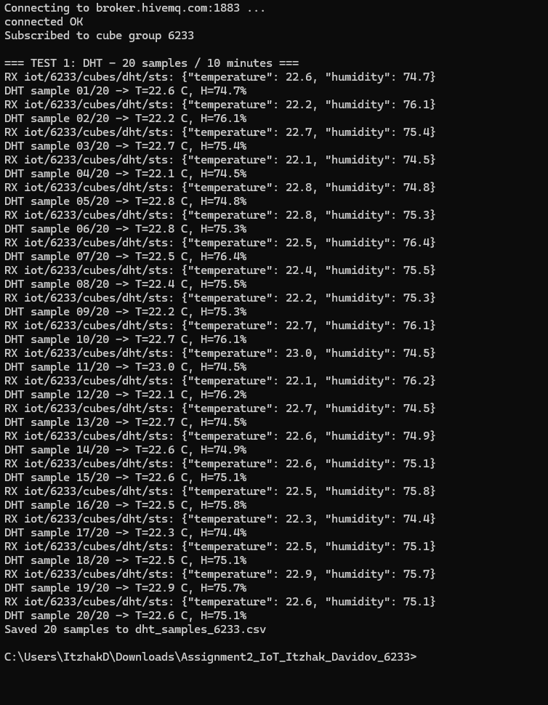

3. Test 2 - RELAY control
Requirement: send an ON command to the RELAY, observe the state change, then send an OFF command and observe the second state change. The live execution below shows both commands and both status confirmations.
PASS – RELAY changed to ON, confirmed ON, then changed to OFF and confirmed OFF.

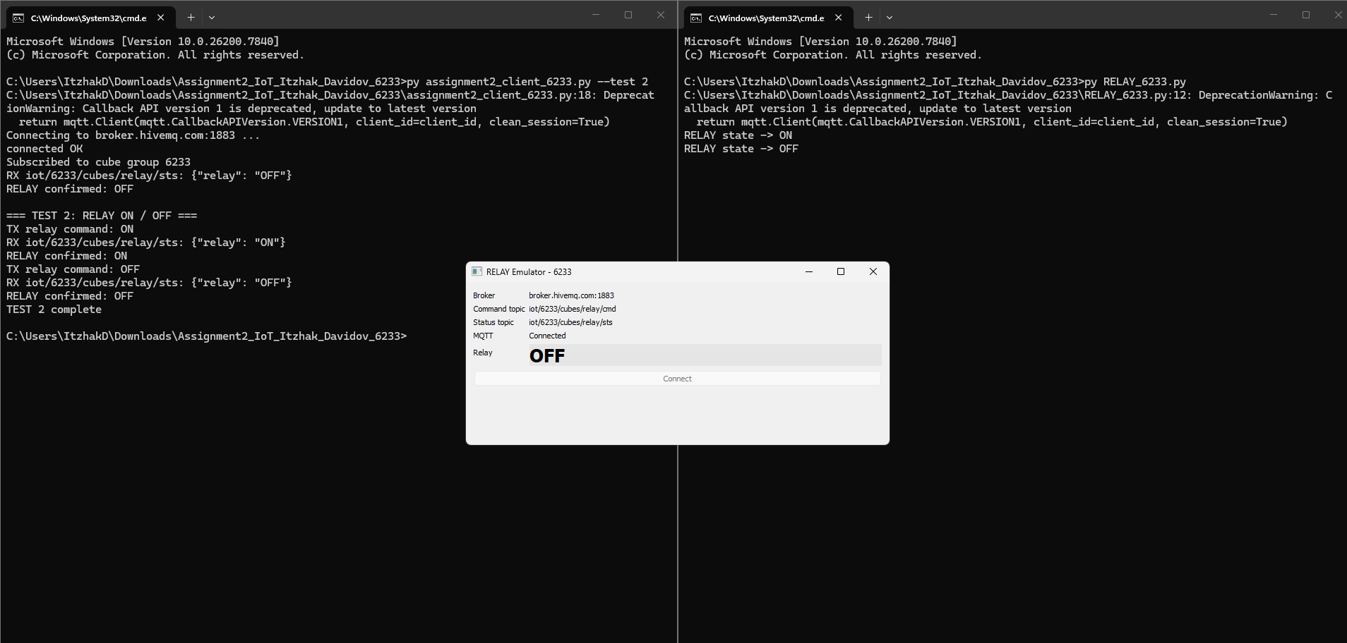

4. Test 3 – BUTTON event detector with RELAY
Requirement: detect each BUTTON push immediately and use the RELAY as a paired device, toggling the RELAY state every time the BUTTON is pushed. During the live run, three BUTTON events were detected and the client issued the sequence ON → OFF → ON.
PASS – every BUTTON event was detected and toggled the RELAY exactly once.

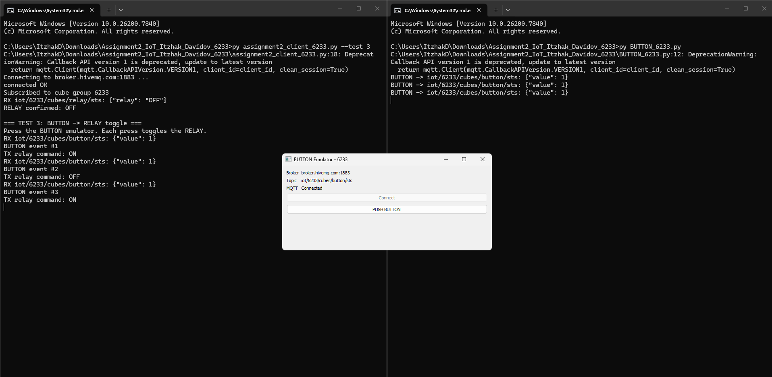

5. Main MQTT implementation
The main client subscribes continuously to DHT, BUTTON and RELAY status topics. DHT messages are parsed and stored, RELAY status messages update the known relay state, and BUTTON events call the relay toggle logic.
def on_message(self, client, userdata, msg):
raw = msg.payload.decode("utf-8", "ignore")

if msg.topic == DHT_TOPIC and self.collect_dht:
self.handle_dht(raw)
elif msg.topic == BUTTON_TOPIC:
self.handle_button(raw)
elif msg.topic == RELAY_STATUS_TOPIC:
self.handle_relay_status(raw)

def handle_button(self, raw):
data = json.loads(raw)
if int(data.get("value", 0)) == 1:
self.button_events += 1
if self.react_to_button:
self.set_relay(not self.relay_on)

def set_relay(self, on):
self.relay_on = bool(on)
payload = json.dumps({"value": 1 if on else 0})
self.client.publish(RELAY_CMD_TOPIC, payload, qos=0)

6. Test summary
Test | Goal | Observed result | Status
1 | Collect 20 DHT samples in 10 min | 20/20 samples received; CSV saved | PASS
2 | Control RELAY ON then OFF | Both state changes and confirmations observed | PASS
3 | Detect BUTTON and toggle RELAY | Three events produced ON → OFF → ON | PASS

Tests 4–5 were not included because the assignment slides explicitly mark them as “only in class”.

7. Conclusion
Assignment 2 was completed for student identifier 6233. The MQTT client connected successfully to HiveMQ, collected the required 20 DHT samples, controlled the RELAY in both directions, and detected BUTTON events that toggled the RELAY state. The screenshots in this report are from the live execution of Tests 1–3.

Appendix – Full Source Code
Student: Itzhak Davidov | Last 4 digits: 6233
The complete source used for this assignment is included below and is also provided as separate files in the GitHub repository.

assignment2_client_6233.py
001 # Assignment 2 - IoT / MQTT
002 # Student: Itzhak Davidov | last 4 digits: 6233
003
004 import argparse
005 import csv
006 import json
007 import time
008 from datetime import datetime
009 import paho.mqtt.client as mqtt
010
011 from mqtt_init_6233 import (
012 BROKER, PORT, KEEPALIVE,
013 DHT_TOPIC, BUTTON_TOPIC, RELAY_CMD_TOPIC, RELAY_STATUS_TOPIC
014 )
015
016 def make_client(client_id):
017 try:
018 return mqtt.Client(mqtt.CallbackAPIVersion.VERSION1, client_id=client_id, clean_session=True)
019 except Exception:
020 return mqtt.Client(client_id=client_id, clean_session=True)
021
022 class Assignment2Client:
023 def __init__(self):
024 self.client = make_client("IOT_ASSIGNMENT2_6233")
025 self.client.on_connect = self.on_connect
026 self.client.on_message = self.on_message
027 self.samples = []
028 self.relay_on = False
029 self.button_events = 0
030 self.collect_dht = False
031 self.react_to_button = False
032
033 def connect(self):
034 print(f"Connecting to {BROKER}:{PORT} ...")
035 self.client.connect(BROKER, PORT, KEEPALIVE)
036 self.client.loop_start()
037
038 def close(self):
039 self.client.loop_stop()
040 self.client.disconnect()
041
042 def on_connect(self, client, userdata, flags, rc):
043 if rc == 0:
044 print("connected OK")
045 client.subscribe([
046 (DHT_TOPIC, 0),
047 (BUTTON_TOPIC, 0),
048 (RELAY_STATUS_TOPIC, 0),
049 ])
050 print("Subscribed to cube group 6233")
051 else:
052 print("Bad connection. rc =", rc)
053
054 def on_message(self, client, userdata, msg):
055 raw = msg.payload.decode("utf-8", "ignore")
056 print(f"RX {msg.topic}: {raw}")
057
058 if msg.topic == DHT_TOPIC and self.collect_dht:
059 self.handle_dht(raw)
060 elif msg.topic == BUTTON_TOPIC:
061 self.handle_button(raw)
062 elif msg.topic == RELAY_STATUS_TOPIC:
063 self.handle_relay_status(raw)
064
065 def handle_dht(self, raw):
066 try:
067 data = json.loads(raw)
068 t = float(data["temperature"])
069 h = float(data["humidity"])
070 except Exception:
071 # Backwards-compatible parser for old emulator:
072 # "Temperature: 22.5 Humidity: 75.1"
073 parts = raw.replace(":", "").split()
074 t = float(parts[1])
075 h = float(parts[3])
076
077 row = (datetime.now().isoformat(timespec="seconds"), t, h)
078 self.samples.append(row)
079 print(f"DHT sample {len(self.samples):02d}/20 -> T={t:.1f} C, H={h:.1f}%")
080
081 def handle_button(self, raw):
082 pressed = False
083 try:
084 data = json.loads(raw)
085 pressed = int(data.get("value", 0)) == 1
086 except Exception:
087 pressed = "1" in raw
088
089 if pressed:
090 self.button_events += 1
091 print(f"BUTTON event #{self.button_events}")
092 if self.react_to_button:
093 self.set_relay(not self.relay_on)
094
095 def handle_relay_status(self, raw):
096 try:
097 data = json.loads(raw)
098 self.relay_on = str(data.get("relay", "")).upper() == "ON"
099 except Exception:
100 self.relay_on = raw.strip().upper() in {"1", "ON", "TRUE"}
101 print("RELAY confirmed:", "ON" if self.relay_on else "OFF")
102
103 def set_relay(self, on):
104 self.relay_on = bool(on)
105 payload = json.dumps({"value": 1 if on else 0})
106 self.client.publish(RELAY_CMD_TOPIC, payload, qos=0)
107 print("TX relay command:", "ON" if on else "OFF")
108
109 def test1(self):
110 print("\n=== TEST 1: DHT - 20 samples / 10 minutes ===")
111 self.collect_dht = True
112 deadline = time.time() + 610
113 while len(self.samples) < 20 and time.time() < deadline:
114 time.sleep(1)
115 self.collect_dht = False
116
117 with open("dht_samples_6233.csv", "w", newline="", encoding="utf-8") as f:
118 w = csv.writer(f)
119 w.writerow(["timestamp", "temperature_c", "humidity_pct"])
120 w.writerows(self.samples)
121 print(f"Saved {len(self.samples)} samples to dht_samples_6233.csv")
122
123 def test2(self):
124 print("\n=== TEST 2: RELAY ON / OFF ===")
125 self.set_relay(True)
126 time.sleep(3)
127 self.set_relay(False)
128 time.sleep(3)
129 print("TEST 2 complete")
130
131 def test3(self):
132 print("\n=== TEST 3: BUTTON -> RELAY toggle ===")
133 self.react_to_button = True
134 print("Press the BUTTON emulator. Each press toggles the RELAY.")
135 time.sleep(120)
136 self.react_to_button = False
137 print(f"TEST 3 complete. Button events detected: {self.button_events}")
138
139 def main():
140 parser = argparse.ArgumentParser()
141 parser.add_argument("--test", choices=["1", "2", "3"], required=True)
142 args = parser.parse_args()
143
144 app = Assignment2Client()
145 app.connect()
146 time.sleep(2)
147 try:
148 {"1": app.test1, "2": app.test2, "3": app.test3}[args.test]()
149 finally:
150 app.close()
151
152 if __name__ == "__main__":
153 main()

DHT_6233.py
001 # Assignment 2 - IoT / MQTT
002 # Student: Itzhak Davidov | last 4 digits: 6233
003
004 import json
005 import random
006 import sys
007 from PyQt5 import QtCore, QtWidgets
008 import paho.mqtt.client as mqtt
009
010 BROKER = "broker.hivemq.com"
011 PORT = 1883
012 KEEPALIVE = 90
013 DHT_TOPIC = "iot/6233/cubes/dht/sts"
014
015
016 def make_client(client_id):
017 # Use callback API v1 to stay compatible with the assignment callbacks.
018 return mqtt.Client(
019 mqtt.CallbackAPIVersion.VERSION1,
020 client_id=client_id,
021 clean_session=True,
022 )
023
024
025 class DHTWindow(QtWidgets.QWidget):
026 mqtt_connected = QtCore.pyqtSignal(int)
027 mqtt_disconnected = QtCore.pyqtSignal(int)
028
029 def __init__(self):
030 super().__init__()
031 self.setWindowTitle("DHT Emulator - 6233")
032
033 self.client = make_client("IOT_DHT_6233")
034 self.client.on_connect = self.on_connect
035 self.client.on_disconnect = self.on_disconnect
036
037 self.status = QtWidgets.QLabel("Disconnected")
038 self.temp = QtWidgets.QLabel("--")
039 self.hum = QtWidgets.QLabel("--")
040 self.btn = QtWidgets.QPushButton("Connect")
041 self.btn.clicked.connect(self.connect_mqtt)
042
043 form = QtWidgets.QFormLayout(self)
044 form.addRow("Broker", QtWidgets.QLabel(f"{BROKER}:{PORT}"))
045 form.addRow("Topic", QtWidgets.QLabel(DHT_TOPIC))
046 form.addRow("Status", self.status)
047 form.addRow("Temperature °C", self.temp)
048 form.addRow("Humidity %", self.hum)
049 form.addRow(self.btn)
050
051 # QTimer must be started from the Qt GUI thread.
052 self.timer = QtCore.QTimer(self)
053 self.timer.setInterval(30_000) # 20 samples in 10 minutes
054 self.timer.timeout.connect(self.publish_sample)
055
056 # MQTT callbacks run on Paho's network thread, so marshal GUI work
057 # back to the Qt thread through signals.
058 self.mqtt_connected.connect(self.handle_connected)
059 self.mqtt_disconnected.connect(self.handle_disconnected)
060
061 def connect_mqtt(self):
062 self.status.setText("Connecting...")
063 self.btn.setEnabled(False)
064 try:
065 self.client.connect(BROKER, PORT, KEEPALIVE)
066 self.client.loop_start()
067 except Exception as exc:
068 self.status.setText(f"Connection failed: {exc}")
069 self.btn.setEnabled(True)
070
071 # Paho thread callback: do not touch Qt widgets/timers directly here.
072 def on_connect(self, client, userdata, flags, rc):
073 self.mqtt_connected.emit(int(rc))
074
075 # Paho thread callback: do not touch Qt widgets/timers directly here.
076 def on_disconnect(self, client, userdata, rc):
077 self.mqtt_disconnected.emit(int(rc))
078
079 @QtCore.pyqtSlot(int)
080 def handle_connected(self, rc):
081 if rc == 0:
082 self.status.setText("Connected")
083 self.btn.setEnabled(False)
084 self.publish_sample() # first sample immediately
085 self.timer.start() # then every 30 seconds
086 else:
087 self.status.setText(f"Connection error: {rc}")
088 self.btn.setEnabled(True)
089
090 @QtCore.pyqtSlot(int)
091 def handle_disconnected(self, rc):
092 self.timer.stop()
093 self.status.setText("Disconnected")
094 self.btn.setEnabled(True)
095
096 @QtCore.pyqtSlot()
097 def publish_sample(self):
098 temperature = round(22.0 + random.uniform(0.1, 1.0), 1)
099 humidity = round(74.0 + random.uniform(0.1, 2.4), 1)
100 payload = json.dumps({"temperature": temperature, "humidity": humidity})
101 self.client.publish(DHT_TOPIC, payload, qos=0)
102 self.temp.setText(str(temperature))
103 self.hum.setText(str(humidity))
104 print(f"DHT -> {DHT_TOPIC}: {payload}", flush=True)
105
106 def closeEvent(self, event):
107 self.timer.stop()
108 try:
109 self.client.loop_stop()
110 self.client.disconnect()
111 except Exception:
112 pass
113 event.accept()
114
115
116 if __name__ == "__main__":
117 app = QtWidgets.QApplication(sys.argv)
118 w = DHTWindow()
119 w.resize(520, 220)
120 w.show()
121 sys.exit(app.exec_())

RELAY_6233.py
001 # Assignment 2 - IoT / MQTT
002 # Student: Itzhak Davidov | last 4 digits: 6233
003
004 import json
005 import sys
006 from PyQt5 import QtWidgets
007 import paho.mqtt.client as mqtt
008 from mqtt_init_6233 import BROKER, PORT, KEEPALIVE, RELAY_CMD_TOPIC, RELAY_STATUS_TOPIC
009
010 def make_client(client_id):
011 try:
012 return mqtt.Client(mqtt.CallbackAPIVersion.VERSION1, client_id=client_id, clean_session=True)
013 except Exception:
014 return mqtt.Client(client_id=client_id, clean_session=True)
015
016 class RelayWindow(QtWidgets.QWidget):
017 def __init__(self):
018 super().__init__()
019 self.setWindowTitle("RELAY Emulator - 6233")
020 self.state = False
021
022 self.client = make_client("IOT_RELAY_6233")
023 self.client.on_connect = self.on_connect
024 self.client.on_message = self.on_message
025
026 self.status = QtWidgets.QLabel("Disconnected")
027 self.state_label = QtWidgets.QLabel("OFF")
028 self.btn = QtWidgets.QPushButton("Connect")
029 self.btn.clicked.connect(self.connect_mqtt)
030
031 form = QtWidgets.QFormLayout(self)
032 form.addRow("Broker", QtWidgets.QLabel(f"{BROKER}:{PORT}"))
033 form.addRow("Command topic", QtWidgets.QLabel(RELAY_CMD_TOPIC))
034 form.addRow("Status topic", QtWidgets.QLabel(RELAY_STATUS_TOPIC))
035 form.addRow("MQTT", self.status)
036 form.addRow("Relay", self.state_label)
037 form.addRow(self.btn)
038 self.update_style()
039
040 def connect_mqtt(self):
041 self.status.setText("Connecting...")
042 self.client.connect(BROKER, PORT, KEEPALIVE)
043 self.client.loop_start()
044
045 def on_connect(self, client, userdata, flags, rc):
046 if rc == 0:
047 self.status.setText("Connected")
048 self.btn.setEnabled(False)
049 self.client.subscribe(RELAY_CMD_TOPIC, qos=0)
050 self.publish_status()
051 else:
052 self.status.setText(f"Connection error: {rc}")
053
054 def on_message(self, client, userdata, msg):
055 raw = msg.payload.decode("utf-8", "ignore").strip()
056 value = raw.upper()
057 try:
058 data = json.loads(raw)
059 value = str(data.get("value", data.get("relay", raw))).upper()
060 except Exception:
061 pass
062
063 if value in {"1", "ON", "TRUE"}:
064 self.set_state(True)
065 elif value in {"0", "OFF", "FALSE"}:
066 self.set_state(False)
067 elif value == "TOGGLE":
068 self.set_state(not self.state)
069 else:
070 print("Unknown relay command:", raw)
071
072 def set_state(self, on):
073 self.state = bool(on)
074 self.state_label.setText("ON" if self.state else "OFF")
075 self.update_style()
076 self.publish_status()
077 print("RELAY state ->", "ON" if self.state else "OFF")
078
079 def update_style(self):
080 self.state_label.setStyleSheet(
081 "font-size: 26px; font-weight: bold; "
082 + ("background:#b7f7bd;" if self.state else "background:#e5e5e5;")
083 )
084
085 def publish_status(self):
086 if self.client.is_connected():
087 self.client.publish(
088 RELAY_STATUS_TOPIC,
089 json.dumps({"relay": "ON" if self.state else "OFF"}),
090 qos=0,
091 retain=True,
092 )
093
094 if __name__ == "__main__":
095 app = QtWidgets.QApplication(sys.argv)
096 w = RelayWindow()
097 w.resize(600, 230)
098 w.show()
099 sys.exit(app.exec_())

BUTTON_6233.py
001 # Assignment 2 - IoT / MQTT
002 # Student: Itzhak Davidov | last 4 digits: 6233
003
004 import json
005 import sys
006 from PyQt5 import QtWidgets
007 import paho.mqtt.client as mqtt
008 from mqtt_init_6233 import BROKER, PORT, KEEPALIVE, BUTTON_TOPIC
009
010 def make_client(client_id):
011 try:
012 return mqtt.Client(mqtt.CallbackAPIVersion.VERSION1, client_id=client_id, clean_session=True)
013 except Exception:
014 return mqtt.Client(client_id=client_id, clean_session=True)
015
016 class ButtonWindow(QtWidgets.QWidget):
017 def __init__(self):
018 super().__init__()
019 self.setWindowTitle("BUTTON Emulator - 6233")
020 self.client = make_client("IOT_BUTTON_6233")
021 self.client.on_connect = self.on_connect
022
023 self.status = QtWidgets.QLabel("Disconnected")
024 self.connect_btn = QtWidgets.QPushButton("Connect")
025 self.connect_btn.clicked.connect(self.connect_mqtt)
026 self.push_btn = QtWidgets.QPushButton("PUSH BUTTON")
027 self.push_btn.setEnabled(False)
028 self.push_btn.clicked.connect(self.push_button)
029
030 form = QtWidgets.QFormLayout(self)
031 form.addRow("Broker", QtWidgets.QLabel(f"{BROKER}:{PORT}"))
032 form.addRow("Topic", QtWidgets.QLabel(BUTTON_TOPIC))
033 form.addRow("MQTT", self.status)
034 form.addRow(self.connect_btn)
035 form.addRow(self.push_btn)
036
037 def connect_mqtt(self):
038 self.status.setText("Connecting...")
039 self.client.connect(BROKER, PORT, KEEPALIVE)
040 self.client.loop_start()
041
042 def on_connect(self, client, userdata, flags, rc):
043 if rc == 0:
044 self.status.setText("Connected")
045 self.connect_btn.setEnabled(False)
046 self.push_btn.setEnabled(True)
047 else:
048 self.status.setText(f"Connection error: {rc}")
049
050 def push_button(self):
051 payload = json.dumps({"value": 1})
052 self.client.publish(BUTTON_TOPIC, payload, qos=0)
053 print(f"BUTTON -> {BUTTON_TOPIC}: {payload}")
054
055 if __name__ == "__main__":
056 app = QtWidgets.QApplication(sys.argv)
057 w = ButtonWindow()
058 w.resize(520, 210)
059 w.show()
060 sys.exit(app.exec_())

mqtt_init_6233.py
001 # Assignment 2 - IoT / MQTT configuration
002 # Student: Itzhak Davidov | last 4 digits: 6233
003
004 BROKER = "broker.hivemq.com"
005 PORT = 1883
006 KEEPALIVE = 60
007
008 BASE_TOPIC = "iot/6233/cubes"
009 DHT_TOPIC = f"{BASE_TOPIC}/dht/sts"
010 BUTTON_TOPIC = f"{BASE_TOPIC}/button/sts"
011 RELAY_CMD_TOPIC = f"{BASE_TOPIC}/relay/cmd"
012 RELAY_STATUS_TOPIC = f"{BASE_TOPIC}/relay/sts"

