Assignment 3
MQTT GUI + Event Handler (Hands-On 6)

Student | Itzhak Davidov
Last 4 digits | 6233
Technology | Python, PyQt5, MQTT (Paho)
Live verification broker | broker.hivemq.com : 1883
Submission Report
The application implements an editable MQTT client GUI, continuous subscriber, publisher/device control, and an automatic sensor event handler with a Relay reaction.

1. Assignment Requirements and Implementation
Hands-On 6 requires a PyQt5 GUI that can create an MQTT client session, subscribe continuously, control devices, and react automatically to sensor data. The implemented application covers the requested fields and behavior.
Requirement | Implementation
Broker IP / host and port | Editable fields + two presets: HiveMQ Demo and the course White Cube preset.
Running time | Editable seconds value; 0 means unlimited. A positive value schedules automatic disconnect.
Topic change | Editable subscribe topic and publish topic.
Client name | Editable unique Client ID with 6233 embedded.
Username / password | Editable authentication fields.
Connection status | Visible CONNECTED / DISCONNECTED indicator.
Continuous subscriber | Subscribes to iot/6233/cubes/# and displays incoming MQTT messages in the application log.
Event handler | DHT temperature events are parsed and compared with a configurable threshold.
Reaction | Relay command is sent automatically: temperature >= threshold -> ON, temperature < threshold -> OFF.
Device control | Manual publish and Relay ON/OFF controls are also included.

2. MQTT Topics Used
- Base topic: iot/6233/cubes
- DHT status: iot/6233/cubes/dht/sts
- Button status: iot/6233/cubes/button/sts
- Relay command: iot/6233/cubes/relay/cmd
- Relay status: iot/6233/cubes/relay/sts
- Continuous subscription: iot/6233/cubes/#

3. GUI and Live MQTT Connection
The application was executed on Windows and connected successfully to the public HiveMQ broker on port 1883 for live verification. The GUI contains all configurable session fields requested by the assignment. The course White Cube server is also available as a preset in the code and GUI.
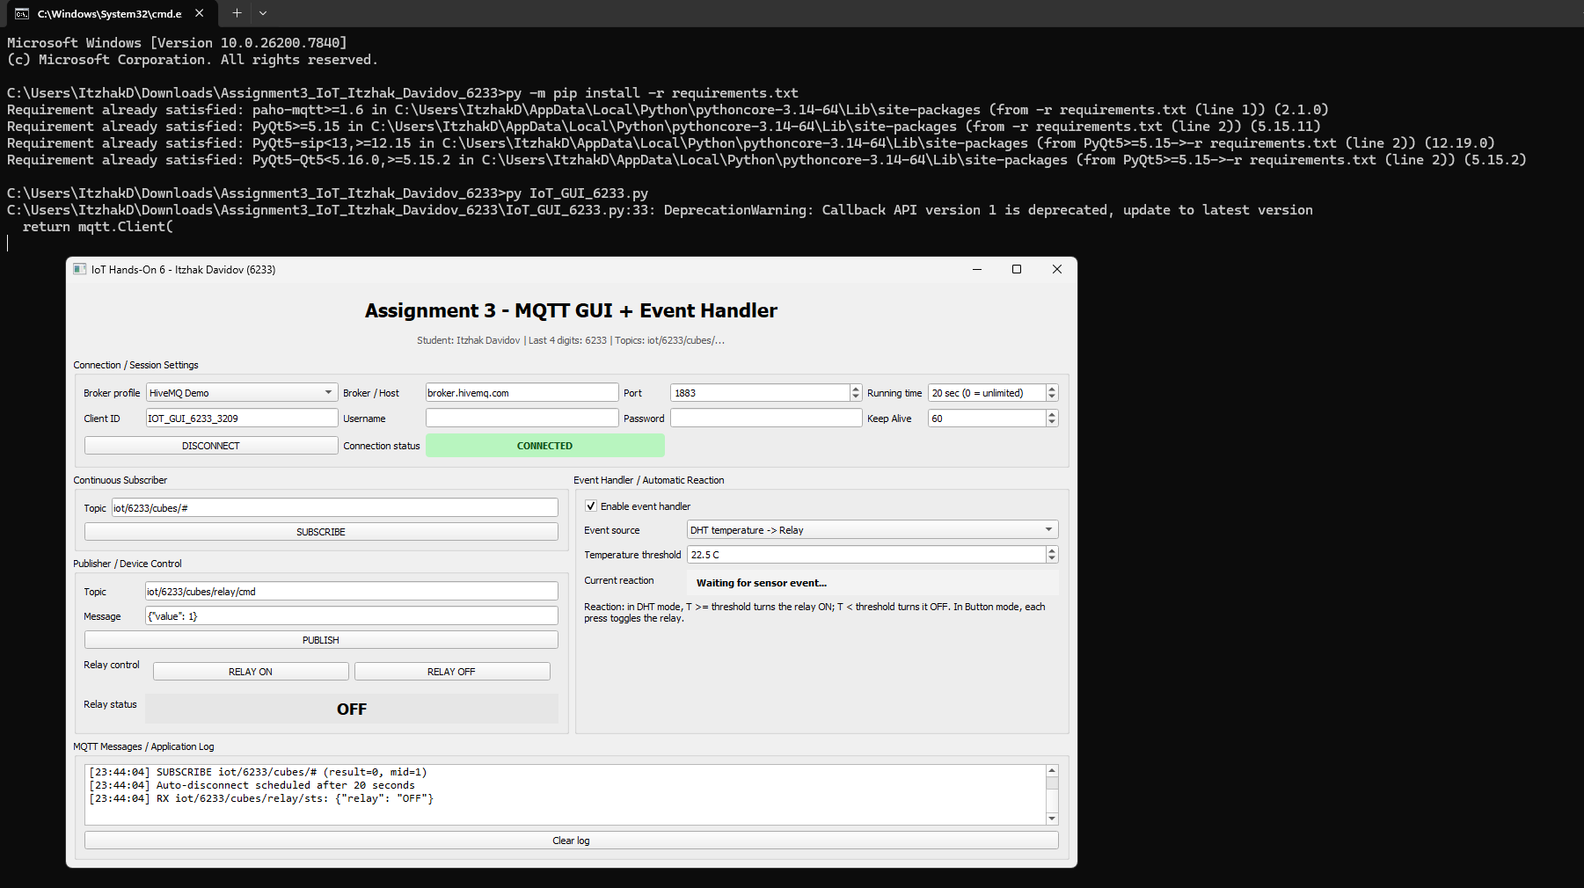

4. Event Handler Logic
Incoming MQTT messages are routed by topic. For DHT data, the JSON payload is parsed, the temperature is compared with the GUI threshold, and the application automatically publishes a Relay command. Repeated commands are suppressed while readings remain on the same side of the threshold.
if mode.startswith("DHT") and topic == DHT_TOPIC:
self.handle_dht_event(payload)
threshold = float(self.threshold.value())
desired = temp >= threshold
if self.last_event_command != desired:
self.set_relay(desired, "DHT event handler")
self.last_event_command = desired

5. Live Test - High Temperature Event -> Relay ON
Test condition: event handler enabled, threshold set to 22.5 C. The simulator sends a DHT message with temperature 23.5 C and humidity 74.0%. Since 23.5 >= 22.5, the GUI reacts automatically by publishing a Relay ON command. The Relay state is visible as ON in both the main GUI and the simulator.
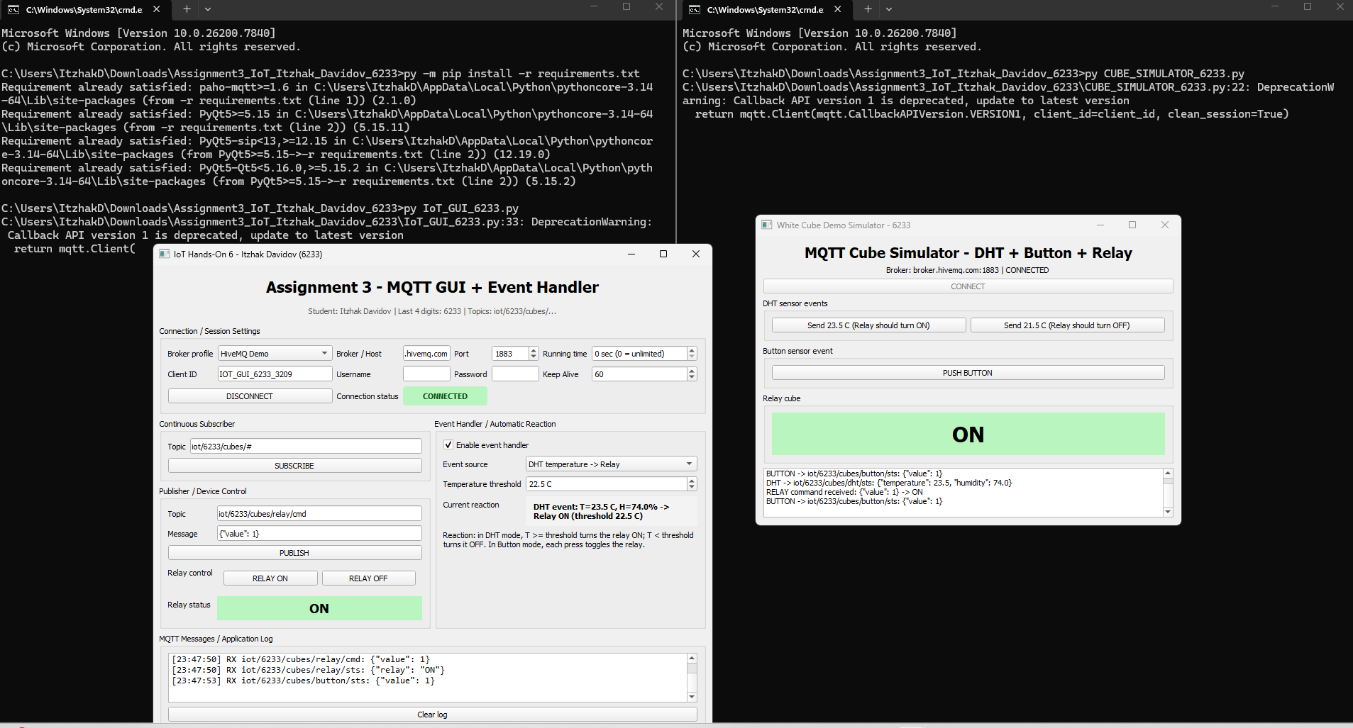

6. Live Test - Low Temperature Event -> Relay OFF
The simulator then sends a DHT message with temperature 21.5 C and humidity 76.0%. Because 21.5 < 22.5, the event-handler logic sends a Relay OFF command. The final Relay state is shown as OFF in both the main GUI and the simulator. The simulator log also shows the 21.5 C DHT messages used for this test.
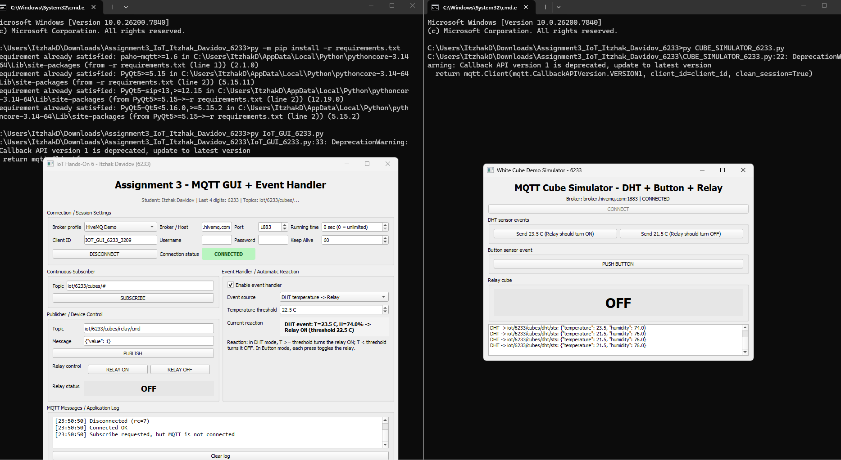

7. Main Code Components
File | Purpose
IoT_GUI_6233.py | Main PyQt5 application: connection settings, subscriber, publisher, Relay controls, event handler, message log and connection status.
CUBE_SIMULATOR_6233.py | Live test simulator that publishes DHT/Button events, receives Relay commands, and publishes Relay status.
requirements.txt | Python dependencies: paho-mqtt and PyQt5.
RUN_ASSIGNMENT3_6233.bat | Convenience launcher for the assignment files.

8. Result Summary
- GUI starts successfully and supports editable broker, port, running time, topics, Client ID, username and password.
- MQTT connection status is shown directly in the interface.
- Continuous subscription to the 6233 cube topic group is implemented.
- DHT event handling was verified live through MQTT.
- 23.5 C with a 22.5 C threshold caused Relay ON.
- 21.5 C with the same threshold caused Relay OFF.
- Manual publisher and manual Relay controls are included in addition to the automatic reaction.
- A Button event-handler mode is also implemented and can toggle the Relay on each press.
Conclusion: The implemented PyQt5 application satisfies the Hands-On 6 GUI and MQTT requirements and demonstrates an automatic reaction to sensor data using a working event handler.

Appendix – Full Source Code
Student: Itzhak Davidov | Last 4 digits: 6233
The complete source used for this assignment is included below and is also provided as separate files in the GitHub repository.

IoT_GUI_6233.py
001 # Assignment 3 - IoT / Hands-On 6
002 # Student: Itzhak Davidov | Last 4 digits: 6233
003
004 import json
005 import random
006 import sys
007 from datetime import datetime
008
009 from PyQt5 import QtCore, QtGui, QtWidgets
010 import paho.mqtt.client as mqtt
011
012 STUDENT = "Itzhak Davidov"
013 LAST4 = "6233"
014
015 DEFAULT_BROKER = "broker.hivemq.com"
016 DEFAULT_PORT = 1883
017 COURSE_BROKER = "139.162.222.115"
018 COURSE_PORT = 80
019 COURSE_USERNAME = "MATZI"
020 COURSE_PASSWORD = "MATZI"
021
022 BASE_TOPIC = f"iot/{LAST4}/cubes"
023 DHT_TOPIC = f"{BASE_TOPIC}/dht/sts"
024 BUTTON_TOPIC = f"{BASE_TOPIC}/button/sts"
025 RELAY_CMD_TOPIC = f"{BASE_TOPIC}/relay/cmd"
026 RELAY_STATUS_TOPIC = f"{BASE_TOPIC}/relay/sts"
027 DEFAULT_SUB_TOPIC = f"{BASE_TOPIC}/#"
028
029
030 def make_client(client_id, clean_session=True):
031 """Create a paho client compatible with paho-mqtt 1.x and 2.x."""
032 try:
033 return mqtt.Client(
034 mqtt.CallbackAPIVersion.VERSION1,
035 client_id=client_id,
036 clean_session=clean_session,
037 )
038 except Exception:
039 return mqtt.Client(client_id=client_id, clean_session=clean_session)
040
041
042 class MqttSignals(QtCore.QObject):
043 connected = QtCore.pyqtSignal(int)
044 disconnected = QtCore.pyqtSignal(int)
045 message = QtCore.pyqtSignal(str, str)
046 log = QtCore.pyqtSignal(str)
047
048
049 class MainWindow(QtWidgets.QMainWindow):
050 def __init__(self):
051 super().__init__()
052 self.setWindowTitle(f"IoT Hands-On 6 - {STUDENT} ({LAST4})")
053 self.resize(1150, 760)
054
055 self.client = None
056 self.signals = MqttSignals()
057 self.signals.connected.connect(self.on_mqtt_connected)
058 self.signals.disconnected.connect(self.on_mqtt_disconnected)
059 self.signals.message.connect(self.on_mqtt_message)
060 self.signals.log.connect(self.append_log)
061
062 self.relay_state = False
063 self.last_event_command = None
064 self.running_timer = QtCore.QTimer(self)
065 self.running_timer.setSingleShot(True)
066 self.running_timer.timeout.connect(self.disconnect_mqtt)
067
068 self.build_ui()
069 self.apply_profile(0)
070
071 # ---------- UI ----------
072 def build_ui(self):
073 central = QtWidgets.QWidget()
074 self.setCentralWidget(central)
075 root = QtWidgets.QVBoxLayout(central)
076
077 title = QtWidgets.QLabel("Assignment 3 - MQTT GUI + Event Handler")
078 title.setAlignment(QtCore.Qt.AlignCenter)
079 title.setStyleSheet("font-size: 22px; font-weight: 700; padding: 8px;")
080 root.addWidget(title)
081
082 subtitle = QtWidgets.QLabel(
083 f"Student: {STUDENT} | Last 4 digits: {LAST4} | Topics: {BASE_TOPIC}/..."
084 )
085 subtitle.setAlignment(QtCore.Qt.AlignCenter)
086 subtitle.setStyleSheet("color: #555; padding-bottom: 8px;")
087 root.addWidget(subtitle)
088
089 # Connection group
090 connection = QtWidgets.QGroupBox("Connection / Session Settings")
091 grid = QtWidgets.QGridLayout(connection)
092
093 self.profile = QtWidgets.QComboBox()
094 self.profile.addItems(["HiveMQ Demo", "White Cube (course preset)"])
095 self.profile.currentIndexChanged.connect(self.apply_profile)
096
097 self.host = QtWidgets.QLineEdit()
098 self.port = QtWidgets.QSpinBox()
099 self.port.setRange(1, 65535)
100 self.runtime = QtWidgets.QSpinBox()
101 self.runtime.setRange(0, 86400)
102 self.runtime.setSuffix(" sec (0 = unlimited)")
103 self.runtime.setValue(0)
104 self.client_id = QtWidgets.QLineEdit(f"IOT_GUI_{LAST4}_{random.randint(1000, 9999)}")
105 self.username = QtWidgets.QLineEdit()
106 self.password = QtWidgets.QLineEdit()
107 self.password.setEchoMode(QtWidgets.QLineEdit.Password)
108 self.keepalive = QtWidgets.QSpinBox()
109 self.keepalive.setRange(10, 600)
110 self.keepalive.setValue(60)
111
112 self.connect_btn = QtWidgets.QPushButton("CONNECT")
113 self.connect_btn.clicked.connect(self.toggle_connection)
114 self.status = QtWidgets.QLabel("DISCONNECTED")
115 self.status.setAlignment(QtCore.Qt.AlignCenter)
116 self.set_status(False)
117
118 labels_widgets = [
119 ("Broker profile", self.profile),
120 ("Broker / Host", self.host),
121 ("Port", self.port),
122 ("Running time", self.runtime),
123 ("Client ID", self.client_id),
124 ("Username", self.username),
125 ("Password", self.password),
126 ("Keep Alive", self.keepalive),
127 ]
128 for i, (label, widget) in enumerate(labels_widgets):
129 row, col = divmod(i, 4)
130 base = col * 2
131 grid.addWidget(QtWidgets.QLabel(label), row, base)
132 grid.addWidget(widget, row, base + 1)
133
134 grid.addWidget(self.connect_btn, 2, 0, 1, 2)
135 grid.addWidget(QtWidgets.QLabel("Connection status"), 2, 2)
136 grid.addWidget(self.status, 2, 3, 1, 2)
137 root.addWidget(connection)
138
139 middle = QtWidgets.QHBoxLayout()
140 root.addLayout(middle, 1)
141
142 # Left: subscribe/publish
143 left = QtWidgets.QVBoxLayout()
144 middle.addLayout(left, 1)
145
146 sub_group = QtWidgets.QGroupBox("Continuous Subscriber")
147 sub_form = QtWidgets.QFormLayout(sub_group)
148 self.sub_topic = QtWidgets.QLineEdit(DEFAULT_SUB_TOPIC)
149 self.subscribe_btn = QtWidgets.QPushButton("SUBSCRIBE")
150 self.subscribe_btn.clicked.connect(self.subscribe_topic)
151 sub_form.addRow("Topic", self.sub_topic)
152 sub_form.addRow(self.subscribe_btn)
153 left.addWidget(sub_group)
154
155 pub_group = QtWidgets.QGroupBox("Publisher / Device Control")
156 pub_form = QtWidgets.QFormLayout(pub_group)
157 self.pub_topic = QtWidgets.QLineEdit(RELAY_CMD_TOPIC)
158 self.pub_message = QtWidgets.QLineEdit('{"value": 1}')
159 self.publish_btn = QtWidgets.QPushButton("PUBLISH")
160 self.publish_btn.clicked.connect(self.publish_manual)
161
162 relay_buttons = QtWidgets.QHBoxLayout()
163 self.relay_on_btn = QtWidgets.QPushButton("RELAY ON")
164 self.relay_off_btn = QtWidgets.QPushButton("RELAY OFF")
165 self.relay_on_btn.clicked.connect(lambda: self.set_relay(True, "manual control"))
166 self.relay_off_btn.clicked.connect(lambda: self.set_relay(False, "manual control"))
167 relay_buttons.addWidget(self.relay_on_btn)
168 relay_buttons.addWidget(self.relay_off_btn)
169 relay_widget = QtWidgets.QWidget()
170 relay_widget.setLayout(relay_buttons)
171
172 self.relay_indicator = QtWidgets.QLabel("UNKNOWN")
173 self.relay_indicator.setAlignment(QtCore.Qt.AlignCenter)
174 self.relay_indicator.setStyleSheet("font-size:18px;font-weight:700;background:#ddd;padding:6px;")
175
176 pub_form.addRow("Topic", self.pub_topic)
177 pub_form.addRow("Message", self.pub_message)
178 pub_form.addRow(self.publish_btn)
179 pub_form.addRow("Relay control", relay_widget)
180 pub_form.addRow("Relay status", self.relay_indicator)
181 left.addWidget(pub_group)
182
183 # Right: event handler
184 event_group = QtWidgets.QGroupBox("Event Handler / Automatic Reaction")
185 event_form = QtWidgets.QFormLayout(event_group)
186 self.event_enabled = QtWidgets.QCheckBox("Enable event handler")
187 self.event_enabled.setChecked(True)
188 self.event_mode = QtWidgets.QComboBox()
189 self.event_mode.addItems([
190 "DHT temperature -> Relay",
191 "Button press -> Relay toggle",
192 ])
193 self.threshold = QtWidgets.QDoubleSpinBox()
194 self.threshold.setRange(-20.0, 80.0)
195 self.threshold.setDecimals(1)
196 self.threshold.setValue(22.5)
197 self.threshold.setSuffix(" C")
198 self.event_status = QtWidgets.QLabel("Waiting for sensor event...")
199 self.event_status.setWordWrap(True)
200 self.event_status.setStyleSheet("font-weight:600;padding:8px;background:#f3f3f3;")
201
202 explanation = QtWidgets.QLabel(
203 "Reaction: in DHT mode, T >= threshold turns the relay ON; "
204 "T < threshold turns it OFF. In Button mode, each press toggles the relay."
205 )
206 explanation.setWordWrap(True)
207
208 event_form.addRow(self.event_enabled)
209 event_form.addRow("Event source", self.event_mode)
210 event_form.addRow("Temperature threshold", self.threshold)
211 event_form.addRow("Current reaction", self.event_status)
212 event_form.addRow(explanation)
213 middle.addWidget(event_group, 1)
214
215 # Log
216 log_group = QtWidgets.QGroupBox("MQTT Messages / Application Log")
217 log_layout = QtWidgets.QVBoxLayout(log_group)
218 self.log_box = QtWidgets.QPlainTextEdit()
219 self.log_box.setReadOnly(True)
220 self.log_box.setFont(QtGui.QFont("Consolas", 10))
221 clear_btn = QtWidgets.QPushButton("Clear log")
222 clear_btn.clicked.connect(self.log_box.clear)
223 log_layout.addWidget(self.log_box)
224 log_layout.addWidget(clear_btn)
225 root.addWidget(log_group, 2)
226
227 def apply_profile(self, index):
228 if index == 1:
229 self.host.setText(COURSE_BROKER)
230 self.port.setValue(COURSE_PORT)
231 self.username.setText(COURSE_USERNAME)
232 self.password.setText(COURSE_PASSWORD)
233 else:
234 self.host.setText(DEFAULT_BROKER)
235 self.port.setValue(DEFAULT_PORT)
236 self.username.clear()
237 self.password.clear()
238
239 def set_status(self, connected):
240 if connected:
241 self.status.setText("CONNECTED")
242 self.status.setStyleSheet(
243 "background:#b8f5bf;color:#14551d;font-weight:800;padding:7px;border-radius:4px;"
244 )
245 self.connect_btn.setText("DISCONNECT")
246 else:
247 self.status.setText("DISCONNECTED")
248 self.status.setStyleSheet(
249 "background:#ffd1d1;color:#7d1111;font-weight:800;padding:7px;border-radius:4px;"
250 )
251 self.connect_btn.setText("CONNECT")
252
253 # ---------- MQTT ----------
254 def toggle_connection(self):
255 if self.client is not None and self.client.is_connected():
256 self.disconnect_mqtt()
257 else:
258 self.connect_mqtt()
259
260 def connect_mqtt(self):
261 try:
262 cid = self.client_id.text().strip() or f"IOT_GUI_{LAST4}_{random.randint(1000,9999)}"
263 self.client = make_client(cid, clean_session=True)
264 self.client.on_connect = self._on_connect
265 self.client.on_disconnect = self._on_disconnect
266 self.client.on_message = self._on_message
267
268 user = self.username.text().strip()
269 if user:
270 self.client.username_pw_set(user, self.password.text())
271
272 host = self.host.text().strip()
273 port = int(self.port.value())
274 keepalive = int(self.keepalive.value())
275 self.append_log(f"Connecting to {host}:{port} as {cid} ...")
276 self.client.connect(host, port, keepalive)
277 self.client.loop_start()
278 except Exception as exc:
279 self.append_log(f"CONNECT ERROR: {exc}")
280 QtWidgets.QMessageBox.critical(self, "MQTT connection error", str(exc))
281
282 def disconnect_mqtt(self):
283 self.running_timer.stop()
284 if self.client is not None:
285 try:
286 self.client.loop_stop()
287 self.client.disconnect()
288 except Exception:
289 pass
290 self.set_status(False)
291 self.append_log("Disconnected")
292
293 def _on_connect(self, client, userdata, flags, rc):
294 self.signals.connected.emit(int(rc))
295
296 def _on_disconnect(self, client, userdata, rc, *args):
297 try:
298 code = int(rc)
299 except Exception:
300 code = 0
301 self.signals.disconnected.emit(code)
302
303 def _on_message(self, client, userdata, msg):
304 payload = msg.payload.decode("utf-8", "ignore")
305 self.signals.message.emit(msg.topic, payload)
306
307 @QtCore.pyqtSlot(int)
308 def on_mqtt_connected(self, rc):
309 if rc == 0:
310 self.set_status(True)
311 self.append_log("Connected OK")
312 self.subscribe_topic()
313 secs = int(self.runtime.value())
314 if secs > 0:
315 self.running_timer.start(secs * 1000)
316 self.append_log(f"Auto-disconnect scheduled after {secs} seconds")
317 else:
318 self.append_log(f"Connection failed, rc={rc}")
319 self.set_status(False)
320
321 @QtCore.pyqtSlot(int)
322 def on_mqtt_disconnected(self, rc):
323 self.set_status(False)
324 self.append_log(f"Disconnected (rc={rc})")
325
326 def subscribe_topic(self):
327 topic = self.sub_topic.text().strip()
328 if not topic:
329 return
330 if self.client is None or not self.client.is_connected():
331 self.append_log("Subscribe requested, but MQTT is not connected")
332 return
333 result, mid = self.client.subscribe(topic, qos=0)
334 self.append_log(f"SUBSCRIBE {topic} (result={result}, mid={mid})")
335
336 def publish_manual(self):
337 self.publish(self.pub_topic.text().strip(), self.pub_message.text())
338
339 def publish(self, topic, payload, qos=0, retain=False):
340 if self.client is None or not self.client.is_connected():
341 self.append_log("Publish requested, but MQTT is not connected")
342 return False
343 info = self.client.publish(topic, payload, qos=qos, retain=retain)
344 self.append_log(f"TX {topic}: {payload}")
345 return info.rc == mqtt.MQTT_ERR_SUCCESS
346
347 # ---------- Message handling / event handler ----------
348 @QtCore.pyqtSlot(str, str)
349 def on_mqtt_message(self, topic, payload):
350 self.append_log(f"RX {topic}: {payload}")
351
352 if topic == RELAY_STATUS_TOPIC:
353 self.handle_relay_status(payload)
354
355 if not self.event_enabled.isChecked():
356 return
357
358 mode = self.event_mode.currentText()
359 if mode.startswith("DHT") and topic == DHT_TOPIC:
360 self.handle_dht_event(payload)
361 elif mode.startswith("Button") and topic == BUTTON_TOPIC:
362 self.handle_button_event(payload)
363
364 def handle_relay_status(self, payload):
365 state = None
366 try:
367 data = json.loads(payload)
368 raw = str(data.get("relay", data.get("value", ""))).upper()
369 except Exception:
370 raw = payload.strip().upper()
371
372 if raw in {"1", "ON", "TRUE"}:
373 state = True
374 elif raw in {"0", "OFF", "FALSE"}:
375 state = False
376
377 if state is not None:
378 self.relay_state = state
379 text = "ON" if state else "OFF"
380 self.relay_indicator.setText(text)
381 bg = "#b8f5bf" if state else "#e6e6e6"
382 self.relay_indicator.setStyleSheet(
383 f"font-size:18px;font-weight:700;background:{bg};padding:6px;"
384 )
385
386 def handle_dht_event(self, payload):
387 try:
388 data = json.loads(payload)
389 temp = float(data["temperature"])
390 humidity = float(data.get("humidity", 0.0))
391 except Exception as exc:
392 self.append_log(f"DHT parse error: {exc}")
393 return
394
395 threshold = float(self.threshold.value())
396 desired = temp >= threshold
397 action = "ON" if desired else "OFF"
398 self.event_status.setText(
399 f"DHT event: T={temp:.1f} C, H={humidity:.1f}% -> Relay {action} "
400 f"(threshold {threshold:.1f} C)"
401 )
402 self.append_log(
403 f"EVENT DHT: {temp:.1f} C {'>=' if desired else '<'} {threshold:.1f} C -> RELAY {action}"
404 )
405 # Avoid unnecessary repeated commands while readings stay on same side of threshold.
406 if self.last_event_command != desired:
407 self.set_relay(desired, "DHT event handler")
408 self.last_event_command = desired
409
410 def handle_button_event(self, payload):
411 pressed = False
412 try:
413 data = json.loads(payload)
414 pressed = int(data.get("value", 0)) == 1
415 except Exception:
416 pressed = payload.strip() in {"1", "ON", "TRUE", "PRESS"}
417
418 if pressed:
419 desired = not self.relay_state
420 self.event_status.setText(
421 f"BUTTON event -> Relay {'ON' if desired else 'OFF'}"
422 )
423 self.append_log(
424 f"EVENT BUTTON: press detected -> RELAY {'ON' if desired else 'OFF'}"
425 )
426 self.set_relay(desired, "button event handler")
427
428 def set_relay(self, on, reason="event handler"):
429 payload = json.dumps({"value": 1 if on else 0})
430 if self.publish(RELAY_CMD_TOPIC, payload):
431 self.append_log(f"REACTION ({reason}): relay command -> {'ON' if on else 'OFF'}")
432
433 def append_log(self, text):
434 stamp = datetime.now().strftime("%H:%M:%S")
435 self.log_box.appendPlainText(f"[{stamp}] {text}")
436 bar = self.log_box.verticalScrollBar()
437 bar.setValue(bar.maximum())
438
439 def closeEvent(self, event):
440 self.disconnect_mqtt()
441 event.accept()
442
443
444 def main():
445 app = QtWidgets.QApplication(sys.argv)
446 app.setStyle("Fusion")
447 window = MainWindow()
448 window.show()
449 sys.exit(app.exec_())
450
451
452 if __name__ == "__main__":
453 main()

CUBE_SIMULATOR_6233.py
001 # Demo support for Assignment 3 - IoT / Hands-On 6
002 # Student: Itzhak Davidov | Last 4 digits: 6233
003
004 import json
005 import random
006 import sys
007 from PyQt5 import QtCore, QtWidgets
008 import paho.mqtt.client as mqtt
009
010 LAST4 = "6233"
011 BROKER = "broker.hivemq.com"
012 PORT = 1883
013 BASE = f"iot/{LAST4}/cubes"
014 DHT_TOPIC = f"{BASE}/dht/sts"
015 BUTTON_TOPIC = f"{BASE}/button/sts"
016 RELAY_CMD_TOPIC = f"{BASE}/relay/cmd"
017 RELAY_STATUS_TOPIC = f"{BASE}/relay/sts"
018
019
020 def make_client(client_id):
021 try:
022 return mqtt.Client(mqtt.CallbackAPIVersion.VERSION1, client_id=client_id, clean_session=True)
023 except Exception:
024 return mqtt.Client(client_id=client_id, clean_session=True)
025
026
027 class Signals(QtCore.QObject):
028 connected = QtCore.pyqtSignal(int)
029 relay_command = QtCore.pyqtSignal(str)
030
031
032 class Simulator(QtWidgets.QWidget):
033 def __init__(self):
034 super().__init__()
035 self.setWindowTitle("White Cube Demo Simulator - 6233")
036 self.resize(600, 360)
037 self.client = make_client(f"IOT_CUBE_SIM_{LAST4}_{random.randint(1000,9999)}")
038 self.client.on_connect = self._on_connect
039 self.client.on_message = self._on_message
040 self.signals = Signals()
041 self.signals.connected.connect(self.on_connected)
042 self.signals.relay_command.connect(self.on_relay_command)
043 self.relay_on = False
044 self.build_ui()
045
046 def build_ui(self):
047 layout = QtWidgets.QVBoxLayout(self)
048 title = QtWidgets.QLabel("MQTT Cube Simulator - DHT + Button + Relay")
049 title.setAlignment(QtCore.Qt.AlignCenter)
050 title.setStyleSheet("font-size:20px;font-weight:700;")
051 layout.addWidget(title)
052
053 self.status = QtWidgets.QLabel(f"Broker: {BROKER}:{PORT} | Disconnected")
054 self.status.setAlignment(QtCore.Qt.AlignCenter)
055 self.connect_btn = QtWidgets.QPushButton("CONNECT")
056 self.connect_btn.clicked.connect(self.connect_mqtt)
057 layout.addWidget(self.status)
058 layout.addWidget(self.connect_btn)
059
060 dht = QtWidgets.QGroupBox("DHT sensor events")
061 dht_layout = QtWidgets.QHBoxLayout(dht)
062 hot = QtWidgets.QPushButton("Send 23.5 C (Relay should turn ON)")
063 cold = QtWidgets.QPushButton("Send 21.5 C (Relay should turn OFF)")
064 hot.clicked.connect(lambda: self.send_dht(23.5, 74.0))
065 cold.clicked.connect(lambda: self.send_dht(21.5, 76.0))
066 dht_layout.addWidget(hot)
067 dht_layout.addWidget(cold)
068 layout.addWidget(dht)
069
070 btn_group = QtWidgets.QGroupBox("Button sensor event")
071 btn_layout = QtWidgets.QHBoxLayout(btn_group)
072 button = QtWidgets.QPushButton("PUSH BUTTON")
073 button.clicked.connect(self.send_button)
074 btn_layout.addWidget(button)
075 layout.addWidget(btn_group)
076
077 relay_group = QtWidgets.QGroupBox("Relay cube")
078 relay_layout = QtWidgets.QVBoxLayout(relay_group)
079 self.relay_label = QtWidgets.QLabel("OFF")
080 self.relay_label.setAlignment(QtCore.Qt.AlignCenter)
081 self.relay_label.setStyleSheet("font-size:30px;font-weight:800;background:#e6e6e6;padding:12px;")
082 relay_layout.addWidget(self.relay_label)
083 layout.addWidget(relay_group)
084
085 self.log = QtWidgets.QPlainTextEdit()
086 self.log.setReadOnly(True)
087 layout.addWidget(self.log)
088
089 def connect_mqtt(self):
090 self.status.setText(f"Broker: {BROKER}:{PORT} | Connecting...")
091 self.client.connect(BROKER, PORT, 60)
092 self.client.loop_start()
093
094 def _on_connect(self, client, userdata, flags, rc):
095 self.signals.connected.emit(int(rc))
096
097 def _on_message(self, client, userdata, msg):
098 self.signals.relay_command.emit(msg.payload.decode("utf-8", "ignore"))
099
100 def on_connected(self, rc):
101 if rc == 0:
102 self.status.setText(f"Broker: {BROKER}:{PORT} | CONNECTED")
103 self.connect_btn.setEnabled(False)
104 self.client.subscribe(RELAY_CMD_TOPIC, qos=0)
105 self.publish_relay_status()
106 self.log.appendPlainText(f"Subscribed: {RELAY_CMD_TOPIC}")
107 else:
108 self.status.setText(f"Connection failed rc={rc}")
109
110 def send_dht(self, temp, humidity):
111 payload = json.dumps({"temperature": temp, "humidity": humidity})
112 self.client.publish(DHT_TOPIC, payload, qos=0)
113 self.log.appendPlainText(f"DHT -> {DHT_TOPIC}: {payload}")
114
115 def send_button(self):
116 payload = json.dumps({"value": 1})
117 self.client.publish(BUTTON_TOPIC, payload, qos=0)
118 self.log.appendPlainText(f"BUTTON -> {BUTTON_TOPIC}: {payload}")
119
120 def on_relay_command(self, raw):
121 try:
122 data = json.loads(raw)
123 value = str(data.get("value", data.get("relay", ""))).upper()
124 except Exception:
125 value = raw.strip().upper()
126 if value in {"1", "ON", "TRUE"}:
127 self.relay_on = True
128 elif value in {"0", "OFF", "FALSE"}:
129 self.relay_on = False
130 elif value == "TOGGLE":
131 self.relay_on = not self.relay_on
132 else:
133 return
134 self.relay_label.setText("ON" if self.relay_on else "OFF")
135 self.relay_label.setStyleSheet(
136 "font-size:30px;font-weight:800;padding:12px;" +
137 ("background:#b8f5bf;" if self.relay_on else "background:#e6e6e6;")
138 )
139 self.log.appendPlainText(f"RELAY command received: {raw} -> {'ON' if self.relay_on else 'OFF'}")
140 self.publish_relay_status()
141
142 def publish_relay_status(self):
143 if self.client.is_connected():
144 payload = json.dumps({"relay": "ON" if self.relay_on else "OFF"})
145 self.client.publish(RELAY_STATUS_TOPIC, payload, qos=0, retain=True)
146
147 def closeEvent(self, event):
148 try:
149 self.client.loop_stop()
150 self.client.disconnect()
151 except Exception:
152 pass
153 event.accept()
154
155
156 if __name__ == "__main__":
157 app = QtWidgets.QApplication(sys.argv)
158 app.setStyle("Fusion")
159 w = Simulator()
160 w.show()
161 sys.exit(app.exec_())

