ASSIGNMENT 4
ThingsBoard QuickStart
Hands-On 7 - Complete Virtual IoT System
Student | Itzhak Davidov
Last 4 digits | 6233
Platform | ThingsBoard Cloud
Result | QuickStart completed with live telemetry, dashboard, alarm and customer sharing
Submission Report
The ThingsBoard QuickStart was completed end-to-end. The report includes live evidence of device telemetry, dashboard configuration, alarm rules, a triggered critical alarm, and customer assignment. More than the required five successful-step screenshots are included.

1. Assignment Requirements
Hands-On 7 requires completing the ThingsBoard “Hello World” QuickStart and creating a short report with screenshots of successful steps. The course slides require at least five successful-step screenshots.
Requirement | Status | Implementation / evidence
Create / provision a device | Completed | Thermometer_6233 created in ThingsBoard Cloud.
Connect device and push data | Completed | HTTP telemetry successfully accepted; latest temperature value visible.
Build dashboard | Completed | IoT_6233_Dashboard created with temperature data source.
Define threshold / alarm rule | Completed | High_Temperature_6233 configured as Critical.
Trigger alarm | Completed | 35 °C telemetry triggered an active Critical alarm.
Share with customer | Completed | Thermometer_6233 and IoT_6233_Dashboard assigned to Customer_6233.

2. Step 1 - ThingsBoard Cloud Ready
The ThingsBoard Cloud tenant was opened successfully and the account status was Active. This established the cloud environment used for the QuickStart.
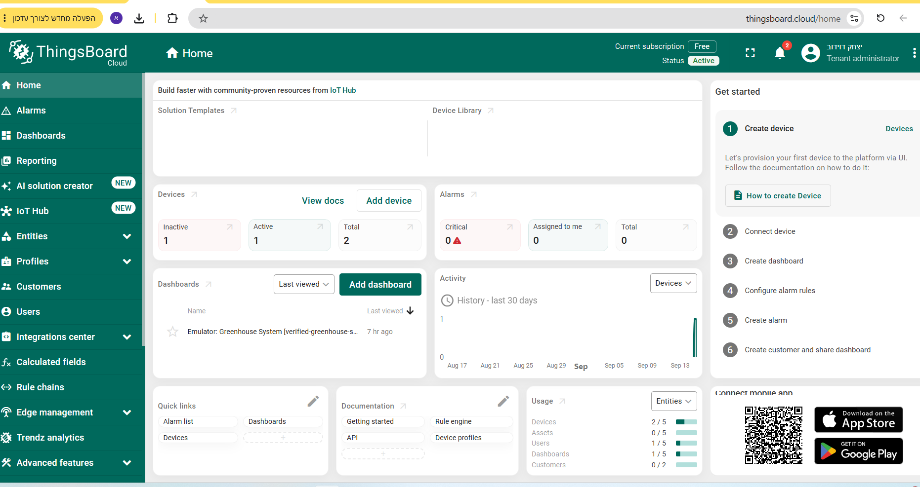

3. Step 2 - Device Telemetry
A device named Thermometer_6233 was provisioned. Telemetry was sent through the ThingsBoard HTTP device API. The HTTP request returned status 200, and ThingsBoard stored the latest telemetry value. The device page shows the key “temperature” with value 25.
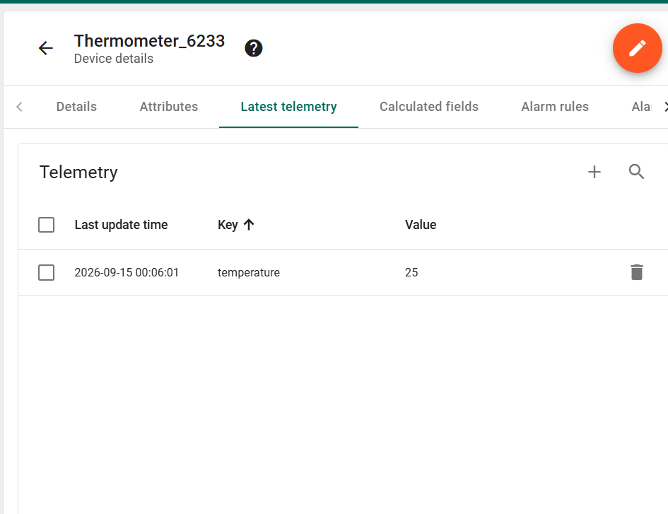

4. Step 3 - Dashboard Configuration
A dashboard was prepared for the device. The widget data source was configured to use Thermometer_6233, the telemetry key temperature, and °C units. The final dashboard was named IoT_6233_Dashboard.
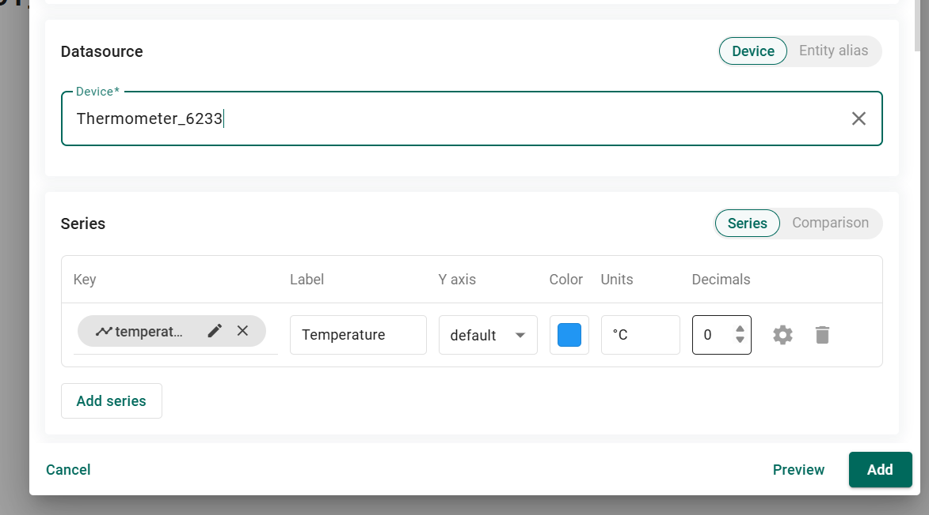

5. Step 4 - Alarm Rule
An alarm rule named High_Temperature_6233 was created. The rule uses the temperature telemetry value and is configured with Critical severity. The trigger threshold used in the test was temperature greater than 30 °C.
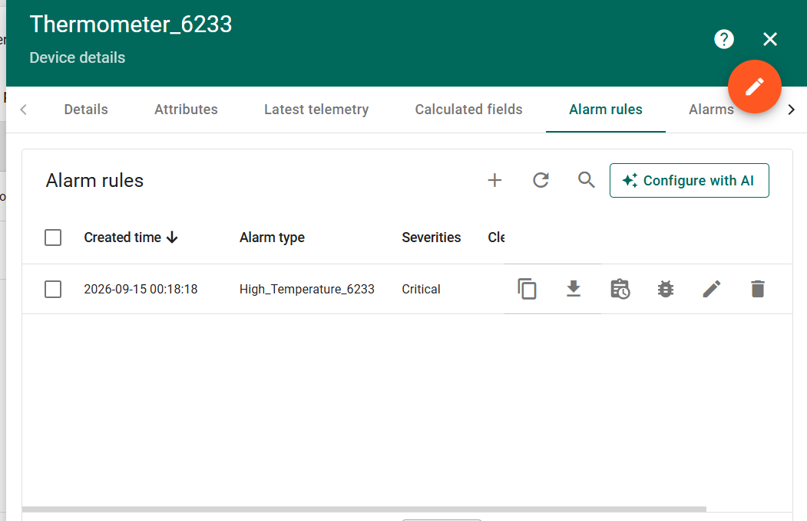

6. Step 5 - Critical Alarm Triggered
To verify the alarm path, a new telemetry value of 35 °C was sent to Thermometer_6233. ThingsBoard generated an active Critical alarm of type High_Temperature_6233. This verifies that the threshold rule and alarm generation are working end-to-end.
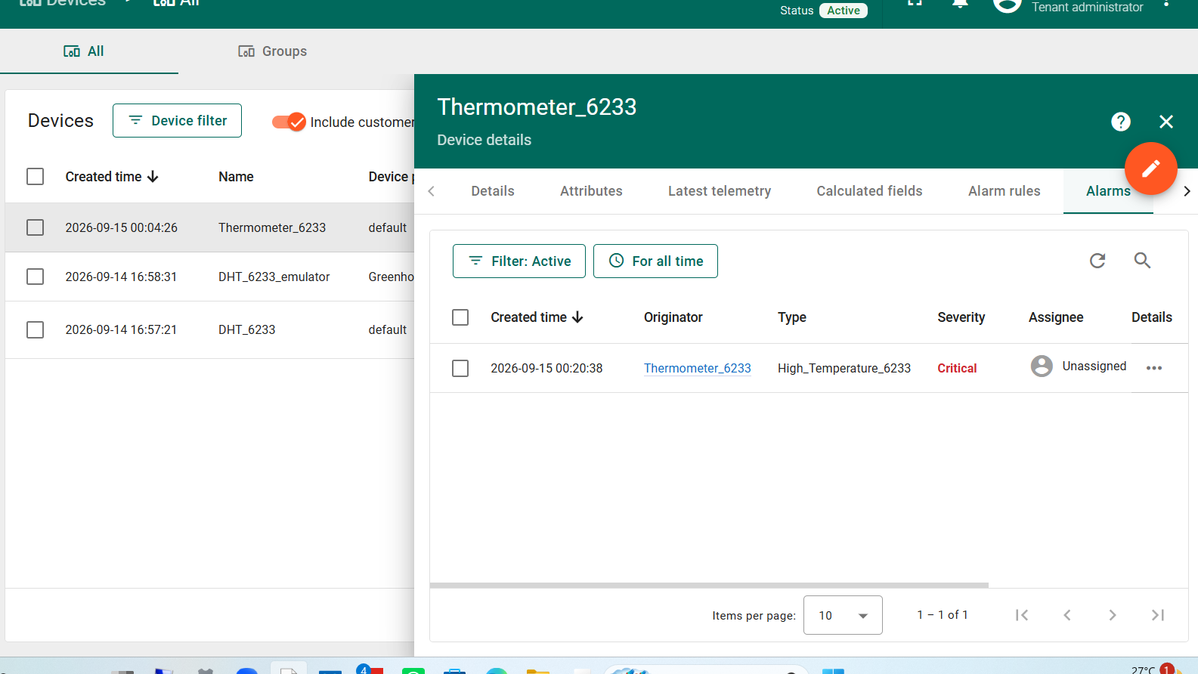

7. Step 6 - Customer Assignment and Sharing
A customer named Customer_6233 was created. The device was assigned to the customer and remained Active. The dashboard IoT_6233_Dashboard was also assigned to the same customer, completing the resource-sharing step of the QuickStart.
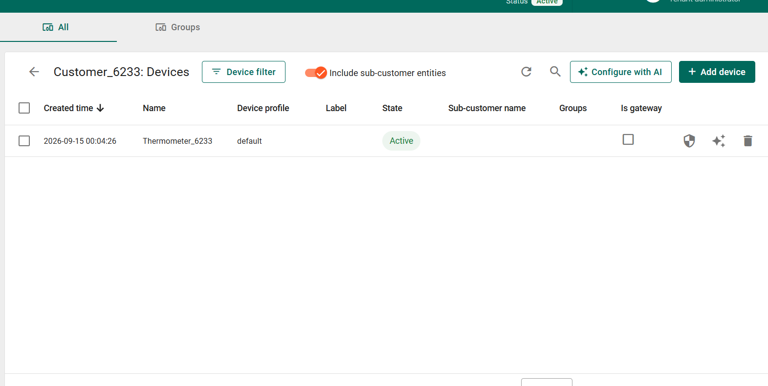
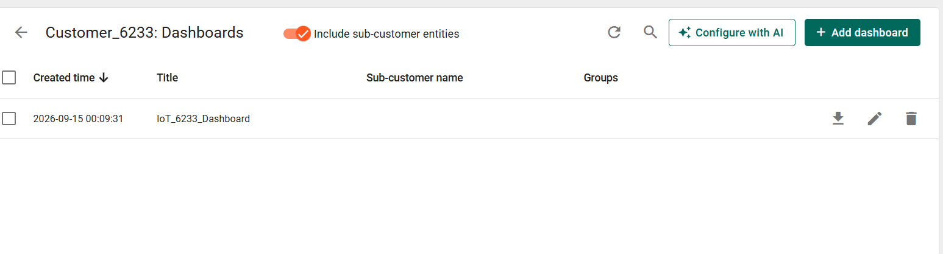

8. Result Summary
- ThingsBoard Cloud tenant accessed successfully.
- Thermometer_6233 created and live telemetry received.
- Temperature data prepared for visualization in IoT_6233_Dashboard.
- Critical high-temperature alarm rule configured and saved.
- 35 °C telemetry triggered a live Critical alarm.
- Device and dashboard assigned to Customer_6233.
- Seven successful-step screenshots are included, exceeding the minimum requirement of five.
Conclusion: Assignment 4 / Hands-On 7 was completed successfully. The final ThingsBoard setup demonstrates the full IoT cloud flow: device provisioning, data ingestion, dashboard configuration, threshold-based alarm creation, and customer sharing.

Appendix – Full Source Code
Student: Itzhak Davidov | Last 4 digits: 6233
The complete source used for this assignment is included below and is also provided as separate files in the GitHub repository.
Security note: the ThingsBoard device access token is intentionally not embedded in the report or repository. The helper reads it from the THINGSBOARD_TOKEN environment variable at runtime.

send_telemetry_6233.py
001 """ThingsBoard telemetry helper for Assignment 4 (6233).
002
003 The device token is intentionally NOT stored in this repository.
004 Set the THINGSBOARD_TOKEN environment variable before running.
005 """
006 import json
007 import os
008 import urllib.request
009
010 HOST = "https://thingsboard.cloud"
011 TOKEN = os.environ.get("THINGSBOARD_TOKEN")
012
013
014 def send_temperature(value: float) -> None:
015 if not TOKEN:
016 raise SystemExit(
017 "THINGSBOARD_TOKEN is not set. Set it in your terminal and run again."
018 )
019 url = f"{HOST}/api/v1/{TOKEN}/telemetry"
020 payload = json.dumps({"temperature": value}).encode("utf-8")
021 request = urllib.request.Request(
022 url,
023 data=payload,
024 headers={"Content-Type": "application/json"},
025 method="POST",
026 )
027 with urllib.request.urlopen(request, timeout=15) as response:
028 print(f"Sent temperature={value}; HTTP {response.status}")
029
030
031 if __name__ == "__main__":
032 send_temperature(25) # normal telemetry example
033 send_temperature(35) # triggers High_Temperature_6233 (> 30 C)

