Augmented Reality Improves Mobility in Dim Light for Users with Night Blindness
Muhammad Haj Ali* Rafael Damouni† Amjad Nassar‡
Information Systems, University of Haifa Information Systems, University of Haifa Information Systems, University of Haifa
Ilan Shimshoni§ Sarit F. A. Szpiro¶
Information Systems, University of Haifa Special Education, University of Haifa
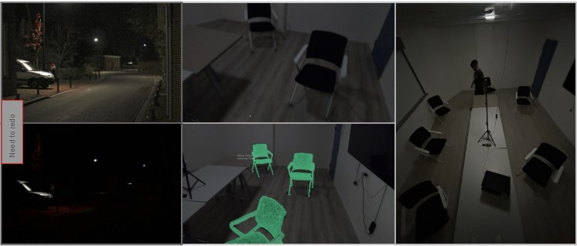
Figure 1: Illustrates key aspects of the visual assistance system and study setup. Left: comparison of normal vision (1) and low-vision (2) conditions in a nighttime street scene, highlighting visibility challenges faced by people with low vision. Middle: user’s point of view during the obstacle navigation task as seen through the HoloLens, shown with (3) and without (4) the AR-based visual enhancements (highlight mesh overlay). Right: (5) top-down view of the full obstacle course taken from the ceiling, showing the spatial layout and distribution of obstacles as well as a researcher walking the path.

ABSTRACT
Night blindness is a condition associated with low vision,which makes it impossible to see in poor light. People with low vision (LV) who suffer from night blindness face significant challenges in dimly lit environments, including loss of the ability to walk independently and safely after dark. Our goal is to examine the potential of AR in helping people with night blindness in dim lighting. Here, we test whether augmenting the visibility of obstacles with AR overlays can improve mobility in a low lit environment. We conducted a study with XXX LV participants with night blindness (e.g., Retinitis Pigmentosa) to examine how AR overlays impact object visibility and mobility using Microsoft Hololens 2. We compared performance in dim lighting conditions without overlays (i.e., control condition; while wearing the headset) versus with bright AR overlays that were placed over real objects. In an object counting task, the AR overlays improved participants’ ability to detect and count objects. Importantly, the AR overlays yielded significant benefits in an obstacle navigation task: users walked faster, had fewer collisions, less hesitations in walking, and reported greater confidence with the AR overlays. Our study demonstrates that spatially anchored
AR overlays can substantially improve perception and mobility for
*e-mail: mhajal04@campus.haifa.ac.il
†e-mail: raphael.d@windowslive.com
‡e-mail: anassa07@campus.haifa.ac.il
§e-mail: ishimshoni@is.haifa.ac.il
¶e-mail: sarit.szpiro@edu.haifa.ac.il
users with night blindness in dim light. Our study illustrates the potential of AR for people with night blindness, and the need for future research in this space..

INTRODUCTION
Navigating safely in dimly lit environments presents a serious challenge for individuals with night blindness (nyctalopia), a visual condition often caused by degenerative retinal diseases such as Retinitis Pigmentosa (RP). These individuals retain varying degrees of residual vision, but under poor lighting conditions they are unable to detect objects. they are frequently unable to detect obstacles or perceive spatial layout—leading to hesitation, disorientation, and a heightened risk of collisions. This severely impairs their ability to move independently, particularly in unfamiliar spaces, and has a substantial negative impact on daily quality of life (Chaumet-Riffaud et al., 2017). Despite the severity of this condition, it remains underrepresented in the design and evaluation of assistive technologies for low vision.
Traditional tools such as wide-beam flashlights or night-vision
goggles have shown partial benefits, but they often come with practical limitations—such as bulkiness, reliance on external hardware, and a tendency to override rather than support the user’s natural vision (S. Szpiro, Y. Zhao, and Azenkot, 2016). Recent developments in wearable sensing systems and mobile-based visual enhancement offer more modern alternatives, yet these systems still fall short in low-light contexts: many rely on RGB camera input which do not work properly in low light, likely require constant user interaction, or obscure the visibility visual scenes with full-screen filters that can overwhelm the user (Kasowski et al., 2023).
Augmented Reality (AR) offers a fundamentally different approach. AR systems can enhance residual vision by selectively overlaying digital information directly onto relevant physical elements in the environment, an approach that has been proven successful in recent years . AR holds particular promise for individuals with low vision, as it allows them to maintain a sense of spatial continuity while receiving targeted visual cues. Yet, the use of AR for night blindness—remains underexplored.
We present and evaluate an AR-based system designed to enhance object visibility and support independent mobility for users with night blindness. Our system leverages the Microsoft HoloLens 2’s integrated depth sensors to project spatially accurate, wireframe overlays onto physical objects in the user’s environment, enhancing the visual salience of a specific object in low light conditions without obscuring the broader visual scene.
We designed a series of tasks that were performed in dim lighting conditions to examine the impact of AR object highlights to assist night blindness. Participants performed an object counting task, a walking task that included navigating around obstacles, and an object interaction task. We assess the system’s impact on detection accuracy, navigation performance, walking confidence, and user experience. Our results show that AR overlays significantly improved performance – it reduced collisions, sped up movement, and enhanced perception of objects in low-light conditions. Importantly, we also uncover critical usability insights about how predictability, timing, and visual consistency shape trust in assistive AR for low-vision users. We discuss the potential of AR and depth sensing in dim lighting conditions and highlight directions for building more adaptive AR tools for users with visual impairment.
This work contributes to a growing body of research on XR and accessibility, demonstrating that minimal, spatially anchored visual augmentation—without full-scene replacement—can support independent navigation for people with night blindness. We discuss the implications of our findings for future AR system design, especially in the context of real-time object detection and low-light performance, and.

RELATED WORK
A major challenge for individuals with low vision is obstacle avoidance. In recent years AR has proved its potential to assist people with low vision by modifying the visibility of the surrounding environment (see reviews XX YY). Several approaches have used full-field of view modifications such as border enhancements (XXref) or color coded depth information (XXref). However, this approach has reduced user experience, as people with low vision reported visual overload (cite chi 2021? paper that reviews different approaches). Instead of replacing full visual scenes, and leveraging advancements in computer vision, recent studies has focused on enhancing specific objects.
.
For example, Fox et al., 2023 found that 3D world-locked AR cues significantly aided low-vision users in an obstacle course, yielding better navigation performance than head-locked arrow cues. Expanding this approach, Maman, Vol, and S. F. Szpiro, 2025 examined how highlighting specifically obstacle borders using 3D AR markers improved walking of low vision participants on a real-world obstacle course. Increasing the 3D outline of obstacles in AR significantly reduced walking time and path length for the low-vision group, and crucially this did not increase collision rates. Participants also rated the AR system positively, indicating higher confidence and usability.
However, prior work has overwhelmingly focused on day time navigation in well-lit environments. The challenges of mobility in night or dim lighting conditions have received little attention.
Below, we review research on the challenges and assistive tools for night blindness as well as computer vision work on low light object detection.

* Van Rheede et al., 2015 developed “residual vision glasses” that use a head-mounted depth camera to display obstacles as brightness-coded cues. In trials on an indoor obstacle course with 11 low-vision participants, all users were able to navigate an obstacle course with the glasses, and those with the poorest baseline performance showed mobility improvements; however, walking speed slowed and hesitations increased under the altered visual representation.
** These findings suggest a trade-off: AR overlays can make hazards more visible, but may initially slow users as they adapt.

*** Our study builds directly on this line of research., we use lightweight wireframe overlays that preserve object geometry while enhancing saliency. By evaluating this method in individuals with night blindness under real-world low-light conditions, our work provides new evidence for the effectiveness of AR-based spatial guidance tailored to residual vision.

Night Blindness: Challenges and Assistive Tools
Night blindness (nyctalopia) severely limits visual function in low light environments, impeding independent mobility and increasing risk during daily activities. Early efforts concentrated on amplifying available light. (Marmor, Ault, and Shamlian, 1980) introduced a Wide-Field High-Intensity Lantern, essentially a wideangle flashlight designed to illuminate a broad area in front of the user. This device was inexpensive and simple, leveraging residual vision by brightly lighting the travel path. Building on a similar idea, (Morrisette, Goodrich, and Marmor, 1985) evaluated the Wide-Angle Mobility Light (WAML), a battery-powered head mounted lamp that emitted a broad beam. In a study with 2 participants, they found that the WAML significantly reduced navigation errors for subjects with night blindness and restricted visual fields, improving their ability to walk an outdoor course at night. However, carrying a lantern or wearing a bulky headlamp is not always practical or comfortable, and the glare from such lights can be a concern for both the user (reducing any remaining night vision) and bystanders.
More technologically advanced tools include night vision goggles (NVGs), which were originally developed for military use, have been repurposed for individuals with night blindness. Although NVGs have shown benefits in enhancing night-time mobility and independence, their cost, form factor, and visual adaptation limitations reduce their practicality for everyday use (Hartong et al., 2004). In a study with 20 night-blind RP participants, they tested the ability to walk a dark indoor corridor while wearing NVGs, revealing that participants average number of obstacle collisions droped from 8 without NVGs to 2 with NVGs, and similar improvements were seen in a dim outdoor setting (hits fell from 8 to near 0). More recently, other approaches like Ikeda et al., 2019 developed a high-sensitivity see-through display mounted with a camera and a complementary metal oxide semiconductor (CMOS) sensor, to assist night-blind patients. A study with 28 participants, showed significantly fewer navigation errors and shorter travel times with the device, alongside improved visual acuity in low-light conditions. Building on similar concepts, [Mawatari et al., 2024] introduced an NVG with interchangeable lenses to broaden the user’s field of view in low light. In a study with 21 participants, they tested the ability to expand peripheral vision while wearing this night-vision headset using various lens angles; results indicate that wider-angle lenses provided a significantly broader horizontal visual field for users in dark settings. These technological aids directly tackle the challenges of night blindness by enhancing illumination or effective field of vision, thereby improving the safety and independence of individuals with severely impaired night vision. Yet, NVGs also have drawbacks for everyday use: they tend to be heavy and conspicuous, have limited field of view, and can be cost-prohibitive..
Researchers have also explored augmented reality (AR) to assist people with night blindness. Unlike NVGs that simply intensify real scenes, AR can alter or superimpose visual information to compensate for impaired vision. [Vargas-Mart´ın and bibinitperiod E. Peli, 2002] pioneered the concept of an
“augmented-view” for people with restricted visual fields (e.g., late stage RP). Their system used a head-mounted display to scale down the surrounding scene and overlay it into the user’s limited field of view, effectively expanding the perceived field. This early work implemented multiple prototypes of see-through AR displays that presented a wide-angle, high-contrast outline of the environment within a small central window. While primarily a proof of concept, it laid the groundwork for later empirical studies. For instance, [Luo and E. Peli, 2006] developed an AR device that superimposed real time contour edge outlines from a wide field camera onto a seethrough display for patients with tunnel vision. In a controlled visual search experiment with 12 RP patients, their augmented-vision system significantly improved search effectiveness: with the AR edge overlay, subjects located targets much faster – search times dropped by 28% up to 74% in a large-area task compared to no aids.
11 introduced RunSight, an AR-based system that helps low vision runners follow a sighted guide for night time runs. RunSight uses an optical see-through head-mounted display (HMD) and a smartphone forward cameraworn by the low vision runner . The system applies image-processing filters (edge detection, brightness/contrast enhancement) to this video so that obstacles and important features appear as clear outlines. On top of this enhanced video, RunSight draws spatial AR cues indicating the guide’s location, a colored trace of the guide’s path line or an arrow. The system does not use any vision-based object detection, instead, the sighted guide and runner each carry wearable sensors (ultra-wideband radio beacons) so the guide’s 3D position is computed directly from sensor ranges. The software then renders the AR overlay (path lines or arrows) at the computed location. A study with eight runners with low vision, able to follow the guide for at least 1 km using RunSight, while without the system, no one could run the same route. In the study, no accidents or unsafe events occurred. In follow up interviews, participants indicated that combining AR overlays with guide verbal instructions gave them confidence to run at night.
Standard smartphone cameras perform worse at dark scenes than well lit environments (Elmannai and Elleithy, 2017). To address this, Khan, Ahsan, and Salam, 2014 developed a smartphone navigation app specifically for night-blind users. The application continuously tracks the smartphone’s time, and computes remaining daylight by comparing current time to sunset, but the application was not tested in a user study. Image-processing approaches can boost smartphone vision in dim light. [Zhou et al., 2024] developed VLight, a single parameter low-light enhancement algorithm that operates in real time on mobile devices. VLight acts as a “brightness booster” on each video frame, producing substantially brighter output (up to 67 FPS at 4K resolution) on the phone itself. Such on-device enhancement could be incorporated into assistive application to make dark environments more visible to low-vision users (for example, amplifying a dimly lit path on the smartphone screen). However, this approach was not evaluated with visually impaired users.
Beyond image-processing approaches, [Kuriakose, Shrestha, and Sandnes, 2023a] introduced DeepNAVI, a purely smartphonebased navigation assistant that uses on-device deep learning. The application runs lightweight convolutional neural networks on the phone, using the rear camera (and embedded sensors) to detect obstacles in real time. It classifies the type of object ahead and estimates its distance, position (left/right), and motion status, while also recognizing scene context (e.g. kitchen, street) to describe the environment. All information is delivered to users through auditory feedback via text-to-speech synthesis and bone conduction headphones, Kuriakose, Shrestha, and Sandnes, 2023b continued and tested the application on 13 visually impaired participants in outdoor environments navigation tasks, The participants reported mixed reactions towards the navigation assistant, from optimism about enhanced self-reliance to wariness and suspicion about whether this technology can actually be reliable and counted on.
[Mukhiddinov and Cho, 2021] propose a deep learning–driven smart glasses system tailored to help BVI users navigate independently at night. The approach integrates four core computer vision modules with an HMD: a low-light image enhancement model that brightens and denoises dark scenes, an object detection component that recognizes a wide range of surrounding objects and provides audio alerts, a salient object detection module to isolate important scene elements, and a text recognition module that reads out textual information via text-to-speech. By combining image enhancement with object and text recognition, the smart glasses can interpret critical visual information in real time (obstacles,people, signs or labels) under low light conditions. The system adopts a client–server architecture - the HMD (paired with a smartphone) serves as a camera and I/O device, capturing images on user request and sending them to a remote AI server for processing. All the heavy deep learning computations (low-light image enhancement, object recognition, salient object extraction, and text to-speech) run on the server, after which the interpreted results are sent back to the user. Although system has been a step forward from previous studies, it has not been tested with potential target low vision users and thus its efficacy is unknown. Moreover, these approaches rely on mostly auditory feedback, and limited visual augmentations.

Object Detection in Low Light
One challenges in improving night vision with object based AR systems, is the object detection in dim conditions. Indeed, object detection in low-light environments has received significant attention in computer vision, with a focus on improving image quality and feature extraction through both traditional and deep learning methods.
LiDAR-based systems have proven effective for depth-based reconstruction in poor lighting. For example,Aflatouni et al., 2015 introduced a nanophotonic coherent imager capable of accurate 3D scene modeling in darkness. Similarly, Dogan et al., 2022 proposed InfraredTags—embedded markers detectable by near-infrared sensors even in complete darkness.
In terms of image processing based approaches, Kvyetnyy et al., 2017 used bilateral filtering and wavelet thresholding to denoise images and enhance visual input for object recognition in dim conditions. More recently, deep learning solutions have dominated the space. CycleGANs have been used to enhance low-light image visibility without traditional processing. Furthermore, Chen and Shah, 2021 and Xu et al., 2021 embedded lighting models directly into neural networks to allow for adaptive brightness normalization. While Xiao et al., 2020 proposed Night Vision Detector, a modified version of RFB-Net optimized for low-light scenes. Additional work has explored adapting YOLOv5 and YOLOv7 models for night vision detection Peng, Ding, and Zhen, 2024,Wang et al., 2023,D. Zhao et al., 2024, with mixed success. Vision transformer models have also been adapted for low-light object detection tasks Tiwari, Pattanaik, and Sharma, 2024. For 3D detection, Li et al., 2023 developed MonoTDP, which uses twin-depth prediction to improve monocular detection performance in adverse conditions.
Although this body of research presents promising tools for low-light detection, few of these solutions have been implemented in edge-based real-time AR systems for accessibility. Most rely on external computation or non-wearable setups. To date, we are unaware of any work that combines state-of-the-art low-light object?? detectors with an edge-based, head-worn AR platform that can deliver immediate feedback to users with visual impairments. One exception is Abe et al., 2025. The studyshows a step toward night-time AR navigation; however,it focuses primarily on reflective signage rendering rather than object detection or machine-learning-based scene understanding. Consequently, a clear gap remains for real-time, wearable AR systems that perform robust low-light object detection, locally on the edge device.

METHODS
This study employed a controlled experimental design to evaluate the effectiveness of augmented reality overlays in improving mobility and object detection for individuals with night blindness under dim lighting conditions. Using the Microsoft HoloLens 2 platform, we used two AR applications that render bright wireframe overlays onto real-world objects: a manual anchoring system for precise experimental control and an automatic detection system for real-world applicability.

Participants
Participants were recruited through public announcements in relevant community groups and via snowball sampling. All participants had formal visual impairment certification qualifying them as legally blind. Participants had medically certified night blindnessand none were completely blind. Most retained some usable central or peripheral vision under normal lighting conditions. Their eligibility was confirmed in a phone interview prior to the session and verified again on site. All participants reported being able to navigate in daylight conditions with relative independence, consistent with residual functional vision typical of Retinitis Pigmentosa or geographic atrophy. This was further supported by their high self-reported confidence in daylight navigation in a questionnaire (see Section 4.1).
ID Age Gender (VI) Occupation |  |  |  | (VI) Duration
P1 | 40 | M | RP Electrical Engineer | 12 years
P2 | 44 | F | GA Unemployed | 5 years
P3 | 41 | F | RP (SH-W) | 5 months
P4 | 55 | M | RP Unemployed | 5 years
P5 | 47 | F | RP (SH-W) | 6 years
P6 | 52 | M | RP Hospital | Since birth
P7 | 56 | M | RP Unemployed | Since birth
P8 | 25 | F | RP Student | Since birth
P9 | 22 | F | RP Student | Since birth
P10 27 |  | M | RP Student | Since birth
Table 1: Participant demographics: age, gender (G), type of visual impairment (VI), occupation, and duration of VI. Abbreviations—VI: visual impairment; SH-W: sheltered workshop; GA: geographic atrophy; RP: retinitis pigmentosa; M: male; F: female.
The study included 10 participants aged 22 to 56 years (mean = 41.9), comprising six males (M = 46.0) and four females (F = 35.8). Nine were diagnosed with retinitis pigmentosa (RP), and one had geographic atrophy (GA). Demographic and clinical information is summarized in Table 1.
The Experiment was approved by the University of Haifa Department of Education ethics committee (IRB approval 085/22 at 16.3.2022), and written informed consent was obtained prior to participation. Each session lasted approximately 90 minutes. Participants received monetary compensation for their time.

Hardware
Microsoft HoloLens 2 is an augmented reality (AR) headset. The device features see-through stereoscopic displays with a field of view of 43° horizontal and 29° vertical in each display. A range of integrated sensors including a 1-Megapixel time-of-flight (ToF) depth sensor and eye tracking with built-in calibration. The headset weighs approximately 570 grams, and will be used as a platform for rendering spatially anchored 3D overlays on real-world objects under dim lighting, thus providing local processing and visual enhancement without external hardware. Erickson et al., 2020 showed the HoloLens 2’s tinted visor reduces environmental light, creating ideal conditions for high-contrast AR displays. This feature benefited our experiment by simulating night blindness conditions. For participants with low-light vision difficulties, the visor provided both a consistent representation of their real-world challenges and optimal conditions for AR overlays. Despite the advantages of the HoloLens 2 for our application, Erickson et al., 2020 documented important limitations in very dim environments, the device can experience tracking failures ”due to the lack of visual features to use in its tracking algorithm, which results in imagery freezing, disappearing, or temporarily becoming user fixed instead of world fixed”. Given our lighting conditions, we anticipated these potential limitations and designed our protocol to include provisions for redoing trials in cases where tracking failures occurred iPhone 13 Pro’s rear LiDAR scanner was used to generate high-resolution 3D meshes of real-world objects. Urceri MT-912 light meter in lux for light intensity measurements,. This meter was selected due to its measurement capability in the range needed for our experimental setup. Based on Erickson et al., 2020, we needed to maintain illuminance levels above 10 lux to ensure reliable HoloLens 2 tracking functionality, making this meter’s accuracy and range sufficient for monitoring our experimental lighting conditions. An Insta360 X4 Insta360, 2025 camera recorded 360-degree video at 30fps during the experiment to document participant interactions and support potential qualitative analysis. The camera was positioned in the middle of the room at a height of 250cm, providing an overhead view of the entire experimental area. The footage served as a supplementary observational record and was not analyzed quantitatively.

Software
The study used two Unity-based applications for the HoloLens 2 platform, both designed to enhance object visibility in low-light conditions using only depth sensor data, and 3D representations of objects that were prescanned prior to the experiment, avoiding RGB camera input which might be ineffective in dim environments Elmannai and Elleithy, 2017. The 3D models that were captured were manually refined using Blender 3.0 to remove scanning artifacts see (Fig 2). Both applications record quantitative data, capturing the 3D positions of both the user and virtual objects, along with user gaze metrics. Data was logged to a CSV file at 10 Hz (every 0.1 seconds). controls for entering participant details per trial and starting/stopping the data logging was done via Bluetooth connected keyboard hotkeys.
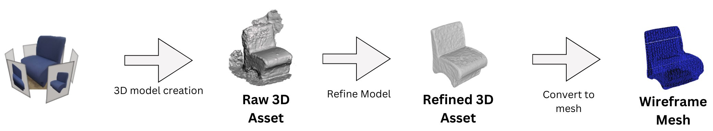
Figure 2: From physical object to wire-frame mesh. The process involves capturing a raw 3D asset, refining the model to remove artifacts, and converting it to a wireframe mesh that can be overlaid onto real objects in augmented reality.
3.3.1 Manual Object Anchoring Application
We developed an application that allows the experimenter to manually place and spatially align 3D scanned virtual objects onto their real-world counterparts. Once aligned, virtual models were worldlocked to maintain alignment as users walked around them (see Fig. 3). Object manipulation was performed using hand controls, keyboard hotkeys for anchoring objects in place, and toggling visibility of all virtual objects.
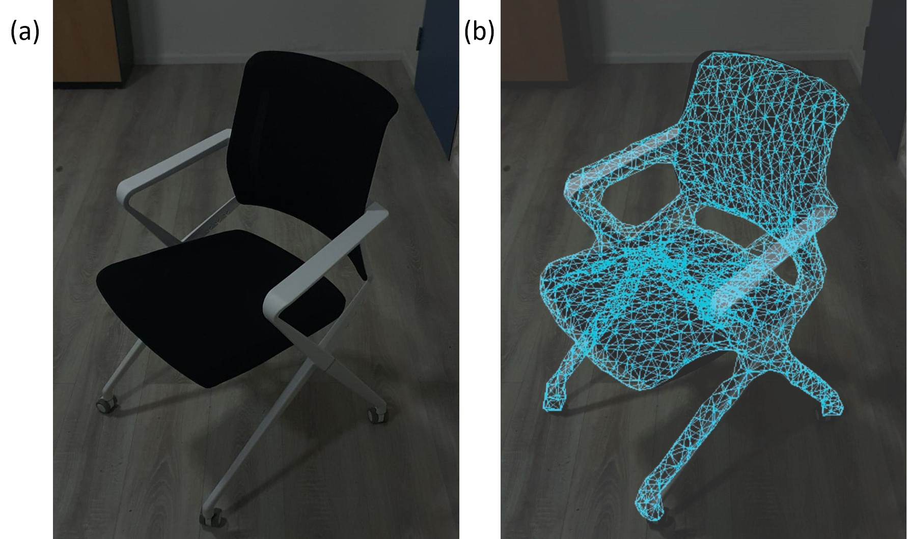
Figure 3: (a) on the left without enhancement and (b) on the right with enhancement. The AR overlay creates a bright wireframe outline that improves visibility in dim lighting conditions.
3.3.2 Automatic Object Detection and Overlay Application
The automatic object detection system uses the HoloLens 2 depth sensor to automatically detect and highlight known objects in the scene. The system matches environmental depth features against a database of pre-scanned 3D meshes and overlays bright, spatiallyanchored holograms onto recognized items without user input. We integrated Microsoft, 2025 for real-time 3D object detection, as it has a functional object detection and anchoring system that is compatible with the HoloLens 2, utilizing the integrated depth sensors. We trained the system on a single object type - a standard chair measuring 70 cm in height, 40 cm in width, and 40 cm in depth (see Fig. 3). We found the Hololens 2’s depth sensor struggled to detect objects much smaller than our chair (approx. 70cm in size), which limited our choice of test objects. The 3D model of the chair was uploaded to AOA’s cloud training service for conversion into a HoloLens-compatible file that allows for automatic anchoring of the virtual object onto the real object. During runtime, the application continuously scans the environment using depth data and overlays a wireframe mesh when the chair is recognized in the user’s environment.
3.3.3 Design of Overlays
Our design choices were also informed by research demonstrating that individuals with impaired vision generally prefer to leverage their residual visual capabilities rather than entirely rely on other assistive tools S. Szpiro, Y. Zhao, and Azenkot, 2016. In our approach, we use AR to specifically utilize and enhance the residual vision of users with night blindness, augmenting their natural perception rather than replacing it. Wireframe meshes provide lightweight and computationally efficient rendering, yet their bright, high-contrast lines clearly delineate object boundaries while maintaining the natural geometric features that represent the chair’s true form. In adittion, Wireframe meshes significantly reduce the processing load on the HoloLens 2. This efficiency enables longer experimental sessions without battery drain or performance degradation. The wireframe design balances between visibility and usability that aligns with our experiment.

Experiment Design
Upon arrival, participants received a comprehensive explanation of the study’s objectives and were asked to review and sign an informed consent form prior to participation. Each participant first completed a 14-item questionnaire assessing their night vision capability on a 5 point Likert-Scale (e.g., “I feel comfortable navigating unfamiliar places in low-light conditions” and “I am able to accurately estimate distances even in low-light conditions”). Participants were then equipped with the Microsoft Hololens 2 headset, and the device’s built-in eye calibration was performed. Calibration succeeded for 6 out of 10 participants, The display brightness was adjusted individually to a comfortable level. To ensure that the AR visuals were perceivable, a virtual object (i.e., a dog) was displayed in normal lighting conditions; participants were asked to visually identify and walk around the object to confirm successful visualization, the rest of the experiment was performed in a dimly lit room (see Fig. 1).
3.4.1 Dim Lighting Calibration
The experimental environment was calibrated to maintain illuminance levels above the 10 lux threshold required for reliable HoloLens 2 tracking Erickson et al., 2020. Before each trial we measured 35 points throughout the space using the Urceri MT-912 light meter. On average the illuminance value was 13 lux, well above the operating threshold of the headset, but also well below the threshold for a bright room, ( 340 lux when all room lighting was turned on). Thus providing sufficient features for AR tracking while presenting significant visual challenges for participants with night blindness.
3.4.2 Tasks
Participants completed three distinct tasks designed to assess different aspects of mobility and object perception in dim lighting conditions.
Task 1: Object Counting Our goal with this stage was to examine the participants’ visual abilities in the dimly lit room. Participants performed a static object counting task: participants were instructed to stand in place without moving and count the number of chairs positioned in front of them at varying distances (range: 1-7 meters). The task was performed a total of four times: twice without AR highlighting (one with two chairs, one with four chairs) and twice with AR overlays enabled (again, one with two chairs and one with four chairs). In each trial, the sequence of with/without AR highlights, spatial arrangement and number of the chairs was randomized to minimize familiarity or memorization effects.
Task 2: Obstacle Navigation Familiarization and Baseline
Measurement: To get familiarized with walking while wearing the HoloLens 2 headset and to record baseline walking speeds, participants first walked the course without any obstacles at their normal walking pace under low light conditions, each baseline trial was performed twice.
The next step involved walking through a structured obstacle course measuring approximately 15 meters, designed in a U-shaped layout with a central table acting as a turnaround point and spatial divider. Each participant completed a series of six walking trials while wearing the Hololens 2 headset, three trials without AR highlights (i.e., control condition) and three trials with the AR highlights enabled (i.e., AR enhanced condition). Before each trial, the experimenter randomly arranged a set of six physical obstacles (chairs) along the path while the participant sat facing away (such that they will not be able to plan a walking path). The sequence of the conditions was randomized, to avoid any order effects or learning biases. During each trial, quantitative measures were collected via the Hololens, including completion time, spatial location, head orientation, eye gaze, spatial location of each obstacle in the path. Although eye gaze and head orientation data were recorded, they were not used in the present analysis.
Each trial was video recorded using a 360-degree camera; however, due to technical issues, video recordings were not successfully captured for some participants. This did not affect the results, as all mobility errors—defined as physical collisions with obstacles—were manually counted in real time by an experimenter, and walking data was logged and saved locally on the HoloLens. At the end of the six trials, participants provided feedback on their experience. First, they completed a questionnaire comparing their experience walking with versus without the enhancements that included questions regarding confidence in walking, and spatial awareness. Second, participants completed the System Usability Scores survey. Finally, participants completed a semi-structured interview and were encouraged to offer any qualitative feedback about the trials.
Task 3: Scene Perception and Interaction with Automatic Detection A final supplementary task was conducted to evaluate the capabilities of the automatic object detection and overlay system.This task took place within the same path used earlier for obstacle navigation trials. the environment was again darkened and a single chair was placed at a random location within the environment. Participants were instructed to visually scan the scene until the application detected the chair and overlaid it with the AR highlighting. Once detected and the AR highlight appeared, participants were asked to approach the chair and move it under a nearby table. This task was designed to simulate real-world user cases, in which AR visual feedback is triggered dynamically, without manual placement or alignment. It also aimed to assess how participants would engage with physical objects based solely on real time visual cues. No quantitative data were collected via the HoloLens during this task. Evaluation was based entirely on experimenter observations and participant feedback gathered through a brief semi-structured interview at the end of the task. At the end of the interview, participants were asked to indicate their preference between the Automatic Object Detection and Overlay Application and the Manual Object Anchoring application.
3.4.3 Evaluation Metrics
Objective Metrics
Average Completion Time The completion time metric represents the average duration participants took to navigate the obstacle course from start to finish, it is the mean of three trial runs for each participant in each condition (with and without assistance). Data was extracted from log files saved by the HoloLens device. In cases where logging failed, timing measurements were obtained from recorded camera video of the trials.
Obstacle Collisions An experimenter observed each trial and manually counted collisions. If a participant was walking too fast or in a way that could cause harm, they were warned about the obstacle, and these cases were also recorded as collisions.
Hesitation Score Calculation To quantitatively assess participants’ walking confidence, we implemented a hesitation score based on speed fluctuations during navigation tasks, adapted from the approach described by Van Rheede et al., 2015, we processed the tracking data to calculate instantaneous speed over time. The resulting speed signal was smoothed using a Savitzky-Golay filter Gallagher, 2020 to preserve meaningful speed changes while removing noise. We then identified significant speed fluctuations by detecting local maxima (peaks) and minima (troughs) in the normalized speed signal. The hesitation score was calculated as the sum of absolute differences between consecutive speed extrema over time.
n−1
Hesitation Score =∑ |v_{i+1}−v_{i}| (1)
i=1
where v_{i} represents the speed value in the i-th extremum (peak or trough) in the filtered speed signal, v_{i+1} is the speed value in the subsequent extremum, n is the total number of extrema identified during the trial.
This metric captures both the frequency and the magnitude of speed changes during navigation. A higher score indicates a more pronounced hesitation behavior, as it reflects a walking pattern with frequent and/or large speed variations over time. Participants who maintain a more steady pace
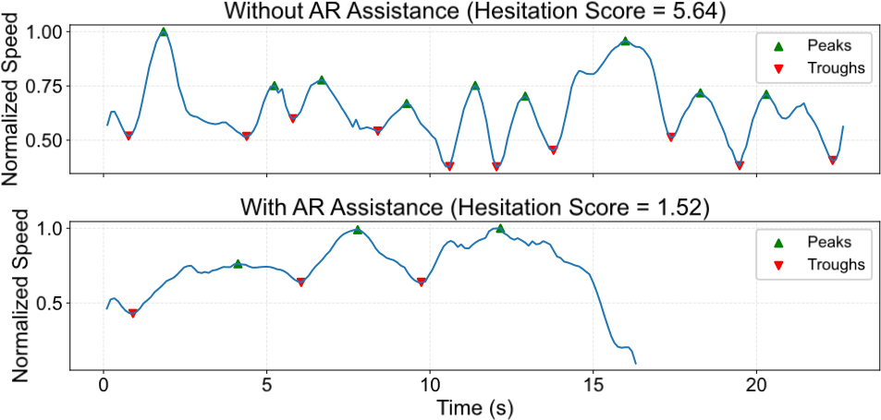
Figure 4: Example of Hesitation Score Calculation Based on Speed Fluctuations During Navigation: illustrates the hesitation score calculation methodology for one representative participant (P6) during obstacle navigation tasks. The bottom panel shows speed over time without AR assistance, displaying frequent speed fluctuations with numerous peaks (green triangles) and troughs (red triangles) indicating high hesitation behavior. The top panel shows the same participant’s speed profile with AR assistance, demonstrating smoother, more consistent walking patterns with fewer speed extrema, resulting in a lower hesitation score.
Subjective Metrics
System Usability Scale (SUS) To assess perceived usability, participants completed the SUS, a widely adopted 10-item questionnaire yielding a total score from 0 to 100, where higher scores reflect better usability Brooke, 1996. A SUS score of 68 is considered the industry average; scores above this threshold indicate good usability, while lower scores may highlight areas for improvement Bangor, Kortum, and Miller, 2008.
Confidence and Clarity Measures Participants responded to four custom Likert-scale items targeting spatial clarity and navigation confidence. These items asked users to rate how clearly they could perceive obstacle locations and how confident they felt walking through the environment—both with and without the system. Each item was scored on a 1–5 scale, allowing us to quantify perceived differences in environmental awareness under assisted and unassisted conditions. The responses provided a subjective but valuable complement to the objective performance data.
Post-Trials Qualitative Feedback - Semi Structured Interviews Participants were interviewed in a semi-structured format, allowing them to share their experiences using the system in their own words. The interviews were conducted in Hebrew, voice recorded, and later translated to English for analysis. After completing the manual overlay obstacle avoidance task, participants responded to a series of open ended questions about their overall experience, what worked well, what they found challenging, and how helpful the AR overlays were in avoiding obstacles. For example they were asked, “Did you feel confident using the system?” and ”How did you feel while using the system compared to when it was turned off?” and “Would you consider using such a system in real life?” Following the automatic detection task, participants were asked a separate set of questions focusing on that experience. These included prompts like, “How did the automatic system perform?”, “Was the timing of the object highlights appropriate?” This structure allowed us to capture detailed, stage-specific feedback and identify recurring themes in participants’ comfort levels, perceived reliability, and suggestions for improvements.

RESULTS

Pre-Experiment Survey: Night Vision SelfAssessment
First, we needed to establish a baseline understanding of participants’ visual capabilities, we analyzed responses from the preexperiment 14-item questionnaire. Responses revealed a clear and consistent pattern; under normal lighting conditions, participants reported high confidence in their navigation abilities (M = 3.50, SD = 0.97), distance estimation (M = 3.00, SD = 1.25), and object recognition (M = 2.30, SD = 1.25 for distant objects; M = 4.00, SD = 1.05 for nearby objects). However, in dim lighting conditions, participants reported significantly lower scores: navigation confidence dropped notably (M = 1.60, SD = 0.84), so did the distance estimation accuracy (M = 1.40, SD = 0.70) and object recognition (M = 1.40, SD = 1.26 for distant objects; M = 2.20, SD = 1.14 for nearby objects).
Notably, participants reported frequently colliding with objects in dim light environments (M = 1.20, SD = 0.42), despite rarely experiencing such collisions under normal lighting (M = 2.40, SD = 0.84). When navigating unfamiliar environments, similar patterns were found, with participants reporting comfort in normal lighting (M = 3.00, SD = 1.25) but considerable discomfort in dim light conditions (M = 1.30, SD = 0.67). These differences between normal and dim lighting were consistently large for all participants. Across every statement, participants reported feeling much less confident and capable in dim light conditions compared to normal light. These results were supported by a paired t-test that confirmed these differences were statistically significant (t(9) = 8.0995, p = 0.00002005). These results suggest that our participants faced serious challenges in seeing and navigating when the lighting is poor, highlighting the importance of testing whether AR overlays can help improve their mobility and confidence in such environments.

Object Counting Task Results
In the object counting task, participants were asked how many chairs they detected within 10 seconds. Without AR highlights, seven out of ten participants failed to detect any chair in at least one of the configurations, and four participants (P6,P7,P9, P10) were unable to detect any chairs in either configuration. When the same tasks were performed with the AR highlights, all participants correctly identified and detected all the chairs in both configurations, achieving a perfect accuracy of 100% (seeing 2 out of 2 in the twochair configuration and 4 out of 4 in the four-chair configuration).
These findings demonstrate that under dim lighting conditions, many participants with night blindness essentially experienced complete object detection failure without assistive technology. The
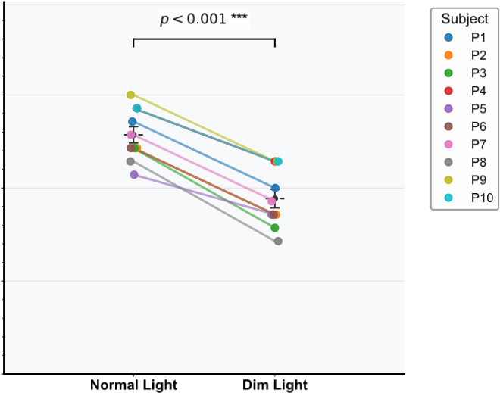

Ligh i g i i
Figure 5: Participants’ self-reported navigation confidence scores across normal and dim lighting conditions, from a 14-item questionnaire assessing their vision capability. Each colored line represents one participant’s confidence ratings on a 5-point Likert scale, where higher scores indicate greater confidence.
perfect performance across all participants with AR highlights suggests that the AR overlays and enhancements effectively compensated for the visual limitations caused by night blindness in dim lighting conditions. Moreover, although response time was not measured, in the control condition, participants used the full duration without successfully detecting all the chairs. In contrast, when the AR highlights were active, all participants completed the task very quickly and before the 10 seconds time limit had elapsed, indicating substantial reduction in search time and increase in accuracy. These results also align with participants’ self-reported difficulties in identifying objects in low light environments as indicated in the pre-experimental survey and provide a foundation for the efficacy of AR-based visual enhancements for individuals with night blindness.
Without AR Assistance With AR Assistance Subject
2 Objects 4 Objects 2 Objects 4 Objects
P1 2 4 2 4
P2 0 2 2 4
P3 2 4 2 4
P4 1 2 2 4
P5 1 3 2 4
P6 0 3 2 4
P7 0 0 2 4
P8 0 0 2 4
P9 0 0 2 4
P10 0 0 2 4

Table 2: Each cell shows the number of objects (chairs) correctly counted by participants under four conditions: without visual assistance and with visual assistance, for 2-chair and 4-chair setups. Visual assistance enabled all participants to correctly count the objects, highlighting the system’s efficacy in supporting perceptual accuracy under low-visibility conditions.

Obstacle Navigation Task Results
4.3.1 Analysis of Completion Times and Collision with Obstacles
 | ig | i | ly i : lli i |  | l | i | i
l  p=0.002** | lli i |  | l i  p=0.004** | i |  |  | i
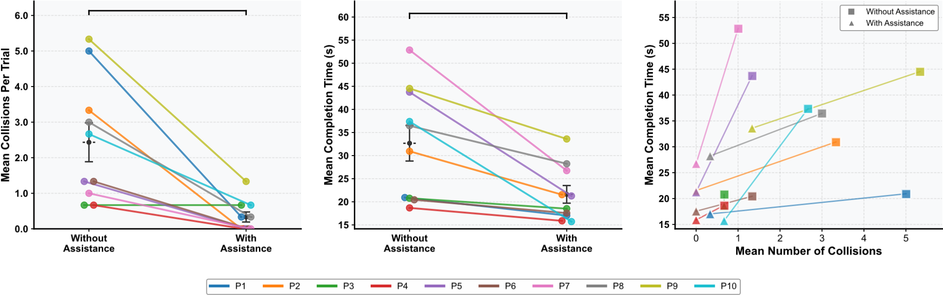
Figure 6: Collisions and completion time, presents navigation performance data across three complementary visualizations, data represents mean performance across three trials per condition. (A) displays mean obstacle collisions per trial, with each colored line connecting individual participants’ performance without assistance (left) to with assistance (right). (B) shows mean completion times using the same before-after format, where each colored line tracks one participant’s completion time across the two conditions. (C) provides a scatter plot comparing collision frequency (x-axis) versus completion time (y-axis) for each participant, with squares representing performance without
Across participants, the mean completion time dropped significantly from 32.68 s without assistance to 21.61 s with AR – an improvement of about 34% (paired-samples t-test: t(9) = 3.85, p assistance and triangles representing performance with AR assistance.
= 0.004, Cohen’s d = 1.22; Fig 6.B). AR assistance also substantially reduced the number of obstacle collisions (see Fig 6.A). Most participants collided with multiple obstacles without assistance, but experienced virtually no collisions when using the AR overlay. On average, the collision count per trial dropped significantly from 2.43 (unaided) to 0.33 with AR, an 86% reduction (paired-samples t-test: t(9) = 4.36, p = 0.002, Cohen’s d = 1.38). This large effect indicates that the visual cues were highly effective in helping participants detect and avoid obstacles they would have otherwise hit in low-light conditions. We compared between time and collisions within participants (Figure 6.C). For example, P1 walked relatively fast even without the mesh, but this came at a cost of colliding with more obstacles. Participants who collided with many obstacles without the mesh both reduced collision count and completion time with the mesh (e.g, P1 and P9); similarly for participant with a low number of collisions the time reduced significantly (e.g., P5 and P7).
4.3.2 Hesitation Score Comparison
Across all participants, hesitation scores were lower in the ARassisted condition than in the baseline (no-AR) condition. On average, the group’s hesitation score decreased from 11.7 (±7.5) without AR to 5.8 (±3.1) with AR, corresponding to roughly a 51% overall reduction in hesitation see Figure 7. One participant (P4) exhibited a minimal change (a 9% reduction, from 2.92 to 2.65), whereas the others showed moderate to dramatic improvements. For example, P5’s hesitation score dropped by 80% (from 21.46 to 4.37) and P10’s by 62% (from 20.75 to 7.89). These reductions show that, under AR assistance, participants tended to navigate with significantly smoother speed profiles.
4.3.3 Obstacle Navigation Task Qualitative Feedback
Feedback from the manually anchored overlay task was strongly positive across all participants. The use of bright wireframe highlights over known obstacle locations (e.g., chairs) significantly improved participants ability to perceive and mentally map their surroundings. Many participants described feeling confident, in control and visually aware of the space even under dim light conditions.
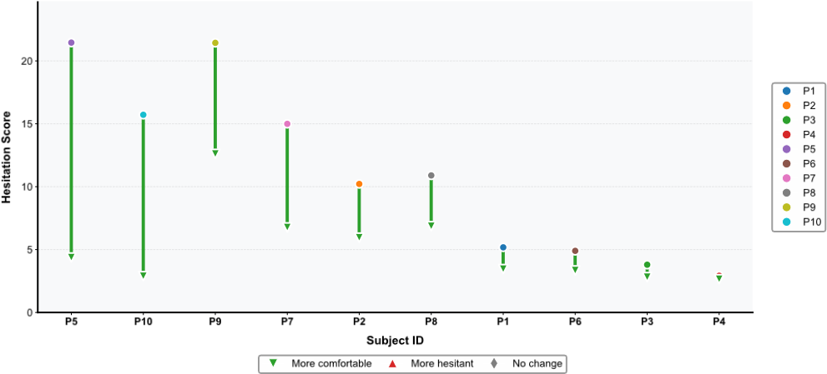
Figure 7: Changes in walking hesitation: With vs Without Assistance: Displays changes in walking hesitation scores for each participant during the obstacle navigation task, data represents mean performance across three trials per condition. Each colored circle represents a participant’s baseline hesitation score without assistance, while the corresponding triangle shows their hesitation score with AR assistance. Connecting lines illustrate the magnitude and direction of change between conditions, with green indicating ”more comfortable” (reduced hesitation) and red indicating ”more hesitant” (increased hesitation). Hesitation scores were calculated using the speed fluctuation methodology described in Figure 4.
For instance, (P10) stated, “I knew exactly where the chairs were, so i could walk around them very easily”, another noted, “The objects were very noticeable, I could see them easily and gain confidence”. The manual overlays particularly impacted participants’ sense of independence and security. (P6) emphasized, “Without the system i did not see anything at all, I was walking while afraid, all the time waving my hands to scan the environment being afraid to collide with anything that might come in my way, but when the highlights were on I was not afraid anymore, I could go confidently because i see and locate this obstacles”. Several participants expressed disbelief at the effectiveness of the system, with (P5) stating, “Regarding my condition I was very confident, very excited and very happy, when i tried it for the first time I couldn’t believe myself that i can see and identify the chair, and asked the experimenter: is this really the chair? I just couldn’t believe it”. Participants also appreciated the consistency and predictability of the manually placed overlays. Unlike traditional assistive technologies that provide auditory or haptic cues, this AR system leveraged their remaining vision and did so in a way that was non-intrusive yet highly effective. (P1) stated: ”The objects were very noticeable, I could see them easily and gain confidence.”. Several participants also noted that the overlays required minimal adaptation time, stating they “immediately knew where the chairs were and how to avoid them”.
4.3.4 System Usability Score
The distribution of SUS scores indicates that participants rated the system as highly usable, with mean score of 88.75 and median above 90, both above the commonly accepted usability threshold of 68. The scores were high, with most ranging between 85 and 95, seven participants exceeded excellent and the remaining three were good. Overall the results reflect excellent perceived usability, supporting the system effectiveness and users-friendliness in dim light navigation tasks.
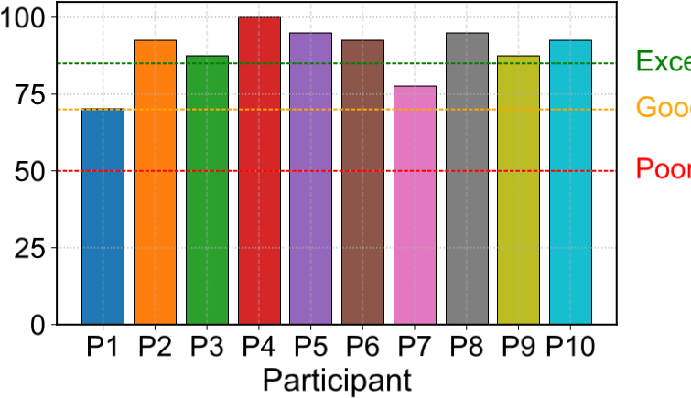
Figure 8: Individual System Usability Scale (SUS) scores for each participant following the obstacle navigation task with AR assistance. Each colored bar represents one participant’s SUS score on a scale from 0 to 100. Horizontal reference lines indicate usability thresholds: poor usability (50, red dashed line), good usability (70, orange dashed line), and excellent usability (85, black dashed line). The bars show the distribution of perceived usability ratings across all participants, with participant IDs (P1-P10) labeled on the X-axis and corresponding SUS scores on the y-axis.
4.3.5 Statements Regarding Confidence and Clarity
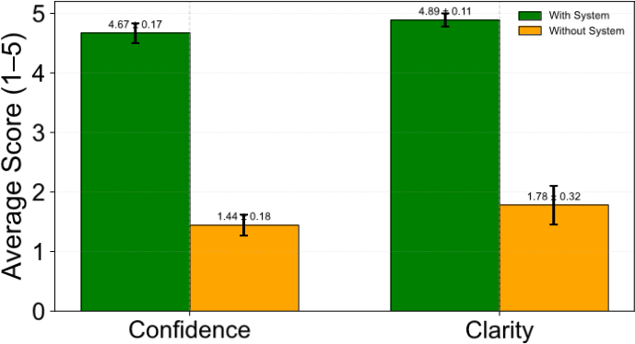
Figure 9: Participants’ reported confidence and clarity ratings based on four custom questions measuring navigational confidence and obstacle clarity, comparing performance with and without the AR assistive system. Green bars represent ratings with the AR system, while orange bars show ratings without assistance, on a 5-point Likert scale.
Participants reported a substantial increase in their confidence when navigating with the AR system. As shown in Figure 9, average confidence ratings were low without AR support (M = 1.5), but significantly increased when using the system (M = 4.7, t(9) = 12.83, p ¡ .001, d = 4.06). In parallel, perceived obstacle clarity also improved considerably, rising from a mean of 1.7 without the system to 4.9 with it (t(9) = 8.91, p ¡ .001, d = 2.82). These self-reported gains in confidence and clarity align closely with the objective improvements observed, suggesting that the AR overlays meaningfully enhanced participants’ perceived spatial awareness and navigational ability.
4.3.6 Automatic Task Feedback
The automatic detection system successfully identified the chair for all participants, and each was able to locate and move the chair under the nearby table. This is especially notable given two key challenges: participants couldn’t see the chair in the dim environment until it was highlighted by the AR system, and the system didn’t provide continuous tracking once the chair was moved. After participants began moving the chair, the overlay remained fixed at its original position for a few seconds before disappearing. Despite this limitation, all participants successfully completed the task—moving a chair they couldn’t physically see to a table they also couldn’t see. This outcome suggests that brief visual enhancements can provide meaningful support. Participants likely relied on a combination of the AR cue and spatial memory developed during earlier trials, as they had become familiar with the room layout and the table’s position. These findings show that even with current technical limitations in real-time tracking, AR-based visual assistance can still offer practical, functional value for individuals with night blindness performing simple spatial tasks in low-light conditions.
In contrast to the manual obstacle navigation task feedback, the real-time object detection and automatic overlay task received more mixed responses. Although the technology successfully identified objects without user input, the detection was slower and less reliable than the manual system, several participants expressed discomfort with how the overlays appeared, a recurring concern was the unexpected nature of the highlights. Since users with night blindness cannot see the object beforehand, the AR highlights would suddenly pop up in their field of view, creating a somewhat unsettling experience. One participant explained, “it was like something just appeared out of nowhere- I couldn’t see anything, and then suddenly there’s a glowing shape in front of me”. Another added, “it gave me a bit of a shock. I didn’t expect the chair to be there and the highlight made it feel like it jumped at me. While both the manual and the automatic systems successfully carry spatial information, when asked, all participants preferred explicitly the manual overlay system due to its predictability, clarity and immediate visibility. Participants valued being able to visually confirm objects early and move with confidence. In contrast, the automatic overlay system introduced unexpected timing and sudden object appearances, which several participants described as distracting or even frightening. This highlights the importance of perceptual timing and user control in AR assistive systems. Especially with people with night blindness, it is not what is shown, but when and how it’s introduced into the visual field that affects trust, comfort, and usability.

DISCUSSION
The results revealed differences in how much each participant benefited from the AR enhancements. Some individuals with the most severe night blindness saw transformative improvements – without AR they could hardly detect any obstacles, yet with bright AR overlays they were suddenly able to perceive every object and navigate almost collision-free (e.g. P7, P8, P9, and P10 were unable to spot any of the sample chairs on their own (0/6 total chairs found in baseline trials), but with AR overlays highlighting the chairs, each of them found 100% (6/6) of the chairs. Navigation collisions for this group dropped to near-zero (e.g., P7 went from 9 contacts without AR to 1 with AR across all tasks, P10 from 8 to 2). Their walking speed also greatly increased (P7 halved his time and hesitation). These users described the system as “unlocking” functional vision they didn’t have before, reflected in their very high usability ratings and enthusiastic feedback. By contrast, participants who already had moderate residual vision or excellent mobility skills unaided showed only marginal gains with AR – their baseline performance was near optimal, so AR provided only slight improvements (e.g. P4 navigated the course in 18.7 s with only 2 collisions without AR – one of the best baseline performances – and P3 likewise was very fast (20.6 s) with minimal collisions. For them, the AR system yielded only marginal gains (P4’s time improved by 2 seconds, with 0 collisions; P3 saw a similar 2 seconds time drop and no change in collisions, and both had very minimal hesitation change) . Interestingly, even these participants appreciated the AR overlay for its subtle assistance or future potential, though a few felt it wasn’t strictly necessary for them (in SUS, P4 got a good score, P3 Excellent). Between these extremes were other notable patterns: fast, confident walkers who tended to rush and bump into obstacles without assistance managed to cut their collision rates substantially with AR, improving safety while maintaining a good pace, (P9 is a prime example – they did not detect any chair in the object recognition task, achieved a baseline time of 44.5 seconds, and hit an average of 16 obstacles, with AR assistance, they counted all of the chairs in the counting task, and dropped collisions to 4) Similarly, P2 was among the quicker baseline walkers (30.9 seconds) but had 10 collisions without AR; with AR, collisions dropped to 0 as they continued at a good pace. However, a handful of minor impacts still occurred, suggesting that AR needs to deliver alerts in a form that can keep up with users who are on the move and perhaps less inclined to slow down – for example, using more salient or attentiongrabbing cues, to catch the notice of a fast, confident walker before a collision occurs.In contrast, the more cautious walkers – those who normally inched forward and probed carefully in the dark – found that AR gave them enough confidence to speed up considerably without losing safety. With the overlays making obstacles obvious, they no longer felt the need to halt and look around every step, resulting in smoother, faster walks with very few hesitations, (e.g. P5 exhibited a very high hesitation score (over 21) and moderate time (43.7 seconds) with only a few collisions, indicating they were looking around the environment carefully and stopping often, with AR, P5’s hesitation plummeted by 80% alongside a 51% time improvement, and gave an SUS score of 95) Across the board, participants reported feeling more aware of their surroundings and more self-assured when using the AR system, underscoring that even though the degree of improvement varied, no one was worse off with AR assistance. All participants navigated the course more quickly and safely with the overlays than without, demonstrating that spatially anchored AR cues can effectively enhance mobility for night-blind users in dim environments. These nuanced differences point to an important insight: the optimal AR support may not be one-size-fits-all, but should adapt to each user’s baseline abilities and behavior for maximum benefit. Despite the positive results, our system has important limitations that suggest directions for improvement. First, the current prototype relied on manually pre-scanning and anchoring specific objects (chairs) for the overlays, which is not scalable to unpredictable real-world settings. Our findings showed that a missed AR warning can still result in a collision if the user doesn’t notice the highlight in time. This is especially relevant for confident walkers who might overlook a peripheral overlay while focused straight ahead. To mitigate this, future AR assistive systems should explore multi-modal alerts, for example, a subtle peripheral indicators (like an arrow or glow at the edge of the display) that guide the user’s gaze toward a hazard outside their current field of view, or a gentle audio tone or haptic vibration when a new obstacle highlight appears. Keeping in mind that any added alerts must be used judiciously to avoid overwhelming or annoying the user. Customization here is key: the style and intensity of cues might be tailored to the user’s walking speed and confidence level. A cautious person may prefer quieter, less distracting signals, whereas a fast-moving person might benefit from more pronounced warnings. In addition to the manually world-locked cues, we tested an automatic object-detection mode, but it could only recognize the one chair model it was trained on and sometimes struggled to maintain tracking when the object moved. The sudden “pop-up” nature of the automatically-triggered highlights also proved annoying for users – because they could not see the real chair until the AR outline appeared, some participants were startled by a glowing object seemingly appearing out of nowhere. This highlights a clear need for more refined detection and visualization techniques. Future versions of the system should incorporate robust, real-time object detection that can handle a variety of obstacles under low light (potentially by leveraging depth sensors or low-light computer vision algorithms) without requiring any manual setup. As part of this, the visual cues themselves could be designed to appear in a more gradual or context-aware fashion. For instance, instead of an overlay instantly materializing at full intensity, the highlight could fade in smoothly as the system gains confidence about an object’s presence or as the user approaches it. This would make the augmentation feel more natural and give the user a moment to adjust their focus, addressing the discomfort with abrupt cues. In addition, using a combination of sensors or perspectives might improve reliability: an extra 360° camera or additional depth units could help cover blind spots and provide more stable tracking in very dark conditions, ensuring that holograms remain correctly aligned and don’t flicker or freeze when lighting is extremely low. Another critical consideration is how to best direct the user’s attention to important cues. Moreover, user trust and comfort with the technology emerged as pivotal factors. Some participants, even after experiencing significant benefits, mentioned they would still rely on their white cane or old navigation habits until they felt completely confident in the AR aid’s accuracy. A few also showed skepticism about reliability, what would happen if the system failed to detect something, would they have any warning? to address this, future designs should strive for transparency and give users a sense of control, in our study’s post-hoc feedback, participants suggested features like a “pause” or “refresh” gesture to reset the highlights, or an adjustable sensitivity setting that they could dial up or down depending on the environment (e.g. turning up the detection aggressiveness when walking into an unfamiliar dark room, and turning it down when sitting or when lighting improves). An Interesting insight has emerged from comparing manual versus automatic object highlighting. While both approaches improved object detection for the users, the sudden appearance of highlights in the automatic detection condition created disorienting experiences for users who could not see the underlying objects beforehand. This reveals a fundamental design consideration for assistive AR: predictability and user control may be more important than technological sophistication, particularly for users who rely on carefully managing limited visual input. This finding challenges common approaches in AR development that prioritize automation over user experience and suggests that future systems should incorporate user-controlled activation or gradual transition cues when enhancing unseen objects.
The limitations of our current automatic enhancement implementation point to important directions for future research. The reliance on pre-scanned 3D models restricts real-world applicability, highlighting the need for advancements in real-time object detection optimized specifically for low-light conditions. Furthermore, further research is needed in optimizing computer vision and 3D object detection models, to allow for real-time detection and rendering on edge devices. Our study demonstrates that augmented reality can significantly improve mobility for users with night blindness in dim lighting conditions. By overlaying bright wireframe visualizations onto real-world objects, we enabled participants to detect obstacles that would otherwise be invisible to them, resulting in faster, safer, and more confident navigation through challenging environments. The improvements across all measured metrics (object detection, navigation speed, collision avoidance, and confidence) establish AR as a viable assistive technology specifically addressing the mobility challenges of night blindness. This represents an important advance in addressing a condition that has received limited attention in the assistive technology literature compared to other visual impairments.

FUTURE WORK
Our findings lead to several design insights and recommendations to make AR navigation aids more effective and better tuned to individual users’ needs. In particular, the results suggest that tailoring AR interfaces to users’ behavioral phenotypes could enhance both performance and satisfaction. Dynamic Visual Overlays (Fade In/Out), To accommodate varying user preferences and reduce visual distraction, AR cues should be presented in a contextdependent, gradual manner. For example, obstacle markers could gently fade in as the user nears a hazard or when an object enters the user’s vicinity, and then fade out once the obstacle is safely passed. Such an approach could maintain the benefits of AR (timely warnings) while minimizing cognitive overload. Confidence-Adjusted Cue Salience, The intensity or prominence of AR cues should adapt to the user’s confidence and the system’s confidence. In our study, more confident walkers (P8, P9, etc.) sometimes still missed or brushed against obstacles even with highlights present, suggesting that the cues might need to be more assertive for these users. On the other hand, already-cautious users might prefer gentler cues that don’t startle or distract them. A smart AR interface could monitor a user’s behavior (e.g., walking speed, head movements) and dynamically adjust cue salience. By preventing under-stimulation for bold users and over-stimulation for careful ones, such a design can keep users engaged and informed without breeding complacency or annoyance. Multi-Modal Attention Direction, Beyond being optional, the use of multiple sensory modalities should be considered a core strategy to direct user attention effectively. Our results showed that a common failure mode was the user occasionally not noticing the visual cue in time, or at all (especially if it was outside their or the Hololens’ field of view, or if they were focused elsewhere). To address this, future AR designs can integrate mechanisms like peripheral indicators or audio/tactile cues that nudge the user to look toward important events. A few participants indicated discomfort with an entirely automatic system. They worried about scenarios where the system might misidentify objects or fail to detect a hazard – an understandable concern given that false positives or negatives in obstacle detection could have safety implications. For example, one participant noted that at times the AR highlight appeared on a chair that they were already aware of, making them wonder if the system would ever “distract me from something else I should notice.” Others mentioned that they still felt the need to rely on their cane or pre-AR habits until they could fully trust the device. These sentiments suggest that transparency and user agency are important design considerations. To address this, future AR aids could allow the user to adjust the sensitivity of detections, confirm or query what the system is highlighting, or easily toggle the AR view on and off. For instance, a mode where the user can point at the device (or perform a gesture) to ask “what’s in front of me?” could give them a feeling of control, complementing the continuous automatic alerts.

REFERENCES
Abe, Yuki et al. (Apr. 26, 2025). ““I can run at night!”: Using Augmented Reality to Support Nighttime Guided Running for Lowvision Runners”. In: Proceedings of the 2025 CHI Conference on Human Factors in Computing Systems. CHI 2025: CHI Conference on Human Factors in Computing Systems. Yokohama Japan: ACM, pp. 1–20. DOI: 10.1145/3706598.3714284. URL: https://dl.acm.org/doi/10.1145/3706598.
3714284 (visited on 07/23/2025).
Aflatouni, Firooz et al. (Feb. 23, 2015). “Nanophotonic coherent imager”. In: Optics Express 23.4. Publisher: Optica Publishing Group, p. 5117. ISSN: 1094-4087. DOI: 10.1364/oe.23. 005117. URL: https://opg.optica.org/abstract.cfm? URI=oe-23-4-5117 (visited on 07/23/2025).
Bangor, Aaron, Philip T. Kortum, and James T. Miller (July 29, 2008). “An Empirical Evaluation of the System Usability Scale”. In: International Journal of Human-Computer Interaction 24.6. Publisher: Informa UK Limited, pp. 574–594. ISSN: 10447318, 1532-7590. DOI: 10.1080/10447310802205776. URL: http://www.tandfonline.com/doi/abs/10.1080/ 10447310802205776 (visited on 07/23/2025).
Brooke, John (June 11, 1996). “SUS: A ’Quick and Dirty’ Usability Scale”. In: Usability Evaluation In Industry. 0th ed. CRC Press, pp. 207–212. ISBN: 978-0-429-15701-1. DOI: 10.1201/ 9781498710411-35. URL: https://www.taylorfrancis. com / books / 9781498710411 / chapters / 10 . 1201 /
9781498710411-35 (visited on 07/23/2025).
Chaumet-Riffaud, Anne Elisabeth et al. (May 2017). “Impact of Retinitis Pigmentosa on Quality of Life, Mental Health, and Employment Among Young Adults”. In: American Journal of Ophthalmology 177. Publisher: Elsevier BV, pp. 169–174. ISSN: 0002-9394. DOI: 10.1016/j.ajo.2017.02.016. URL: https://linkinghub.elsevier.com/retrieve/pii/ S0002939417300764 (visited on 07/23/2025). Chen, Winston and Tejas Shah (July 30, 2021). Exploring Low-light Object Detection Techniques. DOI: 10.48550/arXiv.2107. 14382. arXiv: 2107.14382[cs]. URL: http://arxiv.org/ abs/2107.14382 (visited on 07/23/2025).
Dogan, Mustafa Doga et al. (Apr. 29, 2022). “InfraredTags: Embedding Invisible AR Markers and Barcodes Using Low-Cost, Infrared-Based 3D Printing and Imaging Tools”. In: CHI Conference on Human Factors in Computing Systems. CHI ’22: CHI Conference on Human Factors in Computing Systems. New Orleans LA USA: ACM, pp. 1–12. DOI: 10.1145/3491102. 3501951. URL: https://dl.acm.org/doi/10.1145/
3491102.3501951 (visited on 07/23/2025).
Elmannai, Wafa and Khaled Elleithy (Mar. 10, 2017). “SensorBased Assistive Devices for Visually-Impaired People: Current Status, Challenges, and Future Directions”. In: Sensors 17.3. Publisher: MDPI AG, p. 565. ISSN: 1424-8220. DOI: 10.3390/ s17030565. URL: https://www.mdpi.com/1424-8220/17/ 3/565 (visited on 07/23/2025).
Erickson, Austin et al. (Oct. 31, 2020). “Exploring the Limitations of Environment Lighting on Optical See-Through HeadMounted Displays”. In: Symposium on Spatial User Interaction. SUI ’20: Symposium on Spatial User Interaction. Virtual Event Canada: ACM, pp. 1–8. DOI: 10.1145/3385959.3418445. URL: https://dl.acm.org/doi/10.1145/3385959.
3418445 (visited on 07/23/2025).
Fox, Dylan R. et al. (Feb. 2023). “Using augmented reality to cue obstacles for people with low vision”. English. In: Optics Express 31.4. Publisher Copyright: © 2023 Optica Publishing Group under the terms of the Optica Open Access Publishing Agreement., pp. 6827–6848. DOI: 10.1364/OE.479258.
Gallagher, Neal (2020). “Savitzky-Golay Smoothing and Differentiation Filter”. In: Publisher: Unpublished. DOI: 10.13140/RG.
2.2.20339.50725. URL: https://rgdoi.net/10.13140/ RG.2.2.20339.50725 (visited on 07/23/2025).
Hartong, Dyonne T. et al. (June 1, 2004). “Improved Mobility and Independence of Night-Blind People Using Night-Vision Goggles”. In: Investigative Opthalmology & Visual Science 45.6. Publisher: Association for Research in Vision and Ophthalmology (ARVO), p. 1725. ISSN: 1552-5783. DOI: 10.1167/ iovs.03-1061. URL: http://iovs.arvojournals.org/ article.aspx?doi=10.1167/iovs.03-1061 (visited on
07/23/2025).
Ikeda, Yasuhiro et al. (Mar. 2019). “Night-vision aid using seethrough display for patients with retinitis pigmentosa”. In: Japanese Journal of Ophthalmology 63.2. Publisher: Springer Science and Business Media LLC, pp. 181–185. ISSN: 00215155, 1613-2246. DOI: 10.1007/s10384-018-00644-5. URL: http://link.springer.com/10.1007/s10384-01800644-5 (visited on 07/23/2025).
Insta360 (2025). Insta360 X4. https://www.insta360.com/ product/insta360-x4. Accessed: 2025-07-26.
Kasowski, Justin et al. (May 4, 2023). “A systematic review of extended reality (XR) for understanding and augmenting vision loss”. In: Journal of Vision 23.5. Publisher: Association for Research in Vision and Ophthalmology (ARVO), p. 5. ISSN: 15347362. DOI: 10.1167/jov.23.5.5. URL: https://jov. arvojournals.org/article.aspx?articleid=2785592
(visited on 07/23/2025).
Khan, ObaidUllah Owais, Kamran Ahsan, and Abdul Salam (Oct. 1, 2014). “Assistive Technology For Night Blind Tourist: A Mobile Application Approach”. In: International Journal of E-Services and Mobile Applications 6.4. Publisher: IGI Global, pp. 43–65. ISSN: 1941-627X, 1941-6288. DOI: 10.4018/ ijesma.2014100104. URL: https://services.igiglobal.com/resolvedoi/resolve.aspx?doi=10.4018/ ijesma.2014100104 (visited on 07/23/2025).
Kuriakose, Bineeth, Raju Shrestha, and Frode Eika Sandnes (Feb. 2023a). “DeepNAVI: A deep learning based smartphone navigation assistant for people with visual impairments”. In: Expert Systems with Applications 212. Publisher: Elsevier BV, p. 118720. ISSN: 0957-4174. DOI: 10.1016/j.eswa.2022. 118720. URL: https://linkinghub.elsevier.com/ retrieve/pii/S0957417422017432 (visited on 07/23/2025).
– (Sept. 20, 2023b). “Exploring the User Experience of an AIbased Smartphone Navigation Assistant for People with Visual Impairments”. In: Proceedings of the 15th Biannual Conference of the Italian SIGCHI Chapter. CHItaly 2023: 15th Biannual Conference of the Italian SIGCHI Chapter. Torino Italy: ACM, pp. 1–8. DOI: 10.1145/3605390.3605421. URL: https:// dl.acm.org/doi/10.1145/3605390.3605421 (visited on
07/23/2025).
Kvyetnyy, Roman et al. (Aug. 7, 2017). “Object detection in images with low light condition”. In: SPIE Proceedings. Photonics Applications in Astronomy, Communications, Industry, and High-Energy Physics Experiments 2017. Ed. by Ryszard S. Romaniuk and Maciej Linczuk. Vol. 10445. ISSN: 0277-786X. Wilga, Poland: SPIE, 104450W. DOI: 10.1117/12.2281001.
URL: http://proceedings.spiedigitallibrary.org/ proceeding.aspx?doi=10.1117/12.2281001 (visited on
07/23/2025).
Li, Xingyuan et al. (May 25, 2023). MonoTDP: Twin Depth Perception for Monocular 3D Object Detection in Adverse Scenes. DOI: 10.48550/arXiv.2305.10974. arXiv: 2305.10974[cs]. URL: http://arxiv.org/abs/2305.10974 (visited on
07/23/2025).
Luo, Gang and Eli Peli (Sept. 1, 2006). “Use of an AugmentedVision Device for Visual Search by Patients with Tunnel Vision”. In: Investigative Opthalmology & Visual Science 47.9. Publisher:
Association for Research in Vision and Ophthalmology (ARVO), p. 4152. ISSN: 1552-5783. DOI: 10.1167/iovs.05-1672. URL: http://iovs.arvojournals.org/article.aspx?doi= 10.1167/iovs.05-1672 (visited on 07/23/2025).
Maman, Lior, Ilan Vol, and Sarit F.A. Szpiro (May 2025). “Enhancing Obstacle Visibility with Augmented Reality Improves Mobility in People with Low Vision”. In: IEEE Transactions on Visualization and Computer Graphics 31.5. Publisher: Institute of Electrical and Electronics Engineers (IEEE), pp. 3336–3343. ISSN: 1077-2626, 1941-0506, 2160-9306. DOI: 10.1109/tvcg. 2025.3549542. URL: https://ieeexplore.ieee.org/ document/10934147/ (visited on 07/23/2025).
Marmor, Michael F., Carroll Ault, and Ralph B. Shamlian (Mar. 1980). “Wide-Field High-Intensity Lantern”. In: Ophthalmology 87.3. Publisher: Elsevier BV, pp. 216–217. ISSN: 01616420. DOI: 10.1016/s0161-6420(80)35260-3. URL: https://linkinghub.elsevier.com/retrieve/pii/ S0161642080352603 (visited on 07/23/2025).
Mawatari, Go et al. (July 2024). “Efficacy of a wearable nightvision aid in patients with concentric peripheral visual field loss: a randomized, crossover trial”. In: Japanese Journal of Ophthalmology 68.4. Publisher: Springer Science and Business Media LLC, pp. 321–326. ISSN: 0021-5155, 1613-2246. DOI: 10. 1007/s10384-024-01068-0. URL: https://link. springer.com/10.1007/s10384-024-01068-0 (visited on 07/23/2025).
Microsoft (2025). Azure Mixed Reality Object Anchors Conversion client library for .NET. https://learn.microsoft.com/ en-us/dotnet/api/overview/azure/mixedreality. objectanchors.conversion- readme?view=azuredotnet-preview. Accessed: 2025-07-26.
Min Htike, Hein et al. (May 6, 2021). “Augmented Reality Glasses as an Orientation and Mobility Aid for People with Low Vision: a Feasibility Study of Experiences and Requirements”. In: Proceedings of the 2021 CHI Conference on Human Factors in Computing Systems. CHI ’21: CHI Conference on Human Factors in Computing Systems. Yokohama Japan: ACM, pp. 1–15.
DOI: 10.1145/3411764.3445327. URL: https://dl. acm.org/doi/10.1145/3411764.3445327 (visited on
07/23/2025).
Morrisette, Diane L., Gregory L. Goodrich, and Michael F. Marmor (Mar. 1985). “A Study of the Effectiveness of the Wide Angle Mobility Light”. In: Journal of Visual Impairment & Blindness 79.3. Publisher: SAGE Publications, pp. 109–111. ISSN: 0145482X, 1559-1476. DOI: 10.1177/0145482x8507900304. URL: https://journals.sagepub.com/doi/10.1177/
0145482X8507900304 (visited on 07/23/2025).
Mukhiddinov, Mukhriddin and Jinsoo Cho (Nov. 11, 2021). “Smart Glass System Using Deep Learning for the Blind and Visually
Impaired”. In: Electronics 10.22. Publisher: MDPI AG, p. 2756.
ISSN: 2079-9292. DOI: 10.3390/electronics10222756.
URL: https://www.mdpi.com/2079-9292/10/22/2756
(visited on 07/23/2025).
Peng, Daxin, Wei Ding, and Tong Zhen (Feb. 23, 2024). “A novel low light object detection method based on the YOLOv5 fusion feature enhancement”. In: Scientific Reports 14.1. Publisher: Springer Science and Business Media LLC. ISSN: 2045-2322. DOI: 10.1038/s41598-024-54428-8. URL: https://www. nature.com/articles/s41598-024-54428-8 (visited on
07/23/2025).
Szpiro, Sarit, Yuhang Zhao, and Shiri Azenkot (Sept. 12, 2016). “Finding a store, searching for a product: a study of daily challenges of low vision people”. In: Proceedings of the 2016 ACM International Joint Conference on Pervasive and Ubiquitous
Computing. UbiComp ’16: The 2016 ACM International Joint Conference on Pervasive and Ubiquitous Computing. Heidelberg Germany: ACM, pp. 61–72. DOI: 10.1145/2971648.2971723. URL: https://dl.acm.org/doi/10.1145/2971648.
2971723 (visited on 07/23/2025).
Tiwari, Alok Kumar, Manisha Pattanaik, and G. K. Sharma (Apr. 11, 2024). “Low-light DEtection TRansformer (LDETR): object detection in low-light and adverse weather conditions”. In: Multimedia Tools and Applications 83.36. Publisher: Springer Science and Business Media LLC, pp. 84231–84248.
ISSN: 1573-7721. DOI: 10.1007/s11042-024-19087-x. URL: https://link.springer.com/10.1007/s11042-02419087-x (visited on 07/23/2025).
Van Rheede, Joram J. et al. (July 25, 2015). “Improving Mobility Performance in Low Vision With a Distance-Based Representation of the Visual Scene”. In: Investigative Opthalmology & Visual Science 56.8. Publisher: Association for Research in Vision and Ophthalmology (ARVO), p. 4802. ISSN: 1552-5783. DOI: 10.1167/iovs.14-16311. URL: http://iovs. arvojournals.org/article.aspx?doi=10.1167/iovs. 14-16311 (visited on 07/23/2025).
Vargas-Mart´ın, Fernando and {And} Eli Peli (Nov. 2002). “Augmented-View for Restricted Visual Field: Multiple Device Implementations”. In: Optometry and Vision Science 79.11. Publisher: Ovid Technologies (Wolters Kluwer Health), pp. 715–
723. ISSN: 1040-5488. DOI: 10.1097/00006324-20021100000009. URL: http://journals.lww.com/00006324200211000-00009 (visited on 07/23/2025).
Wang, Jing et al. (July 16, 2023). “Research on Improved YOLOv5 for Low-Light Environment Object Detection”. In: Electronics 12.14. Publisher: MDPI AG, p. 3089. ISSN: 2079-9292. DOI: 10. 3390/electronics12143089. URL: https://www.mdpi.
com/2079-9292/12/14/3089 (visited on 07/23/2025).
Xiao, Yuxuan et al. (2020). “Making of Night Vision: Object Detection Under Low-Illumination”. In: IEEE Access 8. Publisher: Institute of Electrical and Electronics Engineers (IEEE), pp. 123075–123086. ISSN: 2169-3536. DOI: 10.1109/access. 2020.3007610. URL: https://ieeexplore.ieee.org/ document/9134757/ (visited on 07/23/2025).
Xu, Xin et al. (Jan. 31, 2021). “Exploring Image Enhancement for Salient Object Detection in Low Light Images”. In: ACM Transactions on Multimedia Computing, Communications, and Applications 17.1. Publisher: Association for Computing Machinery (ACM), pp. 1–19. ISSN: 1551-6857, 1551-6865. DOI: 10.1145/ 3414839. URL: https://dl.acm.org/doi/10.1145/
3414839 (visited on 07/23/2025).
Zhao, Dewei et al. (Nov. 29, 2024). “Advanced Object Detection in Low-Light Conditions: Enhancements to YOLOv7 Framework”. In: Remote Sensing 16.23. Publisher: MDPI AG, p. 4493. ISSN: 2072-4292. DOI: 10.3390/rs16234493. URL: https://www.
mdpi.com/2072-4292/16/23/4493 (visited on 07/23/2025).
Zhou, Yiming et al. (Oct. 2024). “Real-time low-light video enhancement on smartphones”. In: Journal of Real-Time Image Processing 21.5. Publisher: Springer Science and Business Media LLC. ISSN: 1861-8200, 1861-8219. DOI: 10.1007/s11554024-01532-7. URL: https://link.springer.com/10. 1007/s11554-024-01532-7 (visited on 07/23/2025).

