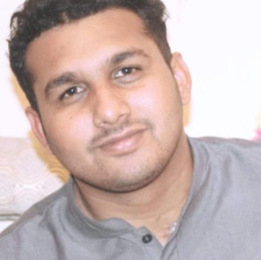

**EXPERIENCE**

**Arfa Kareem(Nexskill)** **2020-present**

Django python

About one Month Experience

**Mandi bahauddin** **2019-2020**

Android developer

Abuot Six month Experience

**Projects**

**Cattle management system(Android application)**

**Online agency Product (Android Application)**

**Mily gold Dust(Android Application)**

**Water delivery (Android Application)**

**Matriculation 2012-2014**

Govt High School Shakargarh

Science

**EDUCATION**

**Bs(Hons) Software Engineering** **2016-2020**

University of Gujrat

**Intermediate** **2010-2014**

Govt Degree Collage Shakargarh

Pre-Engineering

**M AQDAS**

Django python

◼◼◼◼◼◼

Android Studio,

◼◼◼◼◼◼

JAVA

◼◼◼◼◼◼

XML

◼◼◼◼◼◼

HTML

◼◼◼◼◼◼

◼

◼

◼

CSS

◼◼◼◼◼◼

JavaScript ◼◼◼◼◼◼

◼◼◼◼◼◼

Firebase

◼◼◼◼◼◼

SQL

◼◼◼◼◼◼

SKILLS



shakargarh, GB



aqdasmurad@gmail.com



+923069732119

To a successful career in software development. Offering my technical and analytical abilities in object-oriented programming and back-end languages in order to develop above-par applications and underlying systems for my professional growth as well as growth of the company.

CONTACT

LANGUAGES

ENGLISH

URDU

PUNJABI

HOBBIES