**Assignment-3**

**Kaveri Hari Charan Yadav S01996273**

**Logic and how it works**

|  |  |  |  |  |  |  |  |  |  |  |  |  |  |  |  |  |  |  |  |  |  |  |  |  |  |  |  |  |  |  |
| --- | --- | --- | --- | --- | --- | --- | --- | --- | --- | --- | --- | --- | --- | --- | --- | --- | --- | --- | --- | --- | --- | --- | --- | --- | --- | --- | --- | --- | --- | --- |
| **INDEX** | 0 | 1 | 2 | 3 | 4 | 5 | 6 | 7 | 8 | 9 | 10 | 11 | 12 | 13 | 14 | 15 | 16 | 17 | 18 | 19 | 20 | 21 | 22 | 23 | 24 | 25 | 26 | 27 | 28 | 29 |
| **ALPHABETS** | **A** | B | C | D | E | F | G | H | I | J | K | L | M | N | O | P | Q | R | S | T | U | V | W | X | Y | Z | **,** | **.** | **-** | **_** |
| **Text** | S | E | M | O | _ | C | S | - | D | e | p | a | r | t | m | e | n | t | - | i | s | - | t | h | e | - | b | e | s | t |
| **Key** | C | a | p | e | G | i | r | a | r | d | e | a | u |  |  |  |  |  |  |  |  |  |  |  |  |  |  |  |  |  |
| **Indexforvalues for key** | 3 | 0 | 15 | 4 | 6 | 8 | 17 | 0 | 17 | 3 | 4 | 0 | 20 |  |  |  |  |  |  |  |  |  |  |  |  |  |  |  |  |  |
|  | S | E | M | O | _ | C | S | - | D | e | p | a | r | **t** | **m** | **e** | **n** | **t** | **-** | **i** | **s** | **-** | **t** | **h** | **e** | **-** | **b** | **e** | **s** | **t** |
| **Encryption with key** | 18+3 | 0 | 12+15 | 14+4 | 29  +  6 | 2+8 | 18+17 | 28+0 | 3+17 | 4+  3 | 15+4 | 0+0 | 17+20 |  |  |  |  |  |  |  |  |  |  |  |  |  |  |  |  |  |
| **cipher** | **u** | **e** | **.** | **s** | **F** | **k** | **f** | **-** | **u** | **h** | **t** | **a** | **h** | j | q | b | b | y | I | n | q | s | , | , | e | f | k | u | t | u |

**#SourceCode:**

value = input("Enter some text to encrypt: ")

print("- - - - - - - - - - - - - - - - - - - - - - - - - - - -")

key = input("Enter a key(some text): ")

print("- - - - - - - - - - - - - - - - - - - - - - - - - - - -")

print('Plaintext: ',value)

n = len(value)

data= "ABCDEFGHIJKLMNOPQRSTUVWXYZ,.-_"

ciphertext = ""

z= len(key)

for index in range(0, n):

if index!=0 and index%z == 0:

if len(key) < len(value):

key = key + ciphertext[len(ciphertext) - z : int(min(len(key) + z, n))]

ciphertext+= data[(data.index(value[index].upper()) + data.index(key[index].upper())) % 30]

key = key[0:n]

print('Key:',key)

print('Ciphertext: ',ciphertext)

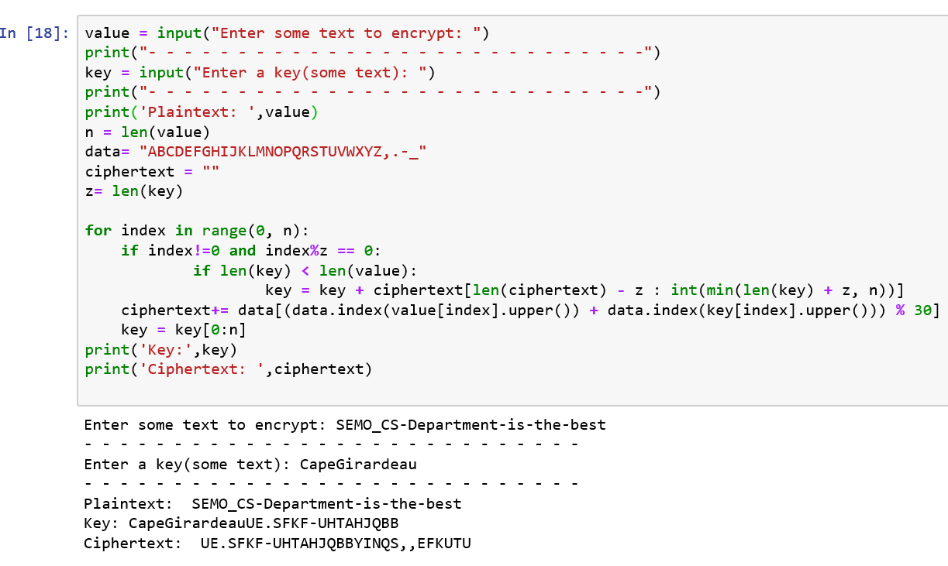

**Output:**

Enter some text to encrypt: SEMO_CS-Department-is-the-best

- - - - - - - - - - - - - - - - - - - - - - - - - - - -

Enter a key(some text): CapeGirardeau

- - - - - - - - - - - - - - - - - - - - - - - - - - - -

Plaintext: SEMO_CS-Department-is-the-best

Key: CapeGirardeauUE.SFKF-UHTAHJQBB

Ciphertext: UE.SFKF-UHTAHJQBBYINQS,,EFKUTU