**Documentation of Bakee wedding creators**

**Date: 2023-10-20 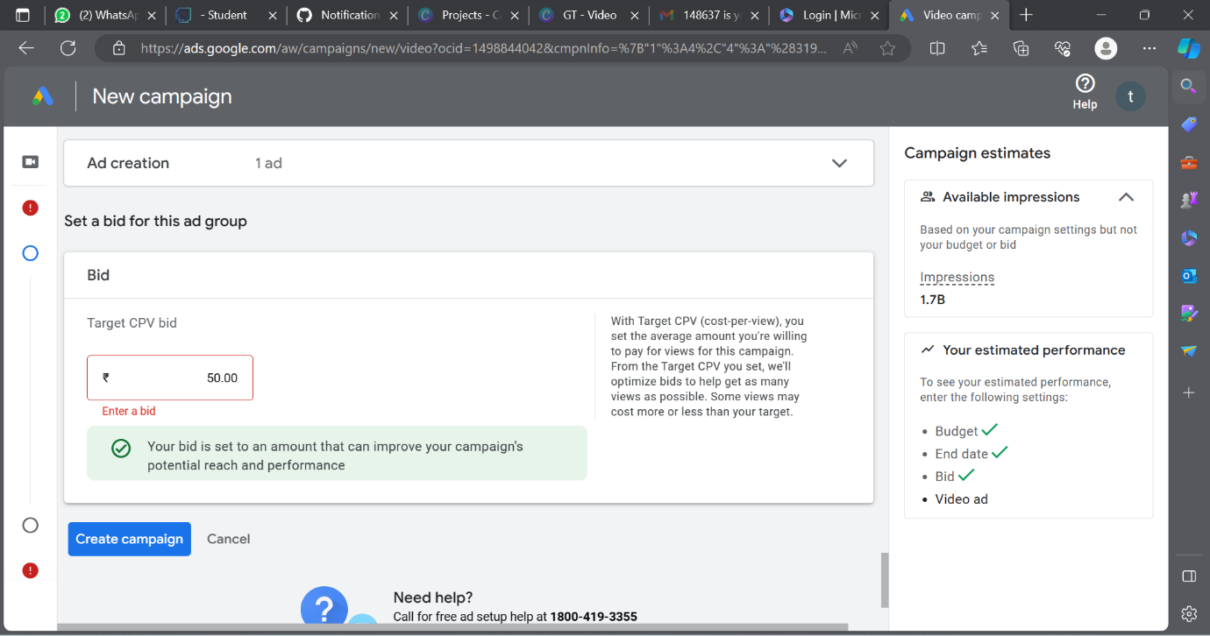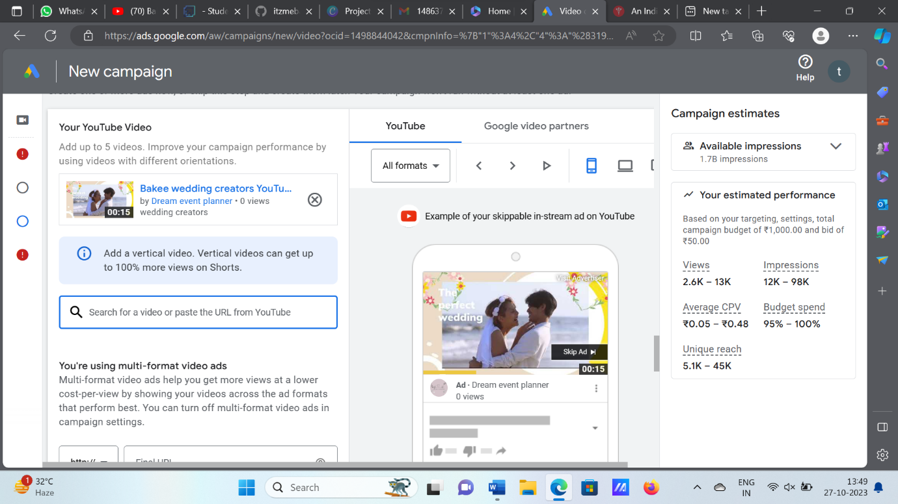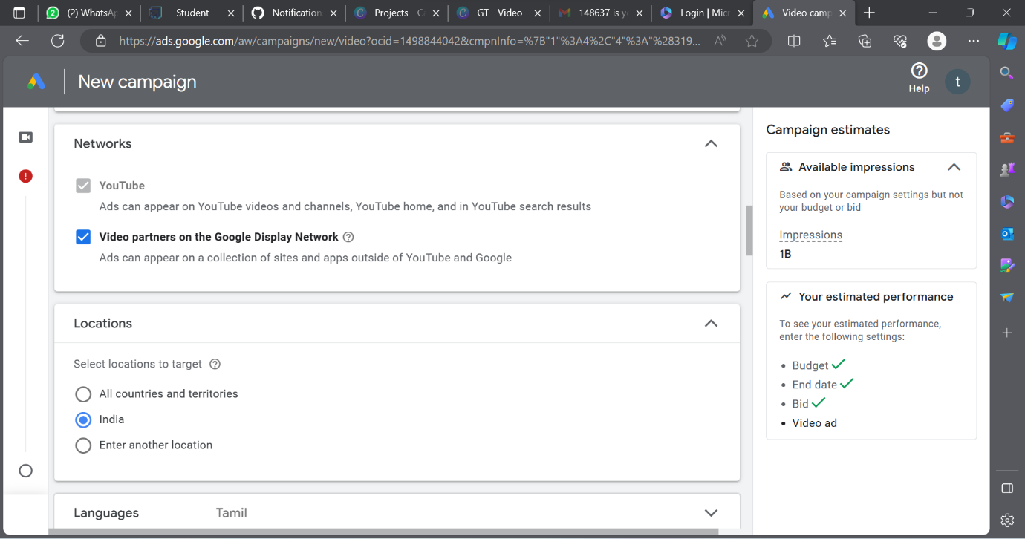 Overview:**

Indian weddings are not a one-day affair. You have the pre-wedding ceremonies, then the wedding itself and of course, the post-wedding ceremonies too! To tell you all about them, here is a general timeline

This is a comprehensive report on the trends and challenges of the Indian wedding industry, based on a survey of over 3000 users and wedding vendors on Bakee wedding creaters, a popular wedding planners. The report covers topics such as the scale and budget of weddings, the change in spending patterns, the effects of Covid-19 on wedding businesses, and the preferences and expectations of couples and vendors.

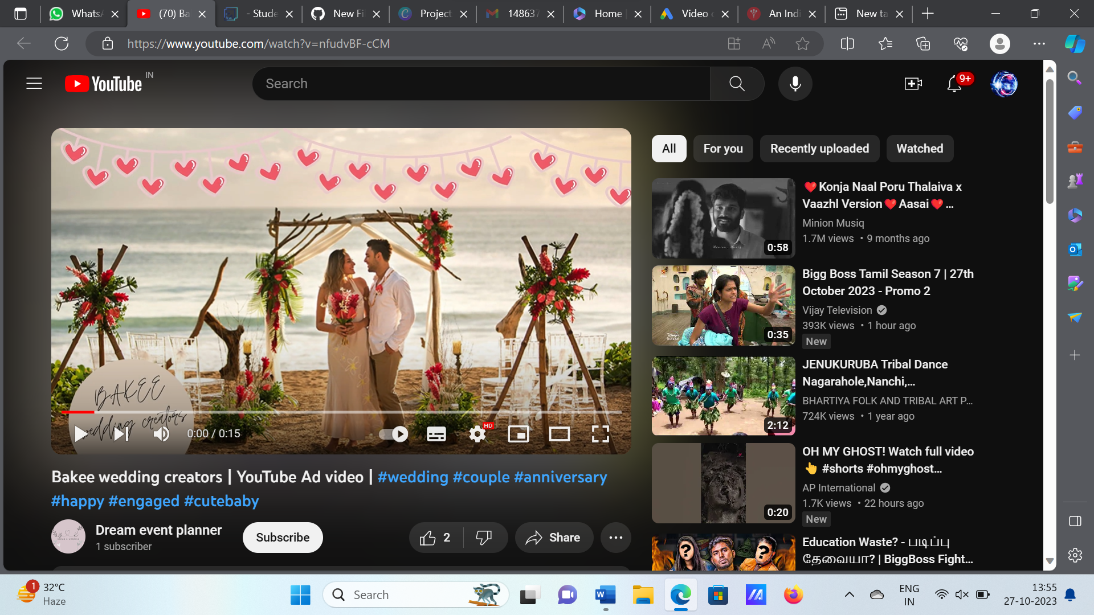

**Project** **link**: https://youtu.be/nfudvBF-cCM

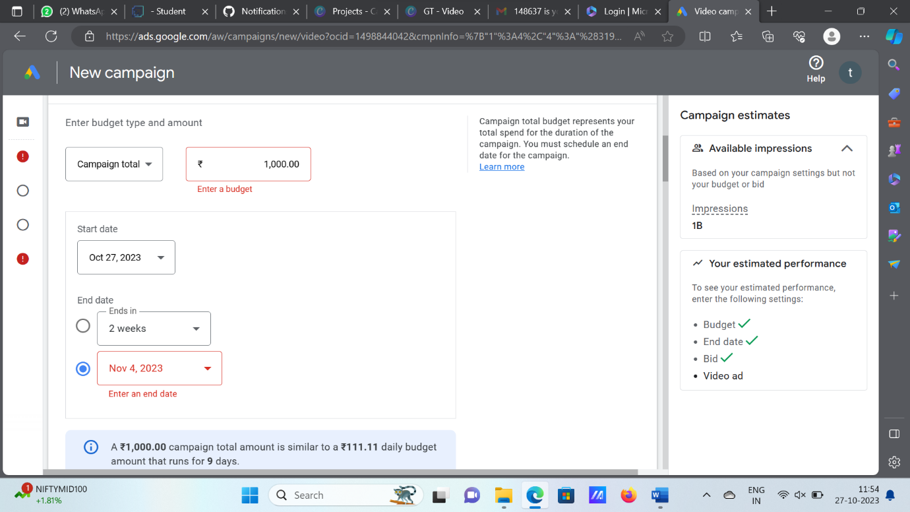

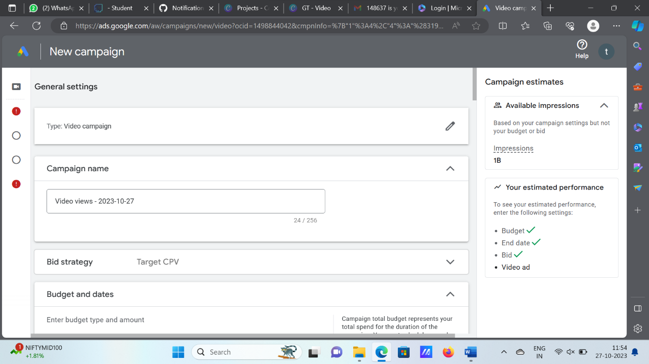

**Brand Email:** [bakeeeventplanner@gmail.com](mailto:bakeeeventplanner@gmail.com)

**Password**: bakee0209

**Category:** Digital marketing

**NM ID:** F6A1E1F6F6F8E5393404A85BCE61B610

**Name :** Gugan S S

**College name:** Saranathan College Of Engineering

**Department:** Electronics and Communication Engineering