

FINANCIAL LITERACY ASSISTANT FOR STUDENTS SYSTEM

In Partial Fulfillment of the
Requirements for the Subject
Computer Programming 1
and Introduction to Computing

Amsula, Kimark M.
Bacarrisas, Clint Jasper G.
Cayran, Jezzille T.
Godes, Almar G.
Lawansa, Yaz Alexander B.
Valeroso, Jay Ivan P.

November 17, 2025
Introduction
In today’s generation, technology continues to influence how individuals manage their personal finances, yet many still struggle with financial literacy. A lack of understanding of financial systems often leads to poor budgeting, overspending, and financial instability, especially among young adults (Bestari, 2024). College students, in particular, begin to make their first significant financial decisions during this stage of life—such as managing allowances, budgeting expenses, and handling savings—which can be overwhelming without proper financial knowledge (Kezar & Yang, 2010). Financial literacy, which includes the knowledge, skills, and confidence to manage money effectively, plays a vital role in shaping one’s financial behavior. However, the absence of these skills can result in poor decision-making and vulnerability to financial problems (Thomasa, 2019; Goyal & Satish, 2018).
To address these challenges, the proponents developed a personal financial management system designed specifically for college students. The system serves as an interactive and user-friendly platform that allows users to record their daily transactions, track their allowances, categorize their expenses, and monitor their overall financial activity. It provides real-time summaries, enabling students to visualize their spending patterns and manage their money wisely. In addition, the system offers personalized tips that guide users in preventing overspending and encourage them to build responsible financial habits (Chen, 2023).
The creation of this system is essential as it promotes financial literacy and empowers students to take control of their finances at an early age. By helping them understand where their money goes and how to manage it properly, the system aims to instill practical financial management skills that support long-term economic stability. Ultimately, its main objective is to guide students toward becoming financially independent individuals who make informed and responsible financial decisions that contribute to a more stable and secure future (Oseifuah, 2010).

Statement of the Problem
Many college students struggle with managing their personal finances due to a lack of financial literacy and inadequate budgeting tools. This often leads to overspending, poor allocation of allowances, and financial stress. Despite the availability of digital technologies, a gap remains in providing an accessible and student-friendly system that promotes effective financial management and literacy among young adults.
Specifically, this study seeks to address the following questions:
- How can the proposed financial management system help students effectively monitor their income, allowances, and expenses?
- In what ways can the system promote better budgeting habits and responsible spending among college students?
- What features can be integrated into the system to enhance financial literacy and improve decision-making in managing personal finances?
- How effective is the system in assisting students to develop long-term financial discipline and independence?
- What challenges might students encounter in using the system, and how can these be addressed to ensure user satisfaction and accessibility?

Objectives of the Study
General Objective:
The general objective of this study is to develop a practical and easy to use financial management system that assists students in managing their allowances and expenses. The system aims to help students become more responsible with their money by providing tools for tracking finances.
Specific Objectives:
- To enable students to input their allowance and expenses in real time, so they can monitor their actual financial situation whenever they need.
- To organize and categorize students’ expenses, making it easier for them to track where their money goes and to identify spending patterns.
- To provide a summary of remaining balances automatically, helping students see how much money they have left after spending.
- To offer financial tips and advice that guide students in budgeting and managing their allowances, promoting better financial habits.
- To empower students with practical money management skills and financial literacy, leading to more responsible spending and long-term independence.

Scope and Limitation
Scope:
The proposed financial management system is designed to help college students effectively manage their personal finances by providing essential tools for budgeting and expense tracking. The system enables users to input their real-time allowances and record their daily expenses accurately. It allows students to track their spending in an organized manner by categorizing expenses and automatically calculating their remaining balance based on total expenditure. Through real-time financial summaries, users can easily monitor their allowance and understand how their money is spent. Additionally, the system provides helpful financial tips that guide students in making wise spending decisions and encourage them to manage their budget responsibly.
Limitation:
Despite its usefulness, the system has certain limitations. It is primarily intended for college students and may not be suitable for users with complex financial portfolios or advanced budgeting needs. Moreover, while the system provides financial advice through automated tips, it does not replace professional financial consultation or expert guidance. Additionally, the system does not use a graphical user interface (GUI) and operates only through a text-based console in Python, which may limit visual interaction and ease of use for some users.

System Requirements
Hardware Requirements:
- Processor: Intel Core i3 or AMD equivalent (Currently using Intel N95 – meets the requirement)
- Memory (RAM): Minimum of 4GB (8GB recommended for smoother performance)
- Storage: At least 500 MB of free disk space
- Display: 1366x768 resolution or higher
Software Requirements:
- Operating System: Windows 10 or 11, macOS, or Linux
- Programming Language: Python 3.10 or higher
- Text Editor/IDE: Visual Studio Code, PyCharm, or IDLE

Flowchart
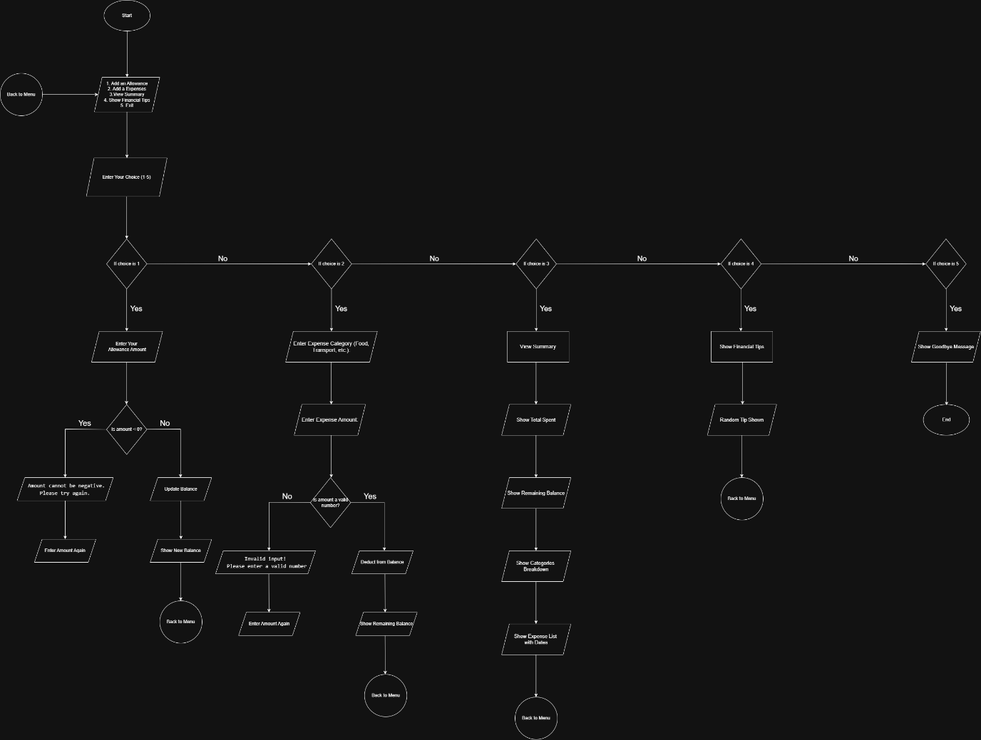

Test Scenarios & Outputs
S1: Selecting an Option
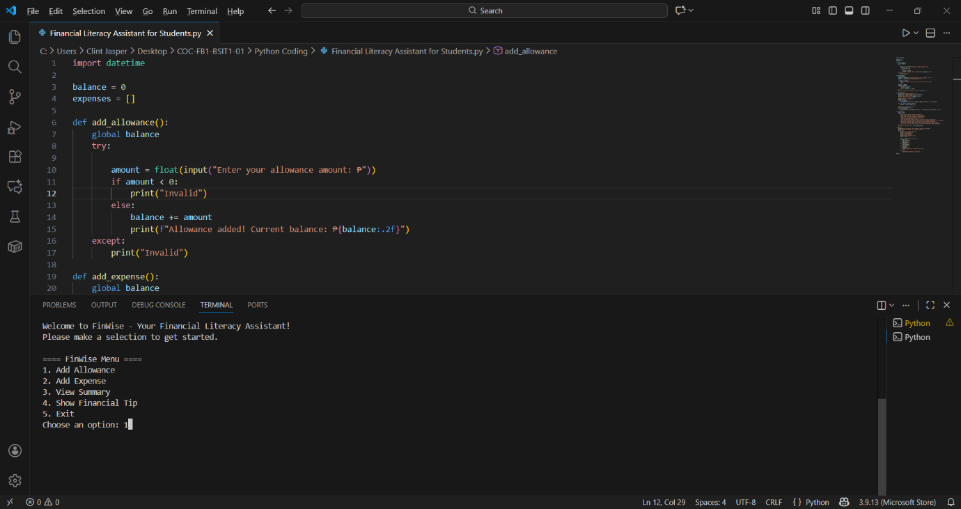
Purpose: The user will select an option.

S2: Adding Allowance
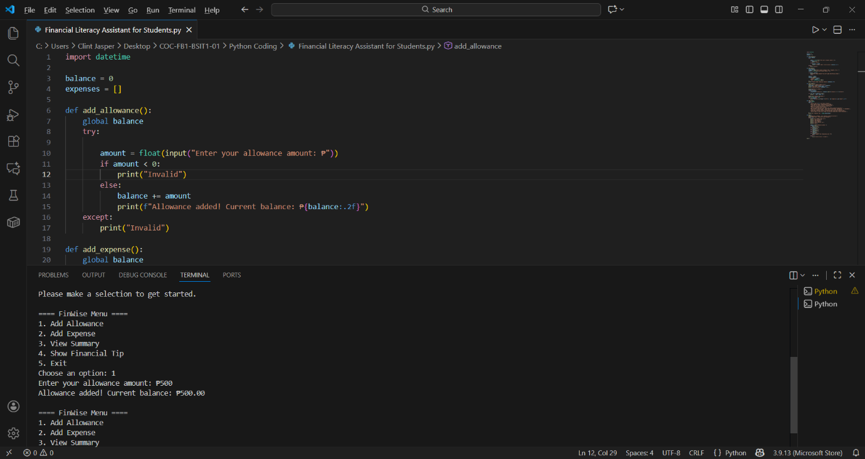
Purpose: To add an allowance from the user.

S3: Adding Expenses
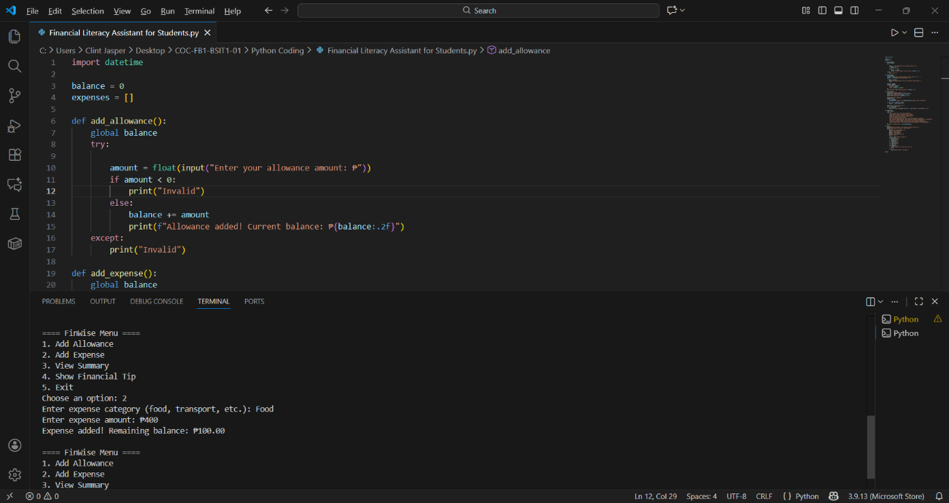
Purpose: To add an expenses to your current balance.

S4: View Summary
Purpose: To view your summary on your expenses.
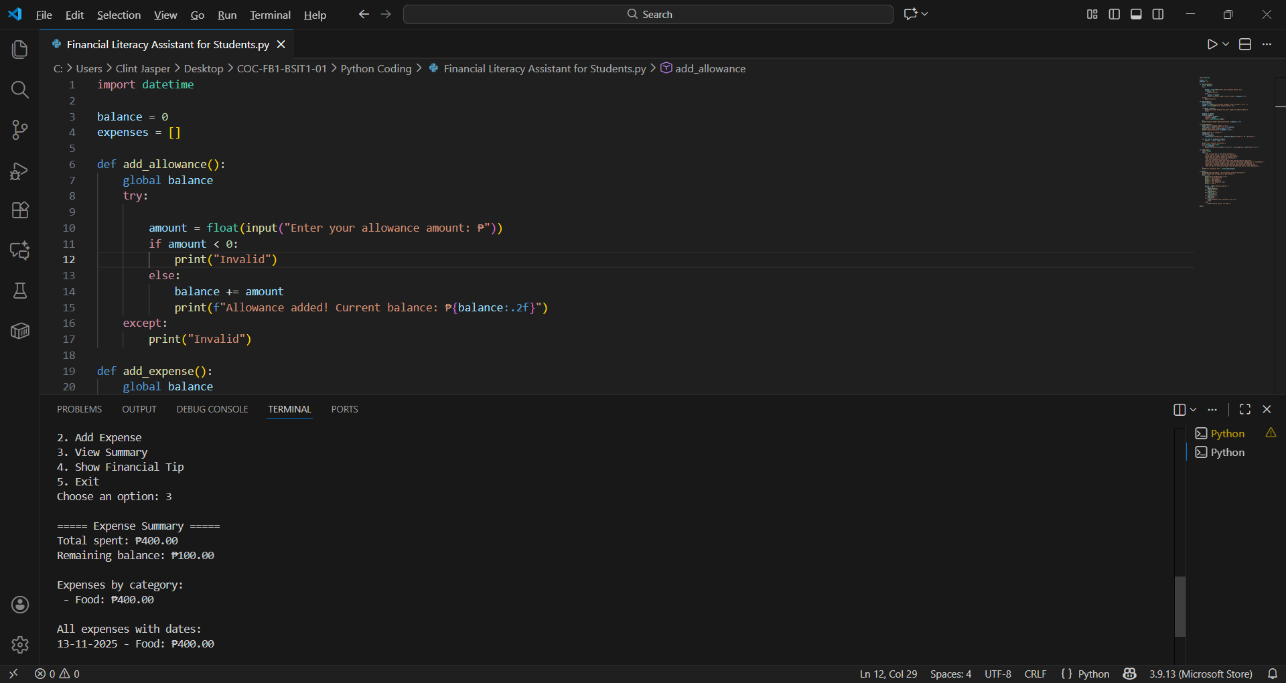

S5: Show Financial Allowance
Purpose: To show some financial tips to the user.
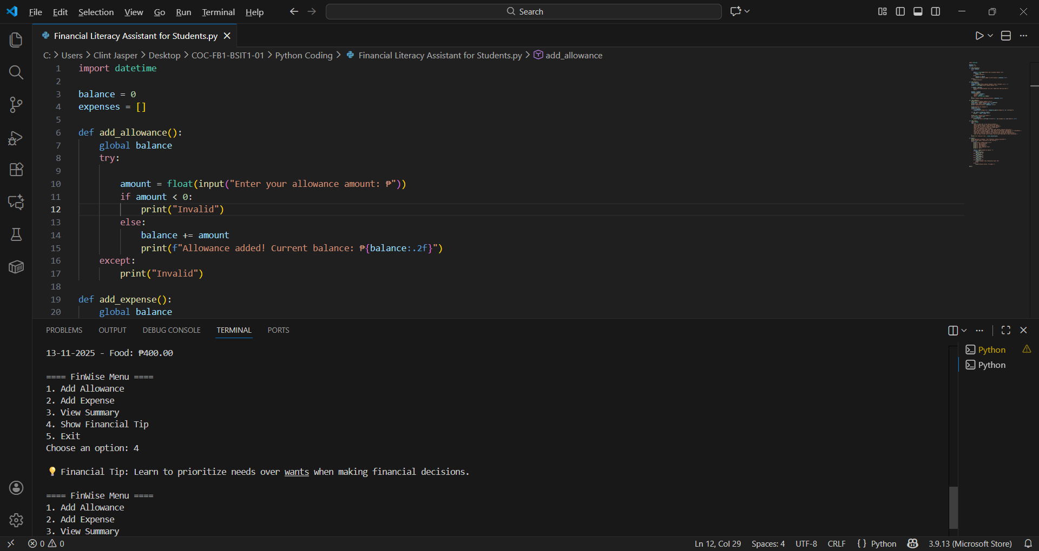

S6: Exit
Purpose: The user will end the system.
