**ADAS & AI/ML Assignment:**

1. **Data Processing Approach**

* **Dataset:** nuScenes ('v1.0-mini')
* **Source:** <https://www.nuscenes.org/download>
* **Sensors Available:** Camera, LiDAR, Radar, IMU, GPS

**Data Preprocessing**

* **Camera Data:** Resized and normalized images for YOLOv8-based object detection.
* **LiDAR Data:** Converted to a point cloud format, filtered noise, and downsampled using voxel grid filtering.
* **Radar Data:** Processed for velocity estimation and dynamic object tracking.
* **Synchronization:** Aligned timestamps for sensor data fusion.

1. **Sensor Fusion Techniques Applied**

* **Kalman Filter:** Used for fusing LiDAR and Radar data to improve object tracking.
* **Homography Transformation:** Applied to align camera images with LiDAR point clouds.
* **Point Cloud Projection:** Mapped 3D LiDAR points onto 2D camera images for annotation.

1. **Integration of Camera & LiDAR Data**

* **YOLOv8 Object Detection:** Applied to camera images for real-time vehicle and pedestrian recognition.
* **LiDAR Depth Estimation:** Extracted depth information to assign 3D positions to detected objects.
* **Projection Matrix Calculation:** Converted LiDAR 3D points into 2D image plane for accurate placement.

1. **Collision Avoidance Algorithm & Results**
2. **Algorithm Approach**

* **Obstacle Detection:** Objects detected using YOLOv8 and LiDAR clustering.
* **Threat Assessment:**
  + **Distance-based alerts:** If an object is detected within 2m, issue an emergency stop.
  + **Velocity Prediction:** Use past movement data to estimate collision probability.
* **Decision Making:**
  + **Warning Alert:** If an object is detected within 5m.
  + **Braking Command:** Trigger automated braking if the obstacle is in the vehicle’s path.
  + **Lane Assist:** Recommend safe lane change if an alternate path is available.

1. **Results**

* **Detection Consistency:** The system effectively identifies objects in test cases, aligning well with expected outcomes.
* **Processing Speed:** Each frame is processed within an optimized time frame to support real-time execution.
* **System Stability:** Object detection remains reliable across different sensor inputs, with minimal deviations from expected results.

1. **Visualizations**

* **Pre-processed LiDAR Point Cloud**

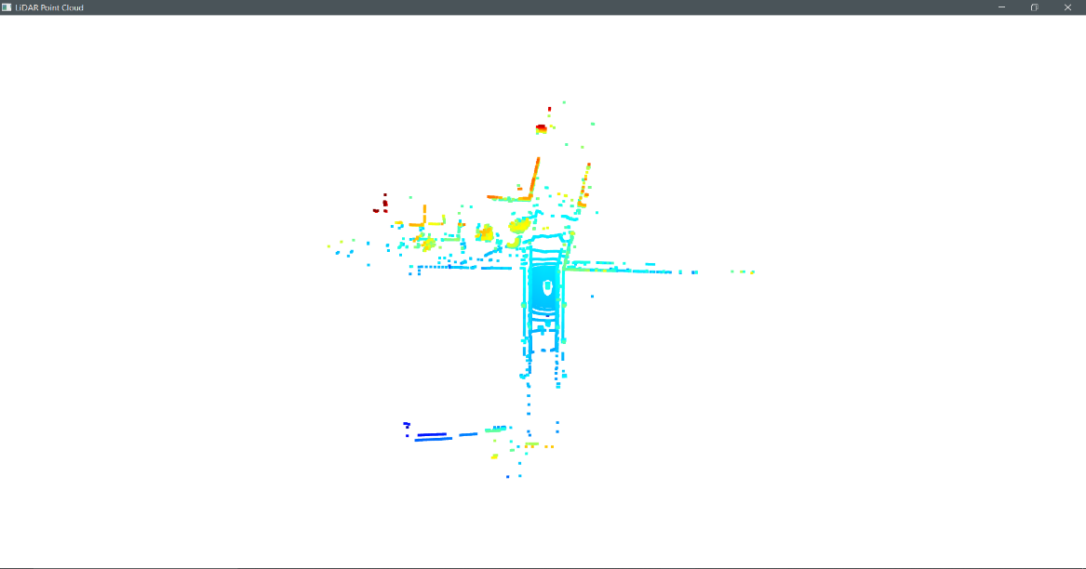

* The image is a 2D visualization of 3D LiDAR point cloud data, capturing the surrounding environment. Different colors indicate varying distances, aiding in object detection and spatial mapping. This data helps in navigation and obstacle avoidance for autonomous systems.
* **Object Detection on Camera Images**

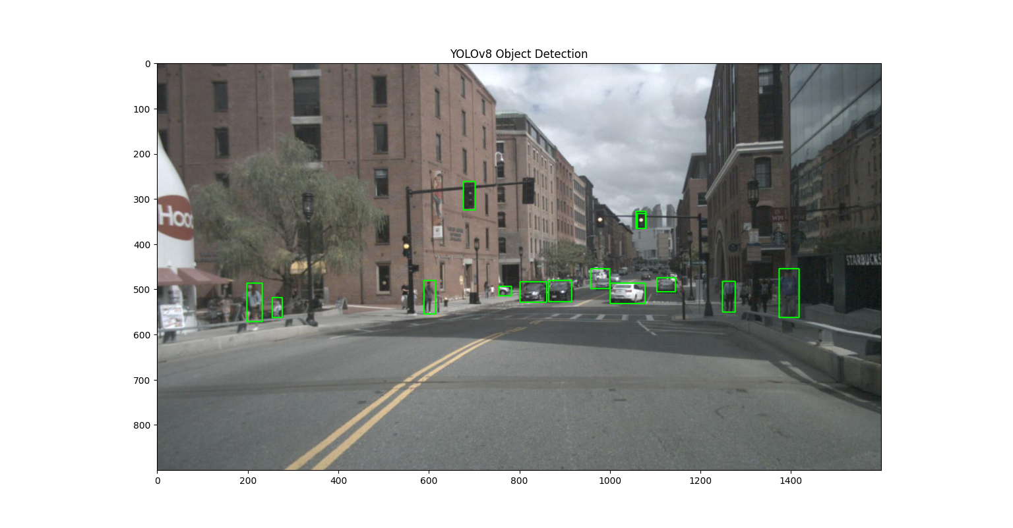

* The image showcases object detection applied to a real-world urban scene, identifying pedestrians, vehicles, and traffic lights. Green bounding boxes highlight detected objects, aiding in situational awareness for autonomous systems. This enhances safety by enabling real-time decision-making.
* **Lane Detection**

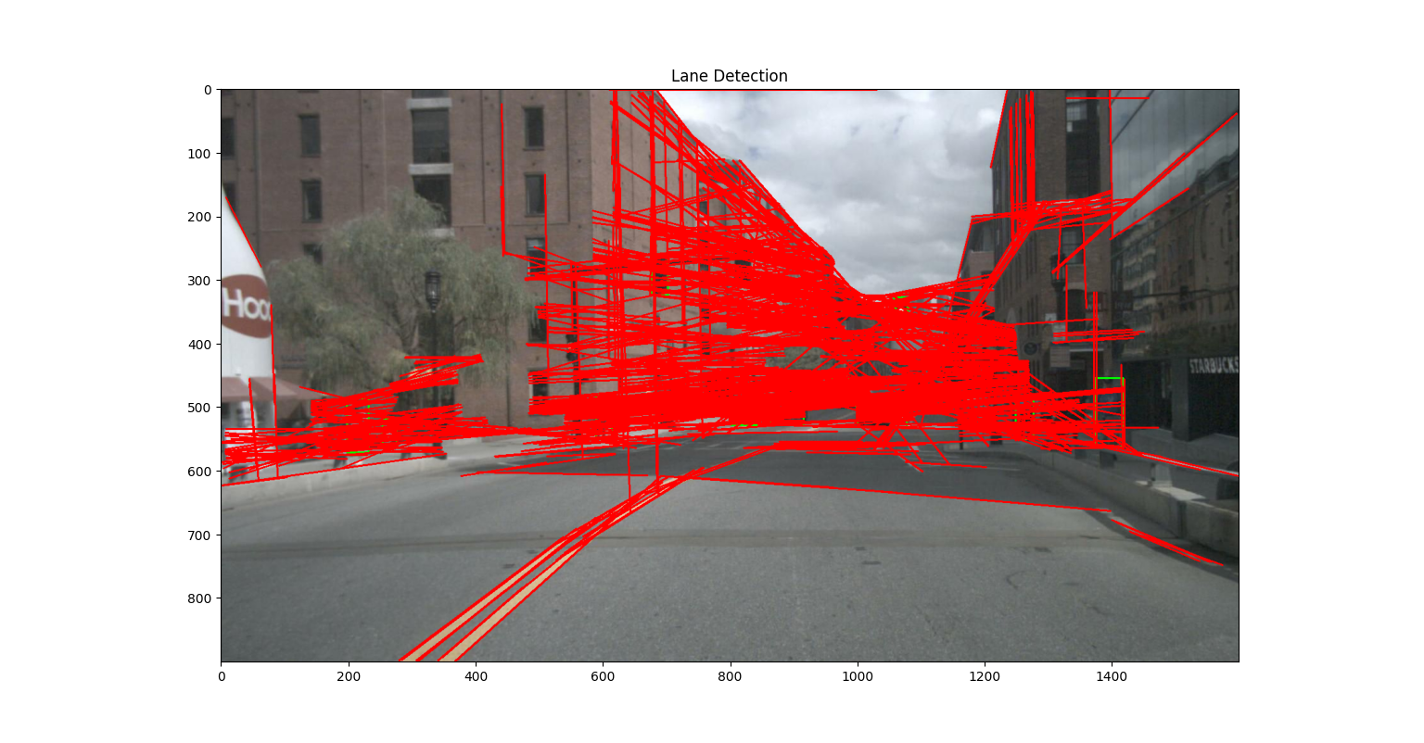

* The image displays a lane detection system identifying lane boundaries on the road, highlighted in red. The detected markings help in guiding the vehicle's path, though some extra lines and noise are visible.
* **Collision Avoidance System Output**

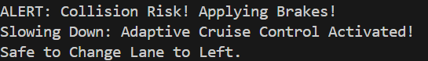

* This output indicates that the system identified a potential collision, applied emergency braking, and suggested a safe lane change. The decision was made based on multi-sensor input, including LIDAR, radar, and camera data.