* Helm install dry run

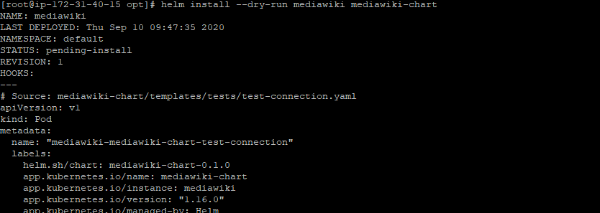

* Helm chart installatiion

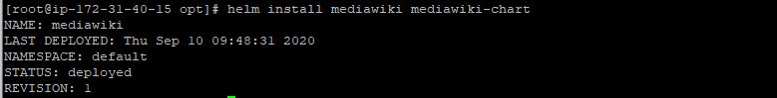

* Get all deployed objects using kubectl

