BATCH 11 - Smart Home Voice Controlled Automation
by

Saranish R – 727723eucs212
Saravanan C – 727723eucs214
Rudhresh - 727723eucs196
Santhosh – 727723eucs208
Circuit Diagram :
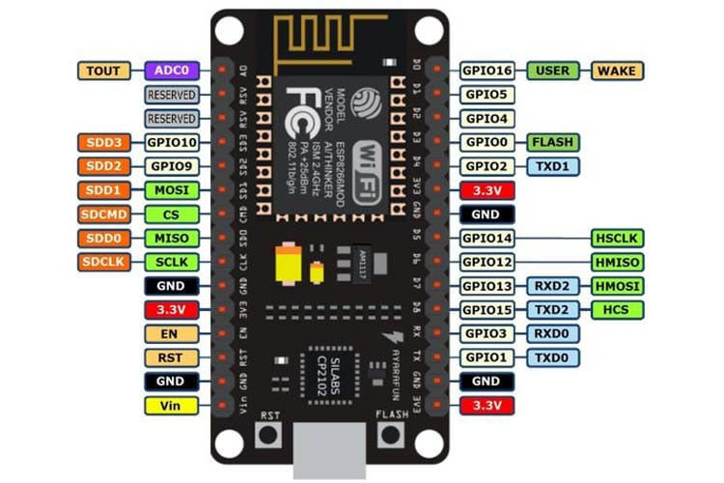
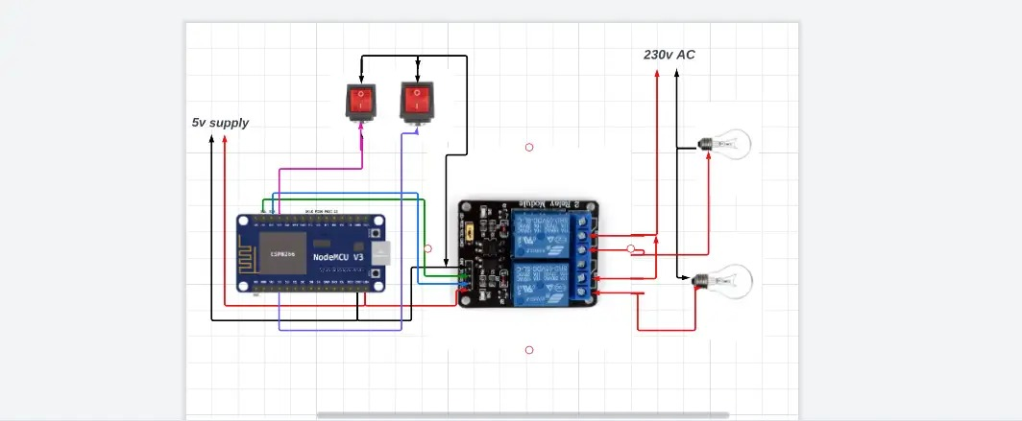
NodeMCU ESP8266:
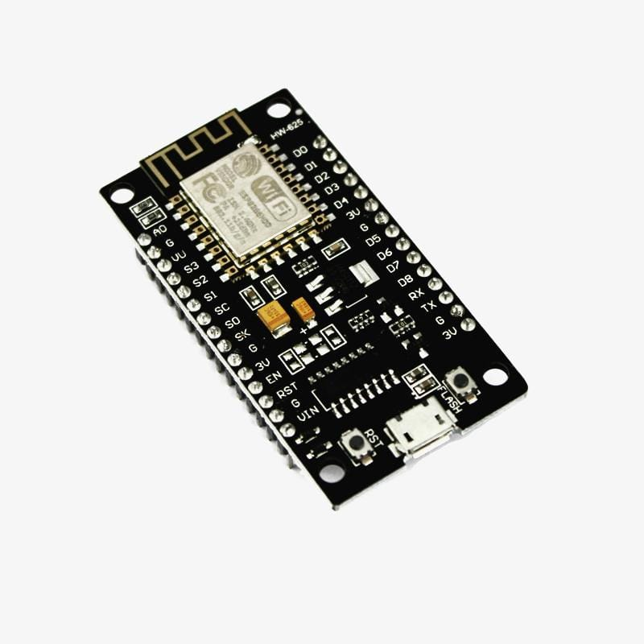

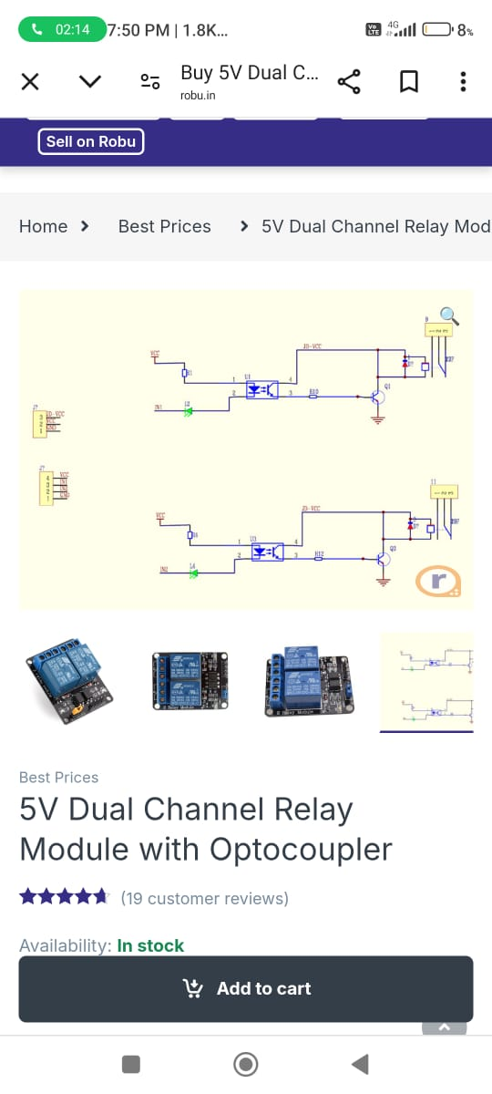
5V Relay 2 Channel :
