**23907 – MDSC-103P – ESE**

1. (a) Max Z = 7x1 + 10x2

Subject to constraints

C1: 5x1 + 6x2 <= 3600

C2: x1 + 2x2 <= 960

C3: x1 <= 500

C4: x2 <= 500

x1, x2 >=0

where x1 = baseball and x2 = softball

Sensitivity Analysis Report:

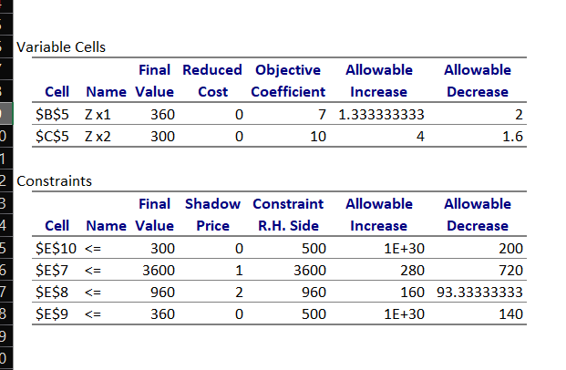

(b) **Cost Coefficient Sensitivity Analysis:**

For the given problem, cost coefficient sensitivity analysis is objective function analysis.

So, the final values are x1 = 360 and x2 = 300 and the formulated objective are 7 and 10 respectively.

From the sensitivity report, the maximum allowable increase of price in baseballs is 1.3333 i.e., the price can be maximum of 8.3333 whereas the maximum allowable increase of price in softballs is 4 i.e., the price can be maximum 14.

And the allowable decrease of price in baseball is 2 i.e., until 5 and the allowable decrease of price in softball is 1.6 i.e., until 8.4

Therefore, the cost ranges for the baseball and cost ball to maintain the same optimum solution i.e., the profit is:

For baseball – x1 – 5 to 8.3333

For softball – x2 – 8.4 to 14

(c) **Right Hand Side Sensitivity Analysis:**

For the given problem, right hand side sensitivity analysis is constraints analysis.

The constraints are as follows:

C1 is the usage of cowhide covers (sheets) to manufacture the balls

C2 is the time (in minutes) required to manufacture the balls

C3 is the max number of baseballs (in dozen) which can be manufactured per day.

C4 is the max number of softballs (in dozen) which can be manufactured per day.

So, the final value of the constraints are as follows:

C1 = 3600, C2 = 960, C3 = 360, C4 = 300.

Here, the allowable decrease of C1 is 720 and the allowable increase is 280 i.e., from 2880 to 3880 and the shadow price is 1, so for increase in each unit of cowhide, the profit increases.

The allowable increase of C2 is 160 and the allowable decrease is 93.3333 i.e., from 866.6667 to 1120 and the shadow price is 2, so for increase in time, the profit increases more than the increase of cowhide.

The allowable decrease in C3 is 140 and it can be increased to a greater extent i.e., from 360 to a finite number and the shadow price is 0, so in change of the value, there is no effect in profit.

The allowable decrease in C4 is 200 and it can be increased to a greater extent i.e., from 300 to a finite number and the shadow price is 0, so in change of the value, there is no effect in profit.

So, finally increase in time i.e., C2 will attain higher profit and increase in cowhide i.e., C1 will get more profit but not more than when we increase time. And there is no effect for C3 and C4.

1. (a) 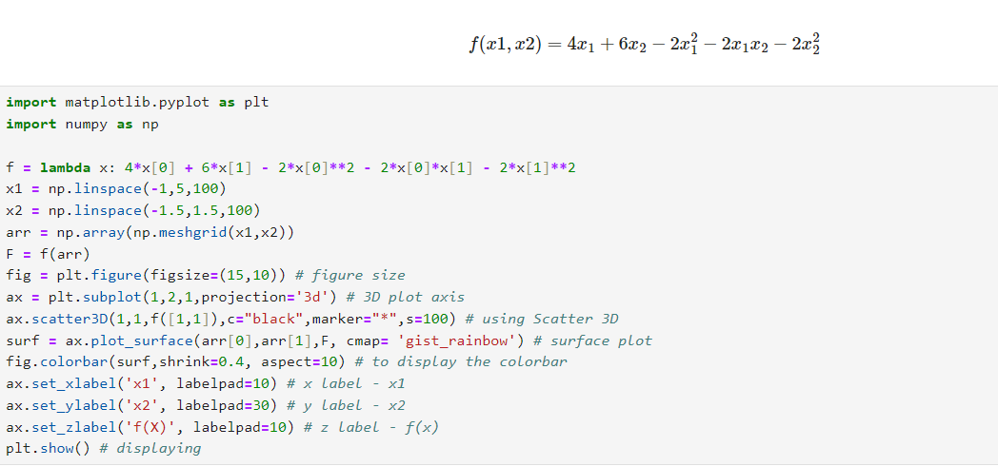

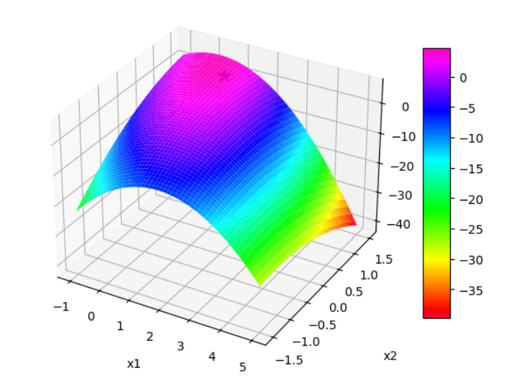

(b)

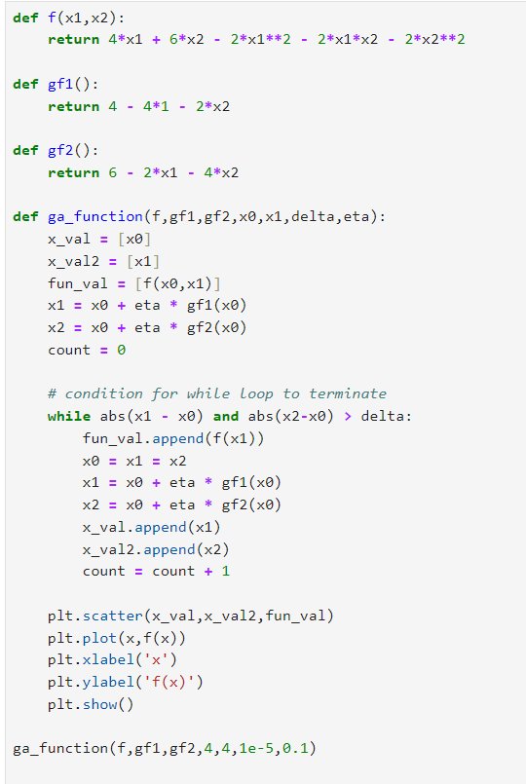

Error:

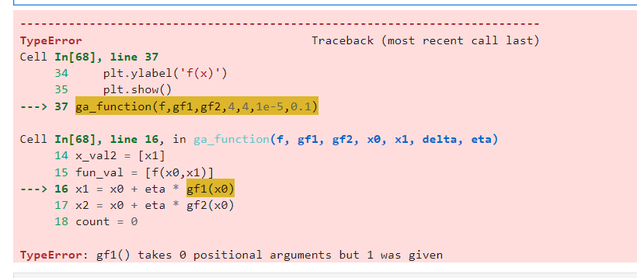

Due to the above error and time, I got stuck.