

Pitch Control from Broadcast Video:

A Computer Vision Pipeline for Set-Piece Analysis
by
Moritz Philipp Haaf, BSc MA
Sports Data Campus - MSc AI Applied to Sports
Academic Year 2025/2026

Table of Contents
1. Executive Summary 1
2. Introduction 2
2.1 Problem Statement 2
2.2 Why Set Pieces 2
2.3 Research Gap 3
2.4 Stakeholder Impact and Expected Benefits 3
2.5 Contribution 4
2.6 Research Scope and Boundaries 4
2.7 Research Structure and Preview 5
3. Objectives 5
3.1 Primary Objective 5
3.2 Research Questions 5
3.3 Academic Objectives 6
3.4 Practical Objectives 6
3.5 Expected Outcomes and Deliverables 7
3.6 Success Criteria 7
3.7 Ethical Considerations 7
4. Project Timeline 8
4.1 Planning Approach 8
4.2 Phase Plan 9
4.3 Key Milestones 10
4.4 Constraints and Dependencies 11
4.5 Business Rules 11
4.6 Risk and Mitigation 12
5. Conceptual and Technological Architecture 13
5.1 Pipeline Overview 13
5.2 Technologies 14
5.3 Coordinate Systems 14
5.4 Core Libraries and Tools 15
5.5 Development and Hardware Environment 16
5.6 Scalability and Constraints 16
6. Methodology: CRISP-DM 17
6.1 Why CRISP-DM 17
6.2 Phase Summary 18
6.3 Methodology Adaptations 18
7. Work Development 19
7.1 Phase 1: Business Understanding 19
7.2 Phase 2: Data Understanding 20
7.3 Phase 3: Data Preparation 23
7.4 Phase 4: Modeling 25
7.5 Phase 5: Evaluation 25
7.6 Phase 6: Deployment 29
7.7 Project Outcomes and Deliverables 30
8. Discussion of Results 31
8.1 What the pipeline gets right 31
8.2 What the pipeline gets wrong: the box inversion 32
8.3 What the pipeline underestimates 32
8.4 Why no metrics pass strict KS 33
8.5 Practical Implications 33
8.6 Cross-Finding Synthesis 33
8.7 Methodological Limits 34
8.8 Practical Prioritisation for Next-Phase Execution 35
9. Conclusions and Future Work 36
9.1 Final Reflections 36
9.2 Core Conclusions 36
9.3 Future Work 38
9.4 Proposed Roadmap 39
9.5 Academic and Practical Contribution 39
9.6 Closing Statement 40
10. Bibliography 41
11. Appendices 43
Appendix A: Repository Structure 43
Appendix B: Key Model Parameters 44
Appendix C: Data Sources 44
Appendix D: Reproducibility 45

List of Figures
Figure 1. Project Gantt chart showing the eight CRISP-DM phases across illustrative weeks W1–W11. Overlapping bars highlight that the pipeline and GT data-preparation tracks run partly in parallel. 10
Figure 2. Set-piece outcome distribution within 10 seconds of execution across 706 Euro 2024 set pieces. 20
Figure 3. Set-piece event counts by type across UEFA Euro 2024 (StatsBomb open data). 21
Figure 4. Spatial distribution of set-piece origins on the pitch. 21
Figure 5. Player spatial density by set-piece type, derived from SoccerNet GSR ground-truth annotations. 22
Figure 6. Soccana multiclass detection example showing Player, Referee, and (informational) Ball classes on a broadcast frame. 23
Figure 7. Players-per-frame distribution: pipeline detections (Soccana + ByteTrack) vs SoccerNet GSR ground truth. 24
Figure 8. Sample Pitch Control surface, pipeline vs ground truth, for a representative corner frame. 25
Figure 9. Distributional histogram overlays for each Pitch Control summary metric, pipeline vs GT. 26
Figure 10. Per-frame paired scatter plots, pipeline vs GT, for each Pitch Control metric. 28
Figure 11. Three-panel deployment overlay for a corner (SNGS-116): broadcast frame with detections, metric minimap, and Pitch Control heatmap. 29
Figure 12. Three-panel deployment overlay for a direct free kick (SNGS-122): broadcast frame with detections, metric minimap, and Pitch Control heatmap. 30
Figure 13. Detected defender count per frame vs pc_mean. The negative trend confirms that defender-recall shortfall is the dominant driver of the global underestimation bias. 32

List of Tables
Table 1. Project success criteria and targets. 7
Table 2. CRISP-DM phase plan with milestones and deliverables. 9
Table 3. Pipeline components and underlying technologies. 14
Table 4. Coordinate-system conventions used across data sources and the pipeline. 14
Table 5. Core Python libraries and their roles in the pipeline. 15
Table 6. CRISP-DM phase to notebook/script and committed output mapping. 18
Table 7. Distributional comparison of Pitch Control summary metrics (pipeline n=940, GT n=949). 26
Table 8. KS validation summary table rendered as a figure for inline reference. 27
Table 9. Per-frame paired comparison (n=940 paired frames). 27
Table 10. Technical deliverables produced by the pipeline. 30
Table 11. Error taxonomy mapping each validation metric to its dominant pipeline failure mode and remediation path. 33
Table 12. Locked pipeline parameters and source files. 44
Table 13. Datasets, models, and external resources with access mechanism. 44

1. Executive Summary
This project delivers an open-source tool that turns broadcast football footage into a tactical metric called Pitch Control, giving clubs without expensive tracking systems a way to analyze set pieces using video alone.
The problem. Top clubs use specialist tracking systems to see which team controls each part of the pitch at any moment. Smaller clubs, women’s leagues, academies, and scouts cannot afford these systems, so they lose a competitive edge in analyzing corners and free kicks, where spatial control often decides whether a chance is created.
The solution. This project builds a computer vision pipeline that watches broadcast video, identifies each player, tracks them across frames, tells the two teams apart by shirt color, places everyone on a virtual pitch, and calculates how much of that pitch each team controls. The whole process runs automatically on a normal laptop in about 30 minutes per match clip, with no cloud services or paid software required.
How it was tested. The tool was evaluated on 33 set-piece clips (17 corners, 16 free kicks) from a public research dataset (SoccerNet), and its output was compared frame-by-frame against the dataset’s hand-labelled reference data.
What works well.
- The system successfully processed every one of the 33 clips end-to-end.
- For the most operationally relevant question, “who controls the area where the ball is”, the tool’s estimate closely matches the reference data.
- The tool is most reliable when measuring control across larger zones such as the attacking third of the pitch.
- It runs entirely on consumer hardware (a standard laptop), so there are no recurring cloud costs.

Where it falls short.
- Inside the crowded penalty box during corners, the system sometimes confuses which team a player belongs to because attackers and defenders stand very close together. This is the main source of error and the clearest target for future improvement.
- The tool detects slightly fewer players per frame than the reference, and tends to miss defenders more often than attackers, which causes it to mildly underestimate overall control values.
Impact. Clubs and analysts with access to broadcast video and a standard laptop can now generate a credible tactical view of set pieces without buying commercial tracking data. The tool is fully reproducible, openly documented, and ready to extend, with the priority next step being automatic ball detection so the workflow no longer depends on any external data feed.

2. Introduction

2.1 Problem Statement
Pitch Control, the probability that a team could reach any point on the pitch first, has emerged as a standard tool for evaluating spatial dominance in elite football, with foundational formulations by Spearman (2018) and Fernández and Bornn (2018). Commercial systems (StatsBomb 360, SkillCorner, Tracab) deliver the underlying tracking data, but their cost restricts access to top-tier competitions.
For the majority of professional clubs, women’s leagues, academies, and scouting departments, data-driven set-piece analysis remains out of reach not because of analytical sophistication but because of data access.

2.2 Why Set Pieces
Set pieces (corners and direct free kicks) are tactically high-leverage and analytically tractable. Across 706 set pieces in UEFA Euro 2024, derived from the StatsBomb open-data release (StatsBomb, 2024), 32.4% produced a shot within 10 seconds and 1.8% produced a goal (own analysis, notebook 01). Set pieces are also optimal for a CV pipeline: the broadcast camera is near-static, relevant players are in frame, and ball position can be sourced from a lightweight event feed.

2.3 Research Gap
Prior literature covers player detection, tracking, calibration, and Pitch Control modelling individually. Detection has matured through the YOLO family (Redmon & Farhadi, 2018; Jocher et al., 2023); multi-object tracking by association is well-established (Zhang et al., 2022); broadcast camera calibration without ground-truth pitch lines has been addressed by TVCalib (Theiner & Ewerth, 2023); the SoccerNet line of benchmarks (Deliege et al., 2021; Somers et al., 2024) provides annotated broadcast footage; and multi-task learning for joint re-identification, team affiliation, and role classification has been proposed for sports tracking (Mansourian et al., 2023). The end-to-end chain, broadcast pixels through to a distributionally validated tactical metric, without proprietary tracking and without ground-truth annotations leaking into the calibration step, remains underdeveloped.

2.4 Stakeholder Impact and Expected Benefits
The primary beneficiaries of this pipeline are organizations that lack access to commercial tracking systems but have access to broadcast footage: second-tier professional clubs, women's football leagues, youth academies, and scouting departments. For these actors, the cost barrier to set-piece analysis is not analytical sophistication but data access. A broadcast-only Pitch Control pipeline removes that barrier.
For a tactical analyst or head coach, the pipeline provides a spatial view of set-piece control, quantifying which team dominates which zone at the moment of execution, without requiring a data engineering team or a tracking subscription. The output is a three-panel broadcast overlay that can be interpreted directly on screen.
For a sporting director or technical lead, the pipeline enables repeatable, comparable set-piece analysis across opponents and competitions using only publicly available or club-owned broadcast footage.
For a data scientist or analyst building on this work, the fully documented codebase, committed Parquet outputs, and explicit error taxonomy provide a validated foundation for extension, rather than a black-box tool.
The primary operational constraint is that ball position currently requires an external annotation or event feed. All other pipeline components run without any ground-truth input.

2.5 Contribution
- A reproducible, validated pipeline from broadcast video to Pitch Control, with:
- Fully autonomous player detection and calibration (no GT annotations consumed at inference time)
- Distributional validation against open SoccerNet GSR annotations
- Bias diagnosis attributing residual error to differential detection recall between attackers and defenders
- Consumer-hardware execution (Apple Silicon MPS or equivalent)

2.6 Research Scope and Boundaries
Data scope. The primary validation dataset is SoccerNet GSR 2024 (Somers et al., 2024): 33 clips covering two set-piece classes (17 corners, 16 direct free kicks) drawn from the train, valid, test, and challenge splits. StatsBomb Euro 2024 open data (StatsBomb, 2024) is used only for distributional context on player counts and set-piece outcomes. It is not part of the primary validation.
Temporal scope. The pipeline was built and validated on a single collection of pre-computed homographies and detections. The SoccerNet GSR ground-truth annotations are used exclusively for validation; they are never consumed at detection or calibration inference time.
Set-piece scope. Only corners and direct free kicks are analysed. These were selected because the broadcast camera is near static for both, all relevant players are in frame at the moment of execution, and ball position is reliably annotatable. Throw-ins, goal kicks, indirect free kicks, and open-play sequences are out of scope.
Out of scope. Autonomous ball detection, player re-identification across clips, multi-camera setups, non-broadcast (e.g., tactical camera) footage, and tracking over full match sequences are all excluded. The pipeline is validated as a static-frame set-piece tool, not a real-time tracking system.

2.7 Research Structure and Preview
Section 3 defines the research objectives and success criteria. Section 4 lays out the project timeline, milestones, and constraints. Section 5 describes the full pipeline architecture and technology stack. Section 6 explains the CRISP-DM methodology and its adaptations. Section 7 documents each phase of development in detail, including all data preparation choices, modelling decisions, and evaluation results. Section 8 discusses the findings, identifies cross-metric patterns, and articulates methodological limits. Section 9 draws conclusions, proposes a development roadmap, and outlines future work. Appendices provide repository structure, model parameters, data sources, and full reproducibility instructions.

3. Objectives

3.1 Primary Objective
Develop a reproducible computer vision pipeline that extracts Pitch Control from broadcast set-piece frames and produces distributions comparable to ground-truth annotation-derived distributions, using only open-source tools and consumer hardware.

3.2 Research Questions
- RQ1. Can a broadcast-video-only pipeline produce Pitch Control distributions comparable to GT-annotation distributions for set-piece frames?
- RQ2. What is the dominant source of systematic bias in pipeline-derived Pitch Control?
- RQ3. Which Pitch Control summary metrics are most robust to pipeline noise?

3.3 Academic Objectives
- Demonstrate end-to-end distributional validation methodology for a broadcast computer vision pipeline, moving beyond aggregate accuracy to per-metric bias attribution.
- Establish which Pitch Control summary metrics are robust to broadcast-pipeline noise and which are structurally contaminated by specific component failures.
- Contribute empirical evidence on the limits of color-based team assignment in crowded set-piece environments, informing future work on supervised team-classification approaches.
- Produce a reproducible codebase and validated outputs that enable independent replication and extension.

3.4 Practical Objectives
- Deliver a working, end-to-end pipeline executable on consumer hardware in under 45 minutes on Apple Silicon MPS (longer on CPU-only hardware) for 33 clips, without cloud infrastructure or proprietary data.
- Identify which PC metrics are operationally deployable by clubs without access to GT tracking, and which require further development before use.
- Produce broadcast-overlay visualizations (three-panel stills and animated GIFs/MP4s) that allow a tactical analyst to interpret pipeline outputs directly on the broadcast frame.
- Document data-quality issues in SoccerNet GSR (notably the action_position global-frame-number misinterpretation) to inform future dataset users.

3.5 Expected Outcomes and Deliverables
Technical deliverables:
- Detection parquets (detections_soccana_tvcalib.parquet, detections_gt_full.parquet) for all 33 clips
- Ball position cache (ball_positions.parquet) and pitch control surfaces (pitch_control_soccana_tvcalib.parquet, pitch_control_gt_full.parquet)
- Validation outputs (validation_summary_tvcalib.parquet, validation_paired.parquet, KS table figure)
- Broadcast-overlay visualizations: static three-panel stills, animated GIFs, and MP4 clips for representative corner and free-kick sequences
Academic deliverables:
- Validated distributional comparison of pipeline-derived vs GT-derived Pitch Control on 31 clips
- Mechanistic bias diagnosis attributing error to three distinct failure modes
(global underestimation, box inversion, calibrated third)
- Documented methodology for adapting a dynamic Pitch Control model to a zero-velocity set-piece context

3.6 Success Criteria
Table 1. Project success criteria and targets.
Criterion | Target
End-to-end execution | All 33 clips, consumer hardware, <45 min (MPS) / <90 min (CPU)
Bias | |bias| < 0.10 on pc_at_ball
Histogram overlap | >0.80 on at least one metric
Bias explanation | Mechanistic, attributable to specific component
Reproducibility | Full pipeline re-runnable from raw SSD data

3.7 Ethical Considerations
Data access. SoccerNet GSR requires a credentialed download via the SoccerNet API; credentials were obtained through the standard academic access request process. StatsBomb open data is freely available under CC BY-SA 4.0. Soccana model weights are publicly hosted on HuggingFace under an open license.
No personal data. No individual player identities, biometric data, or personal identifiable information are stored, processed, or published. Player positions are treated as anonymous spatial coordinates.
Model weights. The Soccana YOLOv11n weights used are not fine-tuned in this project; they are used as-is from HuggingFace and their original licence terms apply.
Reproducibility and transparency. All pipeline code, parameter choices, and known data-quality issues (including the action_position misinterpretation) are documented and committed to the repository. No results are selectively reported; the full validation table including unfavorable metrics is published.

4. Project Timeline

4.1 Planning Approach
The project follows CRISP-DM’s phased structure, with explicit feedback loops between Data Understanding and Data Preparation to accommodate mid-project corrections. The plan below is presented in illustrative weeks (W1 through W11) rather than calendar dates, reflecting the iterative nature of the work and the fact that several phases overlap.

4.2 Phase Plan
Table 2. CRISP-DM phase plan with milestones and deliverables.
Week | CRISP-DM phase | Activity | Deliverable
W1–W2 | Business Understanding | Problem framing, stakeholder identification, set-piece literature review | Research questions locked
W2–W4 | Data Understanding | StatsBomb Euro 2024 EDA, SoccerNet GSR scan, action_position audit | setpieces.parquet, gt_spatial_benchmarks.parquet
W3–W5 | Data Preparation (pipeline track) | TVCalib integration, Soccana detection + ByteTrack, KMeans team assignment | homographies_tvcalib.parquet, detections_soccana_tvcalib.parquet
W4–W5 | Data Preparation (GT track) | SoccerNet bbox_pitch parsing, ball-position cache | detections_gt_full.parquet, ball_positions.parquet
W5–W7 | Modeling | Laurie Shaw TTI zero-velocity adaptation, PC surface computation | pitch_control_*.parquet
W7–W9 | Evaluation | Distributional KS, paired Pearson/Spearman/MAE, bias diagnosis | validation_summary_tvcalib.parquet, validation_paired.parquet
W9–W10 | Deployment | Broadcast-overlay visualizations, three-panel stills, animated GIF/MP4 | still_*.png, anim_*.gif, video_*.mp4
W10–W11 | Reporting | Notebook narrative, thesis write-up, final review | report.md, executable notebooks

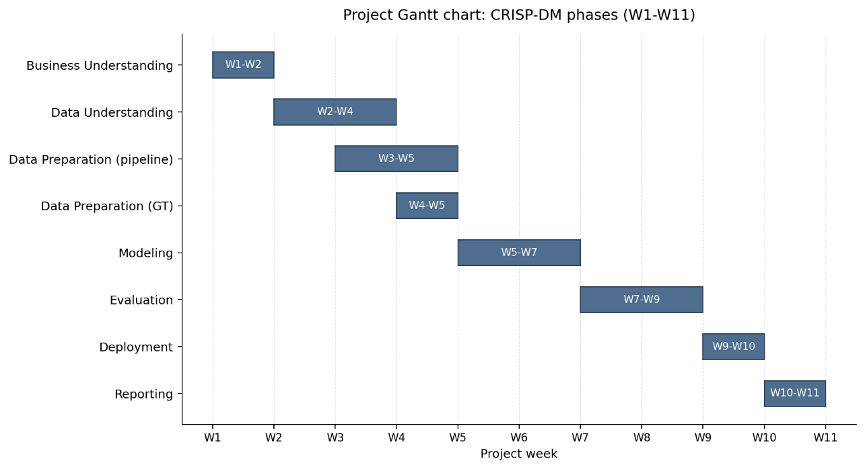
Figure 1. Project Gantt chart showing the eight CRISP-DM phases across illustrative weeks W1–W11. Overlapping bars highlight that the pipeline and GT data-preparation tracks run partly in parallel.

4.3 Key Milestones
- Research scope locked (end W2): primary validation dataset, set-piece classes, success criteria all defined.
- TVCalib batch complete (W4): 1,023 homographies computed for all 33 clips, removing GT pitch-line dependency at inference.
- action_position data-quality discovery (W4–W5): mid-project finding that action_position is a global broadcast frame number, not a clip-local index. Required rewriting the frame-window logic before modelling could produce correct outputs.
- First end-to-end pipeline run (W6): pipeline runs all 33 clips end-to-end with zero homography failures.
- Validation cohort frozen at 31 clips (W7): SNGS-125 and SNGS-145 excluded from the PC phase due to missing ball annotations in the window.
- KS validation table complete (W8): per-metric distributional comparison published with no selective reporting.
- Three-way error taxonomy identified (W8–W9): the partition into calibrated, underestimated, and inverted metrics emerges from the paired analysis.
- Final deliverables ready (W11): committed Parquet outputs, executable notebooks, thesis report, and overlay visualizations.

4.4 Constraints and Dependencies
Constraints.
- Data access. SoccerNet GSR requires a credentialed download; access was obtained through the academic process. StatsBomb open data is freely available.
- Time limitations. The Sports Data Campus submission deadline of 30 June 2026 fixes the upper bound of the planning window and is the binding driver of the eleven-week schedule shown in Table 2 and Figure 1.
- Hardware. Apple Silicon laptop with 16 GB unified memory; SoccerNet video (~35 GB) hosted on an external USB-C SSD.
- External component. TVCalib (Theiner & Ewerth, 2023) runs in a sibling conda environment with PyTorch 2.x patches; required configuring and validating a research codebase before pipeline integration could proceed.
Dependencies.
- Detection requires TVCalib homographies (or at minimum a valid camera model) before pixel-to-pitch projection is meaningful.
- Pitch Control computation requires both detections and ball positions per frame.
- Validation requires aligned pipeline and GT Pitch Control surfaces on a shared clip set.
- Notebooks 02 through 04 are executable from committed Parquet outputs, allowing reproduction without the SSD or TVCalib environment after the initial pipeline run.

4.5 Business Rules
A small number of explicit project rules shaped execution from start to finish. They are documented here so the planning context is auditable; the same rules are reinforced where they apply to individual phases later in the report.
- Inference-time data-leak rule. SoccerNet GSR ground-truth annotations may be used only for validation. They are never consumed at detection, tracking, or calibration inference time. This rule is what makes the pipeline a defensible broadcast-only system and is the central methodological constraint of the project.
- Data licensing and access terms. StatsBomb Euro 2024 open data is used under CC BY-SA 4.0 with attribution. SoccerNet GSR is accessed through the standard credentialed academic process (Somers et al., 2024). The Soccana detector weights are pulled from HuggingFace under their published open license; no weights are redistributed in this repository.
- Reproducibility and hardware rule. The pipeline must execute end-to-end on a consumer laptop with no cloud dependency. All intermediate outputs are committed as Parquet so that notebooks 02 through 04 reproduce on a fresh checkout without the SSD or the TVCalib sibling environment.
- Ethics rule. No personal data, biometric data, or player identities are stored, processed, or published. Player positions are treated as anonymous spatial coordinates throughout the pipeline and the report (full statement in section 3.7).

4.6 Risk and Mitigation
The most significant project risk that materialized was the misinterpretation of action_position: the pipeline initially processed end-of-clip open-play frames instead of set-piece formations. This issue was identified during qualitative review of intermediate outputs in W4–W5 and corrected by setting the center frame to FRAME_WINDOW + 1 = 16, rather than treating action_position as a clip-local index. It was then documented as a methodological contribution. The key mitigation lesson is that intermediate visual inspection is essential when pipeline outputs appear plausible in aggregate but are semantically incorrect.

5. Conceptual and Technological Architecture

5.1 Pipeline Overview
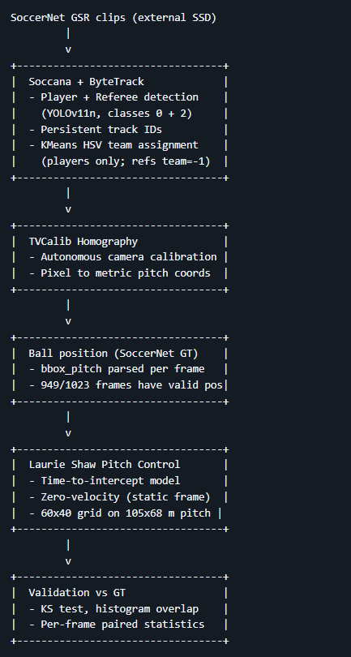

5.2 Technologies
Table 3. Pipeline components and underlying technologies.
Component | Technology
Detection | Soccana (YOLOv11n, football-finetuned, 2.6M params; Jocher et al., 2023)
Tracking | ByteTrack (Zhang et al., 2022) via Ultralytics
Team assignment | KMeans on per-track mean HSV
Calibration | TVCalib (Theiner & Ewerth, 2023)
Ball position | SoccerNet GSR GT annotations (bbox_pitch; Somers et al., 2024)
Pitch Control | Time-to-intercept model (Shaw, 2020)
Data | SoccerNet GSR 2024 (Somers et al., 2024); StatsBomb open data (StatsBomb, 2024)
Language | Python 3.11
Hardware | Apple Silicon (MPS), or any CUDA/CPU-capable host

5.3 Coordinate Systems
Table 4. Coordinate-system conventions used across data sources and the pipeline.
System | Convention | Conversion to pipeline
StatsBomb | 120 yd * 80 yd, origin top-left | x * 105/120, y * 68/80
Pipeline / mplsoccer | 105 m * 68 m, origin top-left | -
SoccerNet GSR bbox_pitch | centered origin (+/- 52.5 m, +/- 34 m) | x + 52.5, y + 34

5.4 Core Libraries and Tools
Table 5. Core Python libraries and their roles in the pipeline.
Library | Version | Role
ultralytics | 8.3.107 | Soccana detection + ByteTrack tracking
torch | >=2.1.0 | Inference backend (Apple MPS)
opencv-python | >=4.8.0 | Frame I/O, HSV colour extraction, video rendering
pandas | >=2.1.0 | Tabular data pipeline
numpy | >=1.26.0 | Array operations, homography math
scipy | >=1.11.0 | KS test, spatial distance computations
scikit-learn | >=1.3.0 | KMeans team assignment
mplsoccer | >=1.4.0 | Pitch visualisation
pyarrow | >=14.0.0 | Parquet I/O
statsbombpy | >=1.14.0 | StatsBomb open data access
huggingface-hub | >=0.20.0 | Soccana weight download
python-dotenv | >=1.0.0 | SSD path and credential configuration
TVCalib (Theiner & Ewerth, 2023) runs in a separate sibling conda environment with its own dependencies (PyTorch 2.1, kornia 0.8.2, pytorch-lightning 2.6.1) and is invoked via subprocess from run_tvcalib_batch.py.

5.5 Development and Hardware Environment
- Hardware: Apple Silicon laptop (M-series, 16 GB unified memory), MPS backend for PyTorch inference. The pipeline also runs on CUDA or CPU; detection will be slower on CPU-only hardware.
- Storage: SoccerNet GSR video data (~35 GB) on an external SSD. All intermediate outputs (Parquet files, figures) live in the repository outputs/ directory and are committed; video frames are not committed.
- Software: macOS 15, Python 3.11 (conda env py311-dev). Detection runs on MPS; Pitch Control computation and validation run on CPU.
- Execution profile: ~30 min total for 33 clips (TVCalib batch ~14 min, Soccana detection ~15 min, all downstream scripts <1 min combined).

5.6 Scalability and Constraints
Horizontal scaling. The pipeline processes clips sequentially; parallelization across clips is straightforward (independent run_clip() calls) but was not implemented, as the 30-minute runtime is acceptable for the 33-clip cohort.
TVCalib coupling. Homography computation requires TVCalib in a sibling directory with its own environment. Pre-computed homographies are committed to the repository (homographies_tvcalib.parquet), decoupling all downstream scripts from the TVCalib dependency for normal operation.
Ball detection dependency. The current architecture requires GT bbox_pitch ball annotations from SoccerNet GSR to identify the ball position per frame. This is the primary constraint preventing fully autonomous deployment. All other pipeline components (detection, tracking, calibration, team assignment, PC computation) run without GT inputs.
Memory. Peak memory consumption during detection inference is approximately 4 GB (MPS), dominated by the YOLO model and frame batch. Pitch Control computation is CPU-bound and uses <1 GB.

6. Methodology: CRISP-DM
CRISP-DM (Cross-Industry Standard Process for Data Mining; Chapman et al., 2000) is a six-phase framework that organizes a data project into Business Understanding, Data Understanding, Data Preparation, Modeling, Evaluation, and Deployment. Each phase has explicit inputs and outputs, and a feedback path to earlier phases, which makes the framework well-suited to projects where validation findings may require revisiting data assumptions. This section explains why CRISP-DM was selected for this project, summarizes how each phase maps to the repository’s notebooks and scripts, and notes two methodological adaptations needed for the broadcast computer vision context.

6.1 Why CRISP-DM
CRISP-DM was selected as the organising framework for three reasons specific to this project.
Iterative fit. Pipeline development rarely proceeds linearly. The discovery that action_position in SoccerNet GSR is a global broadcast frame number (not a clip-local index), uncovered during data understanding, required revising the frame-window logic before preparation and modelling could proceed correctly. CRISP-DM’s explicit feedback loop between phases accommodates this kind of mid-project revision without treating it as a failure.
Validation emphasis. The evaluation phase in CRISP-DM is a first-class phase, not an afterthought. For this project, in which the central research question is whether a broadcast pipeline produces distributions comparable to the ground truth, the evaluation phase is where the research question is answered. CRISP-DM’s structure prevents evaluation from being compressed into a footnote.
Reproducibility. CRISP-DM’s phase separation maps directly onto the script/notebook structure of the repository: each phase has identifiable inputs, processing steps, and committed Parquet outputs. A future user can enter the pipeline at any phase using the committed intermediate outputs, verifying reproducibility of any downstream phase independently.

6.2 Phase Summary
This subsection maps the canonical CRISP-DM phases to the concrete artefacts in the repository: every phase has identifiable inputs, a script or notebook that performs the work, and a committed output. The table is intended to function as both a methodology summary and an entry point for reproducing any individual phase.
Table 6. CRISP-DM phase to notebook/script and committed output mapping.
Phase | Notebook / Script | Key Output
Business Understanding | nb01 | Problem framing, stakeholder identification, set-piece EDA
Data Understanding | nb01 | StatsBomb EDA, SoccerNet GSR scan, action_position audit
Data Preparation | run_tvcalib_batch, run_soccana_tvcalib, dump_* | Detection and ball-position Parquets
Modeling | nb02, run_pc_* | Pitch control surfaces, summary metrics
Evaluation | nb03, ks_table_tvcalib.py | Validation tables, distributional + paired statistics
Deployment | nb04, render_* | Broadcast-overlay visualizations, GIFs, MP4s

6.3 Methodology Adaptations
Two adaptations were required to apply CRISP-DM to this computer vision pipeline context.
Static-frame modelling. The time-to-intercept Pitch Control model (Shaw, 2020) was designed to track data on per-frame player velocities. This project uses a zero-velocity adaptation: all players are assumed to be stationary at the moment of the set-piece, and time-to-intercept reduces to distance divided by maximum speed.
The validity of this assumption varies by set-piece type. For corners, the assumption is well-supported: players typically adopt fixed positions in and around the penalty area before execution, and the broadcast camera is near-static, reducing motion blur that could otherwise degrade detection. For direct free kicks, the assumption is more tenuous. Attacking runners may already be in motion at the moment the ball is struck, and the executing player's run-up velocity is non-zero. Under the zero-velocity model, these players are treated as if stationary, which understates their spatial advantage. This asymmetry is a candidate explanation for any differences in metric reliability between the two set-piece types in future stratified validation, and is the primary reason the velocity-estimation extension (optical flow via ByteTrack IDs) is listed as the second-highest priority in the Phase 2 roadmap.

Distributional evaluation. Standard CRISP-DM evaluation focuses on predictive model accuracy. Here, the pipeline does not predict a label; it computes a spatial metric. Evaluation, therefore, uses distributional comparison (KS test, histogram overlap) and per-frame paired statistics (Pearson r, MAE, bias) to assess whether the pipeline-derived distribution is consistent with the GT-derived distribution, rather than testing classification accuracy or regression error against a held-out set.

7. Work Development

7.1 Phase 1: Business Understanding
Core question: Can a broadcast-only pipeline produce Pitch Control distributions comparable to GT for set-piece frames?
Stakeholders: Clubs without tracking providers (second-tier professional, women’s football, academies, scouting).
Why set pieces: Near-static camera, all players in frame, ball position reliably available from event feeds. Of 706 Euro 2024 set pieces, 65.7% produced no shot within 10 s, 32.4% produced a shot, and 1.8% produced a goal, placing set pieces among the highest-leverage repeatable game situations for tactical investment.
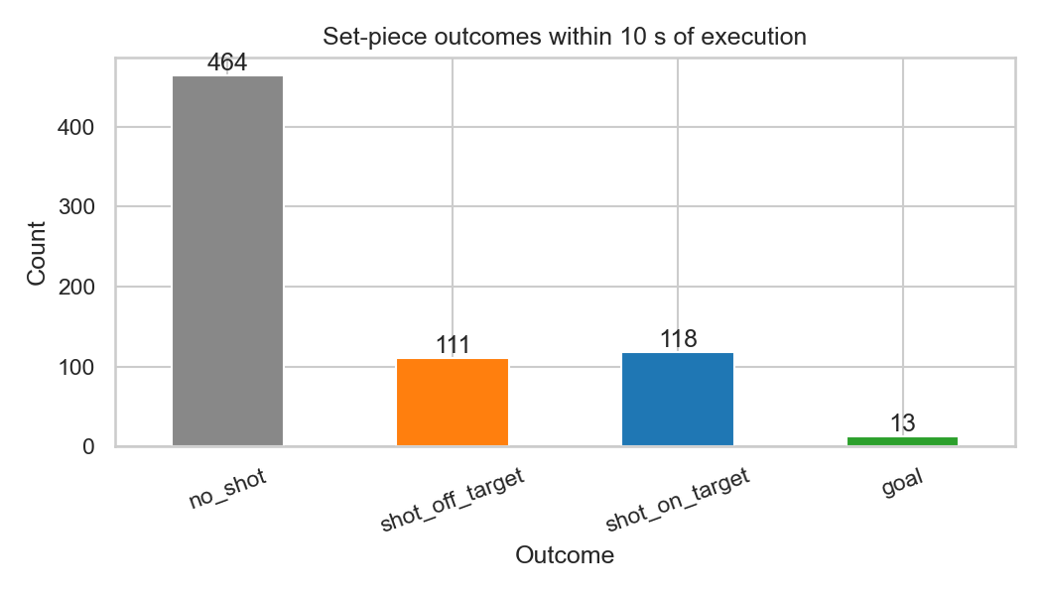
Figure 2. Set-piece outcome distribution within 10 seconds of execution across 706 Euro 2024 set pieces.

7.2 Phase 2: Data Understanding
StatsBomb Euro 2024 (nb01). 51 matches, 706 set-piece events (508 corners, 198 direct free kicks), drawn from the StatsBomb open-data release (StatsBomb, 2024) and accessed via statsbombpy. Freeze-frame coverage for this subset is 64.2% (453/706 events), as not every event in the open data release carries an associated 360 freeze frame. Used only for distributional context on player counts and set-piece outcomes; not used in the primary validation.
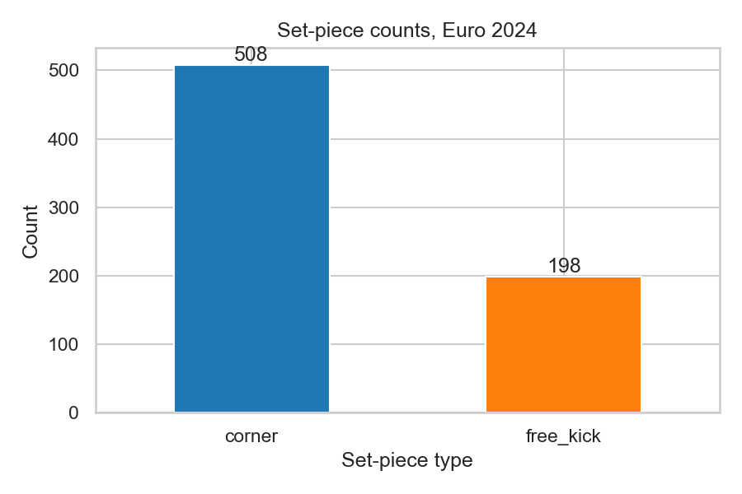
Figure 3. Set-piece event counts by type across UEFA Euro 2024 (StatsBomb open data).
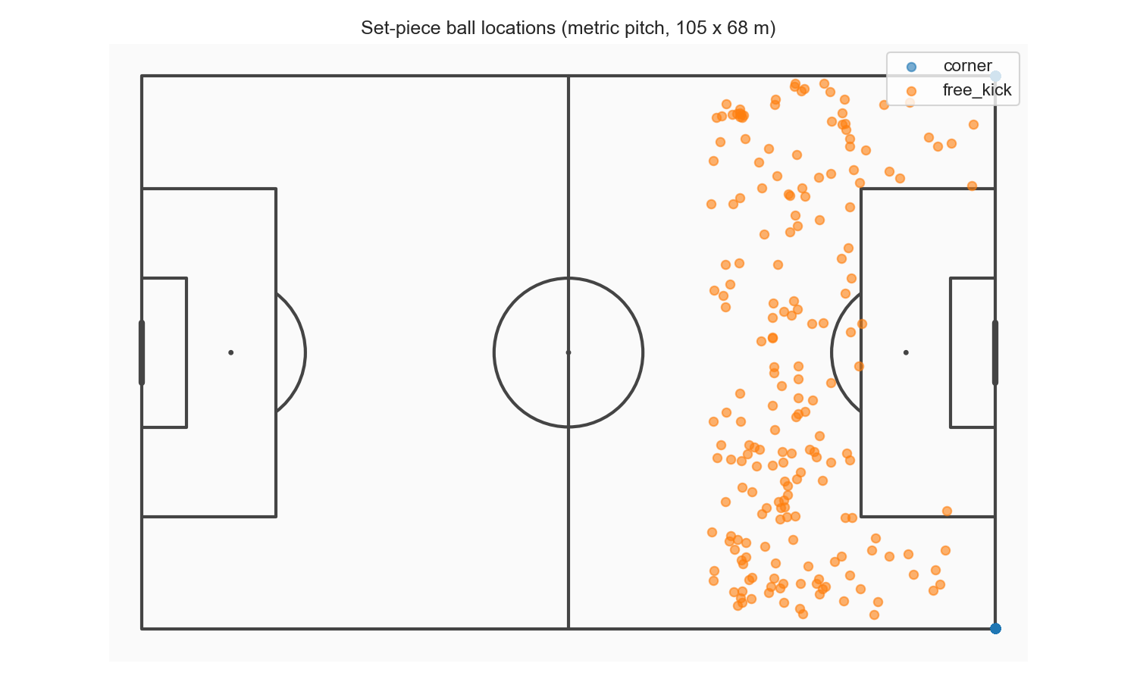
Figure 4. Spatial distribution of set-piece origins on the pitch.
SoccerNet GSR. Drawing on the Game State Reconstruction benchmark (Somers et al., 2024), part of the broader SoccerNet dataset line (Deliege et al., 2021), 33 clips were identified with action_class in {Corner, Direct free-kick}: 17 corners, 16 direct free kicks. Per-frame player annotations (bbox_pitch) and pitch-line annotations are provided. TVCalib homographies (Theiner & Ewerth, 2023) were computed for all 1,023 frames (33 clips × 31 frames).
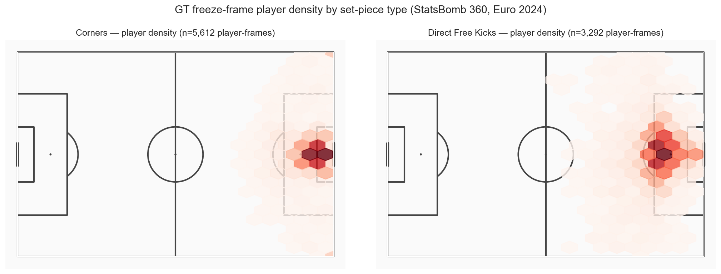
Figure 5. Player spatial density by set-piece type, derived from SoccerNet GSR ground-truth annotations.
Note on action_position. The action_position field in SoccerNet GSR Labels-GameState.json is a global broadcast frame number (ranging from ~300,000 to ~2,600,000), not a clip-local index. Clips are 750 frames numbered 1–750, with the set-piece occurring at frame 1 (confirmed by GT ball-position coordinates at the corner arc on frame 1 for all corner clips). The pipeline uses centre = FRAME_WINDOW + 1 = 16 to place the +/-15-frame window at frames 1–31, covering the static set-piece formation.

7.3 Phase 3: Data Preparation
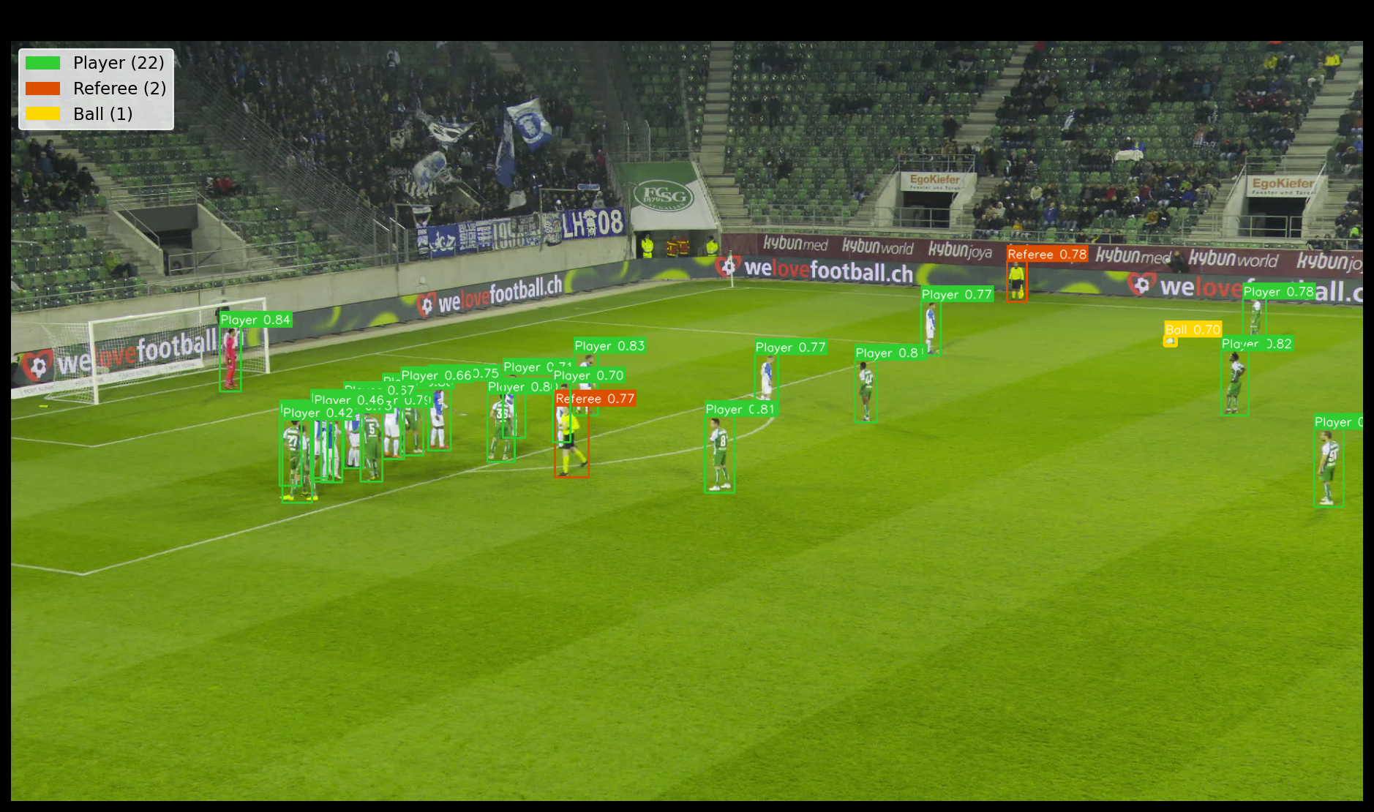
Figure 6. Soccana multiclass detection example showing Player, Referee, and (informational) Ball classes on a broadcast frame.
Pipeline track (run_soccana_tvcalib.py): 1. Soccana detection (YOLOv11n architecture; (Jocher et al., 2023) at confidence 0.40, classes 0 (Player) and 2 (Referee) in a single forward pass. 2. ByteTrack persistent ID assignment (Zhang et al., 2022) across frames for all detected objects. 3. Per-track mean HSV with KMeans (k=3, smallest-cluster drop if <15% of clip population or referee-like HSV centroid, re-fit k=2) applied to player tracks only. Player detections receive a team label (0 or 1); referee detections are assigned team=-1 directly and excluded from pitch control computation. 4. TVCalib homography (Theiner & Ewerth, 2023): pixel foot-point to metric pitch coordinates for both players and referees. 5. Output: 17,260 detection rows across 33 clips (16,209 player rows + 1,051 referee rows).
GT track (dump_gt_setpieces.py).
- SoccerNet GSR bbox_pitch annotations (Somers et al., 2024) parsed directly.
- Centered coordinates converted to top-left origin (0–105, 0–68). Annotations with coordinates outside +/-2 m of pitch boundaries are discarded (handles corner-arc annotation noise and the small number of corrupted GT entries with physically impossible coordinates).
- Output: 18,539 rows across 32 clips (SNGS-125 has no GT player annotations in frames 1–31).
Detection shortfall: Pipeline produces 2,330 fewer rows than GT (12.6% shortfall). Mean players per frame: pipeline 15.99 vs GT 18.69. The defending-team shortfall is larger (pipeline 7.41 vs GT 9.13 per frame) than the attacking-team shortfall (pipeline 8.58 vs GT 9.56), consistent with defenders clustering in occluded, crowded positions near the goal. This asymmetric shortfall drives the directional bias on global metrics under the Shaw (2020) model.
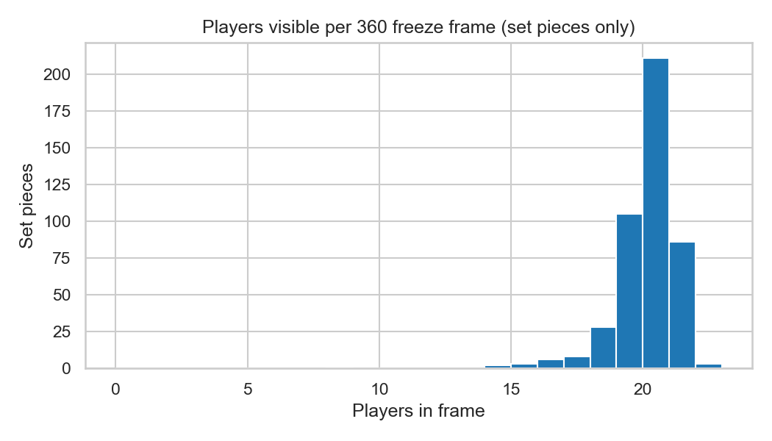
Figure 7. Players-per-frame distribution: pipeline detections (Soccana + ByteTrack) vs SoccerNet GSR ground truth.
Ball positions (dump_ball_positions.py): 1,023 frame positions parsed from SoccerNet GSR GT annotations (bbox_pitch, category_id=4). 949/1,023 frames have valid ball coordinates (within +/-2 m of pitch boundaries). SNGS-125 and SNGS-145 have no ball annotation in any frame within the window; these 2 clips are excluded from the PC computation, reducing the effective validation set from 33 to 31 clips.

7.4 Phase 4: Modeling
Model: Time-to-intercept Pitch Control as implemented by Shaw (2020), used here in a zero-velocity, static-frame adaptation.
Parameters (locked):
- MAX_SPEED: 5.0 m/s
- REACTION_TIME: 0.7 s
- SIGMA: 0.45 s
- Grid: 60 x 40 cells on 105 x 68 m pitch
Attacking team: Per frame, whichever team has the player closest to the ball.
Output: 940 pipeline frames (31 clips), 949 GT frames (31 clips).
Summary metrics per frame:
- pc_mean: Mean attacking PC across all 2,400 grid cells
- pc_at_ball: PC at grid cell nearest ball position
- pc_in_box: Mean attacking PC within the relevant penalty box
- pc_in_third: Mean attacking PC within the relevant attacking third
- pc_area_gt_0p5: Fraction of cells where attacking PC > 0.5

7.5 Phase 5: Evaluation
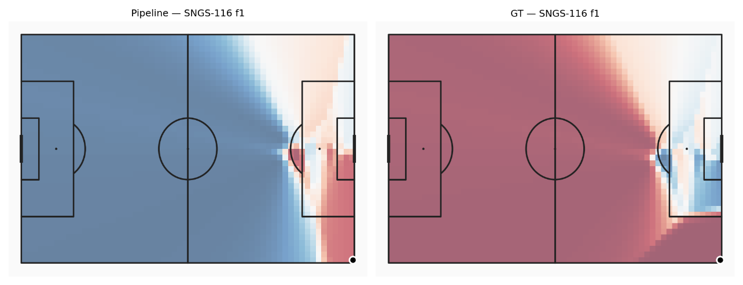
Figure 8. Sample Pitch Control surface, pipeline vs ground truth, for a representative corner frame.

Table 7. Distributional comparison of Pitch Control summary metrics (pipeline n=940, GT n=949).
Metric | Pipeline | GT | Delta (bias) | KS stat | KS p-value | Hist. overlap | Passes KS?
pc_mean | 0.539 | 0.687 | -0.148 | 0.275 | <0.001 | 0.727 | No
pc_at_ball | 0.927 | 0.978 | -0.051 | 0.339 | <0.001 | 0.804 | No
pc_in_box | 0.532 | 0.316 | +0.216 | 0.532 | <0.001 | 0.499 | No
pc_in_third | 0.523 | 0.513 | +0.010 | 0.104 | <0.001 | 0.903 | No
pc_area_gt_0p5 | 0.548 | 0.703 | -0.155 | 0.261 | <0.001 | 0.721 | No

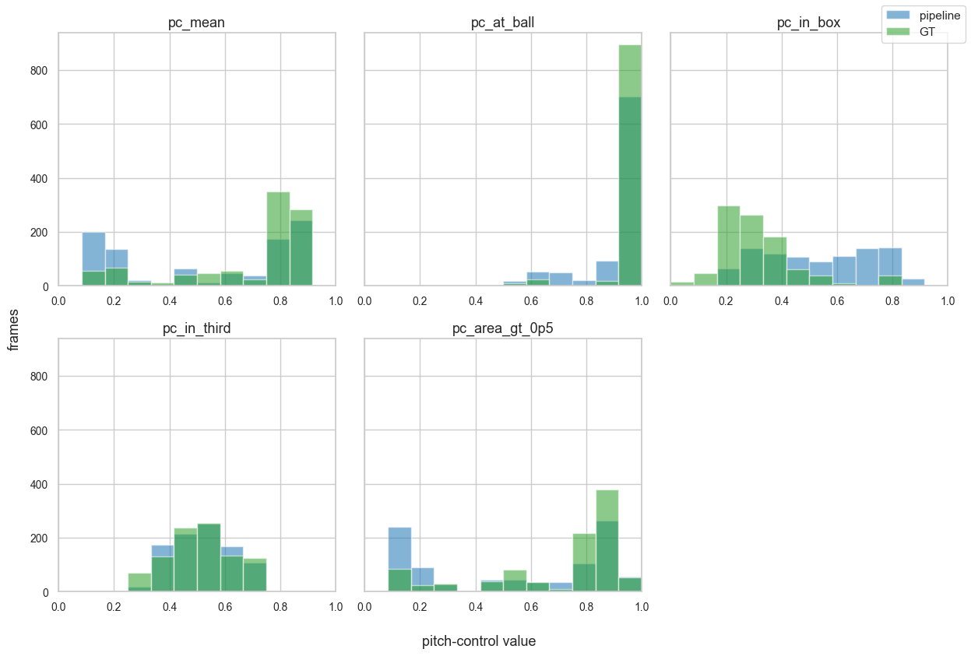
Figure 9. Distributional histogram overlays for each Pitch Control summary metric, pipeline vs GT.

Table 8. KS validation summary table rendered as a figure for inline reference.
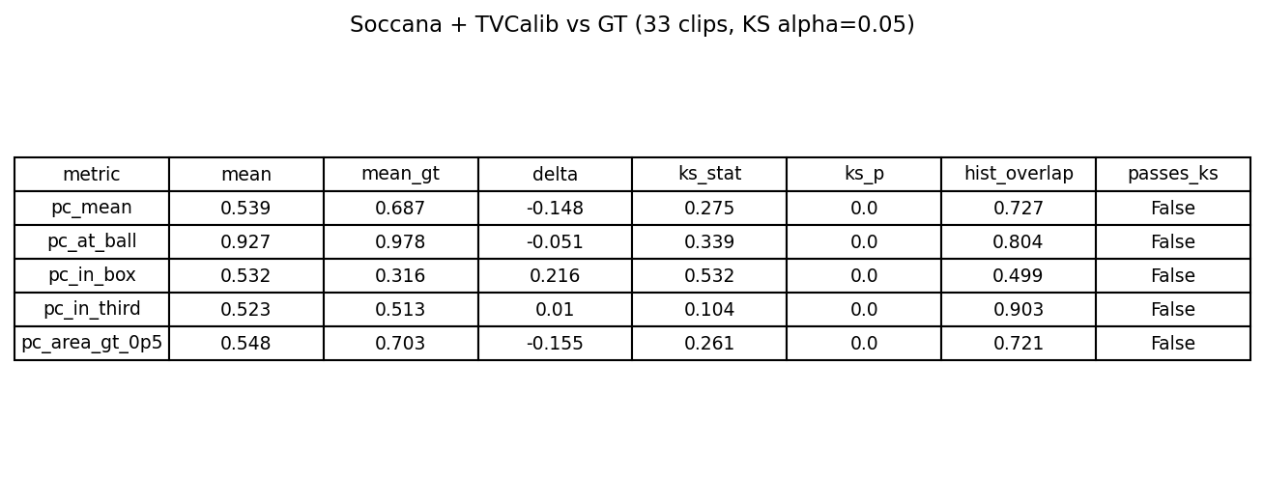
Table 9. Per-frame paired comparison (n=940 paired frames).
Metric | Pearson r | Spearman r | MAE | Bias
pc_mean | 0.349 | 0.199 | 0.206 | -0.149
pc_at_ball | 0.511 | 0.106 | 0.054 | -0.051
pc_in_box | 0.178 | 0.070 | 0.238 | +0.217
pc_in_third | 0.056 | 0.045 | 0.112 | +0.010
pc_area_gt_0p5 | 0.336 | 0.252 | 0.222 | -0.155
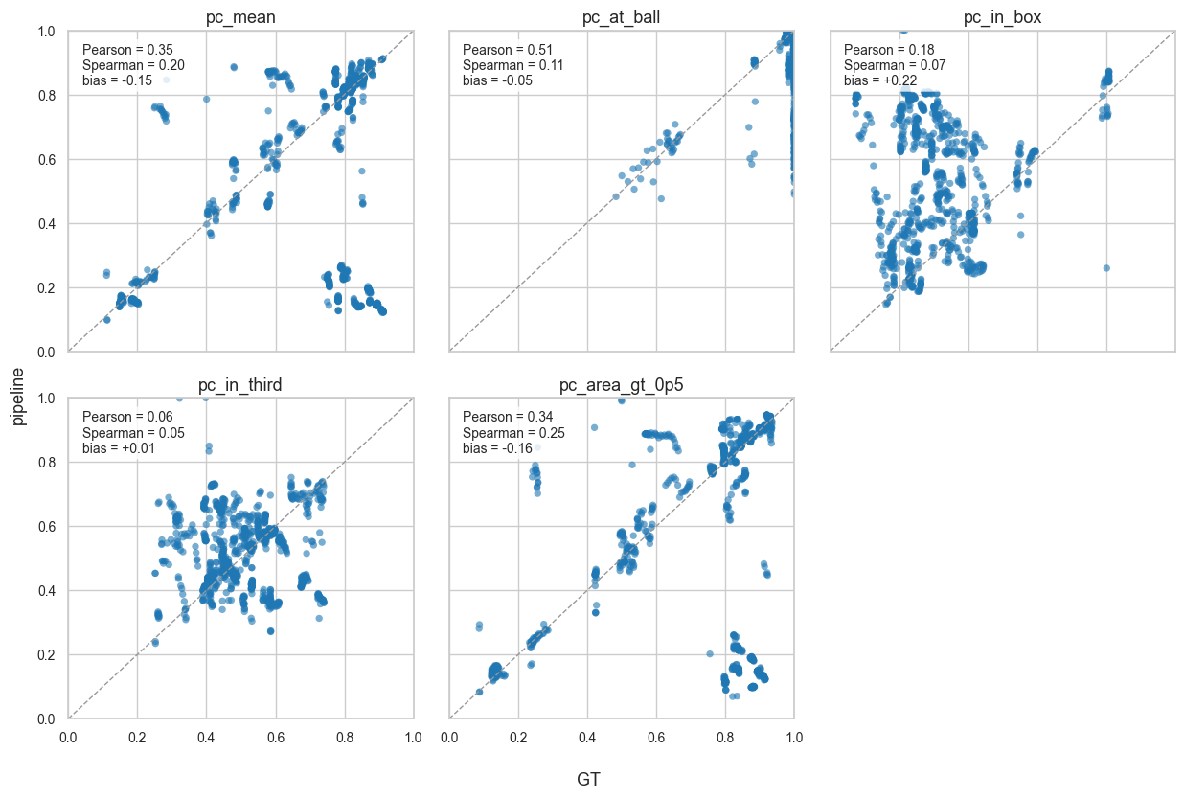
Figure 10. Per-frame paired scatter plots, pipeline vs GT, for each Pitch Control metric.
Low Spearman values reflect compressed score distributions at the set-piece moment (both pipeline and GT cluster near their respective means), which reduces rank variation and makes Spearman less reliable than Pearson.
Bias diagnosis: The five metrics are grouped into three error-type categories.
Global underestimation (pc_mean, pc_area_gt_0p5, pc_at_ball): GT records 18.69 players per frame vs pipeline 15.99 (14.4% shortfall), with the defending team more under-detected (pipeline 7.41 vs GT 9.13) than the attacking team (8.58 vs GT 9.56). Fewer defenders shift the Shaw surface toward attacker control; GT, with more defenders, correctly computes stronger defensive compression. The pipeline, therefore, underestimates the degree to which defenders constrain attacking space.
Box inversion (pc_in_box): This is the largest error and the most structurally distinct. GT shows the defending team controlling the penalty box (mean 0.316, well below 0.5), which is correct, at a corner, defenders pack the box. The pipeline estimates attacker control (0.539), a sign inversion. KMeans on per-track mean HSV fails when both teams are densely packed in the small penalty-area crop: jersey colours are harder to separate under broadcast lighting at this scale, and cluster centroids can interchange between teams.
Calibrated (pc_in_third): delta = +0.010, histogram overlap = 0.903. Attacking-third analysis is unaffected by box crowding and is less sensitive to total player count than global metrics. This is the most reliable operational metric from this pipeline.

7.6 Phase 6: Deployment
- Pipeline runs end-to-end on consumer hardware (validated on Apple Silicon MPS), no cloud dependency.
- Runtime: ~30 minutes for 33 clips.
- Parquet outputs are compatible with DuckDB, pandas, and polars.
- TVCalib (Theiner & Ewerth, 2023) removes any dependency on GT pitch-line annotations for camera calibration.
- Three-panel animated visualizations (broadcast frame, metric minimap, PC heatmap) produced as GIF and MP4 for representative corner and direct free-kick clips (SNGS-116, SNGS-122), now correctly showing frames 1–31 of each clip (the actual set-piece formation); static three-panel stills generated for thesis embedding (see Appendix A).
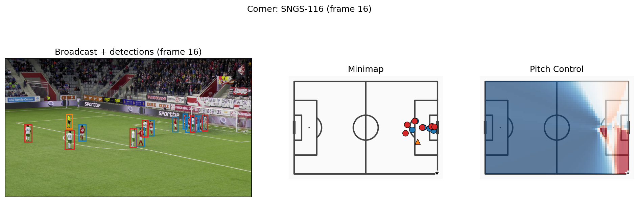
Figure 11. Three-panel deployment overlay for a corner (SNGS-116): broadcast frame with detections, metric minimap, and Pitch Control heatmap.
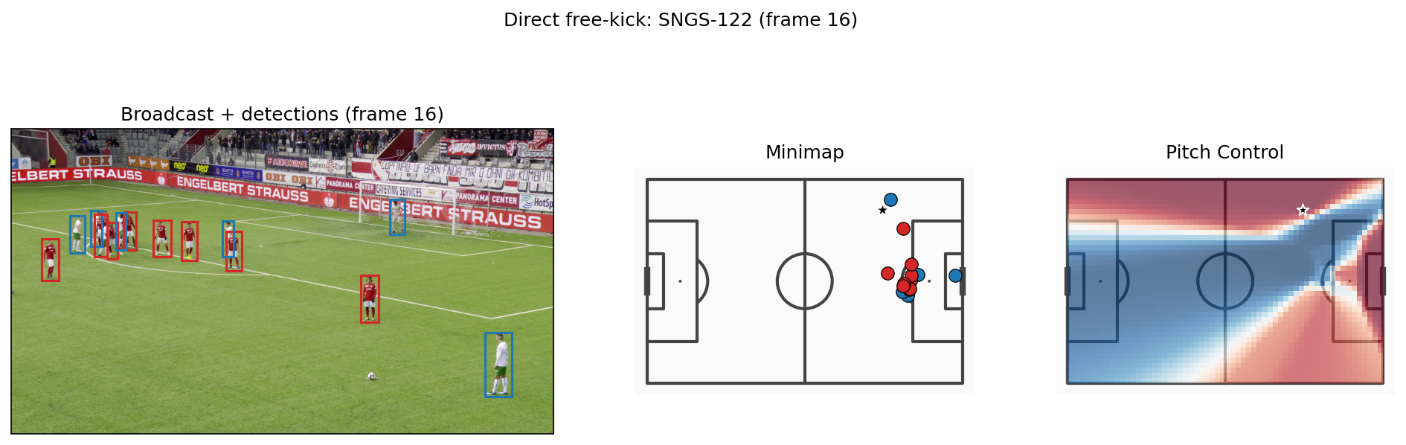
Figure 12. Three-panel deployment overlay for a direct free kick (SNGS-122): broadcast frame with detections, metric minimap, and Pitch Control heatmap.

7.7 Project Outcomes and Deliverables
Technical outcomes. The pipeline successfully processes all 33 set-piece clips end-to-end without homography failures. Intermediate outputs are stored as Parquet files and committed to the repository, enabling SSD-free reproduction of all analysis notebooks and validation scripts.
Table 10. Technical deliverables produced by the pipeline.
Deliverable | Description
homographies_tvcalib.parquet | 1,023 TVCalib homographies (33 clips × 31 frames)
detections_soccana_tvcalib.parquet | 17,260 rows: 16,209 player + 1,051 referee (pipeline)
detections_gt_full.parquet | 18,539 GT player annotation rows
ball_positions.parquet | 1,023 frame ball positions (949 valid)
pitch_control_soccana_tvcalib.parquet | 940 pipeline PC frames (31 clips)
pitch_control_gt_full.parquet | 949 GT PC frames (31 clips)
validation_summary_tvcalib.parquet | Distributional KS + overlap statistics
validation_paired.parquet | Per-frame paired Pearson, Spearman, MAE, bias
Three-panel stills (PNG) | Thesis-embeddable figures for SNGS-116 and SNGS-122
Animated overlays (GIF, MP4) | 31-frame PC heatmap overlays for representative clips

Academic outcome. The research questions are answered: broadcast-only Pitch Control is viable for pc_in_third and pc_at_ball; the dominant bias sources are asymmetric detector recall (global metrics) and KMeans team-assignment inversion in crowded penalty areas (pc_in_box).
Methodological outcome. The action_position data-quality issue in SoccerNet GSR (Somers et al., 2024), where a global broadcast frame number is easily misinterpreted as a clip-local index, was identified, fixed, and documented, a contribution to future users of this dataset.

8. Discussion of Results

8.1 What the pipeline gets right
pc_in_third is the most reliable metric: bias = +0.010, histogram overlap = 0.903. Attacking-third analysis integrates over a large pitch zone (~35 m × 68 m), diluting localised detection errors and team-assignment noise.
The low per-frame correlation values (Pearson r = 0.056, Spearman r = 0.045) are expected and do not contradict this assessment. At the moment of a set-piece, both pipeline and ground truth produce pc_in_third values that cluster tightly around their respective means (pipeline ~0.523, GT ~0.513). With minimal cross-frame variance, rank-based and linear correlation measures lose statistical resolution. The relevant question for this pipeline is not "does the pipeline predict the exact pc_in_third value for each individual frame" but "does the pipeline produce a population-level distribution of attacking-third control that matches the ground-truth distribution". The distributional evidence (overlap = 0.903, bias = +0.010) answers that question affirmatively. pc_in_third is therefore valid as a comparative metric across clips, not as a per-delivery predictor.

8.2 What the pipeline gets wrong: the box inversion
pc_in_box has the largest error: bias = +0.216, histogram overlap = 0.499. GT shows defenders controlling the penalty box (mean 0.316), which is correct: at a corner, the defending team packs the box. The pipeline estimates attacker control (mean 0.539), a full sign inversion. The cause is a KMeans team-assignment failure in crowded penalty-area crops: when both teams are tightly packed near the goal, per-track mean HSV features become harder to distinguish, and cluster centroids can interchange between teams. This is a structural limitation of colour-based team assignment, not a detection recall issue.
Practical implication: pc_in_box should not be used as a reliable signal from this pipeline in its current form.

8.3 What the pipeline underestimates
Global metrics (pc_mean, pc_area_gt_0p5) are underestimated by ~0.15–0.16. The pipeline detects 15.99 mean players per frame vs GT 18.69, with a larger shortfall on defenders (7.41 vs GT 9.13) than on attackers (8.58 vs GT 9.56). In the Shaw (2020) model, additional defenders uniformly compress attacking control across the surface; the asymmetric recall gap leads to an underestimation of attacking control. This is a detection completeness problem, predictable from the model’s mathematics.
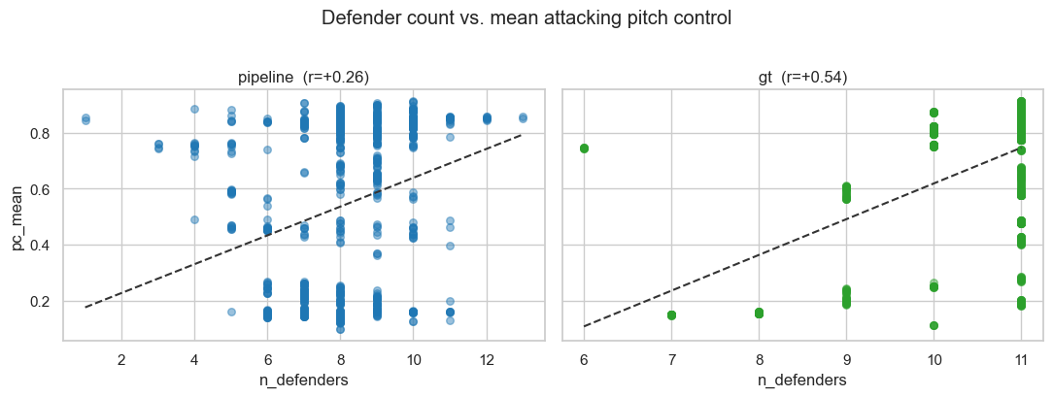
Figure 13. Detected defender count per frame vs pc_mean. The negative trend confirms that defender-recall shortfall is the dominant driver of the global underestimation bias.

8.4 Why no metrics pass strict KS
No metrics pass KS at alpha=0.05. With 940 paired frames, KS has high statistical power and detects small distributional shifts. The strict rejection reflects the sample size and the structural biases above rather than catastrophic model failure.

8.5 Practical Implications
- Use pc_in_third as the primary comparative metric; it is accurately calibrated and robust to local crowding.
- Use pc_at_ball as a secondary signal for per-delivery dominance assessment.
- Do not use pc_in_box from this pipeline without resolving the reliability of team assignment in crowded penalty areas.
- Treat pc_mean and pc_area_gt_0p5 as relative indicators (within-pipeline comparisons) rather than calibrated absolute values.

8.6 Cross-Finding Synthesis
The five validation metrics divide cleanly into three error regimes, and each regime traces to a distinct pipeline component:
Table 11. Error taxonomy mapping each validation metric to its dominant pipeline failure mode and remediation path.
Error type | Metrics | Component | Fix path
Global underestimation | pc_mean, pc_area_gt_0p5 | Soccana detection recall | Lower confidence threshold; ensemble detector
Moderate underestimation | pc_at_ball | Combined recall + proximity | Same as above; lower priority
Sign inversion | pc_in_box | KMeans team assignment | Supervised classifier; cross-frame consistency
Calibrated | pc_in_third | None, unaffected | Retain: primary operational metric
The most important cross-cutting finding is that the error structure is tractable: each failure mode has a clear cause and a concrete remediation path. The pipeline is not uniformly wrong: one metric is already deployment-ready, and the others have predictable bias directions that practitioners can account for.
A second cross-cutting finding concerns the interaction between set-piece type and team assignment: corners impose the most severe crowding (all 22 players converge within ~35 m of the box), while direct free kicks may leave more spatial separation between teams. Future work should stratify validation by set-piece type to assess whether pc_in_box performs better on free kicks than corners.

8.7 Methodological Limits
- Ball detection not automated: Ball positions are sourced from SoccerNet GSR GT annotations. In a club deployment, a separate ball detection or event-feed integration step would be required. This is the main gap between the current implementation and a fully autonomous end-to-end pipeline.
- TVCalib error propagation: TVCalib (Theiner & Ewerth, 2023) introduces reprojection errors of several centimetres to low single-digit metres depending on pitch region and broadcast angle. These propagate directly into player coordinates and modestly affect all PC metrics. Quantifying this error channel is reserved for future work.
- Cohort size: 33 clips; conclusions should not be generalised beyond this cohort or to broadcast conditions substantially different from SoccerNet GSR (Somers et al., 2024).
- Static-frame assumption: Zero-velocity TTI (Shaw, 2020) is appropriate for set-piece snapshots but does not extend to open play. Players may already be in motion at execution; zero velocity understates the spatial advantage of players running toward the ball.
- Per-frame identity ambiguity: Pipeline track IDs are not matched to GT player IDs; team assignment accuracy is assessed implicitly via distributional validation rather than by direct track matching.
- Structural occlusion: Defenders in tight clusters, partially hidden from broadcast angles, cannot be recovered by any detector at the specified confidence threshold.
- Single-broadcast angle: SoccerNet GSR clips are from a single broadcast camera. Performance on tactical cameras or multi-camera feeds has not been tested.

8.8 Practical Prioritisation for Next-Phase Execution
Based on the findings, the highest-leverage next actions in priority order are:
- Autonomous ball detection. Removes the GT dependency and enables fully autonomous deployment. Unlocks the pipeline for any club with broadcast footage and no annotation infrastructure.
- Team assignment hardening. Fix pc_in_box sign inversion via supervised classifier or cross-frame consistency constraint. Required before any box-control signal is used operationally.
- Detector recall improvement. Lower confidence threshold or add an ensemble step to reduce the defending-team shortfall and correct the global underestimation bias.
- Cohort expansion. Validate on additional SoccerNet GSR clips and club-provided broadcast sets before deployment beyond the 33-clip validation cohort.

9. Conclusions and Future Work

9.1 Final Reflections
This project addressed a single practical question: can a broadcast-video-only pipeline generate Pitch Control estimates for set-piece frames that are distributionally comparable to ground-truth annotations on consumer hardware?
The answer is qualified but positive. Measured by bias and histogram overlap, the pipeline matches ground truth well for pc_in_third (bias = +0.010, overlap = 0.903) and retains useful signal for pc_at_ball (bias = −0.051, overlap = 0.804). The two-sample KS test rejects the null hypothesis on all five metrics, but at n = 940 frames this reflects statistical power against small systematic biases rather than distributional failure; the bias and overlap measures are therefore the more informative summary of pipeline fidelity.
The development process surfaced a significant data-quality issue in SoccerNet GSR (Somers et al., 2024): the action_position field is a global broadcast frame number, not a clip-local index, which caused the pipeline to operate on end-of-clip open-play frames rather than set-piece formations until the bug was identified and fixed. This mid-project discovery and correction illustrate the importance of data validation as an active rather than passive phase of CRISP-DM (Chapman et al., 2000), and it is documented here as a methodological lesson for future users of this dataset.
The most informative finding is a clean partition of error modes across the five metrics. One metric is deployment-ready (pc_in_third, near-zero bias). One shows a sign inversion tied specifically to team assignment in crowded penalty areas (pc_in_box, +0.22). Two exhibit predictable directional underestimation from detector recall shortfalls (pc_mean and pc_area_gt_0p5, ~−0.15). The remaining metric, pc_at_ball, sits between these: a small underestimation that leaves it usable as a secondary per-delivery signal but short of fully calibrated. This structure makes the pipeline's limitations diagnosable rather than diffuse: each error mode points to a specific cause and a specific fix.

9.2 Core Conclusions
- Broadcast-only Pitch Control is viable for the most decision-relevant set-piece signals, within this 31-clip cohort of SoccerNet GSR footage (Somers et al., 2024). pc_in_third: bias = +0.010, overlap = 0.903. pc_at_ball: bias = -0.051, overlap = 0.804.
- TVCalib autonomous calibration (Theiner & Ewerth, 2023) enables fully autonomous camera-to-pitch projection: 33/33 clips processed, zero homography failures, no GT pitch-line annotations consumed.
- Bias is structural and attributable by metric: global metrics (pc_mean, pc_area_gt_0p5) are underestimated due to asymmetric detector recall (more defenders missed than attackers); pc_in_box is sign-inverted due to KMeans team-assignment failure in crowded penalty areas; pc_in_third is unaffected by both failure modes.
- ByteTrack persistent IDs (Zhang et al., 2022) enable single-pass team assignment per clip with clean-label coverage (zero discarded tracks), thereby eliminating per-frame label instability.
- The pipeline is fully reproducible on consumer hardware (~30 min on Apple Silicon MPS, no cloud). Parquet outputs are queryable with standard Python data tools.
- Ball position remains a dependency on GT annotations in the current implementation; autonomous ball detection is the primary gap to a fully production-ready pipeline.

9.3 Future Work
- Autonomous ball detection: Integrate a lightweight ball detector (e.g., a YOLO-family model from the Ultralytics framework; Jocher et al., 2023) fine-tuned on SoccerNet to remove the GT ball-position dependency.
- Velocity estimation: Optical flow between consecutive frames (exploiting ByteTrack persistent IDs; Zhang et al., 2022) to enable the full Shaw (2020) model with non-zero initial velocities.
- TVCalib error quantification: Propagate the homography reprojection errors of TVCalib (Theiner & Ewerth, 2023) through to estimate their contribution to PC metric variance.
- Cohort expansion: Additional SoccerNet GSR clips (Somers et al., 2024) or club-provided broadcast sets to validate beyond 33 clips.
- Open-play extension: Throw-ins, goal kicks, dynamic possession sequences.
- Detector recall tuning: Lower confidence threshold or ensemble detection to reduce defender under-detection, particularly in crowded penalty-area crops.
- Team assignment in crowded areas: Replace or augment KMeans HSV with a supervised classifier or cross-frame consistency constraint, drawing on related multi-task learning approaches for sports tracking that jointly model re-identification, team affiliation, and role (Mansourian et al., 2023), to fix the pc_in_box sign-inversion failure mode during corners.
- Operational packaging: CLI + Docker for adoption by clubs without notebook expertise.

9.4 Proposed Roadmap
Phase 1 (0–3 months): Autonomous ball detection. Integrate a lightweight ball detector (YOLOv8n or similar, fine-tuned on SoccerNet tracking data) to replace the GT bbox_pitch ball dependency. This is the single change that converts the pipeline from a research tool into a deployable system. Success criterion: ball detection rate >= 80% of frames across the 33-clip validation set.
Phase 2 (3–6 months): Team assignment hardening + cohort expansion. Replace KMeans HSV with a supervised binary team classifier trained on labelled player crops. Validate on an expanded clip set (target: >=100 SoccerNet GSR clips across more matches and broadcast conditions). Stratify results by set-piece type (corner vs. direct free kick) and validate pc_in_box separately on each type. Success criterion: pc_in_box bias magnitude reduced below 0.05.
Phase 3 (6–12 months): Production packaging + open-play extension. Package as a CLI tool with Docker support. Add optical flow for velocity estimation to enable the full Shaw (2020) TTI model on non-static frames. Begin validation on throw-ins and goal kicks as intermediate steps toward open-play Pitch Control. Success criterion: end-to-end CLI run on a new match in under 10 minutes.

9.5 Academic and Practical Contribution
Academic contribution. This project demonstrates a distributional validation of a broadcast-only Pitch Control pipeline against open ground-truth annotations (Somers et al., 2024). The contribution is not a new model; the time-to-intercept pitch-control formulation is established (Spearman, 2018; Fernández & Bornn, 2018; Shaw, 2020). The contribution is a validated evidence base for which summary metrics survive the broadcast-to-GT gap. The three-way error taxonomy (global underestimation, box inversion, calibrated third) provides a reusable framework for evaluating future broadcast CV pipelines that compute spatial tactical metrics. The action_position data-quality finding contributes a documented correction to the SoccerNet GSR dataset for future users.
Practical contribution. The pipeline is fully open-source, runs on consumer hardware in 30 minutes, and requires no proprietary tracking hardware or GT pitch-line annotations during inference. It delivers pc_in_third, a calibrated, deployment-ready Pitch Control metric, to any club or analyst with broadcast footage and a laptop. The animated broadcast-overlay visualizations provide an interpretable output layer that does not require a data scientist to consume.

9.6 Closing Statement
Broadcast-video Pitch Control for set pieces is achievable today, at zero hardware cost, with honest quantification of what works and what does not. The pipeline described here is not a finished product but a validated foundation: one metric is deployment-ready, the remaining failure modes have identified causes and concrete remediation paths, and the full codebase and methodology are publicly documented. The next primary step, autonomous ball detection, is a well-scoped engineering task that would remove the last GT dependency and complete the autonomous pipeline.

10. Bibliography
Chapman, P., Clinton, J., Kerber, R., Khabaza, T., Reinartz, T., Shearer, C., & Wirth, R. (2000). CRISP-DM 1.0: Step-by-step data mining guide. SPSS Inc. https://www.the-modeling-agency.com/crisp-dm.pdf
Deliege, A., Cioppa, A., Giancola, S., Vandeghen, M., Merminod, V., Van Droogenbroeck, M., Ghanem, B., & Davis, J. (2021). SoccerNet-v2: A dataset and benchmarks for holistic understanding of broadcast soccer videos. Proceedings of the IEEE/CVF Conference on Computer Vision and Pattern Recognition Workshops (CVPRW). https://arxiv.org/abs/2011.13367
Fernández, J., & Bornn, L. (2018). Wide open spaces: A statistical technique for measuring space creation in professional soccer. MIT Sloan Sports Analytics Conference. https://www.sloansportsconference.com/research-papers/wide-open-spaces-a-statistical-technique-for-measuring-space-creation-in-professional-soccer
Jocher, G., Chaurasia, A., & Qiu, J. (2023). Ultralytics YOLO (Version 8.0.0) [Computer software]. Ultralytics. https://github.com/ultralytics/ultralytics
Mansourian, A. M., Somers, V., De Vleeschouwer, C., & Kasaei, S. (2023). Multi-task learning for joint re-identification, team affiliation, and role classification for sports visual tracking. Proceedings of the 6th International Workshop on Multimedia Content Analysis in Sports (MMSports ’23). https://arxiv.org/abs/2401.09942
Redmon, J., & Farhadi, A. (2018). YOLOv3: An incremental improvement. arXiv preprint arXiv:1804.02767. https://arxiv.org/abs/1804.02767
Shaw, L. (2020). LaurieOnTracking: Pitch control model (commit 21f4c2d) [Computer software]. Friends of Tracking Data. https://github.com/Friends-of-Tracking-Data-FoTD/LaurieOnTracking
Somers, V., Joos, V., Giancola, S., Cioppa, A., Davis, J., Ghanem, B., & Van Droogenbroeck, M. (2024). SoccerNet game state reconstruction: End-to-end athlete tracking and identification on a minimap. Proceedings of the IEEE/CVF Conference on Computer Vision and Pattern Recognition Workshops (CVPRW). https://arxiv.org/abs/2404.11335
Spearman, W. (2018). Beyond expected goals. MIT Sloan Sports Analytics Conference. https://www.sloansportsconference.com/research-papers/beyond-expected-goals
StatsBomb. (2024). StatsBomb open data [Data set]. https://github.com/statsbomb/open-data
Theiner, J., & Ewerth, R. (2023). TVCalib: Camera calibration for sports field registration in soccer. Proceedings of the IEEE/CVF Winter Conference on Applications of Computer Vision (WACV), 1166–1175. https://doi.org/10.1109/WACV56688.2023.00122
Zhang, Y., Sun, P., Jiang, Y., Yu, D., Weng, F., Yuan, Z., Luo, P., Liu, W., & Wang, X. (2022). ByteTrack: Multi-object tracking by associating every detection box. In Computer Vision – ECCV 2022 (Lecture Notes in Computer Science, Vol. 13682, pp. 1–21). Springer. https://doi.org/10.1007/978-3-031-20047-2_1

11. Appendices

Appendix A: Repository Structure
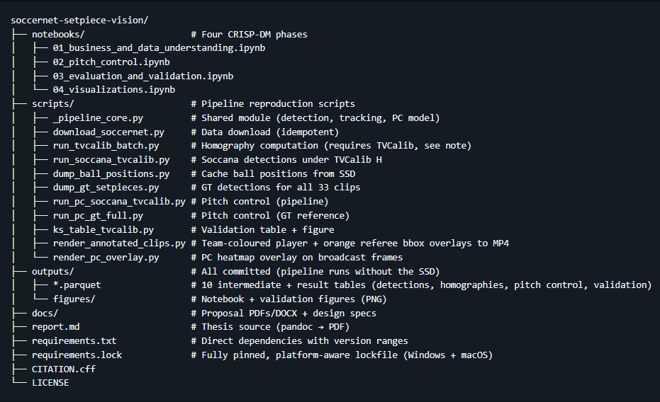

Appendix B: Key Model Parameters
Table 12. Locked pipeline parameters and source files.
Parameter | Value | Location
Detector | Soccana (YOLOv11n, HuggingFace) | run_soccana_tvcalib.py
Confidence threshold | 0.40 | _pipeline_core.py
Detection classes | 0 (Player), 2 (Referee) | run_soccana_tvcalib.py
Tracker | ByteTrack | _pipeline_core.py
KMeans k | 3 (drop smallest if <15% or referee-like) | _pipeline_core.py
Calibration | TVCalib | homographies_tvcalib.parquet
PC grid | 60 x 40 | _pipeline_core.py
MAX_SPEED | 5.0 m/s | _pipeline_core.py
REACTION_TIME | 0.7 s | _pipeline_core.py
SIGMA | 0.45 s | _pipeline_core.py
Frame window | frames 1–31 (centre=16) | _pipeline_core.py
KS alpha | 0.05 | nb03
Histogram bins | 12 | nb03

Appendix C: Data Sources
Table 13. Datasets, models, and external resources with access mechanism.
Dataset | Access
SoccerNet GSR 2024 | Credentialed download (scripts/download_soccernet.py)
StatsBomb Euro 2024 | statsbombpy (open, no auth)
Soccana weights | HuggingFace (Adit-jain/soccana)
TVCalib | Pre-computed, committed as homographies_tvcalib.parquet

Appendix D: Reproducibility
Environment: Python 3.11, conda env py311-dev. Key packages: ultralytics 8.3.107, torch >=2.1.0, scipy, scikit-learn, mplsoccer, statsbombpy.
Hardware: Apple Silicon (M-series), 16 GB unified memory, MPS backend. CUDA and CPU backends also supported.
Runtime: ~30 minutes for full 33-clip pipeline.
Run order:
python scripts/run_soccana_tvcalib.py
python scripts/dump_gt_setpieces.py
python scripts/dump_ball_positions.py
python scripts/run_pc_soccana_tvcalib.py
python scripts/run_pc_gt_full.py
python scripts/ks_table_tvcalib.py
jupyter nbconvert --execute notebooks/02_pitch_control.ipynb --inplace
jupyter nbconvert --execute notebooks/03_evaluation_and_validation.ipynb --inplace
jupyter nbconvert --execute notebooks/04_visualizations.ipynb --inplace

