Install Ubuntu using a Bootable USB Drive

Step:1 Download the ISO file using the following links

Download Ubuntu 15.04 (64-bit)
Download Ubuntu 15.04 (32-bit)

Once the iso file has been downloaded, burn it into DVD or USB drive and make it bootable.

Step:2 Boot your system with Bootable DVD / USB drive.
To start the installation click on “Install Ubuntu”

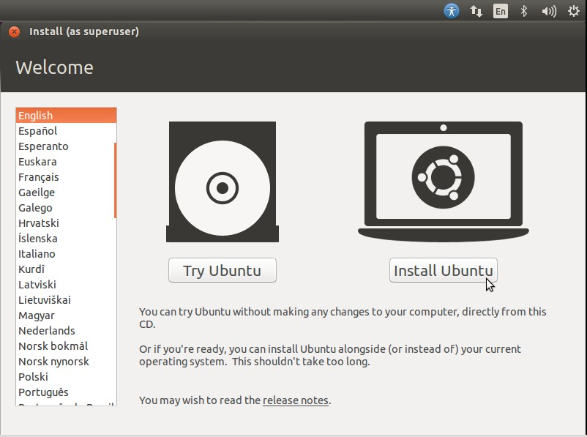

Step:3 Check Install Prerequisite

Make sure you have at least 6.6 GB free disk space and if you want to download updates and third party tools at the installation , check both the boxes and make sure system is connected to Internet

- Download updates while installing
- Install this third-party software

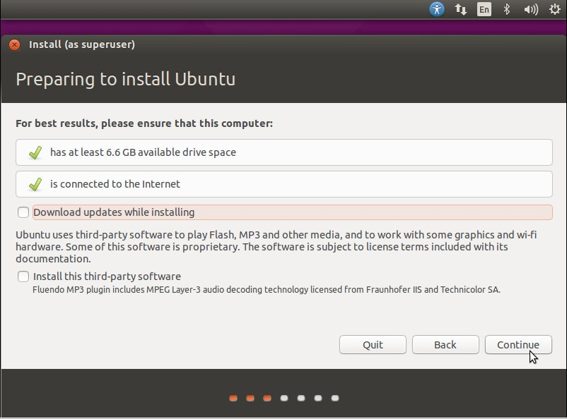
click on Continue….

Step:4 Select the Installation Type

If your system has new hard drive and if nothing installed on it , then you can choose the first option “Erase disk & Install Ubuntu” .

If you want LVM based file system , then use third option “Use LVM with new Ubuntu Installation”

If you want to create customize partition table , the use last option “Some else”

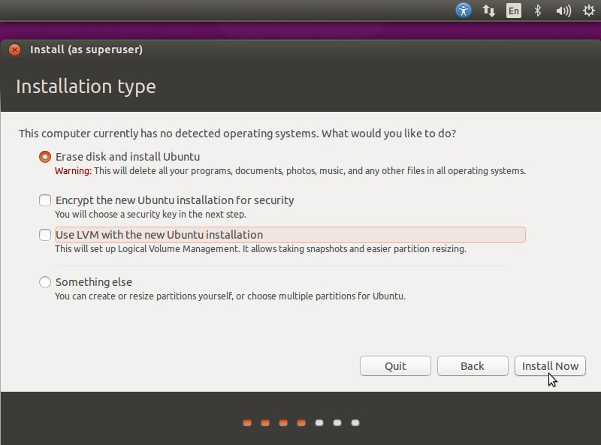
Click on Install Now….

Confirm to Write Changes to Disk

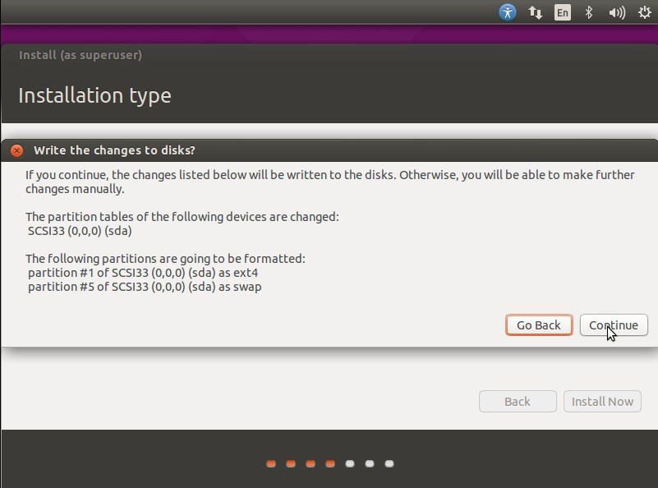

click on Continue….

Step: 5 Select your respective Time Zone

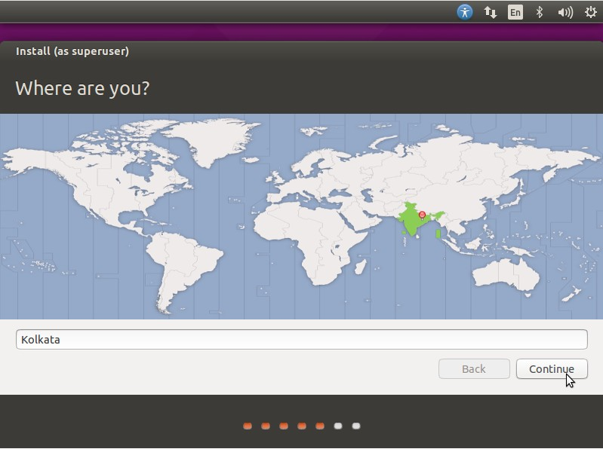

Step:6 Select your respective Keyboard Layout

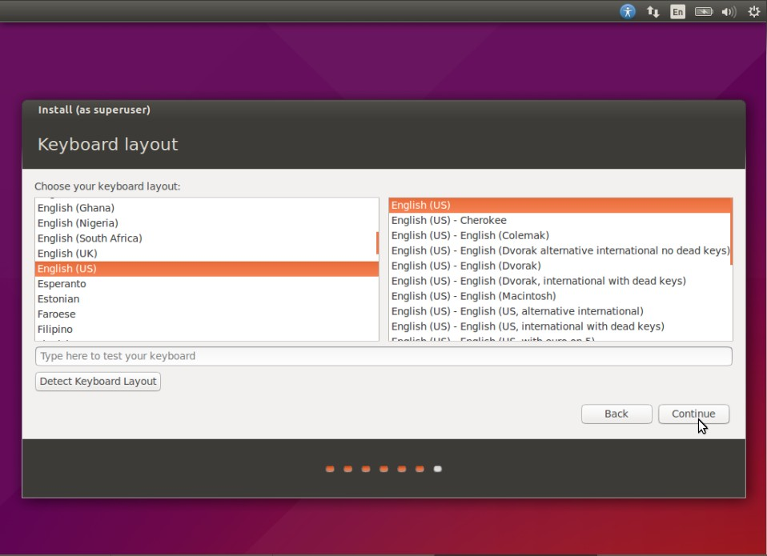

Click on Continue…

Step:7 Set the Hostname of your system and User credentials that will be used after installation.
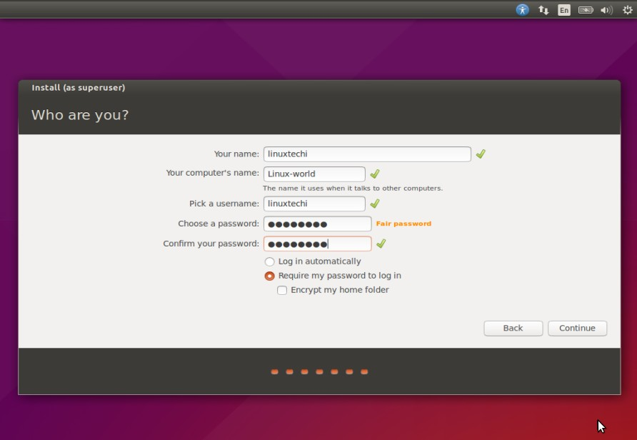

Click on Continue….

Step:7 As shown below Installation has started.

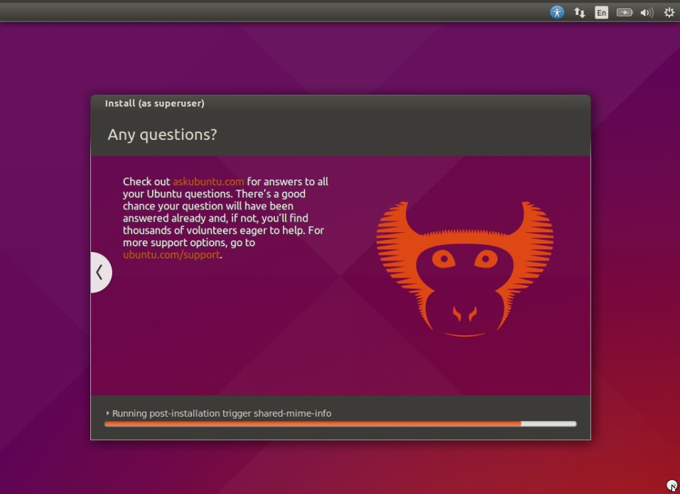

Once the installation is completed, it will ask to restart the Machine.
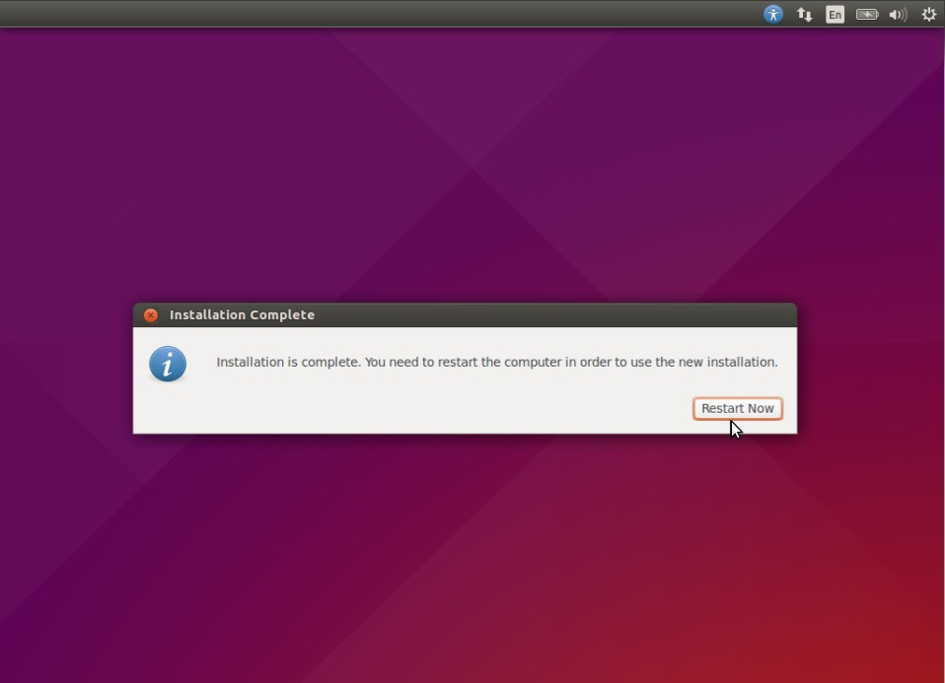

Click on “Restart Now”

Step:8 Login Screen after reboot.
Use the same user and its credentials that we have set during the installation

We will get below screen after entering the credentials.
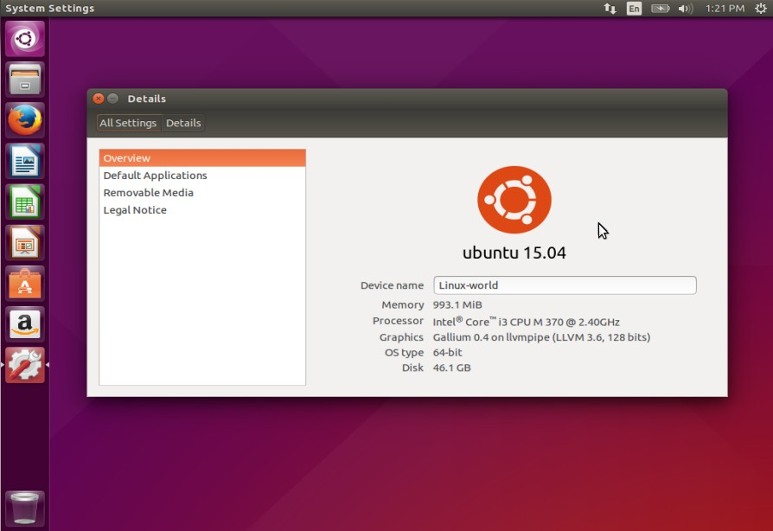
Ubuntu 15.04 Installation is Completed Now. Enjoy and have Fun with latest version of Ubuntu Linux 

You can Download Latest Version of Ubuntu :-

- https://www.ubuntu.com/download/desktop

