Install Windows 10 using a Bootable USB Drive

- Step 1: Connect the Bootable USB flash drive with your PC and reboot it

- Step 2: As soon as your PC boots, press the F11 ( this key will differ from one pc to another ) key to bring up the boot drive selection menu and select the Bootable Windows 10 USB flash drive. This key will differ from one pc to another, so do a quick Google search to find out the correct key to bring up the bios boot menu.
Alternatively, you can also go into the bios of your PC and set the Bootable Windows 10 USB flash drive with the First boot priority.

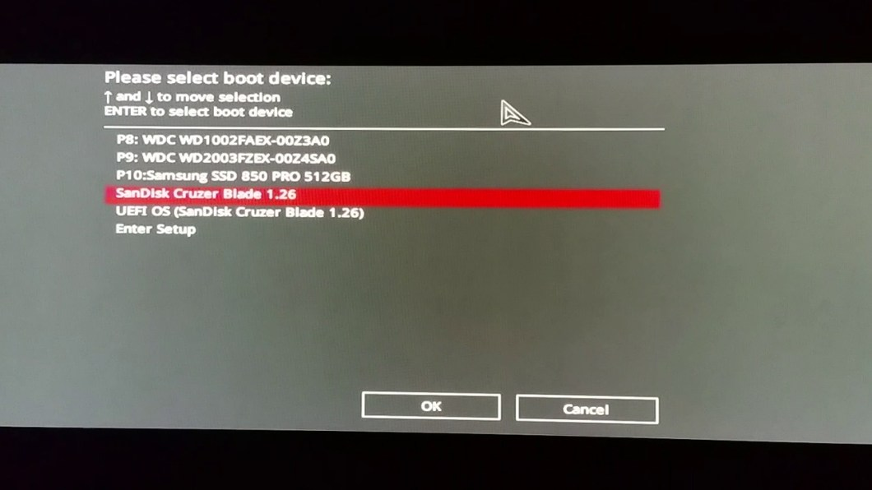

- Step 3: Press any key when you see the “ Press any key to boot from the USB option ”

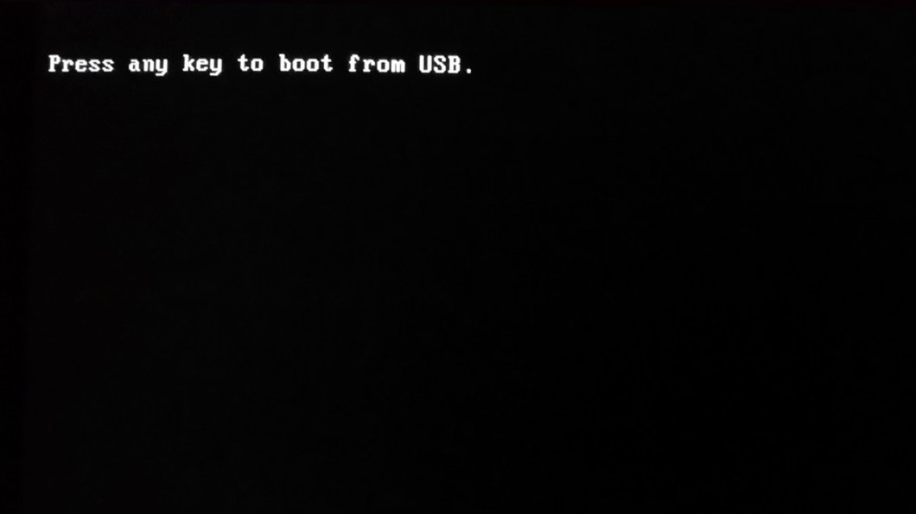

Step 4: Wait for a few seconds for the files to load.

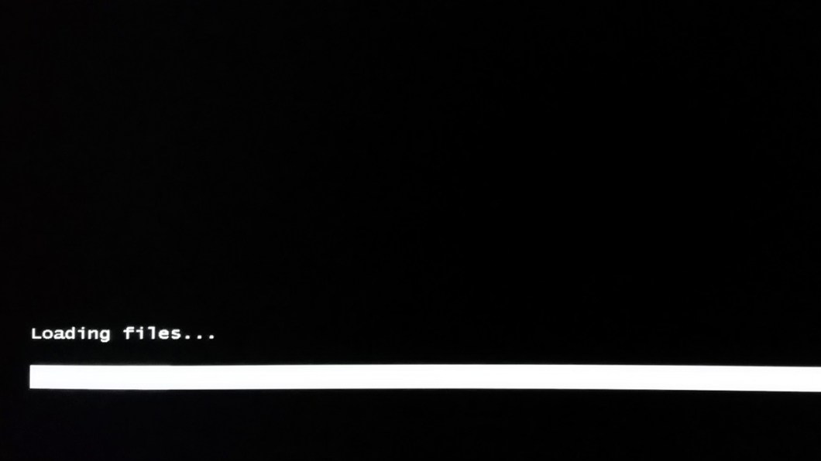

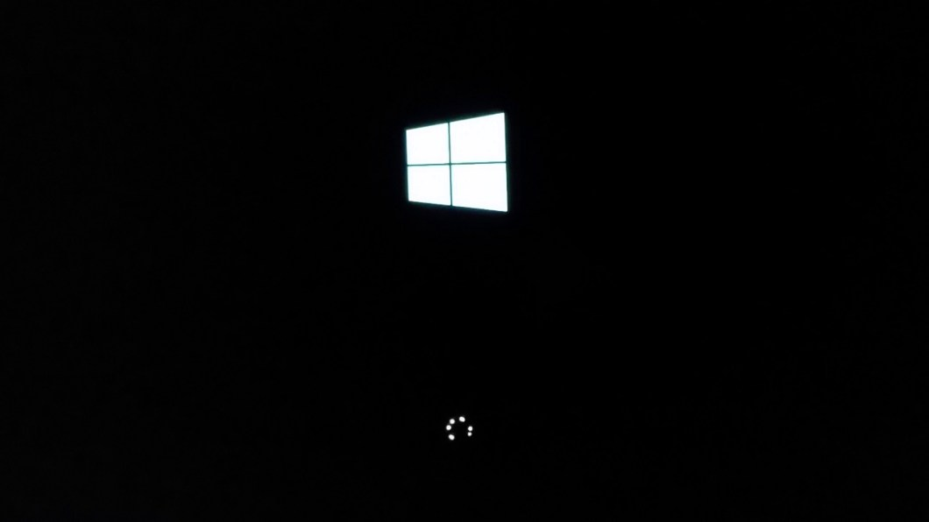

Step 5: Select language, Time and currency format and keyboard input format and click on Next.

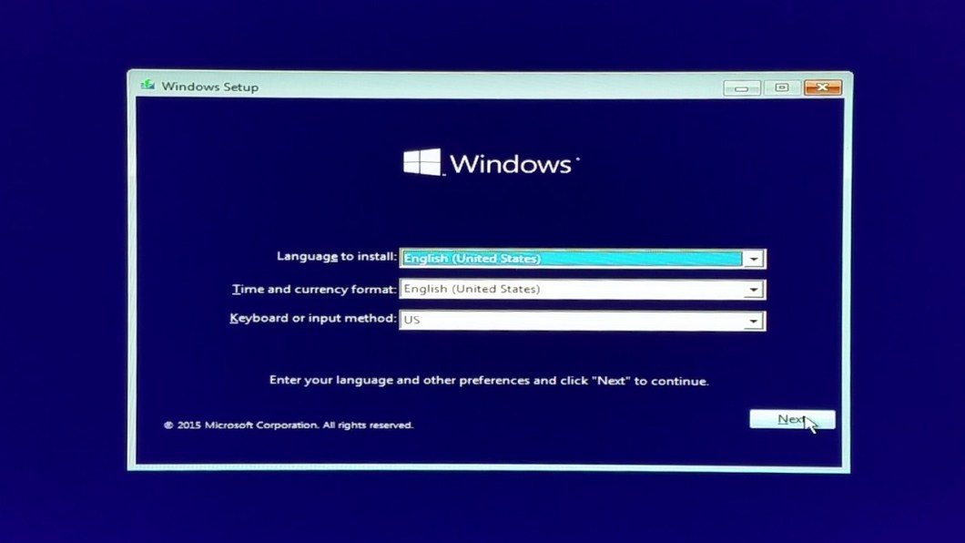

Step 6: Click on Install now.
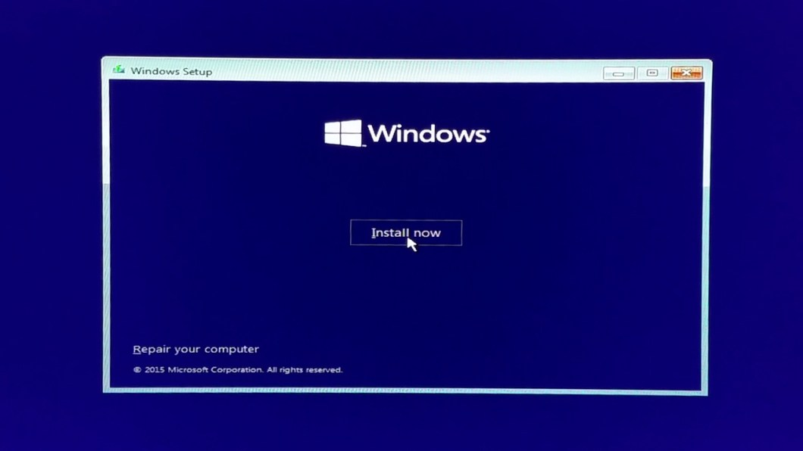

- Step 7: Wait for a few seconds for the setup to start.

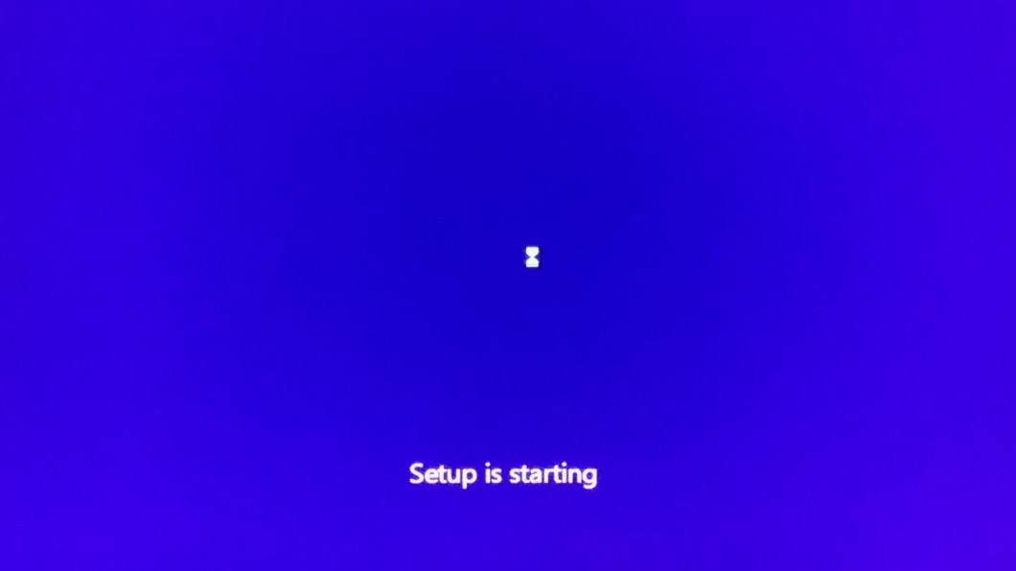

Step 8: If you have a product key, enter it, otherwise click on Skip.

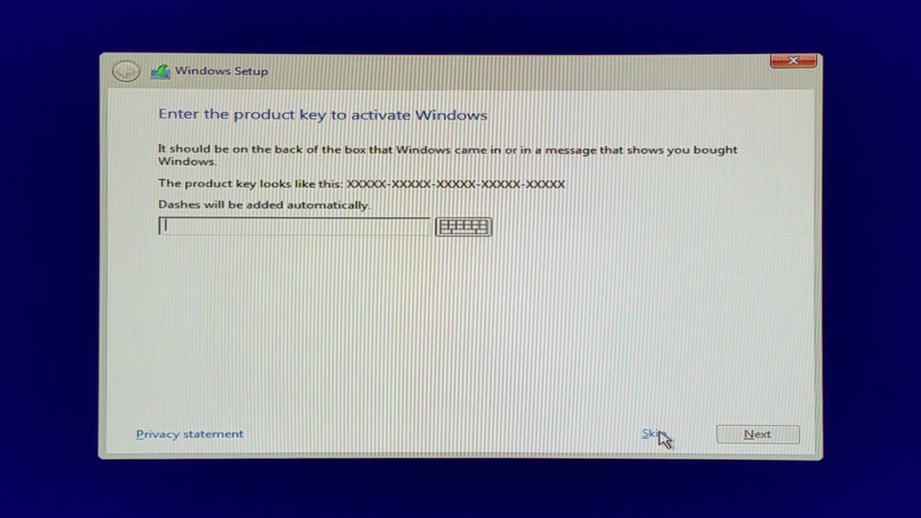
Step 9: Accept the license terms and click on Next.

Step 10: Select “ Custom: install Windows only ( Advanced )
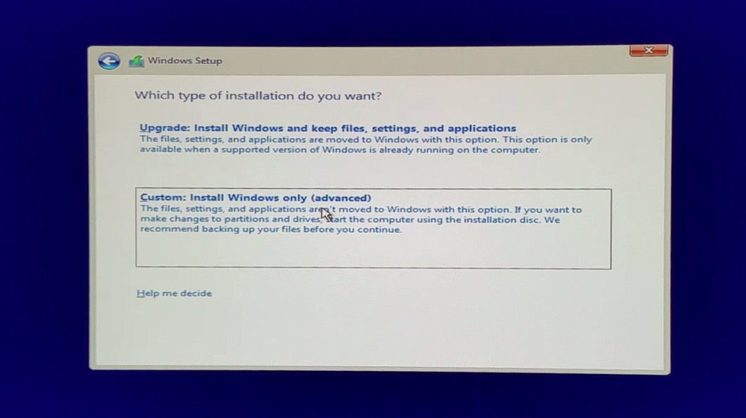

Step 11: Select the drive where you want to install Windows 10.
Note: Make sure the drive is formatted, if not you can format by selecting the format option provided.
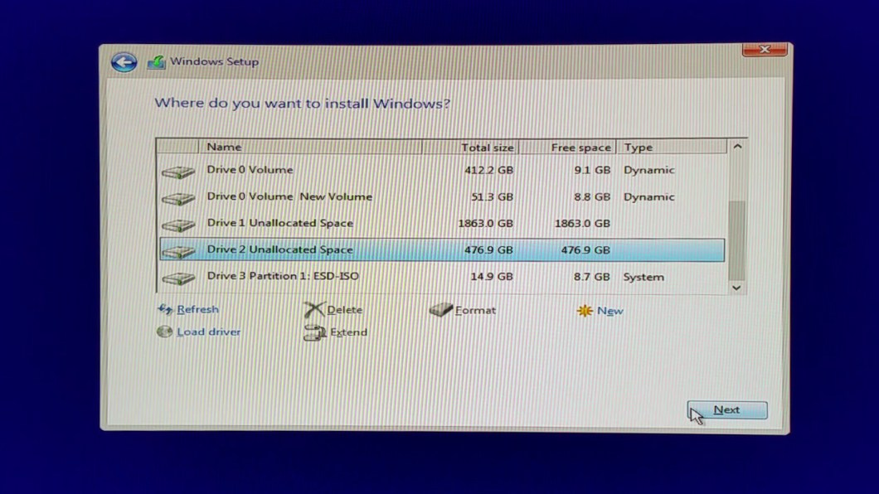

Step 12: Wait for a some time until Windows is being installed. This may take from a few minutes to a hour depending on the hardware of your personal computer. once this process is complete, your PC will restart.
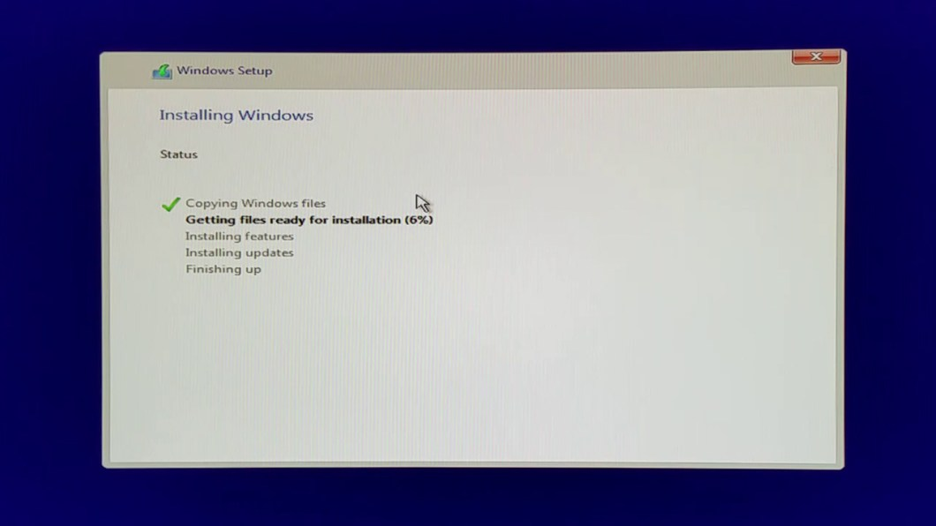
Step 13: Choose Windows 10.

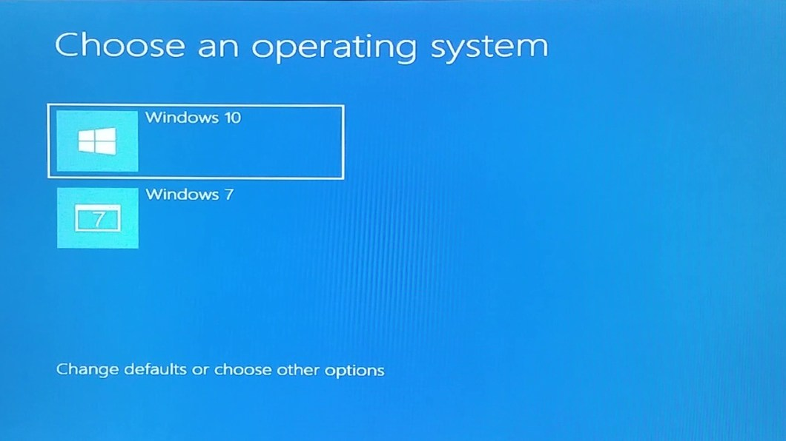

- Step 14: Wait for a some more time.

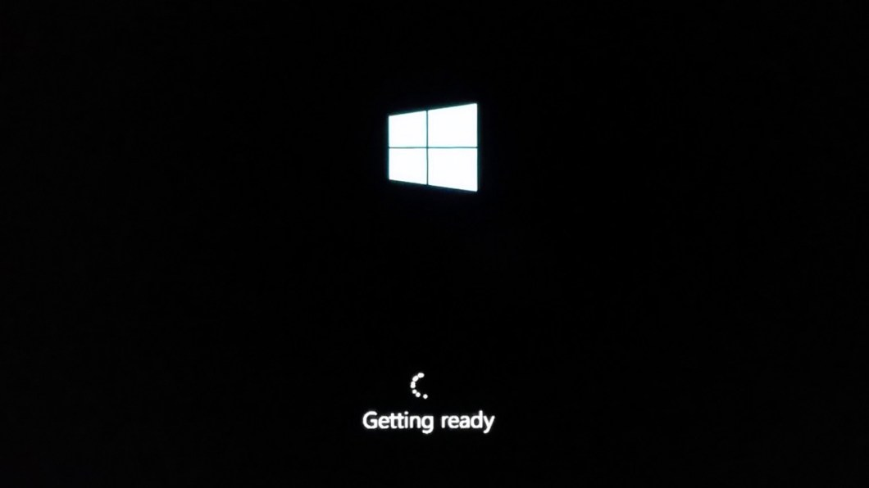
- Step 15: Enter a serial key, otherwise click on Do this later to skip this option.

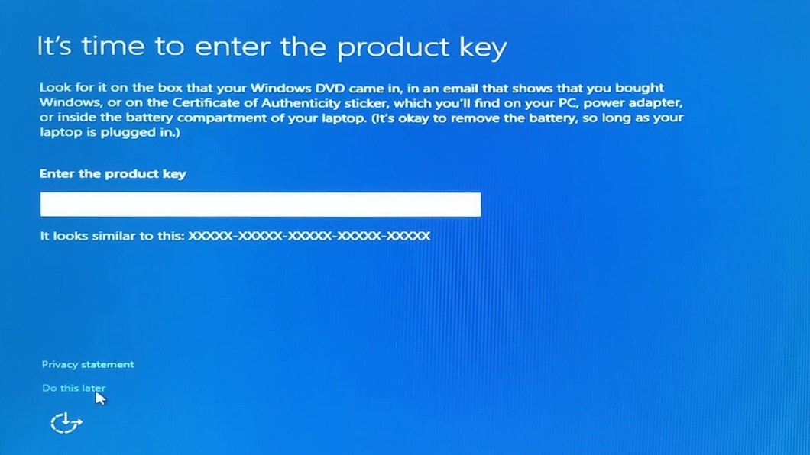

- Step 16: Click on Use express settings to use the recommended settings. Alternatively you can even click on Customize settings to customize the settings.

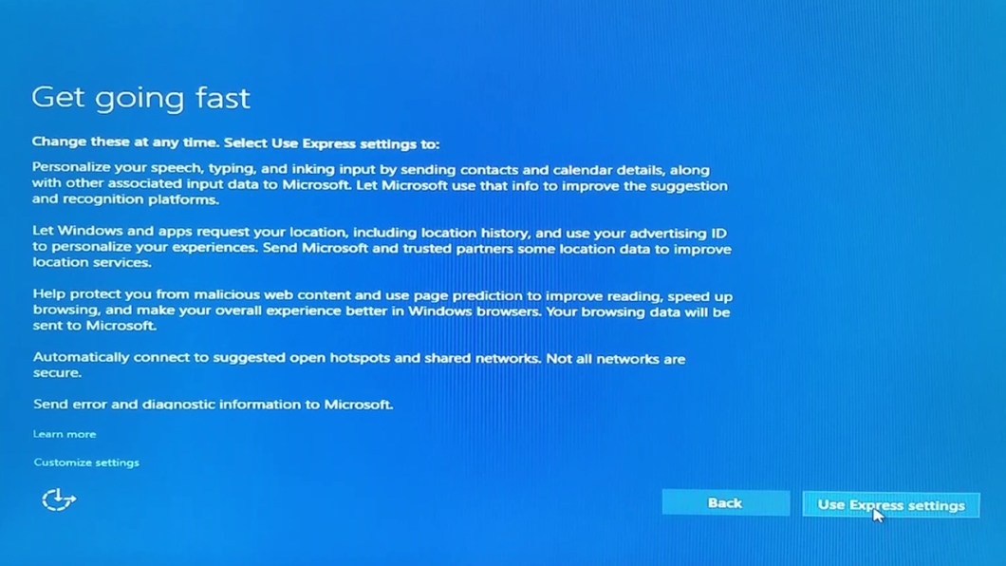
- Step 17: Wait for a few seconds more.

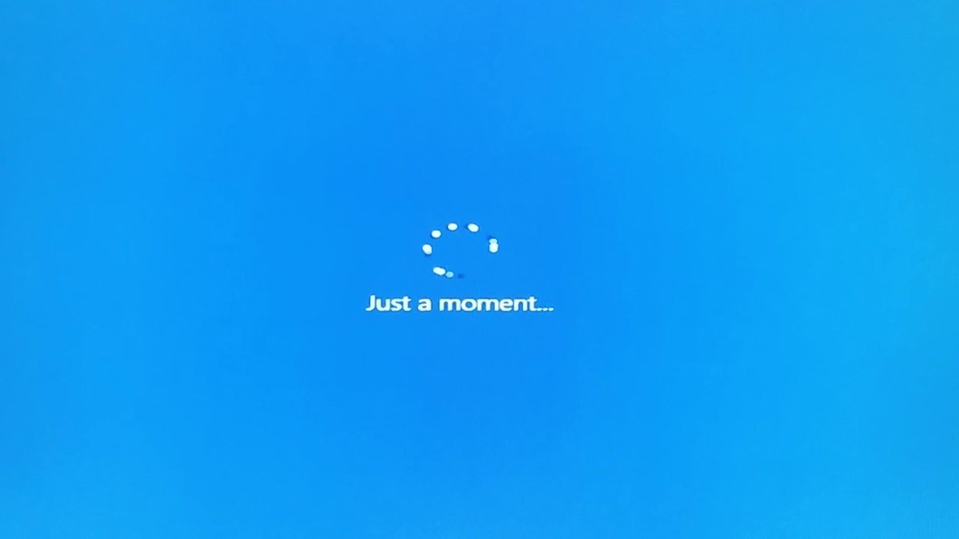

Step 18: Enter a name and password to create your account.

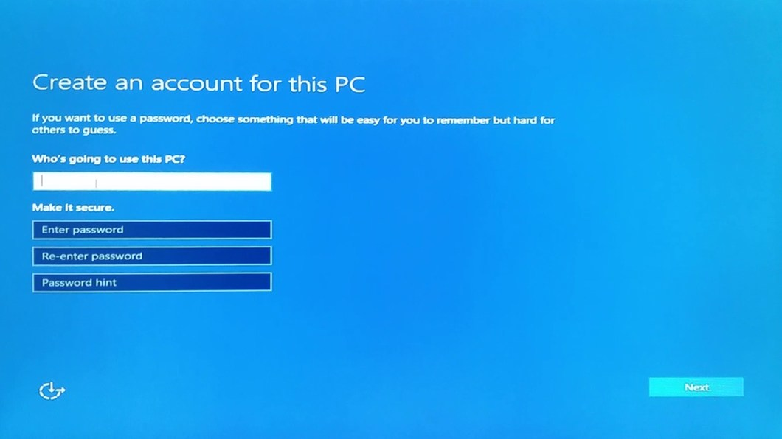
Step 19: Wait for a few seconds more.
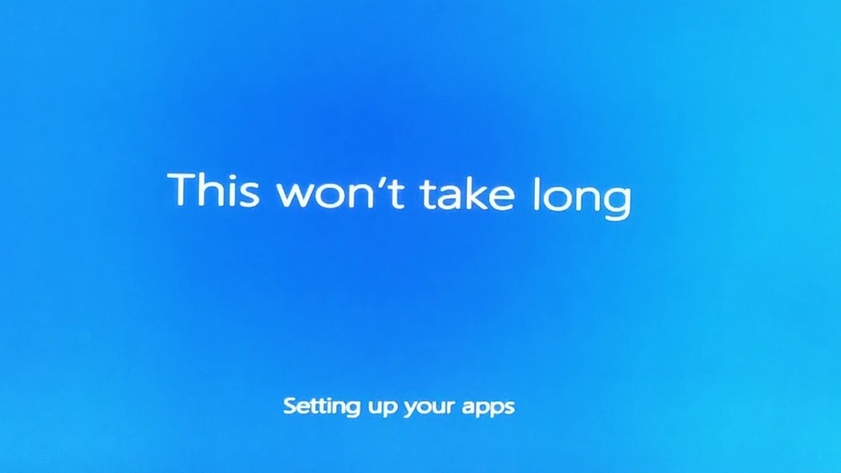

Step 20: There you go, you’re finally on Windows 10.

