**PROJECT DOCUMENTATION**

**INTRODUCTION**

Introduction A crypto currency dashboard that displays historical price data over the past five years is a powerful tool for investors seeking a comprehensive understanding of market dynamics. This feature-rich interface offers users a detailed historical perspective on the performance of various crypto currencies, enabling insightful analysis and informed decision-making. Through visually intuitive charts and graphs, the dashboard allows for effective comparisons of multiple crypto currencies, aiding in the identification of top performers and overall market trends. Users can customize timeframes for a more granular examination of price movements, facilitating in-depth volatility analysis and risk assessment. This historical data not only supports investors in making data-driven decisions but also assists in recognizing recurring patterns and cycles

**Project Title: A Cryptocurrency Dashboard**

|  |  |
| --- | --- |
| **TEAM MEMBERS** | **EMAIL ID** |
| RAMYA J | ramyaprakash792005@gmail.com |
| VISHALI B | vishalibala80@gmail.com |
| POOJA M | icesygurl2005@gmail.com |
| UMAMAGESWARI | Poojamuniyan1818@gmail.com |

**PROJECT OVERVIEW:**

The Crypto Currency Dashboard is a web-based application designed to provide real-time data, analytics, and insights on various cryptocurrencies. The platform enables users to track market trends, view price movements, manage portfolios, and access historical data.

### 2.1 Objectives

* Provide real-time cryptocurrency market data.
* Enable users to manage and track their cryptocurrency investments.
* Offer historical and analytical data visualization.
* Support user authentication for personalized experience.
* Ensure a responsive and user-friendly interface.

### 2.2 Target Audience

* Crypto traders and investors.
* Blockchain enthusiasts.
* Financial analysts.
* Developers and data scientists interested in cryptocurrency trends.

## PURPOSE :

The purpose of this project is to create a user-friendly and efficient dashboard that provides comprehensive cryptocurrency market insights. It aims to:

* Help investors and traders make informed decisions by providing real-time and historical data.
* Offer a portfolio management system to track investments and analyze performance.
* Enhance user experience with interactive charts, alerts, and notifications.
* Improve accessibility to cryptocurrency data through a well-structured and responsive web application.
* Support secure authentication and data protection for user accounts.

**FEATURES :**

Real-Time Price Tracking & Charts  
Display live cryptocurrency prices, price fluctuations, and historical data with graphical charts for various timeframes (hourly, daily, etc.).

1. Watchlist & Portfolio Tracking  
   Allow users to create a watchlist of preferred coins and track their personal portfolio, including profit/loss calculations and real-time updates.
2. Market Overview & Trending Coins  
   Provide an overview of top-performing cryptocurrencies, market cap, 24-hour volume, and display trending coins based on volume and social sentiment.
3. News & Alerts  
   Offer a news feed with the latest updates and allow users to set custom price alerts for specific cryptocurrencies.
4. User Authentication & Personalization  
   Implement user sign-up/sign-in functionality and allow users to customize their experience by saving settings, preferred coins, and theme options.

**ARCHITECTURE :**

### 1. Frontend (UI/UX)

* Framework: React.js (for dynamic and interactive user interface)
* State Management: Redux (for managing global app state, like user preferences, portfolio data)
* Charting Libraries: Chart.js or Recharts (to display price graphs and historical data)
* Design: Material UI or Tailwind CSS (for responsive and sleek design)
* API Integration: Axios or Fetch API (to get real-time data from cryptocurrency APIs)

### 2. Backend (Server-side)

* Framework: Node.js with Express.js (to handle API requests and serve data to the frontend)
* Authentication: Passport.js (for user authentication, OAuth with Google, Facebook, etc.)
* Database: PostgreSQL (to store user data, portfolios, and settings)
* API Integration: External APIs like CoinGecko, CoinMarketCap, CryptoCompare (for fetching live cryptocurrency data)
* Real-time Communication: WebSockets or Server-Sent Events (for real-time price updates)

### 3. API Layer

* Endpoints:
  + /api/cryptos: Fetch a list of cryptocurrencies with real-time price data
  + /api/portfolio: Handle user portfolio data (add/remove coins, track prices)
  + /api/alerts: Set user alerts for price changes
  + /api/user: Manage user authentication and settings

### 4. Data Flow

* Client Request: User interacts with the frontend (e.g., selecting coins or adding them to their portfolio).
* API Call: The frontend sends an API request to the backend (Express.js server).
* Backend Processing: The backend fetches data from external cryptocurrency APIs, processes it, and sends it to the frontend.
* Database Interaction: The backend stores user preferences, portfolios, and alert settings in PostgreSQL.
* Real-Time Updates: Use WebSockets to push real-time price changes or portfolio updates to the frontend.

### 5. Security

* Authentication: JWT (JSON Web Tokens) for managing secure user login sessions.
* Data Encryption: Encrypt sensitive data, like user credentials, in the PostgreSQL database.
* Validation: Input validation in backend to ensure that data submitted by the user is valid and secure.

## SETUP INSTRUCTIONS :

* Backend Setup:
  + Step-by-step instructions for setting up the Node.js backend (installation of required packages, database configuration, setting up environment variables).
* Frontend Setup:
  + Instructions for setting up the React app, installing dependencies, and connecting to the backend API

.

* Database Setup:
  + Instructions for creating the PostgreSQL database and tables, including necessary SQL commands.

### **INSTALLATION PROCESS :**

* Steps for Setting Up the Backend:
  + “Clone the repository, install dependencies using npm, configure PostgreSQL database, and run the Node.js server.”
* Steps for Setting Up the Frontend:
  + “Install frontend dependencies using npm and ensure API calls are properly configured.”
* How to Run the Application:
  + “Start the backend server with node server.js and the frontend with npm start.”

**FOLDER STRUCTURE :**

### 

### Backend (backend/)

* controllers/: Contains the logic for handling HTTP requests, including fetching data, processing, and returning it to the client.
* models/: Contains the models for interacting with the database (PostgreSQL in this case).
* routes/: Defines the routes that connect the backend to the frontend (e.g., /api/cryptos, /api/portfolio).
* server.js: The entry point for the Express server; this file sets up the backend app and listens on a port.
* .env: Environment variables (e.g., database credentials, API keys, JWT secrets) that should be kept secure.
* package.json: Manages backend dependencies (e.g., express, pg for PostgreSQL, axios for external API calls).

#### Frontend (frontend/)

* public/: Contains static files like the index.html page and assets (images, icons).
* src/: The source code for the frontend React application.
  + components/: React components that define the UI (e.g., charts, portfolio section, cryptocurrency list).
  + services/: Handles API calls to the backend, such as fetching cryptocurrency data or managing the portfolio.
  + context/: React Context API files for managing application-wide state (e.g., user authentication state).
  + App.js: The main React component where routes and UI components are assembled.
  + index.js: The entry point for React that renders the app into the index.html file.

#### Root-Level Files

* package.json: Manages the overall project dependencies and scripts.
* .gitignore: Specifies files and folders to be ignored by version control (e.g., node_modules, .env).
* README.md: Provides documentation for setting up and using the project.
* docker-compose.yml: Optional file for Docker configuration, which is useful if you want to containerize both the frontend and backend services.

**COMPONENT DOCUMENTATION :**

### 1. Backend Components

#### 1.1 Server Setup (server.js)

* Purpose:
  + Initialize the Express.js server.
  + Set up middleware like CORS (for cross-origin requests) and bodyParser (to handle incoming JSON requests).
  + Serve as the entry point to handle API routes for cryptocurrency data, portfolio, and user authentication.

#### 1.2 Cryptocurrency Data Fetching (cryptoController.js)

* Purpose:
  + Handle logic to fetch real-time cryptocurrency data from an external API (e.g., CoinGecko).
  + Return the fetched data to the frontend.

#### 1.3 Portfolio Management (portfolioController.js)

* Purpose:
  + Handle the logic to manage user portfolios, such as adding coins to the portfolio.
  + Interact with the PostgreSQL database to store portfolio data.

#### 1.4 Routes (cryptoRoutes.js)

* Purpose:
  + Define routes that connect the frontend with backend functionality.
  + These routes handle API requests like fetching cryptocurrency prices, managing portfolios, and user login.

### 2. Frontend Components

#### 2.1 App Component (App.js)

* Purpose:
  + Acts as the main container for routing and rendering different views of the application (like crypto price list, portfolio, etc.).
  + Uses React Router to navigate between pages.

#### 2.2 Fetching Crypto Data (CryptoList.js)

* Purpose:
  + This component fetches real-time cryptocurrency data from the backend API and displays it.
  + It updates the UI dynamically with the latest price information.

#### 2.3 Portfolio Management (Portfolio.js)

* Purpose:
  + Allows users to manage their cryptocurrency portfolio by adding or removing coins.
  + Fetches and displays the portfolio from the backend, allowing users to track the value of their holdings.

#### 2.4 Watchlist and Alerts (Watchlist.js)

* Purpose:
  + Allows users to track cryptocurrencies they are interested in.
  + Users can add coins to a watchlist and set price alerts for those coins.

#### 2.5 API Service (apiService.js)

* Purpose:
  + A utility file for handling API requests to the backend.
  + Simplifies the process of making HTTP requests like fetching cryptocurrency data or managing user portfolios.

### USER INTERFACE :

* Crypto List: On the homepage, users see a list of cryptocurrencies and their prices.
* Landing Page: User sees a quick overview and logs in or creates an account.
* Portfolio Management: Users can add/remove coins to/from their portfolio and track their holdings.
* Watchlist & Alerts: Users can track coins they are interested in and set price alerts for notifications.
* User Profile: Users can view or update their account settings.

**TESTING :**

1. Functional Testing (Manual Testing)

This type of testing ensures that all features of the dashboard work as expected from a user's perspective.

#### Core Features Testing:

* Login and Authentication:
  + Test if the user can sign up, log in, and log out correctly.
  + Verify if the login error message appears for incorrect credentials.
* Cryptocurrency Price Tracking:
  + Test if real-time prices of cryptocurrencies (e.g., Bitcoin, Ethereum) are displayed correctly.
  + Verify the data is updating periodically or when manually refreshed.
* Portfolio Management:
  + Add a cryptocurrency to the portfolio and verify if it appears with the correct amount.
  + Remove a cryptocurrency from the portfolio and check if the portfolio is updated.
* Watchlist and Alerts:
  + Add a cryptocurrency to the watchlist and verify its presence.
  + Set a price alert and check if it triggers when the price reaches the target.
* User Profile:
  + Test if users can view and update their profile information (e.g., username, email).

### 2. User Interface (UI) Testing

UI testing ensures that the application is visually correct and intuitive to use.

#### Visual Consistency:

* Layout and Design:
  + Check if the elements (buttons, tables, charts) are properly aligned.
  + Ensure that the color scheme, font sizes, and styles are consistent.
* Responsive Design:
  + Verify if the dashboard is responsive across different screen sizes (desktop, tablet, mobile).
  + Ensure elements resize appropriately and the navigation is easy to use on all devices.
* Accessibility:
  + Check if all text has sufficient contrast against the background for readability.
  + Test if the app is navigable using keyboard shortcuts (e.g., tabbing through form fields).
  + Verify that the application works with screen readers.

### 3. Usability Testing

Usability testing focuses on how easy and user-friendly the application is.

#### Navigation and Workflow:

* Ease of Use:
  + Check if users can easily navigate between different sections (Crypto List, Portfolio, Watchlist).
  + Ensure the "Add Coin" and "Remove Coin" functionalities are intuitive.
* Help and Guidance:
  + Verify if there is a help section or tooltips to guide new users.
  + Test if the user can find important information such as "My Portfolio," "Add Coin," or "Set Alert" easily.

### 4. Performance Testing

Performance testing assesses how well the system performs under normal and high loads.

#### Load Time:

* Page Load Time:
  + Measure the time it takes for pages (e.g., cryptocurrency list, portfolio) to load completely. Ensure it's within acceptable limits (e.g., under 3 seconds).
* API Response Time:
  + Manually observe the time it takes for the dashboard to retrieve cryptocurrency data from the API.

#### Stress Testing:

* Handling Multiple Requests:
  + Test the app with multiple users simultaneously accessing the same features (e.g., fetching prices).
* Error Handling:
  + Simulate slow or broken internet connections and check if the application handles errors gracefully (e.g., show a retry button).

### 5. Security Testing

Security testing ensures that the application is safe from vulnerabilities and attacks.

#### Data Protection:

* Data Privacy:
  + Check if sensitive information (e.g., user credentials, portfolio details) is encrypted during transmission.
  + Verify that passwords are stored securely (e.g., hashed in the database).
* Authentication Security:
  + Test the login process with incorrect passwords to ensure proper error messages are shown without revealing too much information.

#### Session Management:

* Session Timeout:
  + Verify that the user is logged out automatically after a period of inactivity.

### 6. Compatibility Testing

This testing ensures that the application works across various browsers, devices, and operating systems.

#### Cross-Browser Testing:

* Verify that the application works as expected on popular browsers (Chrome, Firefox, Safari, Edge).

#### Cross-Device Testing:

* Ensure the app works smoothly on various devices, including desktops, tablets, and smartphones, with different operating systems (Windows, macOS, Android, iOS).

### 7. Regression Testing

Regression testing ensures that new changes or additions do not break existing functionality.

* Testing After Updates:
  + After adding new features or making changes to the codebase, retest all core functionalities (e.g., portfolio management, real-time price updates) to ensure they still work as expected.

### 8. User Acceptance Testing (UAT)

UAT involves testing the application with real users (or stakeholders) to ensure it meets the intended requirements and expectations.

#### Test Scenarios:

* Have real users test key features like portfolio management and setting price alerts.
* Collect feedback on ease of use, any missing features, or bugs they encounter.
* Ask for feedback on the app's design, performance, and any other usability concerns.

### 9. Smoke Testing

Smoke testing is a quick check to ensure the basic functionality of the application is working before more detailed testing.

* Quick Check:
  + Ensure that the app loads without crashing.
  + Verify that users can log in, view cryptocurrency prices, and navigate between basic pages.

### 10. Beta Testing

Before releasing the application to the public, beta testing involves inviting a limited group of users to test the app in a real-world scenario.

* Feedback:
  + Gather user feedback on any issues or improvements they suggest.
  + Monitor for any unforeseen bugs or usability issues.

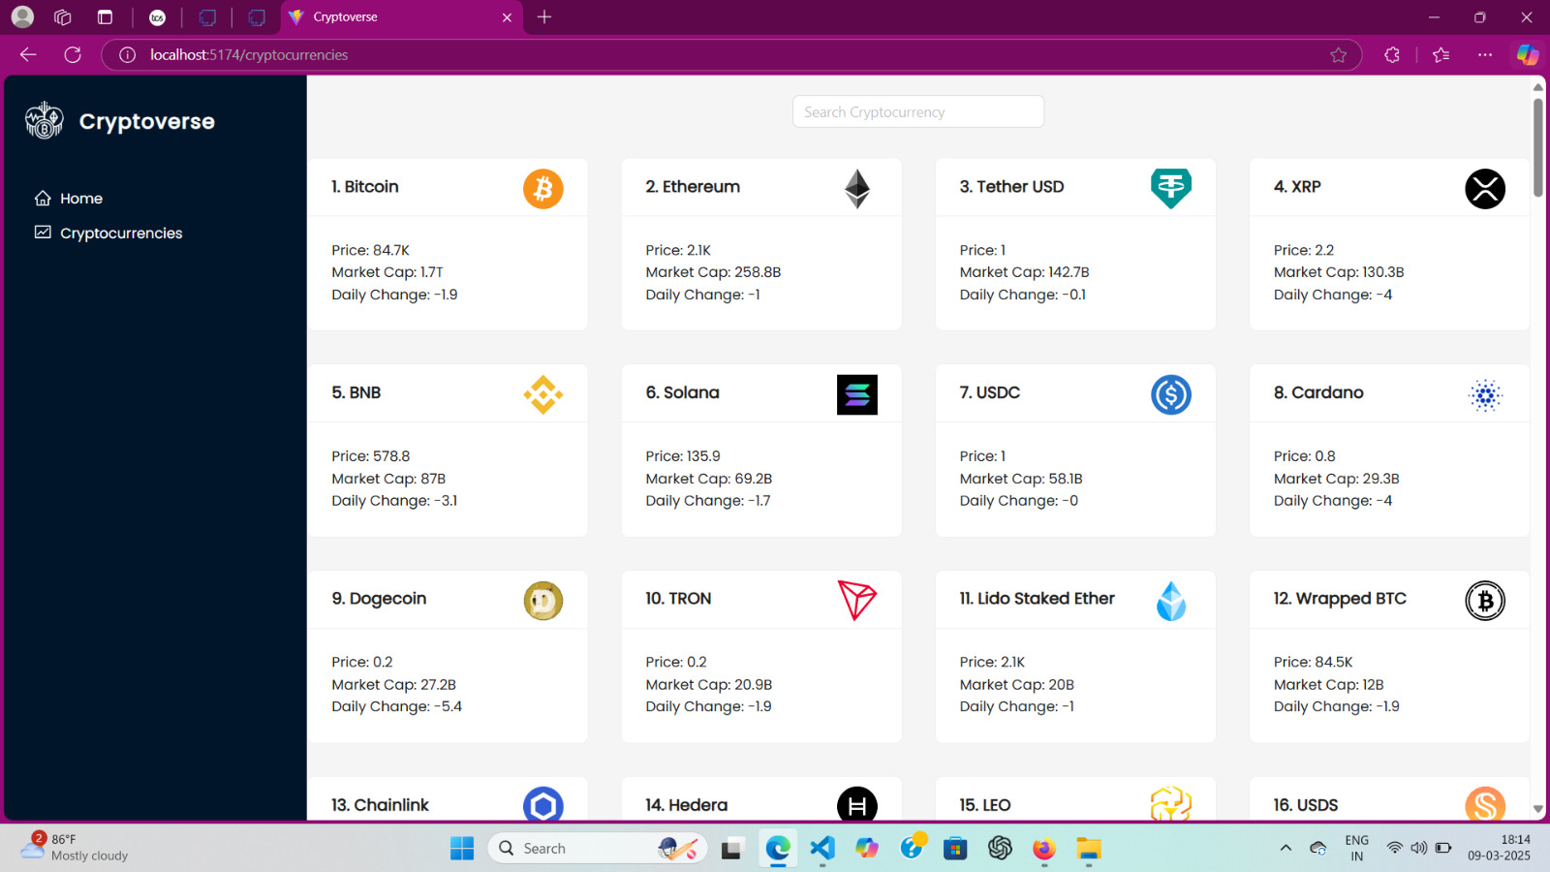**SCREENSHOTS OR DEMO :**

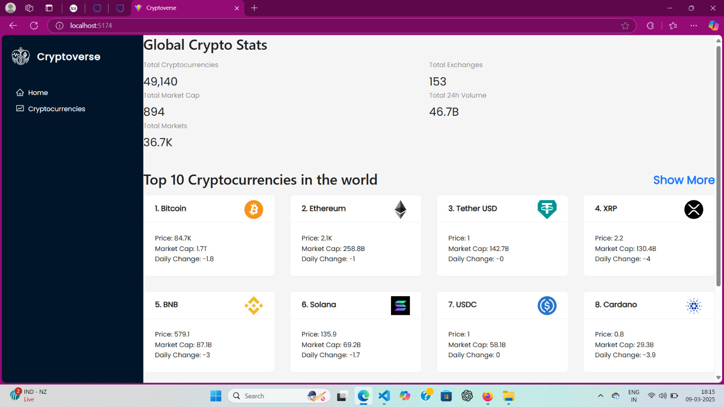

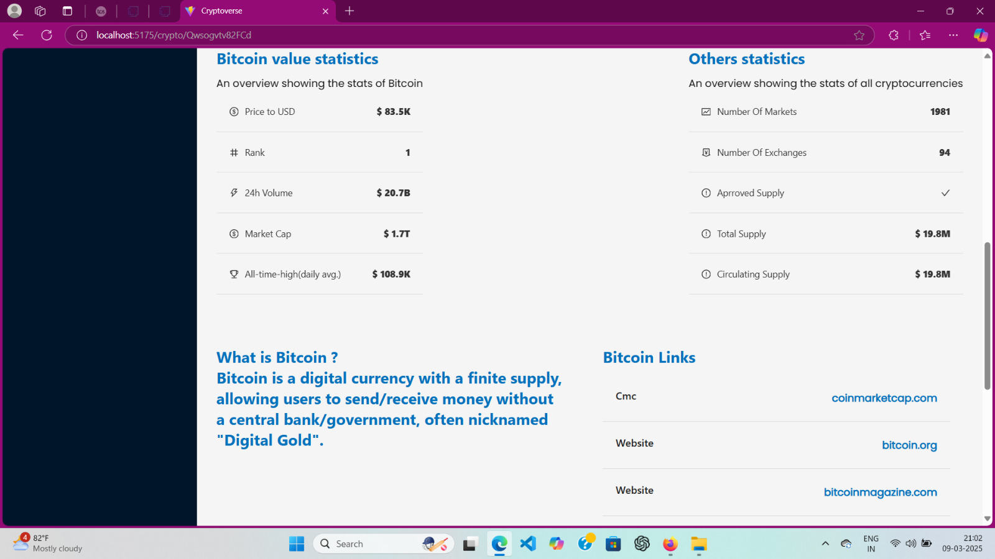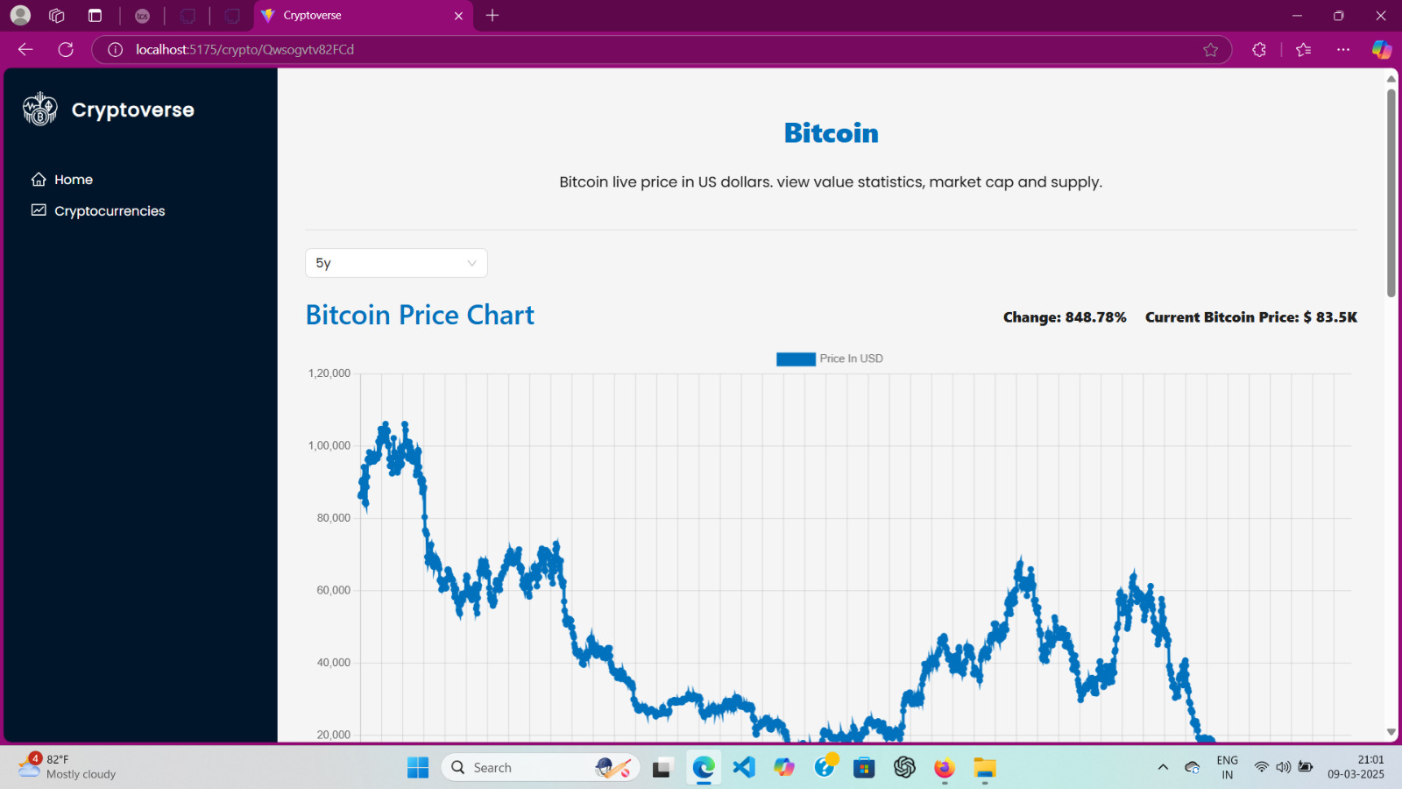

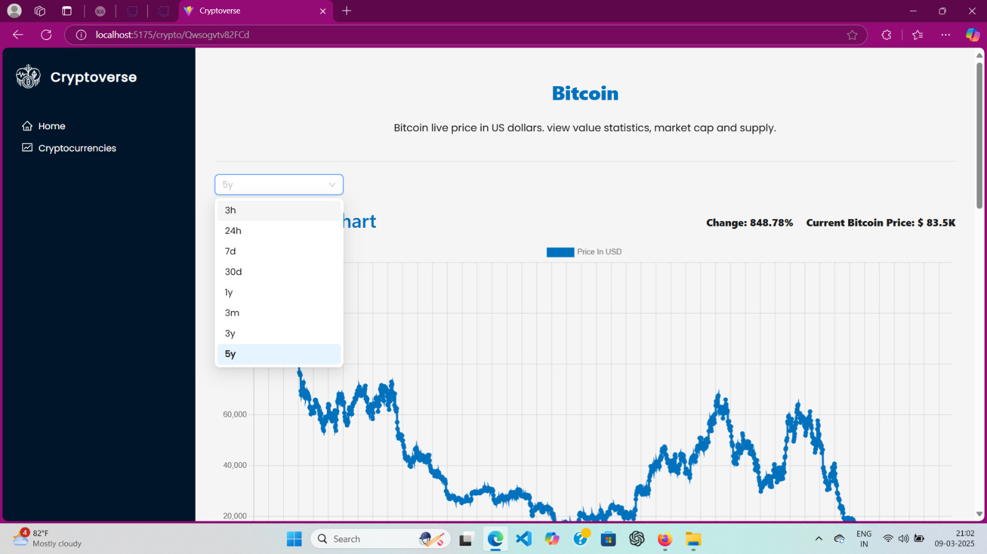

FUTURE SCOPE :

### 1. Advanced Charting and Technical Analysis

#### Enhanced Visualizations:

* Feature: Integrate advanced charting libraries like TradingView or Chart.js to display real-time price trends, historical data, and performance graphs.
* Benefit: Users can perform technical analysis on cryptocurrencies directly within the dashboard, making it a more comprehensive tool for traders.

#### Indicators:

* Feature: Add popular technical indicators such as RSI, MACD, Bollinger Bands, and Moving Averages.
* Benefit: Advanced users will be able to analyze market trends more effectively and make informed investment decisions.

### 2. Multi-Exchange Support

#### Cross-Exchange Integration:

* Feature: Integrate data from multiple cryptocurrency exchanges like Binance, Coinbase, Kraken, etc.
* Benefit: Users will be able to compare prices across different exchanges and find the best prices for trading.

#### Account Linking:

* Feature: Allow users to link their exchange accounts to track their holdings directly from the dashboard.
* Benefit: This will automate the portfolio management process and give users a centralized view of their cryptocurrency holdings across multiple platforms.

### 3. Mobile App Development

#### Mobile App:

* Feature: Develop a mobile version of the cryptocurrency dashboard for iOS and Android using frameworks like React Native or Flutter.
* Benefit: The app will allow users to track their portfolios, set alerts, and view real-time prices on the go, making it more convenient for users.

#### Push Notifications:

* Feature: Implement push notifications for price alerts and other important updates.
* Benefit: Users can get instant notifications directly on their mobile devices, making it easier to respond to market changes.

### 4. AI and Machine Learning Integration

#### Price Prediction:

* Feature: Integrate machine learning algorithms to provide price predictions and market trend forecasts.
* Benefit: Users could leverage AI to make more informed decisions about when to buy or sell cryptocurrencies.

#### Sentiment Analysis:

* Feature: Use sentiment analysis from social media platforms (like Twitter, Reddit, etc.) to gauge market sentiment around specific coins.
* Benefit: Users can get insights into the overall mood of the cryptocurrency market, potentially helping them make better trading decisions.

### 5. Social Features

#### Community and Social Trading:

* Feature: Introduce a community-based feature where users can share their portfolio, discuss trading strategies, and follow other traders.
* Benefit: Building a social component can enhance user engagement and provide valuable insights through peer learning.

#### Copy Trading:

* Feature: Allow users to copy the trades of experienced traders (also known as social trading or copy trading).
* Benefit: New users can learn from the strategies of more experienced traders and potentially improve their returns.

### 6. Cryptocurrency News and Insights

#### Integrated News Feed:

* Feature: Add a news section that aggregates cryptocurrency-related news from trusted sources such as CoinDesk, CoinTelegraph, and CryptoSlate.
* Benefit: Users can stay informed about market-moving news without leaving the app, helping them make timely decisions.

#### Market Insights and Alerts:

* Feature: Provide market insights based on news and events (e.g., regulatory updates, technological advancements, etc.) that could affect cryptocurrency prices.
* Benefit: Users can gain valuable insights into factors influencing the market, helping them stay ahead of the curve.

### 7. DeFi and Staking Integration

#### Staking Dashboard:

* Feature: Introduce staking options for supported cryptocurrencies. Allow users to stake their coins directly from the dashboard and track rewards.
* Benefit: Users can earn passive income by participating in staking, making the platform a one-stop shop for their cryptocurrency investment needs.

#### DeFi Integration:

* Feature: Allow users to interact with decentralized finance (DeFi) protocols directly from the dashboard for lending, borrowing, and yield farming.
* Benefit: This will enhance the platform’s functionality by providing more opportunities for users to earn returns on their holdings.

### 8. Portfolio Diversification and Risk Management Tools

#### Risk Analytics:

* Feature: Introduce tools that help users manage the risk of their portfolio, such as value-at-risk (VaR) calculations or portfolio diversification analysis.
* Benefit: These tools will help users better understand the risk levels of their investments and optimize their portfolios accordingly.

#### Auto-Diversification:

* Feature: Provide automatic portfolio diversification features, where the system recommends diversifying into different coins or sectors (e.g., DeFi, NFTs, etc.) based on the user’s risk tolerance.
* Benefit: This helps users optimize their portfolios for better risk-adjusted returns.

### 9. Cryptocurrency Tax Calculation

#### Tax Reporting:

* Feature: Integrate tax calculation tools that help users calculate the tax on their cryptocurrency gains or losses based on their local regulations.
* Benefit: This will simplify the tax filing process for users, ensuring they stay compliant with cryptocurrency tax laws.

#### Tax Reports and Export:

* Feature: Allow users to generate and download detailed tax reports, including transaction history, capital gains, and losses.
* Benefit: Tax reporting will become more automated and less time-consuming for users, adding value to the platform.

### 10. Multi-Language and Multi-Currency Support

#### Global User Base:

* Feature: Provide multi-language support for users from different regions.
* Benefit: The dashboard will be accessible to a wider audience, increasing its reach.

#### Currency Conversion:

* Feature: Add support for displaying cryptocurrency prices in different local currencies (USD, EUR, GBP, INR, etc.) or allow users to select their preferred currency.
* Benefit: This feature will make the dashboard more user-friendly for a global audience, improving accessibility and engagement.

### 11. Advanced Security Features

#### Two-Factor Authentication (2FA):

* Feature: Implement 2FA for an extra layer of security during login or when making sensitive changes (e.g., portfolio management, withdrawing funds).
* Benefit: This enhances the security of user accounts, making it harder for unauthorized users to access sensitive information.

#### Biometric Authentication:

* Feature: Support biometric login (e.g., Face ID or Fingerprint Authentication) for mobile apps.
* Benefit: Adds convenience and security for mobile users, making it faster and more secure to access their accounts.

### 12. API for Third-Party Integration

#### Public API:

* Feature: Develop and expose a public API for third-party developers to integrate the cryptocurrency data, portfolio management, or price alerts into their own applications.
* Benefit: This will increase the adoption and usage of the platform, opening up opportunities for collaborations with other financial apps or services.

**CONCLUSION :**

Comprehensive Solution: The Cryptocurrency Dashboard provides users with a centralized platform to track real-time cryptocurrency prices, manage portfolios, set price alerts, and monitor market trends.

* User-Friendly Interface: The dashboard’s design is intuitive, ensuring a seamless user experience. Even beginners can navigate through various features like portfolio management and watchlists without difficulty.
* Real-Time Data: By integrating APIs like CoinGecko and CoinMarketCap, the project ensures that users always have access to up-to-date cryptocurrency prices and market data.
* Custom Alerts: The project includes a feature that allows users to set personalized price alerts, enabling them to make informed investment decisions based on market changes.
* Portfolio Tracking: Users can manage their cryptocurrency holdings, track their performance, and calculate the overall value of their portfolios using real-time market data.
* Security and Authentication: The application uses secure login methods with encryption, ensuring that user data and sensitive information are protected.
* Scalability: The system is designed to handle a growing number of users and can be expanded in the future to integrate new cryptocurrencies and features.
* Performance: The dashboard operates efficiently, with fast load times and smooth navigation, ensuring a positive user experience.
* Future Potential: There are various opportunities for expanding the platform with features like advanced charting tools, multi-exchange integration, mobile app support, and machine learning-based price predictions.
* Educational Value: This project offers insights into building real-time web applications, handling cryptocurrency data, and implementing secure authentication, serving as a valuable learning experience.

REFERENCES :

* CoinMarketCap API Documentation: CoinMarketCap API
* React.js Documentation: React
* Node.js Documentation: Node.js
* Express.js Documentation: [Express.js](https://expressjs.com/)
* Chart.js Documentation: Chart.js
* JWT Authentication Overview: JWT.io
* OWASP Top 10 Security Risks: OWASP Top 10
* TradingView API (Charting): TradingView
* Material-UI Documentation: [Material-UI](https://mui.com/)