# Spring Security

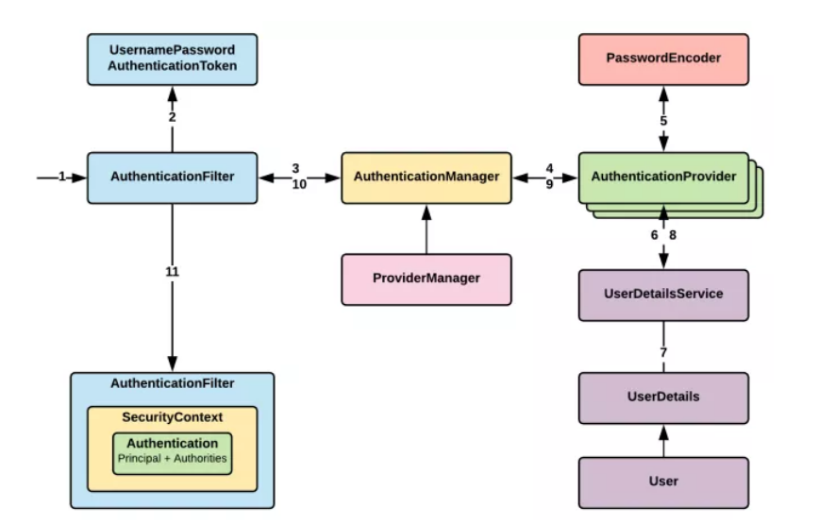

## Ref Guides

https://dzone.com/articles/spring-security-authentication

## Type of Spring Security

1. User name and Password authentication
2. SSO/Okta/LDAP
3. App Level Authorization
4. Intra App Authorization e.g OAuth
5. Microservice security e.g. tokens, JWT
6. method level security

## 5 Key of Spring Security

1. Authentication
2. Authorization
3. Principal
4. Granted Authority
5. Roles

