A PROJECT

on

“Implementation of End-to-End Procure-to-Pay (S2P) Process in SAP MM for Hogwarts Supplies Pvt. Ltd.”

Submitted to

KIIT Deemed to be University

In Partial Fulfilment of the Requirement for the Award of

BACHELOR’S DEGREE IN

COMPUTER SCIENCE AND ENGINEERING

BY

Name: Ridhima
Roll No: 23051772
Course: SAP S2P (MM)
Date: April 2026



SCHOOL OF COMPUTER ENGINEERING

KALINGA INSTITUTE OF COMPUTER SCIENCE AND ENGINEERING

BHUBANESWAR, ODISHA - 751024

April, 2026

Contents

1 | Introduction | 1
2 | Objective | 2
3 | Business Scenario | 3
4 | Process Flow | 4
5 | Implementation Steps | 5-10
6 | Screenshots / Proof | 11
7 | Tools Used | 12
8 | Features | 13
9 | Results / Outcome | 14
10 | Future Improvements | 15
11 | References | 16

Chapter 1

Introduction

SAP (Systems, Applications, and Products in Data Processing) is one of the most widely used Enterprise Resource Planning (ERP) systems across industries. It helps organizations integrate and manage their core business processes such as procurement, finance, sales, and inventory within a unified system. By using SAP, companies can improve efficiency, reduce manual work, and ensure better decision-making through real-time data.
The Source-to-Pay (S2P) process is a key component of business operations, especially in organizations that deal with large-scale procurement activities. It involves the complete cycle starting from identifying the requirement for goods or services, selecting vendors, placing orders, receiving goods, verifying invoices, and finally processing payments.
This project focuses on implementing the Procure-to-Pay (P2P) cycle using the SAP Materials Management (MM) module. The implementation is carried out in a training environment to simulate real-world business scenarios and understand how SAP supports procurement operations effectively.

School of Computer Engineering, KIIT, BBSR 1

Hogwarts Supplies Pvt. Ltd.

Chapter 2

Objective

The primary objective of this project is to understand and demonstrate the complete procurement lifecycle using SAP MM. The project aims to showcase how organizations can streamline their purchasing processes by using SAP functionalities.
Another important objective is to gain hands-on knowledge of key procurement activities such as creating purchase requisitions, generating purchase orders, recording goods receipt, and verifying invoices. This project also helps in understanding how SAP ensures accuracy, transparency, and efficiency in procurement operations.
Additionally, the project highlights how automation reduces manual errors and improves coordination between different departments such as procurement, inventory, and finance.

School of Computer Engineering, KIIT, BBSR 2

Hogwarts Supplies Pvt. Ltd

Chapter 3

Business Scenario

Hogwarts Supplies Pvt. Ltd. is a fictional organization that provides magical equipment, potion ingredients, and academic supplies to wizarding institutions. The company deals with a variety of specialized products such as spell books, enchanted tools, and rare potion ingredients.
To maintain smooth operations, the company regularly procures materials from trusted vendors such as Ollivanders Wand Shop and Slug & Jiggers Apothecary. These vendors supply high-quality magical products that are essential for the organization’s functioning.
Since the procurement process involves multiple steps and coordination between departments, the company uses SAP MM to automate and manage its purchasing activities. By implementing SAP, Hogwarts Supplies Pvt. Ltd. ensures timely procurement, accurate inventory tracking, and efficient payment processing.

School of Computer Engineering, KIIT, BBSR 3

Hogwarts Supplies Pvt. Ltd

Chapter 4

Process Flow

The Procure-to-Pay process follows a structured and sequential flow that ensures smooth procurement operations within the organization.
Purchase Requisition → Purchase Order → Goods Receipt → Invoice Verification → Payment
The process begins with a Purchase Requisition (PR), which is an internal request generated when there is a requirement for materials. Once the requirement is approved, a Purchase Order (PO) is created and sent to the vendor.
After the vendor delivers the materials, a Goods Receipt (GR) is recorded in the system to confirm that the items have been received. The next step is Invoice Verification, where the vendor’s invoice is matched with the purchase order and goods receipt details to ensure accuracy.
Finally, the Payment is processed, completing the procurement cycle. This structured flow ensures transparency, accountability, and efficiency in the procurement process.
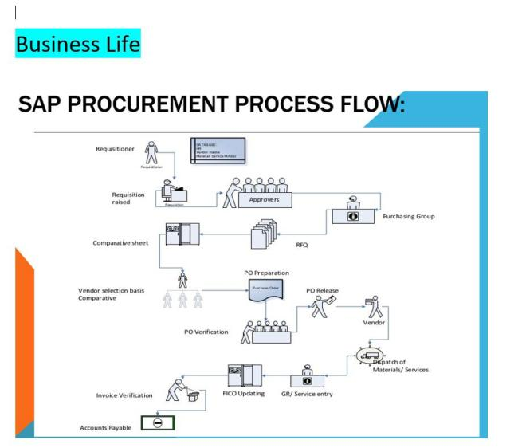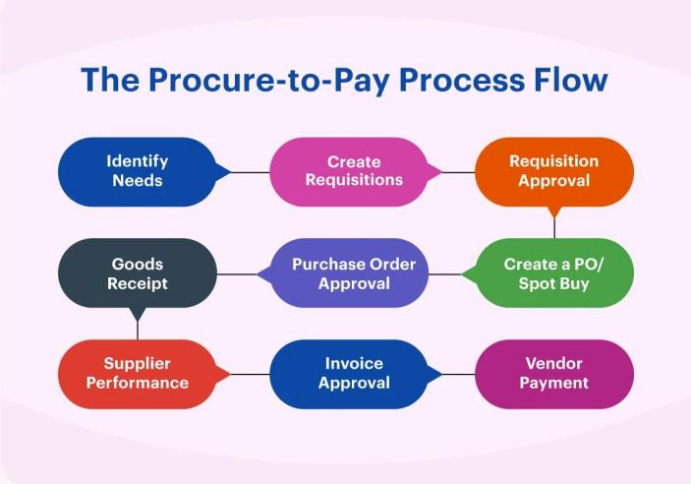

School of Computer Engineering, KIIT, BBSR 4

Hogwarts Supplies Pvt. Ltd

Chapter 5

Implementation Steps

Step 1: Organizational Structure
The organizational structure is defined in SAP to represent the hierarchy of the company. It includes key components such as Company Code, Plant, and Purchasing Organization. These elements help in organizing procurement activities and defining responsibilities within the system.

Step 2: Master Data Creation
Master data plays a crucial role in SAP as it serves as the foundation for all transactions.
The Vendor Master includes details of suppliers such as:
- Ollivanders Wand Shop
- Slug & Jiggers Apothecary
The Material Master includes information about the products being procured, such as:
- Phoenix Feather Wand
- Polyjuice Potion Ingredients

Step 3: Purchase Requisition (PR)
A purchase requisition is created to indicate the requirement for materials. It is an internal document that triggers the procurement process and helps in planning purchases effectively.

School of Computer Engineering, KIIT, BBSR 5
Hogwarts Supplies Pvt. Ltd

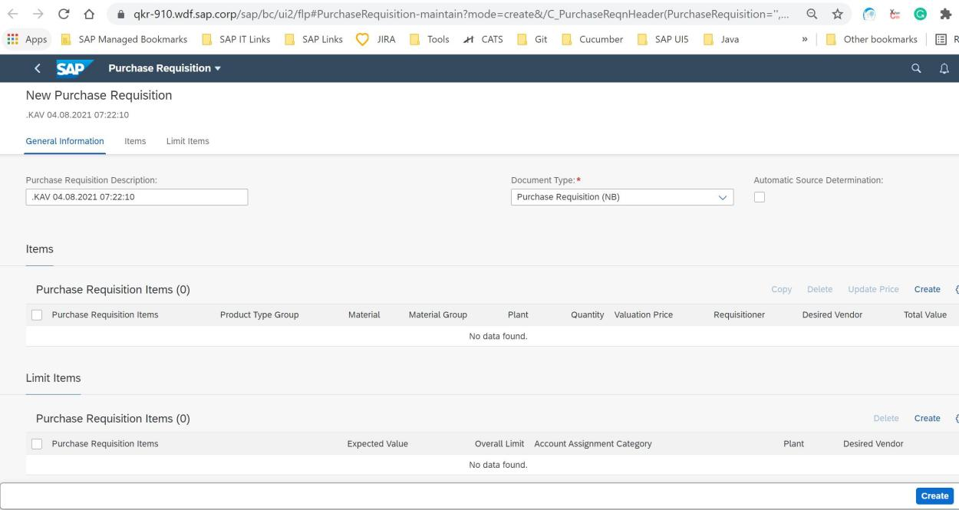
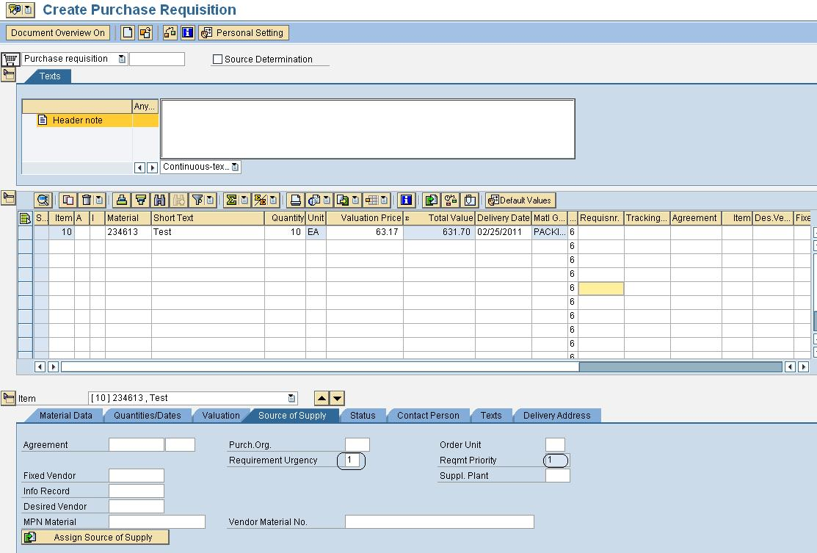

Step 4: Purchase Order (PO)
A purchase order is generated based on the purchase requisition. It is a formal document sent to the vendor specifying the details of materials, quantity, price, and delivery schedule.

School of Computer Engineering, KIIT, BBSR 6

Hogwarts Supplies Pvt. Ltd

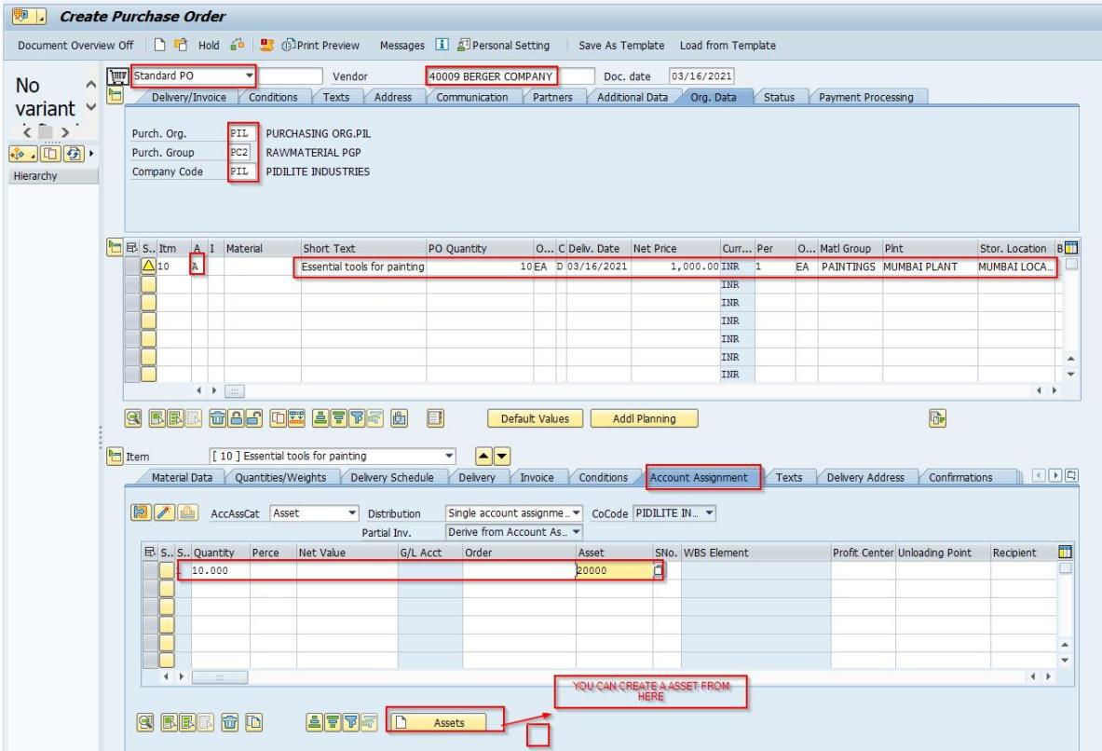
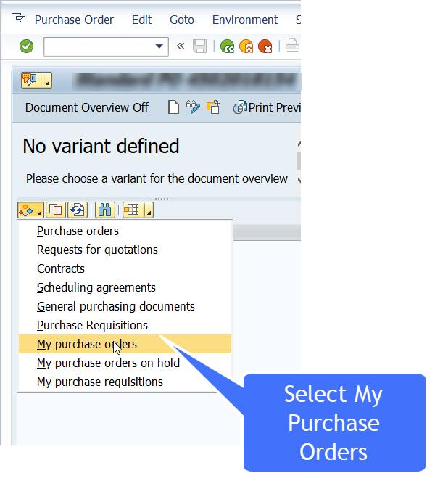

School of Computer Engineering, KIIT, BBSR
7

Hogwarts Supplies Pvt. Ltd

Step 5: Goods Receipt (GR)
Once the materials are delivered by the vendor, a goods receipt is recorded in SAP. This step updates inventory levels and confirms that the materials have been received in good condition.
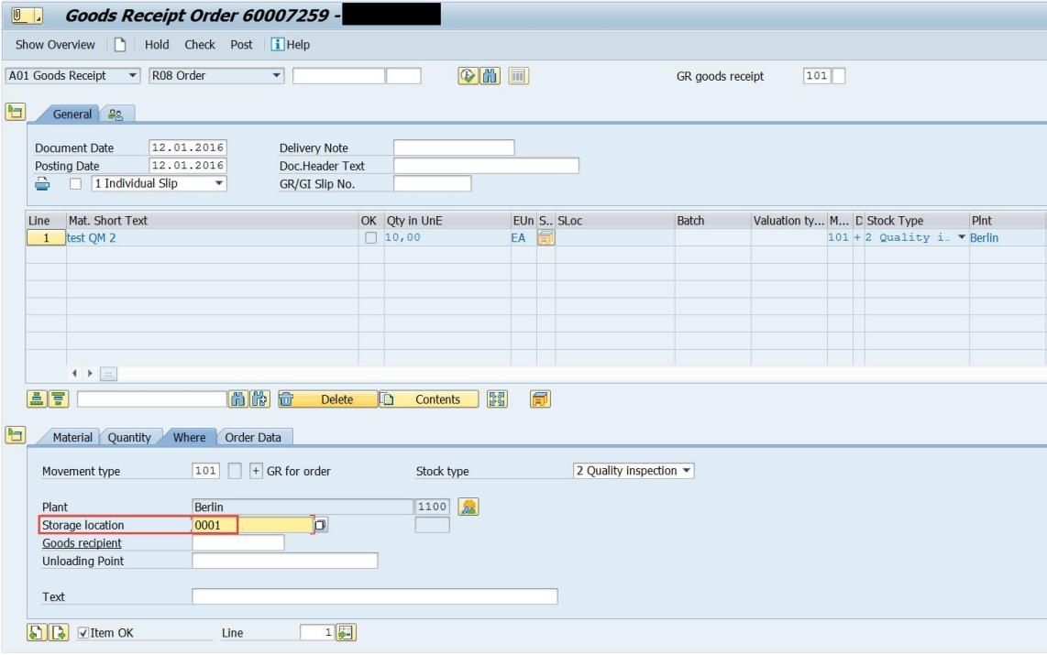
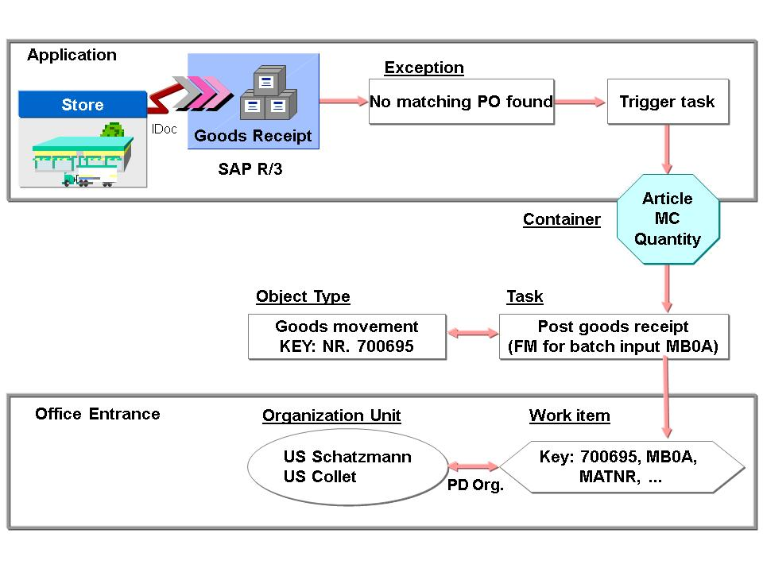

School of Computer Engineering, KIIT, BBS 8
Hogwarts Supplies Pvt. Ltd

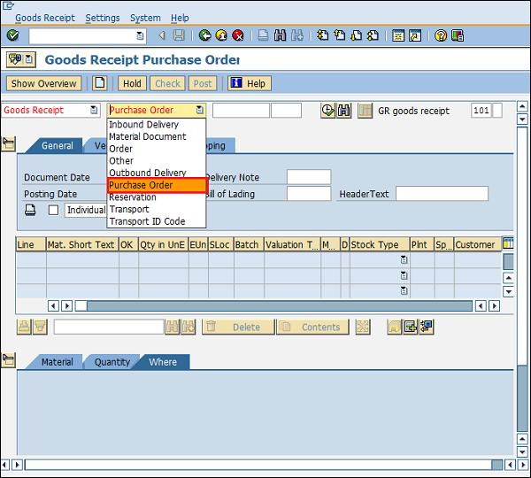

Step 6: Invoice Verification
The vendor invoice is verified against the purchase order and goods receipt. This ensures that there are no discrepancies in quantity or pricing before proceeding with payment.
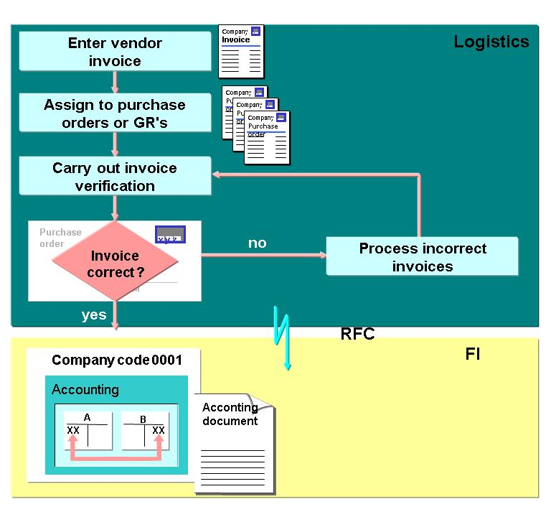

School of Computer Engineering, KIIT, BBSR 9

Hogwarts Supplies Pvt. Ltd

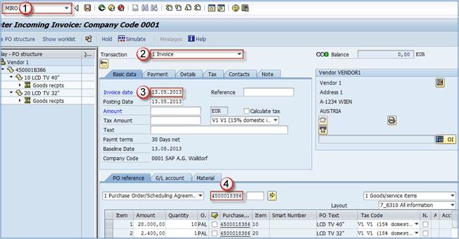

Step 7: Payment Processing
After successful verification, payment is processed to the vendor. This completes the procurement cycle and ensures proper financial closure of the transaction.

School of Computer Engineering, KIIT, BBSR 10

Hogwarts Supplies Pvt. Ltd

Chapter 6

CERTIFICATE / BADGES

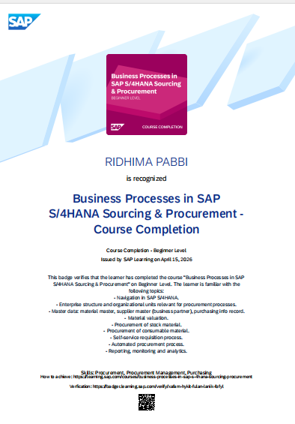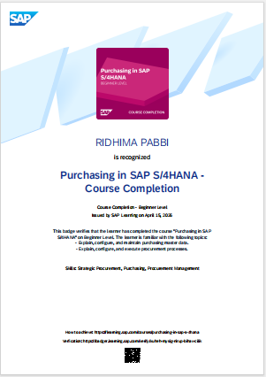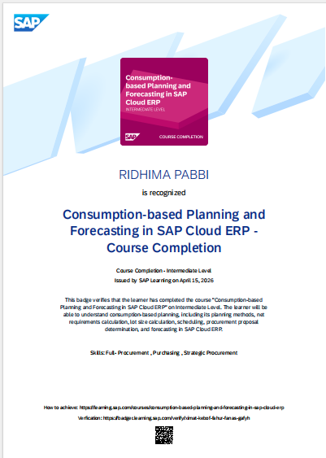

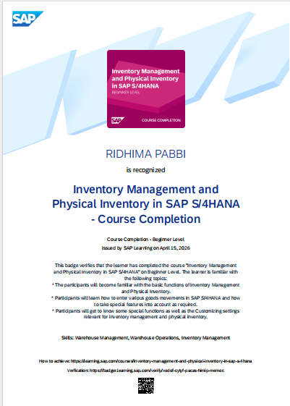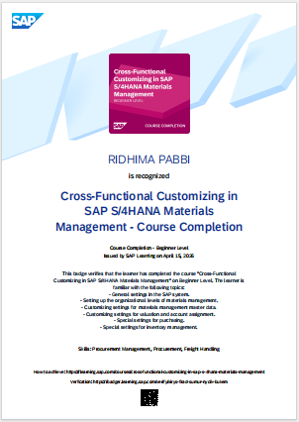

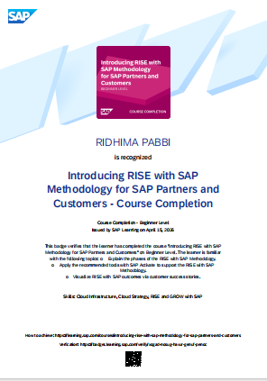

School of Computer Engineering, KIIT, BBSR 11

Hogwarts Supplies Pvt. Ltd

Chapter 7

Tools Used

The primary tool used in this project is SAP MM (Materials Management Module), which is responsible for managing procurement and inventory processes.
The SAP training system is used to simulate real-world scenarios and perform transactions related to procurement activities.

School of Computer Engineering, KIIT, BBSR 12

Hogwarts Supplies Pvt. Ltd

Chapter 8

Features

This project demonstrates several important features of SAP MM, including:
- Automation of procurement processes
- Efficient vendor management
- Real-time inventory tracking
- Accurate invoice verification
- Integration with financial processes
These features help organizations improve efficiency and reduce manual effort.

School of Computer Engineering, KIIT, BBSR 13

Hogwarts Supplies Pvt. Ltd

Chapter 9

Results / Outcome

The project successfully demonstrates the implementation of the Procure-to-Pay cycle using SAP MM. It shows how Hogwarts Supplies Pvt. Ltd. can efficiently manage its procurement activities using a structured and automated system.
The use of SAP ensures better accuracy, improved tracking of materials, and timely payments to vendors. Overall, the project highlights the importance of ERP systems in modern business operations.

School of Computer Engineering, KIIT, BBSR 14

Hogwarts Supplies Pvt. Ltd

Chapter 10

Future Improvements

The project can be further enhanced by integrating advanced technologies such as data analytics and automation tools. Predictive analysis can be used to forecast demand for materials and optimize procurement planning.
Additionally, advanced reporting dashboards can be implemented to provide better insights into procurement performance. Integration with other SAP modules can also improve overall business efficiency.

School of Computer Engineering, KIIT, BBSR 15

Hogwarts Supplies Pvt. Ltd

Chapter 11

References

• SAP Learning Platform
• SAP Training Materials
• Course Resources and Documentation

School of Computer Engineering, KIIT, BBSR 16

