**SOMAIYA**



**V I D Y A V I H A R**

**K J Somaiya Institute of Engineering and Information Technology**

**An Autonomous Institute Affiliated to the University of Mumbai**

# DEPARTMENT OF INFORMATION TECHNOLOGY

***Synopsis of Mini Project On***

Panic Attack Alarm

Prepared By:

Jeet Bhanushali (LY_IT_01)

Tejas Chaplot (LY_IT_03)

Pavan Kulkarni (LY_IT_13)

Under the guidance of:

Prof. Uday Rote

Course In-charge

**Academic Year: 2022-2023**

**Internet Of Everything Lab - Semester VII**

**K J Somaiya Institute of Engineering and Information Technology**

Somaiya Ayurvihar Complex Eastern Express Highway Near Everard Nagar,

Sion East, Mumbai, Maharashtra 400022

**CERTIFICATE**

This is to certify those following students:

|  |  |
| --- | --- |
| **Name of Students** | **Roll No.** |
| Jeet Bhanushali | 01 |
| Tejas Chaplot | 03 |
| Pavan Kulkarni | 13 |
|  |  |

have submitted Internet of Everything Lab – Minor Project Report on *“Panic Attack Alarm”* as the partial fulfilment for the requirement of Last Year of Engineering (7th Semester) in L.Y. - Information Technology under my guidance during the academic year 2022-2023.

**Prof. Uday RoteDr. Radhika Kotecha**

**Course In-charge Head of Department**

**Assistant Professor Associate Professor**

**Date of Examination: _________________**

**Signature of Internal Examiner Signature of External Examiner**

# Table of Contents

Contents Pg. No

1.Introduction 5

2.Literature Review 7

3.Requirements 9

4.Proposed Solution 11

5.Implementation 13

6.Result 20

7.Conclusion 21

8. Future Scope 22

9.References 23

**Abstract**

Panic disorder is a highly prevalent psychiatric disorder that substantially impairs quality of life and psychosocial function. Panic disorder arises from neurobiological substrates and developmental factors that distinguish it from other anxiety disorders. Differential diagnosis between panic disorder and other anxiety disorders has only been conducted in terms of a phenomenological spectrum.

Mental health disorders are among the most important problems of recent decade as they have various individual and social effects. Organizational staff such as law enforcement and mental health departments could suffer from mental health issues like other individuals. They can even be more susceptible to mental health disorders and due to their critical job which has a crucial role in the lives of citizens, and therefore can at times be overwhelming for themselves as well. These mental issues could affect their choices, well-being, health, and can also have numerous other impacts on their professional career. In this paper, we identify mental health disorders, focusing on depression and anxiety, from social media content as an efficient way for analysing the personal and mental state of people. We will utilize machine learning approaches, natural language processing techniques, and sentiment analysis best practices, as well as a knowledge base which will act as the tool to establish relations to a specific domain. Experimental results show that the proposed approach is promising for mental health screening.

# Chapter 1: Introduction

Nowadays, Internet-of-Things (IoT) technologies have been used in many different fields (e.g., smart healthcare, smart home and smart campus) for providing convenience and efficiency to users. Similarly, this paper proposes an panic attack alarm system different from existing systems. The existing systems just sends the emergency messages to the contacts listed as Emergency contacts but there is no data collected regarding the condition of the individual in panic situation. There are some changes in the existing systems which we proposing in this project.

A panic attack is a sudden episode of intense fear that triggers severe physical reactions when there is no real danger or apparent cause. Panic attacks can be very frightening. When panic attacks occur, you might think you're losing control, having a heart attack or even dying.

This project proposes an IoT-based Smart Wrist band which will facilitate to activate the panic attack alarm and send messages to the respective emergency contacts. This system will capture the pulse rate of the user when the panic button is pressed and send to the database, these features is not available in the existing systems. As the data is collected and analysed it will help to warn the user in future case if the pulse rate is increasing or reaching the level where activated the panic alarm.

**Methods**

Data were obtained from the Survey of Adolescent Life in Västmanland Cohort study and comprised 1603 adolescents who completed questionnaires at two time points (ages 16–18 and ages 19–21).

# Chapter 2: Literature Review

This project describes how real-life face detection and identification can prove useful for marking the attendance of students. The paper published by them illustrates an automated attendance system that includes a camera, fixed in the classroom for capturing images, followed by the detection of multiple faces. This system consists of multiple steps such as Face Database Creation of Students, HOG features, Face Detection and Eye Detection, SVM Classifier, Comparison/Recognition, Attendance marking. The paper had certain drawbacks where the system may be sensitive to lighting. The proposed system may eliminate this drawback by using algorithms that may not be sensitive to lighting and also by using advanced high-resolution cameras. [1]

Concentrated on converting conventional manual access to a digitized method using facial recognition. The computer used the MATLAB tools to apply the Principal Component Analysis (PCA) algorithm for the facial recognition module. The code was loaded onto the built-in hardware system using the Microcontroller PIC, which was also connected to the servo engine to open the door before facial authentication was successful. [2]

The first one is Background Subtraction in which the background of an image is subtracted and the only face remains in the image. The second part is face detection and cropping of images i.e., only faces are cropped and stored. The third step is recognizing images with the help of the Eigenvalue method. In this method, Eigenvectors are calculated using formulae and to recognize images Euclidean distance is calculated between stored images and testing images. Then attendance is marked for matching students. This method requires simple hardware installation but face recognition is difficult. The eigenvector method used in this paper gives an accuracy of 60-70%. Hence instead of using an eigenvector, the proposed system will use Haar features for face detection which gives a better result than the eigenvector method. [3]

Paper has described the different techniques to implement the attendance monitoring system using face recognition. The process is divided into two main parts. The first one is the face detection technique and the second one is the face recognition technique. Face detection can be implemented using the Viola-Jones face detection algorithm which includes four main components i.e., Haar-features, integral image, Ada-boost algorithm, cascade feature. Face recognition can be implemented using LBP (local binary patterns). LBP helps to convert the image into machine-understandable formats i.e., in binary format. Before face detection and recognition, the captured image should be converted into grayscale to simplify the calculation. The face detection technique first captures the image (master dataset) and detects faces from the images; the detected faces are stored for further reference. The face recognition technique captures the images from the classroom and tries to recognize them by comparing them with earlier detected faces. [4]

# Chapter 3: Requirements

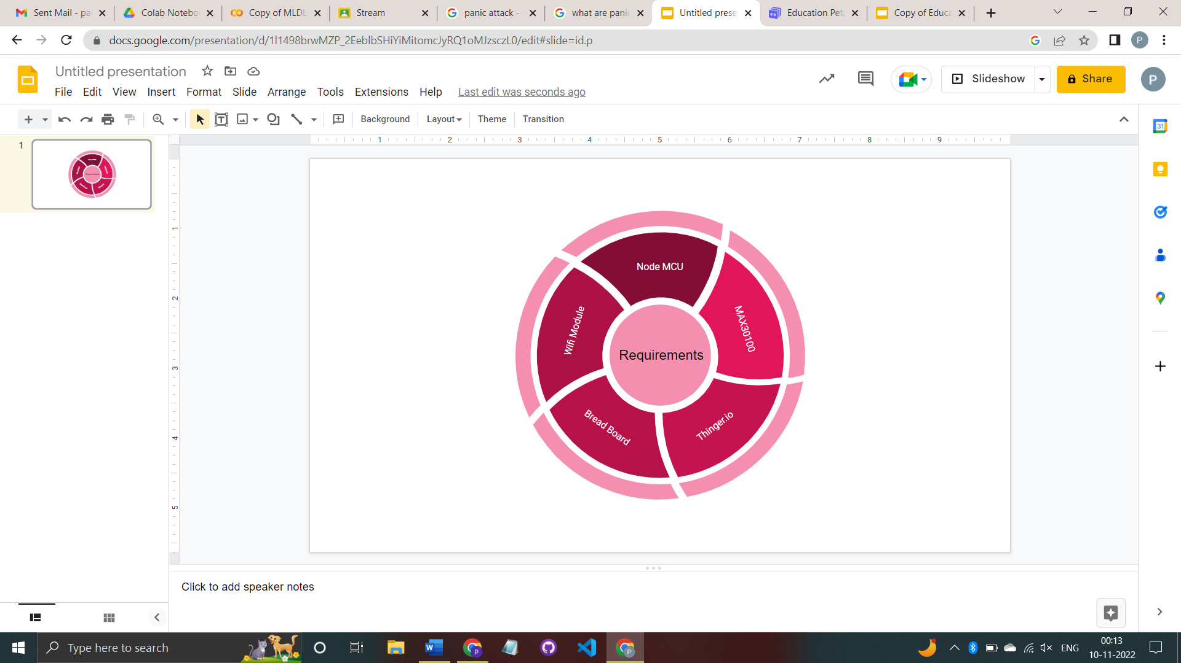

**Fig.1 Requirements**

1. Node MCU: Node MCU is an open-source platform based on ESP8266 which can connect objects and let data transfer using the Wi-Fi protocol. In addition, by providing some of the most important features of microcontrollers such as GPIO, PWM, ADC, and etc, it can solve many of the project's needs alone.

2. Pulse Oximeter MAX30100: The MAX30100 is an integrated pulse oximetry and heartrate monitor sensor solution. It combines two LEDs, a photodetector, optimized optics, and low-noise analogue signal processing to detect pulse oximetry and heart-rate signals.

3. Wi-Fi Module: Wi-Fi modules (wireless fidelity) also known as WLAN modules (wireless local area network) are electronic components used in many products to achieve a wireless connection to the internet.

4. Thinger.io: Thinger.io is a cloud IoT Platform that provides every needed tool to prototype, scale and manage connected products in a very simple way. Our goal is to democratize the use of IoT making it accessible to the whole world, and streamlining the development of big IoT projects.

5. Push Buttons: A push-button (also spelled pushbutton) or simply button is a simple switch mechanism to control some aspect of a machine or a process.

**Chapter 4: Proposed system**

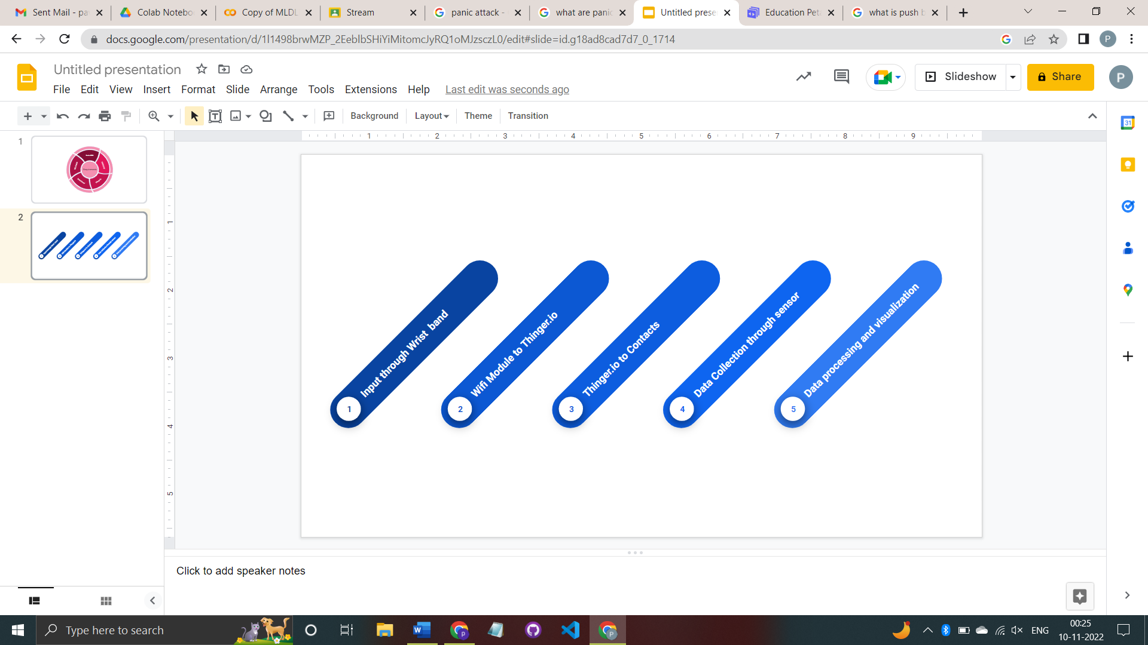

**Fig.2 Flow of project**

The functional flow of our product is as mentioned below:

* User in panic situation will press the push button provided on the Wrist Band.
* Using Wi-Fi module, the message is sent to Thinger.io.
* Thinger.io will shoot the pre stored message to all the emergency contacts.
* At the time of button pressed the pulse oximeter will take the reading of the pulse.
* The data collected will be processed and analysed for used for warning user in future.

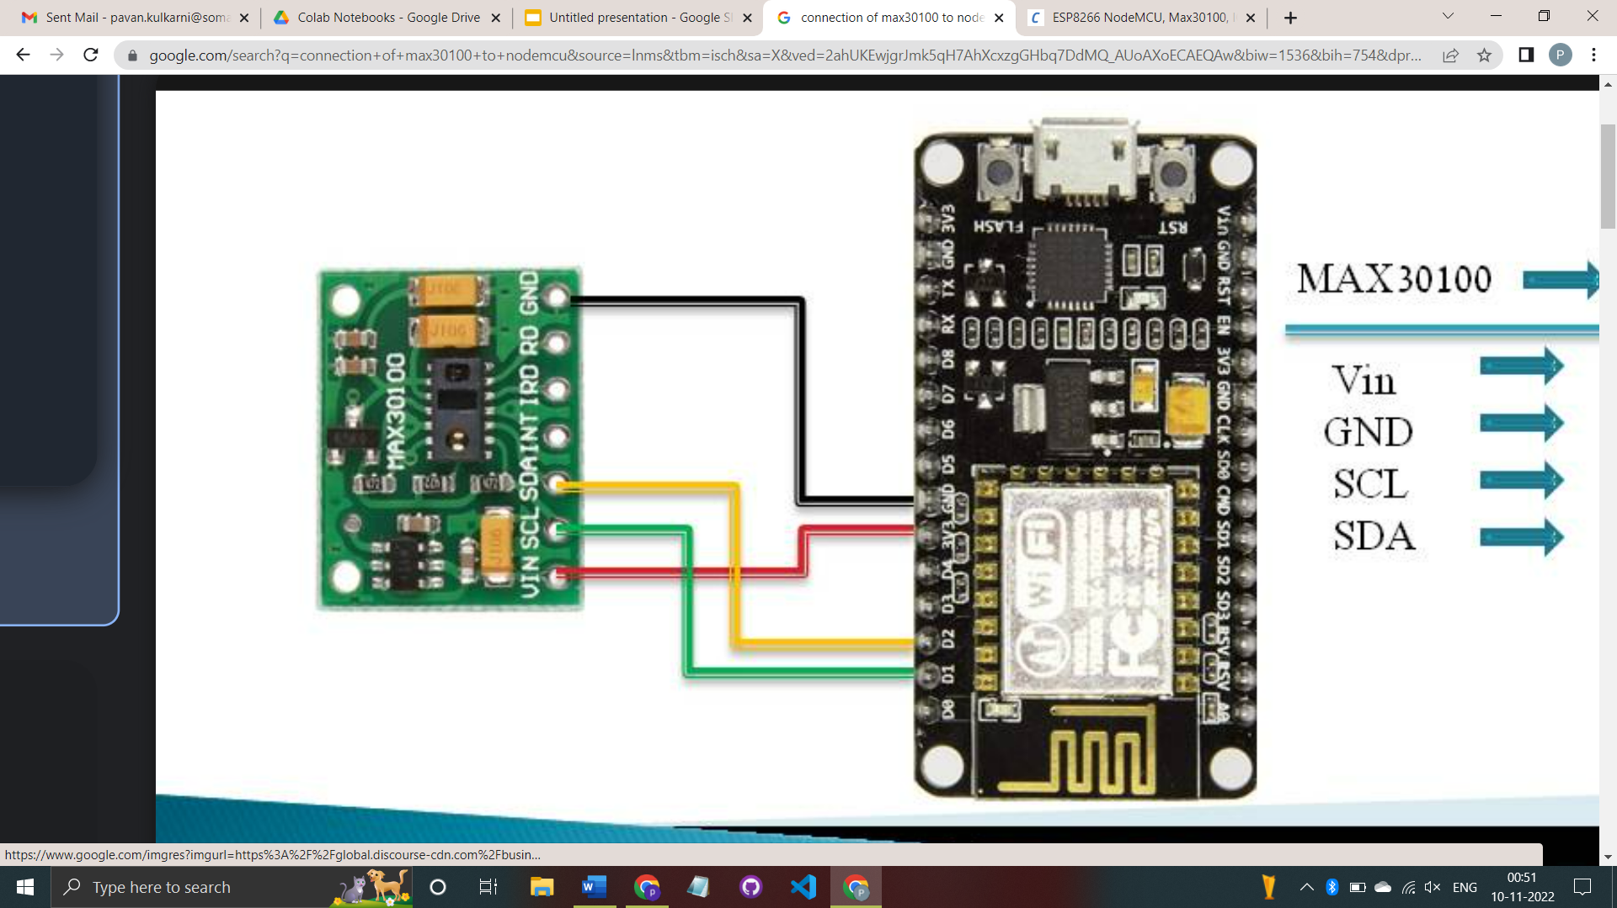

**Fig.3 Connection of Pulse oximeter MAX30100 to NodeMCU**

# Chapter 5: Implementation

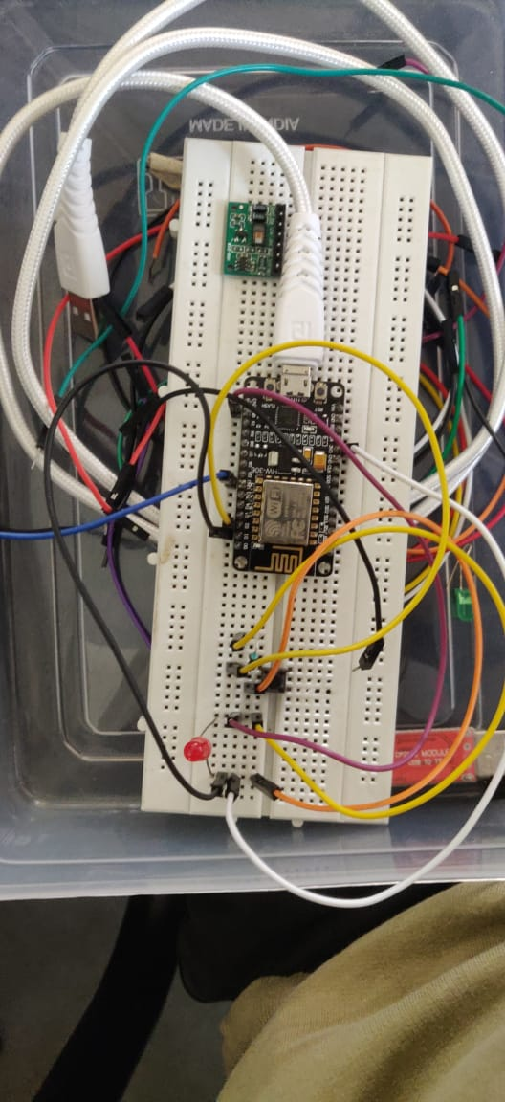

**Fig.4 Node MCU connection**

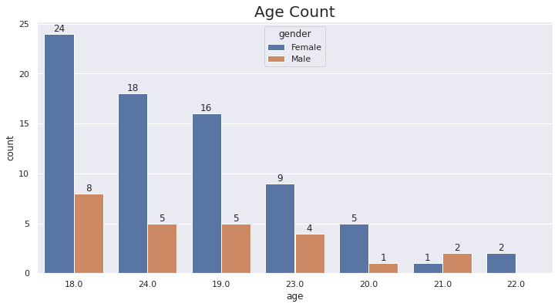

**Fig.5 Data visualisation [1]**

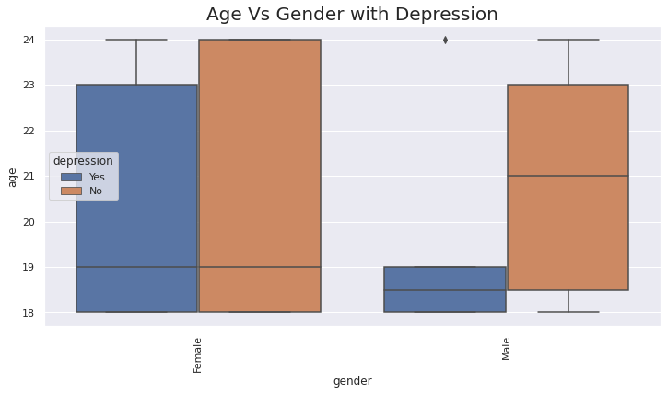

**Fig.6 Data visualisation [2]**

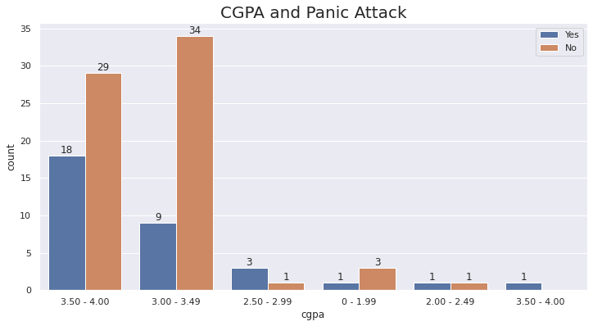

**Fig.7 Data visualisation [3]**

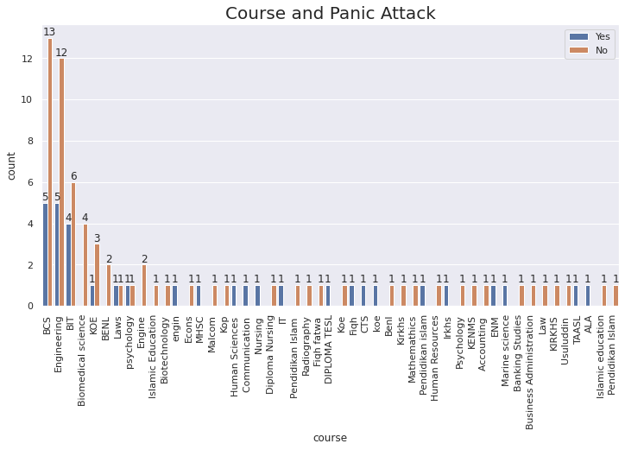

**Fig.8 Data visualisation [4]**

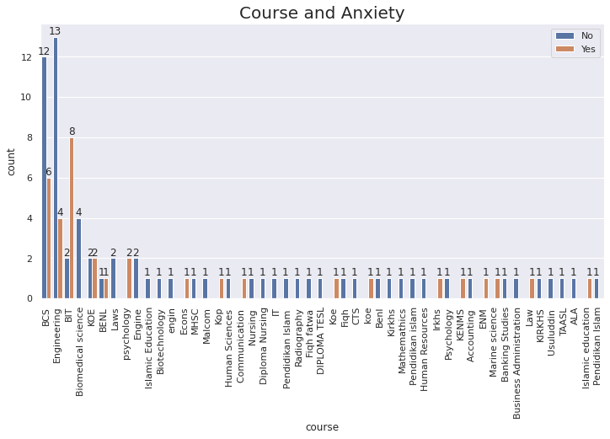

**Fig.9 Data visualisation [5]**

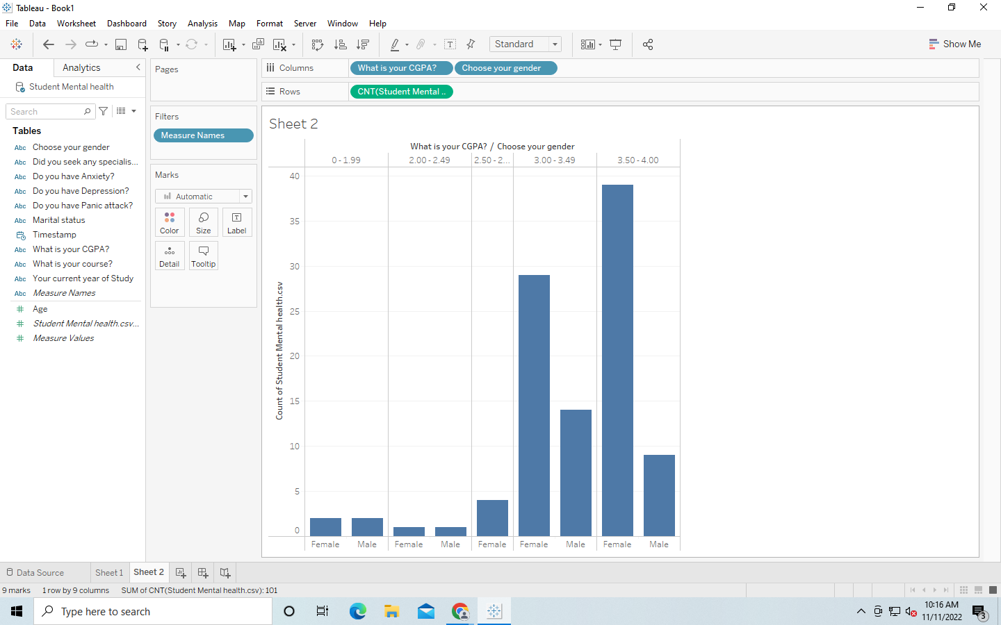

**Fig.10 Data visualisation [6]**

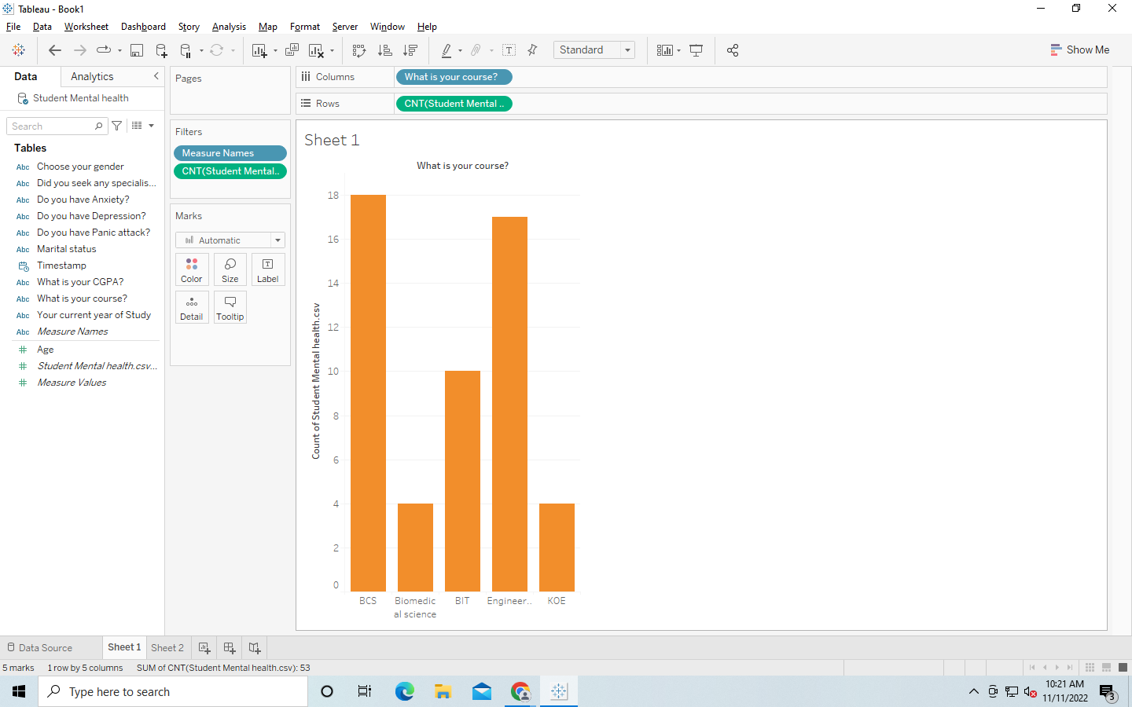

**Fig.10 Data visualisation [7]**

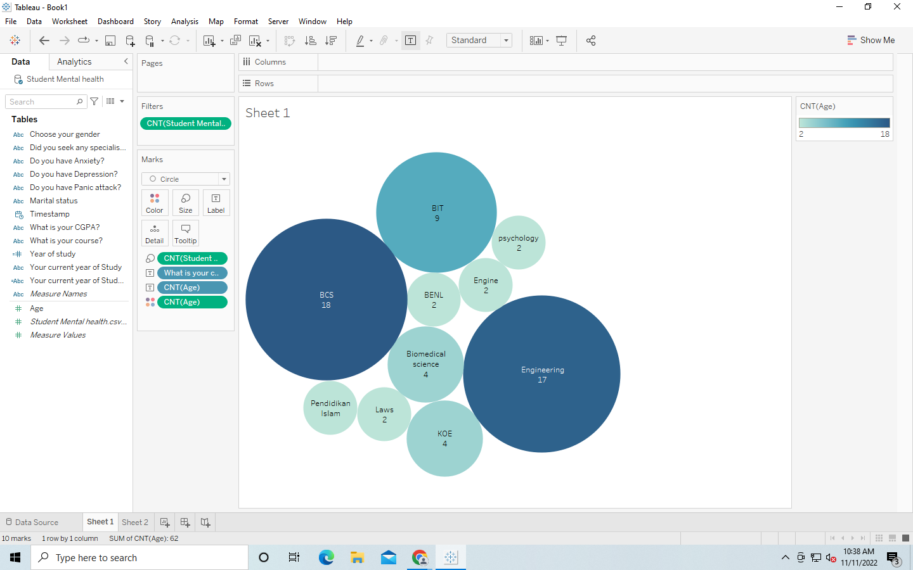

**Fig. 11 Data visualisation [8]**

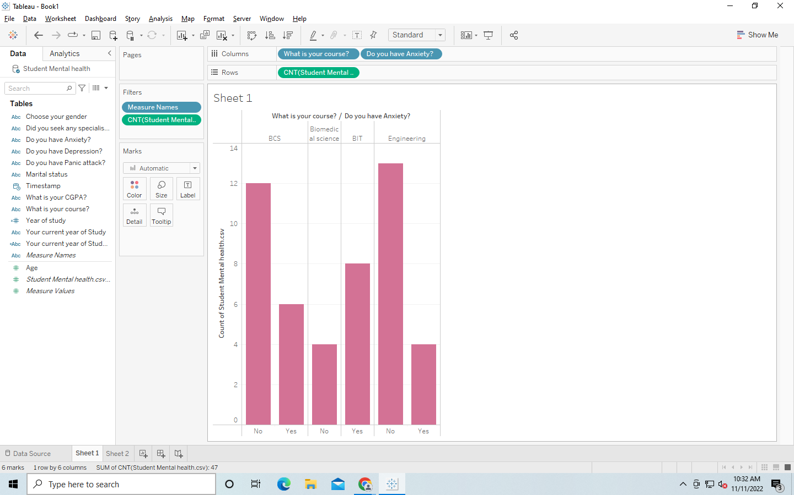

**Fig. 12 Data visualisation [9]**

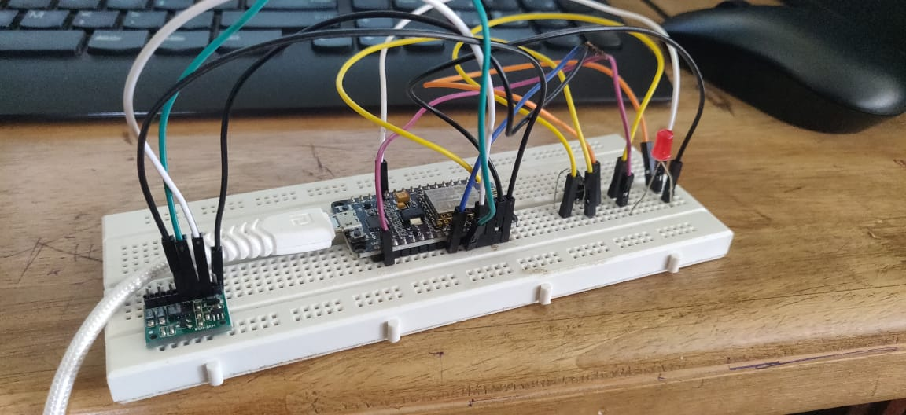

**Fig. 13 Connection of oximeter to NodeMCU [10]**

# Chapter 6: Result

The result we obtained is that, the user can call for help or request for attention with just a single click of button on the IOT device. The oximeter sensor will continuously sense for the pulse rate and keeps a tab on the pulse rate and sends a signal when the rate exceeds the threshold mark.

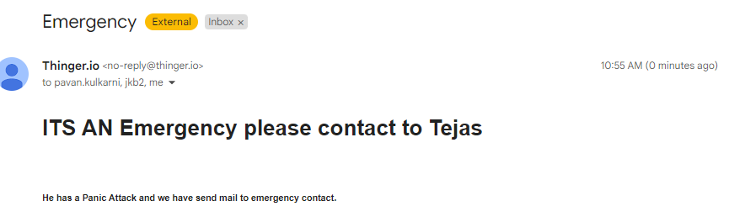

**Fig. 14 Emergency Mail**

# Chapter 7: Conclusion

These findings may make an important contribution to treatment programmes and family-based prevention strategies related to adolescent depressive symptomatology, particularly regarding the potential long-term protective effects of positive parenting style in middle and late adolescence.

Overall, higher levels of mental wellbeing (using both a continuous measure and fixed cut-points) are found to be associated with lower risk for onset or recurrence of common mental disorders (CMDs, antidepressant use, depression based on the PHQ-8). The results showed a dose-response pattern, i.e., lower risk with each increase in the level of mental wellbeing. As compared to low mental wellbeing, moderate mental wellbeing was associated with a 55–68% reduction in risk for all outcomes, while high mental wellbeing was associated with a 69–90% reduction. Future studies are warranted to investigate the effectiveness of universal and targeted approaches to promote mental wellbeing and prevent CMDs.

**Chapter 8: Future Scope**

In terms of future work, we can implement the model on cloud platform so that the data can be used anywhere around the world without the necessity of carrying of server devices. We can also make oximeter to measure pulse rate continuously during performing different activities and can also implement different ml algorithms for better data analysis.

# Chapter 9: References

**[1]** C. A. Trianti, B. Kristianto and Hendry, "Integration of Flask and Python on The Face

Recognition Based Attendance System," 2021 2nd International Conference on

Innovative and Creative Information Technology (ICI Tech), 2021, pp. 164-168, doi:

10.1109/ICITech50181.2021.9590122.

**[2]** M. Khan, S. Chakraborty, R. Astya and S. Khepra, "Face Detection and Recognition

Using OpenCV" 2019 International Conference on Computing, Communication, and

Intelligent Systems (ICCCIS), 2019, pp.116-119, doi:

10.1109/ICCCIS48478.2019.8974493.

**[3]** A. Arjun Raj, M. Shoheb, K. Arvind and K. S. Chethan, "Face Recognition Based Smart

Attendance System," 2020 s-357, doi: 10.1109/ICIEM48762.2020.9160184.

**[4]** H. Rathod, Y. Ware, Snehal Sane, Suresh Raulo, Vishal Pakhare and Imdad A. Rizvi,

"Automated Attendance System using Machine Learning Approach", 2017 International

Conference on Nascent Technologies in the Engineering Field (ICNTE-2017)*, 2017.*

**[5]** Rehm and Shield, 2019 J. Rehm, K.D. Shield

Global burden of disease and the impact of mental and addictive disorders

Current Psychiatry Reports, 21 (2) (2019), p. 10

**[6]** WHO, 2017 WHO

Depression and other common mental disorders: Global health estimates

World Health Organization, Geneva, CH (2017)

**[7]** Plana-Ripoll et al., 2019

O. Plana-Ripoll, C.B. Pedersen, E. Agerbo, Y. Holtz, A. Erlangsen, V. Canudas-Romo,

et al. A comprehensive analysis of mortality-related health metrics associated with

mental disorders: A nationwide, register-based cohort study

The Lancet, 394 (10211) (2019), pp. 1827-1835